

Table of contents
Table of contents 2
About this manual 3
About Hometrainer 2 4
How to load an existing exercise 5
How to create an exercise file 7
How to take an existing test 10
How to create a test 10
This manual’s version history 10

About this manual
This version of the manual (v0.5) is written on the 23rd of September 2009. Hometrainer 2 was at its fifth version (v1.4). At their author’s website, http://www.richelbilderbeek.nl, the most recent version of this manual and Hometrainer 2 can be found.

About Hometrainer 2

Hometrainer 2 is a suite of programs that allows to create, take and score digital exercises and tests. The philosophy responsible for the creation of Hometrainer 2 was the need of such a suite that was both simple to use and free.

With Hometrainer 2 you or your students can create exercises with open and multiple-choice questions, with or without an illustrational image. Additionally, you can create multiple-choice tests, whose results can be scored and graded automatically.

How to load an existing exercise

Start Hometrainer 2.

The following window, the main menu, will appear:

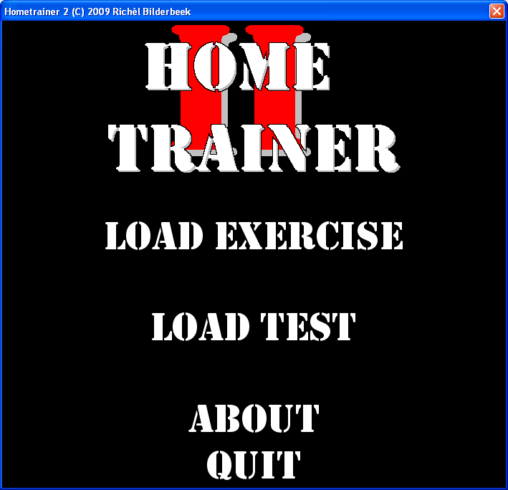
The Hometrainer 2 main menu.
Note that you cannot select ‘Start exercise’

Click on ‘Load exercise’. The following dialog, the select exercise dialog, will appear:

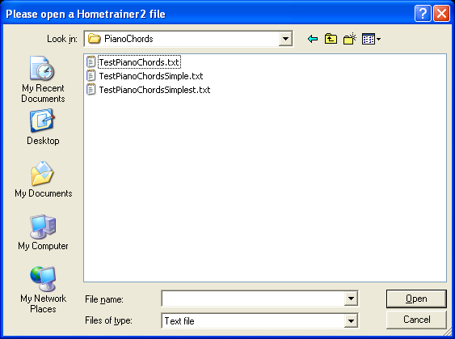
Dialog to select a Hometrainer 2 exercise file

Browse for the existing Hometrainer 2 exercise file, click it and click ‘Open’.

The following window, the main menu, will appear:

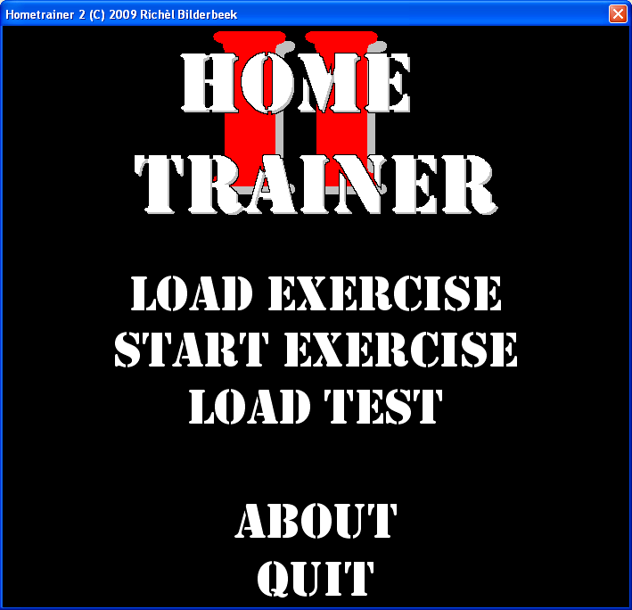
The Hometrainer 2 main menu.
Note that you can select ‘Start exercise’

Click on ‘Start exercise’ to start the exercise.

How to create an exercise file

An exercise file is a plaintext file consisting of one copyright line and the questions’ information, for example the text below:

Hometrainer2 (C) 2009 Richel Bilderbeek
Alphabet.bmp,What's the first letter of the alphabet?,A,B,C,D
Alphabet.jpg,What's the first letter of the alphabet?,A,B,C,D
-,What's the first letter of the alphabet?,A,B,C,D
Alphabet.bmp,What's the first letter of the alphabet?,A/a
Alphabet.jpg,What's the first letter of the alphabet?,A/a
-,What's the first letter of the alphabet?,A/a
Example exercise file. It is copied from Hometrainer 2:
in the main menu, click ‘About’, then ‘Example file’

Each exercise file must have the first copyright line, otherwise it is rejected by Hometrainer 2. Every following line holds one question.

The exercise file does not hold the images you might want to use: it only contains these images’ names. For the example exercise above to fully work, you will need to supply a bitmap (.bmp) with the name ‘alphabet’ and a JPEG (.jpg) named ‘alphabet’ next to the exercise file.

Each question line in an exercise file consists of comma-seperated fields, resulting in open questions or multiple-choice questions, with or without an illustration.

A multiple-choice question line holds the following fields:
- Illustration filename or use a minus sign (or another character) to let the question have no illustration.
- The question
- The right answer
- The wrong answer or the wrong answers

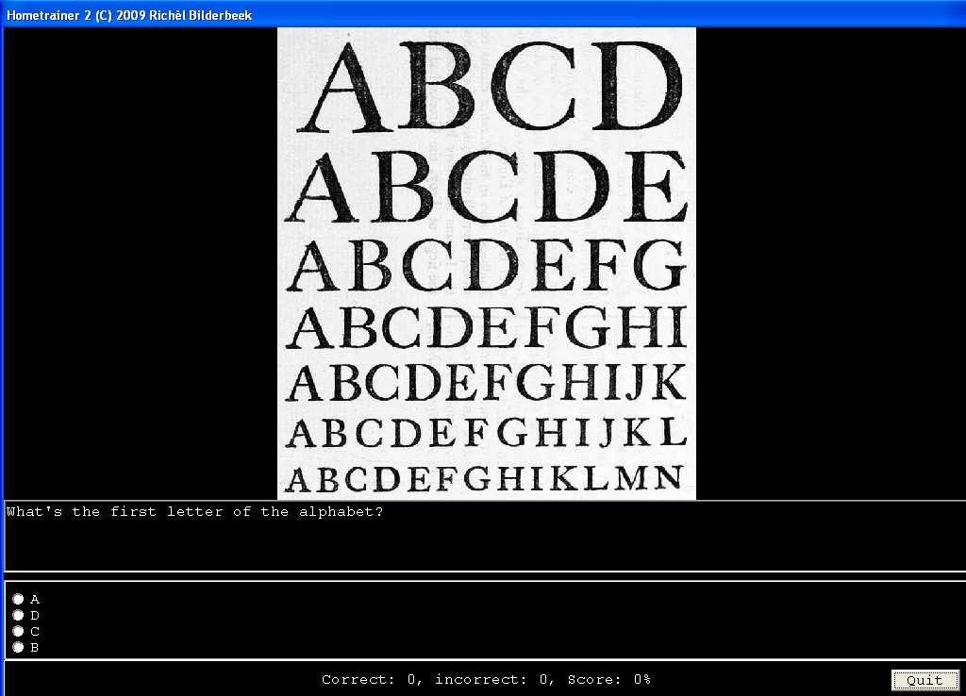Example multiple-choice question.
The question line was

An open question line holds the following fields:
- Illustration filename or use a minus sign (or another character) to let the question have no illustration.
- The question
- The right answer or the right answers, separated by slashes (‘/’)

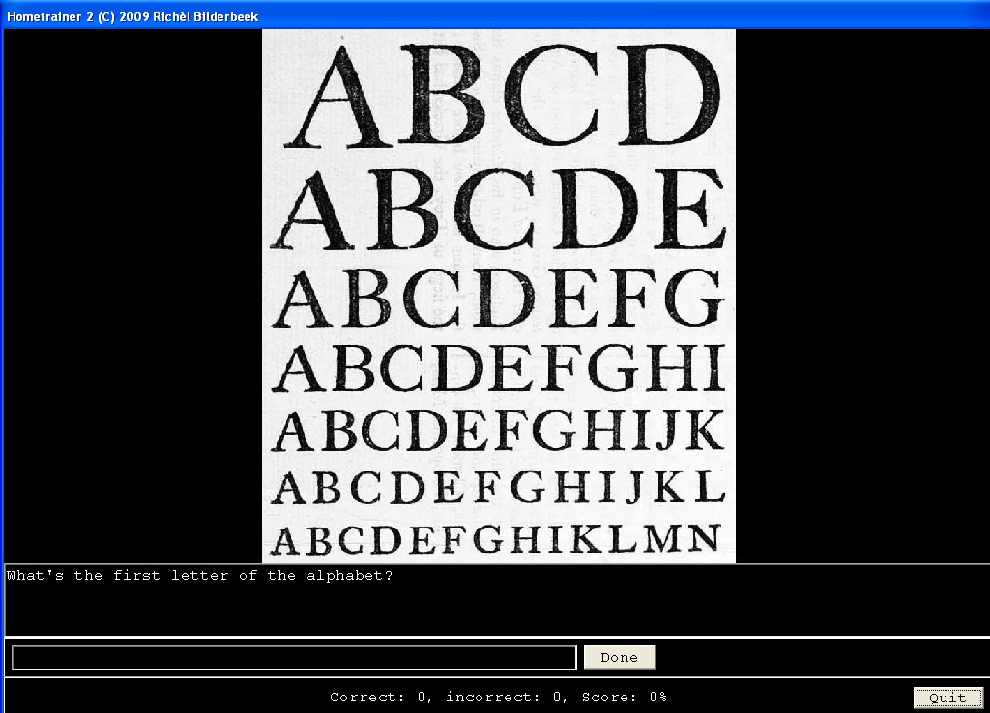
Example open question.
The question line was

Take care in contructing the questions
- A question must be put in one line. In Notapad it might be a good idea to turn off word wrapping
- A question or answer cannot hold comma’s
- The answer of an open question is case-sensitive. Therefore you might want to supply the same correct answer in multiple case-style: for example, an answer might be ‘A’ or ‘a’

How to take an existing test

(To do)

How to create a test

(To do)

This manual’s version history
- v0.5: 2009-09-23: Initial incomplete version
- vX.Y: YYYY-MM-DD: Description

