Speciation and the error we make in phylogenetic inference
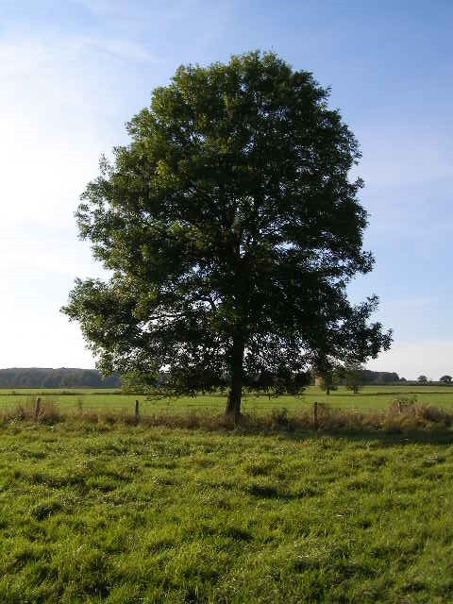
Richèl J.C. Bilderbeek

