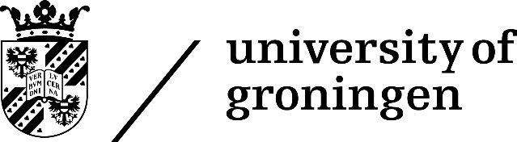
Speciation and the error we make in phylogenetic inference
PhD thesis
to obtain the degree of PhD at the
University of Groningen
on the authority of the
Rector Magnificus Prof. E. Sterken
and in accordance with
the decision by the College of Deans.
This thesis will be defended in public on
Friday September 18th 2020 at 16:15 hours
by
Richèl Jacobus Cornelis Bilderbeek
born on 2 September 1980
in Gennep, The Netherlands

Supervisor
Prof. R.S. Etienne
Co-supervisor
Dr. A.L. Pigot
Assessment Committee
Prof. F. Hartig
Prof. L. Harmon
Prof. E. Wit

