The error in trees without birds
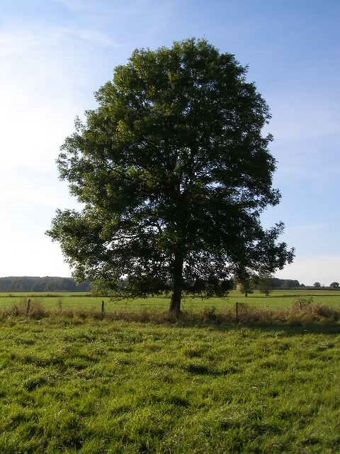
Richèl J.C. Bilderbeek

