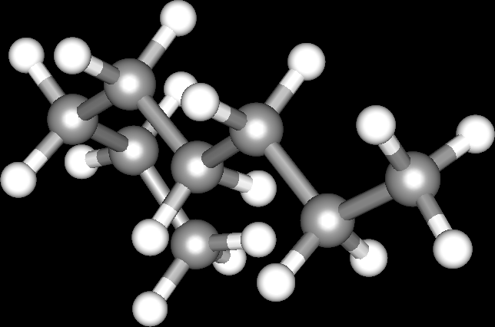
Team Octane
Kontakt: Joshua
2D datorspel, C++, git, GitHub, SFML, Discord

