Questions for the course “Linux Command Line 101", 02 February 2026

Please note the following:
- Add your questions below, numbering them continuously.
- Be careful in case someone else is writing at the same time.
- Please DO NOT delete your questions even when they have been answered, as we are planning to use them to improve our material.
- Do not share any sensitive information as this document is accessible to anyone with the correct link.
- You can start a new line within a question by pressing <SHIFT> + <ENTER>.
- Important info page: https://umeauniversity.sharepoint.com/:w:/s/HPC2N630/IQBsH-Pe_wARRZXveB6zeM63AffGTwAMlQolvDfpaNaZJJk
- General information / summary: Logging in to Tetralith (only for those who needed this for Linux access)
  - SSH: ssh <username>@tetralith.nsc.liu.se
  - ThinLinc: Server should be given as tetralith.nsc.liu.se
    - Enter the username and password you got from NSC
  - Remember to set up the MFA before connecting! Info on that here: https://www.nsc.liu.se/support/2fa/
- You can just use the home directory on Tetralith, as the files for this course are not large.
- Prepare
  - Do one of:
    - Open a terminal on your Linux/macOS computer
    - (Windows) Login to Tetralith (or whatever system you are using). Change to the above directory on Tetralith (or wherever you want to do the type-alongs and exercises).
  - Create a directory to use for the course, change to that, and then you may get the course material from GitHub using EITHER OF:
    - git clone https://github.com/hpc2n/linux-command-line-101.git
    - wget https://github.com/hpc2n/linux-command-line-101/raw/refs/heads/main/exercises.tar.gz
      - If you did this, you also need to do
        - tar zxvf exercises.tar.gz

- When does the course start?
  - [RJCB] Today at 9:00
- What are flags?
  - [RB] text added to a command. For example ‘ls’ (without flags) lists your files. Adding a ‘-a’ flag makes the command ‘ls -a’. This lists all information of all files. Did that answer your question?
- Can you use several flags at the same time?
  - [RB] Yes, you can! E.g. ls –a' and ‘ls -r’ together becomes ‘ls -a -r' or ‘ls -ar’ 😊. Did that answer your question? Yes! Thanks! [RB] Yay!
  - Can you combine all of them or just some?
    - [JH] Depends on the command and the flags used.
- Is `ls -i` ignoring lower case or showing the inode?
  - [RB] I will check, using the command ‘man ls’ to see the manual 😊. Give me a sec 😊 . I see in the manual:
-i, --inode
print the index number of each file
Hence, it shows in the index number 😊
Did that answer your question? Yes, thanks a lot! [RB] Yay!
- How would we search for files accounting for both the capital and non capital letters? Since a[T-g] would cover Z as well. Thanks!
  - [RB] I do not know. I assume your reasoning is correct. I assume the course material uses it as an example.
Did that answer your question?
- How do you automatically copy the code to the new line?
  - I am not getting your question, could you expand?
  - Like when Sahar is writing code she sometimes automatically write the same code again
    - [RB] Press up. It bring back a previous command you run. Did that answer your question?
    - Yes! Thank you! [RB] Yay! Dile
- How to rename a file?
  - [RB] Use `mv`, e.g. `mv from_name.txt to_name.txt` ro rename a file called ‘from_name.txt’ to ‘to_name.txt’.
Did that answer your question? Yes! Thank you [RB] Yay!
- [AJ] When we use export VARIABLE=true, is the variable accessible to Python? How can we test this?
  - [RB] If you do it right: yes! Using ‘sys.env' or something 😊 . I use this search term, found this Stack Overflow post, with the result:
import os
print(os.environ[‘MY_VARIABLE'])
Save that Python code in a file called, e.g. my_code.py
In the terminal do:
export MY_VARIABLE=”hello”
Then run the Python code, e.g.
python my_code.py
It should print ‘hello’.
Does that answer your question?
  - I tried to experiment with the command you provided. This is what I got when logged into Alvis 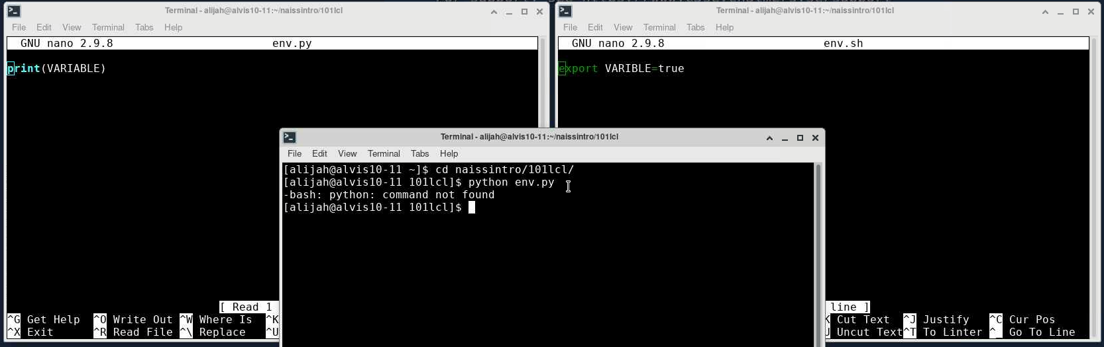I got `python: command not found`. I
    - [RB] do ‘module load Python’ first 😊. This makes Python available. You will learn this tomorrow.
      - 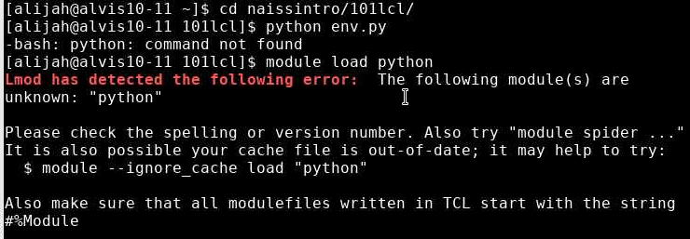
    - [RB] Try uppercase ‘p’ in ‘python’, i.e. ‘module load Python’ 😊 (it differs between HPC clusters)
      - Yes! Sorry about the silly mistake. Now I know to pay attention to upper/lowercase
        - [RB] No worries 😊 . It is what I/we are here for! Again, you will learn this tomorrow 😊.
Did this answer your question?
    - I got Python to work (Yay!) and I can set the variable (yay!). So I think this is OK. I will have some questions for tomorrow maybe. Thanks for helping me appreciate it!
      - [RB] Great! Fun! Maybe see you at 13:00 (I will teach that session 😊)! Will be useful to have a Tetralith user that has already been able to login!
P.S. Your error reporting is great! Support (i.e. my colleagues helping you with your questions) will love that! 😊😊😊😊😊😊😊😊
      - For reference:
        - Bash command: `export VARIABLE=true`
        - `module load Python`
        - nano env.py ->
          - Import os
          - print(os.environ[`VARIABLE`])
        - Python env.py -> prints out `true`
- [AJ] Is it correct to assume that we should use `#!/bin/bash` at the beginning of each .sh script (unless proven otherwise)?
  - [RB] If you use ‘should’ the answer is ‘maybe’. You can safely leave it out. However, you should do this, if you want to do what people expect. You do not need to do it for the operating system: it does not bother: you can do ‘bash my_script.sh’ instead to achieve the same.
Additionally, you can also specify other interpreters, e.g. ‘#!/bin/env Rscript’
Does that answer your question?
    - [AJ] Yes! Got it thanks. At my level, I think I will stick to the basic use, but good to know there are other interpreters to use as well.😊
      - [RB] Smart idea! Let’s take it easy here with all those fancy command line things 😊
- [AJ] As users of the NAISS infrastructure, what applications are there for changing the permission of files beyond the chmod u+x my_first.sh for bash scripts?
  - [RB] chmod is the only program/command to change the permissions of files and folders. Am I misinterpreting your question maybe?
    - [AJ] Aha, this makes life so much simpler. Thanks! One (standard) command to rule them all!
      - [RB] Yay! (there may be others, I don’t know them. These are not standard, but hey, people write tools)
Yes, one standard command to rule them all! Technically: one POSIX command to rule then all (POSIX compliance means having certain tools, such as chmod available) 😊
      - [AJ] I had to do this 😊
        - 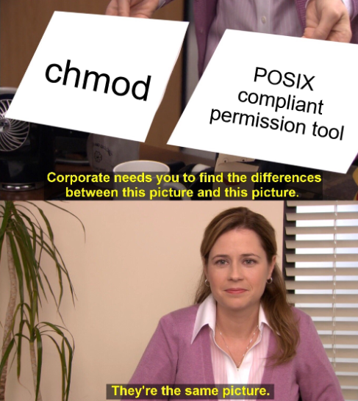
      - [RB]: You did wel 😊😊😊😊😊😊😊😊
- PLACEH OLDER
- PLACEHOLDER
- PLACEHOLDER
- PLACEHOLDER
- PLACEHOLDER
- PLACEHOLDER
- PLACEHOLDER
- PLACEHOLDER
- PLACEHOLDER
- PLACEHOLDER
- PLACEHOLDER
- PLACEHOLDER
- PLACEHOLDER
- PLACEHOLDER
- PLACEHOLDER
- PLACEHOLDER
- PLACEHOLDER
- PLACEHOLDER
- PLACEHOLDER
- PLACEHOLDER
- PLACEHOLDER
- HPC2N’s YouTube channel will have the recordings, probably tomorrow: https://www.youtube.com/user/HPC2N/videos
- Evaluation survey: https://forms.office.com/e/NFR7fyhc3i

