Questions for the course “Running jobs on clusters”, 3 February 2026

Please note the following:
- Add your questions below, numbering them continuously.
- Be careful in case someone else is writing at the same time.
- Please DO NOT delete your questions even when they have been answered, as we are planning to use them to improve our material.
- Do not share any sensitive information as this document is accessible to anyone with the correct link.
- You can start a new line within a question by pressing <SHIFT> + <ENTER>.
- Important info page: https://umeauniversity.sharepoint.com/:w:/s/HPC2N630/IQDiierl0ch9SoZyvNoNQ6FSAVqyDvHWHPF00TLJWkHNJXo?e=8YP1f2
- Prepare
  - Login to Tetralith/Dardel/Alvis (or whatever NAISS branch system you are using).
  - Create a directory to use for the course, change to that, and then you may get the course material from GitHub using EITHER OF:
    - git clone https://github.com/UPPMAX/NAISS_Slurm.git
    - wget https://github.com/UPPMAX/NAISS_Slurm/raw/refs/heads/main/exercises.tar.gz
      - If you did this, you also need to do
        - tar zxvf exercises.tar.gz

- [AJ] What is defined as a heavy computation that should not be run on the login node?
  - To some extent this depends on the service you are using, though often it obvious what it is. To give a few numbers, we have over 200 connections on the tetralith3 login node. There is 386 GB of memory and there are 32 core.
    - To get a few numbers, try uptime and free –h on your login node.
    - [AJ] Cool! Will make a note of this. 😊 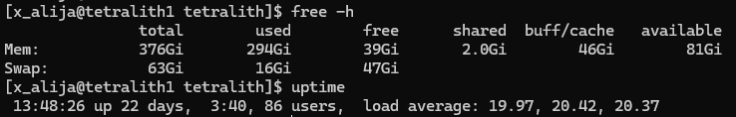
  - Typically, if the process you’re running takes longer than 10 min, you may consider running it on a compute node. rsync may be an exception.
  - [AJ] So with Joachim’s additional explanation, we should “be nice”. Using vim/nano is fine, extracting/transferring files is fine. But stay away from anything that uses continuous memory/compute resources (especially if more than 10 min) as a golden rule.
    - A job that eats 300GB of memory is never ok, even if it is very short.
    - Similarly, a job that occupies all or nearly all of the CPU cores is never really ok. A number of users that is larger than the number of cores on a login node is expected to work fine.
- What is a core in the context of the HPC. Like what is the compute power of this core. Is it just like my laptop cpu core?
  - The cores are very similar and in some cases even the same, though often with access to more cache and/or more memory bandwidth and always with better cooling than in a laptop – so that they can run at full speed for an essentially unlimited time. Also sometimes/usually HPC has error correcting memory, which can be very beneficial for long-running and especially memory-intensive jobs.
- [AJ] On Alvis, we can use OnDemand (https://www.c3se.chalmers.se/documentation/first_time_users/intro-alvis/slides/#alvis-open-ondemand-portal) to create an instance of Jupyter. How does that relate to the jobs system (or is that something else entirely)?
  - Open OnDemand (Alvis, Kebnekaise) and Gfx launcher (Dardel, Cosmos) use the batch system. You ask for resources when you start a Jupyter, MATLAB, etc. and then you are working on a compute node. If you open a terminal and write “squeue --me” you will see that you have indeed a batch job running, corresponding to the resources (cores, time, etc.) you asked for when you started Jupyter, MATLAB, etc. I guess the use of the batch system is just a bit “hidden” when you work interactively like this
    - [AJ] Got it, thanks 😊
- How to extend my Slurm job before the TIMEOUT?
  - There are different policies at different centers. At UPPMAX you may email support to have the job extended. At PDC my understanding is that you cannot. At NSC you may do it yourself, with an additional cost: https://www.nsc.liu.se/support/batch-jobs/boost-tools/timelimit/ and at HPC2N you can email support and ask, and they may – rarely – allow to extend it.
- How can we know the number of cores/nodes we need and for how long (number of hours)?
  - This is a tricky question as it depends on what kind of parallelism your application uses. If is it’s an OpenMP job only, the maximum number of threads or cores that you can use is the number of cores/node. If it has MPI parallelism, in principle you can use as many as possible, in practice, it is limited by how well your application scales. What one should do is to start with a few cores, or nodes if MPI, increase and decrease the number and see how the run time changes. One may also ask a colleague/collaborator what the runtime is for a given input and number of cores, but the painful answer is that it comes with practice.
  - In some cases, where you have a lot of insight into the computation you are running, you may be able to reason about it – you may for example know how many parts it makes sense to split the job into. You may also know how it grows, how much longer or shorter and wider or narrower the computation becomes when you change your input parameters. But some testing is always needed.
- [AJ] In the slide Joachim shows, why doesn’t Job 6 start directly after Job 2?
  - There is not 2 full nodes, 16 cores, available at that point.
  - [AJ] Node 1 and Node 3 are empty (after Job 2 is Done), no?
    - Not Node 1! Job 1 is long.
    - [AJ] Ahaha! I didn’t see that Job 1 😁. Thanks
- [AJ] On the topic of reproducibility, are there any recommended ML experiment tracking solution you would recommend to keep track of the #SBATCH outputs without getting overwhelmed 🤪? I use wandb (https://wandb.ai) locally on my own machine.
  - You can use wandb API too in your scripts to log your outputs. Trackio is also an alternative to that. Tensorboard is also available on Alvis, for example, to track your ML runs.
  - [AJ] Are there any examples of using Trackio/wandb/Tensorboard with sbatch together?

- [AJ] What is the correct format of entering in the project name? Birgitte showed it, I missed it 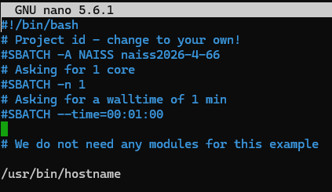
  - Remove the “NAISS” word from that line, account name goes directly after –A
  - [AJ] Thank you!
- Threads need to be run in the same node? So, this means that there is a physical limit of the number of threads in the computer? Or that we need to check. We were using 32 in one case. In kebnekaise we used once 128 threads (and cores?).
  - With shared memory programming, yes you are limited to one node. But there is also distributed programming.
    - We are doing this in cpp, no sharing I think. I don’t know if this is “distributed” or not... and thank you.
- Hello, this is specific with Gaussian but I hope I can get any feedback. I run my submissions at Tetralith.
I specify this to my *.gjf:
%LindaWorkers=node1:1,node2:1
%NProcShared=32
This is my submit file:
#SBATCH --cpus-per-task=32
#SBATCH --ntasks-per-node=1
#SBATCH --constraint=fat
#SBATCH --nodes=2
#SBATCH --time=48:00:00
#SBATCH --job-name=test
module load Gaussian/16.C.01-avx2-nsc1-bdist
g16 1.gjf -m=320Gb
I do seff with my jobid to check what happened:
State: COMPLETED (exit code 0)
Nodes: 2
Cores per node: 32 CPU
Utilized: 28-02:05:46
CPU Efficiency: 48.64% of 57-17:53:04
core-walltime Job Wall-clock time: 21:39:16
Memory Utilized: 317.88 GB Memory Efficiency: 44.03% of 722.00 GB (11.28 GB/core)
Q1: How do I make sure that I run close to 80% (almost two nodes) running the task?
Q2: I also have issues with memory. If I specify n thin nodes to reach 318GB, there seems to be an error as the memory doesn't seem to be "shared." How do I go about this?

Memory is not shared acrross the nodes, I wonder if the output given in memory utilized is per MPI rank or not. Not super familiar with Gaussian. Did you try to run it on one node only?
-> I do not know how to determine the “MPI Rank.” :’(
Regarding the cores, use in of Gaussian per NAISS website says %NProcShared should be 32 max. I will test using 64 instead since I am using 2 cores (2*32).

The maximum of %NProcShared should be the total number of cores per node. If you’re using Tetralith, keep it to 32. The parallelism over nodes is specified with the LindaWorkers.
-> Thank you for the feedback. I will keep it as 32.
I would run a job on one node only and see if the total runtime is lower than the current one for 2 nodes. If it’s ~ 2 times larger, you have very good scaling for the 2-nodes job, so you may keep the settings as they are.
-> I will have to check on this. I usually run one node for almost all my calc unless the system gets “too big” (>200 atoms). That is why I am considering n>1 runs, especially for freq calculations which use a lot of memory for the systems I am looking. Thanks!

- [JH] We have experienced Gaussian users in the NAISS team, though neither of them is on today’s teaching team. I recommend you to submit a support request and our colleagues will be more than happy to discuss this with you. Support requests are best raised in the support form: https://supr.naiss.se/support/
-> I will do these after our training. Thank you!

- [AJ] How can we access the SLURM task scheduler from within a Jupyter Notebook, that is connected to the login node (not compute / OnDemand) over SSH?
  - I assume you are working on Tetralith? SSH tunneling?
    - [AJ] Mostly Alvis, yes with SSH tunneling.
    - If on Alvis, then they do recommend using the OpenOnDemand
  - The information I can find is here (not very new): https://www.nsc.liu.se/support/past-events/Tetralith_Python_training_Oct16_2019/jupyter-notbooks-ssh-tunnel.pdf
    - [AJ] This looks interesting! I will go through it
    - [AJ] I found batchspawner (https://github.com/jupyterhub/batchspawner) which possibly meets my needs. Thanks 👍
- [AJ] So can we say that the Alvis Nvidia A100 and Nvidia A100fat are the same, only difference is that Nvidia A100fat has more system memory? 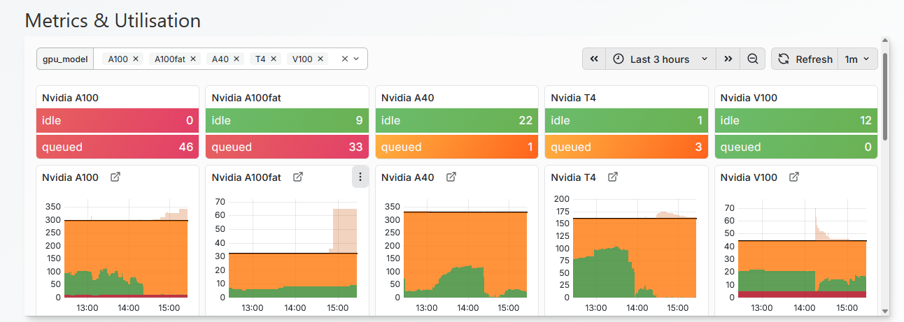
  - It seems so, yes: https://www.c3se.chalmers.se/about/Alvis/#nvidia-a100-based-nodes
- jobstats -p JOBID in Tetralith does not work?
  - It works on Alvis and Bianca. It is afaik a wrapper around squeue
  - See https://uppmax.github.io/NAISS_Slurm/monitoring/#commands__valid__at__all__centres
  - And https://uppmax.github.io/NAISS_Slurm/monitoring/#site-specific__commands
    - But it is of a finished job?
      - It is possible to use it for a running job, but it should be for jobs that run for at least 5 min.
    - sacct -l -j JOBID
    - Or possibly https://www.nsc.liu.se/support/batch-jobs/tetralith/monitoring/
And kebnekaise?
Job-usage JOBID
- PLACEHOLDER
- PLACEHOLDER
- PLACEHOLDER
- PLACEHOLDER
- PLACEHOLDER
- PLACEHOLDER
- PLACEHOLDER
- PLACEHOLDER
- PLACEHOLDER
- PLACEHOLDER
- PLACEHOLDER
- PLACEHOLDER
- PLACEHOLDER
- PLACEHOLDER
- PLACEHOLDER
- PLACEHOLDER
- PLACEHOLDER
- PLACEHOLDER
- PLACEHOLDER
- PLACEHOLDER
- PLACEHOLDER
- PLACEHOLDER
- PLACEHOLDER
- PLACEHOLDER
- PLACEHOLDER
- HPC2N’s YouTube channel will have the recordings, probably tomorrow: https://www.youtube.com/user/HPC2N/videos
- Evaluation survey: https://forms.office.com/e/32FBAC6dJW

