LinkerForge Presentation Study Guide and Speech
A complete guide to understanding, explaining and defending the validation methods and verified results presentation
Prepared 25 October 2026 | Computational evidence only
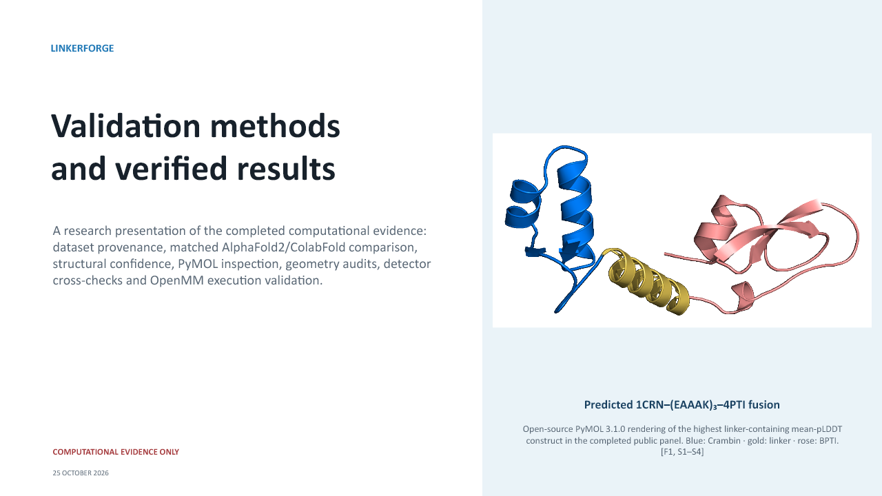
This document has two purposes. Part One teaches the project and the scientific meaning of every slide. Part Two provides a presentation speech that can be practised aloud. The final sections provide a terminology reference, difficult examiner questions and a claim-boundary checklist.
Main conclusion: LinkerForge currently demonstrates a reproducible, provenance-aware computational workflow for comparing fusion-linker candidates and inspecting structural evidence. It does not yet prove which linker is biologically optimal.

How to use this document
Do not try to memorise the entire document word for word. First study Sections 1 to 7 to understand the project. Then use the slide guide to connect each visual to the correct scientific interpretation. Finally practise the speech and use the question bank to test whether you can explain the work without overclaiming.
- Learn the central research problem and why linker selection is context dependent.
- Learn the difference between LinkerForge workflow evidence, AlphaFold confidence, geometry measurements, molecular dynamics and laboratory evidence.
- Practise explaining every graph from its axes, units and individual marks before giving a conclusion.
- Memorise the five prohibited overclaims in the claim-boundary checklist.
- Practise the speech once with the slides and once without them.

Document map
- Part One: project and scientific study guide
- Part Two: slide-by-slide explanation of all 36 slides
- Part Three: complete presentation speech
- Part Four: difficult viva and examiner questions
- Part Five: rapid glossary and final claim-boundary checklist

Part One Project and scientific study guide

1 The research problem
Fusion proteins combine two protein regions into one translated amino-acid chain. The junction is not merely a typing detail. A linker can alter the distance between domains, their freedom of movement, their relative orientation, the accessibility of important residues, local steric packing and the ability of each domain to maintain a useful fold. A linker that works for one domain pair may fail for another because the geometry, surface chemistry, termini and functional constraints of the partners are different.
LinkerForge addresses this as a workflow problem. It accepts two protein-domain sequences, constructs complete fusion sequences with candidate and control linkers, passes those constructs to structure-prediction and analysis tools, preserves provenance and presents the resulting evidence in one interface. The current evidence validates execution, comparison and interpretation components. It does not validate a scientifically trained universal compatibility predictor.

2 What LinkerForge has actually completed
- A provenance-labelled inventory of 27,766 linker-related records with mined, natural and engineered evidence kept separate.
- A 971-record dual-curator review packet, family clustering and scientific preflight that correctly prevents unsupported ranker training.
- A matched public structural comparison using 3 domain pairs, 7 conditions per pair, 21 complete constructs and 105 retained AlphaFold2-pTM outputs.
- Extraction of overall pLDDT, linker pLDDT, pTM and cross-domain PAE.
- PyMOL and embedded-viewer inspection of saved PDB coordinates.
- C-alpha continuity, reference-domain RMSD, protected-site distance and accessibility, hydrogen-aware overlap and surface-burial measurements.
- An orthogonal DFLpred sensitivity check of flexible-linker character.
- Three 50 ps CUDA/OpenMM smoke replicates and automated software/schema verification.
- Versioned and provenance-bearing result artifacts, including source identities, software versions, configuration and file hashes.

3 The evidence ladder
Evidence level | What it establishes | What it does not establish
Software verification | The code, schemas and workflows execute as expected under the tested environment. | That a predicted linker works biologically.
Matched computational comparison | Candidate and controls received the same prediction settings and evaluation rules. | Generalisation to arbitrary proteins or a causal biological effect.
Predictor confidence | How confident AlphaFold2 is in local geometry or relative arrangement. | Expression, activity, thermodynamic stability or LinkerForge accuracy.
Structural descriptors | Properties of a saved predicted pose, such as RMSD, clashes, burial and accessibility. | A complete solution ensemble or retained function.
Short MD smoke test | The preparation, CUDA/OpenMM run and metric-extraction pipeline works. | Equilibrium, convergence or production stability.
Outcome-linked validation | Would connect rankings to measured fusion outcomes. | Not present in the completed evidence.
Experimental validation | Would test expression, stability, activity or structure in the laboratory. | Outside the completed computational scope.

4 The planned model versus the completed workflow
A common examiner trap is to ask for the architecture as though it had already produced the presented ranking. The frozen project design proposes frozen ESM-2 protein embeddings, attachment-point geometric features processed by a graph neural network, a small linker encoder and multitask ranking heads. The intended learning task is pairwise or contrastive compatibility ranking, not a simple success/failure classifier. Candidate production for the MVP is constrained enumeration, mutation and retrieval; learned generation and diffusion remain future work.
The validated presentation does not report a trained or calibrated version of that ranker. The highlighted EAAAK construct was selected from a matched AlphaFold2/ColabFold comparison. It is therefore incorrect to call 93.8 a LinkerForge prediction accuracy or to say that the proposed ranker selected the experimentally best linker.

5 Why the dataset cannot yet train the scientific ranker
The 27,766 records mainly answer an identity question: where might a linker occur, or what linker sequence has been described? The desired compatibility ranker requires an outcome question: when a particular linker was inserted between particular partners, what happened to expression, solubility, activity, stability, structure and other relevant outcomes? Natural interdomain linkers are useful for representation learning, but a native multidomain protein has evolved in a different context from an engineered fusion.
Data type | Available evidence | Use | Limit
Mined candidates | Sequence-model or rule-based candidate spans | Prioritisation and curation | Not ground-truth compatibility
Natural CATH/PDB spans | Domain boundaries supported by public structures | Natural reference and possible pretraining | Not an engineered-fusion outcome
DisProt DFL records | Curated disorder/flexible-linker annotations | Flexible-linker identity reference | Not universal fusion success
Published templates | Documented linker sequences | Controls and retrieval | Published use is context specific
Required outcome data | Partner-linker-partner construct plus measured outcomes | Train and calibrate compatibility ranking | Currently insufficient

6 Why the benchmark is protected and fail closed
A prospective benchmark must remain independent of model development. Predictions, feature choices, thresholds and analysis rules are fixed before the protected outcomes are revealed. If protected labels, public scores or previously revealed outcomes are used to select the model, the final result becomes optimistic because the test set has indirectly become part of development.
Fail closed means that the workflow refuses to continue when the independence conditions are not satisfied. This is a scientific safeguard. It is not the same as a software failure, and it should not be bypassed merely to produce a favorable number.

7 How to interpret the highest-confidence construct
The construct 1CRN-EAAAK15-4PTI had the highest mean pLDDT among the 18 linker-containing constructs in the completed 21-construct public panel. Its overall mean pLDDT was 93.8, linker mean pLDDT 84.9, pTM 0.69 and mean cross-domain PAE 9.7 A. This is a comparatively favorable AlphaFold2 confidence profile for that domain pair and protocol.
It is not the highest overall row if zero-linker controls are included: the 1PGA-1LMB direct-fusion control reached 94.9 mean pLDDT. The selection of the EAAAK example was post hoc and descriptive, so it is suitable for demonstrating the application but not for claiming prospective superiority.

Part Two Slide by slide explanation
Each entry contains the purpose of the slide, the scientific meaning of its content, the correct interpretation and the transition to the next idea. The slide image is included only as a navigation aid; the source PowerPoint has not been modified.

Slide 1 Validation methods and verified results
Slide 1 from the unchanged LinkerForge validation presentation
Purpose: Establish the scope: this is a report of completed computational evidence, not an experimental validation claim.
What to understand: The cover structure is the predicted 1CRN-EAAAK15-4PTI fusion.
- Blue is Crambin, gold is the linker and rose is BPTI.
- PyMOL rendered saved coordinates; it did not predict or simulate them.
How to present it: Open by saying what the workflow proves and what it does not prove.

Slide 2 What is being designed
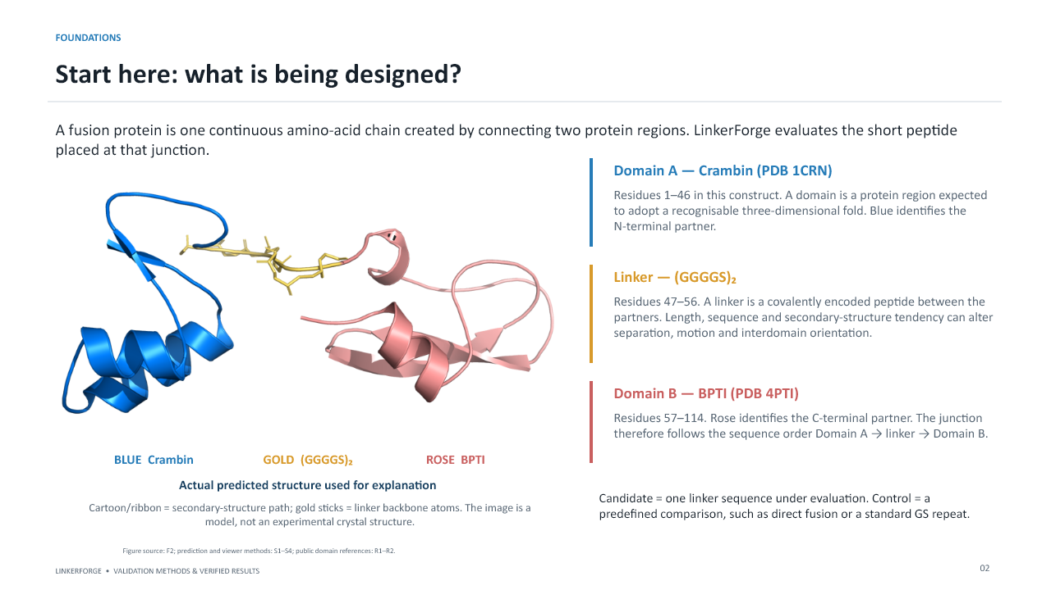
Slide 2 from the unchanged LinkerForge validation presentation
Purpose: Teach the audience the fusion sequence before discussing metrics.
What to understand: A fusion is one continuous amino-acid chain.
- Domain A occupies the N-terminal side, the linker is the junction, and Domain B occupies the C-terminal side.
- The shown GS10 structure is a computational model. A ribbon shows the backbone path; sticks show selected atoms.
How to present it: Transition from the biological object to the design choices at its junction.

Slide 3 Linker classes
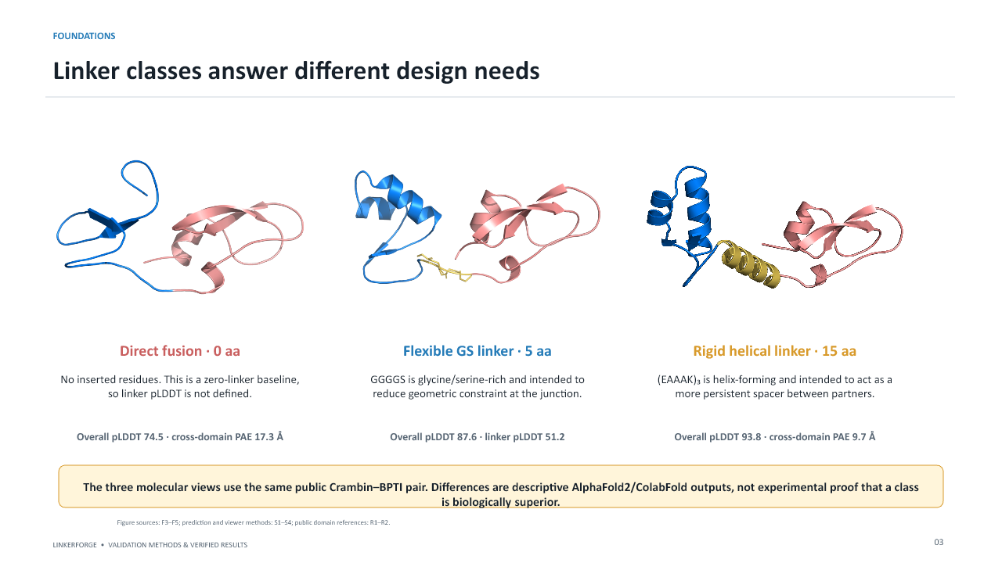
Slide 3 from the unchanged LinkerForge validation presentation
Purpose: Explain why direct, flexible and rigid linkers answer different design questions.
What to understand: Direct fusion is the zero-linker baseline.
- GGGGS is GS-rich and intended to allow motion.
- EAAAK repeats are intended to form a more persistent helical spacer.
- The displayed numerical differences are descriptive for Crambin-BPTI only.
How to present it: Emphasise that linker class is a design hypothesis, not a universal ranking.

Slide 4 AlphaFold2 and ColabFold confidence
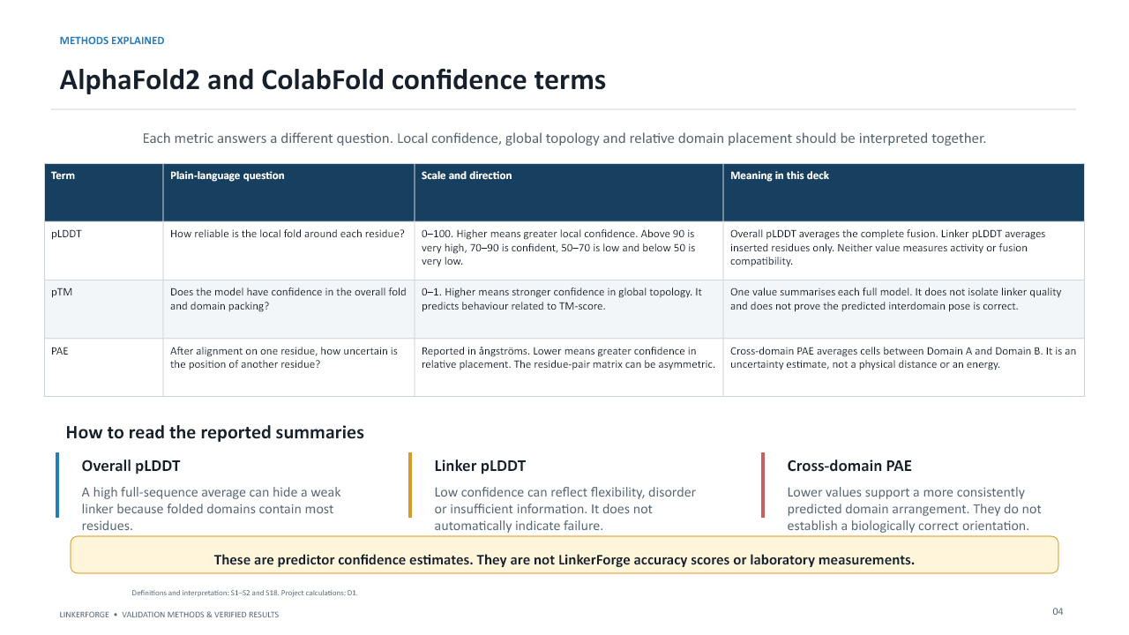
Slide 4 from the unchanged LinkerForge validation presentation
Purpose: Separate local confidence, global topology and interdomain uncertainty.
What to understand: pLDDT is per-residue local confidence on a 0-100 scale.
- pTM is global topology confidence on a 0-1 scale.
- PAE estimates positional uncertainty after alignment and is reported in A.
- A high average pLDDT can hide a low-confidence linker.
How to present it: Say explicitly that none of these values is LinkerForge accuracy.
Do not overclaim: Never convert pLDDT into percent accuracy.

Slide 5 Geometry and simulation terms
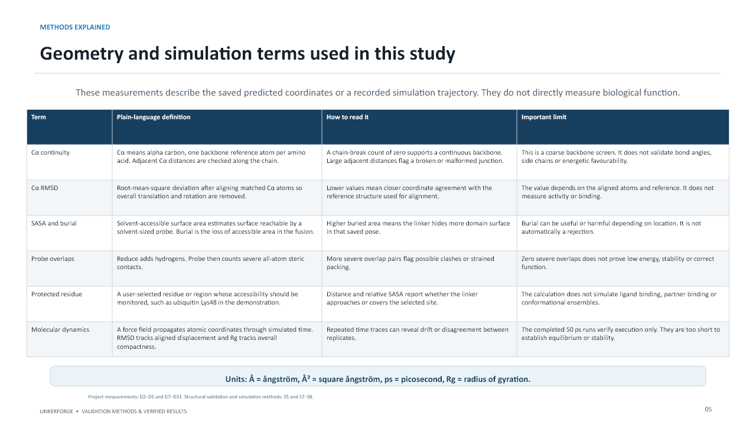
Slide 5 from the unchanged LinkerForge validation presentation
Purpose: Define every structural descriptor before it appears in the results.
What to understand: C-alpha continuity screens for coordinate gaps.
- C-alpha RMSD measures reference-aligned coordinate difference.
- SASA and burial describe solvent exposure.
- Reduce and Probe provide hydrogen-aware contact assessment.
- OpenMM trajectories provide time-dependent coordinates; Rg describes compactness.
How to present it: Use this slide as the vocabulary foundation for slides 21-26.
Do not overclaim: A geometric descriptor is not a biological assay.

Slide 6 Evidence levels and claim boundaries
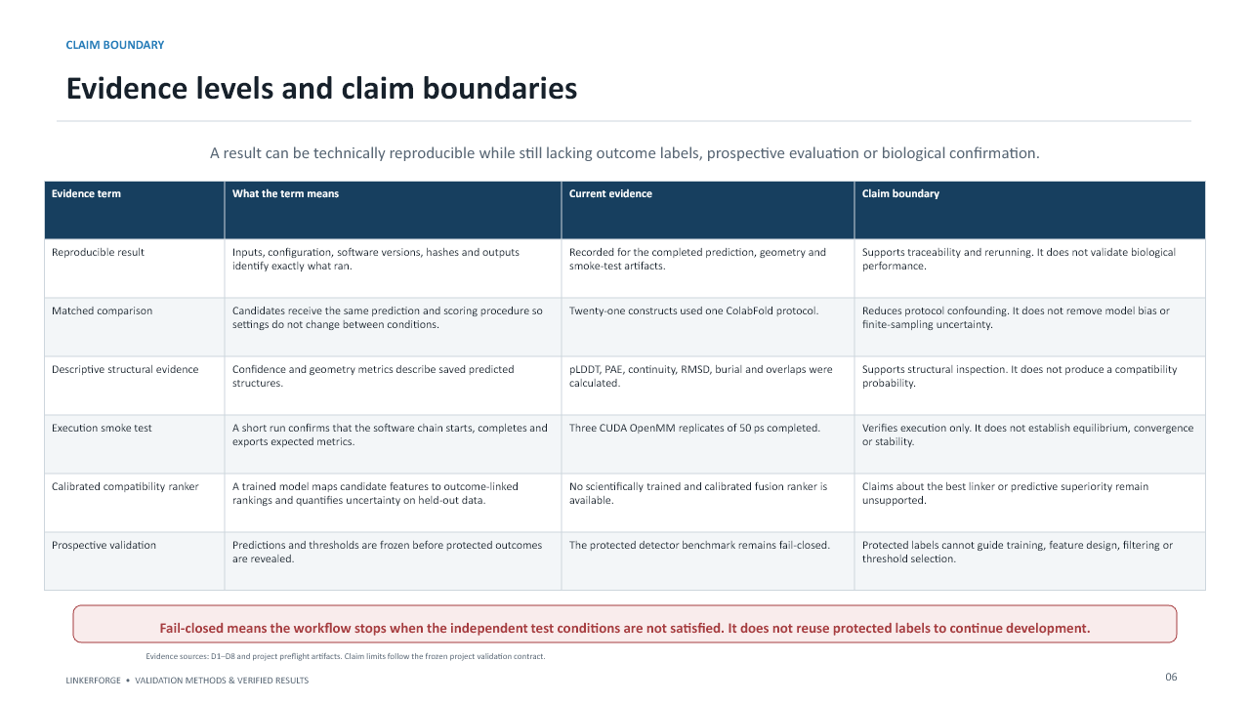
Slide 6 from the unchanged LinkerForge validation presentation
Purpose: Show that reproducibility, confidence, structural description and biological proof are different evidence levels.
What to understand: A reproducible run can still lack outcome labels.
- A matched comparison reduces protocol confounding but does not remove model bias.
- A 50 ps smoke test validates execution, not stability.
- A calibrated ranker and prospective validation are not yet available.
How to present it: Explain fail-closed behaviour as protection against data leakage.
Do not overclaim: Technical reproducibility and scientific validation are not synonyms.

Slide 7 Dataset acquisition
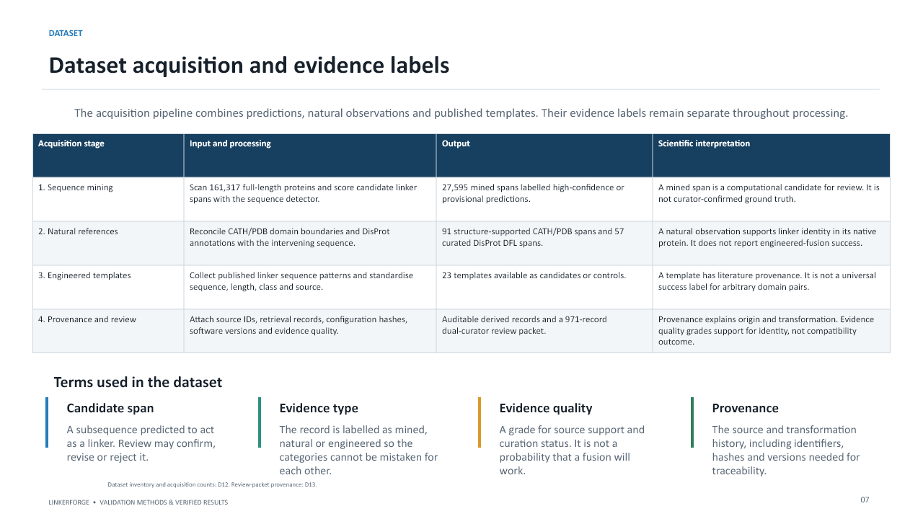
Slide 7 from the unchanged LinkerForge validation presentation
Purpose: Explain how mined candidates, natural references and engineered templates were acquired and kept separately labelled.
What to understand: 161,317 proteins were scanned.
- 27,595 mined spans were identified.
- 91 CATH/PDB and 57 DisProt natural references were collected.
- 23 engineered templates were recorded.
- Provenance includes identifiers, transformations, hashes and versions.
How to present it: Stress that evidence quality is not a probability of fusion success.

Slide 8 Dataset composition
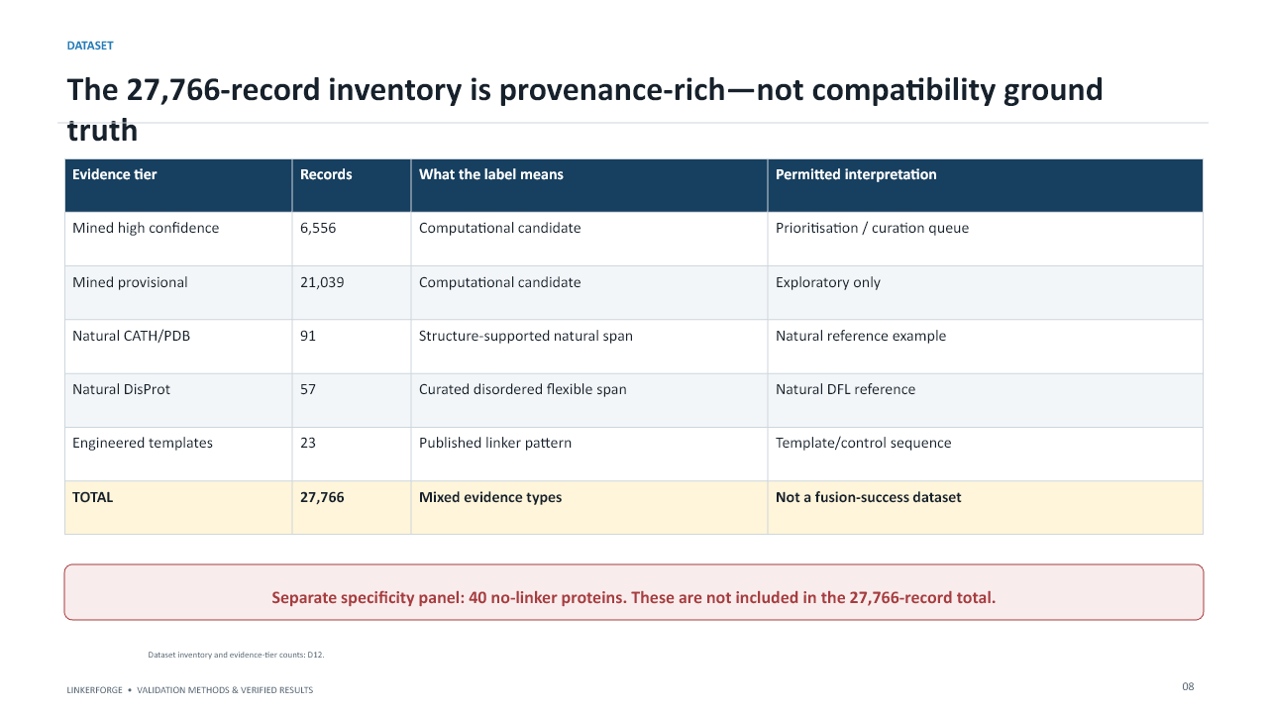
Slide 8 from the unchanged LinkerForge validation presentation
Purpose: Explain the exact 27,766 total and why it is not compatibility ground truth.
What to understand: 6,556 mined high-confidence and 21,039 provisional candidates dominate the inventory.
- 91 CATH/PDB, 57 DisProt and 23 engineered-template records provide stronger source context.
- A separate 40-protein no-linker panel is not part of the total.
How to present it: The inventory supports curation and pretraining research, not a best-linker claim.

Slide 9 Curation and training preflight
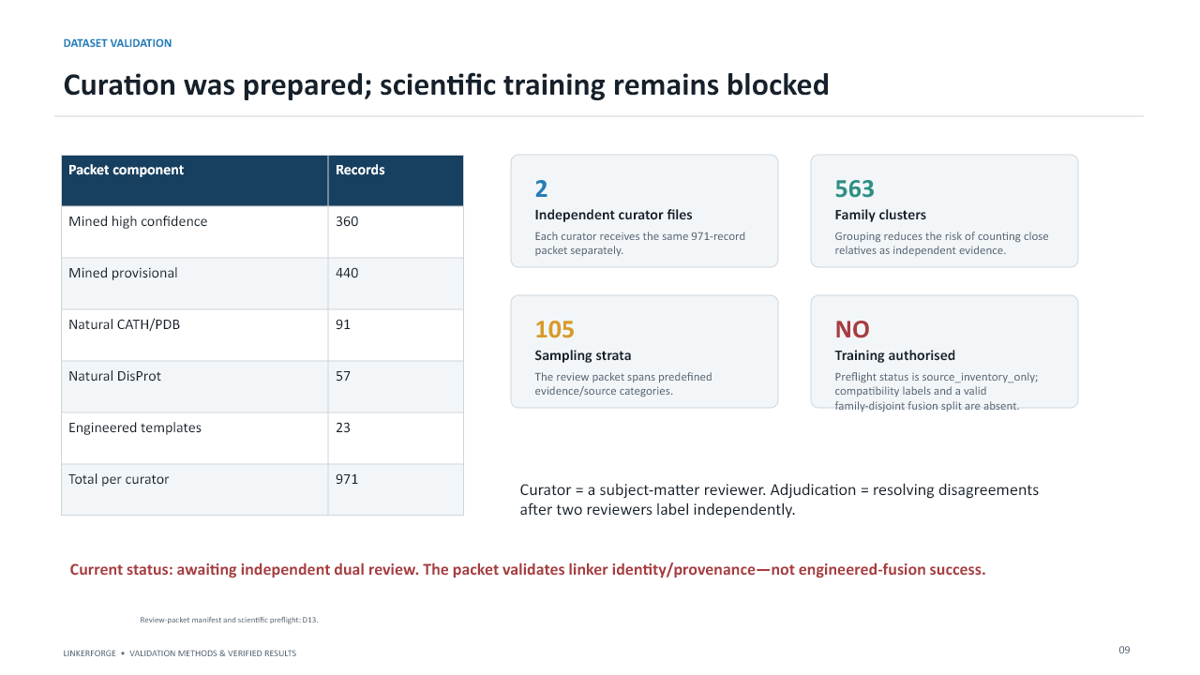
Slide 9 from the unchanged LinkerForge validation presentation
Purpose: Explain what the 971-record packet can validate and why training is blocked.
What to understand: Each of two curators receives the same packet independently.
- The packet spans 563 family clusters and 105 sampling strata.
- Adjudication resolves disagreements only after independent review.
- Compatibility labels and a valid family-disjoint fusion split are missing.
How to present it: Say that the block is scientifically correct rather than an implementation failure.
Do not overclaim: Curation validates identity and provenance, not engineered-fusion success.

Slide 10 Matched public acceptance run
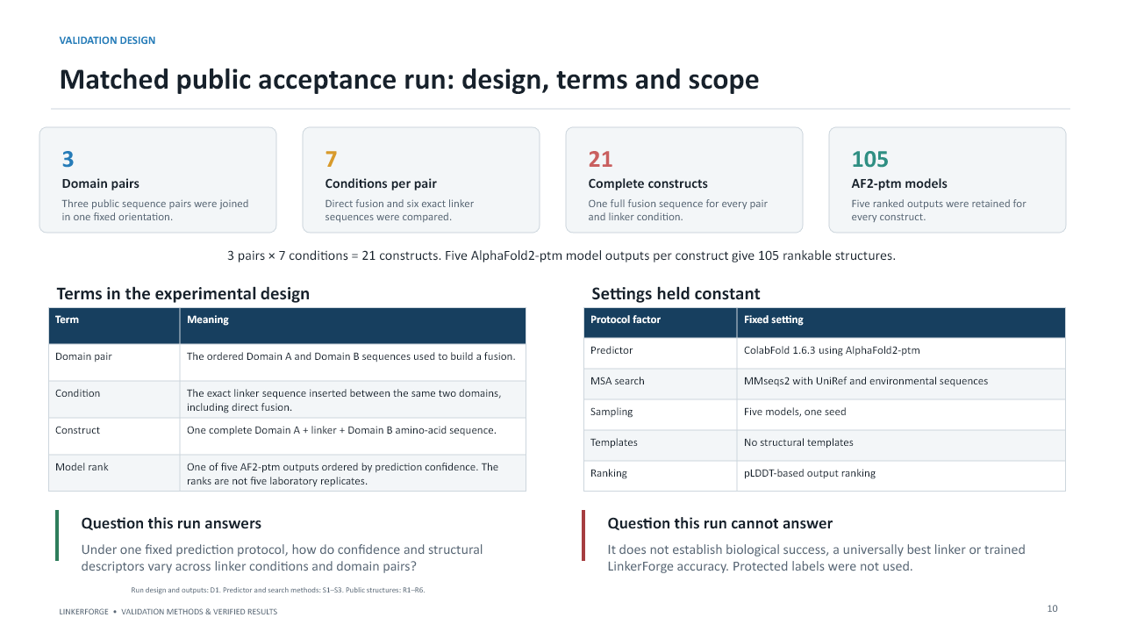
Slide 10 from the unchanged LinkerForge validation presentation
Purpose: Define the experimental unit and the fixed protocol.
What to understand: 3 domain pairs x 7 conditions gives 21 complete constructs.
- Five AF2-pTM ranked outputs gives 105 structures.
- Five ranked models are not laboratory replicates.
- All candidates used the same ColabFold settings, one seed and no templates.
How to present it: The run measures prediction sensitivity to linker and partner context.
Do not overclaim: The five model ranks are correlated predictions, not independent experiments.

Slide 11 Candidate and control panel
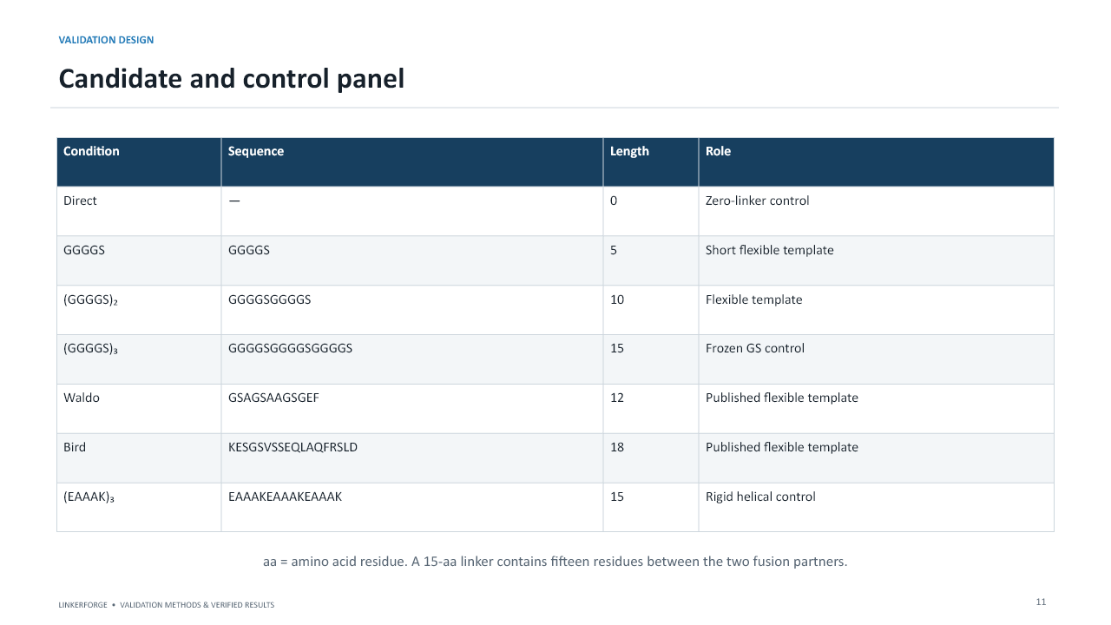
Slide 11 from the unchanged LinkerForge validation presentation
Purpose: Identify the seven exact conditions.
What to understand: Direct fusion is the zero-linker control.
- GGGGS, GS10 and GS15 provide a flexible length series.
- Waldo and Bird are published sequences.
- EAAAK15 is the rigid helical control.
- The fixed GS15 sequence is the project control specified in the design contract.
How to present it: Explain why controls are essential for interpreting a candidate.

Slide 12 Overall pLDDT across pairs
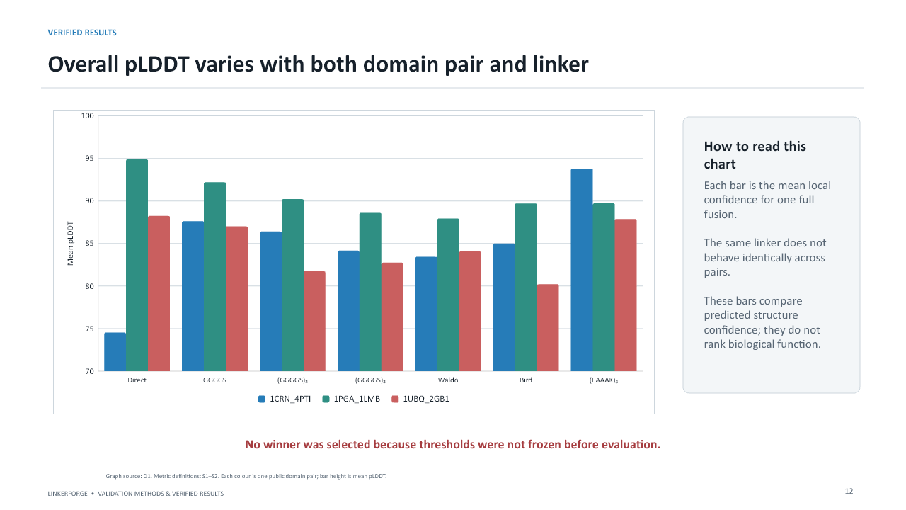
Slide 12 from the unchanged LinkerForge validation presentation
Purpose: Read one bar as one full fusion and compare within the same pair first.
What to understand: Crambin-BPTI showed its highest linker-containing pLDDT with EAAAK.
- Protein G-repressor was highest with direct fusion; short GGGGS led the linked conditions.
- Ubiquitin-GB1 showed direct and EAAAK close in overall pLDDT.
- The same linker behaved differently across pairs.
How to present it: The conclusion is partner dependence, not a universal winner.

Slide 13 Changes relative to direct fusion
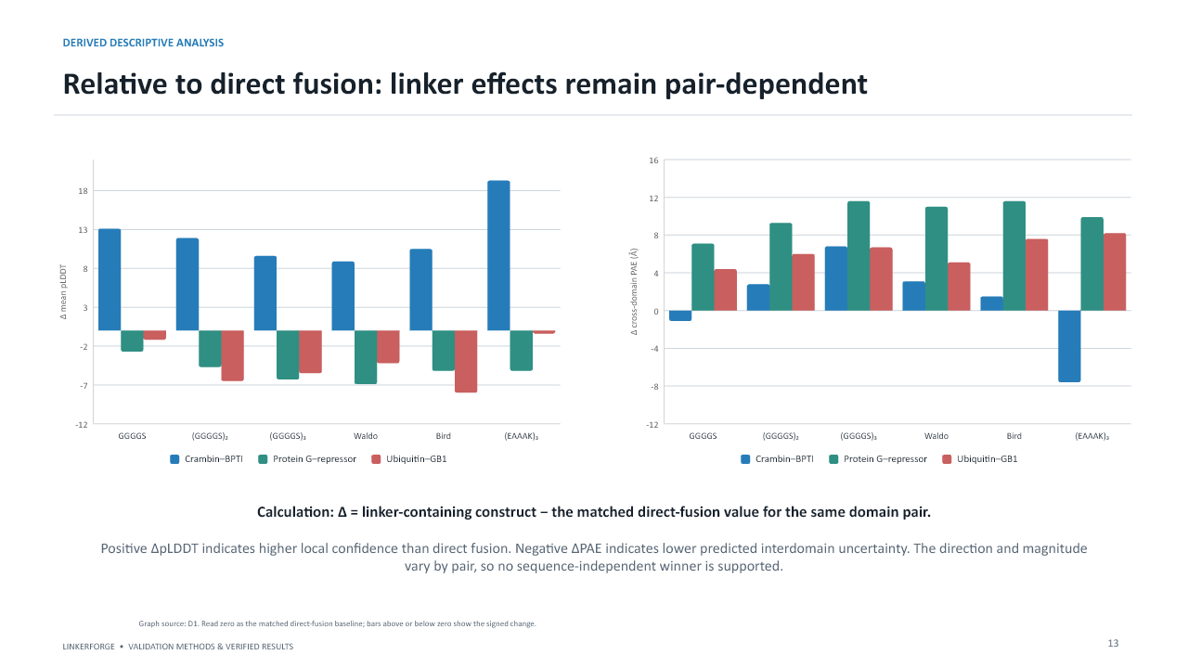
Slide 13 from the unchanged LinkerForge validation presentation
Purpose: Explain the signed delta calculation against the matched zero-linker baseline.
What to understand: Positive delta pLDDT means greater local confidence than direct fusion.
- Negative delta PAE means lower predicted interdomain uncertainty.
- Crambin-BPTI EAAAK improved both descriptors, while other pairs often favored direct fusion.
How to present it: A zero-centered comparison makes direction visible but does not turn confidence into function.

Slide 14 pLDDT versus cross-domain PAE
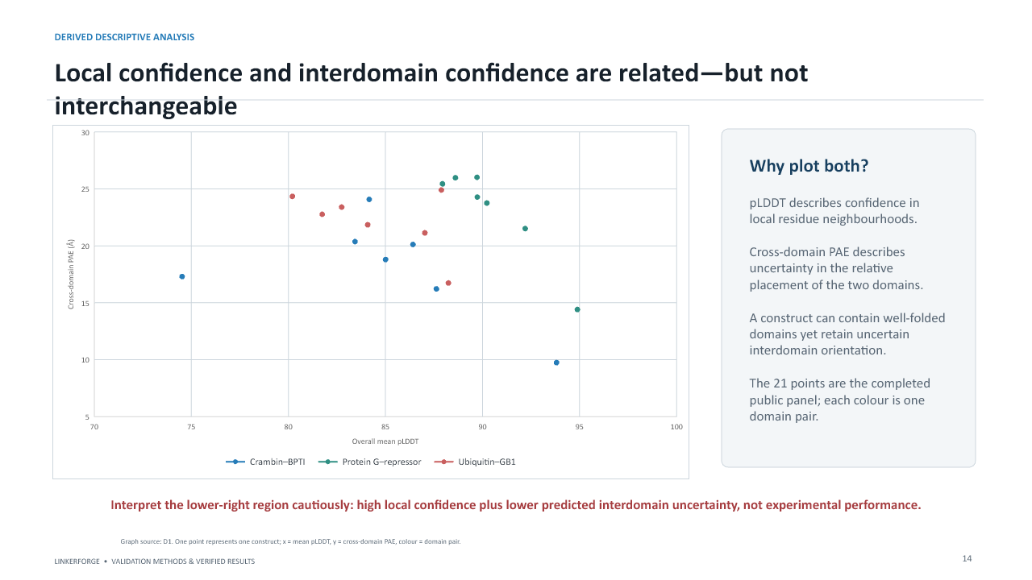
Slide 14 from the unchanged LinkerForge validation presentation
Purpose: Explain why local quality and interdomain placement must be evaluated together.
What to understand: Each point is one construct.
- Moving right means higher mean pLDDT.
- Moving down means lower cross-domain uncertainty.
- The lower-right region is descriptively favorable, not proof of performance.
How to present it: A structure can contain confident domains but an uncertain relative orientation.
Do not overclaim: The lower-right region is favorable only in predictor-confidence terms.

Slide 15 Crambin-BPTI table
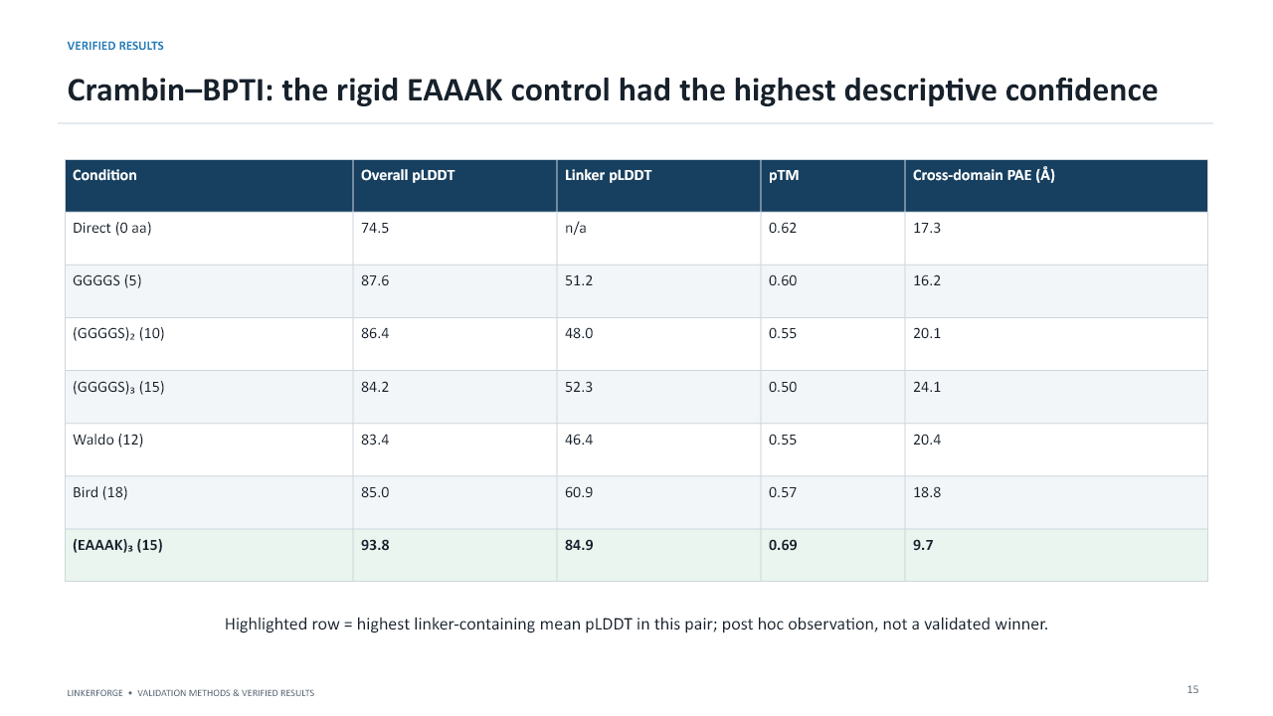
Slide 15 from the unchanged LinkerForge validation presentation
Purpose: Present the complete per-condition confidence profile and the post hoc highlight.
What to understand: EAAAK15: pLDDT 93.8, linker pLDDT 84.9, pTM 0.69, cross-domain PAE 9.7 A.
- Direct fusion was substantially lower in overall pLDDT at 74.5.
- GS linkers had lower linker-specific confidence, consistent with greater flexibility or uncertainty.
How to present it: Call EAAAK the highest linker-containing descriptive result for this pair, not a validated winner.

Slide 16 Protein G-repressor table
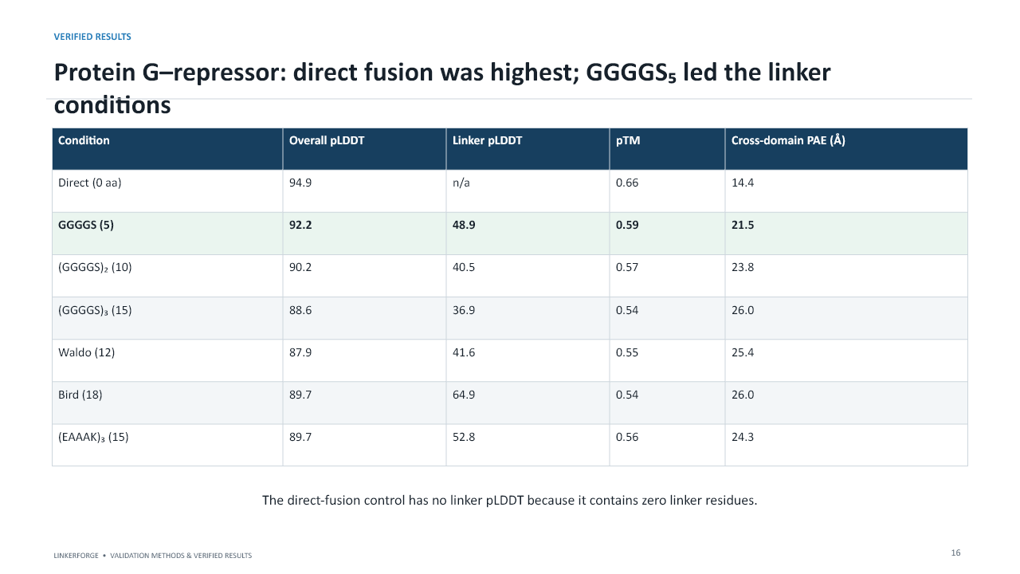
Slide 16 from the unchanged LinkerForge validation presentation
Purpose: Use this pair to show that adding a linker can reduce predictor confidence.
What to understand: Direct fusion: pLDDT 94.9 and PAE 14.4 A.
- Short GGGGS led linked constructs at pLDDT 92.2.
- All linked conditions had higher cross-domain PAE than direct fusion.
How to present it: This is the clearest evidence against a universal best-linker narrative.

Slide 17 Ubiquitin-GB1 table
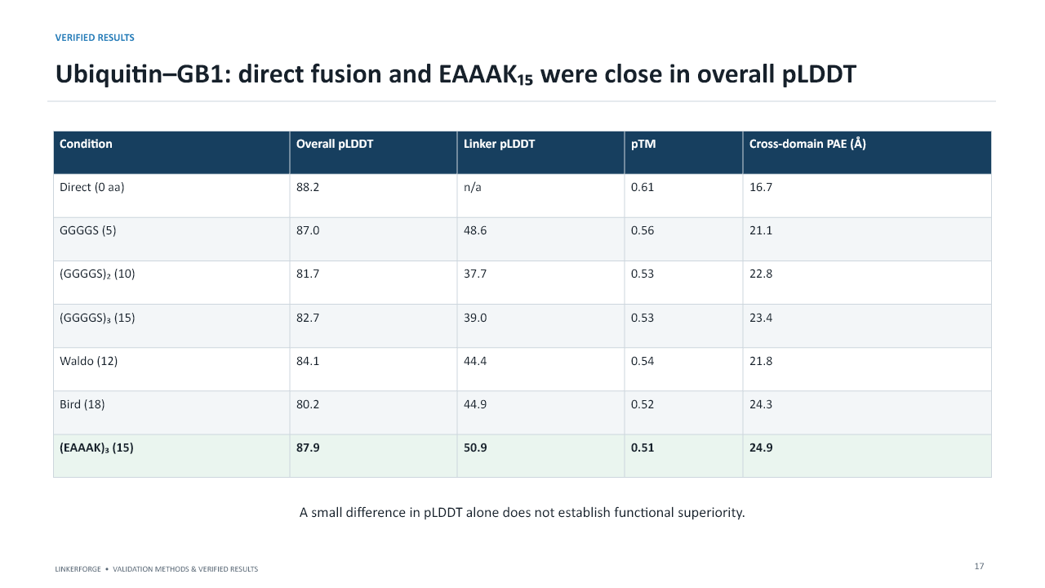
Slide 17 from the unchanged LinkerForge validation presentation
Purpose: Show that one metric can look close while another remains different.
What to understand: Direct fusion pLDDT was 88.2 with PAE 16.7 A.
- EAAAK pLDDT was 87.9 but PAE 24.9 A.
- The 0.3 pLDDT difference does not make the full confidence profile equivalent.
How to present it: Interpret several metrics jointly rather than ranking by one decimal value.

Slide 18 Highest linker-containing confidence spotlight
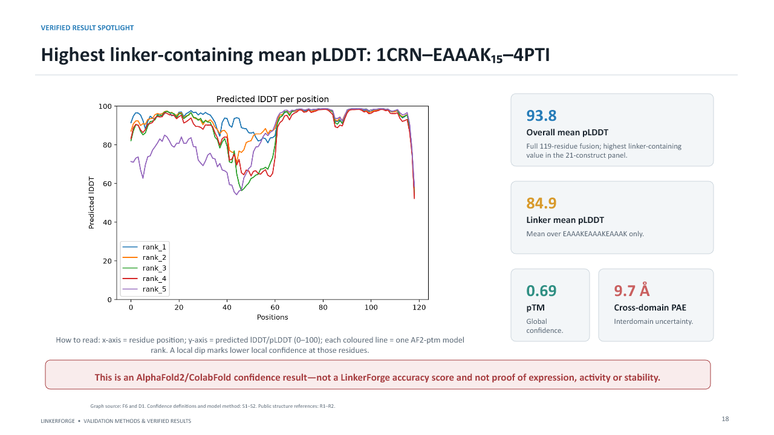
Slide 18 from the unchanged LinkerForge validation presentation
Purpose: Explain exactly what was highest and what the plotted lines represent.
What to understand: The full fusion has 119 residues.
- Overall pLDDT 93.8; linker pLDDT 84.9; pTM 0.69; cross-domain PAE 9.7 A.
- Each coloured line is a ranked AF2-pTM output across residue positions.
- Model disagreement or local dips indicate uncertainty not visible in one average.
How to present it: State that selection was post hoc and descriptive.
Do not overclaim: Highest linker-containing mean pLDDT does not mean universally best linker.

Slide 19 PyMOL structural inspection
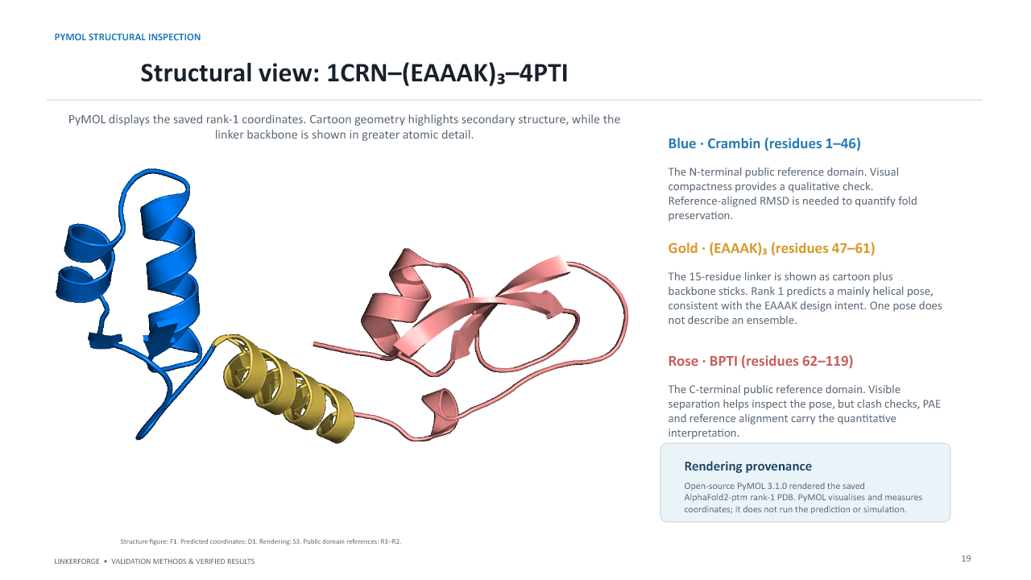
Slide 19 from the unchanged LinkerForge validation presentation
Purpose: Connect sequence ranges to the displayed three-dimensional pose.
What to understand: Crambin is residues 1-46, EAAAK15 is 47-61 and BPTI is 62-119.
- The mainly helical linker pose is consistent with the EAAAK design intent.
- One predicted pose does not represent the full conformational ensemble.
- Quantitative claims require PAE, RMSD and geometry analysis, not visual impression alone.
How to present it: Use PyMOL as an inspection and figure tool, never as a simulation engine.

Slide 20 PAE heatmaps
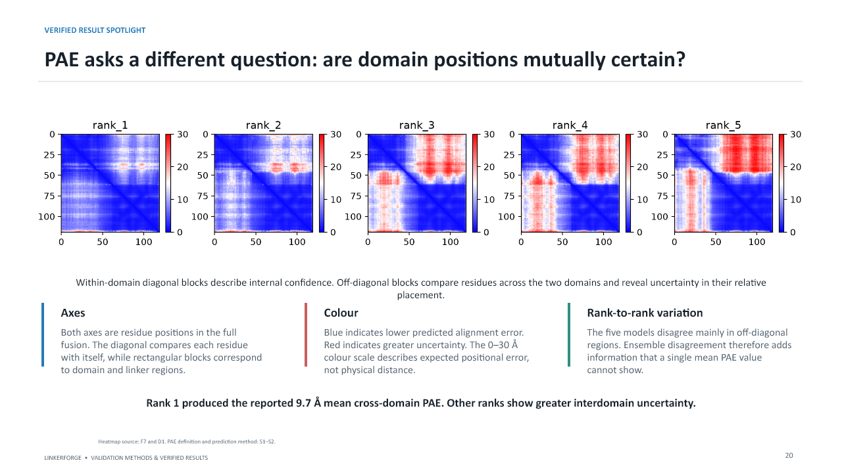
Slide 20 from the unchanged LinkerForge validation presentation
Purpose: Teach how the diagonal and off-diagonal blocks answer different questions.
What to understand: Both axes are residue positions.
- Blue indicates lower predicted alignment error; red indicates higher uncertainty.
- Diagonal blocks describe internal regions; off-diagonal blocks describe their relative placement.
- The five ranks disagree mainly in off-diagonal regions.
How to present it: A PAE value is expected error, not physical inter-residue distance.
Do not overclaim: PAE is predicted error, not the physical distance between residues.

Slide 21 Protected-site example
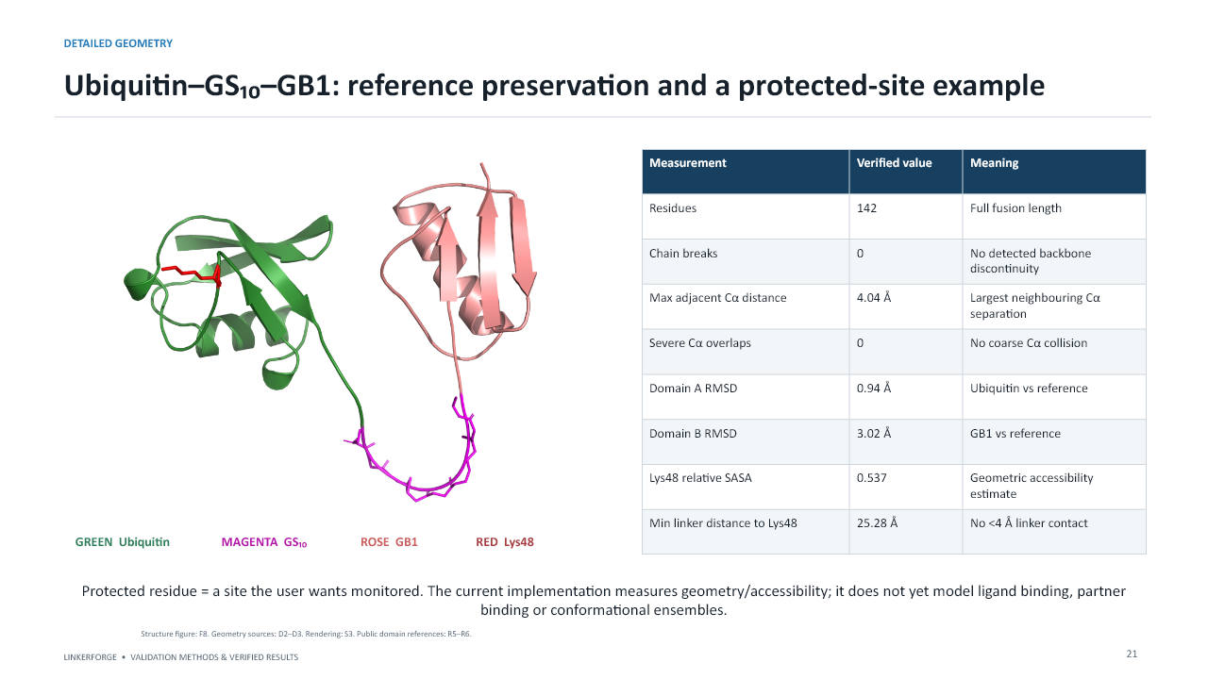
Slide 21 from the unchanged LinkerForge validation presentation
Purpose: Explain how the system monitors a user-selected functional site geometrically.
What to understand: Ubiquitin-GS10-GB1 has 142 residues and zero detected chain breaks.
- Ubiquitin RMSD was 0.94 A; GB1 RMSD was 3.02 A.
- Lys48 relative SASA was 0.537 and the nearest linker distance was 25.28 A.
- No linker contact was closer than 4 A.
How to present it: This supports geometric separation in one pose, not retained ubiquitin function.
Do not overclaim: One protected-site pose cannot prove accessibility throughout a dynamic ensemble.

Slide 22 Reference-domain RMSD
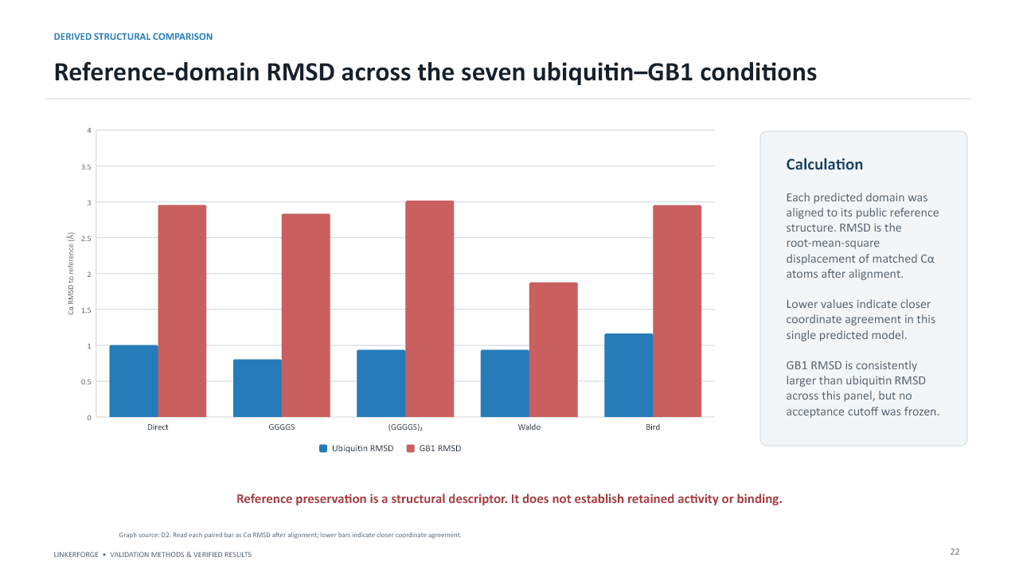
Slide 22 from the unchanged LinkerForge validation presentation
Purpose: Explain separate-domain alignment and why lower RMSD only means closer coordinates.
What to understand: Each predicted domain was aligned to its own public reference.
- Separate alignment prevents domain orientation from dominating fold-preservation measurement.
- GB1 had larger RMSD than ubiquitin across the conditions.
- No validated acceptance cutoff was frozen.
How to present it: Do not describe higher RMSD as unfolding without additional evidence.

Slide 23 Hydrogen-aware overlaps and burial
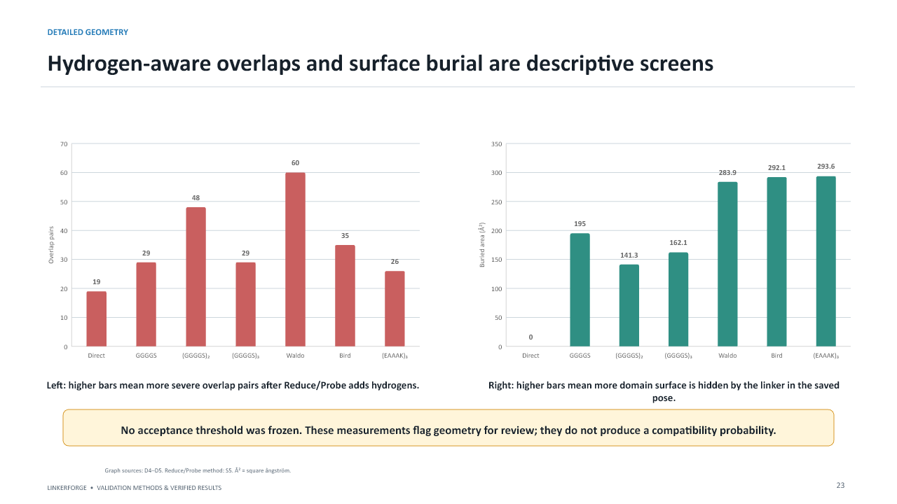
Slide 23 from the unchanged LinkerForge validation presentation
Purpose: Explain these as flags for manual review.
What to understand: Reduce adds or optimizes hydrogens; Probe counts unfavorable contacts.
- Waldo had the largest reported severe-overlap count in this panel.
- Bird and EAAAK had comparatively high linker-related burial.
- No frozen threshold converts these values into pass or fail.
How to present it: Packing may be favorable or obstructive depending on the intended function.
Do not overclaim: No validated overlap or burial cutoff was frozen.

Slide 24 DFLpred orthogonal check
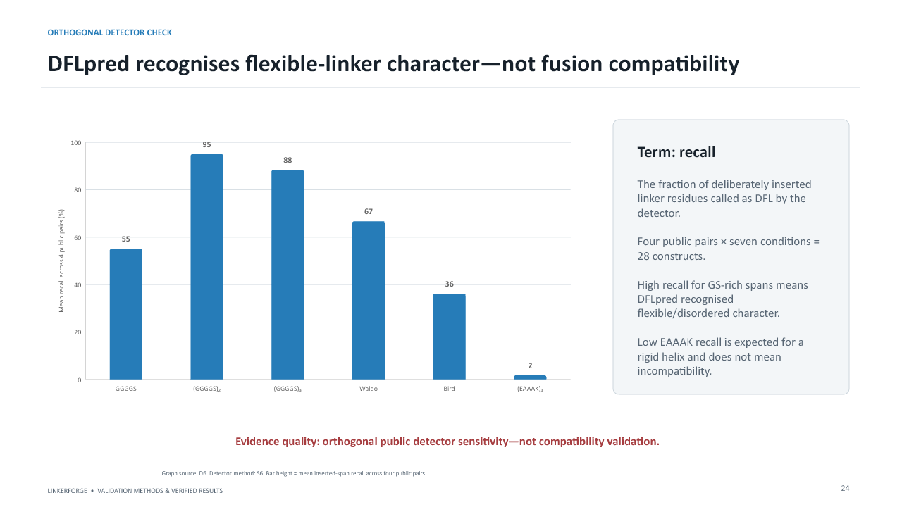
Slide 24 from the unchanged LinkerForge validation presentation
Purpose: Explain the difference between detecting flexible-linker character and validating fusion compatibility.
What to understand: Recall is the fraction of deliberately inserted linker residues called DFL.
- GS10 recall was 95% and GS15 88.3%.
- EAAAK recall was 1.7%, expected for a rigid helix.
- The analysis covered 4 public pairs x 7 conditions, or 28 constructs.
How to present it: Low DFL recall is not a failure for a deliberately structured linker.
Do not overclaim: DFL detection is not compatibility prediction.

Slide 25 OpenMM and software verification
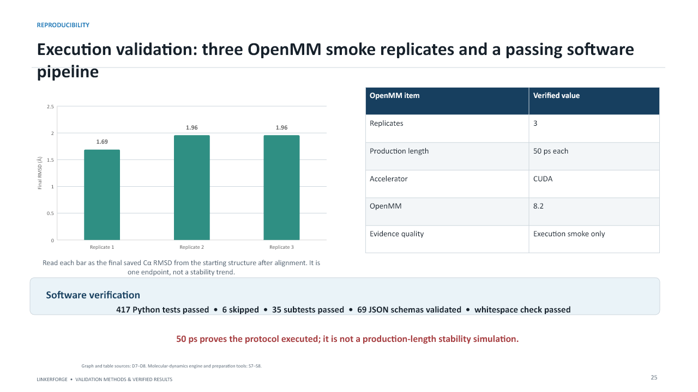
Slide 25 from the unchanged LinkerForge validation presentation
Purpose: Present the simulation as an execution test and the automated tests as software evidence.
What to understand: Three independent 50 ps CUDA/OpenMM runs completed.
- Final C-alpha RMSD values were 1.69, 1.96 and 1.96 A.
- 417 Python tests passed, 6 skipped, 35 subtests passed and 69 JSON schemas validated.
- An endpoint is not a stability trend.
How to present it: Make the 50 ps limitation explicit before anyone asks.
Do not overclaim: A 50 ps smoke test is not production MD.

Slide 26 Time-resolved OpenMM traces
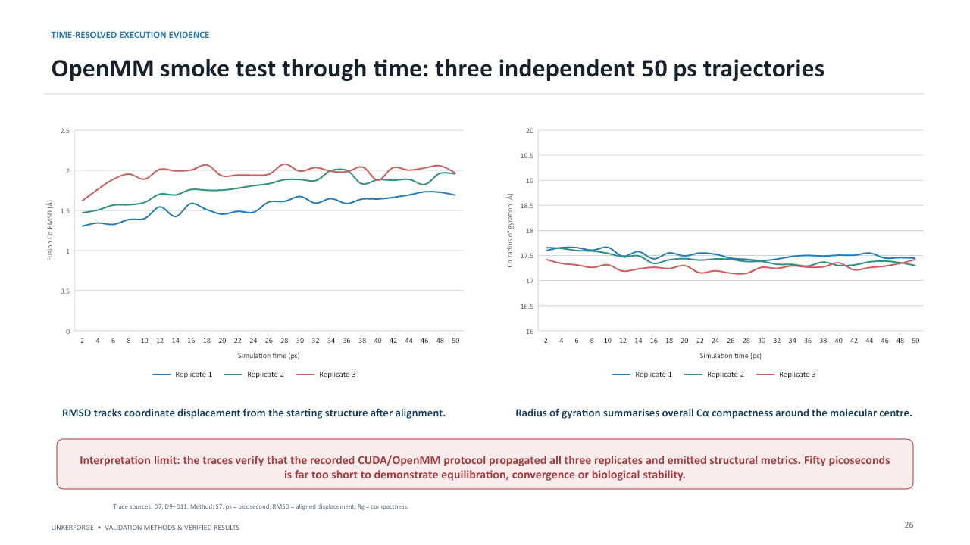
Slide 26 from the unchanged LinkerForge validation presentation
Purpose: Explain RMSD and radius of gyration through time.
What to understand: RMSD measures aligned displacement from the starting structure.
- Rg measures overall compactness around the molecular centre.
- The traces prove that the protocol propagated coordinates and emitted metrics.
- Fifty picoseconds is too short for equilibration, convergence or biological stability.
How to present it: Production MD requires longer replicated runs and convergence analysis.
Do not overclaim: Short traces cannot demonstrate equilibrium or convergence.

Slide 27 Application evidence
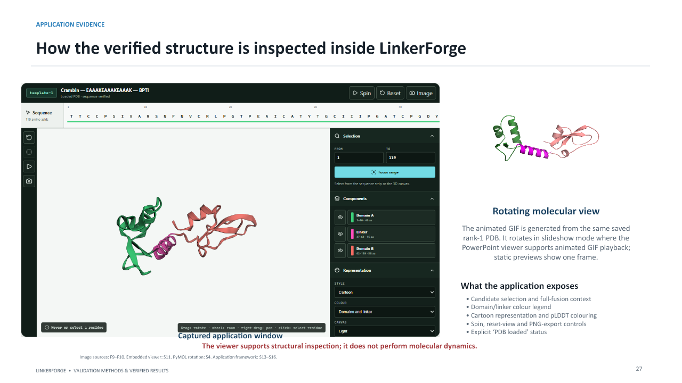
Slide 27 from the unchanged LinkerForge validation presentation
Purpose: Show how predictions and context are exposed to a researcher.
What to understand: The window combines candidate context, domain/linker colour legend and structural viewer.
- The viewer supports cartoon and pLDDT colouring, spin, reset and PNG export.
- The loaded-status message confirms that a PDB was parsed.
- The GIF and embedded viewer use saved coordinates; neither runs MD.
How to present it: This slide demonstrates usability and traceability rather than scientific superiority.

Slide 28 Verified conclusions
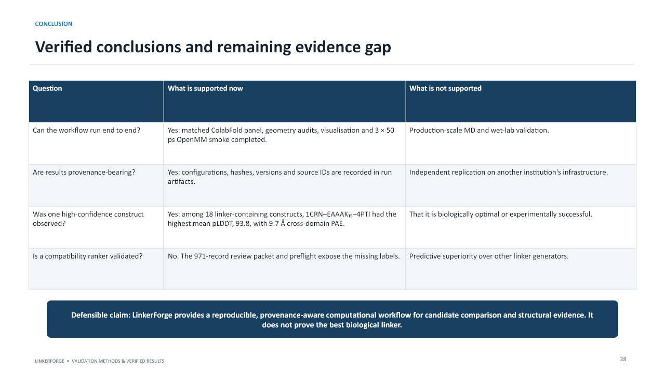
Slide 28 from the unchanged LinkerForge validation presentation
Purpose: Summarise the strongest defensible claims and the remaining gap.
What to understand: The matched structure workflow, geometry audits, visualization and 50 ps smoke simulations executed.
- The highlighted construct is a high-confidence public prediction.
- The ranker is not scientifically trained or calibrated.
- The project does not prove a best biological linker.
How to present it: Use the exact defensible claim printed on the slide.
Do not overclaim: The conclusion must remain computational and provenance-aware.

Slide 29 Evidence needed next
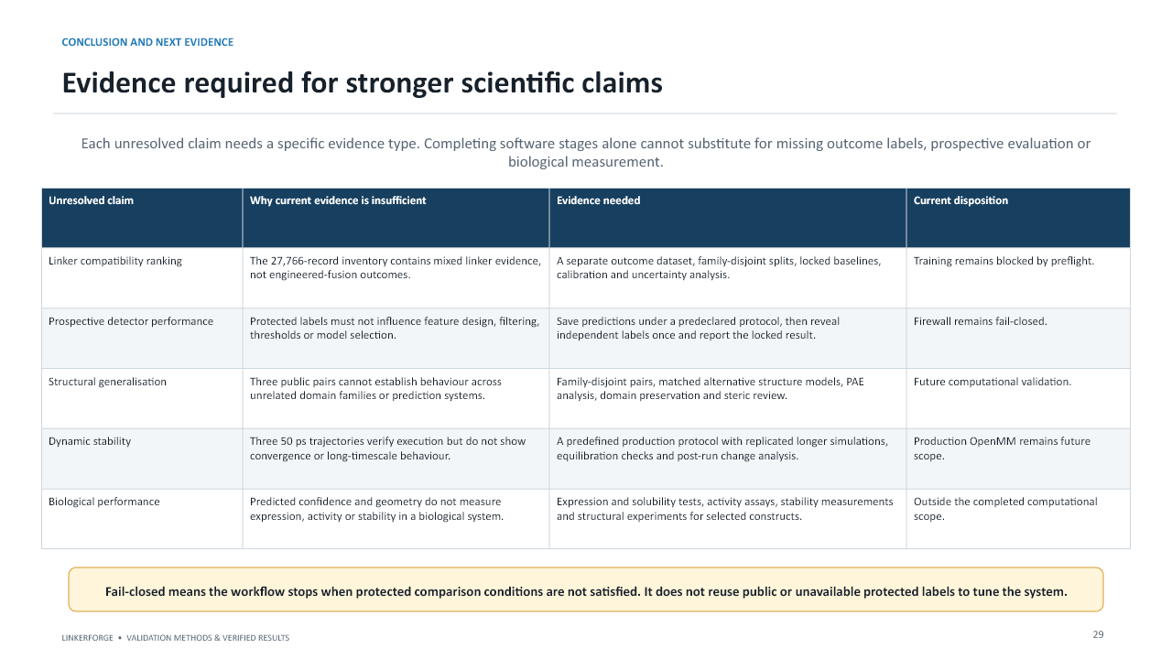
Slide 29 from the unchanged LinkerForge validation presentation
Purpose: Map every unsupported claim to the missing evidence rather than treating all future work as one item.
What to understand: Ranker claims need engineered-fusion outcomes, family-disjoint splits, baselines and calibration.
- Prospective claims need frozen predictions before label reveal.
- Structural generalisation needs more families and model families.
- Dynamic stability needs production MD.
- Biological performance needs appropriate laboratory measurement.
How to present it: Software completion cannot substitute for outcome evidence.
Do not overclaim: Missing biological evidence cannot be replaced by additional software features.

Slide 30 How to read the figures
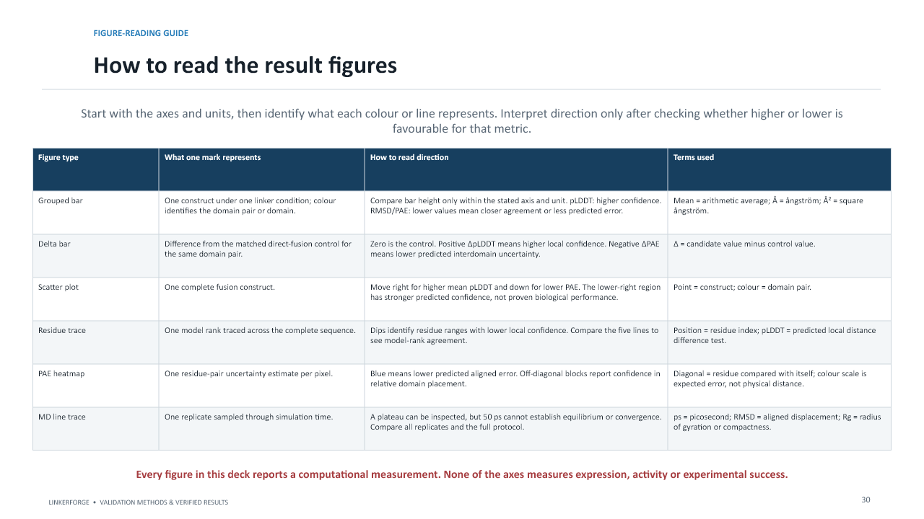
Slide 30 from the unchanged LinkerForge validation presentation
Purpose: Give the audience a reusable graph-reading method.
What to understand: Read axes and units first.
- Identify what one bar, point, line or heatmap cell represents.
- Check whether higher or lower is favorable for that metric.
- Only then interpret biological relevance, which remains limited for these computational measurements.
How to present it: None of the axes measures expression, activity or experimental success.

Slide 31 Scientific software
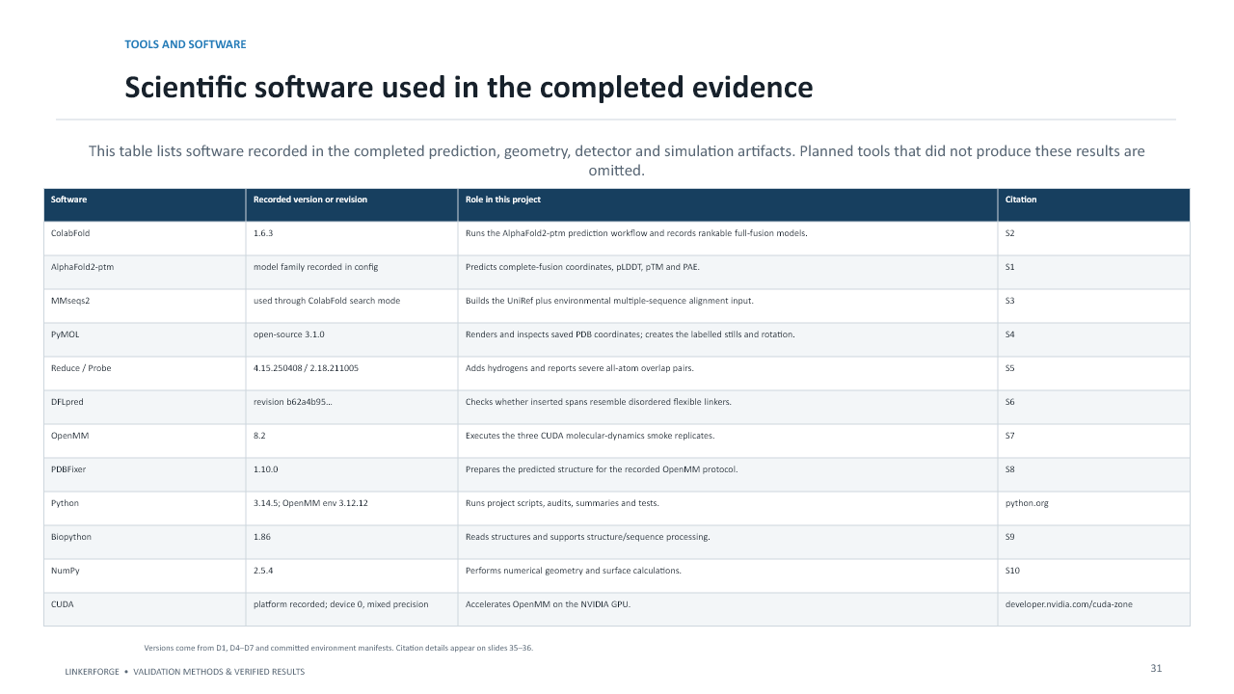
Slide 31 from the unchanged LinkerForge validation presentation
Purpose: Explain the scientific role of each tool and why its version is recorded.
What to understand: ColabFold and AF2-pTM predict structures and confidence.
- MMseqs2 creates sequence alignments.
- PyMOL visualises coordinates.
- Reduce/Probe inspect atomic contacts.
- DFLpred tests flexible-linker character.
- OpenMM and PDBFixer prepare and execute the MD smoke workflow.
How to present it: Versions make reruns interpretable because algorithms and defaults can change.

Slide 32 Application and reproducibility software
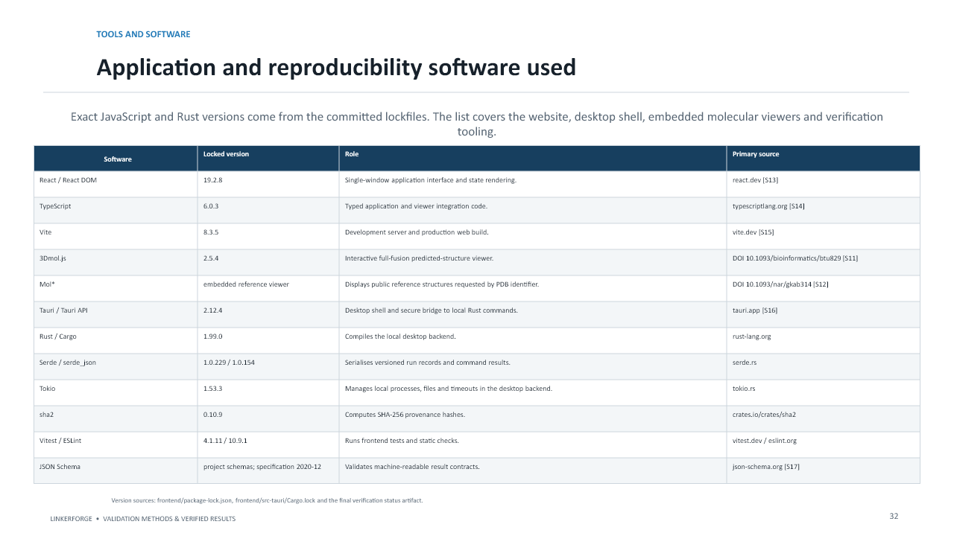
Slide 32 from the unchanged LinkerForge validation presentation
Purpose: Explain how the user interface and native desktop functions are constructed.
What to understand: React and TypeScript implement the interface; Vite builds it.
- 3Dmol.js and Mol* provide embedded molecular viewing.
- Tauri packages the interface as a desktop application with Rust-native commands.
- Serde, Tokio and sha2 support structured data, asynchronous work and hashes.
- Vitest, ESLint and JSON Schema support verification.
How to present it: These tools provide the application, not the biological evidence.

Slide 33 Figure and image provenance
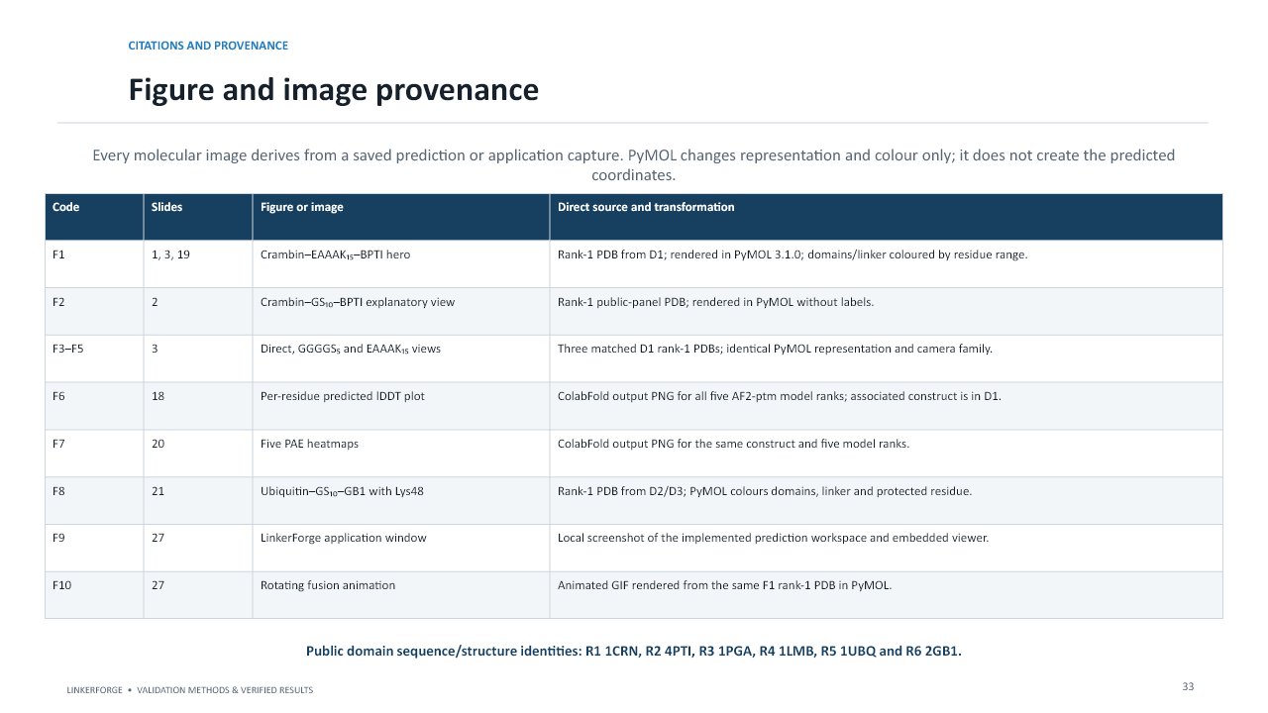
Slide 33 from the unchanged LinkerForge validation presentation
Purpose: Explain that every image is traceable to saved coordinates or an application capture.
What to understand: F codes identify figures and images.
- Public identities are tied to RCSB PDB entries.
- PyMOL changed representation and colour only.
- The figure register allows an examiner to trace a visual to its source file and transformation.
How to present it: Provenance supports auditability; it does not guarantee biological truth.

Slide 34 Graph and measurement provenance
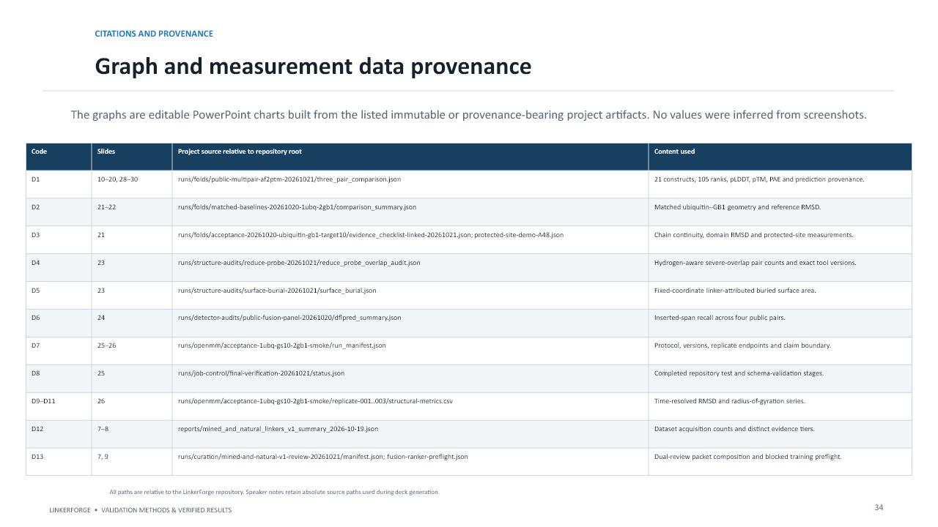
Slide 34 from the unchanged LinkerForge validation presentation
Purpose: Explain that chart values came from saved project artifacts rather than manual reading of pictures.
What to understand: D codes identify data artifacts.
- The PowerPoint charts are editable but sourced from persisted values.
- Speaker notes retain the absolute paths used during deck generation.
- Hashes and versioned schemas protect result identity.
How to present it: This is how the project separates presentation from the underlying evidence.

Slide 35 Primary scientific references
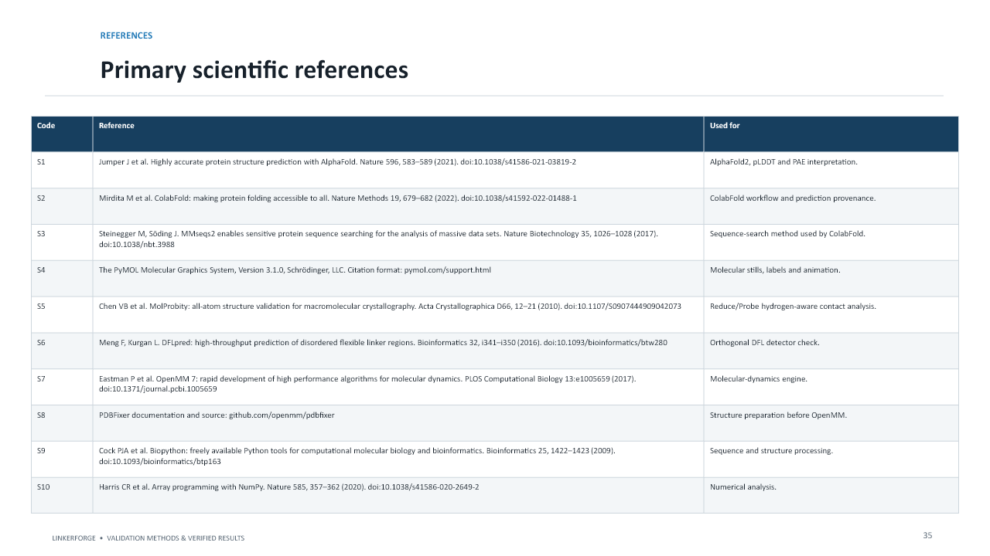
Slide 35 from the unchanged LinkerForge validation presentation
Purpose: Use this as the method register rather than reading every citation aloud.
What to understand: Primary references support AlphaFold2, ColabFold, structure assessment, DFL detection and molecular dynamics.
- When challenged on a method, identify the relevant source code and reference.
- Citation supports the method definition, while the project artifact supports the reported value.
How to present it: Distinguish literature authority from evidence produced in this project.

Slide 36 Application, confidence and public structures
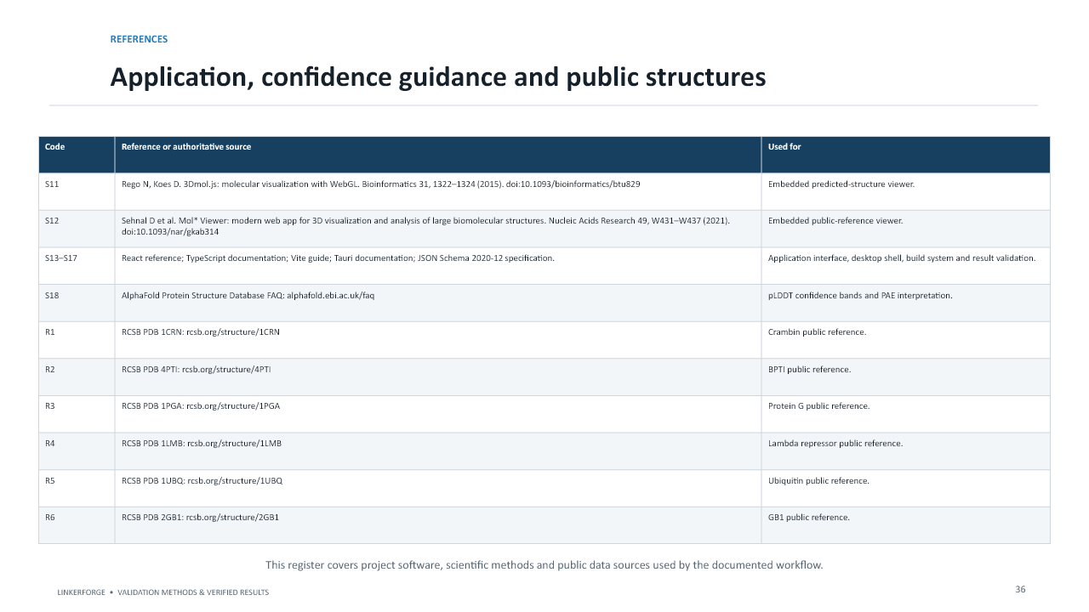
Slide 36 from the unchanged LinkerForge validation presentation
Purpose: Close the traceability chain for software guidance and public protein sources.
What to understand: The register includes authoritative confidence guidance, application software and RCSB entries.
- R codes identify 1CRN, 4PTI, 1PGA, 1LMB, 1UBQ and 2GB1.
- The complete register makes the deck auditable without implying every source validates the final fusion.
How to present it: End by returning to the evidence boundary and inviting questions.

Detailed numerical reference for slides 15 to 17
Domain pair | Condition | Mean pLDDT | Linker pLDDT | pTM | Cross-domain PAE A
1CRN-4PTI | Direct | 74.5 | N/A | 0.62 | 17.3
1CRN-4PTI | GGGGS | 87.6 | 51.2 | 0.60 | 16.2
1CRN-4PTI | GS10 | 86.4 | 48.0 | 0.55 | 20.1
1CRN-4PTI | Waldo12 | 83.4 | 46.4 | 0.55 | 20.4
1CRN-4PTI | EAAAK15 | 93.8 | 84.9 | 0.69 | 9.7
1CRN-4PTI | GS15 | 84.2 | 52.3 | 0.50 | 24.1
1CRN-4PTI | Bird18 | 85.0 | 60.9 | 0.57 | 18.8
1PGA-1LMB | Direct | 94.9 | N/A | 0.66 | 14.4
1PGA-1LMB | GGGGS | 92.2 | 48.9 | 0.59 | 21.5
1PGA-1LMB | GS10 | 90.2 | 40.5 | 0.57 | 23.8
1PGA-1LMB | Waldo12 | 87.9 | 41.6 | 0.55 | 25.4
1PGA-1LMB | EAAAK15 | 89.7 | 52.8 | 0.56 | 24.3
1PGA-1LMB | GS15 | 88.6 | 36.9 | 0.54 | 26.0
1PGA-1LMB | Bird18 | 89.7 | 64.9 | 0.54 | 26.0
1UBQ-2GB1 | Direct | 88.2 | N/A | 0.61 | 16.7
1UBQ-2GB1 | GGGGS | 87.0 | 48.6 | 0.56 | 21.1
1UBQ-2GB1 | GS10 | 81.7 | 37.7 | 0.53 | 22.8
1UBQ-2GB1 | Waldo12 | 84.1 | 44.4 | 0.54 | 21.8
1UBQ-2GB1 | EAAAK15 | 87.9 | 50.9 | 0.51 | 24.9
1UBQ-2GB1 | GS15 | 82.7 | 39.0 | 0.53 | 23.4
1UBQ-2GB1 | Bird18 | 80.2 | 44.9 | 0.52 | 24.3

Use this table for revision, not as a script to read aloud. The main pattern is that results depend on both the linker and the domain pair. Crambin-BPTI EAAAK is the strongest linker-containing confidence profile, whereas Protein G-repressor and Ubiquitin-GB1 show why direct fusion remains an essential control.

Part Three Complete presentation speech
The following speech is written for approximately 24 to 30 minutes at a clear scientific speaking pace. It is intentionally shorter than the study guide. Pause on figures, point to the relevant axis or coloured structure and do not read the reference tables aloud.

Slides 1 to 3 Introduction and biological context
Good morning. Our project is LinkerForge, a computational workflow for designing and evaluating peptide linkers used to join two protein regions into one fusion protein. This presentation reports only the computational evidence that we completed. It does not claim that a selected linker is experimentally proven or universally optimal.
A fusion protein is one continuous amino-acid chain consisting of Domain A, an optional linker and Domain B. The linker may influence separation, motion, orientation and the accessibility of important sites. On slide 2, Crambin is shown in blue, the GS10 linker in gold and BPTI in rose. The displayed structure is an AlphaFold2-family prediction rendered in PyMOL, not an experimental crystal structure.
We compare three broad design ideas: direct fusion, a flexible glycine-serine linker and a more rigid EAAAK helical linker. Direct fusion is the zero-linker baseline. GGGGS is intended to permit motion, while repeated EAAAK is intended to form a more persistent spacer. The differences shown here are descriptive results for the same Crambin-BPTI pair and are not proof that one linker class is generally superior.

Slides 4 to 6 Confidence metrics and evidence boundaries
Before showing results, I need to distinguish the confidence metrics. pLDDT is AlphaFold's per-residue local confidence on a zero-to-one-hundred scale. We report both the overall mean and the mean over linker residues. pTM estimates confidence in global topology, while PAE estimates positional uncertainty after alignment. Cross-domain PAE therefore helps us assess how consistently the two domains are arranged relative to each other. Lower PAE is preferable, but it does not prove that the orientation is biologically correct.
The geometry metrics answer different questions. C-alpha continuity screens for coordinate gaps. Reference RMSD measures coordinate deviation after alignment. SASA describes solvent exposure, burial describes surface hidden in the predicted pose and Reduce plus Probe provide a hydrogen-aware contact screen. OpenMM molecular dynamics generates coordinates through time, and radius of gyration describes overall compactness.
These evidence levels must not be confused. A technically reproducible run can still lack compatibility labels or biological confirmation. The protected benchmark therefore uses a fail-closed rule: if prospective independence is not satisfied, the workflow stops instead of using exposed labels to tune the system.

Slides 7 to 9 Dataset and curation
The dataset inventory combines several evidence categories without treating them as equivalent. We scanned 161,317 full-length proteins and obtained 27,595 mined candidate spans. We also collected 91 structure-supported CATH or PDB natural spans, 57 curated DisProt flexible-linker records and 23 published engineered templates. Together these form 27,766 records. A separate 40-protein no-linker specificity panel is not included in that total.
This is a provenance-rich linker inventory, not a fusion-compatibility ground-truth dataset. Most records tell us that a sequence may be a linker or occurs naturally between domains. They do not tell us whether inserting that linker between arbitrary engineered partners improves expression, activity or stability.
We prepared a 971-record packet for two independent curators, covering 563 family clusters and 105 sampling strata. However, the preflight correctly reports that scientific training is not authorised because outcome-linked compatibility labels and a valid family-disjoint fusion split are absent. Curation can improve linker identity and provenance; it cannot create missing experimental outcomes.

Slides 10 to 14 Matched public comparison design
For the completed public acceptance run, we selected three public domain pairs and evaluated seven conditions per pair: direct fusion, three GS lengths, two published linker sequences and the EAAAK helical control. This produced 21 complete fusion sequences. Five AlphaFold2-pTM outputs were retained for every construct, giving 105 structures. These are ranked prediction outputs, not five independent laboratory replicates.
All conditions used one fixed ColabFold protocol: ColabFold 1.6.3, AlphaFold2-pTM, MMseqs2 sequence searching, one seed, no templates and ranking by pLDDT. Therefore, the run asks how structural-confidence descriptors vary across linkers and partner pairs under matched settings.
The grouped pLDDT graph shows that the same linker does not behave identically across pairs. The delta graphs subtract each pair's direct-fusion value. Positive delta pLDDT means higher local confidence, while negative delta PAE means reduced predicted interdomain uncertainty. The scatter plot combines these two ideas: moving right means higher local confidence and moving down means lower interdomain uncertainty. Even the lower-right region represents predictor confidence, not biological performance.

Slides 15 to 18 Numerical results
For Crambin-BPTI, EAAAK15 produced the strongest linker-containing profile: overall pLDDT 93.8, linker pLDDT 84.9, pTM 0.69 and cross-domain PAE 9.7 angstroms. For Protein G-repressor, direct fusion was strongest overall at 94.9 pLDDT, while short GGGGS led the linker-containing conditions at 92.2. For Ubiquitin-GB1, direct fusion and EAAAK were close in mean pLDDT, but direct fusion had substantially lower cross-domain PAE.
These results are important because they reject a simple universal-winner interpretation. The effect of a linker depends on its partner context and on which metric is examined.
The highlighted construct is 1CRN-EAAAK15-4PTI. It was the highest mean-pLDDT linker-containing result in the 21-construct panel. The residue plot shows confidence across all 119 residues for the five ranked models. This is an AlphaFold2 confidence result, not a LinkerForge accuracy score and not proof of expression, activity or stability.

Slides 19 to 24 Structural inspection and orthogonal checks
PyMOL displays the rank-1 coordinates with Crambin in blue, EAAAK in gold and BPTI in rose. The linker appears mainly helical, which agrees with its design intent, but one predicted pose cannot describe the entire solution ensemble.
The PAE heatmaps ask whether residue positions are mutually certain. Blue diagonal blocks indicate lower internal uncertainty. Off-diagonal blocks describe relative domain placement. The model ranks disagree mainly in these off-diagonal regions, so the relative arrangement is less certain than the local domain folds.
For Ubiquitin-GS10-GB1, we also tested a protected-site workflow using Lys48. The saved model had no detected chain break, ubiquitin reference RMSD of 0.94 angstrom, GB1 RMSD of 3.02 angstrom, Lys48 relative SASA of 0.537 and a minimum linker distance of 25.28 angstrom. This supports geometric separation in one pose, not retained Lys48 function across a dynamic ensemble.
Hydrogen-aware Probe overlaps and linker-related surface burial were then used as descriptive flags. No validated threshold was frozen. Finally, DFLpred was used as an independent flexible-linker-character check. GS-rich sequences showed high recall, whereas EAAAK showed 1.7 percent recall, which is expected for a structured helical linker. DFLpred does not test fusion compatibility.

Slides 25 to 27 OpenMM and application
We ran three independent 50 picosecond OpenMM smoke simulations on CUDA. Their final C-alpha RMSD values were 1.69, 1.96 and 1.96 angstrom. The time traces show RMSD and radius of gyration, but 50 picoseconds is far too short to establish equilibration, convergence or long-term stability. These runs verify that the preparation, simulation and metric-extraction workflow executes.
The software pipeline also passed 417 Python tests, with 6 skipped, 35 subtests passed, 69 JSON schemas validated and the whitespace check passed.
The application slide shows how a researcher can inspect a selected full-fusion model without leaving LinkerForge. It exposes the candidate context, domain and linker colours, cartoon and pLDDT representations, rotation, view reset, PNG export and explicit PDB-loaded status. The viewer displays saved coordinates; it does not run molecular dynamics.

Slides 28 to 36 Conclusions, future evidence and provenance
The completed work supports an end-to-end computational evidence workflow: matched structure prediction, confidence extraction, visual inspection, geometry measurements, an orthogonal detector check, short OpenMM execution tests and provenance-bearing records. The strongest highlighted linker-containing prediction was Crambin-EAAAK15-BPTI.
It does not support a claim that LinkerForge predicts the biologically best linker. A scientifically trained ranker still requires engineered-fusion outcome data, family-disjoint evaluation, matched baselines, calibration and prospective testing. Structural generalisation requires more protein families and additional model families. Dynamic-stability claims require production-length replicated molecular dynamics. Biological performance requires the appropriate experiments.
The remaining slides explain how to read each graph, identify all scientific and application software and trace every image and numerical result to a saved source. The reference register separates the literature supporting each method from the project artifacts supporting each reported value.
In conclusion, LinkerForge currently provides a reproducible and provenance-aware platform for linker-candidate comparison and structural-evidence review. It integrates more of the practical workflow in one application, while keeping the claim boundary explicit. Thank you, and I welcome your questions.

Part Four Difficult viva and examiner questions
Answer the direct question first. Then explain the evidence and finish with the limitation. The longer answers below are for understanding; during the presentation, use the first two or three sentences unless the examiner asks for more detail.

What is the scientific novelty of LinkerForge?
The defensible novelty is workflow integration and evidence discipline. LinkerForge keeps partner-specific inputs, candidate and control construction, matched structure prediction, confidence interpretation, structural inspection, geometry checks and provenance in one application. Predictive superiority is not yet established.

What is the LinkerForge model architecture?
The frozen proposed ranker design uses frozen ESM-2 protein embeddings, attachment-point geometric features, a small linker encoder and multitask ranking heads. Its learning task is pairwise or contrastive compatibility ranking. The presentation does not claim that this ranker has been scientifically trained or calibrated.

Is LinkerForge a generative AI system?
The present MVP creates candidates by constrained enumeration, mutation and retrieval. Learned sequence generation and diffusion are future work. It is therefore inaccurate to describe the completed evidence as validation of a learned generator.

Did LinkerForge achieve 93.8 percent accuracy?
No. 93.8 is the mean AlphaFold2 pLDDT of one construct. It is local structural confidence averaged across residues, not classification accuracy, compatibility probability or an experimental success rate.

Why is EAAAK described as the best result?
It is not described as universally best. It was the highest mean-pLDDT linker-containing construct in the completed public panel and had a favorable PAE for Crambin-BPTI. Other pairs did not show the same pattern.

Why did you exclude the direct-fusion row from the highlighted result?
The highlight explicitly answers a linker-design question, so it selects among constructs containing a linker. The direct-fusion control is still reported and produced the highest overall pLDDT row for Protein G-repressor.

Why is direct fusion necessary?
It provides the zero-linker baseline. Without it, an apparent improvement or deterioration could not be interpreted relative to simply joining the two domains.

Why can low linker pLDDT be acceptable?
A flexible linker may occupy many conformations rather than one stable local structure. AlphaFold can therefore be uncertain. Low pLDDT can be consistent with intended flexibility, although it does not prove flexibility or function.

How can pLDDT be high while PAE is also high?
The two domains can each be locally well folded, producing high pLDDT, while their relative orientation remains uncertain, producing high cross-domain PAE.

Is PAE the distance between two residues?
No. PAE is expected positional error after aligning on another residue. It uses angstrom units but does not report physical separation.

Why use pTM as well as PAE?
pTM compresses global topology confidence into one value, while the PAE matrix reveals where the uncertainty occurs. Cross-domain PAE specifically focuses on relative placement of the partners.

Why were only three domain pairs used?
They were deliberately short public examples used to verify the complete workflow under available compute. They are an acceptance panel, not a representative estimate of performance across protein space.

Are five AlphaFold outputs five replicates?
No. They are related ranked outputs produced by AlphaFold2 model parameterisations under the same input. They reveal some model disagreement but are not independent biological or statistical replicates.

Why use one seed?
One seed made the matched public acceptance run computationally feasible. It limits the uncertainty analysis; a stronger benchmark would include multiple seeds and predeclared aggregation rules.

Why disable structural templates?
Using no templates kept the protocol uniform and reduced the risk that one construct had a favorable template unavailable to the others. It does not make the prediction unbiased; all outputs still come from the same model family.

Why is the 27,766-record dataset not enough?
Most records label possible or natural linker identity, not the outcome of an engineered fusion. Compatibility training requires partner-linker-partner constructs linked to measured outcomes.

What would a proper compatibility dataset contain?
It would contain both partner sequences, attachment positions, exact linker sequence, experimental conditions and measured outcomes such as expression, solubility, activity, stability or structural integrity. It should also record negative and inconclusive outcomes rather than only successful publications.

Why are natural linkers not sufficient ground truth?
Natural multidomain proteins evolved in their native context. An engineered fusion may combine unrelated surfaces, termini and functions. Natural linkers are valuable references and possible pretraining data but are not direct labels for arbitrary engineered compatibility.

What do the curators validate?
They review whether a proposed span is a defensible linker and whether its source and evidence labels are correct. They do not determine whether it will succeed between every pair of engineered proteins.

Why do you need two curators?
Independent review reduces individual bias and enables agreement measurement. Adjudication then resolves disagreements transparently.

What is a family-disjoint split?
Closely related protein families are kept on only one side of the train-test boundary. This prevents near-duplicate biology from making test performance look better than true generalisation.

What is calibration?
Calibration compares predicted probability with observed frequency. A well-calibrated 0.8 prediction should succeed about 80 percent of the time in comparable cases. The current workflow does not have calibrated compatibility probabilities.

Why did the protected benchmark fail closed?
The conditions for an independent prospective test were not satisfied. The workflow therefore refused to use exposed or unavailable protected labels to guide model selection. This preserves the future validity of the benchmark.

Why not use public benchmark scores to choose the model?
Once a public or protected result influences model design, threshold selection or feature choice, it becomes development feedback and no longer provides an unbiased final evaluation.

Does DFLpred prove that the linkers are correct?
It provides an orthogonal check of flexible or disordered linker character. It does not measure fusion compatibility, domain preservation or biological function.

Why did EAAAK fail DFLpred?
It did not fail its design goal. DFLpred looks for disordered flexible-linker character, while EAAAK is intended to form a helix. Low DFL recall is therefore expected.

What does zero chain breaks mean?
The coordinate file did not contain a gap exceeding the implemented C-alpha continuity rule. It supports coordinate continuity but does not validate every bond angle, side chain or energy term.

Does low RMSD prove that the domain is functional?
No. RMSD measures coordinate similarity after alignment. Function can depend on a small number of residues, dynamics, ligands or interactions that a global C-alpha RMSD does not capture.

Why was GB1 RMSD larger?
The predicted GB1 coordinates deviated more from the selected public reference under the defined alignment. The calculation does not establish whether the cause is fusion context, model uncertainty, reference differences or another factor.

Does the Lys48 analysis prove accessibility?
It shows that Lys48 remained geometrically separated from the linker and partially solvent accessible in one saved pose. It does not prove accessibility across a conformational ensemble or during partner binding.

Are more Probe overlaps always worse?
They indicate more severe close-contact pairs after hydrogen placement and deserve review. They are not a validated universal rejection score, and relaxation may change some contacts.

Is greater surface burial always undesirable?
No. Burial may obstruct a functional surface or create favorable packing. It must be interpreted using the intended biological function and protected sites.

Why use OpenMM for only 50 ps?
The objective was execution validation: preparation, CUDA dynamics, replication and metric output. The result does not support a stability claim.

What would production MD require?
Longer simulations, multiple replicas, explicit equilibration criteria, convergence analysis, suitable force-field and solvent choices, trajectory quality control and predeclared post-run metrics. The required duration depends on the question and system.

Why use PyMOL if the application has a viewer?
The embedded viewer supports convenient user inspection. PyMOL provides reproducible selections, measurements and high-quality scientific renders. Neither tool performs AlphaFold prediction or molecular dynamics.

Can AlphaFold predict linker dynamics?
AlphaFold predicts coordinates and confidence, not a time-resolved ensemble. Low confidence or model disagreement may indicate uncertainty, but it is not a molecular-dynamics trajectory.

Why was the highlighted construct selected after the run?
It was chosen post hoc to demonstrate the application using the strongest linker-containing mean-pLDDT result. The deck labels that selection as descriptive and reports the complete panel, so it is not presented as an independent winning benchmark.

Is LinkerForge better than existing linker tools?
The present evidence supports broader workflow integration and provenance. It does not establish predictive superiority because no locked family-disjoint outcome benchmark has compared all methods under identical rules.

Could the method favour structured linkers because AlphaFold is more confident about helices?
Yes, that is a plausible model-related confound. AlphaFold confidence may favor regions with stable predicted structure, whereas a functional flexible linker may appropriately remain uncertain. This is why biological outcomes and matched linker classes are needed.

Why not rank only by mean pLDDT?
Mean pLDDT can hide a weak linker, ignore interdomain uncertainty and overlook steric or functional-site problems. A defensible funnel must consider several metrics and ultimately outcome evidence.

What is the strongest claim you can make today?
LinkerForge executes a reproducible, provenance-aware workflow for matched candidate comparison and structural-evidence review, and it produced a clearly documented high-confidence public example. It has not yet proven the biologically best linker.

What is required for publication?
A software or methods paper may be possible with accurate scoping, reproducible artifacts and transparent limitations. A predictive-superiority paper requires outcome-linked data, family-disjoint prospective evaluation, calibration, matched external baselines and appropriate biological validation.

Part Five Rapid glossary
Term | Meaning in this project
Adjudication | Resolution of disagreements after independent curators complete their reviews.
Amino acid | A chemical building block of a protein.
AlphaFold2-pTM | An AlphaFold2 configuration that predicts coordinates and global-topology confidence.
Angstrom A | A distance unit equal to 10^-10 metres.
Baseline | A predefined reference condition used for comparison.
Calibration | Agreement between predicted probabilities and observed frequencies.
Candidate | One sequence or design being evaluated.
C-alpha | The central backbone carbon used as one reference point per amino-acid residue.
ColabFold | A practical AlphaFold-family workflow using fast MMseqs2 sequence searching.
Compatibility ranker | A model intended to order linkers for a particular pair of fusion partners.
Condition | One exact linker choice applied to one domain pair.
Construct | The complete Domain A-linker-Domain B amino-acid sequence.
Control | A comparison chosen before interpretation, such as direct fusion or a standard GS repeat.
Cross-domain PAE | Mean predicted alignment uncertainty between the two domain regions.
CUDA | NVIDIA GPU-computing platform used by the OpenMM smoke runs.
Curator | A subject-matter reviewer who examines the biological identity and supporting evidence of a record.
DFL | Disordered flexible linker.
Domain | A protein region expected to adopt a recognisable fold.
Evidence quality | A label describing source support and curation status, not probability of biological success.
Family-disjoint | Related protein families are prevented from appearing on both sides of a train-test split.
Fail closed | Stop when protected conditions are not satisfied rather than weaken the scientific rule.
Fusion protein | One amino-acid chain created by joining two protein regions.
Hash | A file fingerprint used to detect changes and identify exact artifacts.
Linker | A covalently encoded peptide placed between fusion partners.
MMseqs2 | Fast protein-sequence search and alignment software.
MSA | Multiple sequence alignment containing evolutionary sequence relationships.
OpenMM | A molecular-dynamics simulation engine.
PAE | Predicted aligned error, an AlphaFold estimate of relative positional uncertainty.
PDB | Protein Data Bank or the coordinate-file format commonly used for macromolecular structures.
pLDDT | AlphaFold per-residue local confidence on a 0-100 scale.
Prospective | Predictions and rules are frozen before the protected outcome is revealed.
Protected residue | A site selected for monitoring because accessibility or geometry may be functionally important.
Provenance | The source, processing, configuration and version history of a result.
pTM | AlphaFold predicted global-topology confidence on a 0-1 scale.
Radius of gyration | A measure of overall atomic compactness around the molecular centre.
Recall | The fraction of true target residues or cases that a detector identifies.
Replicate | A separately executed run under a defined protocol.
Residue | An amino acid incorporated into a protein chain.
RMSD | Root-mean-square coordinate deviation after structural alignment.
SASA | Solvent-accessible surface area.
Schema | A machine-readable definition of required result fields and formats.
Smoke test | A short execution test that validates the workflow rather than the full scientific hypothesis.
Steric overlap | Atoms occupying physically incompatible space in a structural model.

Final claim boundary checklist
Avoid: Our model achieved 93.8 percent accuracy.
Use: The construct had a mean AlphaFold2 pLDDT of 93.8.
Avoid: EAAAK is the best linker.
Use: EAAAK was the highest mean-pLDDT linker-containing condition in this public panel.
Avoid: The 27,766 records are experimentally validated compatibility data.
Use: They are a mixed-evidence, provenance-labelled linker inventory.
Avoid: DFLpred confirmed compatibility.
Use: DFLpred detected flexible-linker character in inserted spans.
Avoid: OpenMM proved stability.
Use: Three 50 ps OpenMM smoke replicates validated execution.
Avoid: PyMOL simulated the protein.
Use: PyMOL rendered and inspected saved coordinates.
Avoid: The protected benchmark failed because the model was bad.
Use: The benchmark failed closed because independence requirements were not satisfied.
Avoid: LinkerForge outperforms current methods.
Use: LinkerForge integrates a broader provenance-aware workflow; superiority remains to be tested.

Thirty second closing summary
LinkerForge has demonstrated a reproducible workflow for constructing and comparing fusion-linker candidates, running matched AlphaFold2/ColabFold predictions, interpreting multiple confidence measures, inspecting structures, measuring geometry, checking flexible-linker character and validating the OpenMM execution path. The strongest linker-containing public prediction was 1CRN-EAAAK15-4PTI, but this remains computational evidence. A trained and calibrated compatibility ranker, prospective family-disjoint evaluation, production dynamics and biological outcomes are still required for stronger claims.

