LinkerForge Revision 18 Presentation Study Guide and Speech
A detailed guide to understanding, explaining and defending the 95 slide mini project presentation
Prepared 26 October 2026 | Source presentation preserved unchanged
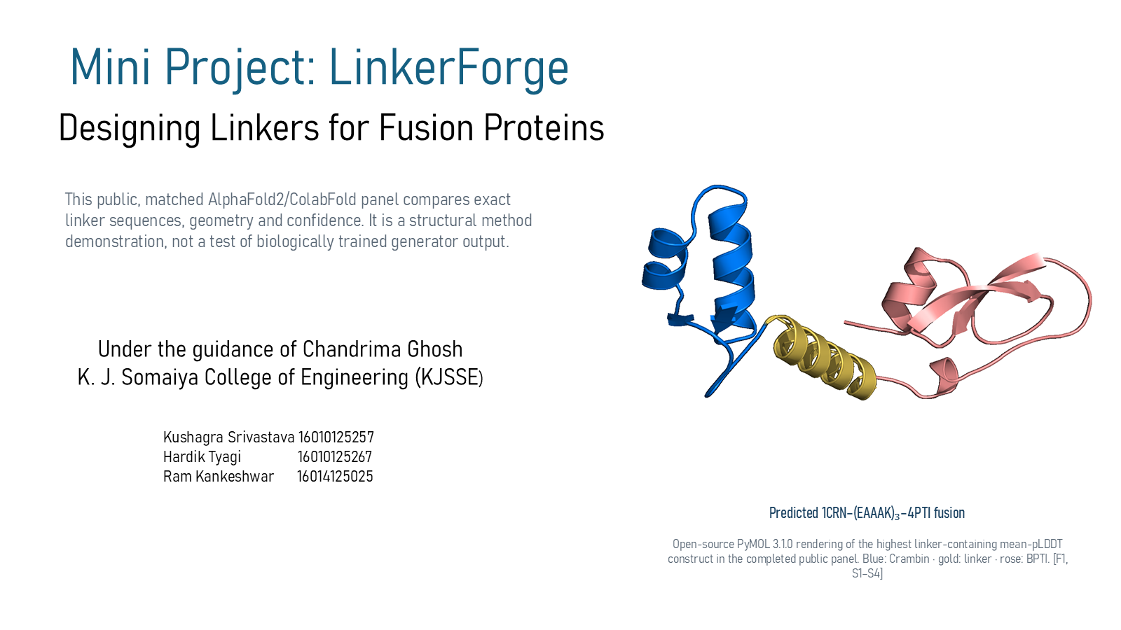
This companion document follows Revision 18 exactly. It explains the project before providing a speech. It keeps the DFL detector, Version 1 generator and fixed-control structural panel separate because they have different inputs, outputs and validation status.
Central conclusion: LinkerForge contains implemented detector and generator software plus a reproducible public structural-comparison workflow. The generator has not been trained on approved biological linker data, and biological linker superiority remains untested.

How to use this guide
First learn the system map and evidence boundaries in Part One. Then study the slide guide in Part Two while keeping Revision 18 open. Part Three gives a full speech and a shorter presentation route. Part Four tests your understanding through difficult examiner questions. Part Five contains the glossary and the exact phrases to avoid.
- Learn what the detector, generator and structural panel each do.
- Understand the difference between software verification, retrospective evaluation, prospective testing and biological validation.
- Practise the full speech, then shorten it using the recommended route if your allotted time is limited.
- Answer questions using the pattern: direct answer, supporting evidence, limitation and next evidence gate.

The 95 slide structure
Slides | Section | Main purpose
1-6 | Research question and scope | Problem, aim, prior art, workflow and evidence status
7-17 | Biological foundations | DNA, protein structure, fusion anatomy, linker classes, metrics and databases
18-36 | Dataset and curation | Labels, mining, exclusion gates, inventory, review and training preflight
37-41 | DFL detector | Frozen ESM-2 embeddings, compact CNN, interval caller and protected training contract
42-53 | Version 1 generator | Two-flank prompt, transformer, loss, training software, baselines and evidence separation
54-74 | Structural validation | Confidence metrics, matched controls, geometry, DFLpred, OpenMM and application viewer
75-82 | Results and limitations | Detector results, weak transfer, evidence gaps, conclusion and next gates
83-95 | References and appendix | Sources, software, provenance, quality control, example runs and discussion

Part One Project and scientific study guide

1 The project in one clear explanation
LinkerForge investigates peptide linkers that connect two protein domains into one fusion protein. The project currently contains three connected but scientifically separate components. The detector finds candidate disordered flexible linker residues in natural proteins. The conditional generator proposes an exact-length sequence between the attachment-adjacent flanks of two selected domains. The structural workflow compares complete fusion predictions and calculates confidence and geometry descriptors.
The project goal is to connect natural-linker discovery to context-specific fusion design, but the current evidence does not yet close that loop scientifically. The detector has historical and retrospective results. The generator has executable software and synthetic smoke tests but no reviewed-data training. The structural panel uses fixed controls rather than generator output.

2 The three evidence streams
Stream | Input | Output | What is verified | What remains open
DFL detector | A natural protein sequence with 1, 0 and unknown residue masks during training | One score per residue, then candidate spans | Architecture, historical runs, mining execution and retrospective comparisons | Fresh family-certified prospective benchmark and mining precision
Generator Version 1 | Domain A C-terminal flank, Domain B N-terminal flank, supplied length and constraints | Exact-length peptide sequence proposals plus rejection records | Model, trainer, decoder, tests and synthetic three-update smoke | Reviewed biological training, held-out reconstruction and fusion outcomes
Structural panel | Complete fusion sequences with fixed candidate and control linkers | Predicted structures, confidence and geometry metrics | 21 constructs, 105 AF2-pTM outputs, geometry audits, visualization and short MD execution | Generated-candidate validation, broader generalisation and biological measurements

3 Research gap and novelty boundary
The research gap is not that no linker detector or generator exists. DFLpred and LINKER-Pred address sequence-based linker detection. LINKER generated fusion-linker sequences before LinkerForge. ProtFIM demonstrated two-flank protein-sequence infilling. The defensible hypothesis is that a traceable workflow can connect curated natural evidence, context-specific two-flank generation and matched complete-fusion evaluation while preserving source, family and benchmark boundaries.
Defensible novelty statement: LinkerForge tests an integrated evidence-to-design workflow under explicit provenance and validation gates. Its superiority over existing detection or generation methods has not been demonstrated.

4 Biological foundations
Fusion protein: One continuous amino-acid chain containing two joined protein regions.
Domain: A region expected to adopt a recognisable folded structure, often associated with a function.
Linker: A covalently encoded peptide between domains. It can alter spacing, movement, orientation and surface accessibility.
N-terminus and C-terminus: The amino and carboxyl ends of a protein chain. Revision 18 focuses on a C-terminus of Domain A to N-terminus of Domain B connection.
DFL: A disordered flexible linker. It is a sequence-label concept and is not identical to every structural domain gap.
IDL and DDL: DLD structural classes for independent-domain and dependent-domain linkers. They are an auxiliary task, not automatic DFL truth.
Flexible GS-rich linker: A glycine and serine rich connector intended to allow relative motion.
Rigid EAAAK linker: A repeat intended to favour an alpha-helical spacer. Rigid describes design intent and relative behaviour, not a motionless structure.

5 Dataset logic
A mined domain gap becomes a candidate only after two distinct, adjacent and non-overlapping domain calls define flanks. Terminal tails, internal loops, overlapping domains, nested annotations, repeated-domain ambiguity and unresolved coordinate conflicts are rejected or kept outside the approved set. The prospective miner uses a 10-60 residue gap window, whereas the older fusion demonstration uses 5-30 residues. Neither window is a universal biological law.
Tier | Rows | Meaning
Mined high score | 6,556 | Computational candidates for prioritisation and curation
Mined provisional | 21,039 | Exploratory computational candidates
Natural CATH or PDB | 91 | Structure-supported natural spans
Natural DisProt | 57 | Curated DFL spans
Engineered templates | 23 | Published sequence patterns used as templates or controls
Total inventory | 27,766 | Mixed evidence, not compatibility ground truth

A separate 40-protein no-linker panel supports diagnostics but is not included in the 27,766 total. A 971-record packet has been prepared for two independent curators, but completed adjudication is not documented.

6 Detector architecture and metrics
The detector freezes ESM-2 t12 35M and uses its 480-dimensional contextual vector for each residue. A small convolutional head applies kernel widths 1, 5 and 1 with channels 480 to 50 to 5 to 1. The first width-one layer mixes features at each position. The width-five layer incorporates a local neighbourhood while padding preserves alignment. The final width-one layer emits one logit per residue.
Masked binary cross entropy uses only sourced positive and explicit negative residues. Unknown x positions and padding do not contribute to the loss. A sigmoid converts logits to scores, while a separately frozen threshold and contiguous-span rule produce candidate intervals.
Metric | Meaning | Revision 18 interpretation
Precision | TP divided by TP plus FP | At high precision, few predicted positives are false, but recall may be low
Recall | TP divided by TP plus FN | DLD fold-4 recall remains low near 0.90 observed precision
APS | Area under the precision-recall curve | Useful for imbalanced residue labels; development and CAID3 values are not interchangeable
AUROC | Ranking of positives above negatives across thresholds | Can look optimistic under strong class imbalance, so APS and raw counts remain important
Fmax | Best F1 score across thresholds | A post-threshold summary, not prospective proof
Specificity | True-negative rate | Requires appropriate verified negatives or no-linker examples

7 Generator architecture and training objective
Version 1 serializes a request as BOS, PREFIX, the Domain A flank, SUFFIX, the Domain B flank, control tokens such as rigidity, cleavage and length, optional motif information, and MIDDLE before linker residues. This order exposes both attachment contexts before generation starts. Length is supplied, so exact length is enforced rather than learned.
The native generator has four pre-normalized causal transformer blocks, eight attention heads, hidden width 256, four-times feed-forward expansion and 0.1 dropout. It produces logits over 20 canonical amino acids. An optional frozen Hugging Face causal protein model with LoRA-style trainable projections is implemented, but the project has not selected or biologically tested a compatible pretrained checkpoint.
Masked next-token cross entropy scores only free linker positions. Prompt tokens, padding and forced motif residues are ignored. The trainer uses deterministic batching, AdamW, finite-loss checks, gradient clipping and provenance-preserving checkpoints. The only completed optimisation used invented records for three CPU updates, then reloaded a checkpoint and emitted one sequence.

8 Structural validation and confidence
Term | What it measures | What it does not prove
pLDDT | AlphaFold local confidence per residue on a 0-100 scale | Linker compatibility, activity or accuracy of LinkerForge
pTM | Confidence in global topology on a 0-1 scale | That the predicted relative pose is experimentally correct
PAE | Expected positional error after alignment, in angstrom | Physical distance or interaction energy
C-alpha RMSD | Reference-aligned coordinate deviation | Activity, binding or degradation
SASA and burial | Solvent exposure and surface hidden in one pose | Whether burial is biologically helpful or harmful
Probe overlaps | Hydrogen-aware unfavorable close contacts | A calibrated fusion-failure probability
OpenMM 50 ps | Execution of preparation, CUDA dynamics and metric output | Equilibrium, convergence or long-term stability

9 What the completed results mean
The matched structural panel used three public domain pairs, seven exact conditions per pair, one fixed ColabFold protocol, five AF2-pTM ranks and one seed. It produced 21 complete constructs and 105 rankable outputs. The same linker behaved differently across domain pairs. Crambin-BPTI with EAAAK15 had the highest linker-containing mean pLDDT at 93.8 and cross-domain PAE 9.7 angstrom, but Protein G-repressor favoured direct fusion and Ubiquitin-GB1 did not show the same interdomain-confidence advantage.
The detector's historical development APS, DLD fold-4 high-precision recall and retrospective CAID3 APS answer different questions. Revision 18 reports CAID3 common-27 APS 0.241 for LinkerForge versus 0.398 for LINKER-Pred and 0.429 for LINKER-Pred-Lite. These viewed public results cannot guide another model-selection round and do not support superiority.

10 Repository evidence used to clarify the deck
The guide uses the presentation as its primary source and cross-checks technical wording against the LinkerForge repository at the recorded revisions. The repository confirms that Version 1 is executable generator software awaiting approved data, the length is supplied rather than predicted, the native transformer starts from random weights, the optional pretrained route lacks a selected checkpoint, and the protected DFL benchmark rules remain binding.
- README.md for the project specification and claim boundaries.
- FUSION_GENERATOR.md at commit 7a4ccc2 for serialization, architecture, constrained decoding, data preflight and synthetic smoke-test limits.
- RESEARCH_HANDOFF.md for the active classifier direction and spent-CAID3 rule.
- literature/DFL_UNTOUCHED_COMPARISON_CONTRACT_2026-10-17.md for the prospective benchmark firewall.
- datasets/README.md for published row counts, hashes, mask semantics and dataset limitations.

Part Two Slide by slide learning guide
This section follows the exact 95-slide order of Revision 18. It is designed as a teaching guide rather than a short caption list. For every slide it explains the scientific purpose, the reasoning behind the content, the visible evidence, the terminology, the correct way to read the figure or table, a usable speaking sequence, a difficult examiner question and the claim boundary. The original slide image is included for navigation; no slide in the source PPT has been changed.

Slide 1 Mini Project LinkerForge
Revision 18 slide 1

Purpose and connection to the project
Introduce the project as a computational method demonstration. The hero structure shows a fixed public linker control, not a sequence produced by a biologically trained generator.
This opening section establishes the scientific question and prevents a common mistake: treating implemented software, model output and biological validation as the same thing. The detector, generator and structural panel are connected by the application, but each has different inputs, outputs and evidence requirements.
Why this slide matters: It tells the audience exactly what problem is being attempted, what has already been implemented and which conclusion is still only a research hypothesis.

Evidence and labels shown on the slide
The following visible elements carry the slide's scientific content. Their role and evidence level are explained in the presentation script below.
- This public, matched AlphaFold2/ColabFold panel compares exact linker sequences, geometry and confidence. It is a structural method demonstration, not a test of biologically trained generator output.
- Predicted 1CRN–(EAAAK)₃–4PTI fusion
- Open-source PyMOL 3.1.0 rendering of the highest linker-containing mean-pLDDT construct in the completed public panel. Blue: Crambin · gold: linker · rose: BPTI. [F1, S1–S4]
- Mini Project: LinkerForge
- Under the guidance of Chandrima Ghosh K. J. Somaiya College of Engineering (KJSSE)
- Kushagra Srivastava 16010125257 Hardik Tyagi 16010125267 Ram Kankeshwar 16014125025
- Designing Linkers for Fusion Proteins

Terms explained on this slide
FUSION PROTEIN: A fusion protein is one covalently continuous polypeptide containing two or more joined protein regions.
LINKER: A linker is the peptide segment between joined domains. Its sequence and length can influence spacing, flexibility, orientation and exposure, but cannot guarantee function.
EAAAK: EAAAK repeats are used as helix-favouring spacers. The term rigid is relative: the peptide still fluctuates and its performance depends on the attached proteins.
ALPHAFOLD2: AlphaFold2 predicts protein coordinates and confidence from sequence. Its confidence outputs describe the predictor, not LinkerForge accuracy or experimental function.
COLABFOLD: ColabFold is a workflow that accelerates AlphaFold-style prediction, including MMseqs2-based sequence searches. It is the prediction runner used for the matched structural panel.
PLDDT: pLDDT is AlphaFold local confidence for each residue on a 0 to 100 scale. It is not percent biological accuracy and does not establish domain orientation.
PYMOL: PyMOL is used to render, inspect and measure structures. It does not generate the AlphaFold prediction or run the OpenMM simulation.

Detailed interpretation of the visual
The slide's question establishes the interpretation, then separate completed work from objectives and future work. End by connecting the slide to the next stage of the project.
The object or dataset, comparison, axes, units, colours and layer dimensions define what the visual represents. The observed pattern is interpreted only within those definitions, preventing a prominent number or molecular rendering from being mistaken for broader biological proof.

Exact presentation script
This slide introduces the project as a computational method demonstration. The hero structure shows a fixed public linker control, not a sequence produced by a biologically trained generator.
This opening section establishes the scientific question and prevents a common mistake: treating implemented software, model output and biological validation as the same thing. The detector, generator and structural panel are connected by the application, but each has different inputs, outputs and evidence requirements.
On this slide, the concrete evidence and labels shown are: This public, matched AlphaFold2/ColabFold panel compares exact linker sequences, geometry and confidence. It is a structural method demonstration, not a test of biologically trained generator output; Predicted 1CRN–(EAAAK)₃–4PTI fusion; Open-source PyMOL 3.1.0 rendering of the highest linker-containing mean-pLDDT construct in the completed public panel. Blue: Crambin · gold: linker · rose: BPTI. [F1, S1–S4]; Mini Project: LinkerForge; and Under the guidance of Chandrima Ghosh K. J. Somaiya College of Engineering (KJSSE). Together, these items establish exactly what was examined here, while retaining their individual evidence levels.
A fusion protein is one covalently continuous polypeptide containing two or more joined protein regions. A linker is the peptide segment between joined domains. Its sequence and length can influence spacing, flexibility, orientation and exposure, but cannot guarantee function. EAAAK repeats are used as helix-favouring spacers. The term rigid is relative: the peptide still fluctuates and its performance depends on the attached proteins.
The reason this result belongs in the project is that it tells the audience exactly what problem is being attempted, what has already been implemented and which conclusion is still only a research hypothesis.
The conclusion from this slide is deliberately limited. I am not claiming that the pictured structure came from the trained generator; it is a fixed public structural control.

Likely examiner question
Question: What does slide 1 allow you to conclude?
Defensible answer: It supports the limited interpretation described above. The safe stopping point is: Do not imply that the pictured structure came from trained generator output.

Scientific claim boundary
Do not imply that the pictured structure came from trained generator output.
This boundary is part of the scientific interpretation, not a weakness to hide. State it clearly so the audience can distinguish what was measured from what would require prospective or experimental validation.

Slide 2 From natural linkers to designed fusion linkers
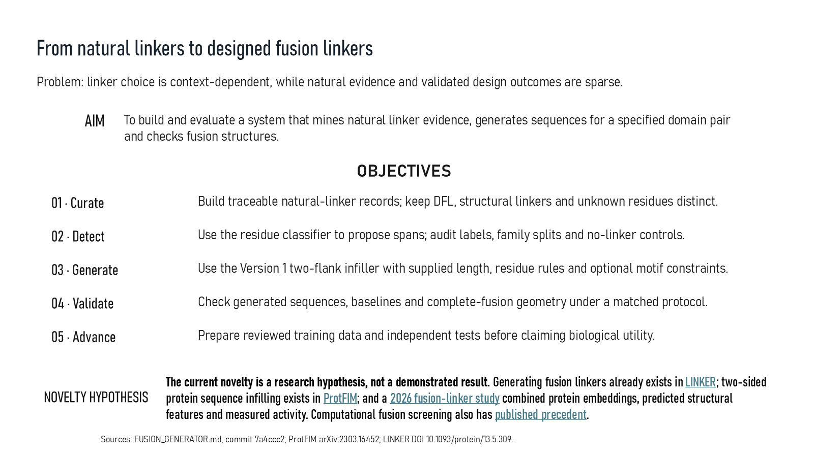
Revision 18 slide 2

Purpose and connection to the project
State the research problem, aim and five objectives. The novelty remains a hypothesis because LINKER and ProtFIM already establish sequence generation and infilling prior art.
This opening section establishes the scientific question and prevents a common mistake: treating implemented software, model output and biological validation as the same thing. The detector, generator and structural panel are connected by the application, but each has different inputs, outputs and evidence requirements.
Why this slide matters: It tells the audience exactly what problem is being attempted, what has already been implemented and which conclusion is still only a research hypothesis.

Evidence and labels shown on the slide
The following visible elements carry the slide's scientific content. Their role and evidence level are explained in the presentation script below.
- Problem: linker choice is context-dependent, while natural evidence and validated design outcomes are sparse.
- To build and evaluate a system that mines natural linker evidence, generates sequences for a specified domain pair and checks fusion structures.
- NOVELTY HYPOTHESIS
- The current novelty is a research hypothesis, not a demonstrated result. Generating fusion linkers already exists in LINKER; two-sided protein sequence infilling exists in ProtFIM; and a 2026 fusion-linker study combined protein embeddings, predicted structural features and measured activity. Computational fusion screening also has published precedent.
- Sources: FUSION_GENERATOR.md, commit 7a4ccc2; ProtFIM arXiv:2303.16452; LINKER DOI 10.1093/protein/13.5.309.

Terms explained on this slide
DOMAIN: A protein domain is a region expected to form a recognizable three-dimensional unit. Domain boundaries are structural or annotation claims, not simply changes in sequence composition.
LINKER: A linker is the peptide segment between joined domains. Its sequence and length can influence spacing, flexibility, orientation and exposure, but cannot guarantee function.
EMBEDDING: An embedding is a numerical vector representing sequence context. It is a learned representation, not a biological measurement.

Detailed interpretation of the visual
The slide progresses from research problem to aim, then move through the numbered objectives. Treat the final novelty statement as a hypothesis to be tested, not as a completed result.
The object or dataset, comparison, axes, units, colours and layer dimensions define what the visual represents. The observed pattern is interpreted only within those definitions, preventing a prominent number or molecular rendering from being mistaken for broader biological proof.

Exact presentation script
This slide states the research problem, aim and five objectives. The novelty remains a hypothesis because LINKER and ProtFIM already establish sequence generation and infilling prior art.
This opening section establishes the scientific question and prevents a common mistake: treating implemented software, model output and biological validation as the same thing. The detector, generator and structural panel are connected by the application, but each has different inputs, outputs and evidence requirements.
On this slide, the concrete evidence and labels shown are: Problem: linker choice is context-dependent, while natural evidence and validated design outcomes are sparse; To build and evaluate a system that mines natural linker evidence, generates sequences for a specified domain pair and checks fusion structures; NOVELTY HYPOTHESIS; The current novelty is a research hypothesis, not a demonstrated result. Generating fusion linkers already exists in LINKER; two-sided protein sequence infilling exists in ProtFIM; and a 2026 fusion-linker study combined protein embeddings, predicted structural features and measured activity. Computational fusion screening also has published precedent; and Sources: FUSION_GENERATOR.md, commit 7a4ccc2; ProtFIM arXiv:2303.16452; LINKER DOI 10.1093/protein/13.5.309. Together, these items establish exactly what was examined here, while retaining their individual evidence levels.
A protein domain is a region expected to form a recognizable three-dimensional unit. Domain boundaries are structural or annotation claims, not simply changes in sequence composition. A linker is the peptide segment between joined domains. Its sequence and length can influence spacing, flexibility, orientation and exposure, but cannot guarantee function. An embedding is a numerical vector representing sequence context. It is a learned representation, not a biological measurement.
The reason this result belongs in the project is that it tells the audience exactly what problem is being attempted, what has already been implemented and which conclusion is still only a research hypothesis.
The conclusion from this slide is deliberately limited. Novelty is a hypothesis until a matched independent comparison supports it.

Likely examiner question
Question: What does slide 2 allow you to conclude?
Defensible answer: It supports the limited interpretation described above. The safe stopping point is: Novelty is a hypothesis until a matched independent comparison supports it.

Scientific claim boundary
Novelty is a hypothesis until a matched independent comparison supports it.
This boundary is part of the scientific interpretation, not a weakness to hide. State it clearly so the audience can distinguish what was measured from what would require prospective or experimental validation.

Slide 3 Detection and generation literature
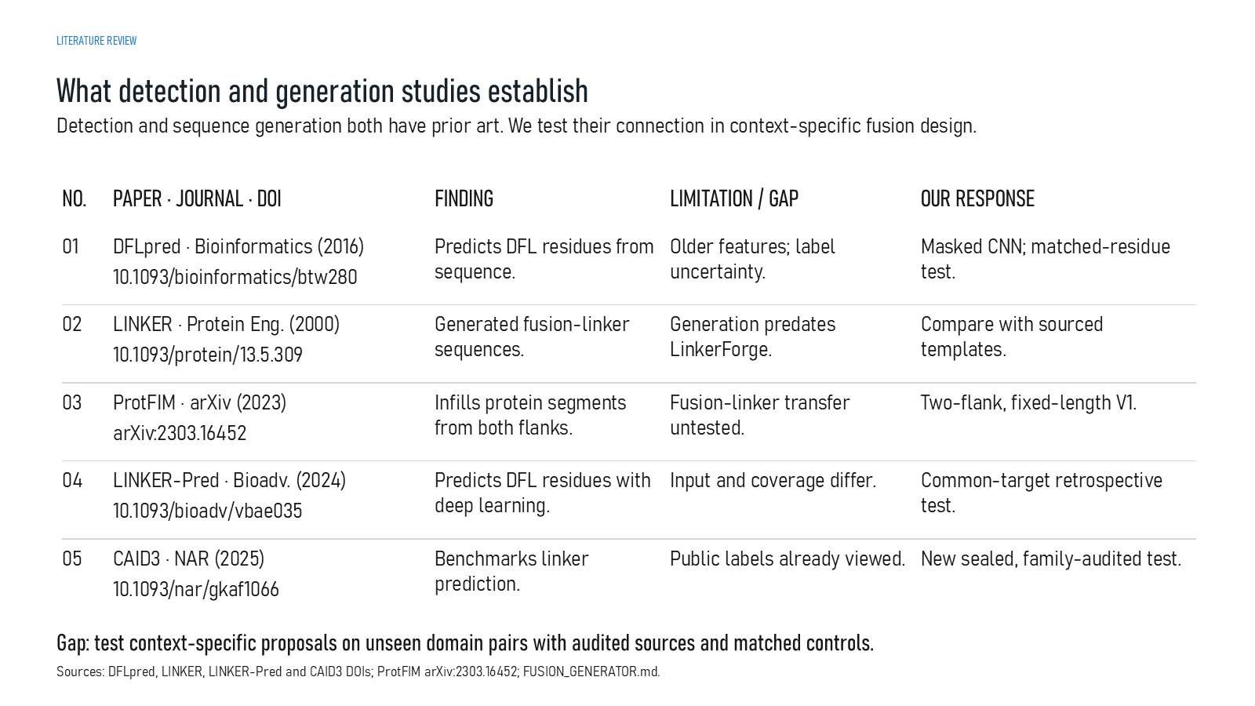
Revision 18 slide 3

Purpose and connection to the project
Explain how each cited method defines the research gap. DFLpred and LINKER-Pred address detection, LINKER addresses generation, ProtFIM addresses two-flank infilling and CAID3 supplies a benchmark that has already been viewed.
This opening section establishes the scientific question and prevents a common mistake: treating implemented software, model output and biological validation as the same thing. The detector, generator and structural panel are connected by the application, but each has different inputs, outputs and evidence requirements.
Why this slide matters: It tells the audience exactly what problem is being attempted, what has already been implemented and which conclusion is still only a research hypothesis.

Evidence and labels shown on the slide
The following visible elements carry the slide's scientific content. Their role and evidence level are explained in the presentation script below.
- LITERATURE REVIEW
- What detection and generation studies establish
- Detection and sequence generation both have prior art. We test their connection in context-specific fusion design.
- PAPER · JOURNAL · DOI
- LIMITATION / GAP
- OUR RESPONSE
- DFLpred · Bioinformatics (2016) 10.1093/bioinformatics/btw280

Terms explained on this slide
DOMAIN: A protein domain is a region expected to form a recognizable three-dimensional unit. Domain boundaries are structural or annotation claims, not simply changes in sequence composition.
LINKER: A linker is the peptide segment between joined domains. Its sequence and length can influence spacing, flexibility, orientation and exposure, but cannot guarantee function.
DFL: DFL means disordered flexible linker. It is a residue-label concept used by the detector and is not synonymous with every domain gap.
CAID3: CAID3 is a public disorder/linker benchmark. Once viewed, its labels and scores are retrospective and cannot be used to tune a supposedly untouched model.

Detailed interpretation of the visual
Each method row by task: detection, generation, infilling or benchmarking. Then state what that method establishes as prior art and what LinkerForge still needs to compare directly.
The object or dataset, comparison, axes, units, colours and layer dimensions define what the visual represents. The observed pattern is interpreted only within those definitions, preventing a prominent number or molecular rendering from being mistaken for broader biological proof.

Exact presentation script
This slide explains how each cited method defines the research gap. DFLpred and LINKER-Pred address detection, LINKER addresses generation, ProtFIM addresses two-flank infilling and CAID3 supplies a benchmark that has already been viewed.
This opening section establishes the scientific question and prevents a common mistake: treating implemented software, model output and biological validation as the same thing. The detector, generator and structural panel are connected by the application, but each has different inputs, outputs and evidence requirements.
On this slide, the concrete evidence and labels shown are: LITERATURE REVIEW; What detection and generation studies establish; Detection and sequence generation both have prior art. We test their connection in context-specific fusion design; PAPER · JOURNAL · DOI; and LIMITATION / GAP. Together, these items establish exactly what was examined here, while retaining their individual evidence levels.
A protein domain is a region expected to form a recognizable three-dimensional unit. Domain boundaries are structural or annotation claims, not simply changes in sequence composition. A linker is the peptide segment between joined domains. Its sequence and length can influence spacing, flexibility, orientation and exposure, but cannot guarantee function. DFL means disordered flexible linker. It is a residue-label concept used by the detector and is not synonymous with every domain gap.
The reason this result belongs in the project is that it tells the audience exactly what problem is being attempted, what has already been implemented and which conclusion is still only a research hypothesis.
The conclusion from this slide is deliberately limited. Prior art exists for both detection and generation.

Likely examiner question
Question: If generation already exists, what is new here?
Defensible answer: The defensible novelty is the proposed integration of provenance-aware natural evidence, two-flank context, explicit data gates and matched complete-fusion evaluation. Predictive superiority is not yet demonstrated.

Scientific claim boundary
Prior art exists for both detection and generation.
This boundary is part of the scientific interpretation, not a weakness to hide. State it clearly so the audience can distinguish what was measured from what would require prospective or experimental validation.

Slide 4 Evidence to design workflow
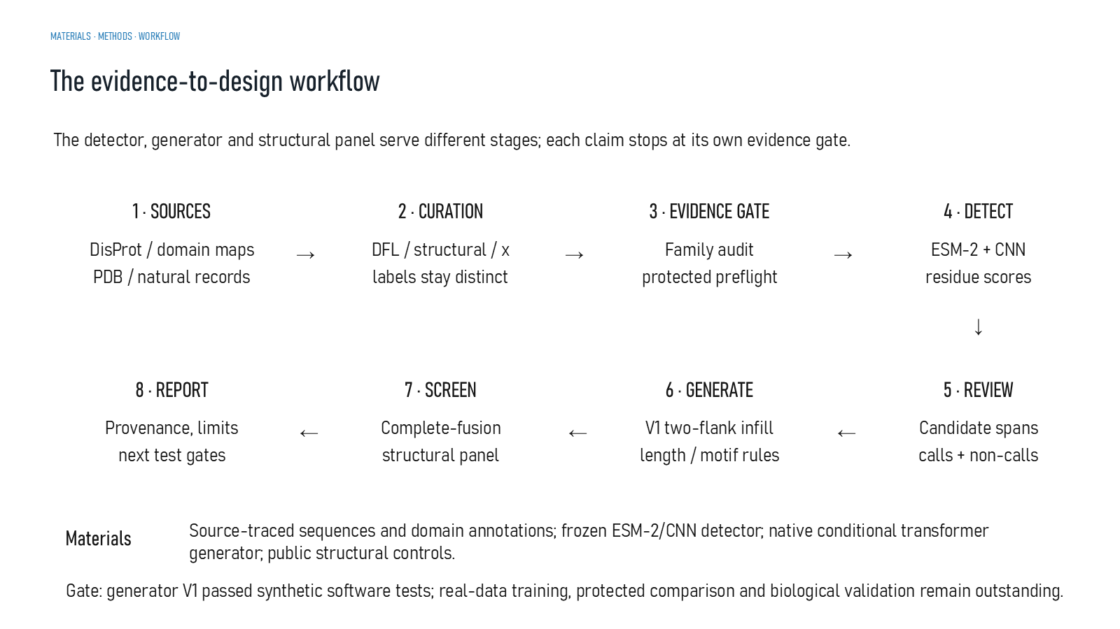
Revision 18 slide 4

Purpose and connection to the project
Walk through sources, curation, evidence gating, residue detection, review, conditional generation, structural screening and reporting. Each stage has a separate claim boundary.
This opening section establishes the scientific question and prevents a common mistake: treating implemented software, model output and biological validation as the same thing. The detector, generator and structural panel are connected by the application, but each has different inputs, outputs and evidence requirements.
Why this slide matters: It tells the audience exactly what problem is being attempted, what has already been implemented and which conclusion is still only a research hypothesis.

Evidence and labels shown on the slide
The following visible elements carry the slide's scientific content. Their role and evidence level are explained in the presentation script below.
- MATERIALS · METHODS · WORKFLOW
- The evidence-to-design workflow
- The detector, generator and structural panel serve different stages; each claim stops at its own evidence gate.
- DisProt / domain maps PDB / natural records
- 2 · CURATION
- DFL / structural / x labels stay distinct
- 3 · EVIDENCE GATE

Terms explained on this slide
DOMAIN: A protein domain is a region expected to form a recognizable three-dimensional unit. Domain boundaries are structural or annotation claims, not simply changes in sequence composition.
DFL: DFL means disordered flexible linker. It is a residue-label concept used by the detector and is not synonymous with every domain gap.
PROVENANCE: Provenance is the recorded origin and transformation history of a datum, model, prediction or figure, including source identifiers, code revision and configuration.
CURATION: Curation is a documented human review process that resolves coordinates, labels, evidence quality and eligibility. Preparing a review packet is not the same as completing adjudication.
ESM-2: ESM-2 is a protein language model. LinkerForge uses frozen per-residue embeddings from the 35-million-parameter t12 variant as detector features.
APS: Average precision score summarizes the precision-recall curve and is useful for imbalanced labels. It depends on the dataset and cannot be compared across unrelated tasks as a universal score.
TRANSFORMER: A transformer models relationships among tokens using attention and feed-forward layers. Version 1 is causal, so each generated residue can use the prompt and earlier linker residues but not future residues.

Detailed interpretation of the visual
The arrows move from source data to curation, detection, review, generation, structural screening and reporting. At every transition ask what evidence is allowed to move forward.
The object or dataset, comparison, axes, units, colours and layer dimensions define what the visual represents. The observed pattern is interpreted only within those definitions, preventing a prominent number or molecular rendering from being mistaken for broader biological proof.

Exact presentation script
This slide follows sources, curation, evidence gating, residue detection, review, conditional generation, structural screening and reporting. Each stage has a separate claim boundary.
This opening section establishes the scientific question and prevents a common mistake: treating implemented software, model output and biological validation as the same thing. The detector, generator and structural panel are connected by the application, but each has different inputs, outputs and evidence requirements.
On this slide, the concrete evidence and labels shown are: MATERIALS · METHODS · WORKFLOW; The evidence-to-design workflow; The detector, generator and structural panel serve different stages; each claim stops at its own evidence gate; DisProt / domain maps PDB / natural records; and 2 · CURATION. Together, these items establish exactly what was examined here, while retaining their individual evidence levels.
A protein domain is a region expected to form a recognizable three-dimensional unit. Domain boundaries are structural or annotation claims, not simply changes in sequence composition. DFL means disordered flexible linker. It is a residue-label concept used by the detector and is not synonymous with every domain gap. Provenance is the recorded origin and transformation history of a datum, model, prediction or figure, including source identifiers, code revision and configuration.
The reason this result belongs in the project is that it tells the audience exactly what problem is being attempted, what has already been implemented and which conclusion is still only a research hypothesis.
The conclusion from this slide is deliberately limited. Passing a software gate does not satisfy a biological gate.

Likely examiner question
Question: What does slide 4 allow you to conclude?
Defensible answer: It supports the limited interpretation described above. The safe stopping point is: Passing a software gate does not satisfy a biological gate.

Scientific claim boundary
Passing a software gate does not satisfy a biological gate.
This boundary is part of the scientific interpretation, not a weakness to hide. State it clearly so the audience can distinguish what was measured from what would require prospective or experimental validation.

Slide 5 Two implemented components
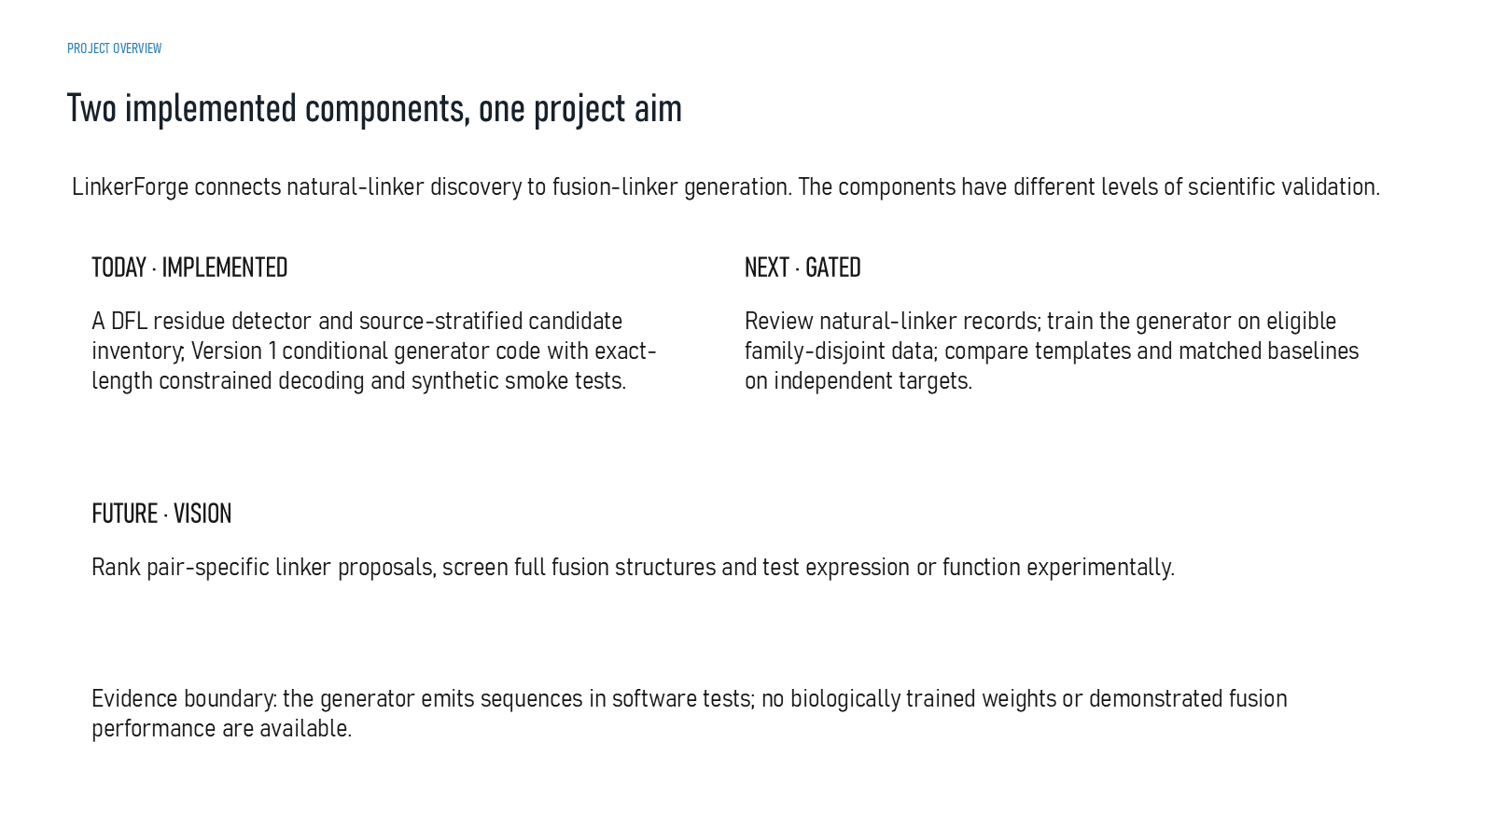
Revision 18 slide 5

Purpose and connection to the project
Separate what exists today from what remains gated. The detector and generator code exist, but reviewed biological training and experimentally supported fusion performance do not.
This opening section establishes the scientific question and prevents a common mistake: treating implemented software, model output and biological validation as the same thing. The detector, generator and structural panel are connected by the application, but each has different inputs, outputs and evidence requirements.
Why this slide matters: It tells the audience exactly what problem is being attempted, what has already been implemented and which conclusion is still only a research hypothesis.

Evidence and labels shown on the slide
The following visible elements carry the slide's scientific content. Their role and evidence level are explained in the presentation script below.
- PROJECT OVERVIEW
- Two implemented components, one project aim
- LinkerForge connects natural-linker discovery to fusion-linker generation. The components have different levels of scientific validation.
- TODAY · IMPLEMENTED
- A DFL residue detector and source-stratified candidate inventory; Version 1 conditional generator code with exact-length constrained decoding and synthetic smoke tests.
- NEXT · GATED
- Review natural-linker records; train the generator on eligible family-disjoint data; compare templates and matched baselines on independent targets.

Terms explained on this slide
LINKER: A linker is the peptide segment between joined domains. Its sequence and length can influence spacing, flexibility, orientation and exposure, but cannot guarantee function.
DFL: DFL means disordered flexible linker. It is a residue-label concept used by the detector and is not synonymous with every domain gap.
FAMILY-DISJOINT: A family-disjoint split keeps related protein families out of both training and evaluation, reducing memorization through homology.
CONSTRAINED DECODING: Constrained decoding enforces rules such as exact length, canonical residues, forced motifs and bounded retries while sampling. Rule compliance is not evidence of biological compatibility.

Detailed interpretation of the visual
The slide's question establishes the interpretation, then separate completed work from objectives and future work. End by connecting the slide to the next stage of the project.
The object or dataset, comparison, axes, units, colours and layer dimensions define what the visual represents. The observed pattern is interpreted only within those definitions, preventing a prominent number or molecular rendering from being mistaken for broader biological proof.

Exact presentation script
This slide separates what exists today from what remains gated. The detector and generator code exist, but reviewed biological training and experimentally supported fusion performance do not.
This opening section establishes the scientific question and prevents a common mistake: treating implemented software, model output and biological validation as the same thing. The detector, generator and structural panel are connected by the application, but each has different inputs, outputs and evidence requirements.
On this slide, the concrete evidence and labels shown are: PROJECT OVERVIEW; Two implemented components, one project aim; LinkerForge connects natural-linker discovery to fusion-linker generation. The components have different levels of scientific validation; TODAY · IMPLEMENTED; and A DFL residue detector and source-stratified candidate inventory; Version 1 conditional generator code with exact-length constrained decoding and synthetic smoke tests. Together, these items establish exactly what was examined here, while retaining their individual evidence levels.
A linker is the peptide segment between joined domains. Its sequence and length can influence spacing, flexibility, orientation and exposure, but cannot guarantee function. DFL means disordered flexible linker. It is a residue-label concept used by the detector and is not synonymous with every domain gap. A family-disjoint split keeps related protein families out of both training and evaluation, reducing memorization through homology.
The reason this result belongs in the project is that it tells the audience exactly what problem is being attempted, what has already been implemented and which conclusion is still only a research hypothesis.
The conclusion from this slide is deliberately limited. Implemented software and validated biological performance are different states.

Likely examiner question
Question: What does slide 5 allow you to conclude?
Defensible answer: It supports the limited interpretation described above. The safe stopping point is: Implemented software and validated biological performance are different states.

Scientific claim boundary
Implemented software and validated biological performance are different states.
This boundary is part of the scientific interpretation, not a weakness to hide. State it clearly so the audience can distinguish what was measured from what would require prospective or experimental validation.

Slide 6 Proteins and records in scope
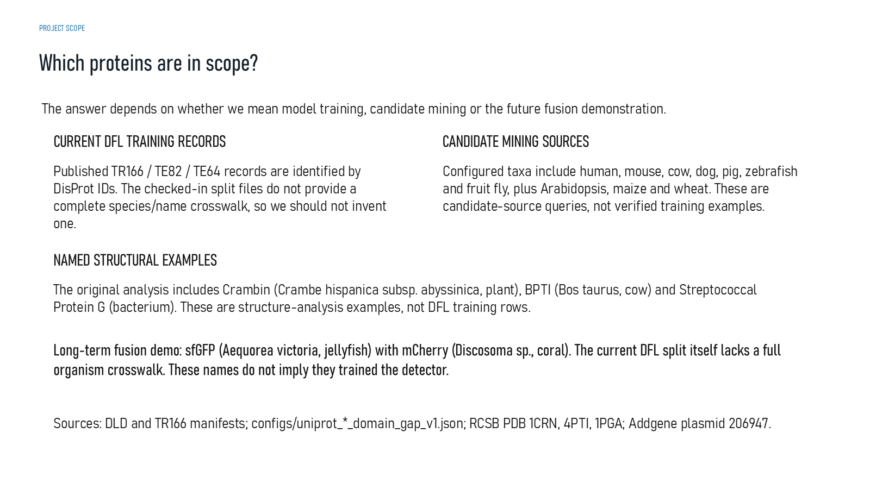
Revision 18 slide 6

Purpose and connection to the project
Distinguish training records, mining queries, named structure examples and the long-term sfGFP-mCherry demonstration. A protein name appearing in the project does not mean it trained the detector.
This opening section establishes the scientific question and prevents a common mistake: treating implemented software, model output and biological validation as the same thing. The detector, generator and structural panel are connected by the application, but each has different inputs, outputs and evidence requirements.
Why this slide matters: It tells the audience exactly what problem is being attempted, what has already been implemented and which conclusion is still only a research hypothesis.

Evidence and labels shown on the slide
The following visible elements carry the slide's scientific content. Their role and evidence level are explained in the presentation script below.
- PROJECT SCOPE
- Which proteins are in scope?
- The answer depends on whether we mean model training, candidate mining or the future fusion demonstration.
- CURRENT DFL TRAINING RECORDS
- Published TR166 / TE82 / TE64 records are identified by DisProt IDs. The checked-in split files do not provide a complete species/name crosswalk, so we should not invent one.
- CANDIDATE MINING SOURCES
- Configured taxa include human, mouse, cow, dog, pig, zebrafish and fruit fly, plus Arabidopsis, maize and wheat. These are candidate-source queries, not verified training examples.

Terms explained on this slide
DOMAIN: A protein domain is a region expected to form a recognizable three-dimensional unit. Domain boundaries are structural or annotation claims, not simply changes in sequence composition.
DFL: DFL means disordered flexible linker. It is a residue-label concept used by the detector and is not synonymous with every domain gap.

Detailed interpretation of the visual
The slide's question establishes the interpretation, then separate completed work from objectives and future work. End by connecting the slide to the next stage of the project.
The object or dataset, comparison, axes, units, colours and layer dimensions define what the visual represents. The observed pattern is interpreted only within those definitions, preventing a prominent number or molecular rendering from being mistaken for broader biological proof.

Exact presentation script
This slide distinguishes training records, mining queries, named structure examples and the long-term sfGFP-mCherry demonstration. A protein name appearing in the project does not mean it trained the detector.
This opening section establishes the scientific question and prevents a common mistake: treating implemented software, model output and biological validation as the same thing. The detector, generator and structural panel are connected by the application, but each has different inputs, outputs and evidence requirements.
On this slide, the concrete evidence and labels shown are: PROJECT SCOPE; Which proteins are in scope?; The answer depends on whether we mean model training, candidate mining or the future fusion demonstration; CURRENT DFL TRAINING RECORDS; and Published TR166 / TE82 / TE64 records are identified by DisProt IDs. The checked-in split files do not provide a complete species/name crosswalk, so we should not invent one. Together, these items establish exactly what was examined here, while retaining their individual evidence levels.
A protein domain is a region expected to form a recognizable three-dimensional unit. Domain boundaries are structural or annotation claims, not simply changes in sequence composition. DFL means disordered flexible linker. It is a residue-label concept used by the detector and is not synonymous with every domain gap.
The reason this result belongs in the project is that it tells the audience exactly what problem is being attempted, what has already been implemented and which conclusion is still only a research hypothesis.
The conclusion from this slide is deliberately limited. A named protein or taxon is not automatically a training example.

Likely examiner question
Question: What does slide 6 allow you to conclude?
Defensible answer: It supports the limited interpretation described above. The safe stopping point is: A named protein or taxon is not automatically a training example.

Scientific claim boundary
A named protein or taxon is not automatically a training example.
This boundary is part of the scientific interpretation, not a weakness to hide. State it clearly so the audience can distinguish what was measured from what would require prospective or experimental validation.

Slide 7 From DNA to a multidomain protein
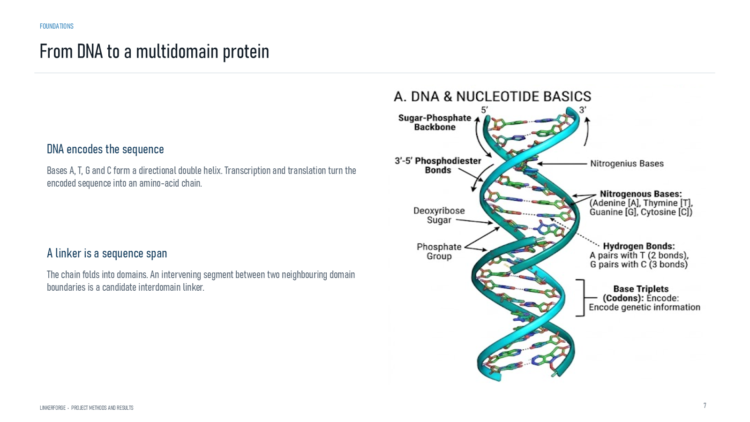
Revision 18 slide 7

Purpose and connection to the project
Connect DNA sequence information to an amino-acid chain and then to domain boundaries. A sequence between neighbouring domains becomes a candidate linker only after annotation and review.
This foundation section translates sequence notation into physical protein design. The key reasoning step is to move from a one-dimensional amino-acid chain to domain boundaries, attachment points and a complete covalent fusion without assuming that sequence adjacency alone guarantees a viable structure.
Why this slide matters: It gives the audience enough molecular vocabulary to understand why linker length, composition, attachment geometry and domain context must be considered together.

Evidence and labels shown on the slide
The following visible elements carry the slide's scientific content. Their role and evidence level are explained in the presentation script below.
- LINKERFORGE • PROJECT METHODS AND RESULTS
- DNA encodes the sequence
- Bases A, T, G and C form a directional double helix. Transcription and translation turn the encoded sequence into an amino-acid chain.
- A linker is a sequence span
- The chain folds into domains. An intervening segment between two neighbouring domain boundaries is a candidate interdomain linker.

Terms explained on this slide
DOMAIN: A protein domain is a region expected to form a recognizable three-dimensional unit. Domain boundaries are structural or annotation claims, not simply changes in sequence composition.
LINKER: A linker is the peptide segment between joined domains. Its sequence and length can influence spacing, flexibility, orientation and exposure, but cannot guarantee function.

Detailed interpretation of the visual
The physical object or sequence segment establishes the interpretation or sequence segment, follow the N-to-C direction where shown, and distinguish structural evidence from explanatory illustration.
The object or dataset, comparison, axes, units, colours and layer dimensions define what the visual represents. The observed pattern is interpreted only within those definitions, preventing a prominent number or molecular rendering from being mistaken for broader biological proof.

Exact presentation script
This slide connects DNA sequence information to an amino-acid chain and then to domain boundaries. A sequence between neighbouring domains becomes a candidate linker only after annotation and review.
This foundation section translates sequence notation into physical protein design. The key reasoning step is to move from a one-dimensional amino-acid chain to domain boundaries, attachment points and a complete covalent fusion without assuming that sequence adjacency alone guarantees a viable structure.
On this slide, the concrete evidence and labels shown are: LINKERFORGE • PROJECT METHODS AND RESULTS; DNA encodes the sequence; Bases A, T, G and C form a directional double helix. Transcription and translation turn the encoded sequence into an amino-acid chain; A linker is a sequence span; and The chain folds into domains. An intervening segment between two neighbouring domain boundaries is a candidate interdomain linker. Together, these items establish exactly what was examined here, while retaining their individual evidence levels.
A protein domain is a region expected to form a recognizable three-dimensional unit. Domain boundaries are structural or annotation claims, not simply changes in sequence composition. A linker is the peptide segment between joined domains. Its sequence and length can influence spacing, flexibility, orientation and exposure, but cannot guarantee function.
The reason this result belongs in the project is that it gives the audience enough molecular vocabulary to understand why linker length, composition, attachment geometry and domain context must be considered together.
The conclusion from this slide is deliberately limited. An intervening sequence is a candidate until evidence confirms its role.

Likely examiner question
Question: What does slide 7 allow you to conclude?
Defensible answer: It supports the limited interpretation described above. The safe stopping point is: An intervening sequence is a candidate until evidence confirms its role.

Scientific claim boundary
An intervening sequence is a candidate until evidence confirms its role.
This boundary is part of the scientific interpretation, not a weakness to hide. State it clearly so the audience can distinguish what was measured from what would require prospective or experimental validation.

Slide 8 Protein structural hierarchy
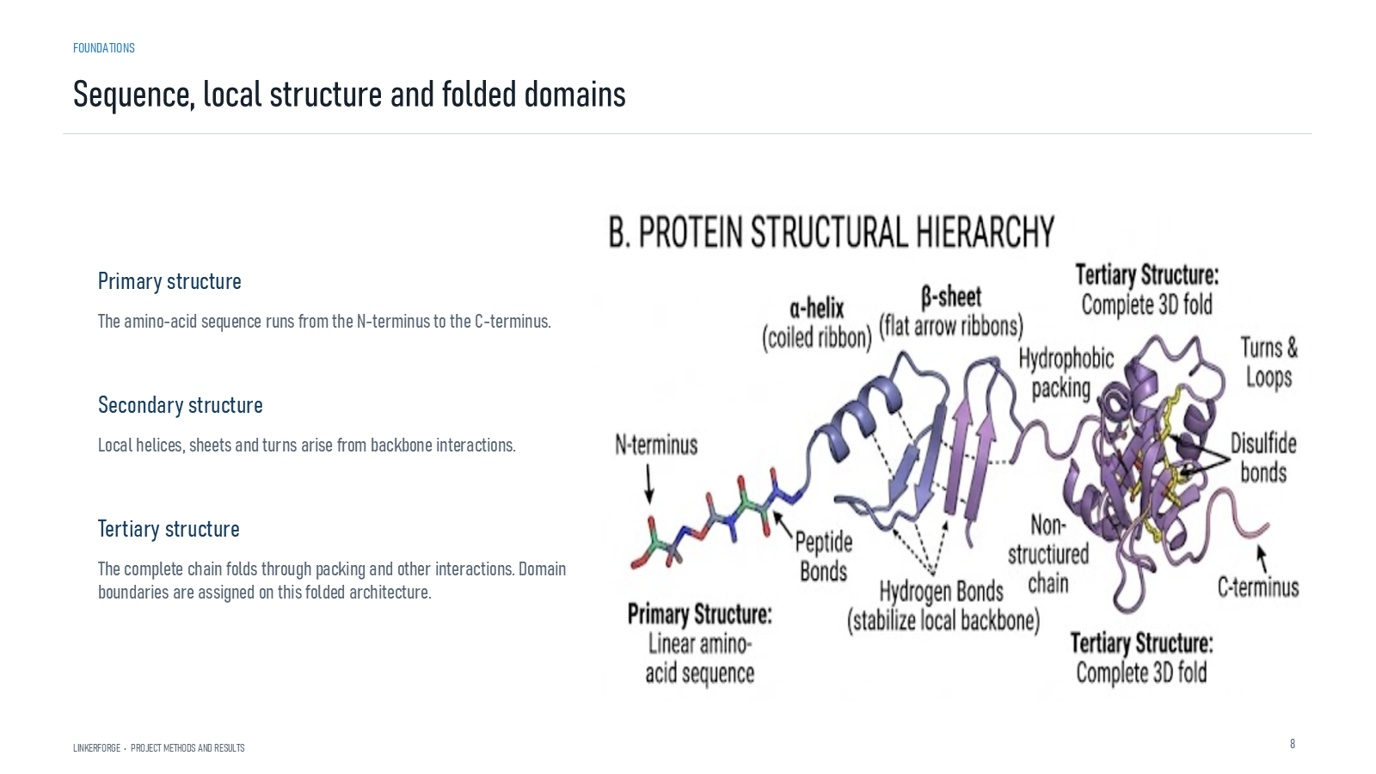
Revision 18 slide 8

Purpose and connection to the project
Define primary, secondary and tertiary structure. Domain assignments refer to the folded architecture rather than sequence composition alone.
This foundation section translates sequence notation into physical protein design. The key reasoning step is to move from a one-dimensional amino-acid chain to domain boundaries, attachment points and a complete covalent fusion without assuming that sequence adjacency alone guarantees a viable structure.
Why this slide matters: It gives the audience enough molecular vocabulary to understand why linker length, composition, attachment geometry and domain context must be considered together.

Evidence and labels shown on the slide
The following visible elements carry the slide's scientific content. Their role and evidence level are explained in the presentation script below.
- Sequence, local structure and folded domains
- LINKERFORGE • PROJECT METHODS AND RESULTS
- Primary structure
- The amino-acid sequence runs from the N-terminus to the C-terminus.
- Secondary structure
- Local helices, sheets and turns arise from backbone interactions.
- Tertiary structure

Terms explained on this slide
DOMAIN: A protein domain is a region expected to form a recognizable three-dimensional unit. Domain boundaries are structural or annotation claims, not simply changes in sequence composition.
LINKER: A linker is the peptide segment between joined domains. Its sequence and length can influence spacing, flexibility, orientation and exposure, but cannot guarantee function.

Detailed interpretation of the visual
The physical object or sequence segment establishes the interpretation or sequence segment, follow the N-to-C direction where shown, and distinguish structural evidence from explanatory illustration.
The object or dataset, comparison, axes, units, colours and layer dimensions define what the visual represents. The observed pattern is interpreted only within those definitions, preventing a prominent number or molecular rendering from being mistaken for broader biological proof.

Exact presentation script
This slide defines primary, secondary and tertiary structure. Domain assignments refer to the folded architecture rather than sequence composition alone.
This foundation section translates sequence notation into physical protein design. The key reasoning step is to move from a one-dimensional amino-acid chain to domain boundaries, attachment points and a complete covalent fusion without assuming that sequence adjacency alone guarantees a viable structure.
On this slide, the concrete evidence and labels shown are: Sequence, local structure and folded domains; LINKERFORGE • PROJECT METHODS AND RESULTS; Primary structure; The amino-acid sequence runs from the N-terminus to the C-terminus; and Secondary structure. Together, these items establish exactly what was examined here, while retaining their individual evidence levels.
A protein domain is a region expected to form a recognizable three-dimensional unit. Domain boundaries are structural or annotation claims, not simply changes in sequence composition. A linker is the peptide segment between joined domains. Its sequence and length can influence spacing, flexibility, orientation and exposure, but cannot guarantee function.
The reason this result belongs in the project is that it gives the audience enough molecular vocabulary to understand why linker length, composition, attachment geometry and domain context must be considered together.
The conclusion from this slide is deliberately limited. Sequence composition alone does not define a structural domain boundary.

Likely examiner question
Question: What does slide 8 allow you to conclude?
Defensible answer: It supports the limited interpretation described above. The safe stopping point is: Sequence composition alone does not define a structural domain boundary.

Scientific claim boundary
Sequence composition alone does not define a structural domain boundary.
This boundary is part of the scientific interpretation, not a weakness to hide. State it clearly so the audience can distinguish what was measured from what would require prospective or experimental validation.

Slide 9 Fusion protein design object
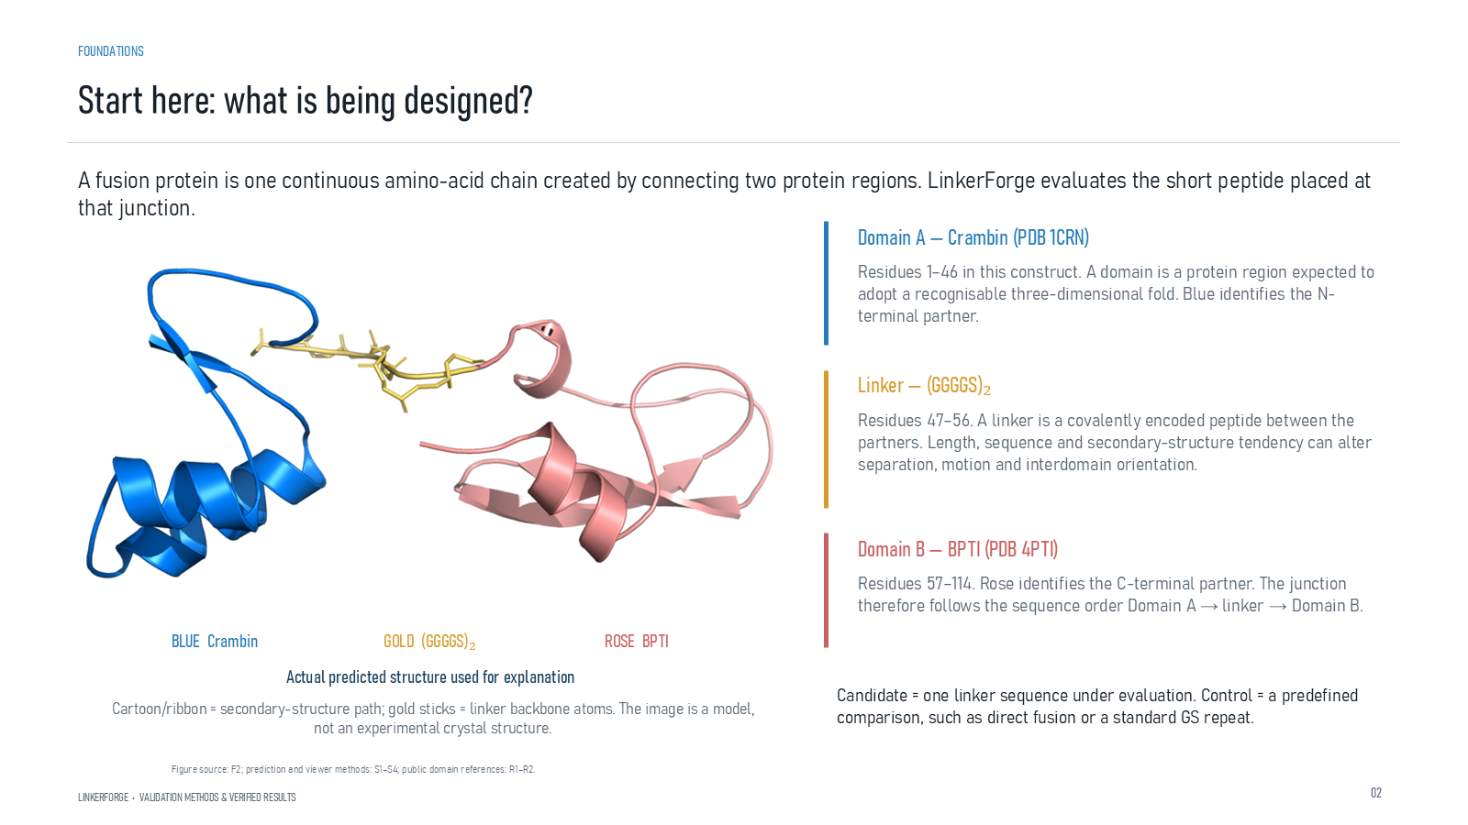
Revision 18 slide 9

Purpose and connection to the project
Define the complete fusion as Domain A plus linker plus Domain B. Explain the N-terminal and C-terminal order and the difference between a candidate and a control.
This foundation section translates sequence notation into physical protein design. The key reasoning step is to move from a one-dimensional amino-acid chain to domain boundaries, attachment points and a complete covalent fusion without assuming that sequence adjacency alone guarantees a viable structure.
Why this slide matters: It gives the audience enough molecular vocabulary to understand why linker length, composition, attachment geometry and domain context must be considered together.

Evidence and labels shown on the slide
The following visible elements carry the slide's scientific content. Their role and evidence level are explained in the presentation script below.
- Start here: what is being designed?
- LINKERFORGE • VALIDATION METHODS & VERIFIED RESULTS
- A fusion protein is one continuous amino-acid chain created by connecting two protein regions. LinkerForge evaluates the short peptide placed at that junction.
- BLUE Crambin
- GOLD (GGGGS)₂
- Actual predicted structure used for explanation
- Cartoon/ribbon = secondary-structure path; gold sticks = linker backbone atoms. The image is a model, not an experimental crystal structure.

Terms explained on this slide
DOMAIN: A protein domain is a region expected to form a recognizable three-dimensional unit. Domain boundaries are structural or annotation claims, not simply changes in sequence composition.
FUSION PROTEIN: A fusion protein is one covalently continuous polypeptide containing two or more joined protein regions.
LINKER: A linker is the peptide segment between joined domains. Its sequence and length can influence spacing, flexibility, orientation and exposure, but cannot guarantee function.

Detailed interpretation of the visual
The physical object or sequence segment establishes the interpretation or sequence segment, follow the N-to-C direction where shown, and distinguish structural evidence from explanatory illustration.
The object or dataset, comparison, axes, units, colours and layer dimensions define what the visual represents. The observed pattern is interpreted only within those definitions, preventing a prominent number or molecular rendering from being mistaken for broader biological proof.

Exact presentation script
This slide defines the complete fusion as Domain A plus linker plus Domain B. Explain the N-terminal and C-terminal order and the difference between a candidate and a control.
This foundation section translates sequence notation into physical protein design. The key reasoning step is to move from a one-dimensional amino-acid chain to domain boundaries, attachment points and a complete covalent fusion without assuming that sequence adjacency alone guarantees a viable structure.
On this slide, the concrete evidence and labels shown are: Start here: what is being designed?; LINKERFORGE • VALIDATION METHODS & VERIFIED RESULTS; A fusion protein is one continuous amino-acid chain created by connecting two protein regions. LinkerForge evaluates the short peptide placed at that junction; BLUE Crambin; and GOLD (GGGGS)₂. Together, these items establish exactly what was examined here, while retaining their individual evidence levels.
A protein domain is a region expected to form a recognizable three-dimensional unit. Domain boundaries are structural or annotation claims, not simply changes in sequence composition. A fusion protein is one covalently continuous polypeptide containing two or more joined protein regions. A linker is the peptide segment between joined domains. Its sequence and length can influence spacing, flexibility, orientation and exposure, but cannot guarantee function.
The reason this result belongs in the project is that it gives the audience enough molecular vocabulary to understand why linker length, composition, attachment geometry and domain context must be considered together.
The conclusion from this slide is deliberately limited. The model image is predicted rather than experimentally solved.

Likely examiner question
Question: What does slide 9 allow you to conclude?
Defensible answer: It supports the limited interpretation described above. The safe stopping point is: The model image is predicted rather than experimentally solved.

Scientific claim boundary
The model image is predicted rather than experimentally solved.
This boundary is part of the scientific interpretation, not a weakness to hide. State it clearly so the audience can distinguish what was measured from what would require prospective or experimental validation.

Slide 10 Flexible and rigid linker classes
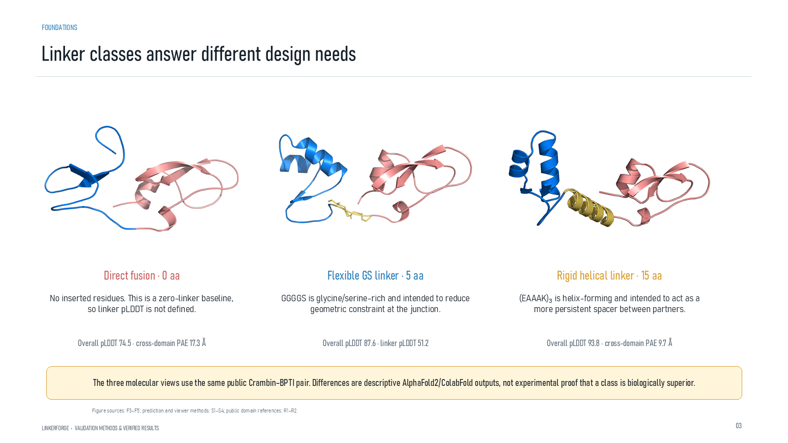
Revision 18 slide 10

Purpose and connection to the project
Compare direct fusion, a short flexible GS linker and a rigid helical EAAAK linker. The displayed values belong only to the Crambin-BPTI example.
This foundation section translates sequence notation into physical protein design. The key reasoning step is to move from a one-dimensional amino-acid chain to domain boundaries, attachment points and a complete covalent fusion without assuming that sequence adjacency alone guarantees a viable structure.
Why this slide matters: It gives the audience enough molecular vocabulary to understand why linker length, composition, attachment geometry and domain context must be considered together.

Evidence and labels shown on the slide
The following visible elements carry the slide's scientific content. Their role and evidence level are explained in the presentation script below.
- Linker classes answer different design needs
- LINKERFORGE • VALIDATION METHODS & VERIFIED RESULTS
- Direct fusion · 0 aa
- No inserted residues. This is a zero-linker baseline, so linker pLDDT is not defined.
- Overall pLDDT 74.5 · cross-domain PAE 17.3 Å
- Flexible GS linker · 5 aa
- GGGGS is glycine/serine-rich and intended to reduce geometric constraint at the junction.

Terms explained on this slide
DOMAIN: A protein domain is a region expected to form a recognizable three-dimensional unit. Domain boundaries are structural or annotation claims, not simply changes in sequence composition.
LINKER: A linker is the peptide segment between joined domains. Its sequence and length can influence spacing, flexibility, orientation and exposure, but cannot guarantee function.
EAAAK: EAAAK repeats are used as helix-favouring spacers. The term rigid is relative: the peptide still fluctuates and its performance depends on the attached proteins.
ALPHAFOLD2: AlphaFold2 predicts protein coordinates and confidence from sequence. Its confidence outputs describe the predictor, not LinkerForge accuracy or experimental function.
COLABFOLD: ColabFold is a workflow that accelerates AlphaFold-style prediction, including MMseqs2-based sequence searches. It is the prediction runner used for the matched structural panel.
PLDDT: pLDDT is AlphaFold local confidence for each residue on a 0 to 100 scale. It is not percent biological accuracy and does not establish domain orientation.
PAE: Predicted aligned error estimates positional uncertainty after alignment, in angstrom. Off-diagonal domain blocks are useful for interdomain confidence; PAE is not physical distance.

Detailed interpretation of the visual
The physical object or sequence segment establishes the interpretation or sequence segment, follow the N-to-C direction where shown, and distinguish structural evidence from explanatory illustration.
The object or dataset, comparison, axes, units, colours and layer dimensions define what the visual represents. The observed pattern is interpreted only within those definitions, preventing a prominent number or molecular rendering from being mistaken for broader biological proof.

Exact presentation script
This slide compares direct fusion, a short flexible GS linker and a rigid helical EAAAK linker. The displayed values belong only to the Crambin-BPTI example.
This foundation section translates sequence notation into physical protein design. The key reasoning step is to move from a one-dimensional amino-acid chain to domain boundaries, attachment points and a complete covalent fusion without assuming that sequence adjacency alone guarantees a viable structure.
On this slide, the concrete evidence and labels shown are: Linker classes answer different design needs; LINKERFORGE • VALIDATION METHODS & VERIFIED RESULTS; Direct fusion · 0 aa; No inserted residues. This is a zero-linker baseline, so linker pLDDT is not defined; and Overall pLDDT 74.5 · cross-domain PAE 17.3 Å. Together, these items establish exactly what was examined here, while retaining their individual evidence levels.
A protein domain is a region expected to form a recognizable three-dimensional unit. Domain boundaries are structural or annotation claims, not simply changes in sequence composition. A linker is the peptide segment between joined domains. Its sequence and length can influence spacing, flexibility, orientation and exposure, but cannot guarantee function. EAAAK repeats are used as helix-favouring spacers. The term rigid is relative: the peptide still fluctuates and its performance depends on the attached proteins.
The reason this result belongs in the project is that it gives the audience enough molecular vocabulary to understand why linker length, composition, attachment geometry and domain context must be considered together.
The conclusion from this slide is deliberately limited. The Crambin-BPTI result does not establish a universal linker class.

Likely examiner question
Question: What does slide 10 allow you to conclude?
Defensible answer: It supports the limited interpretation described above. The safe stopping point is: The Crambin-BPTI result does not establish a universal linker class.

Scientific claim boundary
The Crambin-BPTI result does not establish a universal linker class.
This boundary is part of the scientific interpretation, not a weakness to hide. State it clearly so the audience can distinguish what was measured from what would require prospective or experimental validation.

Slide 11 Flexible and rigid linker functions
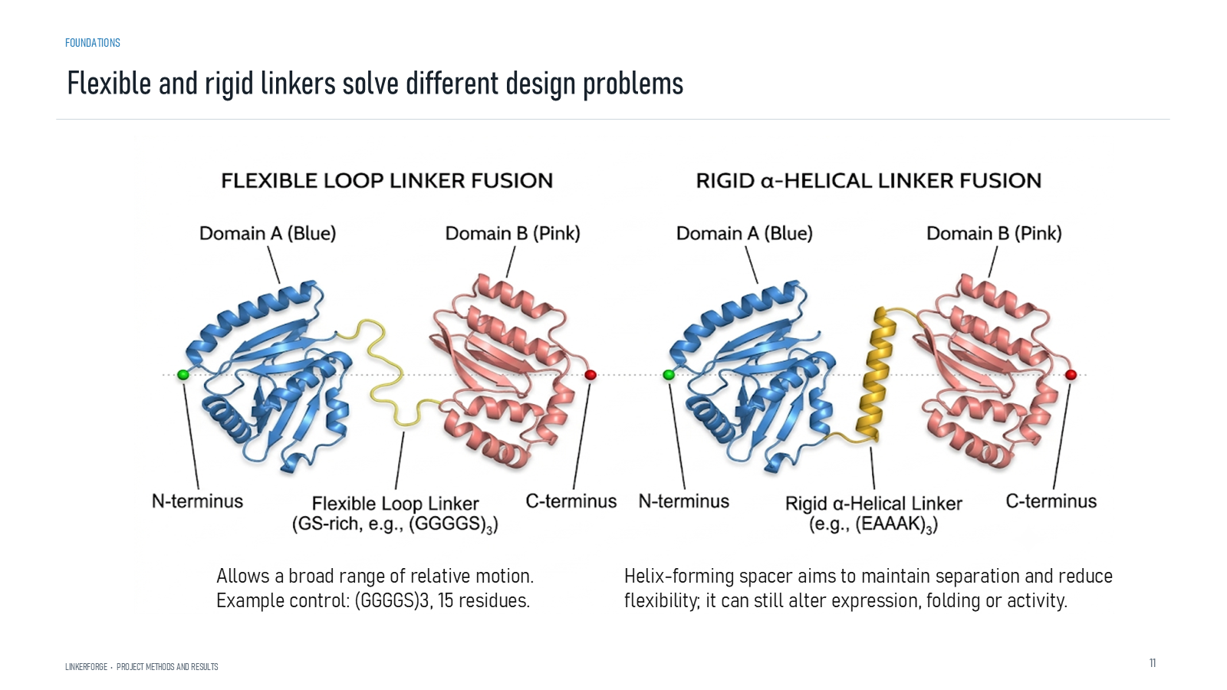
Revision 18 slide 11

Purpose and connection to the project
Flexible linkers permit relative motion, while helical linkers aim to maintain separation. Neither class guarantees expression, folding or activity.
This foundation section translates sequence notation into physical protein design. The key reasoning step is to move from a one-dimensional amino-acid chain to domain boundaries, attachment points and a complete covalent fusion without assuming that sequence adjacency alone guarantees a viable structure.
Why this slide matters: It gives the audience enough molecular vocabulary to understand why linker length, composition, attachment geometry and domain context must be considered together.

Evidence and labels shown on the slide
The following visible elements carry the slide's scientific content. Their role and evidence level are explained in the presentation script below.
- LINKERFORGE • PROJECT METHODS AND RESULTS
- Flexible and rigid linkers solve different design problems
- Allows a broad range of relative motion. Example control: (GGGGS)3, 15 residues.
- Helix-forming spacer aims to maintain separation and reduce flexibility; it can still alter expression, folding or activity.

Terms explained on this slide
LINKER: A linker is the peptide segment between joined domains. Its sequence and length can influence spacing, flexibility, orientation and exposure, but cannot guarantee function.

Detailed interpretation of the visual
The physical object or sequence segment establishes the interpretation or sequence segment, follow the N-to-C direction where shown, and distinguish structural evidence from explanatory illustration.
The object or dataset, comparison, axes, units, colours and layer dimensions define what the visual represents. The observed pattern is interpreted only within those definitions, preventing a prominent number or molecular rendering from being mistaken for broader biological proof.

Exact presentation script
This slide shows that flexible linkers permit relative motion, while helical linkers aim to maintain separation. Neither class guarantees expression, folding or activity.
This foundation section translates sequence notation into physical protein design. The key reasoning step is to move from a one-dimensional amino-acid chain to domain boundaries, attachment points and a complete covalent fusion without assuming that sequence adjacency alone guarantees a viable structure.
On this slide, the concrete evidence and labels shown are: LINKERFORGE • PROJECT METHODS AND RESULTS; Flexible and rigid linkers solve different design problems; Allows a broad range of relative motion. Example control: (GGGGS)3, 15 residues; and Helix-forming spacer aims to maintain separation and reduce flexibility; it can still alter expression, folding or activity. Together, these items establish exactly what was examined here, while retaining their individual evidence levels.
A linker is the peptide segment between joined domains. Its sequence and length can influence spacing, flexibility, orientation and exposure, but cannot guarantee function.
The reason this result belongs in the project is that it gives the audience enough molecular vocabulary to understand why linker length, composition, attachment geometry and domain context must be considered together.
The conclusion from this slide is deliberately limited. Rigid and flexible are design tendencies, not absolute physical states.

Likely examiner question
Question: What does slide 11 allow you to conclude?
Defensible answer: It supports the limited interpretation described above. The safe stopping point is: Rigid and flexible are design tendencies, not absolute physical states.

Scientific claim boundary
Rigid and flexible are design tendencies, not absolute physical states.
This boundary is part of the scientific interpretation, not a weakness to hide. State it clearly so the audience can distinguish what was measured from what would require prospective or experimental validation.

Slide 12 Linker anatomy and computational workflow
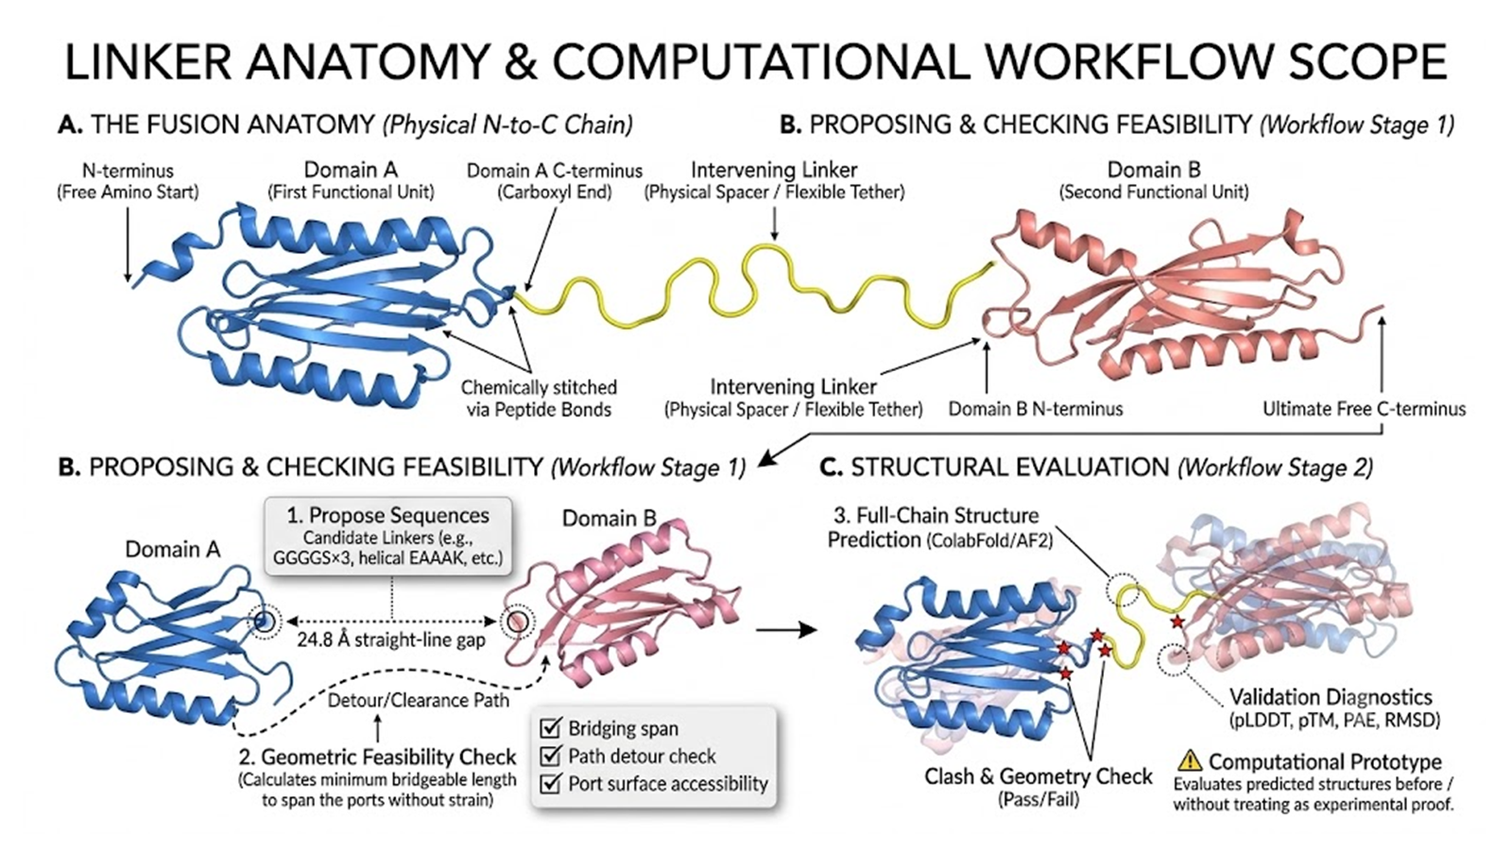
Revision 18 slide 12

Purpose and connection to the project
Use the diagram to connect physical fusion anatomy with the two-stage computational workflow: feasibility before folding and structural evaluation after full-chain prediction.
This foundation section translates sequence notation into physical protein design. The key reasoning step is to move from a one-dimensional amino-acid chain to domain boundaries, attachment points and a complete covalent fusion without assuming that sequence adjacency alone guarantees a viable structure.
Why this slide matters: It gives the audience enough molecular vocabulary to understand why linker length, composition, attachment geometry and domain context must be considered together.

Terms explained on this slide
LINKER: A linker is the peptide segment between joined domains. Its sequence and length can influence spacing, flexibility, orientation and exposure, but cannot guarantee function.

Detailed interpretation of the visual
The upper anatomy panel first, identifying Domain A, the linker and Domain B. Then follow the lower workflow from proposal and feasibility checks to complete-fusion prediction and structural assessment.
The object or dataset, comparison, axes, units, colours and layer dimensions define what the visual represents. The observed pattern is interpreted only within those definitions, preventing a prominent number or molecular rendering from being mistaken for broader biological proof.

Exact presentation script
This slide uses the diagram to connect physical fusion anatomy with the two-stage computational workflow: feasibility before folding and structural evaluation after full-chain prediction.
This foundation section translates sequence notation into physical protein design. The key reasoning step is to move from a one-dimensional amino-acid chain to domain boundaries, attachment points and a complete covalent fusion without assuming that sequence adjacency alone guarantees a viable structure.
A linker is the peptide segment between joined domains. Its sequence and length can influence spacing, flexibility, orientation and exposure, but cannot guarantee function.
The reason this result belongs in the project is that it gives the audience enough molecular vocabulary to understand why linker length, composition, attachment geometry and domain context must be considered together.
The conclusion from this slide is deliberately limited. The geometry shown is an explanatory workflow, not a universal measured threshold.

Likely examiner question
Question: What does slide 12 allow you to conclude?
Defensible answer: It supports the limited interpretation described above. The safe stopping point is: The geometry shown is an explanatory workflow, not a universal measured threshold.

Scientific claim boundary
The geometry shown is an explanatory workflow, not a universal measured threshold.
This boundary is part of the scientific interpretation, not a weakness to hide. State it clearly so the audience can distinguish what was measured from what would require prospective or experimental validation.

Slide 13 Ubiquitin GS10 GB1 example
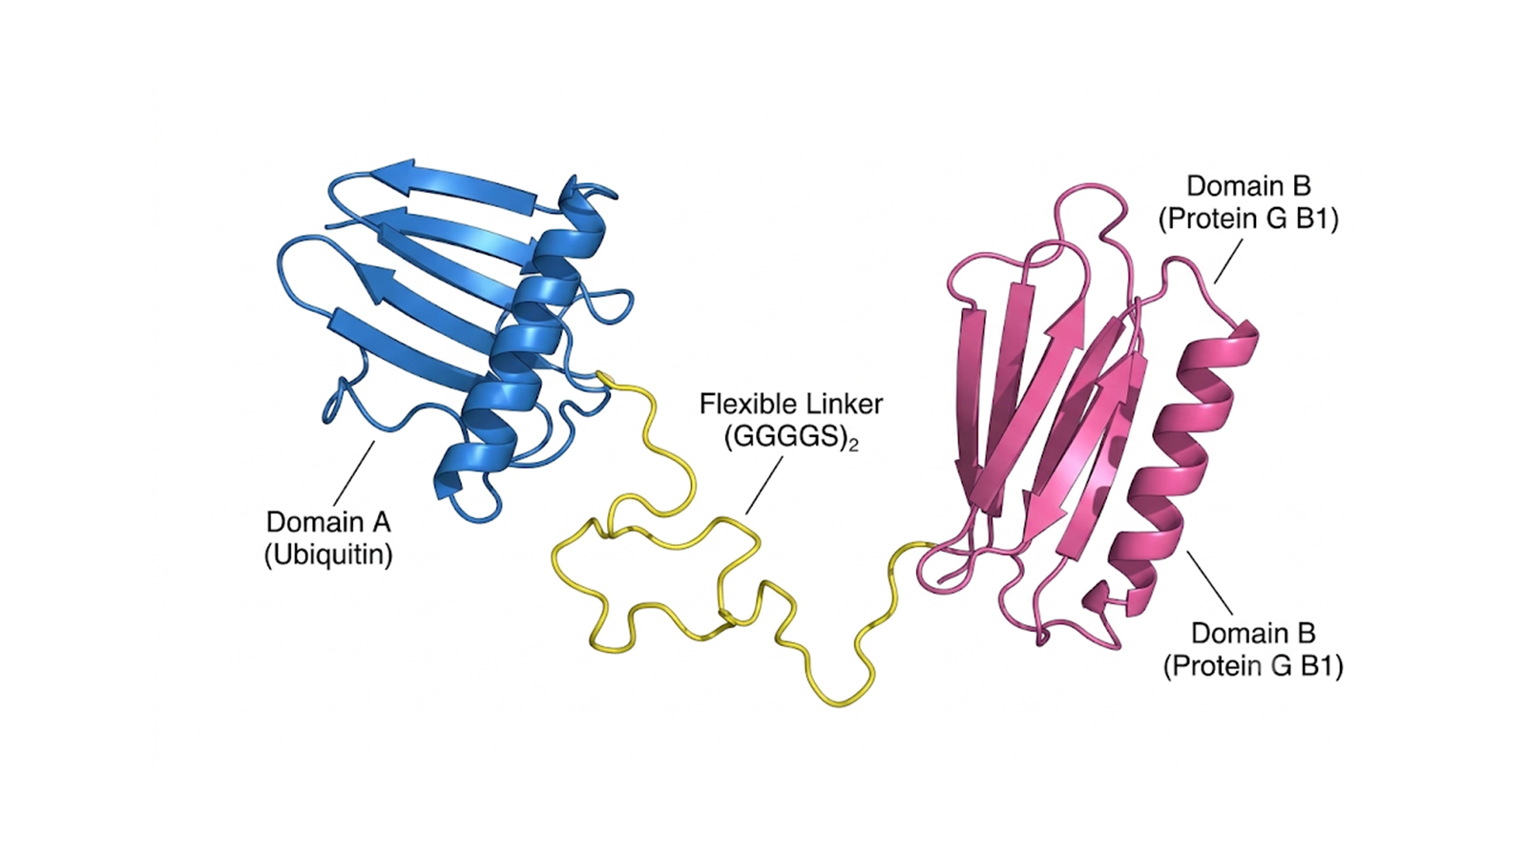
Revision 18 slide 13

Purpose and connection to the project
Identify ubiquitin as Domain A, GS10 as the flexible linker and GB1 as Domain B. The picture illustrates domain-linker-domain anatomy and is not a result from the trained generator.
This foundation section translates sequence notation into physical protein design. The key reasoning step is to move from a one-dimensional amino-acid chain to domain boundaries, attachment points and a complete covalent fusion without assuming that sequence adjacency alone guarantees a viable structure.
Why this slide matters: It gives the audience enough molecular vocabulary to understand why linker length, composition, attachment geometry and domain context must be considered together.

Terms explained on this slide
DOMAIN: A protein domain is a region expected to form a recognizable three-dimensional unit. Domain boundaries are structural or annotation claims, not simply changes in sequence composition.
LINKER: A linker is the peptide segment between joined domains. Its sequence and length can influence spacing, flexibility, orientation and exposure, but cannot guarantee function.

Detailed interpretation of the visual
The physical object or sequence segment establishes the interpretation or sequence segment, follow the N-to-C direction where shown, and distinguish structural evidence from explanatory illustration.
The object or dataset, comparison, axes, units, colours and layer dimensions define what the visual represents. The observed pattern is interpreted only within those definitions, preventing a prominent number or molecular rendering from being mistaken for broader biological proof.

Exact presentation script
This slide identifies ubiquitin as Domain A, GS10 as the flexible linker and GB1 as Domain B. The picture illustrates domain-linker-domain anatomy and is not a result from the trained generator.
This foundation section translates sequence notation into physical protein design. The key reasoning step is to move from a one-dimensional amino-acid chain to domain boundaries, attachment points and a complete covalent fusion without assuming that sequence adjacency alone guarantees a viable structure.
A protein domain is a region expected to form a recognizable three-dimensional unit. Domain boundaries are structural or annotation claims, not simply changes in sequence composition. A linker is the peptide segment between joined domains. Its sequence and length can influence spacing, flexibility, orientation and exposure, but cannot guarantee function.
The reason this result belongs in the project is that it gives the audience enough molecular vocabulary to understand why linker length, composition, attachment geometry and domain context must be considered together.
The conclusion from this slide is deliberately limited. This illustration does not show generator efficacy.

Likely examiner question
Question: What does slide 13 allow you to conclude?
Defensible answer: It supports the limited interpretation described above. The safe stopping point is: This illustration does not show generator efficacy.

Scientific claim boundary
This illustration does not show generator efficacy.
This boundary is part of the scientific interpretation, not a weakness to hide. State it clearly so the audience can distinguish what was measured from what would require prospective or experimental validation.

Slide 14 Fusion anatomy in sequence order
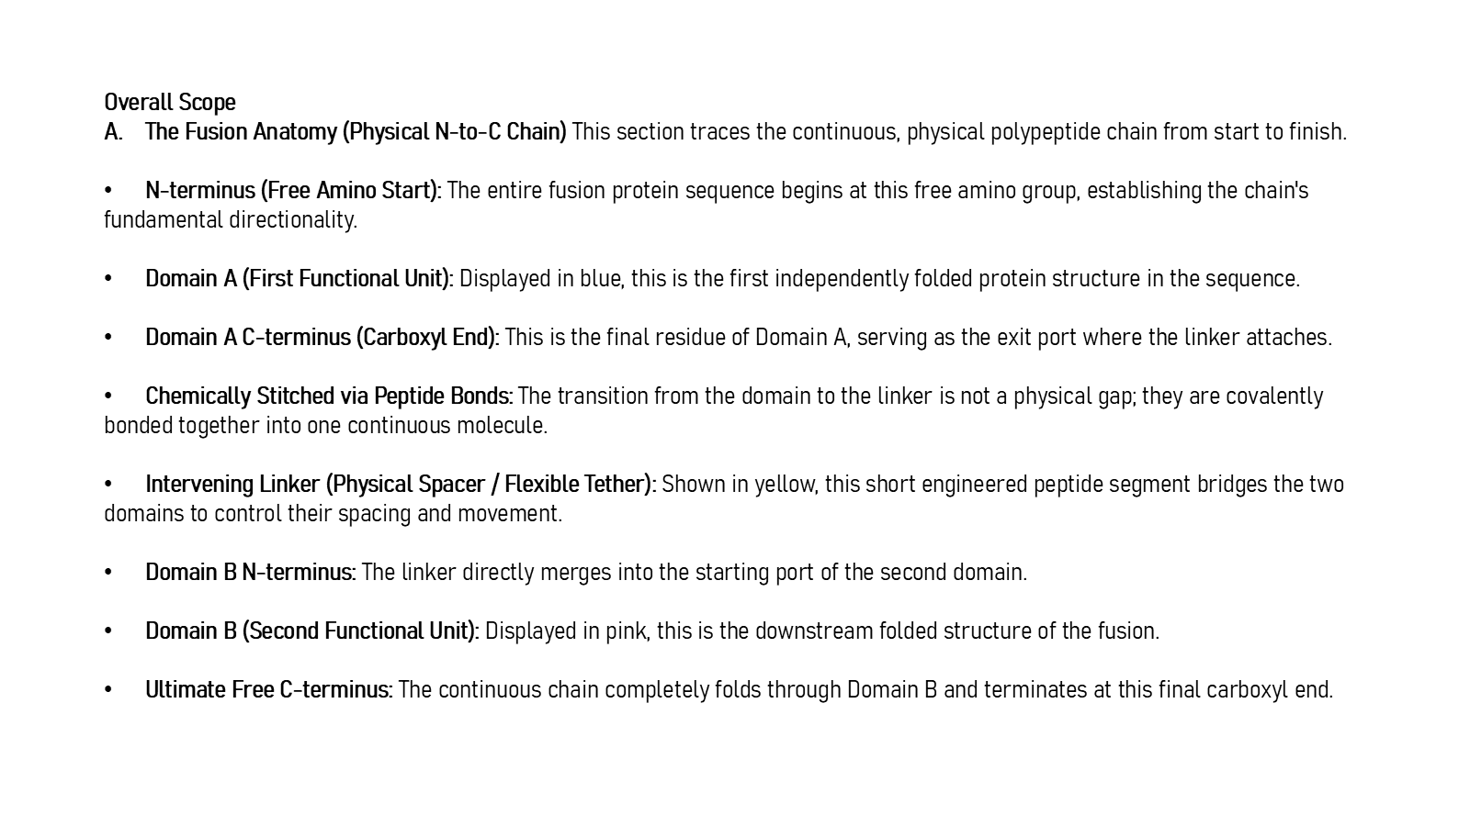
Revision 18 slide 14

Purpose and connection to the project
Trace the covalently continuous chain from the free N-terminus through Domain A, the linker and Domain B to the free C-terminus.
This foundation section translates sequence notation into physical protein design. The key reasoning step is to move from a one-dimensional amino-acid chain to domain boundaries, attachment points and a complete covalent fusion without assuming that sequence adjacency alone guarantees a viable structure.
Why this slide matters: It gives the audience enough molecular vocabulary to understand why linker length, composition, attachment geometry and domain context must be considered together.

Evidence and labels shown on the slide
The following visible elements carry the slide's scientific content. Their role and evidence level are explained in the presentation script below.
- Overall Scope The Fusion Anatomy (Physical N-to-C Chain) This section traces the continuous, physical polypeptide chain from start to finish. N-terminus (Free Amino Start): The entire fusion protein sequence begins at this free amino group, establishing the chain's fundamental directionality. Domain A (First Functional Unit): Displayed in blue, this is th...

Terms explained on this slide
DOMAIN: A protein domain is a region expected to form a recognizable three-dimensional unit. Domain boundaries are structural or annotation claims, not simply changes in sequence composition.
FUSION PROTEIN: A fusion protein is one covalently continuous polypeptide containing two or more joined protein regions.
LINKER: A linker is the peptide segment between joined domains. Its sequence and length can influence spacing, flexibility, orientation and exposure, but cannot guarantee function.

Detailed interpretation of the visual
The physical object or sequence segment establishes the interpretation or sequence segment, follow the N-to-C direction where shown, and distinguish structural evidence from explanatory illustration.
The object or dataset, comparison, axes, units, colours and layer dimensions define what the visual represents. The observed pattern is interpreted only within those definitions, preventing a prominent number or molecular rendering from being mistaken for broader biological proof.

Exact presentation script
This slide shows that trace the covalently continuous chain from the free N-terminus through Domain A, the linker and Domain B to the free C-terminus.
This foundation section translates sequence notation into physical protein design. The key reasoning step is to move from a one-dimensional amino-acid chain to domain boundaries, attachment points and a complete covalent fusion without assuming that sequence adjacency alone guarantees a viable structure.
On this slide, the concrete evidence and labels shown are: Overall Scope The Fusion Anatomy (Physical N-to-C Chain) This section traces the continuous, physical polypeptide chain from start to finish. N-terminus (Free Amino Start): The entire fusion protein sequence begins at this free amino group, establishing the chain's fundamental directionality. Domain A (First Functional Unit): Displayed in blue, this is th. Together, these items establish exactly what was examined here, while retaining their individual evidence levels.
A protein domain is a region expected to form a recognizable three-dimensional unit. Domain boundaries are structural or annotation claims, not simply changes in sequence composition. A fusion protein is one covalently continuous polypeptide containing two or more joined protein regions. A linker is the peptide segment between joined domains. Its sequence and length can influence spacing, flexibility, orientation and exposure, but cannot guarantee function.
The reason this result belongs in the project is that it gives the audience enough molecular vocabulary to understand why linker length, composition, attachment geometry and domain context must be considered together.
The conclusion from this slide is deliberately limited. The linker is covalently continuous with both domains.

Likely examiner question
Question: What does slide 14 allow you to conclude?
Defensible answer: It supports the limited interpretation described above. The safe stopping point is: The linker is covalently continuous with both domains.

Scientific claim boundary
The linker is covalently continuous with both domains.
This boundary is part of the scientific interpretation, not a weakness to hide. State it clearly so the audience can distinguish what was measured from what would require prospective or experimental validation.

Slide 15 Key terms and metrics
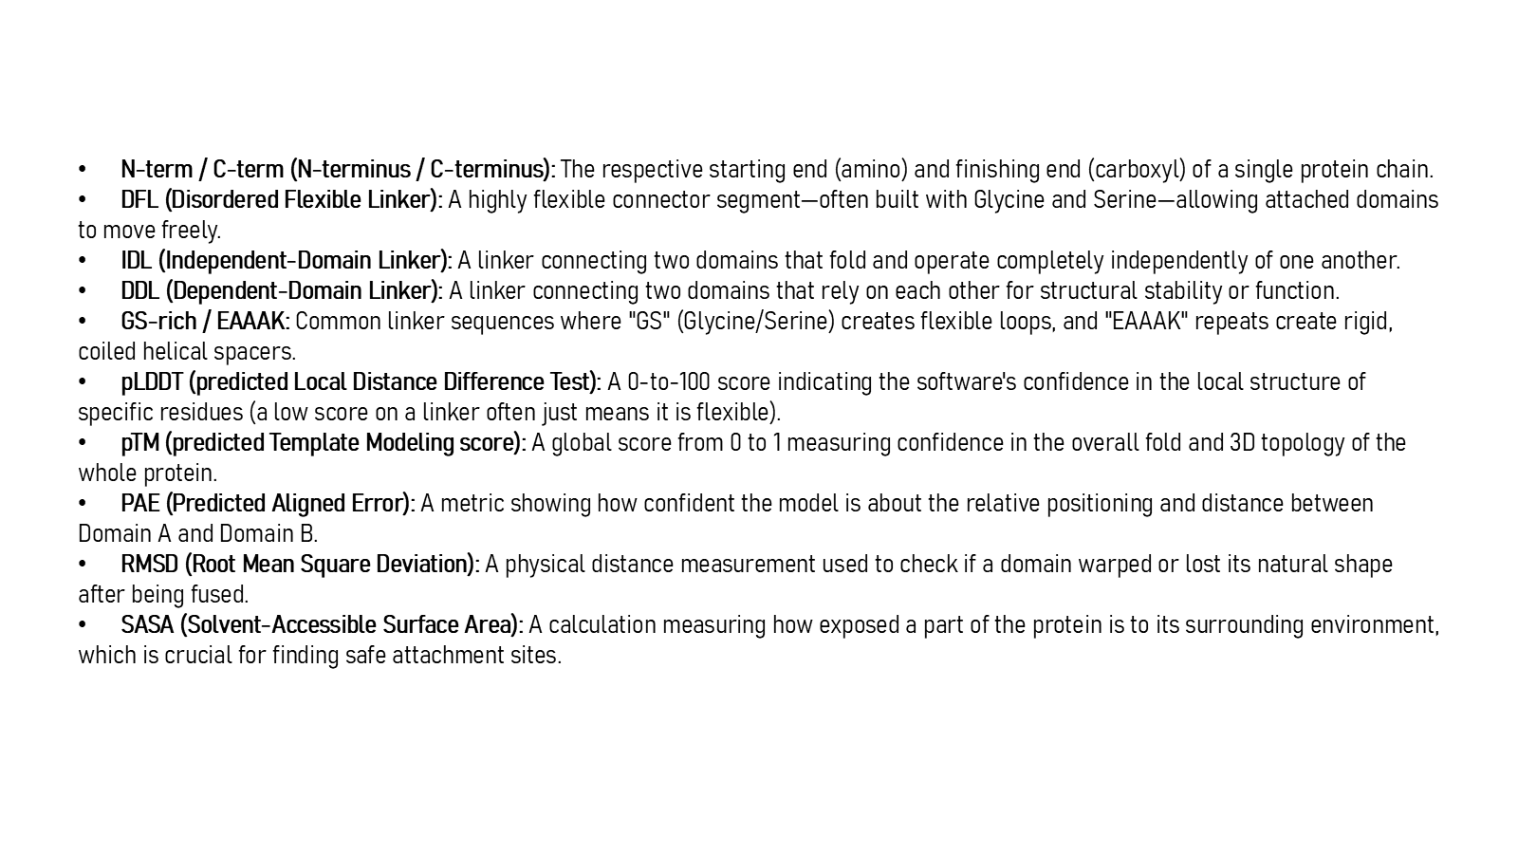
Revision 18 slide 15

Purpose and connection to the project
Learn the vocabulary: N and C termini, DFL, IDL, DDL, GS-rich and EAAAK linkers, pLDDT, pTM, PAE, RMSD and SASA. These terms refer to different biological or computational questions.
This foundation section translates sequence notation into physical protein design. The key reasoning step is to move from a one-dimensional amino-acid chain to domain boundaries, attachment points and a complete covalent fusion without assuming that sequence adjacency alone guarantees a viable structure.
Why this slide matters: It gives the audience enough molecular vocabulary to understand why linker length, composition, attachment geometry and domain context must be considered together.

Evidence and labels shown on the slide
The following visible elements carry the slide's scientific content. Their role and evidence level are explained in the presentation script below.
- N-term / C-term (N-terminus / C-terminus): The respective starting end (amino) and finishing end (carboxyl) of a single protein chain. DFL (Disordered Flexible Linker): A highly flexible connector segment—often built with Glycine and Serine—allowing attached domains to move freely. IDL (Independent-Domain Linker): A linker connecting two domains that fold...

Terms explained on this slide
DOMAIN: A protein domain is a region expected to form a recognizable three-dimensional unit. Domain boundaries are structural or annotation claims, not simply changes in sequence composition.
LINKER: A linker is the peptide segment between joined domains. Its sequence and length can influence spacing, flexibility, orientation and exposure, but cannot guarantee function.
DFL: DFL means disordered flexible linker. It is a residue-label concept used by the detector and is not synonymous with every domain gap.
IDL: IDL is an independent-domain-linker class in the DLD structural task. It must not be silently relabelled as DFL truth.
DDL: DDL is a dependent-domain-linker class in the DLD structural task. It describes a structural relationship, not a fusion-success outcome.
GS-RICH: GS-rich linkers contain many glycine and serine residues. Glycine permits backbone freedom and serine contributes polarity, but the label flexible is a design tendency rather than a guarantee.
EAAAK: EAAAK repeats are used as helix-favouring spacers. The term rigid is relative: the peptide still fluctuates and its performance depends on the attached proteins.
PLDDT: pLDDT is AlphaFold local confidence for each residue on a 0 to 100 scale. It is not percent biological accuracy and does not establish domain orientation.

Detailed interpretation of the visual
The physical object or sequence segment establishes the interpretation or sequence segment, follow the N-to-C direction where shown, and distinguish structural evidence from explanatory illustration.
The object or dataset, comparison, axes, units, colours and layer dimensions define what the visual represents. The observed pattern is interpreted only within those definitions, preventing a prominent number or molecular rendering from being mistaken for broader biological proof.

Exact presentation script
This slide presents the vocabulary: N and C termini, DFL, IDL, DDL, GS-rich and EAAAK linkers, pLDDT, pTM, PAE, RMSD and SASA. These terms refer to different biological or computational questions.
This foundation section translates sequence notation into physical protein design. The key reasoning step is to move from a one-dimensional amino-acid chain to domain boundaries, attachment points and a complete covalent fusion without assuming that sequence adjacency alone guarantees a viable structure.
On this slide, the concrete evidence and labels shown are: N-term / C-term (N-terminus / C-terminus): The respective starting end (amino) and finishing end (carboxyl) of a single protein chain. DFL (Disordered Flexible Linker): A highly flexible connector segment—often built with Glycine and Serine—allowing attached domains to move freely. IDL (Independent-Domain Linker): A linker connecting two domains that fold. Together, these items establish exactly what was examined here, while retaining their individual evidence levels.
A protein domain is a region expected to form a recognizable three-dimensional unit. Domain boundaries are structural or annotation claims, not simply changes in sequence composition. A linker is the peptide segment between joined domains. Its sequence and length can influence spacing, flexibility, orientation and exposure, but cannot guarantee function. DFL means disordered flexible linker. It is a residue-label concept used by the detector and is not synonymous with every domain gap.
The reason this result belongs in the project is that it gives the audience enough molecular vocabulary to understand why linker length, composition, attachment geometry and domain context must be considered together.
The conclusion from this slide is deliberately limited. pLDDT, pTM, PAE, RMSD and SASA are not interchangeable.

Likely examiner question
Question: What does slide 15 allow you to conclude?
Defensible answer: It supports the limited interpretation described above. The safe stopping point is: pLDDT, pTM, PAE, RMSD and SASA are not interchangeable.

Scientific claim boundary
pLDDT, pTM, PAE, RMSD and SASA are not interchangeable.
This boundary is part of the scientific interpretation, not a weakness to hide. State it clearly so the audience can distinguish what was measured from what would require prospective or experimental validation.

Slide 16 Feasibility and structural evaluation
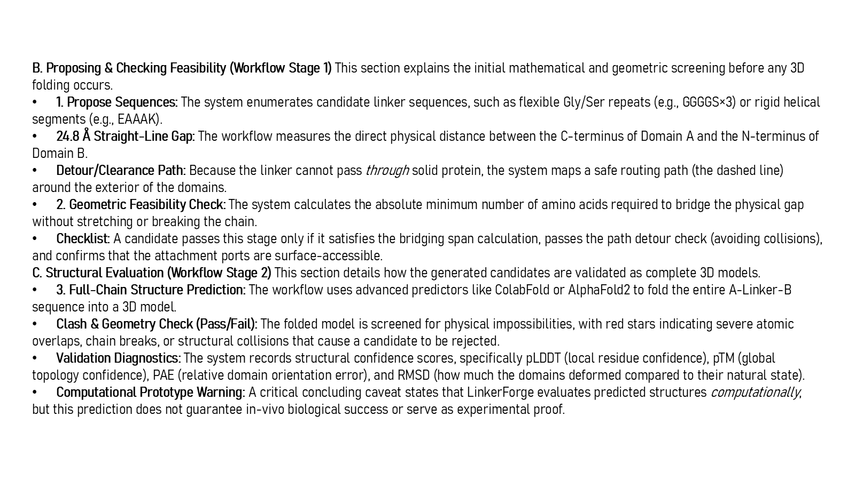
Revision 18 slide 16

Purpose and connection to the project
Explain the proposed feasibility logic, detour path, attachment-site accessibility, full-chain prediction and post-prediction structural checks. The 24.8 angstrom gap is an illustrative geometry, not a universal rule.
This foundation section translates sequence notation into physical protein design. The key reasoning step is to move from a one-dimensional amino-acid chain to domain boundaries, attachment points and a complete covalent fusion without assuming that sequence adjacency alone guarantees a viable structure.
Why this slide matters: It gives the audience enough molecular vocabulary to understand why linker length, composition, attachment geometry and domain context must be considered together.

Evidence and labels shown on the slide
The following visible elements carry the slide's scientific content. Their role and evidence level are explained in the presentation script below.
- B. Proposing & Checking Feasibility (Workflow Stage 1) This section explains the initial mathematical and geometric screening before any 3D folding occurs. 1. Propose Sequences: The system enumerates candidate linker sequences, such as flexible Gly/Ser repeats (e.g., GGGGS×3) or rigid helical segments (e.g., EAAAK). 24.8 Å Straight-Line Gap: The workflow...

Terms explained on this slide
AMINO ACID: An amino acid is one residue in a protein chain. Twenty canonical amino acids are used by the Version 1 generator vocabulary.
DOMAIN: A protein domain is a region expected to form a recognizable three-dimensional unit. Domain boundaries are structural or annotation claims, not simply changes in sequence composition.
LINKER: A linker is the peptide segment between joined domains. Its sequence and length can influence spacing, flexibility, orientation and exposure, but cannot guarantee function.
EAAAK: EAAAK repeats are used as helix-favouring spacers. The term rigid is relative: the peptide still fluctuates and its performance depends on the attached proteins.
APS: Average precision score summarizes the precision-recall curve and is useful for imbalanced labels. It depends on the dataset and cannot be compared across unrelated tasks as a universal score.
ALPHAFOLD2: AlphaFold2 predicts protein coordinates and confidence from sequence. Its confidence outputs describe the predictor, not LinkerForge accuracy or experimental function.
COLABFOLD: ColabFold is a workflow that accelerates AlphaFold-style prediction, including MMseqs2-based sequence searches. It is the prediction runner used for the matched structural panel.
PLDDT: pLDDT is AlphaFold local confidence for each residue on a 0 to 100 scale. It is not percent biological accuracy and does not establish domain orientation.

Detailed interpretation of the visual
The physical object or sequence segment establishes the interpretation or sequence segment, follow the N-to-C direction where shown, and distinguish structural evidence from explanatory illustration.
The object or dataset, comparison, axes, units, colours and layer dimensions define what the visual represents. The observed pattern is interpreted only within those definitions, preventing a prominent number or molecular rendering from being mistaken for broader biological proof.

Exact presentation script
This slide explains the proposed feasibility logic, detour path, attachment-site accessibility, full-chain prediction and post-prediction structural checks. The 24.8 angstrom gap is an illustrative geometry, not a universal rule.
This foundation section translates sequence notation into physical protein design. The key reasoning step is to move from a one-dimensional amino-acid chain to domain boundaries, attachment points and a complete covalent fusion without assuming that sequence adjacency alone guarantees a viable structure.
On this slide, the concrete evidence and labels shown are: B. Proposing & Checking Feasibility (Workflow Stage 1) This section explains the initial mathematical and geometric screening before any 3D folding occurs. 1. Propose Sequences: The system enumerates candidate linker sequences, such as flexible Gly/Ser repeats (e.g., GGGGS×3) or rigid helical segments (e.g., EAAAK). 24.8 Å Straight-Line Gap: The workflow. Together, these items establish exactly what was examined here, while retaining their individual evidence levels.
An amino acid is one residue in a protein chain. Twenty canonical amino acids are used by the Version 1 generator vocabulary. A protein domain is a region expected to form a recognizable three-dimensional unit. Domain boundaries are structural or annotation claims, not simply changes in sequence composition. A linker is the peptide segment between joined domains. Its sequence and length can influence spacing, flexibility, orientation and exposure, but cannot guarantee function.
The reason this result belongs in the project is that it gives the audience enough molecular vocabulary to understand why linker length, composition, attachment geometry and domain context must be considered together.
The conclusion from this slide is deliberately limited. Predicted structural feasibility does not guarantee in vivo success.

Likely examiner question
Question: What does slide 16 allow you to conclude?
Defensible answer: It supports the limited interpretation described above. The safe stopping point is: Predicted structural feasibility does not guarantee in vivo success.

Scientific claim boundary
Predicted structural feasibility does not guarantee in vivo success.
This boundary is part of the scientific interpretation, not a weakness to hide. State it clearly so the audience can distinguish what was measured from what would require prospective or experimental validation.

Slide 17 Biological data sources
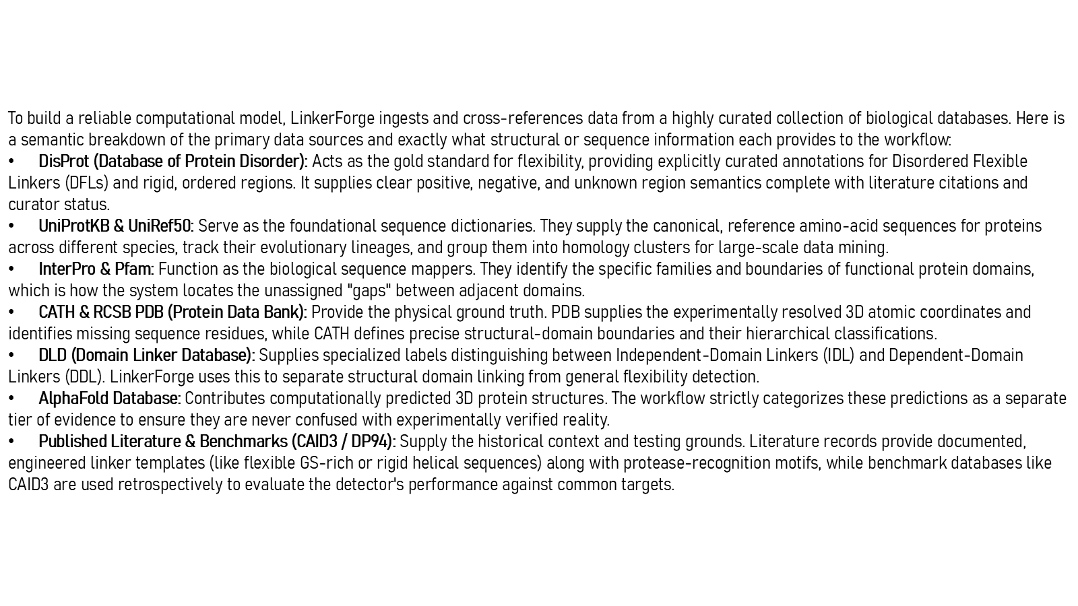
Revision 18 slide 17

Purpose and connection to the project
Explain what each database contributes and keep experimental structures, curated disorder, structural linker classes, predicted structures and literature templates as separate evidence tiers.
This foundation section translates sequence notation into physical protein design. The key reasoning step is to move from a one-dimensional amino-acid chain to domain boundaries, attachment points and a complete covalent fusion without assuming that sequence adjacency alone guarantees a viable structure.
Why this slide matters: It gives the audience enough molecular vocabulary to understand why linker length, composition, attachment geometry and domain context must be considered together.

Evidence and labels shown on the slide
The following visible elements carry the slide's scientific content. Their role and evidence level are explained in the presentation script below.
- To build a reliable computational model, LinkerForge ingests and cross-references data from a highly curated collection of biological databases. Here is a semantic breakdown of the primary data sources and exactly what structural or sequence information each provides to the workflow: DisProt (Database of Protein Disorder): Acts as the gold standard for fl...

Terms explained on this slide
DOMAIN: A protein domain is a region expected to form a recognizable three-dimensional unit. Domain boundaries are structural or annotation claims, not simply changes in sequence composition.
LINKER: A linker is the peptide segment between joined domains. Its sequence and length can influence spacing, flexibility, orientation and exposure, but cannot guarantee function.
DFL: DFL means disordered flexible linker. It is a residue-label concept used by the detector and is not synonymous with every domain gap.
IDL: IDL is an independent-domain-linker class in the DLD structural task. It must not be silently relabelled as DFL truth.
DDL: DDL is a dependent-domain-linker class in the DLD structural task. It describes a structural relationship, not a fusion-success outcome.
GS-RICH: GS-rich linkers contain many glycine and serine residues. Glycine permits backbone freedom and serine contributes polarity, but the label flexible is a design tendency rather than a guarantee.
APS: Average precision score summarizes the precision-recall curve and is useful for imbalanced labels. It depends on the dataset and cannot be compared across unrelated tasks as a universal score.
CAID3: CAID3 is a public disorder/linker benchmark. Once viewed, its labels and scores are retrospective and cannot be used to tune a supposedly untouched model.

Detailed interpretation of the visual
The physical object or sequence segment establishes the interpretation or sequence segment, follow the N-to-C direction where shown, and distinguish structural evidence from explanatory illustration.
The object or dataset, comparison, axes, units, colours and layer dimensions define what the visual represents. The observed pattern is interpreted only within those definitions, preventing a prominent number or molecular rendering from being mistaken for broader biological proof.

Exact presentation script
This slide explains what each database contributes and keep experimental structures, curated disorder, structural linker classes, predicted structures and literature templates as separate evidence tiers.
This foundation section translates sequence notation into physical protein design. The key reasoning step is to move from a one-dimensional amino-acid chain to domain boundaries, attachment points and a complete covalent fusion without assuming that sequence adjacency alone guarantees a viable structure.
On this slide, the concrete evidence and labels shown are: To build a reliable computational model, LinkerForge ingests and cross-references data from a highly curated collection of biological databases. Here is a semantic breakdown of the primary data sources and exactly what structural or sequence information each provides to the workflow: DisProt (Database of Protein Disorder): Acts as the gold standard for fl. Together, these items establish exactly what was examined here, while retaining their individual evidence levels.
A protein domain is a region expected to form a recognizable three-dimensional unit. Domain boundaries are structural or annotation claims, not simply changes in sequence composition. A linker is the peptide segment between joined domains. Its sequence and length can influence spacing, flexibility, orientation and exposure, but cannot guarantee function. DFL means disordered flexible linker. It is a residue-label concept used by the detector and is not synonymous with every domain gap.
The reason this result belongs in the project is that it gives the audience enough molecular vocabulary to understand why linker length, composition, attachment geometry and domain context must be considered together.
The conclusion from this slide is deliberately limited. Predicted and experimental structures must remain different evidence tiers.

Likely examiner question
Question: What does slide 17 allow you to conclude?
Defensible answer: It supports the limited interpretation described above. The safe stopping point is: Predicted and experimental structures must remain different evidence tiers.

Scientific claim boundary
Predicted and experimental structures must remain different evidence tiers.
This boundary is part of the scientific interpretation, not a weakness to hide. State it clearly so the audience can distinguish what was measured from what would require prospective or experimental validation.

Slide 18 From source records to residue labels
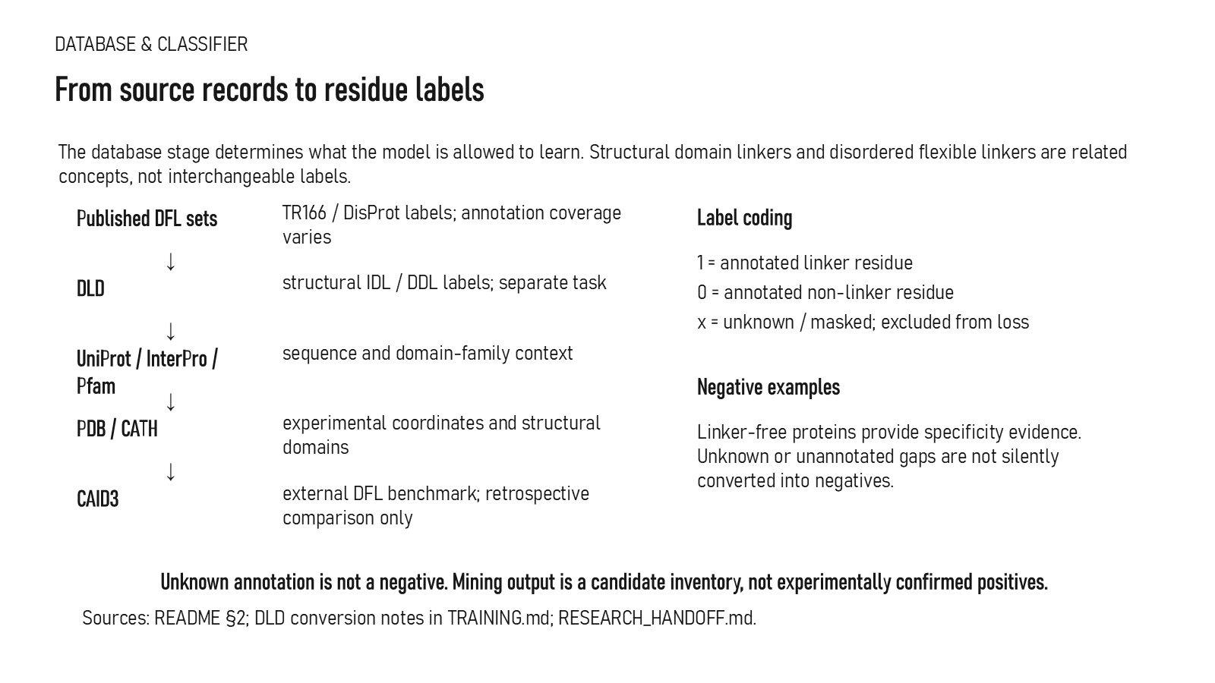
Revision 18 slide 18

Purpose and connection to the project
Show how sources become residue labels. Positive, explicit negative and unknown masks must remain distinct; DLD structural classes cannot silently become DFL labels.
This data section explains how source records become eligible labels. The important distinction is between discovery, review and training: a mined interval may be useful for prioritisation while remaining ineligible as biological truth until its coordinates, evidence and family relationship are resolved.
Why this slide matters: It protects the model from learning mislabeled tails, internal loops, duplicated families or model-generated candidates presented as ground truth.

Evidence and labels shown on the slide
The following visible elements carry the slide's scientific content. Their role and evidence level are explained in the presentation script below.
- DATABASE & CLASSIFIER
- The database stage determines what the model is allowed to learn. Structural domain linkers and disordered flexible linkers are related concepts, not interchangeable labels.
- Published DFL sets
- TR166 / DisProt labels; annotation coverage varies
- structural IDL / DDL labels; separate task
- UniProt / InterPro / Pfam
- sequence and domain-family context

Terms explained on this slide
DOMAIN: A protein domain is a region expected to form a recognizable three-dimensional unit. Domain boundaries are structural or annotation claims, not simply changes in sequence composition.
LINKER: A linker is the peptide segment between joined domains. Its sequence and length can influence spacing, flexibility, orientation and exposure, but cannot guarantee function.
DFL: DFL means disordered flexible linker. It is a residue-label concept used by the detector and is not synonymous with every domain gap.
IDL: IDL is an independent-domain-linker class in the DLD structural task. It must not be silently relabelled as DFL truth.
DDL: DDL is a dependent-domain-linker class in the DLD structural task. It describes a structural relationship, not a fusion-success outcome.
APS: Average precision score summarizes the precision-recall curve and is useful for imbalanced labels. It depends on the dataset and cannot be compared across unrelated tasks as a universal score.
CAID3: CAID3 is a public disorder/linker benchmark. Once viewed, its labels and scores are retrospective and cannot be used to tune a supposedly untouched model.

Detailed interpretation of the visual
The pipeline runs from source identifier to coordinate mapping and finally to residue labels. Pay particular attention to the separate encodings for positive, explicit negative, unknown and padding positions.
The object or dataset, comparison, axes, units, colours and layer dimensions define what the visual represents. The observed pattern is interpreted only within those definitions, preventing a prominent number or molecular rendering from being mistaken for broader biological proof.

Exact presentation script
This slide shows how sources become residue labels. Positive, explicit negative and unknown masks must remain distinct; DLD structural classes cannot silently become DFL labels.
This data section explains how source records become eligible labels. The important distinction is between discovery, review and training: a mined interval may be useful for prioritisation while remaining ineligible as biological truth until its coordinates, evidence and family relationship are resolved.
On this slide, the concrete evidence and labels shown are: DATABASE & CLASSIFIER; The database stage determines what the model is allowed to learn. Structural domain linkers and disordered flexible linkers are related concepts, not interchangeable labels; Published DFL sets; TR166 / DisProt labels; annotation coverage varies; and structural IDL / DDL labels; separate task. Together, these items establish exactly what was examined here, while retaining their individual evidence levels.
A protein domain is a region expected to form a recognizable three-dimensional unit. Domain boundaries are structural or annotation claims, not simply changes in sequence composition. A linker is the peptide segment between joined domains. Its sequence and length can influence spacing, flexibility, orientation and exposure, but cannot guarantee function. DFL means disordered flexible linker. It is a residue-label concept used by the detector and is not synonymous with every domain gap.
The reason this result belongs in the project is that it protects the model from learning mislabeled tails, internal loops, duplicated families or model-generated candidates presented as ground truth.
The conclusion from this slide is deliberately limited. Unknown residues cannot be relabelled negative.

Likely examiner question
Question: What does slide 18 allow you to conclude?
Defensible answer: It supports the limited interpretation described above. The safe stopping point is: Unknown residues cannot be relabelled negative.

Scientific claim boundary
Unknown residues cannot be relabelled negative.
This boundary is part of the scientific interpretation, not a weakness to hide. State it clearly so the audience can distinguish what was measured from what would require prospective or experimental validation.

Slide 19 Mining candidates and creating evidence
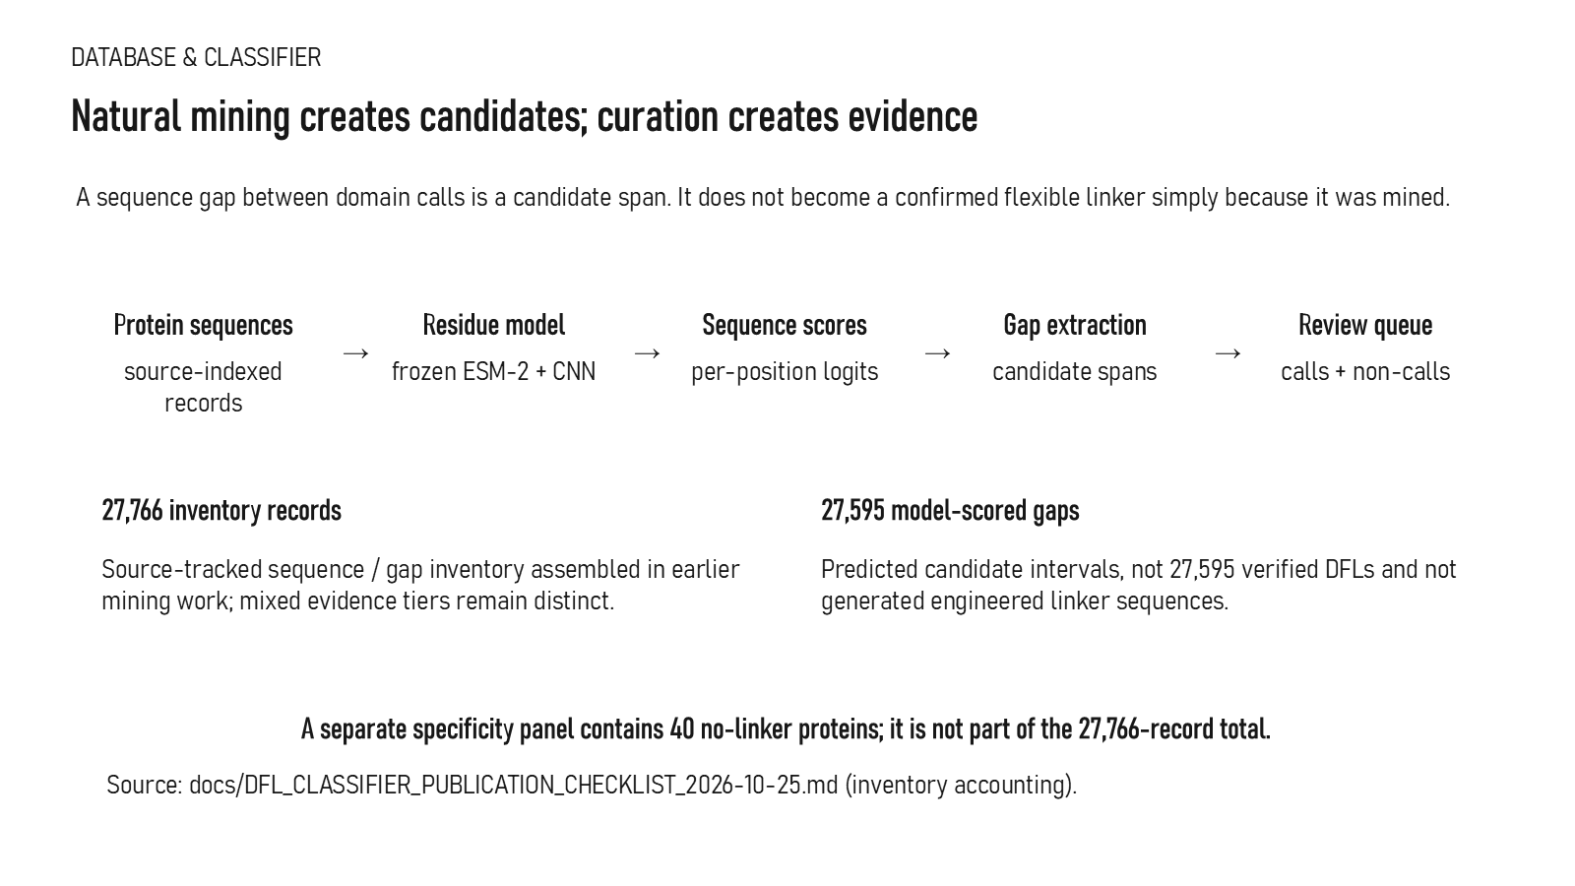
Revision 18 slide 19

Purpose and connection to the project
Mining produces candidate intervals and a review queue. The 27,595 model-scored gaps are not verified linkers and are not generated fusion sequences.
This data section explains how source records become eligible labels. The important distinction is between discovery, review and training: a mined interval may be useful for prioritisation while remaining ineligible as biological truth until its coordinates, evidence and family relationship are resolved.
Why this slide matters: It protects the model from learning mislabeled tails, internal loops, duplicated families or model-generated candidates presented as ground truth.

Evidence and labels shown on the slide
The following visible elements carry the slide's scientific content. Their role and evidence level are explained in the presentation script below.
- DATABASE & CLASSIFIER
- Natural mining creates candidates; curation creates evidence
- A sequence gap between domain calls is a candidate span. It does not become a confirmed flexible linker simply because it was mined.
- Protein sequences
- source-indexed records
- Residue model
- frozen ESM-2 + CNN

Terms explained on this slide
DOMAIN: A protein domain is a region expected to form a recognizable three-dimensional unit. Domain boundaries are structural or annotation claims, not simply changes in sequence composition.
LINKER: A linker is the peptide segment between joined domains. Its sequence and length can influence spacing, flexibility, orientation and exposure, but cannot guarantee function.
DFL: DFL means disordered flexible linker. It is a residue-label concept used by the detector and is not synonymous with every domain gap.
CURATION: Curation is a documented human review process that resolves coordinates, labels, evidence quality and eligibility. Preparing a review packet is not the same as completing adjudication.
ESM-2: ESM-2 is a protein language model. LinkerForge uses frozen per-residue embeddings from the 35-million-parameter t12 variant as detector features.
LOGIT: A logit is an unconstrained model output. A sigmoid maps it to a score between zero and one, but calibration must be demonstrated before treating that score as a probability.
APS: Average precision score summarizes the precision-recall curve and is useful for imbalanced labels. It depends on the dataset and cannot be compared across unrelated tasks as a universal score.

Detailed interpretation of the visual
Read from source record to coordinate rule, exclusion decision, label and final eligibility. Counts should be interpreted by evidence tier rather than as one homogeneous dataset.
The object or dataset, comparison, axes, units, colours and layer dimensions define what the visual represents. The observed pattern is interpreted only within those definitions, preventing a prominent number or molecular rendering from being mistaken for broader biological proof.

Exact presentation script
This slide shows that mining produces candidate intervals and a review queue. The 27,595 model-scored gaps are not verified linkers and are not generated fusion sequences.
This data section explains how source records become eligible labels. The important distinction is between discovery, review and training: a mined interval may be useful for prioritisation while remaining ineligible as biological truth until its coordinates, evidence and family relationship are resolved.
On this slide, the concrete evidence and labels shown are: DATABASE & CLASSIFIER; Natural mining creates candidates; curation creates evidence; A sequence gap between domain calls is a candidate span. It does not become a confirmed flexible linker simply because it was mined; Protein sequences; and source-indexed records. Together, these items establish exactly what was examined here, while retaining their individual evidence levels.
A protein domain is a region expected to form a recognizable three-dimensional unit. Domain boundaries are structural or annotation claims, not simply changes in sequence composition. A linker is the peptide segment between joined domains. Its sequence and length can influence spacing, flexibility, orientation and exposure, but cannot guarantee function. DFL means disordered flexible linker. It is a residue-label concept used by the detector and is not synonymous with every domain gap.
The reason this result belongs in the project is that it protects the model from learning mislabeled tails, internal loops, duplicated families or model-generated candidates presented as ground truth.
The conclusion from this slide is deliberately limited. Model-scored gaps are not verified DFLs.

Likely examiner question
Question: What does slide 19 allow you to conclude?
Defensible answer: It supports the limited interpretation described above. The safe stopping point is: Model-scored gaps are not verified DFLs.

Scientific claim boundary
Model-scored gaps are not verified DFLs.
This boundary is part of the scientific interpretation, not a weakness to hide. State it clearly so the audience can distinguish what was measured from what would require prospective or experimental validation.

Slide 20 Source acquisition and mining filters
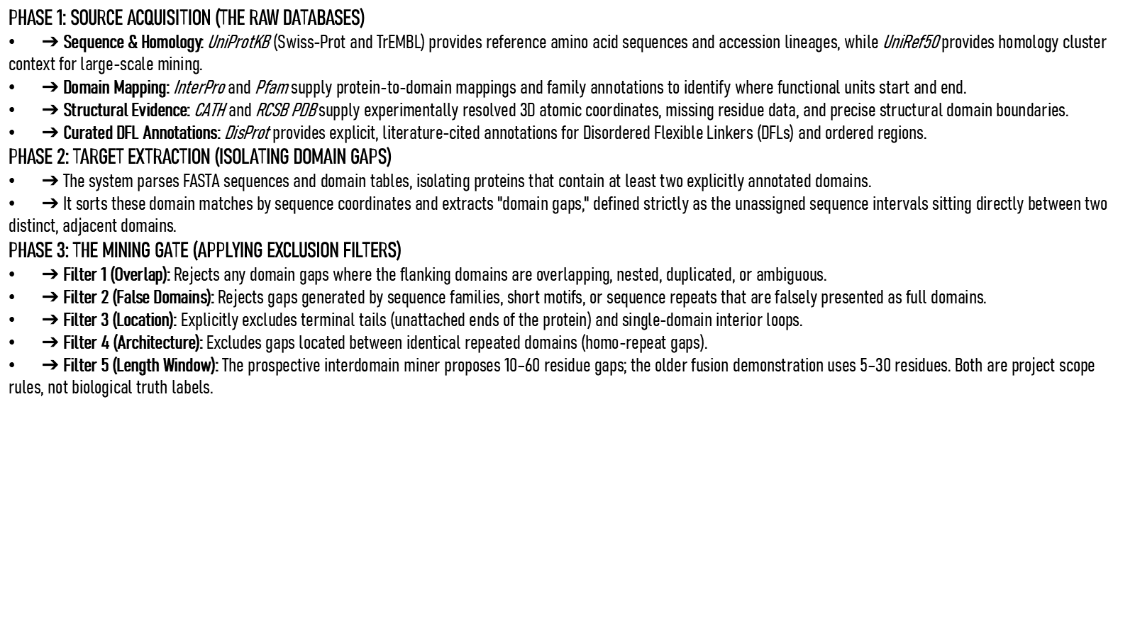
Revision 18 slide 20

Purpose and connection to the project
Explain source acquisition, domain-gap extraction and the five exclusion filters. The mining and fusion-design length windows are project rules rather than biological laws.
This data section explains how source records become eligible labels. The important distinction is between discovery, review and training: a mined interval may be useful for prioritisation while remaining ineligible as biological truth until its coordinates, evidence and family relationship are resolved.
Why this slide matters: It protects the model from learning mislabeled tails, internal loops, duplicated families or model-generated candidates presented as ground truth.

Evidence and labels shown on the slide
The following visible elements carry the slide's scientific content. Their role and evidence level are explained in the presentation script below.
- PHASE 1: SOURCE ACQUISITION (THE RAW DATABASES) ➔ Sequence & Homology: UniProtKB (Swiss-Prot and TrEMBL) provides reference amino acid sequences and accession lineages, while UniRef50 provides homology cluster context for large-scale mining. ➔ Domain Mapping: InterPro and Pfam supply protein-to-domain mappings and family annotations to identify where func...

Terms explained on this slide
AMINO ACID: An amino acid is one residue in a protein chain. Twenty canonical amino acids are used by the Version 1 generator vocabulary.
DOMAIN: A protein domain is a region expected to form a recognizable three-dimensional unit. Domain boundaries are structural or annotation claims, not simply changes in sequence composition.
LINKER: A linker is the peptide segment between joined domains. Its sequence and length can influence spacing, flexibility, orientation and exposure, but cannot guarantee function.
DFL: DFL means disordered flexible linker. It is a residue-label concept used by the detector and is not synonymous with every domain gap.
APS: Average precision score summarizes the precision-recall curve and is useful for imbalanced labels. It depends on the dataset and cannot be compared across unrelated tasks as a universal score.

Detailed interpretation of the visual
The acquisition section presents sources first, then the gap-construction rule, and finally the exclusion filters. The order matters because filtering cannot repair an incorrectly mapped coordinate system.
The object or dataset, comparison, axes, units, colours and layer dimensions define what the visual represents. The observed pattern is interpreted only within those definitions, preventing a prominent number or molecular rendering from being mistaken for broader biological proof.

Exact presentation script
This slide explains source acquisition, domain-gap extraction and the five exclusion filters. The mining and fusion-design length windows are project rules rather than biological laws.
This data section explains how source records become eligible labels. The important distinction is between discovery, review and training: a mined interval may be useful for prioritisation while remaining ineligible as biological truth until its coordinates, evidence and family relationship are resolved.
On this slide, the concrete evidence and labels shown are: PHASE 1: SOURCE ACQUISITION (THE RAW DATABASES) ➔ Sequence & Homology: UniProtKB (Swiss-Prot and TrEMBL) provides reference amino acid sequences and accession lineages, while UniRef50 provides homology cluster context for large-scale mining. ➔ Domain Mapping: InterPro and Pfam supply protein-to-domain mappings and family annotations to identify where func. Together, these items establish exactly what was examined here, while retaining their individual evidence levels.
An amino acid is one residue in a protein chain. Twenty canonical amino acids are used by the Version 1 generator vocabulary. A protein domain is a region expected to form a recognizable three-dimensional unit. Domain boundaries are structural or annotation claims, not simply changes in sequence composition. A linker is the peptide segment between joined domains. Its sequence and length can influence spacing, flexibility, orientation and exposure, but cannot guarantee function.
The reason this result belongs in the project is that it protects the model from learning mislabeled tails, internal loops, duplicated families or model-generated candidates presented as ground truth.
The conclusion from this slide is deliberately limited. Length filters and mining rules are project scope choices.

Likely examiner question
Question: What does slide 20 allow you to conclude?
Defensible answer: It supports the limited interpretation described above. The safe stopping point is: Length filters and mining rules are project scope choices.

Scientific claim boundary
Length filters and mining rules are project scope choices.
This boundary is part of the scientific interpretation, not a weakness to hide. State it clearly so the audience can distinguish what was measured from what would require prospective or experimental validation.

Slide 21 Length windows and their meaning
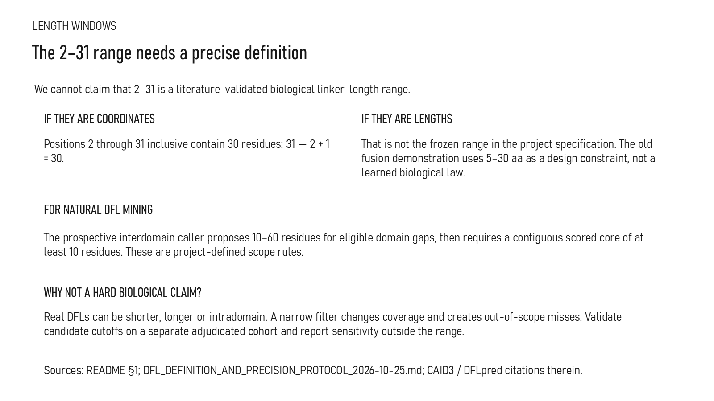
Revision 18 slide 21

Purpose and connection to the project
Clarify the ambiguous 2-31 notation. Coordinates 2 through 31 contain 30 residues, while the project uses 5-30 for an older design constraint and 10-60 for prospective gap mining.
This data section explains how source records become eligible labels. The important distinction is between discovery, review and training: a mined interval may be useful for prioritisation while remaining ineligible as biological truth until its coordinates, evidence and family relationship are resolved.
Why this slide matters: It protects the model from learning mislabeled tails, internal loops, duplicated families or model-generated candidates presented as ground truth.

Evidence and labels shown on the slide
The following visible elements carry the slide's scientific content. Their role and evidence level are explained in the presentation script below.
- LENGTH WINDOWS
- The 2–31 range needs a precise definition
- We cannot claim that 2–31 is a literature-validated biological linker-length range.
- IF THEY ARE COORDINATES
- Positions 2 through 31 inclusive contain 30 residues: 31 − 2 + 1 = 30.
- IF THEY ARE LENGTHS
- That is not the frozen range in the project specification. The old fusion demonstration uses 5–30 aa as a design constraint, not a learned biological law.

Terms explained on this slide
DOMAIN: A protein domain is a region expected to form a recognizable three-dimensional unit. Domain boundaries are structural or annotation claims, not simply changes in sequence composition.
LINKER: A linker is the peptide segment between joined domains. Its sequence and length can influence spacing, flexibility, orientation and exposure, but cannot guarantee function.
DFL: DFL means disordered flexible linker. It is a residue-label concept used by the detector and is not synonymous with every domain gap.
PRECISION: Precision is TP divided by TP plus FP: among predicted positives, the fraction that is correct.
APS: Average precision score summarizes the precision-recall curve and is useful for imbalanced labels. It depends on the dataset and cannot be compared across unrelated tasks as a universal score.
CAID3: CAID3 is a public disorder/linker benchmark. Once viewed, its labels and scores are retrospective and cannot be used to tune a supposedly untouched model.

Detailed interpretation of the visual
Read from source record to coordinate rule, exclusion decision, label and final eligibility. Counts should be interpreted by evidence tier rather than as one homogeneous dataset.
The object or dataset, comparison, axes, units, colours and layer dimensions define what the visual represents. The observed pattern is interpreted only within those definitions, preventing a prominent number or molecular rendering from being mistaken for broader biological proof.

Exact presentation script
This slide clarifies the ambiguous 2-31 notation. Coordinates 2 through 31 contain 30 residues, while the project uses 5-30 for an older design constraint and 10-60 for prospective gap mining.
This data section explains how source records become eligible labels. The important distinction is between discovery, review and training: a mined interval may be useful for prioritisation while remaining ineligible as biological truth until its coordinates, evidence and family relationship are resolved.
On this slide, the concrete evidence and labels shown are: LENGTH WINDOWS; The 2–31 range needs a precise definition; We cannot claim that 2–31 is a literature-validated biological linker-length range; IF THEY ARE COORDINATES; and Positions 2 through 31 inclusive contain 30 residues: 31 − 2 + 1 = 30. Together, these items establish exactly what was examined here, while retaining their individual evidence levels.
A protein domain is a region expected to form a recognizable three-dimensional unit. Domain boundaries are structural or annotation claims, not simply changes in sequence composition. A linker is the peptide segment between joined domains. Its sequence and length can influence spacing, flexibility, orientation and exposure, but cannot guarantee function. DFL means disordered flexible linker. It is a residue-label concept used by the detector and is not synonymous with every domain gap.
The reason this result belongs in the project is that it protects the model from learning mislabeled tails, internal loops, duplicated families or model-generated candidates presented as ground truth.
The conclusion from this slide is deliberately limited. The 2-to-31 coordinate example is not being presented as a validated universal biological linker-length range.

Likely examiner question
Question: Why are several length ranges shown?
Defensible answer: They belong to different project operations: older design constraints, mining windows and coordinate examples. None is claimed as a universal biological range.

Scientific claim boundary
Do not call 2-31 a validated biological length range.
This boundary is part of the scientific interpretation, not a weakness to hide. State it clearly so the audience can distinguish what was measured from what would require prospective or experimental validation.

Slide 22 Structurally overlapping domains
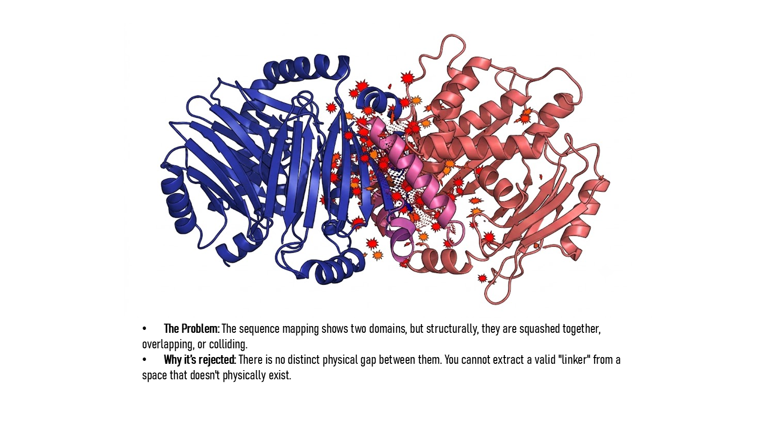
Revision 18 slide 22

Purpose and connection to the project
Use the collision image to explain why sequence adjacency alone is insufficient. Domains that overlap in three dimensions do not define a usable physical linker gap.
This data section explains how source records become eligible labels. The important distinction is between discovery, review and training: a mined interval may be useful for prioritisation while remaining ineligible as biological truth until its coordinates, evidence and family relationship are resolved.
Why this slide matters: It protects the model from learning mislabeled tails, internal loops, duplicated families or model-generated candidates presented as ground truth.

Evidence and labels shown on the slide
The following visible elements carry the slide's scientific content. Their role and evidence level are explained in the presentation script below.
- The Problem: The sequence mapping shows two domains, but structurally, they are squashed together, overlapping, or colliding. Why it’s rejected: There is no distinct physical gap between them. You cannot extract a valid "linker" from a space that doesn't physically exist.

Terms explained on this slide
DOMAIN: A protein domain is a region expected to form a recognizable three-dimensional unit. Domain boundaries are structural or annotation claims, not simply changes in sequence composition.
LINKER: A linker is the peptide segment between joined domains. Its sequence and length can influence spacing, flexibility, orientation and exposure, but cannot guarantee function.

Detailed interpretation of the visual
Read from source record to coordinate rule, exclusion decision, label and final eligibility. Counts should be interpreted by evidence tier rather than as one homogeneous dataset.
The object or dataset, comparison, axes, units, colours and layer dimensions define what the visual represents. The observed pattern is interpreted only within those definitions, preventing a prominent number or molecular rendering from being mistaken for broader biological proof.

Exact presentation script
This slide uses the collision image to explain why sequence adjacency alone is insufficient. Domains that overlap in three dimensions do not define a usable physical linker gap.
This data section explains how source records become eligible labels. The important distinction is between discovery, review and training: a mined interval may be useful for prioritisation while remaining ineligible as biological truth until its coordinates, evidence and family relationship are resolved.
On this slide, the concrete evidence and labels shown are: The Problem: The sequence mapping shows two domains, but structurally, they are squashed together, overlapping, or colliding. Why it’s rejected: There is no distinct physical gap between them. You cannot extract a valid "linker" from a space that doesn't physically exist. Together, these items establish exactly what was examined here, while retaining their individual evidence levels.
A protein domain is a region expected to form a recognizable three-dimensional unit. Domain boundaries are structural or annotation claims, not simply changes in sequence composition. A linker is the peptide segment between joined domains. Its sequence and length can influence spacing, flexibility, orientation and exposure, but cannot guarantee function.
The reason this result belongs in the project is that it protects the model from learning mislabeled tails, internal loops, duplicated families or model-generated candidates presented as ground truth.
The conclusion from this slide is deliberately limited. A sequence gap without physical clearance is not automatically usable.

Likely examiner question
Question: What does slide 22 allow you to conclude?
Defensible answer: It supports the limited interpretation described above. The safe stopping point is: A sequence gap without physical clearance is not automatically usable.

Scientific claim boundary
A sequence gap without physical clearance is not automatically usable.
This boundary is part of the scientific interpretation, not a weakness to hide. State it clearly so the audience can distinguish what was measured from what would require prospective or experimental validation.

Slide 23 Building the linker evidence base
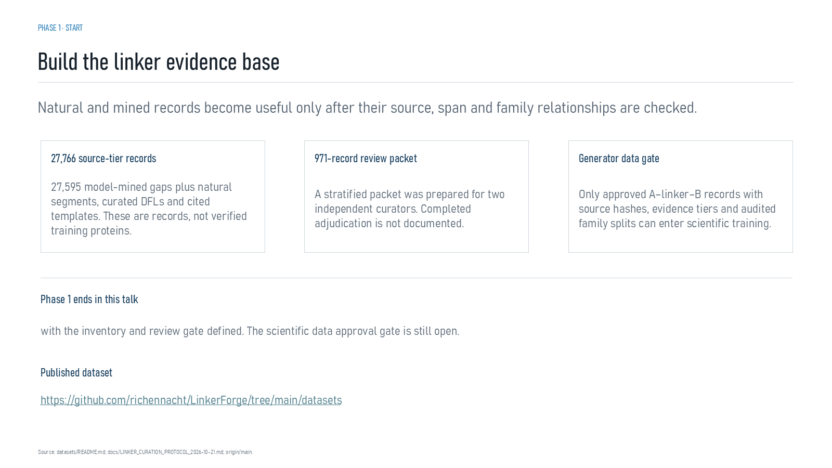
Revision 18 slide 23

Purpose and connection to the project
Summarise the Phase 1 deliverables and open gate: 27,766 records, a prepared 971-record packet and no approved generator training set.
This data section explains how source records become eligible labels. The important distinction is between discovery, review and training: a mined interval may be useful for prioritisation while remaining ineligible as biological truth until its coordinates, evidence and family relationship are resolved.
Why this slide matters: It protects the model from learning mislabeled tails, internal loops, duplicated families or model-generated candidates presented as ground truth.

Evidence and labels shown on the slide
The following visible elements carry the slide's scientific content. Their role and evidence level are explained in the presentation script below.
- PHASE 1 · START
- Build the linker evidence base
- Natural and mined records become useful only after their source, span and family relationships are checked.
- 27,766 source-tier records
- 27,595 model-mined gaps plus natural segments, curated DFLs and cited templates. These are records, not verified training proteins.
- 971-record review packet
- A stratified packet was prepared for two independent curators. Completed adjudication is not documented.

Terms explained on this slide
LINKER: A linker is the peptide segment between joined domains. Its sequence and length can influence spacing, flexibility, orientation and exposure, but cannot guarantee function.
DFL: DFL means disordered flexible linker. It is a residue-label concept used by the detector and is not synonymous with every domain gap.
CURATION: Curation is a documented human review process that resolves coordinates, labels, evidence quality and eligibility. Preparing a review packet is not the same as completing adjudication.
APS: Average precision score summarizes the precision-recall curve and is useful for imbalanced labels. It depends on the dataset and cannot be compared across unrelated tasks as a universal score.

Detailed interpretation of the visual
Read from source record to coordinate rule, exclusion decision, label and final eligibility. Counts should be interpreted by evidence tier rather than as one homogeneous dataset.
The object or dataset, comparison, axes, units, colours and layer dimensions define what the visual represents. The observed pattern is interpreted only within those definitions, preventing a prominent number or molecular rendering from being mistaken for broader biological proof.

Exact presentation script
This slide summarises the Phase 1 deliverables and open gate: 27,766 records, a prepared 971-record packet and no approved generator training set.
This data section explains how source records become eligible labels. The important distinction is between discovery, review and training: a mined interval may be useful for prioritisation while remaining ineligible as biological truth until its coordinates, evidence and family relationship are resolved.
On this slide, the concrete evidence and labels shown are: PHASE 1 · START; Build the linker evidence base; Natural and mined records become useful only after their source, span and family relationships are checked; 27,766 source-tier records; and 27,595 model-mined gaps plus natural segments, curated DFLs and cited templates. These are records, not verified training proteins. Together, these items establish exactly what was examined here, while retaining their individual evidence levels.
A linker is the peptide segment between joined domains. Its sequence and length can influence spacing, flexibility, orientation and exposure, but cannot guarantee function. DFL means disordered flexible linker. It is a residue-label concept used by the detector and is not synonymous with every domain gap. Curation is a documented human review process that resolves coordinates, labels, evidence quality and eligibility. Preparing a review packet is not the same as completing adjudication.
The reason this result belongs in the project is that it protects the model from learning mislabeled tails, internal loops, duplicated families or model-generated candidates presented as ground truth.
The conclusion from this slide is deliberately limited. The Phase 1 scientific data approval gate remains open.

Likely examiner question
Question: What does slide 23 allow you to conclude?
Defensible answer: It supports the limited interpretation described above. The safe stopping point is: The Phase 1 scientific data approval gate remains open.

Scientific claim boundary
The Phase 1 scientific data approval gate remains open.
This boundary is part of the scientific interpretation, not a weakness to hide. State it clearly so the audience can distinguish what was measured from what would require prospective or experimental validation.

Slide 24 Candidate entry into the inventory
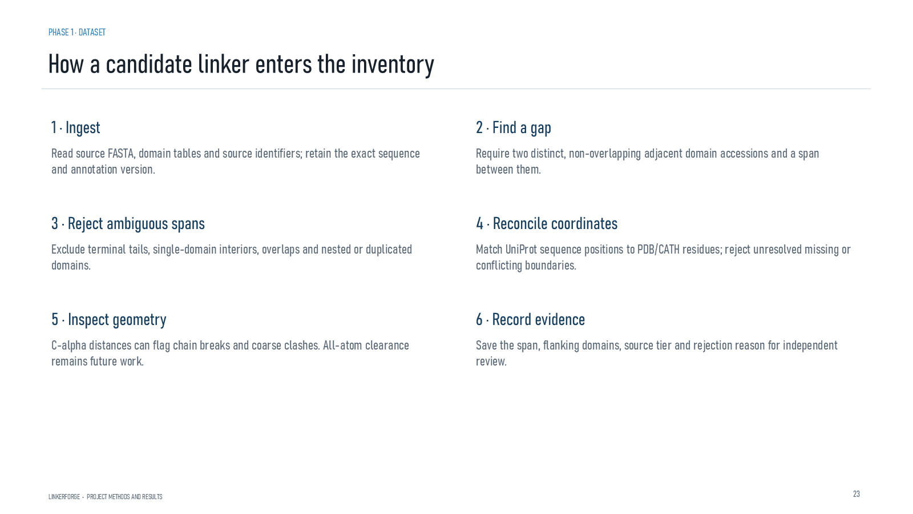
Revision 18 slide 24

Purpose and connection to the project
Explain ingest, gap detection, ambiguity rejection, coordinate reconciliation, geometry inspection and evidence recording as the inventory entry process.
This data section explains how source records become eligible labels. The important distinction is between discovery, review and training: a mined interval may be useful for prioritisation while remaining ineligible as biological truth until its coordinates, evidence and family relationship are resolved.
Why this slide matters: It protects the model from learning mislabeled tails, internal loops, duplicated families or model-generated candidates presented as ground truth.

Evidence and labels shown on the slide
The following visible elements carry the slide's scientific content. Their role and evidence level are explained in the presentation script below.
- PHASE 1 · DATASET
- How a candidate linker enters the inventory
- LINKERFORGE • PROJECT METHODS AND RESULTS
- Read source FASTA, domain tables and source identifiers; retain the exact sequence and annotation version.
- 2 · Find a gap
- Require two distinct, non-overlapping adjacent domain accessions and a span between them.
- 3 · Reject ambiguous spans

Terms explained on this slide
DOMAIN: A protein domain is a region expected to form a recognizable three-dimensional unit. Domain boundaries are structural or annotation claims, not simply changes in sequence composition.
LINKER: A linker is the peptide segment between joined domains. Its sequence and length can influence spacing, flexibility, orientation and exposure, but cannot guarantee function.
APS: Average precision score summarizes the precision-recall curve and is useful for imbalanced labels. It depends on the dataset and cannot be compared across unrelated tasks as a universal score.

Detailed interpretation of the visual
Read from source record to coordinate rule, exclusion decision, label and final eligibility. Counts should be interpreted by evidence tier rather than as one homogeneous dataset.
The object or dataset, comparison, axes, units, colours and layer dimensions define what the visual represents. The observed pattern is interpreted only within those definitions, preventing a prominent number or molecular rendering from being mistaken for broader biological proof.

Exact presentation script
This slide explains ingest, gap detection, ambiguity rejection, coordinate reconciliation, geometry inspection and evidence recording as the inventory entry process.
This data section explains how source records become eligible labels. The important distinction is between discovery, review and training: a mined interval may be useful for prioritisation while remaining ineligible as biological truth until its coordinates, evidence and family relationship are resolved.
On this slide, the concrete evidence and labels shown are: PHASE 1 · DATASET; How a candidate linker enters the inventory; LINKERFORGE • PROJECT METHODS AND RESULTS; Read source FASTA, domain tables and source identifiers; retain the exact sequence and annotation version; and 2 · Find a gap. Together, these items establish exactly what was examined here, while retaining their individual evidence levels.
A protein domain is a region expected to form a recognizable three-dimensional unit. Domain boundaries are structural or annotation claims, not simply changes in sequence composition. A linker is the peptide segment between joined domains. Its sequence and length can influence spacing, flexibility, orientation and exposure, but cannot guarantee function. Average precision score summarizes the precision-recall curve and is useful for imbalanced labels. It depends on the dataset and cannot be compared across unrelated tasks as a universal score.
The reason this result belongs in the project is that it protects the model from learning mislabeled tails, internal loops, duplicated families or model-generated candidates presented as ground truth.
The conclusion from this slide is deliberately limited. A recorded candidate is not automatically an eligible positive label.

Likely examiner question
Question: What does slide 24 allow you to conclude?
Defensible answer: It supports the limited interpretation described above. The safe stopping point is: A recorded candidate is not automatically an eligible positive label.

Scientific claim boundary
A recorded candidate is not automatically an eligible positive label.
This boundary is part of the scientific interpretation, not a weakness to hide. State it clearly so the audience can distinguish what was measured from what would require prospective or experimental validation.

Slide 25 Terminal tail exclusion
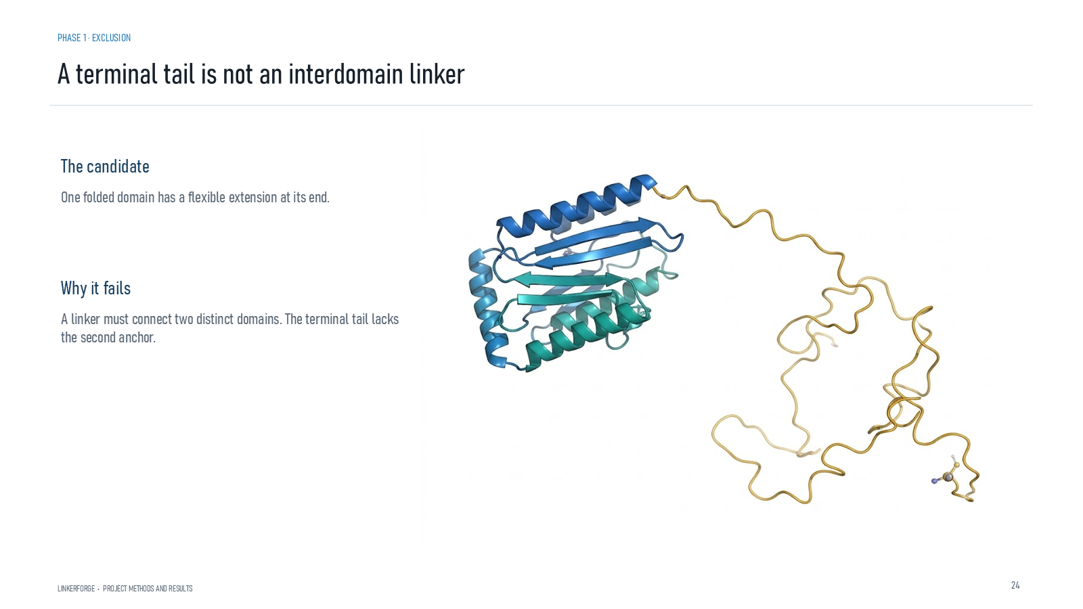
Revision 18 slide 25

Purpose and connection to the project
A terminal tail has only one domain anchor. Flexibility alone does not make it an interdomain linker.
This data section explains how source records become eligible labels. The important distinction is between discovery, review and training: a mined interval may be useful for prioritisation while remaining ineligible as biological truth until its coordinates, evidence and family relationship are resolved.
Why this slide matters: It protects the model from learning mislabeled tails, internal loops, duplicated families or model-generated candidates presented as ground truth.

Evidence and labels shown on the slide
The following visible elements carry the slide's scientific content. Their role and evidence level are explained in the presentation script below.
- PHASE 1 · EXCLUSION
- A terminal tail is not an interdomain linker
- LINKERFORGE • PROJECT METHODS AND RESULTS
- The candidate
- One folded domain has a flexible extension at its end.
- Why it fails
- A linker must connect two distinct domains. The terminal tail lacks the second anchor.

Terms explained on this slide
DOMAIN: A protein domain is a region expected to form a recognizable three-dimensional unit. Domain boundaries are structural or annotation claims, not simply changes in sequence composition.
LINKER: A linker is the peptide segment between joined domains. Its sequence and length can influence spacing, flexibility, orientation and exposure, but cannot guarantee function.

Detailed interpretation of the visual
Read from source record to coordinate rule, exclusion decision, label and final eligibility. Counts should be interpreted by evidence tier rather than as one homogeneous dataset.
The object or dataset, comparison, axes, units, colours and layer dimensions define what the visual represents. The observed pattern is interpreted only within those definitions, preventing a prominent number or molecular rendering from being mistaken for broader biological proof.

Exact presentation script
This slide shows that a terminal tail has only one domain anchor. Flexibility alone does not make it an interdomain linker.
This data section explains how source records become eligible labels. The important distinction is between discovery, review and training: a mined interval may be useful for prioritisation while remaining ineligible as biological truth until its coordinates, evidence and family relationship are resolved.
On this slide, the concrete evidence and labels shown are: PHASE 1 · EXCLUSION; A terminal tail is not an interdomain linker; LINKERFORGE • PROJECT METHODS AND RESULTS; The candidate; and One folded domain has a flexible extension at its end. Together, these items establish exactly what was examined here, while retaining their individual evidence levels.
A protein domain is a region expected to form a recognizable three-dimensional unit. Domain boundaries are structural or annotation claims, not simply changes in sequence composition. A linker is the peptide segment between joined domains. Its sequence and length can influence spacing, flexibility, orientation and exposure, but cannot guarantee function.
The reason this result belongs in the project is that it protects the model from learning mislabeled tails, internal loops, duplicated families or model-generated candidates presented as ground truth.
The conclusion from this slide is deliberately limited. A terminal tail lacks the second domain anchor.

Likely examiner question
Question: What does slide 25 allow you to conclude?
Defensible answer: It supports the limited interpretation described above. The safe stopping point is: A terminal tail lacks the second domain anchor.

Scientific claim boundary
A terminal tail lacks the second domain anchor.
This boundary is part of the scientific interpretation, not a weakness to hide. State it clearly so the audience can distinguish what was measured from what would require prospective or experimental validation.

Slide 26 Terminal tail rejection gate
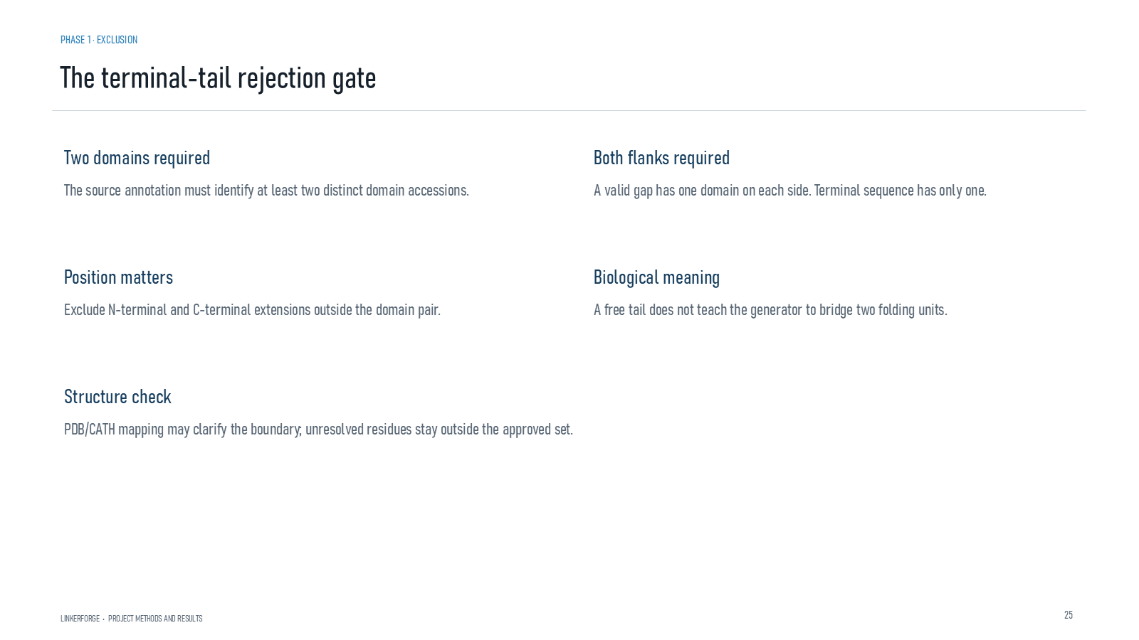
Revision 18 slide 26

Purpose and connection to the project
Explain the checks for two distinct domains, both flanks, correct position and structural boundary support before accepting an interdomain gap.
This data section explains how source records become eligible labels. The important distinction is between discovery, review and training: a mined interval may be useful for prioritisation while remaining ineligible as biological truth until its coordinates, evidence and family relationship are resolved.
Why this slide matters: It protects the model from learning mislabeled tails, internal loops, duplicated families or model-generated candidates presented as ground truth.

Evidence and labels shown on the slide
The following visible elements carry the slide's scientific content. Their role and evidence level are explained in the presentation script below.
- PHASE 1 · EXCLUSION
- The terminal-tail rejection gate
- LINKERFORGE • PROJECT METHODS AND RESULTS
- Two domains required
- The source annotation must identify at least two distinct domain accessions.
- Both flanks required
- A valid gap has one domain on each side. Terminal sequence has only one.

Terms explained on this slide
DOMAIN: A protein domain is a region expected to form a recognizable three-dimensional unit. Domain boundaries are structural or annotation claims, not simply changes in sequence composition.
LINKER: A linker is the peptide segment between joined domains. Its sequence and length can influence spacing, flexibility, orientation and exposure, but cannot guarantee function.

Detailed interpretation of the visual
Read from source record to coordinate rule, exclusion decision, label and final eligibility. Counts should be interpreted by evidence tier rather than as one homogeneous dataset.
The object or dataset, comparison, axes, units, colours and layer dimensions define what the visual represents. The observed pattern is interpreted only within those definitions, preventing a prominent number or molecular rendering from being mistaken for broader biological proof.

Exact presentation script
This slide explains the checks for two distinct domains, both flanks, correct position and structural boundary support before accepting an interdomain gap.
This data section explains how source records become eligible labels. The important distinction is between discovery, review and training: a mined interval may be useful for prioritisation while remaining ineligible as biological truth until its coordinates, evidence and family relationship are resolved.
On this slide, the concrete evidence and labels shown are: PHASE 1 · EXCLUSION; The terminal-tail rejection gate; LINKERFORGE • PROJECT METHODS AND RESULTS; Two domains required; and The source annotation must identify at least two distinct domain accessions. Together, these items establish exactly what was examined here, while retaining their individual evidence levels.
A protein domain is a region expected to form a recognizable three-dimensional unit. Domain boundaries are structural or annotation claims, not simply changes in sequence composition. A linker is the peptide segment between joined domains. Its sequence and length can influence spacing, flexibility, orientation and exposure, but cannot guarantee function.
The reason this result belongs in the project is that it protects the model from learning mislabeled tails, internal loops, duplicated families or model-generated candidates presented as ground truth.
The conclusion from this slide is deliberately limited. Boundary ambiguity keeps a record outside the approved set.

Likely examiner question
Question: What does slide 26 allow you to conclude?
Defensible answer: It supports the limited interpretation described above. The safe stopping point is: Boundary ambiguity keeps a record outside the approved set.

Scientific claim boundary
Boundary ambiguity keeps a record outside the approved set.
This boundary is part of the scientific interpretation, not a weakness to hide. State it clearly so the audience can distinguish what was measured from what would require prospective or experimental validation.

Slide 27 Internal loop exclusion
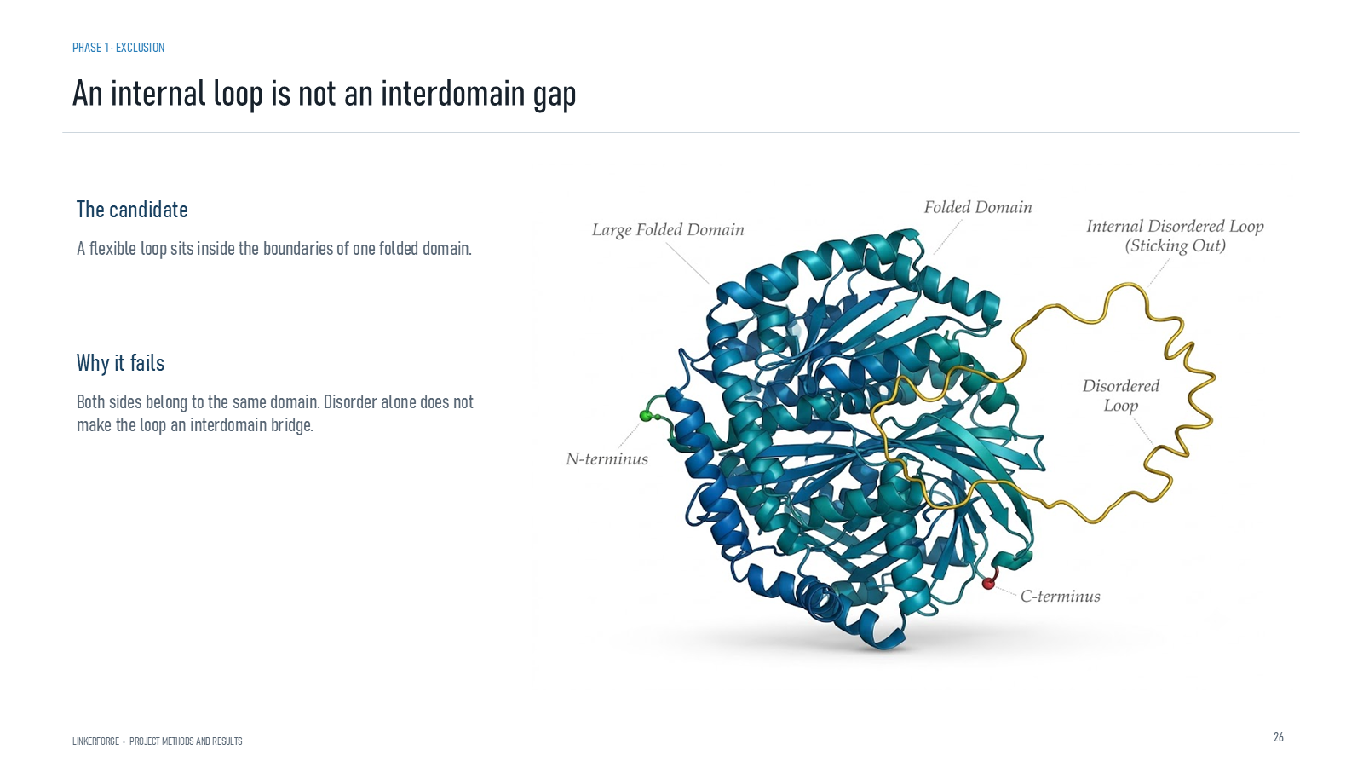
Revision 18 slide 27

Purpose and connection to the project
An internal loop belongs inside one folded domain. Disorder does not by itself establish an interdomain connection.
This data section explains how source records become eligible labels. The important distinction is between discovery, review and training: a mined interval may be useful for prioritisation while remaining ineligible as biological truth until its coordinates, evidence and family relationship are resolved.
Why this slide matters: It protects the model from learning mislabeled tails, internal loops, duplicated families or model-generated candidates presented as ground truth.

Evidence and labels shown on the slide
The following visible elements carry the slide's scientific content. Their role and evidence level are explained in the presentation script below.
- PHASE 1 · EXCLUSION
- An internal loop is not an interdomain gap
- LINKERFORGE • PROJECT METHODS AND RESULTS
- The candidate
- A flexible loop sits inside the boundaries of one folded domain.
- Why it fails
- Both sides belong to the same domain. Disorder alone does not make the loop an interdomain bridge.

Terms explained on this slide
DOMAIN: A protein domain is a region expected to form a recognizable three-dimensional unit. Domain boundaries are structural or annotation claims, not simply changes in sequence composition.
LINKER: A linker is the peptide segment between joined domains. Its sequence and length can influence spacing, flexibility, orientation and exposure, but cannot guarantee function.

Detailed interpretation of the visual
Read from source record to coordinate rule, exclusion decision, label and final eligibility. Counts should be interpreted by evidence tier rather than as one homogeneous dataset.
The object or dataset, comparison, axes, units, colours and layer dimensions define what the visual represents. The observed pattern is interpreted only within those definitions, preventing a prominent number or molecular rendering from being mistaken for broader biological proof.

Exact presentation script
This slide shows that an internal loop belongs inside one folded domain. Disorder does not by itself establish an interdomain connection.
This data section explains how source records become eligible labels. The important distinction is between discovery, review and training: a mined interval may be useful for prioritisation while remaining ineligible as biological truth until its coordinates, evidence and family relationship are resolved.
On this slide, the concrete evidence and labels shown are: PHASE 1 · EXCLUSION; An internal loop is not an interdomain gap; LINKERFORGE • PROJECT METHODS AND RESULTS; The candidate; and A flexible loop sits inside the boundaries of one folded domain. Together, these items establish exactly what was examined here, while retaining their individual evidence levels.
A protein domain is a region expected to form a recognizable three-dimensional unit. Domain boundaries are structural or annotation claims, not simply changes in sequence composition. A linker is the peptide segment between joined domains. Its sequence and length can influence spacing, flexibility, orientation and exposure, but cannot guarantee function.
The reason this result belongs in the project is that it protects the model from learning mislabeled tails, internal loops, duplicated families or model-generated candidates presented as ground truth.
The conclusion from this slide is deliberately limited. Disorder alone does not define an interdomain linker.

Likely examiner question
Question: What does slide 27 allow you to conclude?
Defensible answer: It supports the limited interpretation described above. The safe stopping point is: Disorder alone does not define an interdomain linker.

Scientific claim boundary
Disorder alone does not define an interdomain linker.
This boundary is part of the scientific interpretation, not a weakness to hide. State it clearly so the audience can distinguish what was measured from what would require prospective or experimental validation.

Slide 28 Single domain interior rejection gate
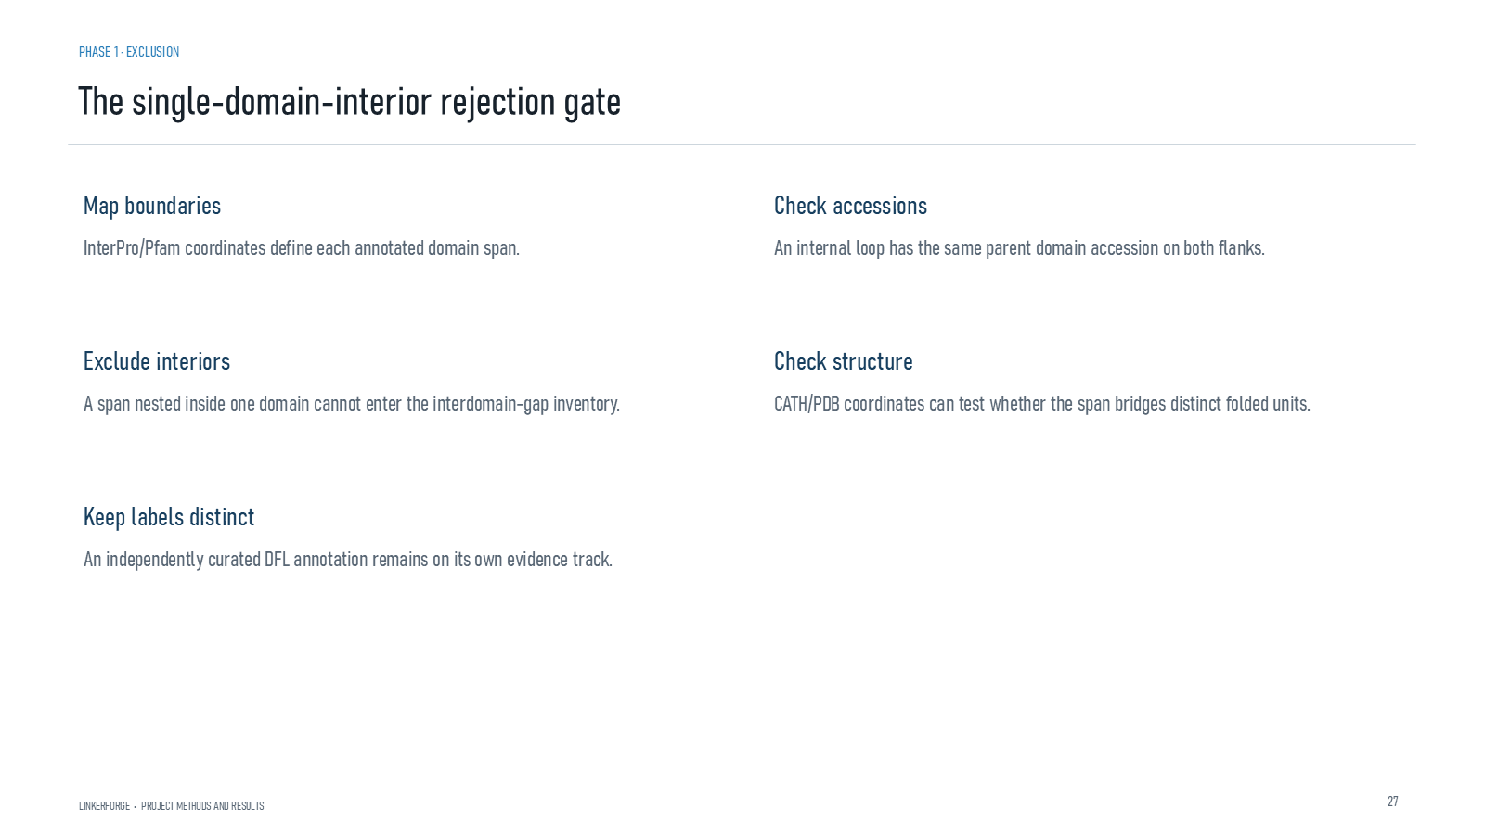
Revision 18 slide 28

Purpose and connection to the project
Use domain coordinates and accessions to reject spans nested within one domain while preserving any independent DFL annotation on its own track.
This data section explains how source records become eligible labels. The important distinction is between discovery, review and training: a mined interval may be useful for prioritisation while remaining ineligible as biological truth until its coordinates, evidence and family relationship are resolved.
Why this slide matters: It protects the model from learning mislabeled tails, internal loops, duplicated families or model-generated candidates presented as ground truth.

Evidence and labels shown on the slide
The following visible elements carry the slide's scientific content. Their role and evidence level are explained in the presentation script below.
- PHASE 1 · EXCLUSION
- The single-domain-interior rejection gate
- LINKERFORGE • PROJECT METHODS AND RESULTS
- Map boundaries
- InterPro/Pfam coordinates define each annotated domain span.
- Check accessions
- An internal loop has the same parent domain accession on both flanks.

Terms explained on this slide
DOMAIN: A protein domain is a region expected to form a recognizable three-dimensional unit. Domain boundaries are structural or annotation claims, not simply changes in sequence composition.
LINKER: A linker is the peptide segment between joined domains. Its sequence and length can influence spacing, flexibility, orientation and exposure, but cannot guarantee function.
DFL: DFL means disordered flexible linker. It is a residue-label concept used by the detector and is not synonymous with every domain gap.

Detailed interpretation of the visual
Read from source record to coordinate rule, exclusion decision, label and final eligibility. Counts should be interpreted by evidence tier rather than as one homogeneous dataset.
The object or dataset, comparison, axes, units, colours and layer dimensions define what the visual represents. The observed pattern is interpreted only within those definitions, preventing a prominent number or molecular rendering from being mistaken for broader biological proof.

Exact presentation script
This slide uses domain coordinates and accessions to reject spans nested within one domain while preserving any independent DFL annotation on its own track.
This data section explains how source records become eligible labels. The important distinction is between discovery, review and training: a mined interval may be useful for prioritisation while remaining ineligible as biological truth until its coordinates, evidence and family relationship are resolved.
On this slide, the concrete evidence and labels shown are: PHASE 1 · EXCLUSION; The single-domain-interior rejection gate; LINKERFORGE • PROJECT METHODS AND RESULTS; Map boundaries; and InterPro/Pfam coordinates define each annotated domain span. Together, these items establish exactly what was examined here, while retaining their individual evidence levels.
A protein domain is a region expected to form a recognizable three-dimensional unit. Domain boundaries are structural or annotation claims, not simply changes in sequence composition. A linker is the peptide segment between joined domains. Its sequence and length can influence spacing, flexibility, orientation and exposure, but cannot guarantee function. DFL means disordered flexible linker. It is a residue-label concept used by the detector and is not synonymous with every domain gap.
The reason this result belongs in the project is that it protects the model from learning mislabeled tails, internal loops, duplicated families or model-generated candidates presented as ground truth.
The conclusion from this slide is deliberately limited. Structural and DFL labels remain separate.

Likely examiner question
Question: What does slide 28 allow you to conclude?
Defensible answer: It supports the limited interpretation described above. The safe stopping point is: Structural and DFL labels remain separate.

Scientific claim boundary
Structural and DFL labels remain separate.
This boundary is part of the scientific interpretation, not a weakness to hide. State it clearly so the audience can distinguish what was measured from what would require prospective or experimental validation.

Slide 29 Candidate interdomain gap
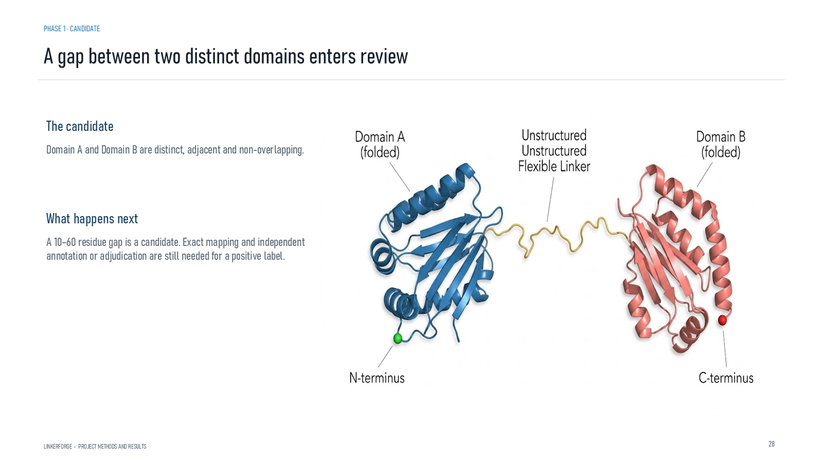
Revision 18 slide 29

Purpose and connection to the project
A non-overlapping gap between distinct adjacent domains enters review. Length eligibility does not make it a positive label.
This data section explains how source records become eligible labels. The important distinction is between discovery, review and training: a mined interval may be useful for prioritisation while remaining ineligible as biological truth until its coordinates, evidence and family relationship are resolved.
Why this slide matters: It protects the model from learning mislabeled tails, internal loops, duplicated families or model-generated candidates presented as ground truth.

Evidence and labels shown on the slide
The following visible elements carry the slide's scientific content. Their role and evidence level are explained in the presentation script below.
- PHASE 1 · CANDIDATE
- A gap between two distinct domains enters review
- LINKERFORGE • PROJECT METHODS AND RESULTS
- The candidate
- Domain A and Domain B are distinct, adjacent and non-overlapping.
- What happens next
- A 10–60 residue gap is a candidate. Exact mapping and independent annotation or adjudication are still needed for a positive label.

Terms explained on this slide
DOMAIN: A protein domain is a region expected to form a recognizable three-dimensional unit. Domain boundaries are structural or annotation claims, not simply changes in sequence composition.
LINKER: A linker is the peptide segment between joined domains. Its sequence and length can influence spacing, flexibility, orientation and exposure, but cannot guarantee function.

Detailed interpretation of the visual
Read from source record to coordinate rule, exclusion decision, label and final eligibility. Counts should be interpreted by evidence tier rather than as one homogeneous dataset.
The object or dataset, comparison, axes, units, colours and layer dimensions define what the visual represents. The observed pattern is interpreted only within those definitions, preventing a prominent number or molecular rendering from being mistaken for broader biological proof.

Exact presentation script
This slide shows that a non-overlapping gap between distinct adjacent domains enters review. Length eligibility does not make it a positive label.
This data section explains how source records become eligible labels. The important distinction is between discovery, review and training: a mined interval may be useful for prioritisation while remaining ineligible as biological truth until its coordinates, evidence and family relationship are resolved.
On this slide, the concrete evidence and labels shown are: PHASE 1 · CANDIDATE; A gap between two distinct domains enters review; LINKERFORGE • PROJECT METHODS AND RESULTS; The candidate; and Domain A and Domain B are distinct, adjacent and non-overlapping. Together, these items establish exactly what was examined here, while retaining their individual evidence levels.
A protein domain is a region expected to form a recognizable three-dimensional unit. Domain boundaries are structural or annotation claims, not simply changes in sequence composition. A linker is the peptide segment between joined domains. Its sequence and length can influence spacing, flexibility, orientation and exposure, but cannot guarantee function.
The reason this result belongs in the project is that it protects the model from learning mislabeled tails, internal loops, duplicated families or model-generated candidates presented as ground truth.
The conclusion from this slide is deliberately limited. Candidate status is not positive-label status.

Likely examiner question
Question: What does slide 29 allow you to conclude?
Defensible answer: It supports the limited interpretation described above. The safe stopping point is: Candidate status is not positive-label status.

Scientific claim boundary
Candidate status is not positive-label status.
This boundary is part of the scientific interpretation, not a weakness to hide. State it clearly so the audience can distinguish what was measured from what would require prospective or experimental validation.

Slide 30 Candidate gap adjudication
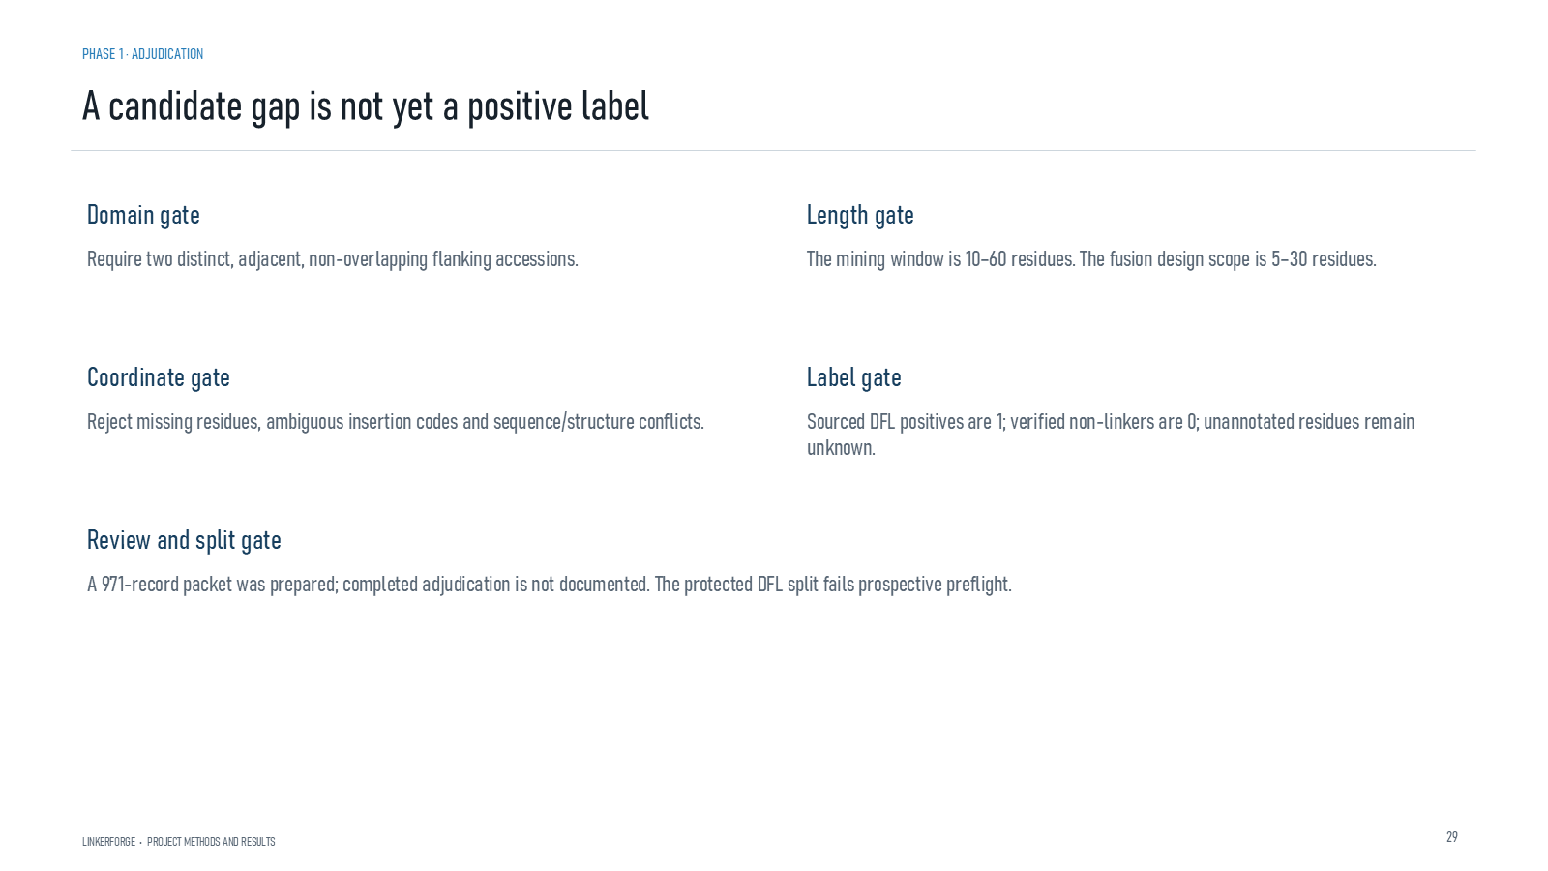
Revision 18 slide 30

Purpose and connection to the project
Explain domain, length, coordinate, label, review and split gates. The current protected DFL split fails prospective preflight.
This data section explains how source records become eligible labels. The important distinction is between discovery, review and training: a mined interval may be useful for prioritisation while remaining ineligible as biological truth until its coordinates, evidence and family relationship are resolved.
Why this slide matters: It protects the model from learning mislabeled tails, internal loops, duplicated families or model-generated candidates presented as ground truth.

Evidence and labels shown on the slide
The following visible elements carry the slide's scientific content. Their role and evidence level are explained in the presentation script below.
- PHASE 1 · ADJUDICATION
- A candidate gap is not yet a positive label
- LINKERFORGE • PROJECT METHODS AND RESULTS
- Require two distinct, adjacent, non-overlapping flanking accessions.
- The mining window is 10–60 residues. The fusion design scope is 5–30 residues.
- Coordinate gate
- Reject missing residues, ambiguous insertion codes and sequence/structure conflicts.

Terms explained on this slide
DOMAIN: A protein domain is a region expected to form a recognizable three-dimensional unit. Domain boundaries are structural or annotation claims, not simply changes in sequence composition.
LINKER: A linker is the peptide segment between joined domains. Its sequence and length can influence spacing, flexibility, orientation and exposure, but cannot guarantee function.
DFL: DFL means disordered flexible linker. It is a residue-label concept used by the detector and is not synonymous with every domain gap.

Detailed interpretation of the visual
The slide functions as a sequence of gates. A record must pass domain identity, coordinates, length, label review and family-split checks; failure at any gate keeps it outside approved training.
The object or dataset, comparison, axes, units, colours and layer dimensions define what the visual represents. The observed pattern is interpreted only within those definitions, preventing a prominent number or molecular rendering from being mistaken for broader biological proof.

Exact presentation script
This slide explains domain, length, coordinate, label, review and split gates. The current protected DFL split fails prospective preflight.
This data section explains how source records become eligible labels. The important distinction is between discovery, review and training: a mined interval may be useful for prioritisation while remaining ineligible as biological truth until its coordinates, evidence and family relationship are resolved.
On this slide, the concrete evidence and labels shown are: PHASE 1 · ADJUDICATION; A candidate gap is not yet a positive label; LINKERFORGE • PROJECT METHODS AND RESULTS; Require two distinct, adjacent, non-overlapping flanking accessions; and The mining window is 10–60 residues. The fusion design scope is 5–30 residues. Together, these items establish exactly what was examined here, while retaining their individual evidence levels.
A protein domain is a region expected to form a recognizable three-dimensional unit. Domain boundaries are structural or annotation claims, not simply changes in sequence composition. A linker is the peptide segment between joined domains. Its sequence and length can influence spacing, flexibility, orientation and exposure, but cannot guarantee function. DFL means disordered flexible linker. It is a residue-label concept used by the detector and is not synonymous with every domain gap.
The reason this result belongs in the project is that it protects the model from learning mislabeled tails, internal loops, duplicated families or model-generated candidates presented as ground truth.
The conclusion from this slide is deliberately limited. The current protected split fails prospective preflight.

Likely examiner question
Question: Why did the protected benchmark fail?
Defensible answer: The preflight detected conditions incompatible with a fresh prospective claim, such as previously exposed labels or unresolved family/split rules. The fail-closed response preserves validity instead of bypassing the contract.

Scientific claim boundary
The current protected split fails prospective preflight.
This boundary is part of the scientific interpretation, not a weakness to hide. State it clearly so the audience can distinguish what was measured from what would require prospective or experimental validation.

Slide 31 Labels and family splits
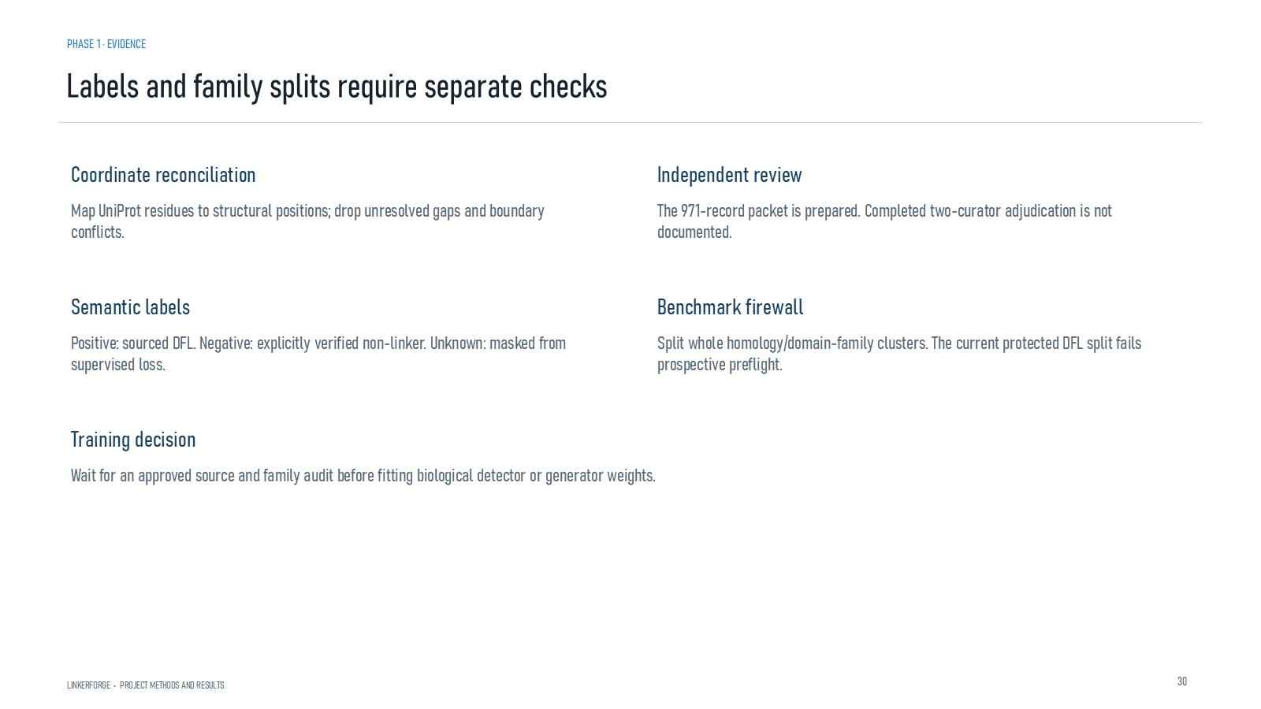
Revision 18 slide 31

Purpose and connection to the project
Coordinate reconciliation, independent review, label semantics and the family firewall must all pass before biological training.
This data section explains how source records become eligible labels. The important distinction is between discovery, review and training: a mined interval may be useful for prioritisation while remaining ineligible as biological truth until its coordinates, evidence and family relationship are resolved.
Why this slide matters: It protects the model from learning mislabeled tails, internal loops, duplicated families or model-generated candidates presented as ground truth.

Evidence and labels shown on the slide
The following visible elements carry the slide's scientific content. Their role and evidence level are explained in the presentation script below.
- PHASE 1 · EVIDENCE
- Labels and family splits require separate checks
- LINKERFORGE • PROJECT METHODS AND RESULTS
- Coordinate reconciliation
- Map UniProt residues to structural positions; drop unresolved gaps and boundary conflicts.
- Independent review
- The 971-record packet is prepared. Completed two-curator adjudication is not documented.

Terms explained on this slide
DOMAIN: A protein domain is a region expected to form a recognizable three-dimensional unit. Domain boundaries are structural or annotation claims, not simply changes in sequence composition.
LINKER: A linker is the peptide segment between joined domains. Its sequence and length can influence spacing, flexibility, orientation and exposure, but cannot guarantee function.
DFL: DFL means disordered flexible linker. It is a residue-label concept used by the detector and is not synonymous with every domain gap.
APS: Average precision score summarizes the precision-recall curve and is useful for imbalanced labels. It depends on the dataset and cannot be compared across unrelated tasks as a universal score.

Detailed interpretation of the visual
Read from source record to coordinate rule, exclusion decision, label and final eligibility. Counts should be interpreted by evidence tier rather than as one homogeneous dataset.
The object or dataset, comparison, axes, units, colours and layer dimensions define what the visual represents. The observed pattern is interpreted only within those definitions, preventing a prominent number or molecular rendering from being mistaken for broader biological proof.

Exact presentation script
This slide shows that coordinate reconciliation, independent review, label semantics and the family firewall must all pass before biological training.
This data section explains how source records become eligible labels. The important distinction is between discovery, review and training: a mined interval may be useful for prioritisation while remaining ineligible as biological truth until its coordinates, evidence and family relationship are resolved.
On this slide, the concrete evidence and labels shown are: PHASE 1 · EVIDENCE; Labels and family splits require separate checks; LINKERFORGE • PROJECT METHODS AND RESULTS; Coordinate reconciliation; and Map UniProt residues to structural positions; drop unresolved gaps and boundary conflicts. Together, these items establish exactly what was examined here, while retaining their individual evidence levels.
A protein domain is a region expected to form a recognizable three-dimensional unit. Domain boundaries are structural or annotation claims, not simply changes in sequence composition. A linker is the peptide segment between joined domains. Its sequence and length can influence spacing, flexibility, orientation and exposure, but cannot guarantee function. DFL means disordered flexible linker. It is a residue-label concept used by the detector and is not synonymous with every domain gap.
The reason this result belongs in the project is that it protects the model from learning mislabeled tails, internal loops, duplicated families or model-generated candidates presented as ground truth.
The conclusion from this slide is deliberately limited. Biological weights remain unfit because the source audit and family audit have not yet passed.

Likely examiner question
Question: What does slide 31 allow you to conclude?
Defensible answer: It supports the limited interpretation described above. The safe stopping point is: Do not fit biological weights before source and family audits pass.

Scientific claim boundary
Do not fit biological weights before source and family audits pass.
This boundary is part of the scientific interpretation, not a weakness to hide. State it clearly so the audience can distinguish what was measured from what would require prospective or experimental validation.

Slide 32 DLD reference set and split
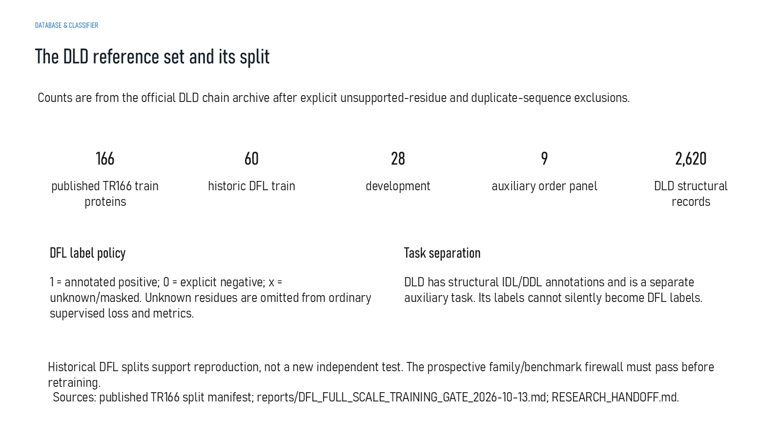
Revision 18 slide 32

Purpose and connection to the project
Explain the DLD counts and why DLD is an auxiliary structural-linker task. Historical splits support reproduction but cannot serve as a fresh independent test.
This data section explains how source records become eligible labels. The important distinction is between discovery, review and training: a mined interval may be useful for prioritisation while remaining ineligible as biological truth until its coordinates, evidence and family relationship are resolved.
Why this slide matters: It protects the model from learning mislabeled tails, internal loops, duplicated families or model-generated candidates presented as ground truth.

Evidence and labels shown on the slide
The following visible elements carry the slide's scientific content. Their role and evidence level are explained in the presentation script below.
- DATABASE & CLASSIFIER
- The DLD reference set and its split
- Counts are from the official DLD chain archive after explicit unsupported-residue and duplicate-sequence exclusions.
- published TR166 train proteins
- historic DFL train
- auxiliary order panel
- DLD structural records

Terms explained on this slide
LINKER: A linker is the peptide segment between joined domains. Its sequence and length can influence spacing, flexibility, orientation and exposure, but cannot guarantee function.
DFL: DFL means disordered flexible linker. It is a residue-label concept used by the detector and is not synonymous with every domain gap.
IDL: IDL is an independent-domain-linker class in the DLD structural task. It must not be silently relabelled as DFL truth.
DDL: DDL is a dependent-domain-linker class in the DLD structural task. It describes a structural relationship, not a fusion-success outcome.

Detailed interpretation of the visual
Read from source record to coordinate rule, exclusion decision, label and final eligibility. Counts should be interpreted by evidence tier rather than as one homogeneous dataset.
The object or dataset, comparison, axes, units, colours and layer dimensions define what the visual represents. The observed pattern is interpreted only within those definitions, preventing a prominent number or molecular rendering from being mistaken for broader biological proof.

Exact presentation script
This slide explains the DLD counts and why DLD is an auxiliary structural-linker task. Historical splits support reproduction but cannot serve as a fresh independent test.
This data section explains how source records become eligible labels. The important distinction is between discovery, review and training: a mined interval may be useful for prioritisation while remaining ineligible as biological truth until its coordinates, evidence and family relationship are resolved.
On this slide, the concrete evidence and labels shown are: DATABASE & CLASSIFIER; The DLD reference set and its split; Counts are from the official DLD chain archive after explicit unsupported-residue and duplicate-sequence exclusions; published TR166 train proteins; and historic DFL train. Together, these items establish exactly what was examined here, while retaining their individual evidence levels.
A linker is the peptide segment between joined domains. Its sequence and length can influence spacing, flexibility, orientation and exposure, but cannot guarantee function. DFL means disordered flexible linker. It is a residue-label concept used by the detector and is not synonymous with every domain gap. IDL is an independent-domain-linker class in the DLD structural task. It must not be silently relabelled as DFL truth.
The reason this result belongs in the project is that it protects the model from learning mislabeled tails, internal loops, duplicated families or model-generated candidates presented as ground truth.
The conclusion from this slide is deliberately limited. DLD IDL/DDL labels are not DFL labels.

Likely examiner question
Question: What does slide 32 allow you to conclude?
Defensible answer: It supports the limited interpretation described above. The safe stopping point is: DLD IDL/DDL labels are not DFL labels.

Scientific claim boundary
DLD IDL/DDL labels are not DFL labels.
This boundary is part of the scientific interpretation, not a weakness to hide. State it clearly so the audience can distinguish what was measured from what would require prospective or experimental validation.

Slide 33 Dataset acquisition and evidence labels
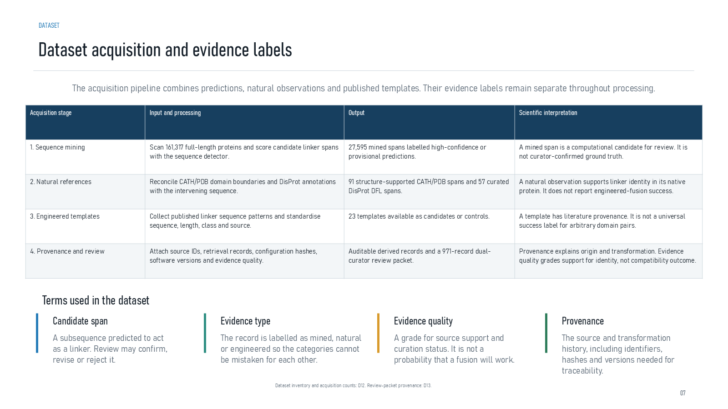
Revision 18 slide 33

Purpose and connection to the project
Explain the four acquisition stages and the meaning of candidate span, evidence type, evidence quality and provenance.
This data section explains how source records become eligible labels. The important distinction is between discovery, review and training: a mined interval may be useful for prioritisation while remaining ineligible as biological truth until its coordinates, evidence and family relationship are resolved.
Why this slide matters: It protects the model from learning mislabeled tails, internal loops, duplicated families or model-generated candidates presented as ground truth.

Evidence and labels shown on the slide
The following visible elements carry the slide's scientific content. Their role and evidence level are explained in the presentation script below.
- The acquisition pipeline combines predictions, natural observations and published templates. Their evidence labels remain separate throughout processing.
- Terms used in the dataset
- Candidate span
- A subsequence predicted to act as a linker. Review may confirm, revise or reject it.
- Evidence type
- The record is labelled as mined, natural or engineered so the categories cannot be mistaken for each other.
- Evidence quality

Terms explained on this slide
LINKER: A linker is the peptide segment between joined domains. Its sequence and length can influence spacing, flexibility, orientation and exposure, but cannot guarantee function.
PROVENANCE: Provenance is the recorded origin and transformation history of a datum, model, prediction or figure, including source identifiers, code revision and configuration.
CURATION: Curation is a documented human review process that resolves coordinates, labels, evidence quality and eligibility. Preparing a review packet is not the same as completing adjudication.

Detailed interpretation of the visual
Read from source record to coordinate rule, exclusion decision, label and final eligibility. Counts should be interpreted by evidence tier rather than as one homogeneous dataset.
The object or dataset, comparison, axes, units, colours and layer dimensions define what the visual represents. The observed pattern is interpreted only within those definitions, preventing a prominent number or molecular rendering from being mistaken for broader biological proof.

Exact presentation script
This slide explains the four acquisition stages and the meaning of candidate span, evidence type, evidence quality and provenance.
This data section explains how source records become eligible labels. The important distinction is between discovery, review and training: a mined interval may be useful for prioritisation while remaining ineligible as biological truth until its coordinates, evidence and family relationship are resolved.
On this slide, the concrete evidence and labels shown are: The acquisition pipeline combines predictions, natural observations and published templates. Their evidence labels remain separate throughout processing; Terms used in the dataset; Candidate span; A subsequence predicted to act as a linker. Review may confirm, revise or reject it; and Evidence type. Together, these items establish exactly what was examined here, while retaining their individual evidence levels.
A linker is the peptide segment between joined domains. Its sequence and length can influence spacing, flexibility, orientation and exposure, but cannot guarantee function. Provenance is the recorded origin and transformation history of a datum, model, prediction or figure, including source identifiers, code revision and configuration. Curation is a documented human review process that resolves coordinates, labels, evidence quality and eligibility. Preparing a review packet is not the same as completing adjudication.
The reason this result belongs in the project is that it protects the model from learning mislabeled tails, internal loops, duplicated families or model-generated candidates presented as ground truth.
The conclusion from this slide is deliberately limited. Evidence quality grades identity support, not compatibility success.

Likely examiner question
Question: What does slide 33 allow you to conclude?
Defensible answer: It supports the limited interpretation described above. The safe stopping point is: Evidence quality grades identity support, not compatibility success.

Scientific claim boundary
Evidence quality grades identity support, not compatibility success.
This boundary is part of the scientific interpretation, not a weakness to hide. State it clearly so the audience can distinguish what was measured from what would require prospective or experimental validation.

Slide 34 The 27766 record inventory
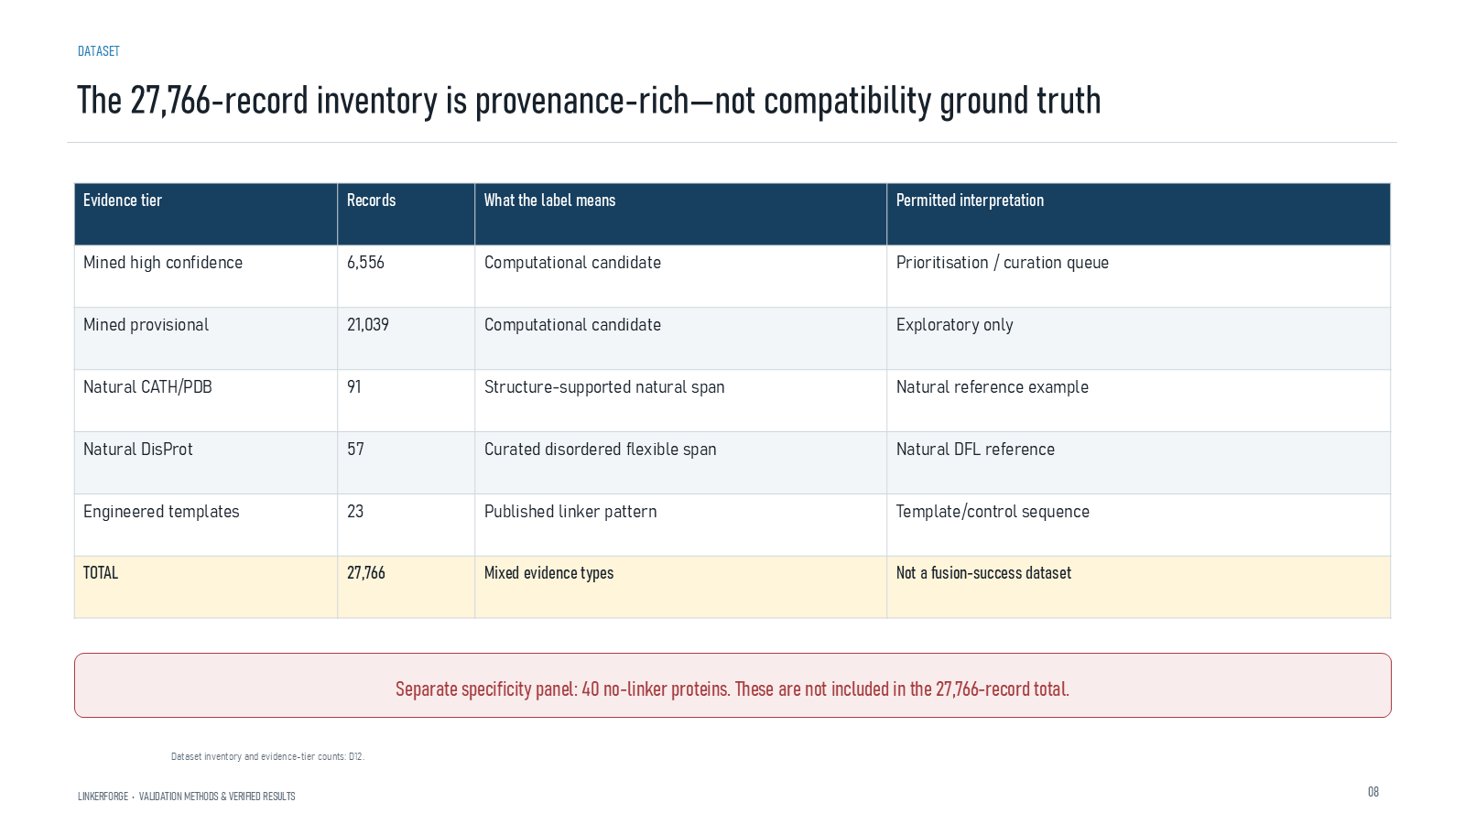
Revision 18 slide 34

Purpose and connection to the project
Break down the 27,766 rows by tier. Most are model-mined candidates, and the total must not be described as fusion-success ground truth.
This data section explains how source records become eligible labels. The important distinction is between discovery, review and training: a mined interval may be useful for prioritisation while remaining ineligible as biological truth until its coordinates, evidence and family relationship are resolved.
Why this slide matters: It protects the model from learning mislabeled tails, internal loops, duplicated families or model-generated candidates presented as ground truth.

Evidence and labels shown on the slide
The following visible elements carry the slide's scientific content. Their role and evidence level are explained in the presentation script below.
- The 27,766-record inventory is provenance-rich—not compatibility ground truth
- LINKERFORGE • VALIDATION METHODS & VERIFIED RESULTS
- Separate specificity panel: 40 no-linker proteins. These are not included in the 27,766-record total.
- Dataset inventory and evidence-tier counts: D12.

Terms explained on this slide
LINKER: A linker is the peptide segment between joined domains. Its sequence and length can influence spacing, flexibility, orientation and exposure, but cannot guarantee function.
PROVENANCE: Provenance is the recorded origin and transformation history of a datum, model, prediction or figure, including source identifiers, code revision and configuration.

Detailed interpretation of the visual
The table is organised by evidence tier rather than only by the total. The large mined tiers dominate the count, while the smaller curated and structural tiers carry different evidential weight.
The object or dataset, comparison, axes, units, colours and layer dimensions define what the visual represents. The observed pattern is interpreted only within those definitions, preventing a prominent number or molecular rendering from being mistaken for broader biological proof.

Exact presentation script
This slide breaks down the 27,766 rows by tier. Most are model-mined candidates, and the total must not be described as fusion-success ground truth.
This data section explains how source records become eligible labels. The important distinction is between discovery, review and training: a mined interval may be useful for prioritisation while remaining ineligible as biological truth until its coordinates, evidence and family relationship are resolved.
On this slide, the concrete evidence and labels shown are: The 27,766-record inventory is provenance-rich—not compatibility ground truth; LINKERFORGE • VALIDATION METHODS & VERIFIED RESULTS; Separate specificity panel: 40 no-linker proteins. These are not included in the 27,766-record total; and Dataset inventory and evidence-tier counts: D12. Together, these items establish exactly what was examined here, while retaining their individual evidence levels.
A linker is the peptide segment between joined domains. Its sequence and length can influence spacing, flexibility, orientation and exposure, but cannot guarantee function. Provenance is the recorded origin and transformation history of a datum, model, prediction or figure, including source identifiers, code revision and configuration.
The reason this result belongs in the project is that it protects the model from learning mislabeled tails, internal loops, duplicated families or model-generated candidates presented as ground truth.
The conclusion from this slide is deliberately limited. The inventory is not a fusion-success dataset.

Likely examiner question
Question: Why can the 27,766 records not train the generator directly?
Defensible answer: Most rows are mined candidates with mixed evidence rather than reviewed A-linker-B biological examples. Training on them as truth would convert model suggestions into labels and amplify bias.

Scientific claim boundary
The inventory is not a fusion-success dataset.
This boundary is part of the scientific interpretation, not a weakness to hide. State it clearly so the audience can distinguish what was measured from what would require prospective or experimental validation.

Slide 35 Current dataset contents
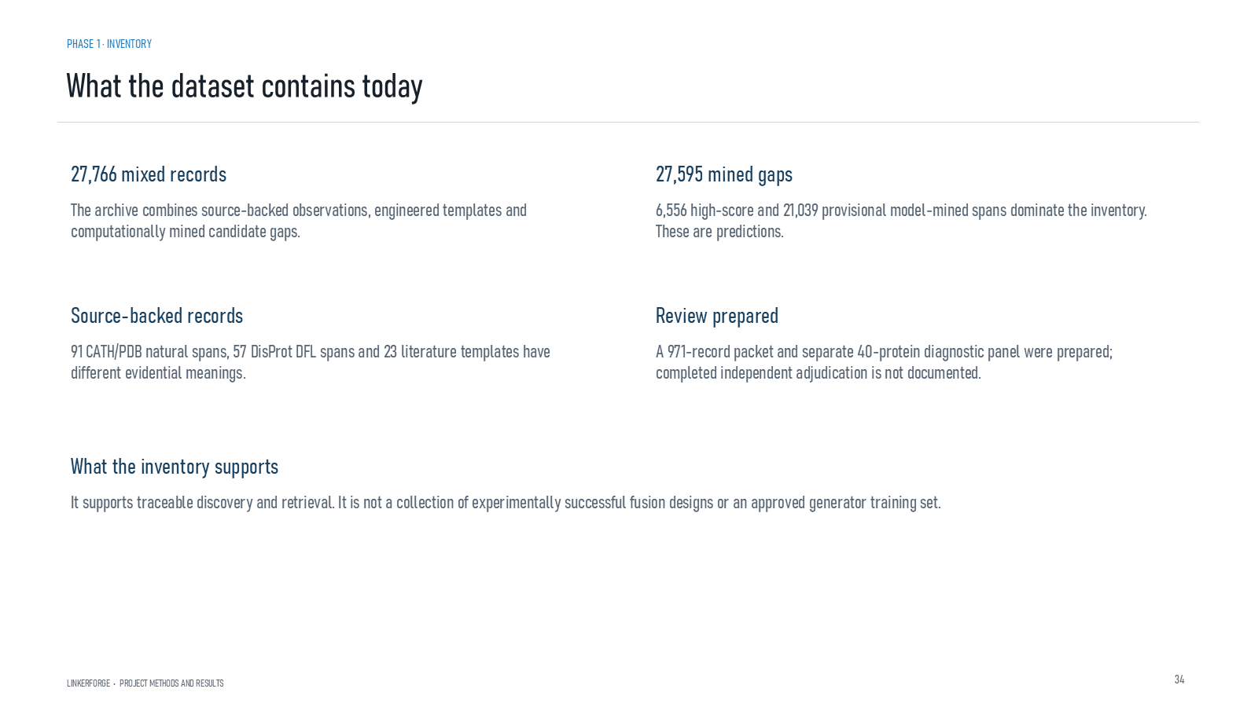
Revision 18 slide 35

Purpose and connection to the project
Summarise the current inventory and its permitted use: traceable discovery and retrieval, not an approved generator training set.
This data section explains how source records become eligible labels. The important distinction is between discovery, review and training: a mined interval may be useful for prioritisation while remaining ineligible as biological truth until its coordinates, evidence and family relationship are resolved.
Why this slide matters: It protects the model from learning mislabeled tails, internal loops, duplicated families or model-generated candidates presented as ground truth.

Evidence and labels shown on the slide
The following visible elements carry the slide's scientific content. Their role and evidence level are explained in the presentation script below.
- PHASE 1 · INVENTORY
- What the dataset contains today
- LINKERFORGE • PROJECT METHODS AND RESULTS
- 27,766 mixed records
- The archive combines source-backed observations, engineered templates and computationally mined candidate gaps.
- 27,595 mined gaps
- 6,556 high-score and 21,039 provisional model-mined spans dominate the inventory. These are predictions.

Terms explained on this slide
LINKER: A linker is the peptide segment between joined domains. Its sequence and length can influence spacing, flexibility, orientation and exposure, but cannot guarantee function.
DFL: DFL means disordered flexible linker. It is a residue-label concept used by the detector and is not synonymous with every domain gap.
APS: Average precision score summarizes the precision-recall curve and is useful for imbalanced labels. It depends on the dataset and cannot be compared across unrelated tasks as a universal score.

Detailed interpretation of the visual
Read from source record to coordinate rule, exclusion decision, label and final eligibility. Counts should be interpreted by evidence tier rather than as one homogeneous dataset.
The object or dataset, comparison, axes, units, colours and layer dimensions define what the visual represents. The observed pattern is interpreted only within those definitions, preventing a prominent number or molecular rendering from being mistaken for broader biological proof.

Exact presentation script
This slide summarises the current inventory and its permitted use: traceable discovery and retrieval, not an approved generator training set.
This data section explains how source records become eligible labels. The important distinction is between discovery, review and training: a mined interval may be useful for prioritisation while remaining ineligible as biological truth until its coordinates, evidence and family relationship are resolved.
On this slide, the concrete evidence and labels shown are: PHASE 1 · INVENTORY; What the dataset contains today; LINKERFORGE • PROJECT METHODS AND RESULTS; 27,766 mixed records; and The archive combines source-backed observations, engineered templates and computationally mined candidate gaps. Together, these items establish exactly what was examined here, while retaining their individual evidence levels.
A linker is the peptide segment between joined domains. Its sequence and length can influence spacing, flexibility, orientation and exposure, but cannot guarantee function. DFL means disordered flexible linker. It is a residue-label concept used by the detector and is not synonymous with every domain gap. Average precision score summarizes the precision-recall curve and is useful for imbalanced labels. It depends on the dataset and cannot be compared across unrelated tasks as a universal score.
The reason this result belongs in the project is that it protects the model from learning mislabeled tails, internal loops, duplicated families or model-generated candidates presented as ground truth.
The conclusion from this slide is deliberately limited. Discovery inventory does not equal approved training set.

Likely examiner question
Question: What does slide 35 allow you to conclude?
Defensible answer: It supports the limited interpretation described above. The safe stopping point is: Discovery inventory does not equal approved training set.

Scientific claim boundary
Discovery inventory does not equal approved training set.
This boundary is part of the scientific interpretation, not a weakness to hide. State it clearly so the audience can distinguish what was measured from what would require prospective or experimental validation.

Slide 36 Curation and training gate
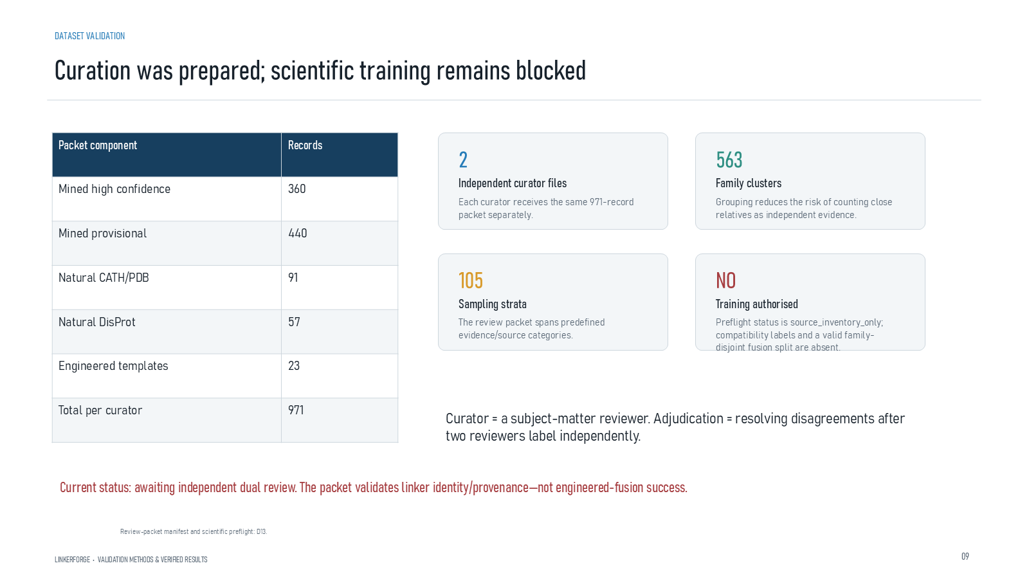
Revision 18 slide 36

Purpose and connection to the project
Explain the prepared dual-curator packet, family clusters, sampling strata and the source_inventory_only training decision.
This data section explains how source records become eligible labels. The important distinction is between discovery, review and training: a mined interval may be useful for prioritisation while remaining ineligible as biological truth until its coordinates, evidence and family relationship are resolved.
Why this slide matters: It protects the model from learning mislabeled tails, internal loops, duplicated families or model-generated candidates presented as ground truth.

Evidence and labels shown on the slide
The following visible elements carry the slide's scientific content. Their role and evidence level are explained in the presentation script below.
- DATASET VALIDATION
- Curation was prepared; scientific training remains blocked
- LINKERFORGE • VALIDATION METHODS & VERIFIED RESULTS
- Independent curator files
- Each curator receives the same 971-record packet separately.
- Family clusters
- Grouping reduces the risk of counting close relatives as independent evidence.

Terms explained on this slide
LINKER: A linker is the peptide segment between joined domains. Its sequence and length can influence spacing, flexibility, orientation and exposure, but cannot guarantee function.
PROVENANCE: Provenance is the recorded origin and transformation history of a datum, model, prediction or figure, including source identifiers, code revision and configuration.
CURATION: Curation is a documented human review process that resolves coordinates, labels, evidence quality and eligibility. Preparing a review packet is not the same as completing adjudication.
FAMILY-DISJOINT: A family-disjoint split keeps related protein families out of both training and evaluation, reducing memorization through homology.

Detailed interpretation of the visual
Read from source record to coordinate rule, exclusion decision, label and final eligibility. Counts should be interpreted by evidence tier rather than as one homogeneous dataset.
The object or dataset, comparison, axes, units, colours and layer dimensions define what the visual represents. The observed pattern is interpreted only within those definitions, preventing a prominent number or molecular rendering from being mistaken for broader biological proof.

Exact presentation script
This slide explains the prepared dual-curator packet, family clusters, sampling strata and the source_inventory_only training decision.
This data section explains how source records become eligible labels. The important distinction is between discovery, review and training: a mined interval may be useful for prioritisation while remaining ineligible as biological truth until its coordinates, evidence and family relationship are resolved.
On this slide, the concrete evidence and labels shown are: DATASET VALIDATION; Curation was prepared; scientific training remains blocked; LINKERFORGE • VALIDATION METHODS & VERIFIED RESULTS; Independent curator files; and Each curator receives the same 971-record packet separately. Together, these items establish exactly what was examined here, while retaining their individual evidence levels.
A linker is the peptide segment between joined domains. Its sequence and length can influence spacing, flexibility, orientation and exposure, but cannot guarantee function. Provenance is the recorded origin and transformation history of a datum, model, prediction or figure, including source identifiers, code revision and configuration. Curation is a documented human review process that resolves coordinates, labels, evidence quality and eligibility. Preparing a review packet is not the same as completing adjudication.
The reason this result belongs in the project is that it protects the model from learning mislabeled tails, internal loops, duplicated families or model-generated candidates presented as ground truth.
The conclusion from this slide is deliberately limited. Prepared curation is not completed adjudication.

Likely examiner question
Question: What does slide 36 allow you to conclude?
Defensible answer: It supports the limited interpretation described above. The safe stopping point is: Prepared curation is not completed adjudication.

Scientific claim boundary
Prepared curation is not completed adjudication.
This boundary is part of the scientific interpretation, not a weakness to hide. State it clearly so the audience can distinguish what was measured from what would require prospective or experimental validation.

Slide 37 DFL classifier architecture
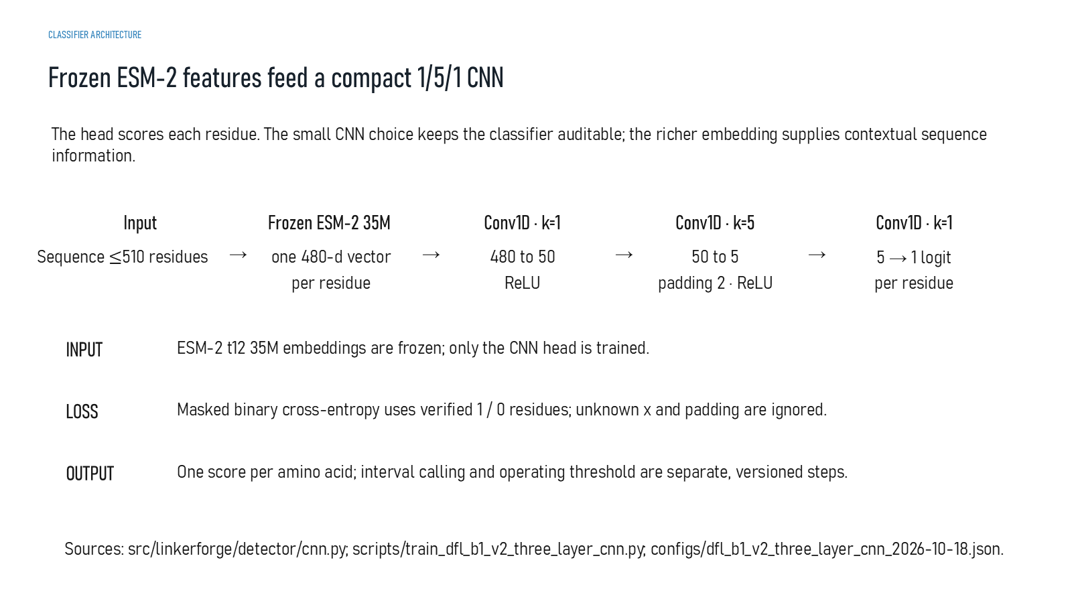
Revision 18 slide 37

Purpose and connection to the project
Describe the active detector: frozen ESM-2 35M embeddings feed a compact Conv1D 1-5-1 head that emits one logit per residue.
This detector section follows the full inference path from residues to contextual embeddings, local convolutional scores and candidate intervals. Model architecture must be read together with masking, split rules, threshold freezing and the protected benchmark contract.
Why this slide matters: It shows that performance depends on more than the neural-network layers: label masks, family separation and a frozen prospective protocol are equally important.

Evidence and labels shown on the slide
The following visible elements carry the slide's scientific content. Their role and evidence level are explained in the presentation script below.
- CLASSIFIER ARCHITECTURE
- Frozen ESM-2 features feed a compact 1/5/1 CNN
- The head scores each residue. The small CNN choice keeps the classifier auditable; the richer embedding supplies contextual sequence information.
- Sequence ≤510 residues
- Frozen ESM-2 35M
- one 480-d vector per residue
- Conv1D · k=1

Terms explained on this slide
AMINO ACID: An amino acid is one residue in a protein chain. Twenty canonical amino acids are used by the Version 1 generator vocabulary.
LINKER: A linker is the peptide segment between joined domains. Its sequence and length can influence spacing, flexibility, orientation and exposure, but cannot guarantee function.
DFL: DFL means disordered flexible linker. It is a residue-label concept used by the detector and is not synonymous with every domain gap.
ESM-2: ESM-2 is a protein language model. LinkerForge uses frozen per-residue embeddings from the 35-million-parameter t12 variant as detector features.
EMBEDDING: An embedding is a numerical vector representing sequence context. It is a learned representation, not a biological measurement.
CONV1D: A one-dimensional convolution scans sequence positions. Kernel width one mixes features at the same residue; width five incorporates a local five-residue neighbourhood.
LOGIT: A logit is an unconstrained model output. A sigmoid maps it to a score between zero and one, but calibration must be demonstrated before treating that score as a probability.

Detailed interpretation of the visual
The arrows move from amino-acid sequence to frozen ESM-2 embeddings, the compact Conv1D head and one residue score per position. This is a detector, not a sequence generator.
The object or dataset, comparison, axes, units, colours and layer dimensions define what the visual represents. The observed pattern is interpreted only within those definitions, preventing a prominent number or molecular rendering from being mistaken for broader biological proof.

Exact presentation script
This slide describes the active detector: frozen ESM-2 35M embeddings feed a compact Conv1D 1-5-1 head that emits one logit per residue.
This detector section follows the full inference path from residues to contextual embeddings, local convolutional scores and candidate intervals. Model architecture must be read together with masking, split rules, threshold freezing and the protected benchmark contract.
On this slide, the concrete evidence and labels shown are: CLASSIFIER ARCHITECTURE; Frozen ESM-2 features feed a compact 1/5/1 CNN; The head scores each residue. The small CNN choice keeps the classifier auditable; the richer embedding supplies contextual sequence information; Sequence ≤510 residues; and Frozen ESM-2 35M. Together, these items establish exactly what was examined here, while retaining their individual evidence levels.
An amino acid is one residue in a protein chain. Twenty canonical amino acids are used by the Version 1 generator vocabulary. A linker is the peptide segment between joined domains. Its sequence and length can influence spacing, flexibility, orientation and exposure, but cannot guarantee function. DFL means disordered flexible linker. It is a residue-label concept used by the detector and is not synonymous with every domain gap.
The reason this result belongs in the project is that it shows that performance depends on more than the neural-network layers: label masks, family separation and a frozen prospective protocol are equally important.
The conclusion from this slide is deliberately limited. The detector is not the fusion-linker generator.

Likely examiner question
Question: What does slide 37 allow you to conclude?
Defensible answer: It supports the limited interpretation described above. The safe stopping point is: The detector is not the fusion-linker generator.

Scientific claim boundary
The detector is not the fusion-linker generator.
This boundary is part of the scientific interpretation, not a weakness to hide. State it clearly so the audience can distinguish what was measured from what would require prospective or experimental validation.

Slide 38 Detailed detector architecture
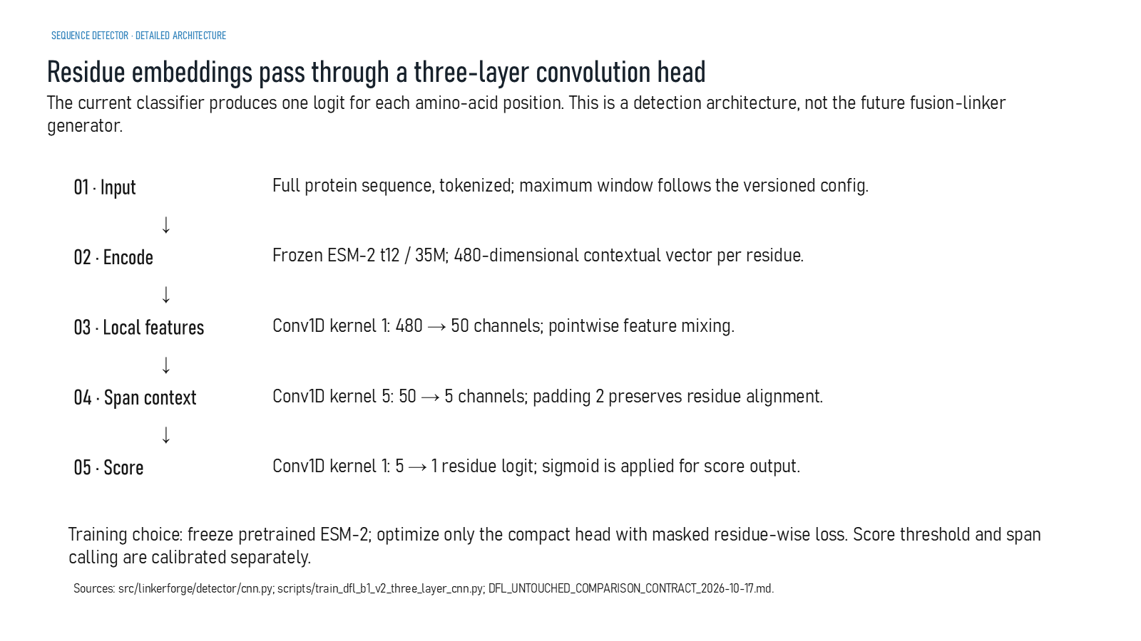
Revision 18 slide 38

Purpose and connection to the project
Follow the detector layer by layer from tokenized sequence to 480-dimensional embeddings, local feature mixing, five-residue context and one residue score.
This detector section follows the full inference path from residues to contextual embeddings, local convolutional scores and candidate intervals. Model architecture must be read together with masking, split rules, threshold freezing and the protected benchmark contract.
Why this slide matters: It shows that performance depends on more than the neural-network layers: label masks, family separation and a frozen prospective protocol are equally important.

Evidence and labels shown on the slide
The following visible elements carry the slide's scientific content. Their role and evidence level are explained in the presentation script below.
- SEQUENCE DETECTOR · DETAILED ARCHITECTURE
- Residue embeddings pass through a three-layer convolution head
- The current classifier produces one logit for each amino-acid position. This is a detection architecture, not the future fusion-linker generator.
- Full protein sequence, tokenized; maximum window follows the versioned config.
- Frozen ESM-2 t12 / 35M; 480-dimensional contextual vector per residue.
- 03 · Local features
- Conv1D kernel 1: 480 → 50 channels; pointwise feature mixing.

Terms explained on this slide
LINKER: A linker is the peptide segment between joined domains. Its sequence and length can influence spacing, flexibility, orientation and exposure, but cannot guarantee function.
DFL: DFL means disordered flexible linker. It is a residue-label concept used by the detector and is not synonymous with every domain gap.
ESM-2: ESM-2 is a protein language model. LinkerForge uses frozen per-residue embeddings from the 35-million-parameter t12 variant as detector features.
EMBEDDING: An embedding is a numerical vector representing sequence context. It is a learned representation, not a biological measurement.
CONV1D: A one-dimensional convolution scans sequence positions. Kernel width one mixes features at the same residue; width five incorporates a local five-residue neighbourhood.
LOGIT: A logit is an unconstrained model output. A sigmoid maps it to a score between zero and one, but calibration must be demonstrated before treating that score as a probability.

Detailed interpretation of the visual
Tensor shape is tracked and sequence alignment at every layer. Width-one convolutions preserve position while mixing channels; the width-five layer adds local context; the last width-one layer produces one logit for each residue.
The object or dataset, comparison, axes, units, colours and layer dimensions define what the visual represents. The observed pattern is interpreted only within those definitions, preventing a prominent number or molecular rendering from being mistaken for broader biological proof.

Exact presentation script
This slide follows the detector layer by layer from tokenized sequence to 480-dimensional embeddings, local feature mixing, five-residue context and one residue score.
This detector section follows the full inference path from residues to contextual embeddings, local convolutional scores and candidate intervals. Model architecture must be read together with masking, split rules, threshold freezing and the protected benchmark contract.
On this slide, the concrete evidence and labels shown are: SEQUENCE DETECTOR · DETAILED ARCHITECTURE; Residue embeddings pass through a three-layer convolution head; The current classifier produces one logit for each amino-acid position. This is a detection architecture, not the future fusion-linker generator; Full protein sequence, tokenized; maximum window follows the versioned config; and Frozen ESM-2 t12 / 35M; 480-dimensional contextual vector per residue. Together, these items establish exactly what was examined here, while retaining their individual evidence levels.
A linker is the peptide segment between joined domains. Its sequence and length can influence spacing, flexibility, orientation and exposure, but cannot guarantee function. DFL means disordered flexible linker. It is a residue-label concept used by the detector and is not synonymous with every domain gap. ESM-2 is a protein language model. LinkerForge uses frozen per-residue embeddings from the 35-million-parameter t12 variant as detector features.
The reason this result belongs in the project is that it shows that performance depends on more than the neural-network layers: label masks, family separation and a frozen prospective protocol are equally important.
The conclusion from this slide is deliberately limited. A logit is an uncalibrated model output before thresholding.

Likely examiner question
Question: What does slide 38 allow you to conclude?
Defensible answer: It supports the limited interpretation described above. The safe stopping point is: A logit is an uncalibrated model output before thresholding.

Scientific claim boundary
A logit is an uncalibrated model output before thresholding.
This boundary is part of the scientific interpretation, not a weakness to hide. State it clearly so the audience can distinguish what was measured from what would require prospective or experimental validation.

Slide 39 Why the detector head stays small
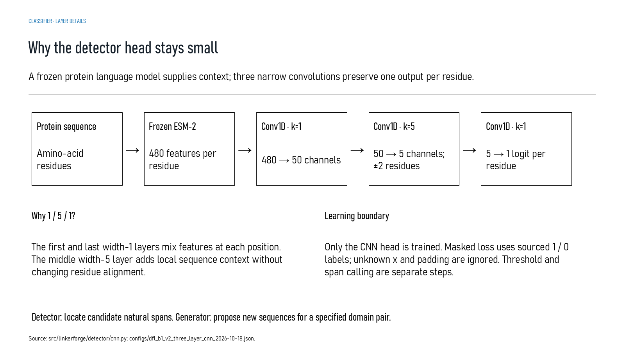
Revision 18 slide 39

Purpose and connection to the project
Explain why width-one convolutions mix features without shifting alignment and why the width-five layer introduces local context. Only the CNN head is trained.
This detector section follows the full inference path from residues to contextual embeddings, local convolutional scores and candidate intervals. Model architecture must be read together with masking, split rules, threshold freezing and the protected benchmark contract.
Why this slide matters: It shows that performance depends on more than the neural-network layers: label masks, family separation and a frozen prospective protocol are equally important.

Evidence and labels shown on the slide
The following visible elements carry the slide's scientific content. Their role and evidence level are explained in the presentation script below.
- CLASSIFIER · LAYER DETAILS
- A frozen protein language model supplies context; three narrow convolutions preserve one output per residue.
- Protein sequence
- Amino-acid residues
- Frozen ESM-2
- 480 features per residue
- Conv1D · k=1

Terms explained on this slide
DOMAIN: A protein domain is a region expected to form a recognizable three-dimensional unit. Domain boundaries are structural or annotation claims, not simply changes in sequence composition.
LINKER: A linker is the peptide segment between joined domains. Its sequence and length can influence spacing, flexibility, orientation and exposure, but cannot guarantee function.
DFL: DFL means disordered flexible linker. It is a residue-label concept used by the detector and is not synonymous with every domain gap.
DDL: DDL is a dependent-domain-linker class in the DLD structural task. It describes a structural relationship, not a fusion-success outcome.
ESM-2: ESM-2 is a protein language model. LinkerForge uses frozen per-residue embeddings from the 35-million-parameter t12 variant as detector features.
CONV1D: A one-dimensional convolution scans sequence positions. Kernel width one mixes features at the same residue; width five incorporates a local five-residue neighbourhood.
LOGIT: A logit is an unconstrained model output. A sigmoid maps it to a score between zero and one, but calibration must be demonstrated before treating that score as a probability.

Detailed interpretation of the visual
The inference path contains input, numerical representation, trainable head, residue score and interval decision. Then check which labels, masks and split rules make the result interpretable.
The object or dataset, comparison, axes, units, colours and layer dimensions define what the visual represents. The observed pattern is interpreted only within those definitions, preventing a prominent number or molecular rendering from being mistaken for broader biological proof.

Exact presentation script
This slide explains why width-one convolutions mix features without shifting alignment and why the width-five layer introduces local context. Only the CNN head is trained.
This detector section follows the full inference path from residues to contextual embeddings, local convolutional scores and candidate intervals. Model architecture must be read together with masking, split rules, threshold freezing and the protected benchmark contract.
On this slide, the concrete evidence and labels shown are: CLASSIFIER · LAYER DETAILS; A frozen protein language model supplies context; three narrow convolutions preserve one output per residue; Protein sequence; Amino-acid residues; and Frozen ESM-2. Together, these items establish exactly what was examined here, while retaining their individual evidence levels.
A protein domain is a region expected to form a recognizable three-dimensional unit. Domain boundaries are structural or annotation claims, not simply changes in sequence composition. A linker is the peptide segment between joined domains. Its sequence and length can influence spacing, flexibility, orientation and exposure, but cannot guarantee function. DFL means disordered flexible linker. It is a residue-label concept used by the detector and is not synonymous with every domain gap.
The reason this result belongs in the project is that it shows that performance depends on more than the neural-network layers: label masks, family separation and a frozen prospective protocol are equally important.
The conclusion from this slide is deliberately limited. The frozen encoder does not make the head independently validated.

Likely examiner question
Question: Why keep the detector head small?
Defensible answer: A small head limits trainable capacity and preserves residue alignment, making it easier to attribute learning to the labelled task. It still requires independent validation.

Scientific claim boundary
The frozen encoder does not make the head independently validated.
This boundary is part of the scientific interpretation, not a weakness to hide. State it clearly so the audience can distinguish what was measured from what would require prospective or experimental validation.

Slide 40 From residue scores to candidate spans
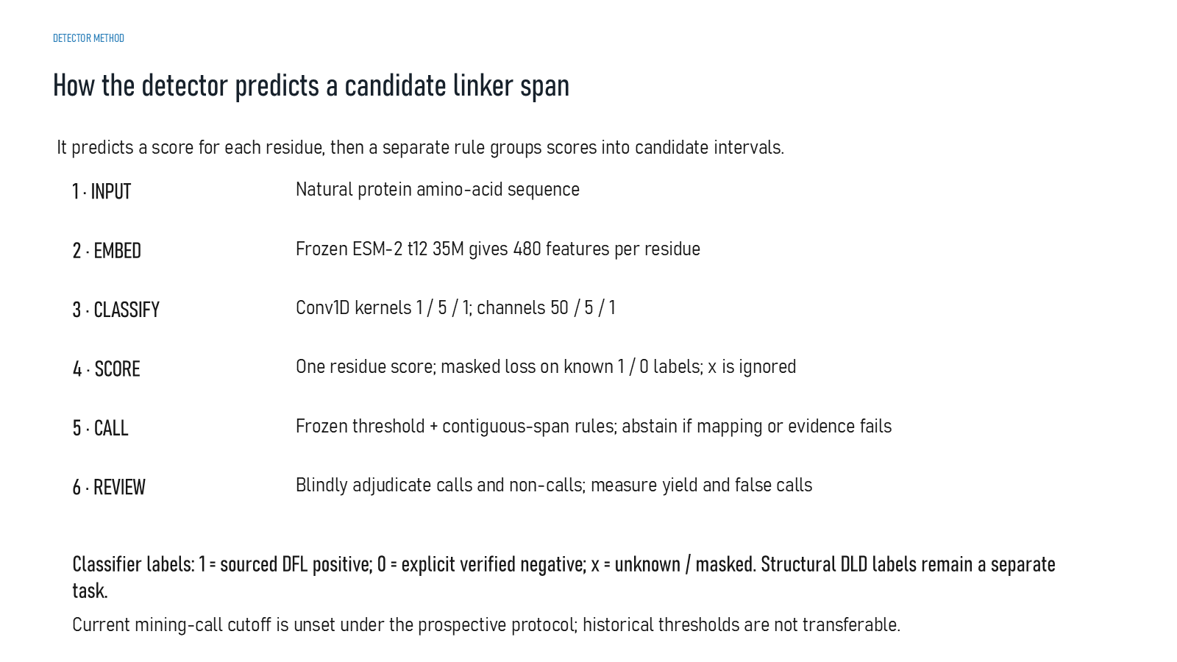
Revision 18 slide 40

Purpose and connection to the project
Separate residue scoring from interval calling. A threshold and contiguous-span rule convert scores into candidates, and abstention applies when mapping or evidence fails.
This detector section follows the full inference path from residues to contextual embeddings, local convolutional scores and candidate intervals. Model architecture must be read together with masking, split rules, threshold freezing and the protected benchmark contract.
Why this slide matters: It shows that performance depends on more than the neural-network layers: label masks, family separation and a frozen prospective protocol are equally important.

Evidence and labels shown on the slide
The following visible elements carry the slide's scientific content. Their role and evidence level are explained in the presentation script below.
- DETECTOR METHOD
- How the detector predicts a candidate linker span
- It predicts a score for each residue, then a separate rule groups scores into candidate intervals.
- Natural protein amino-acid sequence
- Frozen ESM-2 t12 35M gives 480 features per residue
- 3 · CLASSIFY
- Conv1D kernels 1 / 5 / 1; channels 50 / 5 / 1

Terms explained on this slide
LINKER: A linker is the peptide segment between joined domains. Its sequence and length can influence spacing, flexibility, orientation and exposure, but cannot guarantee function.
DFL: DFL means disordered flexible linker. It is a residue-label concept used by the detector and is not synonymous with every domain gap.
ESM-2: ESM-2 is a protein language model. LinkerForge uses frozen per-residue embeddings from the 35-million-parameter t12 variant as detector features.
CONV1D: A one-dimensional convolution scans sequence positions. Kernel width one mixes features at the same residue; width five incorporates a local five-residue neighbourhood.

Detailed interpretation of the visual
The interpretation begins with the score trace, then apply the frozen threshold, group contiguous positives and inspect interval-level rules. This explains why a residue score is not yet a final linker call.
The object or dataset, comparison, axes, units, colours and layer dimensions define what the visual represents. The observed pattern is interpreted only within those definitions, preventing a prominent number or molecular rendering from being mistaken for broader biological proof.

Exact presentation script
This slide separates residue scoring from interval calling. A threshold and contiguous-span rule convert scores into candidates, and abstention applies when mapping or evidence fails.
This detector section follows the full inference path from residues to contextual embeddings, local convolutional scores and candidate intervals. Model architecture must be read together with masking, split rules, threshold freezing and the protected benchmark contract.
On this slide, the concrete evidence and labels shown are: DETECTOR METHOD; How the detector predicts a candidate linker span; It predicts a score for each residue, then a separate rule groups scores into candidate intervals; Natural protein amino-acid sequence; and Frozen ESM-2 t12 35M gives 480 features per residue. Together, these items establish exactly what was examined here, while retaining their individual evidence levels.
A linker is the peptide segment between joined domains. Its sequence and length can influence spacing, flexibility, orientation and exposure, but cannot guarantee function. DFL means disordered flexible linker. It is a residue-label concept used by the detector and is not synonymous with every domain gap. ESM-2 is a protein language model. LinkerForge uses frozen per-residue embeddings from the 35-million-parameter t12 variant as detector features.
The reason this result belongs in the project is that it shows that performance depends on more than the neural-network layers: label masks, family separation and a frozen prospective protocol are equally important.
The conclusion from this slide is deliberately limited. Historical thresholds cannot be transferred into a new prospective protocol.

Likely examiner question
Question: What does slide 40 allow you to conclude?
Defensible answer: It supports the limited interpretation described above. The safe stopping point is: Historical thresholds cannot be transferred into a new prospective protocol.

Scientific claim boundary
Historical thresholds cannot be transferred into a new prospective protocol.
This boundary is part of the scientific interpretation, not a weakness to hide. State it clearly so the audience can distinguish what was measured from what would require prospective or experimental validation.

Slide 41 Detector training and validation gate
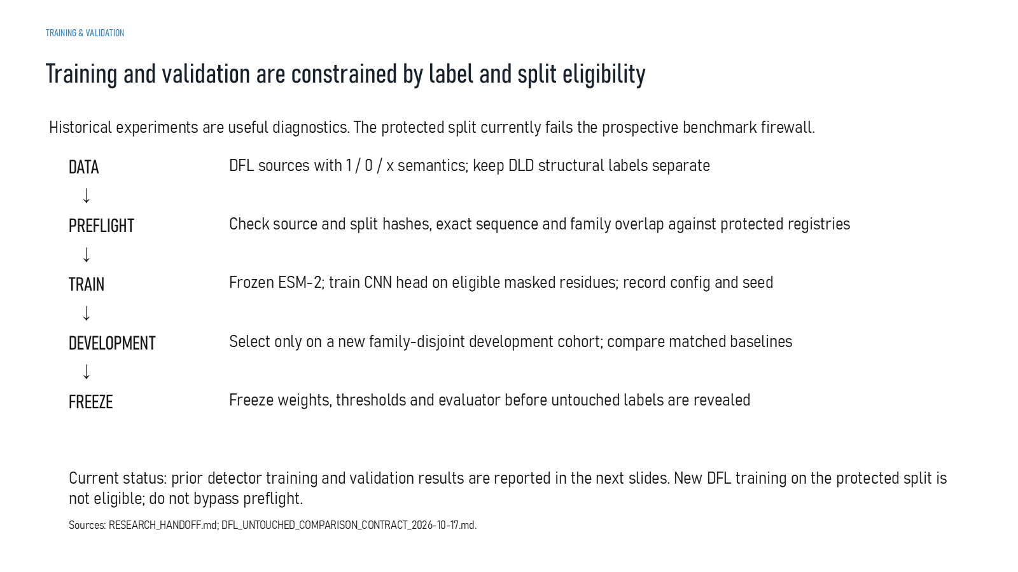
Revision 18 slide 41

Purpose and connection to the project
Explain the prospective training contract: preflight, eligible masked training, family-disjoint development, frozen selection and one-time untouched evaluation.
This detector section follows the full inference path from residues to contextual embeddings, local convolutional scores and candidate intervals. Model architecture must be read together with masking, split rules, threshold freezing and the protected benchmark contract.
Why this slide matters: It shows that performance depends on more than the neural-network layers: label masks, family separation and a frozen prospective protocol are equally important.

Evidence and labels shown on the slide
The following visible elements carry the slide's scientific content. Their role and evidence level are explained in the presentation script below.
- TRAINING & VALIDATION
- Training and validation are constrained by label and split eligibility
- Historical experiments are useful diagnostics. The protected split currently fails the prospective benchmark firewall.
- DFL sources with 1 / 0 / x semantics; keep DLD structural labels separate
- Check source and split hashes, exact sequence and family overlap against protected registries
- Frozen ESM-2; train CNN head on eligible masked residues; record config and seed
- Select only on a new family-disjoint development cohort; compare matched baselines

Terms explained on this slide
DFL: DFL means disordered flexible linker. It is a residue-label concept used by the detector and is not synonymous with every domain gap.
FAMILY-DISJOINT: A family-disjoint split keeps related protein families out of both training and evaluation, reducing memorization through homology.
ESM-2: ESM-2 is a protein language model. LinkerForge uses frozen per-residue embeddings from the 35-million-parameter t12 variant as detector features.

Detailed interpretation of the visual
The protocol follows chronological order: preflight, masked training, family-disjoint development, frozen selection and one untouched evaluation. If the preflight fails, the prospective claim stops there.
The object or dataset, comparison, axes, units, colours and layer dimensions define what the visual represents. The observed pattern is interpreted only within those definitions, preventing a prominent number or molecular rendering from being mistaken for broader biological proof.

Exact presentation script
This slide explains the prospective training contract: preflight, eligible masked training, family-disjoint development, frozen selection and one-time untouched evaluation.
This detector section follows the full inference path from residues to contextual embeddings, local convolutional scores and candidate intervals. Model architecture must be read together with masking, split rules, threshold freezing and the protected benchmark contract.
On this slide, the concrete evidence and labels shown are: TRAINING & VALIDATION; Training and validation are constrained by label and split eligibility; Historical experiments are useful diagnostics. The protected split currently fails the prospective benchmark firewall; DFL sources with 1 / 0 / x semantics; keep DLD structural labels separate; and Check source and split hashes, exact sequence and family overlap against protected registries. Together, these items establish exactly what was examined here, while retaining their individual evidence levels.
DFL means disordered flexible linker. It is a residue-label concept used by the detector and is not synonymous with every domain gap. A family-disjoint split keeps related protein families out of both training and evaluation, reducing memorization through homology. ESM-2 is a protein language model. LinkerForge uses frozen per-residue embeddings from the 35-million-parameter t12 variant as detector features.
The reason this result belongs in the project is that it shows that performance depends on more than the neural-network layers: label masks, family separation and a frozen prospective protocol are equally important.
The conclusion from this slide is deliberately limited. Public CAID3 feedback cannot guide a new model.

Likely examiner question
Question: What does slide 41 allow you to conclude?
Defensible answer: It supports the limited interpretation described above. The safe stopping point is: Public CAID3 feedback cannot guide a new model.

Scientific claim boundary
Public CAID3 feedback cannot guide a new model.
This boundary is part of the scientific interpretation, not a weakness to hide. State it clearly so the audience can distinguish what was measured from what would require prospective or experimental validation.

Slide 42 Transition from detection to generation
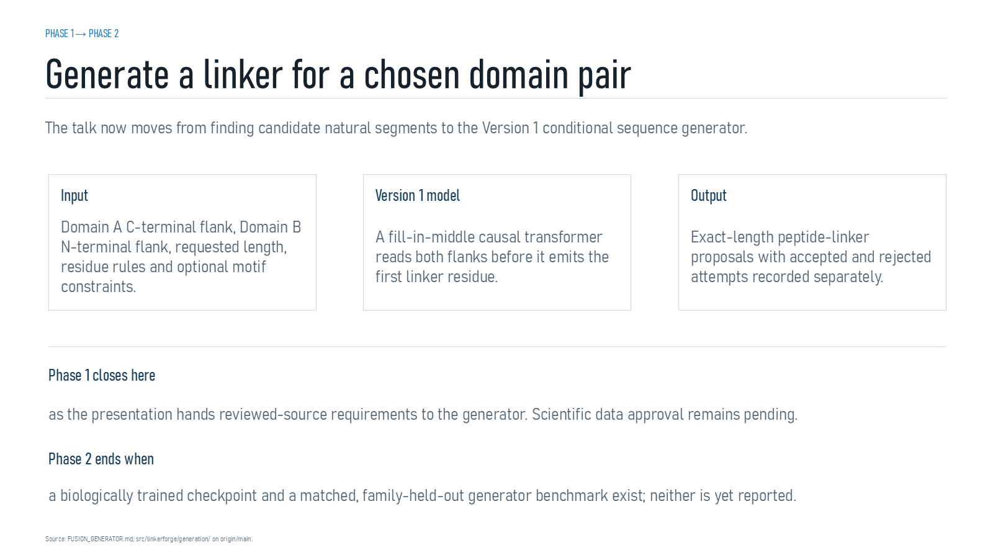
Revision 18 slide 42

Purpose and connection to the project
Mark the transition from detecting natural spans to proposing a linker for a specified domain pair. The generator still waits for approved biological training data.
This generator section describes executable conditional sequence-generation software. It explains what information enters the prompt, what parameters are trained, how exact length and constraints are enforced and why a synthetic smoke test cannot substitute for training on reviewed biological examples.
Why this slide matters: It separates a working model implementation from a scientifically trained generator and makes the required training evidence explicit.

Evidence and labels shown on the slide
The following visible elements carry the slide's scientific content. Their role and evidence level are explained in the presentation script below.
- PHASE 1 → PHASE 2
- Generate a linker for a chosen domain pair
- The talk now moves from finding candidate natural segments to the Version 1 conditional sequence generator.
- Domain A C-terminal flank, Domain B N-terminal flank, requested length, residue rules and optional motif constraints.
- Version 1 model
- A fill-in-middle causal transformer reads both flanks before it emits the first linker residue.
- Exact-length peptide-linker proposals with accepted and rejected attempts recorded separately.

Terms explained on this slide
DOMAIN: A protein domain is a region expected to form a recognizable three-dimensional unit. Domain boundaries are structural or annotation claims, not simply changes in sequence composition.
LINKER: A linker is the peptide segment between joined domains. Its sequence and length can influence spacing, flexibility, orientation and exposure, but cannot guarantee function.
DDL: DDL is a dependent-domain-linker class in the DLD structural task. It describes a structural relationship, not a fusion-success outcome.
TRANSFORMER: A transformer models relationships among tokens using attention and feed-forward layers. Version 1 is causal, so each generated residue can use the prompt and earlier linker residues but not future residues.

Detailed interpretation of the visual
Domain context and control tokens into the model, then distinguish learned residue probabilities from deterministic constraints and rejection rules.
The object or dataset, comparison, axes, units, colours and layer dimensions define what the visual represents. The observed pattern is interpreted only within those definitions, preventing a prominent number or molecular rendering from being mistaken for broader biological proof.

Exact presentation script
This slide marks the transition from detecting natural spans to proposing a linker for a specified domain pair. The generator still waits for approved biological training data.
This generator section describes executable conditional sequence-generation software. It explains what information enters the prompt, what parameters are trained, how exact length and constraints are enforced and why a synthetic smoke test cannot substitute for training on reviewed biological examples.
On this slide, the concrete evidence and labels shown are: PHASE 1 → PHASE 2; Generate a linker for a chosen domain pair; The talk now moves from finding candidate natural segments to the Version 1 conditional sequence generator; Domain A C-terminal flank, Domain B N-terminal flank, requested length, residue rules and optional motif constraints; and Version 1 model. Together, these items establish exactly what was examined here, while retaining their individual evidence levels.
A protein domain is a region expected to form a recognizable three-dimensional unit. Domain boundaries are structural or annotation claims, not simply changes in sequence composition. A linker is the peptide segment between joined domains. Its sequence and length can influence spacing, flexibility, orientation and exposure, but cannot guarantee function. DDL is a dependent-domain-linker class in the DLD structural task. It describes a structural relationship, not a fusion-success outcome.
The reason this result belongs in the project is that it separates a working model implementation from a scientifically trained generator and makes the required training evidence explicit.
The conclusion from this slide is deliberately limited. Phase 2 begins with implemented software and pending scientific data approval.

Likely examiner question
Question: What does slide 42 allow you to conclude?
Defensible answer: It supports the limited interpretation described above. The safe stopping point is: Phase 2 begins with implemented software and pending scientific data approval.

Scientific claim boundary
Phase 2 begins with implemented software and pending scientific data approval.
This boundary is part of the scientific interpretation, not a weakness to hide. State it clearly so the audience can distinguish what was measured from what would require prospective or experimental validation.

Slide 43 Version 1 conditional generator
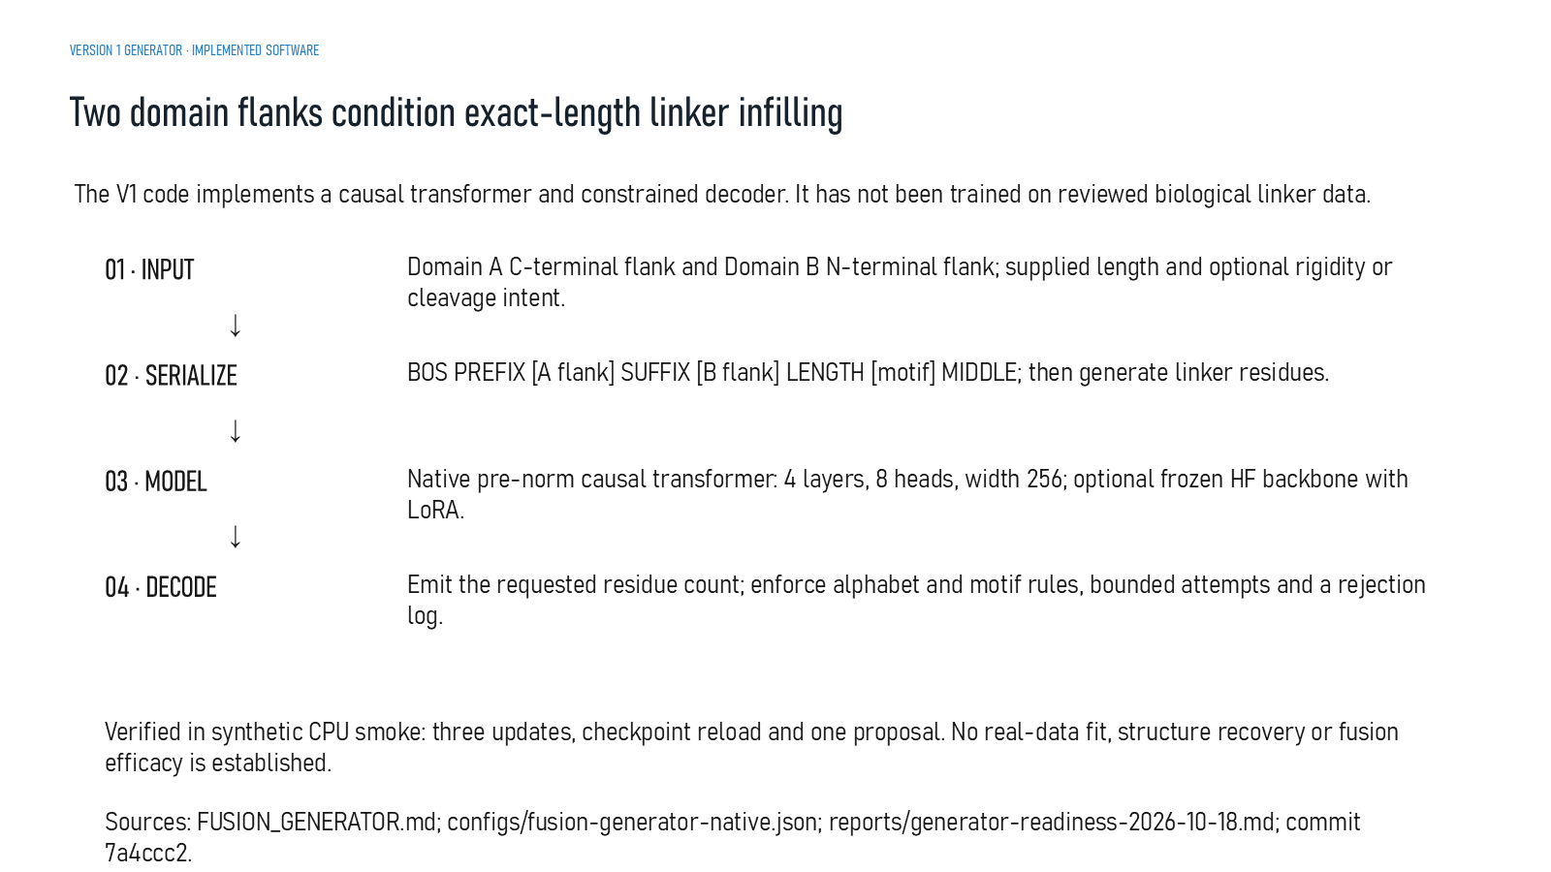
Revision 18 slide 43

Purpose and connection to the project
Describe Version 1 as a two-flank, known-length conditional causal transformer with constrained decoding. Only a synthetic software smoke test has run.
This generator section describes executable conditional sequence-generation software. It explains what information enters the prompt, what parameters are trained, how exact length and constraints are enforced and why a synthetic smoke test cannot substitute for training on reviewed biological examples.
Why this slide matters: It separates a working model implementation from a scientifically trained generator and makes the required training evidence explicit.

Evidence and labels shown on the slide
The following visible elements carry the slide's scientific content. Their role and evidence level are explained in the presentation script below.
- VERSION 1 GENERATOR · IMPLEMENTED SOFTWARE
- Two domain flanks condition exact-length linker infilling
- The V1 code implements a causal transformer and constrained decoder. It has not been trained on reviewed biological linker data.
- Domain A C-terminal flank and Domain B N-terminal flank; supplied length and optional rigidity or cleavage intent.
- 02 · SERIALIZE
- BOS PREFIX [A flank] SUFFIX [B flank] LENGTH [motif] MIDDLE; then generate linker residues.
- Native pre-norm causal transformer: 4 layers, 8 heads, width 256; optional frozen HF backbone with LoRA.

Terms explained on this slide
DOMAIN: A protein domain is a region expected to form a recognizable three-dimensional unit. Domain boundaries are structural or annotation claims, not simply changes in sequence composition.
LINKER: A linker is the peptide segment between joined domains. Its sequence and length can influence spacing, flexibility, orientation and exposure, but cannot guarantee function.
DDL: DDL is a dependent-domain-linker class in the DLD structural task. It describes a structural relationship, not a fusion-success outcome.
TRANSFORMER: A transformer models relationships among tokens using attention and feed-forward layers. Version 1 is causal, so each generated residue can use the prompt and earlier linker residues but not future residues.
LORA: LoRA trains low-rank adapter parameters around a frozen pretrained model. LinkerForge implements an optional route but has not selected and validated a biological checkpoint for it.
CONSTRAINED DECODING: Constrained decoding enforces rules such as exact length, canonical residues, forced motifs and bounded retries while sampling. Rule compliance is not evidence of biological compatibility.

Detailed interpretation of the visual
The conditional input moves through the transformer to exact-length residue proposals. Separate architectural capability from biological training status.
The object or dataset, comparison, axes, units, colours and layer dimensions define what the visual represents. The observed pattern is interpreted only within those definitions, preventing a prominent number or molecular rendering from being mistaken for broader biological proof.

Exact presentation script
This slide describes Version 1 as a two-flank, known-length conditional causal transformer with constrained decoding. Only a synthetic software smoke test has run.
This generator section describes executable conditional sequence-generation software. It explains what information enters the prompt, what parameters are trained, how exact length and constraints are enforced and why a synthetic smoke test cannot substitute for training on reviewed biological examples.
On this slide, the concrete evidence and labels shown are: VERSION 1 GENERATOR · IMPLEMENTED SOFTWARE; Two domain flanks condition exact-length linker infilling; The V1 code implements a causal transformer and constrained decoder. It has not been trained on reviewed biological linker data; Domain A C-terminal flank and Domain B N-terminal flank; supplied length and optional rigidity or cleavage intent; and 02 · SERIALIZE. Together, these items establish exactly what was examined here, while retaining their individual evidence levels.
A protein domain is a region expected to form a recognizable three-dimensional unit. Domain boundaries are structural or annotation claims, not simply changes in sequence composition. A linker is the peptide segment between joined domains. Its sequence and length can influence spacing, flexibility, orientation and exposure, but cannot guarantee function. DDL is a dependent-domain-linker class in the DLD structural task. It describes a structural relationship, not a fusion-success outcome.
The reason this result belongs in the project is that it separates a working model implementation from a scientifically trained generator and makes the required training evidence explicit.
The conclusion from this slide is deliberately limited. Synthetic smoke testing does not establish biological sequence quality.

Likely examiner question
Question: Is Version 1 already a trained biological generator?
Defensible answer: No. The architecture, trainer and decoder execute, but only a synthetic three-update smoke test has been completed. Reviewed biological weights do not yet exist.

Scientific claim boundary
Synthetic smoke testing does not establish biological sequence quality.
This boundary is part of the scientific interpretation, not a weakness to hide. State it clearly so the audience can distinguish what was measured from what would require prospective or experimental validation.

Slide 44 Generator data handoff
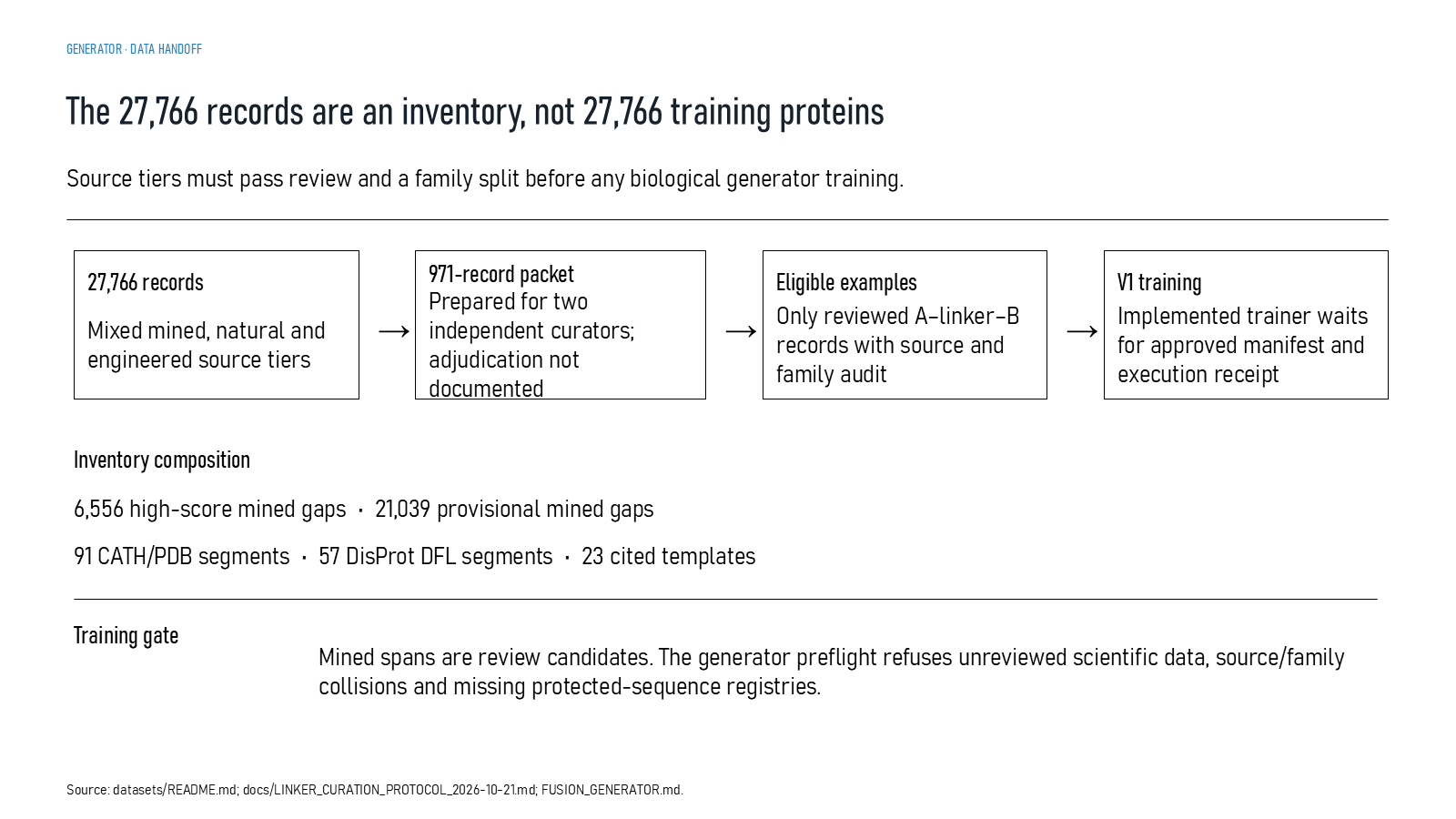
Revision 18 slide 44

Purpose and connection to the project
Explain why the 27,766-row inventory cannot directly train the generator. Only reviewed A-linker-B records with source and family audits are eligible.
This generator section describes executable conditional sequence-generation software. It explains what information enters the prompt, what parameters are trained, how exact length and constraints are enforced and why a synthetic smoke test cannot substitute for training on reviewed biological examples.
Why this slide matters: It separates a working model implementation from a scientifically trained generator and makes the required training evidence explicit.

Evidence and labels shown on the slide
The following visible elements carry the slide's scientific content. Their role and evidence level are explained in the presentation script below.
- GENERATOR · DATA HANDOFF
- The 27,766 records are an inventory, not 27,766 training proteins
- Source tiers must pass review and a family split before any biological generator training.
- 27,766 records
- Mixed mined, natural and engineered source tiers
- 971-record packet
- Prepared for two independent curators; adjudication not documented

Terms explained on this slide
LINKER: A linker is the peptide segment between joined domains. Its sequence and length can influence spacing, flexibility, orientation and exposure, but cannot guarantee function.
DFL: DFL means disordered flexible linker. It is a residue-label concept used by the detector and is not synonymous with every domain gap.
CURATION: Curation is a documented human review process that resolves coordinates, labels, evidence quality and eligibility. Preparing a review packet is not the same as completing adjudication.
APS: Average precision score summarizes the precision-recall curve and is useful for imbalanced labels. It depends on the dataset and cannot be compared across unrelated tasks as a universal score.

Detailed interpretation of the visual
Domain context and control tokens into the model, then distinguish learned residue probabilities from deterministic constraints and rejection rules.
The object or dataset, comparison, axes, units, colours and layer dimensions define what the visual represents. The observed pattern is interpreted only within those definitions, preventing a prominent number or molecular rendering from being mistaken for broader biological proof.

Exact presentation script
This slide explains why the 27,766-row inventory cannot directly train the generator. Only reviewed A-linker-B records with source and family audits are eligible.
This generator section describes executable conditional sequence-generation software. It explains what information enters the prompt, what parameters are trained, how exact length and constraints are enforced and why a synthetic smoke test cannot substitute for training on reviewed biological examples.
On this slide, the concrete evidence and labels shown are: GENERATOR · DATA HANDOFF; The 27,766 records are an inventory, not 27,766 training proteins; Source tiers must pass review and a family split before any biological generator training; 27,766 records; and Mixed mined, natural and engineered source tiers. Together, these items establish exactly what was examined here, while retaining their individual evidence levels.
A linker is the peptide segment between joined domains. Its sequence and length can influence spacing, flexibility, orientation and exposure, but cannot guarantee function. DFL means disordered flexible linker. It is a residue-label concept used by the detector and is not synonymous with every domain gap. Curation is a documented human review process that resolves coordinates, labels, evidence quality and eligibility. Preparing a review packet is not the same as completing adjudication.
The reason this result belongs in the project is that it separates a working model implementation from a scientifically trained generator and makes the required training evidence explicit.
The conclusion from this slide is deliberately limited. The unreviewed mined candidates are not being treated as training truth.

Likely examiner question
Question: What does slide 44 allow you to conclude?
Defensible answer: It supports the limited interpretation described above. The safe stopping point is: Do not train on unreviewed mined candidates as if they were truth.

Scientific claim boundary
Do not train on unreviewed mined candidates as if they were truth.
This boundary is part of the scientific interpretation, not a weakness to hide. State it clearly so the audience can distinguish what was measured from what would require prospective or experimental validation.

Slide 45 Generator input serialization
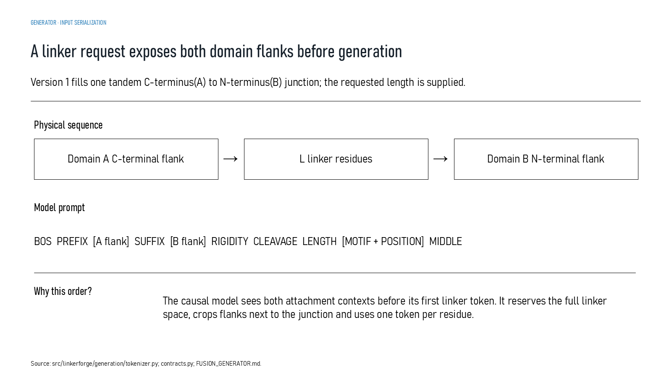
Revision 18 slide 45

Purpose and connection to the project
Explain the fill-in-middle prompt. Both attachment flanks and control tokens appear before the model emits the first linker residue.
This generator section describes executable conditional sequence-generation software. It explains what information enters the prompt, what parameters are trained, how exact length and constraints are enforced and why a synthetic smoke test cannot substitute for training on reviewed biological examples.
Why this slide matters: It separates a working model implementation from a scientifically trained generator and makes the required training evidence explicit.

Evidence and labels shown on the slide
The following visible elements carry the slide's scientific content. Their role and evidence level are explained in the presentation script below.
- GENERATOR · INPUT SERIALIZATION
- A linker request exposes both domain flanks before generation
- Version 1 fills one tandem C-terminus(A) to N-terminus(B) junction; the requested length is supplied.
- Physical sequence
- Domain A C-terminal flank
- L linker residues
- Domain B N-terminal flank

Terms explained on this slide
DOMAIN: A protein domain is a region expected to form a recognizable three-dimensional unit. Domain boundaries are structural or annotation claims, not simply changes in sequence composition.
LINKER: A linker is the peptide segment between joined domains. Its sequence and length can influence spacing, flexibility, orientation and exposure, but cannot guarantee function.
DDL: DDL is a dependent-domain-linker class in the DLD structural task. It describes a structural relationship, not a fusion-success outcome.

Detailed interpretation of the visual
The serialized prompt runs left to right. Both attachment flanks and control tokens are visible before the MIDDLE marker; only after that marker does the model emit linker residues.
The object or dataset, comparison, axes, units, colours and layer dimensions define what the visual represents. The observed pattern is interpreted only within those definitions, preventing a prominent number or molecular rendering from being mistaken for broader biological proof.

Exact presentation script
This slide explains the fill-in-middle prompt. Both attachment flanks and control tokens appear before the model emits the first linker residue.
This generator section describes executable conditional sequence-generation software. It explains what information enters the prompt, what parameters are trained, how exact length and constraints are enforced and why a synthetic smoke test cannot substitute for training on reviewed biological examples.
On this slide, the concrete evidence and labels shown are: GENERATOR · INPUT SERIALIZATION; A linker request exposes both domain flanks before generation; Version 1 fills one tandem C-terminus(A) to N-terminus(B) junction; the requested length is supplied; Physical sequence; and Domain A C-terminal flank. Together, these items establish exactly what was examined here, while retaining their individual evidence levels.
A protein domain is a region expected to form a recognizable three-dimensional unit. Domain boundaries are structural or annotation claims, not simply changes in sequence composition. A linker is the peptide segment between joined domains. Its sequence and length can influence spacing, flexibility, orientation and exposure, but cannot guarantee function. DDL is a dependent-domain-linker class in the DLD structural task. It describes a structural relationship, not a fusion-success outcome.
The reason this result belongs in the project is that it separates a working model implementation from a scientifically trained generator and makes the required training evidence explicit.
The conclusion from this slide is deliberately limited. The requested length is supplied rather than predicted.

Likely examiner question
Question: What does slide 45 allow you to conclude?
Defensible answer: It supports the limited interpretation described above. The safe stopping point is: The requested length is supplied rather than predicted.

Scientific claim boundary
The requested length is supplied rather than predicted.
This boundary is part of the scientific interpretation, not a weakness to hide. State it clearly so the audience can distinguish what was measured from what would require prospective or experimental validation.

Slide 46 Generator transformer architecture
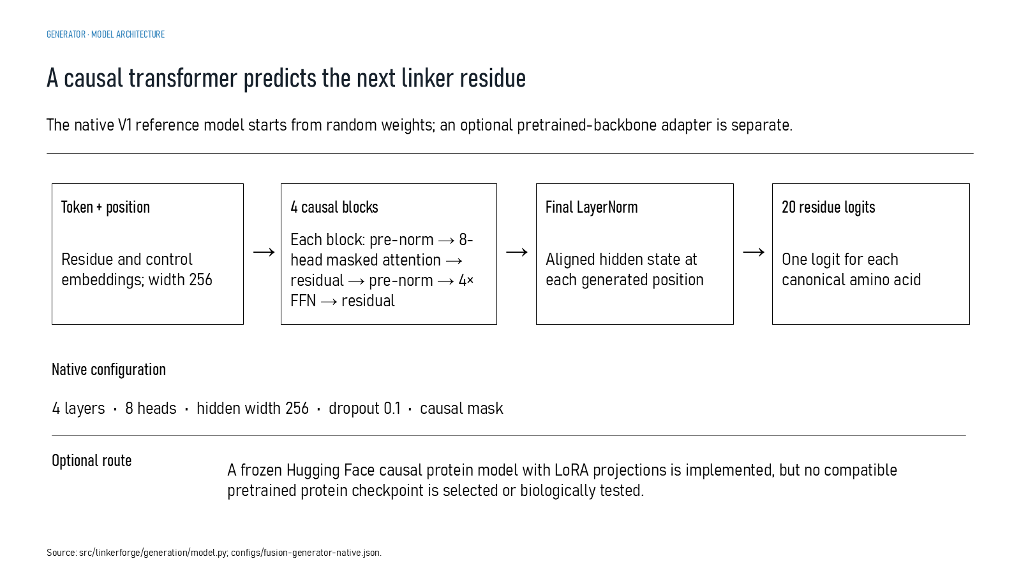
Revision 18 slide 46

Purpose and connection to the project
Describe the native 4-layer, 8-head, width-256 transformer and its 20 amino-acid logits. The optional frozen Hugging Face plus LoRA route has no selected biological checkpoint.
This generator section describes executable conditional sequence-generation software. It explains what information enters the prompt, what parameters are trained, how exact length and constraints are enforced and why a synthetic smoke test cannot substitute for training on reviewed biological examples.
Why this slide matters: It separates a working model implementation from a scientifically trained generator and makes the required training evidence explicit.

Evidence and labels shown on the slide
The following visible elements carry the slide's scientific content. Their role and evidence level are explained in the presentation script below.
- GENERATOR · MODEL ARCHITECTURE
- A causal transformer predicts the next linker residue
- The native V1 reference model starts from random weights; an optional pretrained-backbone adapter is separate.
- Token + position
- Residue and control embeddings; width 256
- 4 causal blocks
- Each block: pre-norm → 8-head masked attention → residual → pre-norm → 4× FFN → residual

Terms explained on this slide
AMINO ACID: An amino acid is one residue in a protein chain. Twenty canonical amino acids are used by the Version 1 generator vocabulary.
LINKER: A linker is the peptide segment between joined domains. Its sequence and length can influence spacing, flexibility, orientation and exposure, but cannot guarantee function.
EMBEDDING: An embedding is a numerical vector representing sequence context. It is a learned representation, not a biological measurement.
LOGIT: A logit is an unconstrained model output. A sigmoid maps it to a score between zero and one, but calibration must be demonstrated before treating that score as a probability.
TRANSFORMER: A transformer models relationships among tokens using attention and feed-forward layers. Version 1 is causal, so each generated residue can use the prompt and earlier linker residues but not future residues.
ATTENTION: Attention forms weighted combinations of token representations. Multiple heads can learn different relationships, but attention weights are not automatically biological explanations.
LORA: LoRA trains low-rank adapter parameters around a frozen pretrained model. LinkerForge implements an optional route but has not selected and validated a biological checkpoint for it.

Detailed interpretation of the visual
The architecture consists of token embedding, four pre-normalized causal blocks, final normalization and a 20-amino-acid output head. The causal mask prevents access to future linker residues.
The object or dataset, comparison, axes, units, colours and layer dimensions define what the visual represents. The observed pattern is interpreted only within those definitions, preventing a prominent number or molecular rendering from being mistaken for broader biological proof.

Exact presentation script
This slide describes the native 4-layer, 8-head, width-256 transformer and its 20 amino-acid logits. The optional frozen Hugging Face plus LoRA route has no selected biological checkpoint.
This generator section describes executable conditional sequence-generation software. It explains what information enters the prompt, what parameters are trained, how exact length and constraints are enforced and why a synthetic smoke test cannot substitute for training on reviewed biological examples.
On this slide, the concrete evidence and labels shown are: GENERATOR · MODEL ARCHITECTURE; A causal transformer predicts the next linker residue; The native V1 reference model starts from random weights; an optional pretrained-backbone adapter is separate; Token + position; and Residue and control embeddings; width 256. Together, these items establish exactly what was examined here, while retaining their individual evidence levels.
An amino acid is one residue in a protein chain. Twenty canonical amino acids are used by the Version 1 generator vocabulary. A linker is the peptide segment between joined domains. Its sequence and length can influence spacing, flexibility, orientation and exposure, but cannot guarantee function. An embedding is a numerical vector representing sequence context. It is a learned representation, not a biological measurement.
The reason this result belongs in the project is that it separates a working model implementation from a scientifically trained generator and makes the required training evidence explicit.
The conclusion from this slide is deliberately limited. The native transformer begins from random weights; the optional pretrained route is unselected.

Likely examiner question
Question: Why use a causal transformer for fill-in-the-middle?
Defensible answer: Both flanks are placed in the prompt before generation. Causal attention can therefore condition on both attachment contexts while still predicting the linker one residue at a time.

Scientific claim boundary
The native transformer begins from random weights; the optional pretrained route is unselected.
This boundary is part of the scientific interpretation, not a weakness to hide. State it clearly so the audience can distinguish what was measured from what would require prospective or experimental validation.

Slide 47 Generator training objective
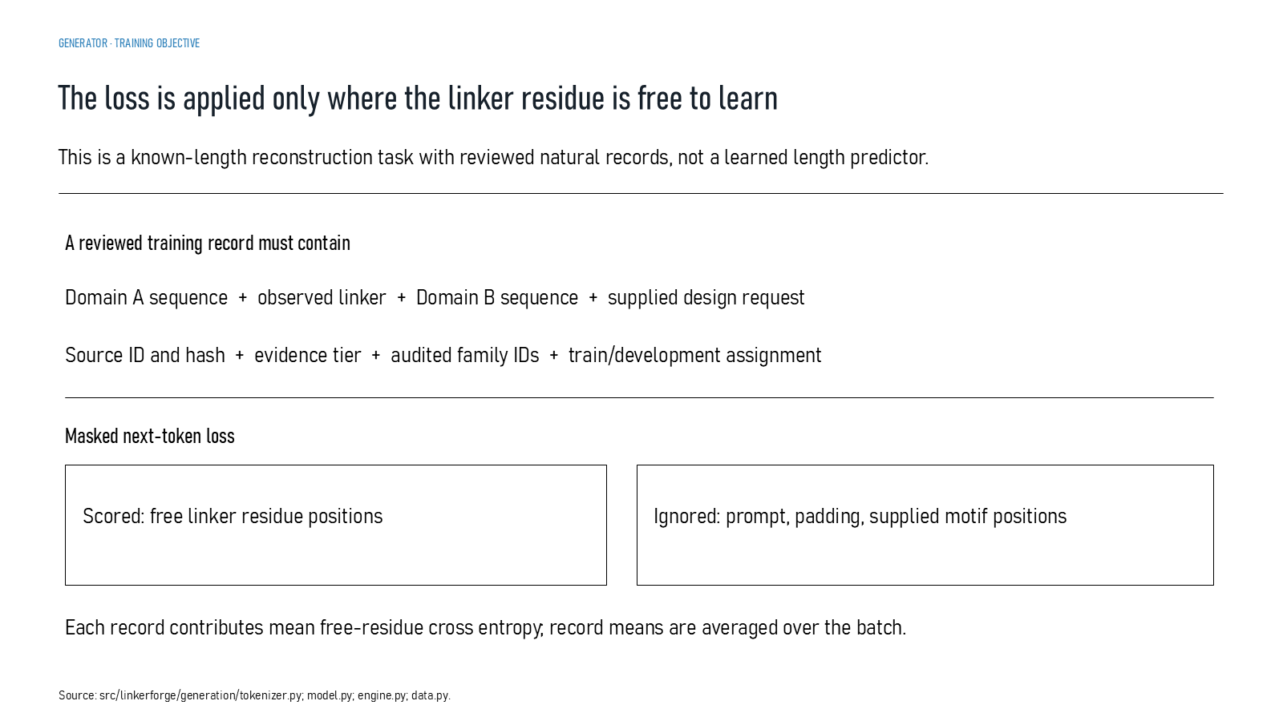
Revision 18 slide 47

Purpose and connection to the project
Explain masked next-token cross entropy. Only free linker positions contribute to the loss; prompt, padding and supplied motif positions are ignored.
This generator section describes executable conditional sequence-generation software. It explains what information enters the prompt, what parameters are trained, how exact length and constraints are enforced and why a synthetic smoke test cannot substitute for training on reviewed biological examples.
Why this slide matters: It separates a working model implementation from a scientifically trained generator and makes the required training evidence explicit.

Evidence and labels shown on the slide
The following visible elements carry the slide's scientific content. Their role and evidence level are explained in the presentation script below.
- GENERATOR · TRAINING OBJECTIVE
- The loss is applied only where the linker residue is free to learn
- This is a known-length reconstruction task with reviewed natural records, not a learned length predictor.
- A reviewed training record must contain
- Domain A sequence + observed linker + Domain B sequence + supplied design request
- Source ID and hash + evidence tier + audited family IDs + train/development assignment
- Masked next-token loss

Terms explained on this slide
DOMAIN: A protein domain is a region expected to form a recognizable three-dimensional unit. Domain boundaries are structural or annotation claims, not simply changes in sequence composition.
LINKER: A linker is the peptide segment between joined domains. Its sequence and length can influence spacing, flexibility, orientation and exposure, but cannot guarantee function.
CROSS ENTROPY: Cross entropy penalizes disagreement between predicted residue probabilities and the known next residue. LinkerForge masks prompt, padding and forced positions so only free linker residues contribute.

Detailed interpretation of the visual
The scored and ignored positions are separated and which are ignored. The loss covers free linker residues only; it excludes prompt tokens, padding and any forced motif positions.
The object or dataset, comparison, axes, units, colours and layer dimensions define what the visual represents. The observed pattern is interpreted only within those definitions, preventing a prominent number or molecular rendering from being mistaken for broader biological proof.

Exact presentation script
This slide explains masked next-token cross entropy. Only free linker positions contribute to the loss; prompt, padding and supplied motif positions are ignored.
This generator section describes executable conditional sequence-generation software. It explains what information enters the prompt, what parameters are trained, how exact length and constraints are enforced and why a synthetic smoke test cannot substitute for training on reviewed biological examples.
On this slide, the concrete evidence and labels shown are: GENERATOR · TRAINING OBJECTIVE; The loss is applied only where the linker residue is free to learn; This is a known-length reconstruction task with reviewed natural records, not a learned length predictor; A reviewed training record must contain; and Domain A sequence + observed linker + Domain B sequence + supplied design request. Together, these items establish exactly what was examined here, while retaining their individual evidence levels.
A protein domain is a region expected to form a recognizable three-dimensional unit. Domain boundaries are structural or annotation claims, not simply changes in sequence composition. A linker is the peptide segment between joined domains. Its sequence and length can influence spacing, flexibility, orientation and exposure, but cannot guarantee function. Cross entropy penalizes disagreement between predicted residue probabilities and the known next residue. LinkerForge masks prompt, padding and forced positions so only free linker residues contribute.
The reason this result belongs in the project is that it separates a working model implementation from a scientifically trained generator and makes the required training evidence explicit.
The conclusion from this slide is deliberately limited. Known-length reconstruction is not length prediction.

Likely examiner question
Question: What does slide 47 allow you to conclude?
Defensible answer: It supports the limited interpretation described above. The safe stopping point is: Known-length reconstruction is not length prediction.

Scientific claim boundary
Known-length reconstruction is not length prediction.
This boundary is part of the scientific interpretation, not a weakness to hide. State it clearly so the audience can distinguish what was measured from what would require prospective or experimental validation.

Slide 48 Generator training implementation
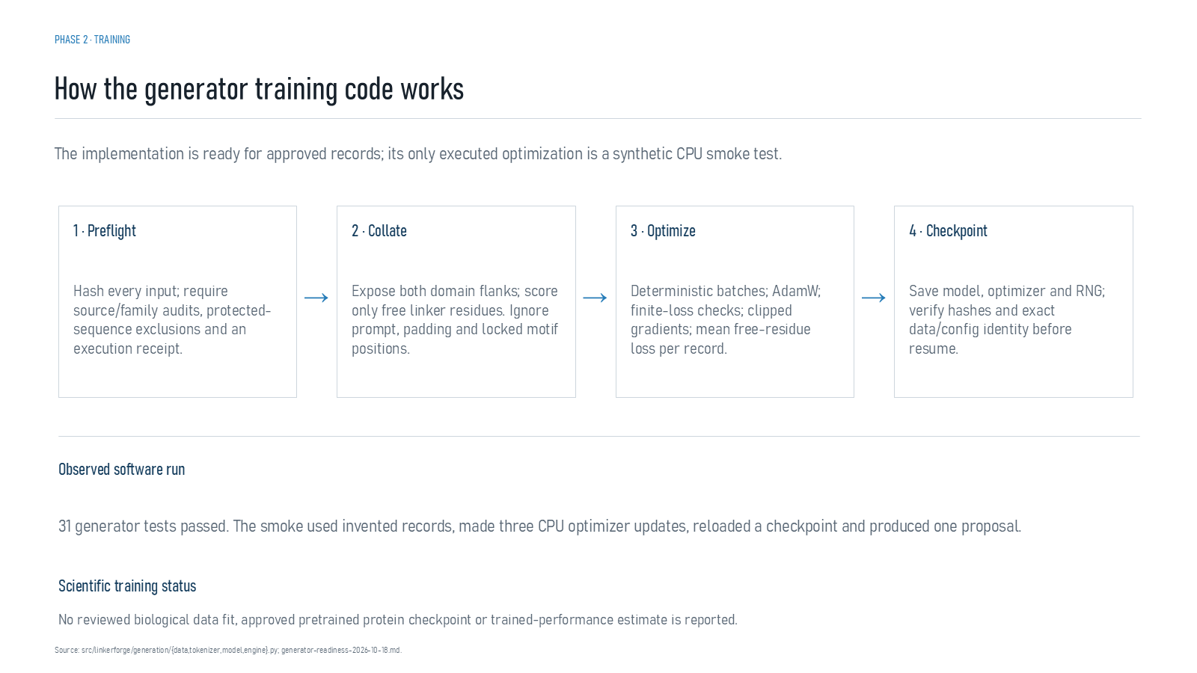
Revision 18 slide 48

Purpose and connection to the project
Walk through preflight, collation, AdamW optimisation and provenance-preserving checkpoints. The only executed optimisation used invented records for three CPU updates.
This generator section describes executable conditional sequence-generation software. It explains what information enters the prompt, what parameters are trained, how exact length and constraints are enforced and why a synthetic smoke test cannot substitute for training on reviewed biological examples.
Why this slide matters: It separates a working model implementation from a scientifically trained generator and makes the required training evidence explicit.

Evidence and labels shown on the slide
The following visible elements carry the slide's scientific content. Their role and evidence level are explained in the presentation script below.
- PHASE 2 · TRAINING
- How the generator training code works
- The implementation is ready for approved records; its only executed optimization is a synthetic CPU smoke test.
- 1 · Preflight
- Hash every input; require source/family audits, protected-sequence exclusions and an execution receipt.
- Expose both domain flanks; score only free linker residues. Ignore prompt, padding and locked motif positions.
- 3 · Optimize

Terms explained on this slide
DOMAIN: A protein domain is a region expected to form a recognizable three-dimensional unit. Domain boundaries are structural or annotation claims, not simply changes in sequence composition.
LINKER: A linker is the peptide segment between joined domains. Its sequence and length can influence spacing, flexibility, orientation and exposure, but cannot guarantee function.
PROVENANCE: Provenance is the recorded origin and transformation history of a datum, model, prediction or figure, including source identifiers, code revision and configuration.

Detailed interpretation of the visual
Domain context and control tokens into the model, then distinguish learned residue probabilities from deterministic constraints and rejection rules.
The object or dataset, comparison, axes, units, colours and layer dimensions define what the visual represents. The observed pattern is interpreted only within those definitions, preventing a prominent number or molecular rendering from being mistaken for broader biological proof.

Exact presentation script
This slide follows preflight, collation, AdamW optimisation and provenance-preserving checkpoints. The only executed optimisation used invented records for three CPU updates.
This generator section describes executable conditional sequence-generation software. It explains what information enters the prompt, what parameters are trained, how exact length and constraints are enforced and why a synthetic smoke test cannot substitute for training on reviewed biological examples.
On this slide, the concrete evidence and labels shown are: PHASE 2 · TRAINING; How the generator training code works; The implementation is ready for approved records; its only executed optimization is a synthetic CPU smoke test; 1 · Preflight; and Hash every input; require source/family audits, protected-sequence exclusions and an execution receipt. Together, these items establish exactly what was examined here, while retaining their individual evidence levels.
A protein domain is a region expected to form a recognizable three-dimensional unit. Domain boundaries are structural or annotation claims, not simply changes in sequence composition. A linker is the peptide segment between joined domains. Its sequence and length can influence spacing, flexibility, orientation and exposure, but cannot guarantee function. Provenance is the recorded origin and transformation history of a datum, model, prediction or figure, including source identifiers, code revision and configuration.
The reason this result belongs in the project is that it separates a working model implementation from a scientifically trained generator and makes the required training evidence explicit.
The conclusion from this slide is deliberately limited. Three synthetic updates are an execution test only.

Likely examiner question
Question: What does slide 48 allow you to conclude?
Defensible answer: It supports the limited interpretation described above. The safe stopping point is: Three synthetic updates are an execution test only.

Scientific claim boundary
Three synthetic updates are an execution test only.
This boundary is part of the scientific interpretation, not a weakness to hide. State it clearly so the audience can distinguish what was measured from what would require prospective or experimental validation.

Slide 49 Generator benchmarking plan
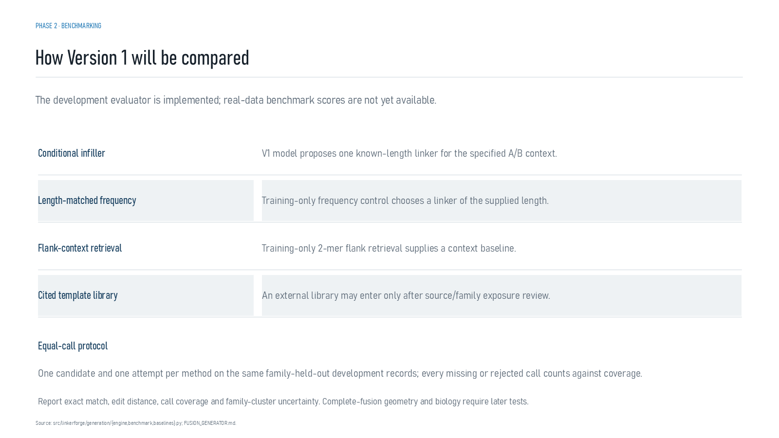
Revision 18 slide 49

Purpose and connection to the project
Explain the planned equal-call comparison among conditional infilling, length-matched frequency, flank-context retrieval and a cited template library.
This generator section describes executable conditional sequence-generation software. It explains what information enters the prompt, what parameters are trained, how exact length and constraints are enforced and why a synthetic smoke test cannot substitute for training on reviewed biological examples.
Why this slide matters: It separates a working model implementation from a scientifically trained generator and makes the required training evidence explicit.

Evidence and labels shown on the slide
The following visible elements carry the slide's scientific content. Their role and evidence level are explained in the presentation script below.
- PHASE 2 · BENCHMARKING
- How Version 1 will be compared
- The development evaluator is implemented; real-data benchmark scores are not yet available.
- Conditional infiller
- V1 model proposes one known-length linker for the specified A/B context.
- Length-matched frequency
- Training-only frequency control chooses a linker of the supplied length.

Terms explained on this slide
LINKER: A linker is the peptide segment between joined domains. Its sequence and length can influence spacing, flexibility, orientation and exposure, but cannot guarantee function.

Detailed interpretation of the visual
The methods are compared row by row under equal candidate budgets and matched downstream scoring. A fair comparison changes the proposal method while holding the evaluation funnel constant.
The object or dataset, comparison, axes, units, colours and layer dimensions define what the visual represents. The observed pattern is interpreted only within those definitions, preventing a prominent number or molecular rendering from being mistaken for broader biological proof.

Exact presentation script
This slide explains the planned equal-call comparison among conditional infilling, length-matched frequency, flank-context retrieval and a cited template library.
This generator section describes executable conditional sequence-generation software. It explains what information enters the prompt, what parameters are trained, how exact length and constraints are enforced and why a synthetic smoke test cannot substitute for training on reviewed biological examples.
On this slide, the concrete evidence and labels shown are: PHASE 2 · BENCHMARKING; How Version 1 will be compared; The development evaluator is implemented; real-data benchmark scores are not yet available; Conditional infiller; and V1 model proposes one known-length linker for the specified A/B context. Together, these items establish exactly what was examined here, while retaining their individual evidence levels.
A linker is the peptide segment between joined domains. Its sequence and length can influence spacing, flexibility, orientation and exposure, but cannot guarantee function.
The reason this result belongs in the project is that it separates a working model implementation from a scientifically trained generator and makes the required training evidence explicit.
The conclusion from this slide is deliberately limited. Benchmark scores are not yet available.

Likely examiner question
Question: What does slide 49 allow you to conclude?
Defensible answer: It supports the limited interpretation described above. The safe stopping point is: Benchmark scores are not yet available.

Scientific claim boundary
Benchmark scores are not yet available.
This boundary is part of the scientific interpretation, not a weakness to hide. State it clearly so the audience can distinguish what was measured from what would require prospective or experimental validation.

Slide 50 Constrained decoding and rejection records
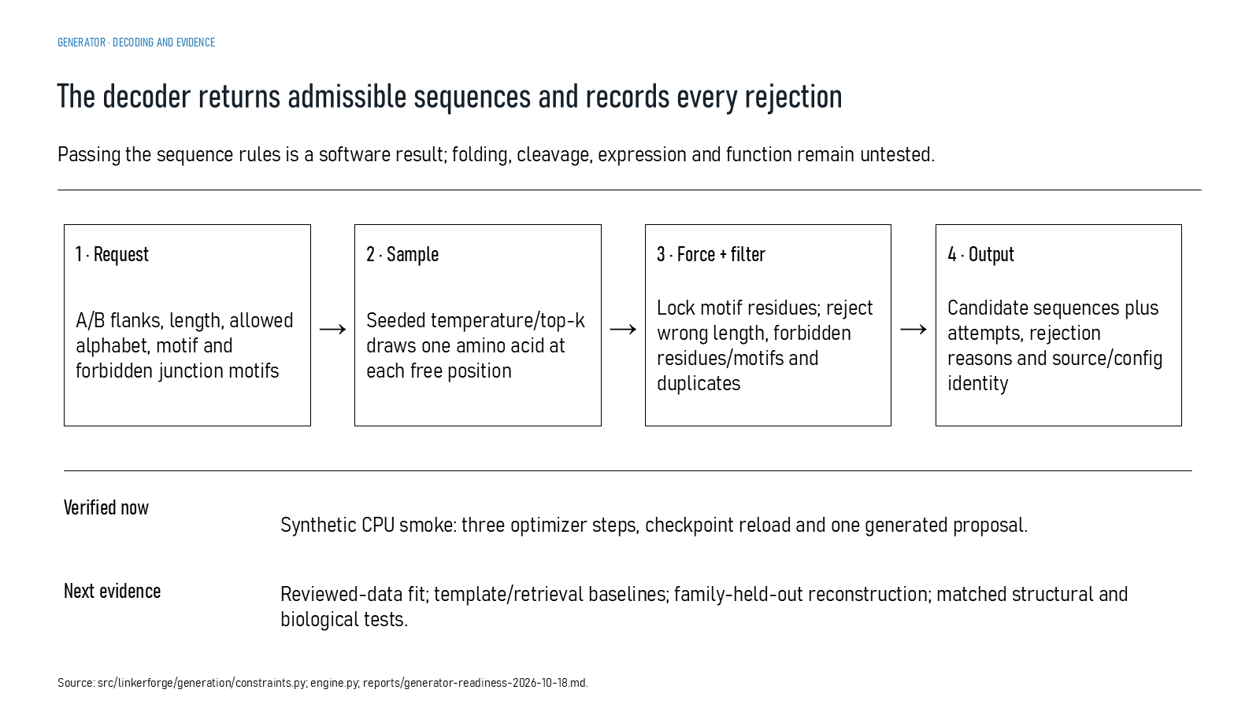
Revision 18 slide 50

Purpose and connection to the project
Explain constrained sampling, forced motif positions, rejection rules, bounded attempts and the rejection log. Sequence-rule compliance is not biological validation.
This generator section describes executable conditional sequence-generation software. It explains what information enters the prompt, what parameters are trained, how exact length and constraints are enforced and why a synthetic smoke test cannot substitute for training on reviewed biological examples.
Why this slide matters: It separates a working model implementation from a scientifically trained generator and makes the required training evidence explicit.

Evidence and labels shown on the slide
The following visible elements carry the slide's scientific content. Their role and evidence level are explained in the presentation script below.
- GENERATOR · DECODING AND EVIDENCE
- The decoder returns admissible sequences and records every rejection
- Passing the sequence rules is a software result; folding, cleavage, expression and function remain untested.
- A/B flanks, length, allowed alphabet, motif and forbidden junction motifs
- Seeded temperature/top-k draws one amino acid at each free position
- 3 · Force + filter
- Lock motif residues; reject wrong length, forbidden residues/motifs and duplicates

Terms explained on this slide
AMINO ACID: An amino acid is one residue in a protein chain. Twenty canonical amino acids are used by the Version 1 generator vocabulary.
LINKER: A linker is the peptide segment between joined domains. Its sequence and length can influence spacing, flexibility, orientation and exposure, but cannot guarantee function.
CONSTRAINED DECODING: Constrained decoding enforces rules such as exact length, canonical residues, forced motifs and bounded retries while sampling. Rule compliance is not evidence of biological compatibility.

Detailed interpretation of the visual
One sampling attempt moves through residue choice, motif forcing, rule checks and either acceptance or a recorded rejection. The log is part of reproducibility, not proof of function.
The object or dataset, comparison, axes, units, colours and layer dimensions define what the visual represents. The observed pattern is interpreted only within those definitions, preventing a prominent number or molecular rendering from being mistaken for broader biological proof.

Exact presentation script
This slide explains constrained sampling, forced motif positions, rejection rules, bounded attempts and the rejection log. Sequence-rule compliance is not biological validation.
This generator section describes executable conditional sequence-generation software. It explains what information enters the prompt, what parameters are trained, how exact length and constraints are enforced and why a synthetic smoke test cannot substitute for training on reviewed biological examples.
On this slide, the concrete evidence and labels shown are: GENERATOR · DECODING AND EVIDENCE; The decoder returns admissible sequences and records every rejection; Passing the sequence rules is a software result; folding, cleavage, expression and function remain untested; A/B flanks, length, allowed alphabet, motif and forbidden junction motifs; and Seeded temperature/top-k draws one amino acid at each free position. Together, these items establish exactly what was examined here, while retaining their individual evidence levels.
An amino acid is one residue in a protein chain. Twenty canonical amino acids are used by the Version 1 generator vocabulary. A linker is the peptide segment between joined domains. Its sequence and length can influence spacing, flexibility, orientation and exposure, but cannot guarantee function. Constrained decoding enforces rules such as exact length, canonical residues, forced motifs and bounded retries while sampling. Rule compliance is not evidence of biological compatibility.
The reason this result belongs in the project is that it separates a working model implementation from a scientifically trained generator and makes the required training evidence explicit.
The conclusion from this slide is deliberately limited. Passing sequence constraints does not prove folding, expression or function.

Likely examiner question
Question: What does slide 50 allow you to conclude?
Defensible answer: It supports the limited interpretation described above. The safe stopping point is: Passing sequence constraints does not prove folding, expression or function.

Scientific claim boundary
Passing sequence constraints does not prove folding, expression or function.
This boundary is part of the scientific interpretation, not a weakness to hide. State it clearly so the audience can distinguish what was measured from what would require prospective or experimental validation.

Slide 51 Detection is not compatibility
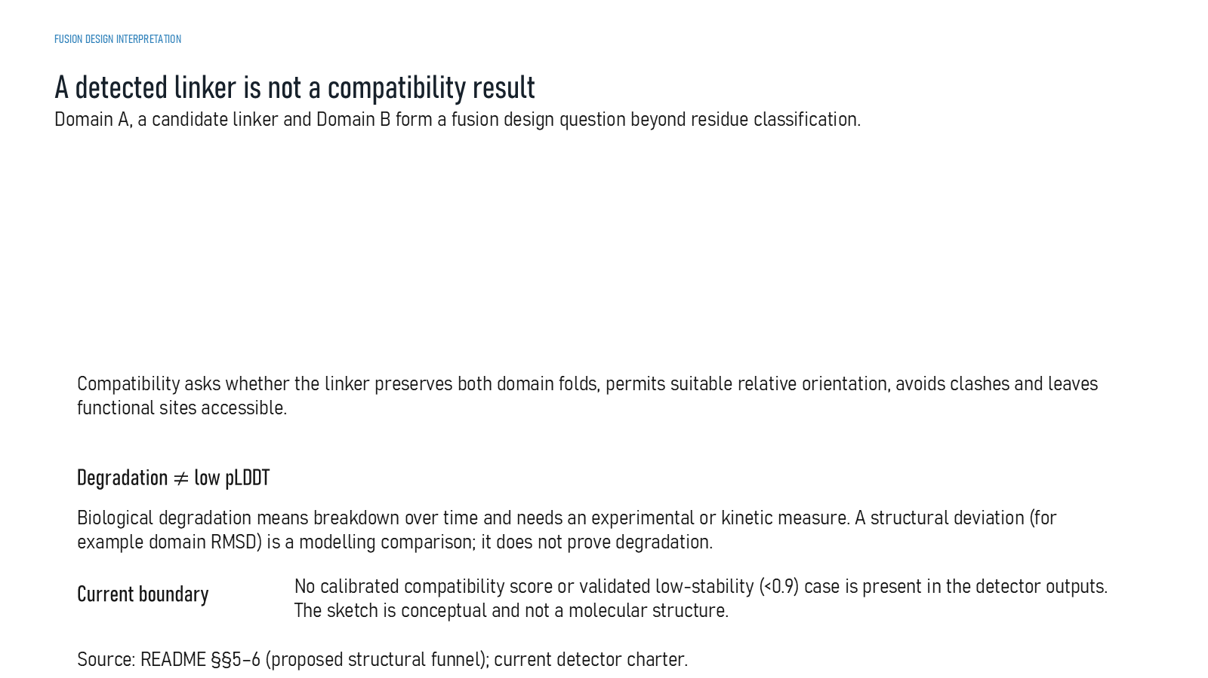
Revision 18 slide 51

Purpose and connection to the project
Differentiate linker detection from fusion compatibility. Compatibility also requires domain preservation, acceptable orientation, low clashes and functional-site access.
This generator section describes executable conditional sequence-generation software. It explains what information enters the prompt, what parameters are trained, how exact length and constraints are enforced and why a synthetic smoke test cannot substitute for training on reviewed biological examples.
Why this slide matters: It separates a working model implementation from a scientifically trained generator and makes the required training evidence explicit.

Evidence and labels shown on the slide
The following visible elements carry the slide's scientific content. Their role and evidence level are explained in the presentation script below.
- FUSION DESIGN INTERPRETATION
- A detected linker is not a compatibility result
- Domain A, a candidate linker and Domain B form a fusion design question beyond residue classification.
- Compatibility asks whether the linker preserves both domain folds, permits suitable relative orientation, avoids clashes and leaves functional sites accessible.
- Degradation ≠ low pLDDT
- Biological degradation means breakdown over time and needs an experimental or kinetic measure. A structural deviation (for example domain RMSD) is a modelling comparison; it does not prove degradation.
- Current boundary

Terms explained on this slide
DOMAIN: A protein domain is a region expected to form a recognizable three-dimensional unit. Domain boundaries are structural or annotation claims, not simply changes in sequence composition.
LINKER: A linker is the peptide segment between joined domains. Its sequence and length can influence spacing, flexibility, orientation and exposure, but cannot guarantee function.
PLDDT: pLDDT is AlphaFold local confidence for each residue on a 0 to 100 scale. It is not percent biological accuracy and does not establish domain orientation.
RMSD: Root-mean-square deviation summarizes coordinate differences after alignment. It depends on atom selection and reference frame and does not directly measure retained function.

Detailed interpretation of the visual
Domain context and control tokens into the model, then distinguish learned residue probabilities from deterministic constraints and rejection rules.
The object or dataset, comparison, axes, units, colours and layer dimensions define what the visual represents. The observed pattern is interpreted only within those definitions, preventing a prominent number or molecular rendering from being mistaken for broader biological proof.

Exact presentation script
This slide shows that differentiate linker detection from fusion compatibility. Compatibility also requires domain preservation, acceptable orientation, low clashes and functional-site access.
This generator section describes executable conditional sequence-generation software. It explains what information enters the prompt, what parameters are trained, how exact length and constraints are enforced and why a synthetic smoke test cannot substitute for training on reviewed biological examples.
On this slide, the concrete evidence and labels shown are: FUSION DESIGN INTERPRETATION; A detected linker is not a compatibility result; Domain A, a candidate linker and Domain B form a fusion design question beyond residue classification; Compatibility asks whether the linker preserves both domain folds, permits suitable relative orientation, avoids clashes and leaves functional sites accessible; and Degradation ≠ low pLDDT. Together, these items establish exactly what was examined here, while retaining their individual evidence levels.
A protein domain is a region expected to form a recognizable three-dimensional unit. Domain boundaries are structural or annotation claims, not simply changes in sequence composition. A linker is the peptide segment between joined domains. Its sequence and length can influence spacing, flexibility, orientation and exposure, but cannot guarantee function. pLDDT is AlphaFold local confidence for each residue on a 0 to 100 scale. It is not percent biological accuracy and does not establish domain orientation.
The reason this result belongs in the project is that it separates a working model implementation from a scientifically trained generator and makes the required training evidence explicit.
The conclusion from this slide is deliberately limited. Detection output is not a calibrated compatibility score.

Likely examiner question
Question: What does slide 51 allow you to conclude?
Defensible answer: It supports the limited interpretation described above. The safe stopping point is: Detection output is not a calibrated compatibility score.

Scientific claim boundary
Detection output is not a calibrated compatibility score.
This boundary is part of the scientific interpretation, not a weakness to hide. State it clearly so the audience can distinguish what was measured from what would require prospective or experimental validation.

Slide 52 Three separate evidence streams
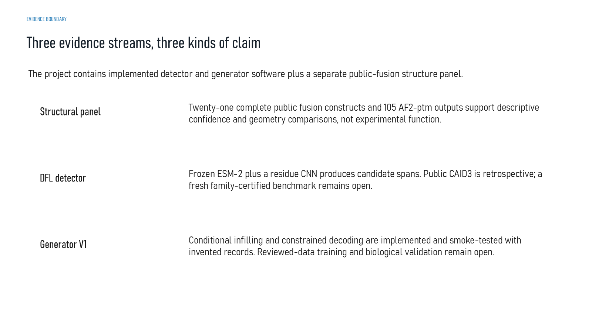
Revision 18 slide 52

Purpose and connection to the project
Keep the three evidence streams separate: structural panel, DFL detector and generator Version 1. No single stream validates the other two.
This generator section describes executable conditional sequence-generation software. It explains what information enters the prompt, what parameters are trained, how exact length and constraints are enforced and why a synthetic smoke test cannot substitute for training on reviewed biological examples.
Why this slide matters: It separates a working model implementation from a scientifically trained generator and makes the required training evidence explicit.

Evidence and labels shown on the slide
The following visible elements carry the slide's scientific content. Their role and evidence level are explained in the presentation script below.
- EVIDENCE BOUNDARY
- Three evidence streams, three kinds of claim
- The project contains implemented detector and generator software plus a separate public-fusion structure panel.
- Structural panel
- Twenty-one complete public fusion constructs and 105 AF2-ptm outputs support descriptive confidence and geometry comparisons, not experimental function.
- DFL detector
- Frozen ESM-2 plus a residue CNN produces candidate spans. Public CAID3 is retrospective; a fresh family-certified benchmark remains open.

Terms explained on this slide
DFL: DFL means disordered flexible linker. It is a residue-label concept used by the detector and is not synonymous with every domain gap.
ESM-2: ESM-2 is a protein language model. LinkerForge uses frozen per-residue embeddings from the 35-million-parameter t12 variant as detector features.
CONSTRAINED DECODING: Constrained decoding enforces rules such as exact length, canonical residues, forced motifs and bounded retries while sampling. Rule compliance is not evidence of biological compatibility.
PTM: pTM is a zero-to-one confidence estimate for the global fold and relative topology. It does not prove that an interdomain pose is experimentally correct.
CAID3: CAID3 is a public disorder/linker benchmark. Once viewed, its labels and scores are retrospective and cannot be used to tune a supposedly untouched model.

Detailed interpretation of the visual
Domain context and control tokens into the model, then distinguish learned residue probabilities from deterministic constraints and rejection rules.
The object or dataset, comparison, axes, units, colours and layer dimensions define what the visual represents. The observed pattern is interpreted only within those definitions, preventing a prominent number or molecular rendering from being mistaken for broader biological proof.

Exact presentation script
This slide keeps the three evidence streams separate: structural panel, DFL detector and generator Version 1. No single stream validates the other two.
This generator section describes executable conditional sequence-generation software. It explains what information enters the prompt, what parameters are trained, how exact length and constraints are enforced and why a synthetic smoke test cannot substitute for training on reviewed biological examples.
On this slide, the concrete evidence and labels shown are: EVIDENCE BOUNDARY; Three evidence streams, three kinds of claim; The project contains implemented detector and generator software plus a separate public-fusion structure panel; Structural panel; and Twenty-one complete public fusion constructs and 105 AF2-ptm outputs support descriptive confidence and geometry comparisons, not experimental function. Together, these items establish exactly what was examined here, while retaining their individual evidence levels.
DFL means disordered flexible linker. It is a residue-label concept used by the detector and is not synonymous with every domain gap. ESM-2 is a protein language model. LinkerForge uses frozen per-residue embeddings from the 35-million-parameter t12 variant as detector features. Constrained decoding enforces rules such as exact length, canonical residues, forced motifs and bounded retries while sampling. Rule compliance is not evidence of biological compatibility.
The reason this result belongs in the project is that it separates a working model implementation from a scientifically trained generator and makes the required training evidence explicit.
The conclusion from this slide is deliberately limited. The detector, generator and structural-panel conclusions remain separate because they answer different scientific questions.

Likely examiner question
Question: What does slide 52 allow you to conclude?
Defensible answer: It supports the limited interpretation described above. The safe stopping point is: Never merge detector, generator and structural-panel claims.

Scientific claim boundary
Never merge detector, generator and structural-panel claims.
This boundary is part of the scientific interpretation, not a weakness to hide. State it clearly so the audience can distinguish what was measured from what would require prospective or experimental validation.

Slide 53 Transition from generator to structural validation
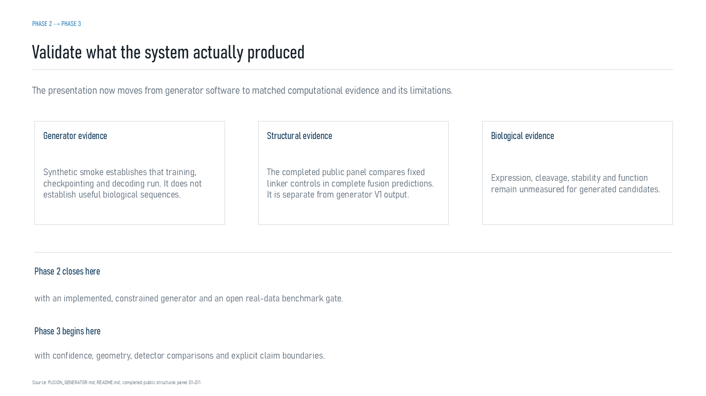
Revision 18 slide 53

Purpose and connection to the project
Introduce Phase 3 while stating that the structural panel uses fixed controls, not biologically trained generator output.
This generator section describes executable conditional sequence-generation software. It explains what information enters the prompt, what parameters are trained, how exact length and constraints are enforced and why a synthetic smoke test cannot substitute for training on reviewed biological examples.
Why this slide matters: It separates a working model implementation from a scientifically trained generator and makes the required training evidence explicit.

Evidence and labels shown on the slide
The following visible elements carry the slide's scientific content. Their role and evidence level are explained in the presentation script below.
- PHASE 2 → PHASE 3
- Validate what the system actually produced
- The presentation now moves from generator software to matched computational evidence and its limitations.
- Generator evidence
- Synthetic smoke establishes that training, checkpointing and decoding run. It does not establish useful biological sequences.
- Structural evidence
- The completed public panel compares fixed linker controls in complete fusion predictions. It is separate from generator V1 output.

Terms explained on this slide
LINKER: A linker is the peptide segment between joined domains. Its sequence and length can influence spacing, flexibility, orientation and exposure, but cannot guarantee function.

Detailed interpretation of the visual
Domain context and control tokens into the model, then distinguish learned residue probabilities from deterministic constraints and rejection rules.
The object or dataset, comparison, axes, units, colours and layer dimensions define what the visual represents. The observed pattern is interpreted only within those definitions, preventing a prominent number or molecular rendering from being mistaken for broader biological proof.

Exact presentation script
This slide introduces Phase 3 while stating that the structural panel uses fixed controls, not biologically trained generator output.
This generator section describes executable conditional sequence-generation software. It explains what information enters the prompt, what parameters are trained, how exact length and constraints are enforced and why a synthetic smoke test cannot substitute for training on reviewed biological examples.
On this slide, the concrete evidence and labels shown are: PHASE 2 → PHASE 3; Validate what the system actually produced; The presentation now moves from generator software to matched computational evidence and its limitations; Generator evidence; and Synthetic smoke establishes that training, checkpointing and decoding run. It does not establish useful biological sequences. Together, these items establish exactly what was examined here, while retaining their individual evidence levels.
A linker is the peptide segment between joined domains. Its sequence and length can influence spacing, flexibility, orientation and exposure, but cannot guarantee function.
The reason this result belongs in the project is that it separates a working model implementation from a scientifically trained generator and makes the required training evidence explicit.
The conclusion from this slide is deliberately limited. The structural controls are separate from Version 1 generated output.

Likely examiner question
Question: What does slide 53 allow you to conclude?
Defensible answer: It supports the limited interpretation described above. The safe stopping point is: The structural controls are separate from Version 1 generated output.

Scientific claim boundary
The structural controls are separate from Version 1 generated output.
This boundary is part of the scientific interpretation, not a weakness to hide. State it clearly so the audience can distinguish what was measured from what would require prospective or experimental validation.

Slide 54 AlphaFold2 and ColabFold confidence terms
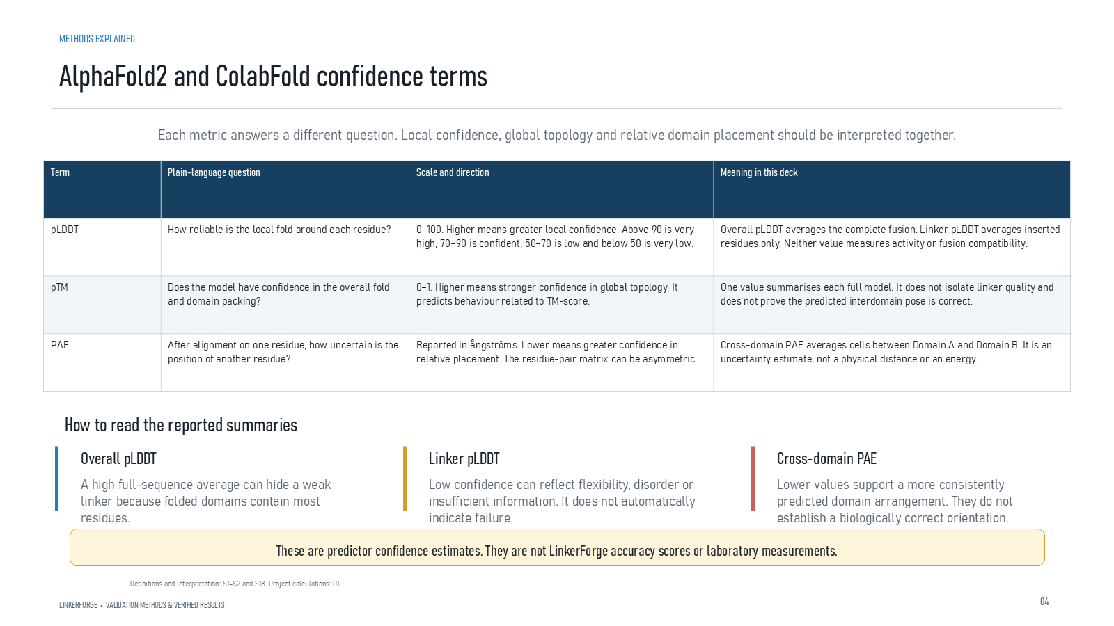
Revision 18 slide 54

Purpose and connection to the project
Define pLDDT, pTM and PAE. Explain that local confidence, global topology and relative domain placement answer different questions.
This structural section compares complete fusion constructs under matched prediction settings. Every metric answers a limited question: local confidence, global topology, relative domain placement, geometric preservation, clashes or short-run dynamics. None alone establishes expression, stability or activity.
Why this slide matters: It allows candidate and control sequences to be compared reproducibly while keeping confidence scores distinct from experimental outcomes.

Evidence and labels shown on the slide
The following visible elements carry the slide's scientific content. Their role and evidence level are explained in the presentation script below.
- METHODS EXPLAINED
- LINKERFORGE • VALIDATION METHODS & VERIFIED RESULTS
- Each metric answers a different question. Local confidence, global topology and relative domain placement should be interpreted together.
- How to read the reported summaries
- Overall pLDDT
- A high full-sequence average can hide a weak linker because folded domains contain most residues.
- Linker pLDDT

Terms explained on this slide
DOMAIN: A protein domain is a region expected to form a recognizable three-dimensional unit. Domain boundaries are structural or annotation claims, not simply changes in sequence composition.
LINKER: A linker is the peptide segment between joined domains. Its sequence and length can influence spacing, flexibility, orientation and exposure, but cannot guarantee function.
ALPHAFOLD2: AlphaFold2 predicts protein coordinates and confidence from sequence. Its confidence outputs describe the predictor, not LinkerForge accuracy or experimental function.
COLABFOLD: ColabFold is a workflow that accelerates AlphaFold-style prediction, including MMseqs2-based sequence searches. It is the prediction runner used for the matched structural panel.
PLDDT: pLDDT is AlphaFold local confidence for each residue on a 0 to 100 scale. It is not percent biological accuracy and does not establish domain orientation.
PTM: pTM is a zero-to-one confidence estimate for the global fold and relative topology. It does not prove that an interdomain pose is experimentally correct.
PAE: Predicted aligned error estimates positional uncertainty after alignment, in angstrom. Off-diagonal domain blocks are useful for interdomain confidence; PAE is not physical distance.

Detailed interpretation of the visual
pLDDT, pTM and PAE answer three different confidence questions: local residue confidence, overall topology and pairwise positional uncertainty. Do not convert them into one accuracy percentage.
The object or dataset, comparison, axes, units, colours and layer dimensions define what the visual represents. The observed pattern is interpreted only within those definitions, preventing a prominent number or molecular rendering from being mistaken for broader biological proof.

Exact presentation script
This slide defines pLDDT, pTM and PAE. Explain that local confidence, global topology and relative domain placement answer different questions.
This structural section compares complete fusion constructs under matched prediction settings. Every metric answers a limited question: local confidence, global topology, relative domain placement, geometric preservation, clashes or short-run dynamics. None alone establishes expression, stability or activity.
On this slide, the concrete evidence and labels shown are: METHODS EXPLAINED; LINKERFORGE • VALIDATION METHODS & VERIFIED RESULTS; Each metric answers a different question. Local confidence, global topology and relative domain placement should be interpreted together; How to read the reported summaries; and Overall pLDDT. Together, these items establish exactly what was examined here, while retaining their individual evidence levels.
A protein domain is a region expected to form a recognizable three-dimensional unit. Domain boundaries are structural or annotation claims, not simply changes in sequence composition. A linker is the peptide segment between joined domains. Its sequence and length can influence spacing, flexibility, orientation and exposure, but cannot guarantee function. AlphaFold2 predicts protein coordinates and confidence from sequence. Its confidence outputs describe the predictor, not LinkerForge accuracy or experimental function.
The reason this result belongs in the project is that it allows candidate and control sequences to be compared reproducibly while keeping confidence scores distinct from experimental outcomes.
The conclusion from this slide is deliberately limited. AlphaFold confidence is not LinkerForge accuracy.

Likely examiner question
Question: Which confidence score is the LinkerForge accuracy?
Defensible answer: None. pLDDT, pTM and PAE are AlphaFold/ColabFold outputs. LinkerForge records and interprets them but does not own them as an accuracy score.

Scientific claim boundary
AlphaFold confidence is not LinkerForge accuracy.
This boundary is part of the scientific interpretation, not a weakness to hide. State it clearly so the audience can distinguish what was measured from what would require prospective or experimental validation.

Slide 55 Geometry and simulation terms
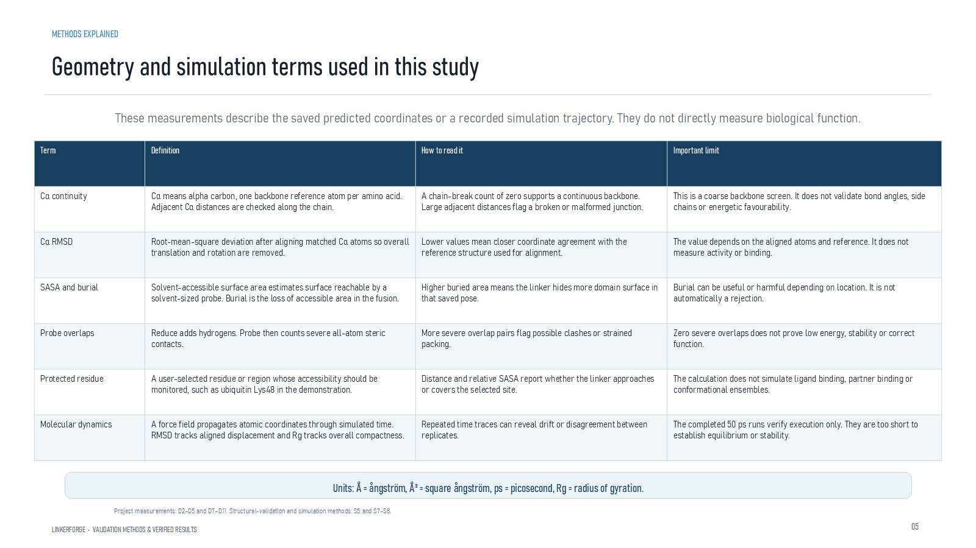
Revision 18 slide 55

Purpose and connection to the project
Define C-alpha continuity, reference RMSD, SASA, burial, Probe overlaps, protected residues, molecular dynamics and radius of gyration.
This structural section compares complete fusion constructs under matched prediction settings. Every metric answers a limited question: local confidence, global topology, relative domain placement, geometric preservation, clashes or short-run dynamics. None alone establishes expression, stability or activity.
Why this slide matters: It allows candidate and control sequences to be compared reproducibly while keeping confidence scores distinct from experimental outcomes.

Evidence and labels shown on the slide
The following visible elements carry the slide's scientific content. Their role and evidence level are explained in the presentation script below.
- METHODS EXPLAINED
- Geometry and simulation terms used in this study
- LINKERFORGE • VALIDATION METHODS & VERIFIED RESULTS
- These measurements describe the saved predicted coordinates or a recorded simulation trajectory. They do not directly measure biological function.
- Units: Å = ångström, Å² = square ångström, ps = picosecond, Rg = radius of gyration.
- Project measurements: D2–D5 and D7–D11. Structural-validation and simulation methods: S5 and S7–S8.

Terms explained on this slide
LINKER: A linker is the peptide segment between joined domains. Its sequence and length can influence spacing, flexibility, orientation and exposure, but cannot guarantee function.
APS: Average precision score summarizes the precision-recall curve and is useful for imbalanced labels. It depends on the dataset and cannot be compared across unrelated tasks as a universal score.
RMSD: Root-mean-square deviation summarizes coordinate differences after alignment. It depends on atom selection and reference frame and does not directly measure retained function.
SASA: Solvent-accessible surface area estimates how much molecular surface a probe can reach in one structure. Burial is a geometric observation, not automatically harmful or beneficial.
PROBE: Probe evaluates hydrogen-aware close contacts and overlaps. Severe overlap counts flag steric concerns but are not calibrated fusion-failure probabilities.
PROTECTED RESIDUE: A protected residue is a user-identified site that should remain spatially accessible or structurally preserved. The software can measure it only if numbering is mapped correctly.
RADIUS OF GYRATION: Radius of gyration summarizes how far atoms are distributed around their center of mass. A stable short trace does not prove a converged ensemble.

Detailed interpretation of the visual
The construct and reference establish the comparison, read the axes and units, compare only matched conditions, and finish by stating what the metric cannot establish.
The object or dataset, comparison, axes, units, colours and layer dimensions define what the visual represents. The observed pattern is interpreted only within those definitions, preventing a prominent number or molecular rendering from being mistaken for broader biological proof.

Exact presentation script
This slide defines C-alpha continuity, reference RMSD, SASA, burial, Probe overlaps, protected residues, molecular dynamics and radius of gyration.
This structural section compares complete fusion constructs under matched prediction settings. Every metric answers a limited question: local confidence, global topology, relative domain placement, geometric preservation, clashes or short-run dynamics. None alone establishes expression, stability or activity.
On this slide, the concrete evidence and labels shown are: METHODS EXPLAINED; Geometry and simulation terms used in this study; LINKERFORGE • VALIDATION METHODS & VERIFIED RESULTS; These measurements describe the saved predicted coordinates or a recorded simulation trajectory. They do not directly measure biological function; and Units: Å = ångström, Å² = square ångström, ps = picosecond, Rg = radius of gyration. Together, these items establish exactly what was examined here, while retaining their individual evidence levels.
A linker is the peptide segment between joined domains. Its sequence and length can influence spacing, flexibility, orientation and exposure, but cannot guarantee function. Average precision score summarizes the precision-recall curve and is useful for imbalanced labels. It depends on the dataset and cannot be compared across unrelated tasks as a universal score. Root-mean-square deviation summarizes coordinate differences after alignment. It depends on atom selection and reference frame and does not directly measure retained function.
The reason this result belongs in the project is that it allows candidate and control sequences to be compared reproducibly while keeping confidence scores distinct from experimental outcomes.
The conclusion from this slide is deliberately limited. Geometric descriptors do not directly measure biological function.

Likely examiner question
Question: What does slide 55 allow you to conclude?
Defensible answer: It supports the limited interpretation described above. The safe stopping point is: Geometric descriptors do not directly measure biological function.

Scientific claim boundary
Geometric descriptors do not directly measure biological function.
This boundary is part of the scientific interpretation, not a weakness to hide. State it clearly so the audience can distinguish what was measured from what would require prospective or experimental validation.

Slide 56 Evidence levels and claim boundaries
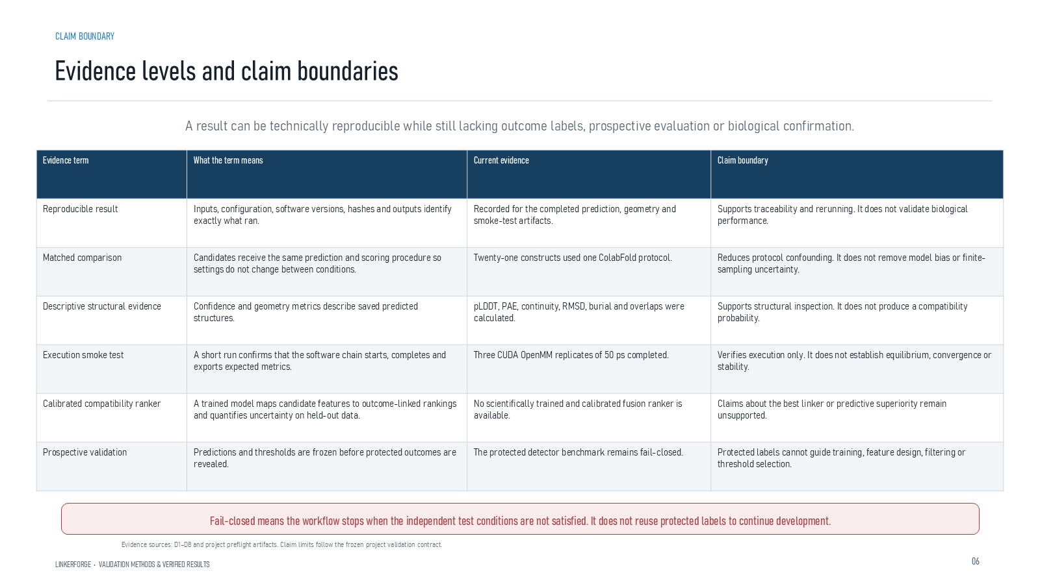
Revision 18 slide 56

Purpose and connection to the project
Explain reproducibility, matched comparison, descriptive evidence, smoke testing, compatibility calibration and prospective validation as distinct evidence levels.
This structural section compares complete fusion constructs under matched prediction settings. Every metric answers a limited question: local confidence, global topology, relative domain placement, geometric preservation, clashes or short-run dynamics. None alone establishes expression, stability or activity.
Why this slide matters: It allows candidate and control sequences to be compared reproducibly while keeping confidence scores distinct from experimental outcomes.

Evidence and labels shown on the slide
The following visible elements carry the slide's scientific content. Their role and evidence level are explained in the presentation script below.
- CLAIM BOUNDARY
- LINKERFORGE • VALIDATION METHODS & VERIFIED RESULTS
- A result can be technically reproducible while still lacking outcome labels, prospective evaluation or biological confirmation.
- Fail-closed means the workflow stops when the independent test conditions are not satisfied. It does not reuse protected labels to continue development.
- Evidence sources: D1–D8 and project preflight artifacts. Claim limits follow the frozen project validation contract.

Terms explained on this slide
LINKER: A linker is the peptide segment between joined domains. Its sequence and length can influence spacing, flexibility, orientation and exposure, but cannot guarantee function.

Detailed interpretation of the visual
The construct and reference establish the comparison, read the axes and units, compare only matched conditions, and finish by stating what the metric cannot establish.
The object or dataset, comparison, axes, units, colours and layer dimensions define what the visual represents. The observed pattern is interpreted only within those definitions, preventing a prominent number or molecular rendering from being mistaken for broader biological proof.

Exact presentation script
This slide explains reproducibility, matched comparison, descriptive evidence, smoke testing, compatibility calibration and prospective validation as distinct evidence levels.
This structural section compares complete fusion constructs under matched prediction settings. Every metric answers a limited question: local confidence, global topology, relative domain placement, geometric preservation, clashes or short-run dynamics. None alone establishes expression, stability or activity.
On this slide, the concrete evidence and labels shown are: CLAIM BOUNDARY; LINKERFORGE • VALIDATION METHODS & VERIFIED RESULTS; A result can be technically reproducible while still lacking outcome labels, prospective evaluation or biological confirmation; Fail-closed means the workflow stops when the independent test conditions are not satisfied. It does not reuse protected labels to continue development; and Evidence sources: D1–D8 and project preflight artifacts. Claim limits follow the frozen project validation contract. Together, these items establish exactly what was examined here, while retaining their individual evidence levels.
A linker is the peptide segment between joined domains. Its sequence and length can influence spacing, flexibility, orientation and exposure, but cannot guarantee function.
The reason this result belongs in the project is that it allows candidate and control sequences to be compared reproducibly while keeping confidence scores distinct from experimental outcomes.
The conclusion from this slide is deliberately limited. Traceability does not substitute for prospective outcome validation.

Likely examiner question
Question: What does slide 56 allow you to conclude?
Defensible answer: It supports the limited interpretation described above. The safe stopping point is: Traceability does not substitute for prospective outcome validation.

Scientific claim boundary
Traceability does not substitute for prospective outcome validation.
This boundary is part of the scientific interpretation, not a weakness to hide. State it clearly so the audience can distinguish what was measured from what would require prospective or experimental validation.

Slide 57 Matched public acceptance run
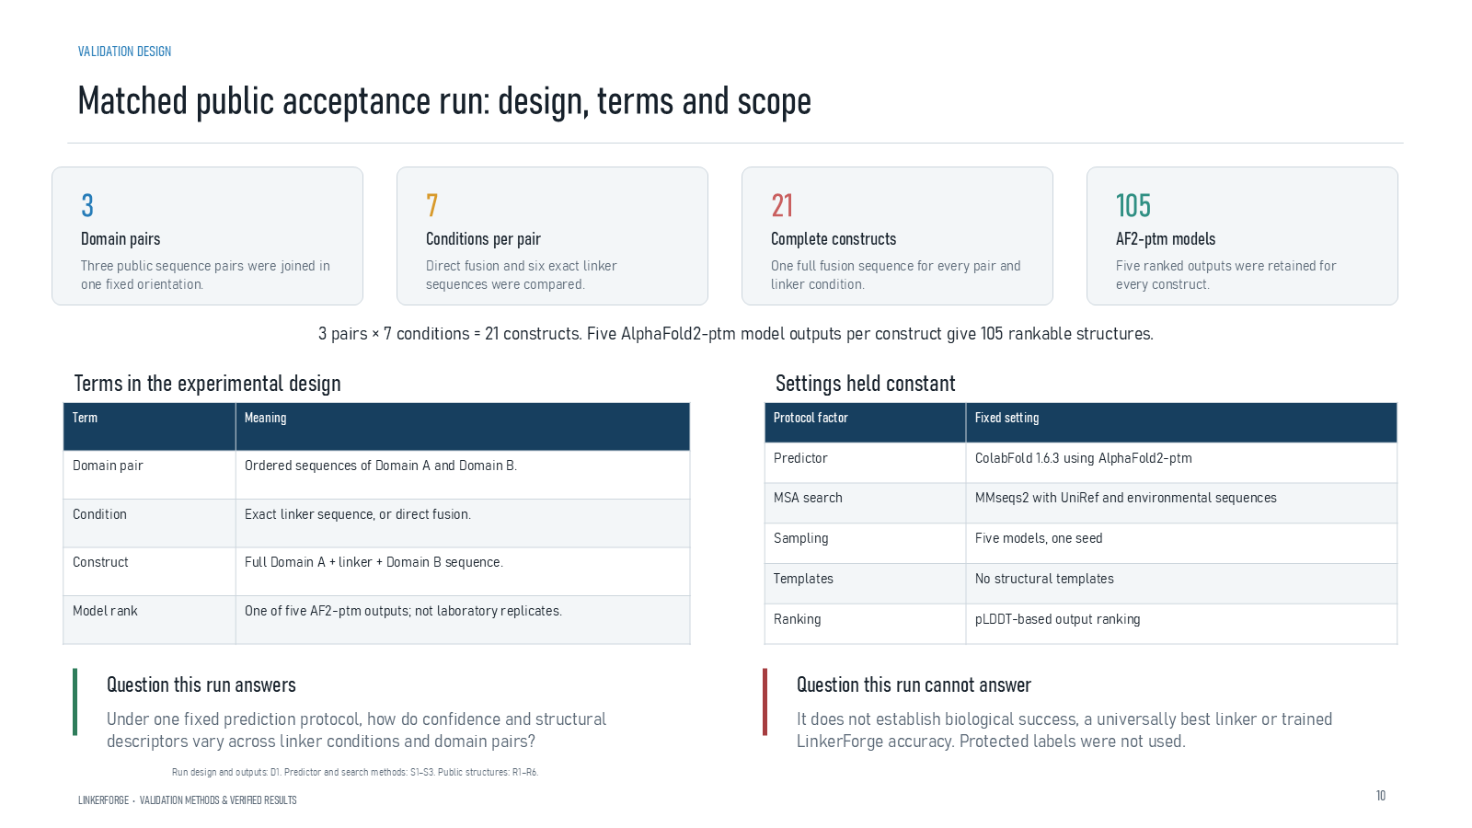
Revision 18 slide 57

Purpose and connection to the project
Define the matched panel: three public domain pairs, seven conditions, 21 constructs and 105 AF2-pTM outputs under one fixed protocol.
This structural section compares complete fusion constructs under matched prediction settings. Every metric answers a limited question: local confidence, global topology, relative domain placement, geometric preservation, clashes or short-run dynamics. None alone establishes expression, stability or activity.
Why this slide matters: It allows candidate and control sequences to be compared reproducibly while keeping confidence scores distinct from experimental outcomes.

Evidence and labels shown on the slide
The following visible elements carry the slide's scientific content. Their role and evidence level are explained in the presentation script below.
- VALIDATION DESIGN
- Matched public acceptance run: design, terms and scope
- LINKERFORGE • VALIDATION METHODS & VERIFIED RESULTS
- Domain pairs
- Three public sequence pairs were joined in one fixed orientation.
- Conditions per pair
- Direct fusion and six exact linker sequences were compared.

Terms explained on this slide
DOMAIN: A protein domain is a region expected to form a recognizable three-dimensional unit. Domain boundaries are structural or annotation claims, not simply changes in sequence composition.
LINKER: A linker is the peptide segment between joined domains. Its sequence and length can influence spacing, flexibility, orientation and exposure, but cannot guarantee function.
ALPHAFOLD2: AlphaFold2 predicts protein coordinates and confidence from sequence. Its confidence outputs describe the predictor, not LinkerForge accuracy or experimental function.
PTM: pTM is a zero-to-one confidence estimate for the global fold and relative topology. It does not prove that an interdomain pose is experimentally correct.

Detailed interpretation of the visual
The panel design is established before looking at results: three domain pairs, seven exact conditions, five model ranks and one fixed protocol. Five ranks are correlated outputs rather than independent biological replicates.
The object or dataset, comparison, axes, units, colours and layer dimensions define what the visual represents. The observed pattern is interpreted only within those definitions, preventing a prominent number or molecular rendering from being mistaken for broader biological proof.

Exact presentation script
This slide defines the matched panel: three public domain pairs, seven conditions, 21 constructs and 105 AF2-pTM outputs under one fixed protocol.
This structural section compares complete fusion constructs under matched prediction settings. Every metric answers a limited question: local confidence, global topology, relative domain placement, geometric preservation, clashes or short-run dynamics. None alone establishes expression, stability or activity.
On this slide, the concrete evidence and labels shown are: VALIDATION DESIGN; Matched public acceptance run: design, terms and scope; LINKERFORGE • VALIDATION METHODS & VERIFIED RESULTS; Domain pairs; and Three public sequence pairs were joined in one fixed orientation. Together, these items establish exactly what was examined here, while retaining their individual evidence levels.
A protein domain is a region expected to form a recognizable three-dimensional unit. Domain boundaries are structural or annotation claims, not simply changes in sequence composition. A linker is the peptide segment between joined domains. Its sequence and length can influence spacing, flexibility, orientation and exposure, but cannot guarantee function. AlphaFold2 predicts protein coordinates and confidence from sequence. Its confidence outputs describe the predictor, not LinkerForge accuracy or experimental function.
The reason this result belongs in the project is that it allows candidate and control sequences to be compared reproducibly while keeping confidence scores distinct from experimental outcomes.
The conclusion from this slide is deliberately limited. Five model ranks are correlated predictions, not laboratory replicates.

Likely examiner question
Question: Are the five AlphaFold ranks five replicates?
Defensible answer: No. They are correlated alternative predictions from the same construct and protocol. They describe model uncertainty, not independent experiments.

Scientific claim boundary
Five model ranks are correlated predictions, not laboratory replicates.
This boundary is part of the scientific interpretation, not a weakness to hide. State it clearly so the audience can distinguish what was measured from what would require prospective or experimental validation.

Slide 58 Candidate and control panel
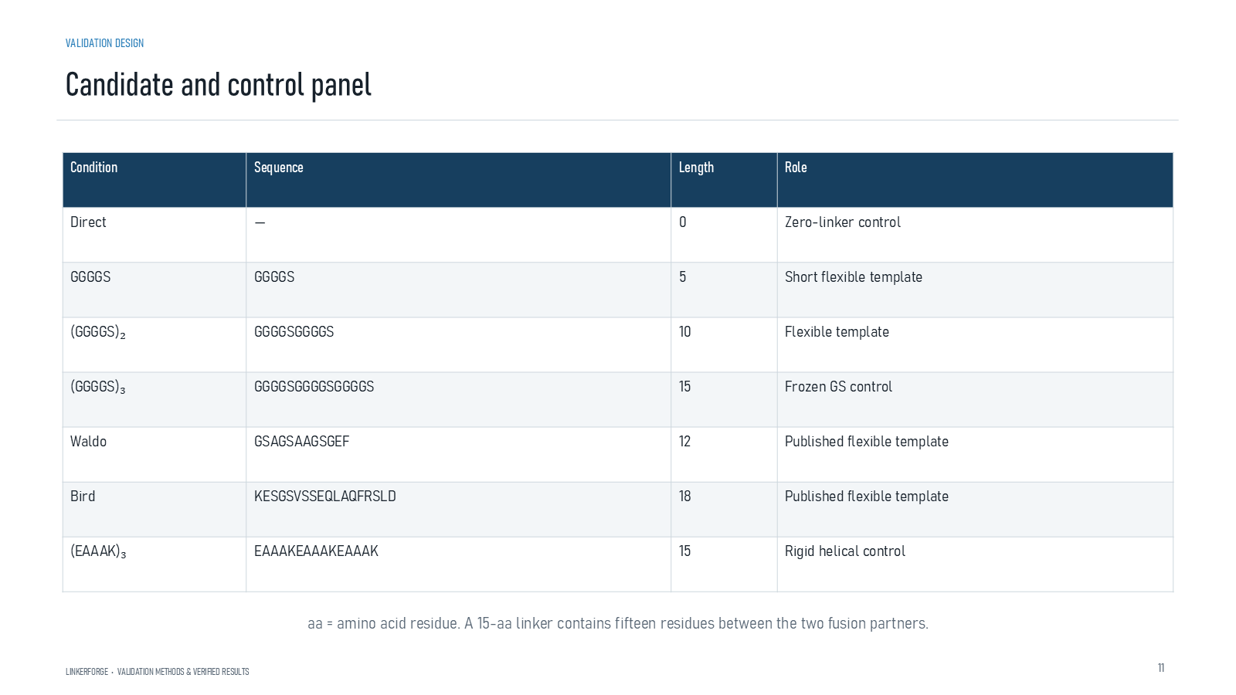
Revision 18 slide 58

Purpose and connection to the project
Identify direct fusion, three GS lengths, Waldo, Bird and EAAAK15. Explain the role of each control and template.
This structural section compares complete fusion constructs under matched prediction settings. Every metric answers a limited question: local confidence, global topology, relative domain placement, geometric preservation, clashes or short-run dynamics. None alone establishes expression, stability or activity.
Why this slide matters: It allows candidate and control sequences to be compared reproducibly while keeping confidence scores distinct from experimental outcomes.

Evidence and labels shown on the slide
The following visible elements carry the slide's scientific content. Their role and evidence level are explained in the presentation script below.
- VALIDATION DESIGN
- LINKERFORGE • VALIDATION METHODS & VERIFIED RESULTS
- aa = amino acid residue. A 15-aa linker contains fifteen residues between the two fusion partners.

Terms explained on this slide
AMINO ACID: An amino acid is one residue in a protein chain. Twenty canonical amino acids are used by the Version 1 generator vocabulary.
LINKER: A linker is the peptide segment between joined domains. Its sequence and length can influence spacing, flexibility, orientation and exposure, but cannot guarantee function.
EAAAK: EAAAK repeats are used as helix-favouring spacers. The term rigid is relative: the peptide still fluctuates and its performance depends on the attached proteins.

Detailed interpretation of the visual
Each row as an exact sequence condition and identify whether it is direct fusion, a GS length control, a literature template or the helical EAAAK control.
The object or dataset, comparison, axes, units, colours and layer dimensions define what the visual represents. The observed pattern is interpreted only within those definitions, preventing a prominent number or molecular rendering from being mistaken for broader biological proof.

Exact presentation script
This slide identifies direct fusion, three GS lengths, Waldo, Bird and EAAAK15. Explain the role of each control and template.
This structural section compares complete fusion constructs under matched prediction settings. Every metric answers a limited question: local confidence, global topology, relative domain placement, geometric preservation, clashes or short-run dynamics. None alone establishes expression, stability or activity.
On this slide, the concrete evidence and labels shown are: VALIDATION DESIGN; LINKERFORGE • VALIDATION METHODS & VERIFIED RESULTS; and aa = amino acid residue. A 15-aa linker contains fifteen residues between the two fusion partners. Together, these items establish exactly what was examined here, while retaining their individual evidence levels.
An amino acid is one residue in a protein chain. Twenty canonical amino acids are used by the Version 1 generator vocabulary. A linker is the peptide segment between joined domains. Its sequence and length can influence spacing, flexibility, orientation and exposure, but cannot guarantee function. EAAAK repeats are used as helix-favouring spacers. The term rigid is relative: the peptide still fluctuates and its performance depends on the attached proteins.
The reason this result belongs in the project is that it allows candidate and control sequences to be compared reproducibly while keeping confidence scores distinct from experimental outcomes.
The conclusion from this slide is deliberately limited. Published templates are context-specific controls rather than universal success labels.

Likely examiner question
Question: What does slide 58 allow you to conclude?
Defensible answer: It supports the limited interpretation described above. The safe stopping point is: Published templates are context-specific controls rather than universal success labels.

Scientific claim boundary
Published templates are context-specific controls rather than universal success labels.
This boundary is part of the scientific interpretation, not a weakness to hide. State it clearly so the audience can distinguish what was measured from what would require prospective or experimental validation.

Slide 59 Overall pLDDT across domain pairs
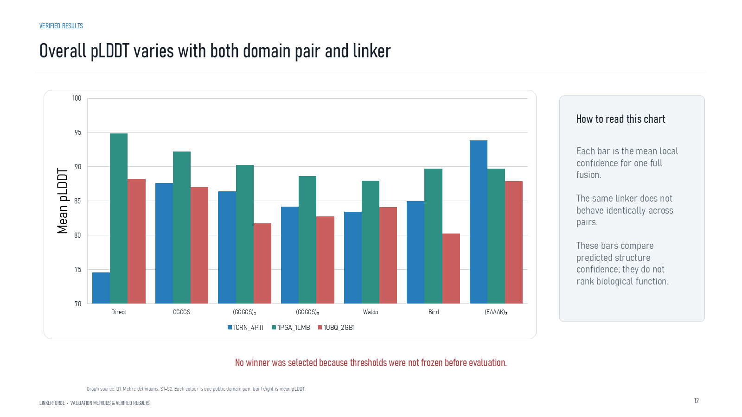
Revision 18 slide 59

Purpose and connection to the project
Read each bar as one complete fusion's mean pLDDT. The same linker behaves differently across domain pairs, so no universal winner follows.
This structural section compares complete fusion constructs under matched prediction settings. Every metric answers a limited question: local confidence, global topology, relative domain placement, geometric preservation, clashes or short-run dynamics. None alone establishes expression, stability or activity.
Why this slide matters: It allows candidate and control sequences to be compared reproducibly while keeping confidence scores distinct from experimental outcomes.

Evidence and labels shown on the slide
The following visible elements carry the slide's scientific content. Their role and evidence level are explained in the presentation script below.
- VERIFIED RESULTS
- Overall pLDDT varies with both domain pair and linker
- LINKERFORGE • VALIDATION METHODS & VERIFIED RESULTS
- How to read this chart
- Each bar is the mean local confidence for one full fusion. The same linker does not behave identically across pairs. These bars compare predicted structure confidence; they do not rank biological function.
- No winner was selected because thresholds were not frozen before evaluation.
- Graph source: D1. Metric definitions: S1–S2. Each colour is one public domain pair; bar height is mean pLDDT.

Terms explained on this slide
DOMAIN: A protein domain is a region expected to form a recognizable three-dimensional unit. Domain boundaries are structural or annotation claims, not simply changes in sequence composition.
LINKER: A linker is the peptide segment between joined domains. Its sequence and length can influence spacing, flexibility, orientation and exposure, but cannot guarantee function.
PLDDT: pLDDT is AlphaFold local confidence for each residue on a 0 to 100 scale. It is not percent biological accuracy and does not establish domain orientation.

Detailed interpretation of the visual
The x-axis to identify domain pair and linker condition, and the y-axis to read mean pLDDT. Compare conditions within a domain pair before comparing across pairs.
The object or dataset, comparison, axes, units, colours and layer dimensions define what the visual represents. The observed pattern is interpreted only within those definitions, preventing a prominent number or molecular rendering from being mistaken for broader biological proof.

Exact presentation script
This slide shows that read each bar as one complete fusion's mean pLDDT. The same linker behaves differently across domain pairs, so no universal winner follows.
This structural section compares complete fusion constructs under matched prediction settings. Every metric answers a limited question: local confidence, global topology, relative domain placement, geometric preservation, clashes or short-run dynamics. None alone establishes expression, stability or activity.
On this slide, the concrete evidence and labels shown are: VERIFIED RESULTS; Overall pLDDT varies with both domain pair and linker; LINKERFORGE • VALIDATION METHODS & VERIFIED RESULTS; How to read this chart; and Each bar is the mean local confidence for one full fusion. The same linker does not behave identically across pairs. These bars compare predicted structure confidence; they do not rank biological function. Together, these items establish exactly what was examined here, while retaining their individual evidence levels.
A protein domain is a region expected to form a recognizable three-dimensional unit. Domain boundaries are structural or annotation claims, not simply changes in sequence composition. A linker is the peptide segment between joined domains. Its sequence and length can influence spacing, flexibility, orientation and exposure, but cannot guarantee function. pLDDT is AlphaFold local confidence for each residue on a 0 to 100 scale. It is not percent biological accuracy and does not establish domain orientation.
The reason this result belongs in the project is that it allows candidate and control sequences to be compared reproducibly while keeping confidence scores distinct from experimental outcomes.
The conclusion from this slide is deliberately limited. Bar height ranks predictor confidence, not biological function.

Likely examiner question
Question: What does slide 59 allow you to conclude?
Defensible answer: It supports the limited interpretation described above. The safe stopping point is: Bar height ranks predictor confidence, not biological function.

Scientific claim boundary
Bar height ranks predictor confidence, not biological function.
This boundary is part of the scientific interpretation, not a weakness to hide. State it clearly so the audience can distinguish what was measured from what would require prospective or experimental validation.

Slide 60 Changes relative to direct fusion
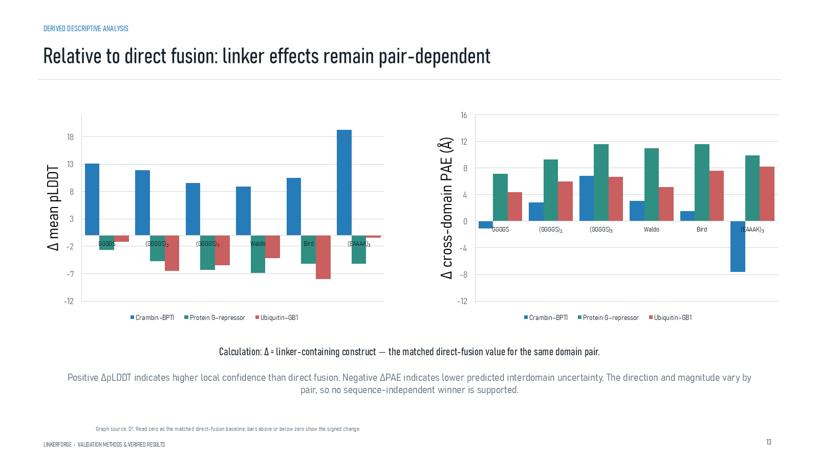
Revision 18 slide 60

Purpose and connection to the project
Explain delta relative to direct fusion. Positive delta pLDDT and negative delta PAE are descriptively favorable, but the pattern remains pair dependent.
This structural section compares complete fusion constructs under matched prediction settings. Every metric answers a limited question: local confidence, global topology, relative domain placement, geometric preservation, clashes or short-run dynamics. None alone establishes expression, stability or activity.
Why this slide matters: It allows candidate and control sequences to be compared reproducibly while keeping confidence scores distinct from experimental outcomes.

Evidence and labels shown on the slide
The following visible elements carry the slide's scientific content. Their role and evidence level are explained in the presentation script below.
- DERIVED DESCRIPTIVE ANALYSIS
- Relative to direct fusion: linker effects remain pair-dependent
- LINKERFORGE • VALIDATION METHODS & VERIFIED RESULTS
- Calculation: Δ = linker-containing construct − the matched direct-fusion value for the same domain pair.
- Positive ΔpLDDT indicates higher local confidence than direct fusion. Negative ΔPAE indicates lower predicted interdomain uncertainty. The direction and magnitude vary by pair, so no sequence-independent winner is supported.
- Graph source: D1. Read zero as the matched direct-fusion baseline; bars above or below zero show the signed change.

Terms explained on this slide
DOMAIN: A protein domain is a region expected to form a recognizable three-dimensional unit. Domain boundaries are structural or annotation claims, not simply changes in sequence composition.
LINKER: A linker is the peptide segment between joined domains. Its sequence and length can influence spacing, flexibility, orientation and exposure, but cannot guarantee function.
PLDDT: pLDDT is AlphaFold local confidence for each residue on a 0 to 100 scale. It is not percent biological accuracy and does not establish domain orientation.
PAE: Predicted aligned error estimates positional uncertainty after alignment, in angstrom. Off-diagonal domain blocks are useful for interdomain confidence; PAE is not physical distance.

Detailed interpretation of the visual
Zero is the direct-fusion reference. Bars above zero for pLDDT indicate higher predicted local confidence; bars below zero for PAE indicate lower predicted interdomain uncertainty. These are descriptive deltas, not causal effects.
The object or dataset, comparison, axes, units, colours and layer dimensions define what the visual represents. The observed pattern is interpreted only within those definitions, preventing a prominent number or molecular rendering from being mistaken for broader biological proof.

Exact presentation script
This slide explains delta relative to direct fusion. Positive delta pLDDT and negative delta PAE are descriptively favorable, but the pattern remains pair dependent.
This structural section compares complete fusion constructs under matched prediction settings. Every metric answers a limited question: local confidence, global topology, relative domain placement, geometric preservation, clashes or short-run dynamics. None alone establishes expression, stability or activity.
On this slide, the concrete evidence and labels shown are: DERIVED DESCRIPTIVE ANALYSIS; Relative to direct fusion: linker effects remain pair-dependent; LINKERFORGE • VALIDATION METHODS & VERIFIED RESULTS; Calculation: Δ = linker-containing construct − the matched direct-fusion value for the same domain pair; and Positive ΔpLDDT indicates higher local confidence than direct fusion. Negative ΔPAE indicates lower predicted interdomain uncertainty. The direction and magnitude vary by pair, so no sequence-independent winner is supported. Together, these items establish exactly what was examined here, while retaining their individual evidence levels.
A protein domain is a region expected to form a recognizable three-dimensional unit. Domain boundaries are structural or annotation claims, not simply changes in sequence composition. A linker is the peptide segment between joined domains. Its sequence and length can influence spacing, flexibility, orientation and exposure, but cannot guarantee function. pLDDT is AlphaFold local confidence for each residue on a 0 to 100 scale. It is not percent biological accuracy and does not establish domain orientation.
The reason this result belongs in the project is that it allows candidate and control sequences to be compared reproducibly while keeping confidence scores distinct from experimental outcomes.
The conclusion from this slide is deliberately limited. A delta from direct fusion is descriptive, not causal proof.

Likely examiner question
Question: What does slide 60 allow you to conclude?
Defensible answer: It supports the limited interpretation described above. The safe stopping point is: A delta from direct fusion is descriptive, not causal proof.

Scientific claim boundary
A delta from direct fusion is descriptive, not causal proof.
This boundary is part of the scientific interpretation, not a weakness to hide. State it clearly so the audience can distinguish what was measured from what would require prospective or experimental validation.

Slide 61 pLDDT and cross domain PAE
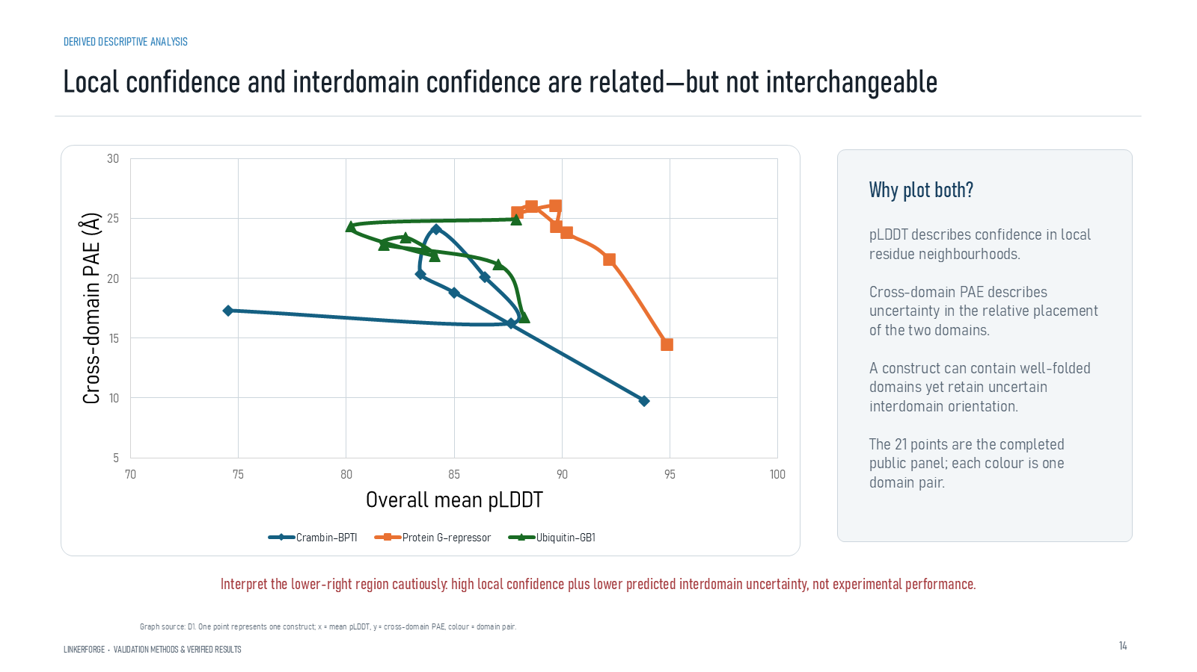
Revision 18 slide 61

Purpose and connection to the project
Interpret the scatter plot jointly. High local confidence can coexist with uncertain relative domain placement.
This structural section compares complete fusion constructs under matched prediction settings. Every metric answers a limited question: local confidence, global topology, relative domain placement, geometric preservation, clashes or short-run dynamics. None alone establishes expression, stability or activity.
Why this slide matters: It allows candidate and control sequences to be compared reproducibly while keeping confidence scores distinct from experimental outcomes.

Evidence and labels shown on the slide
The following visible elements carry the slide's scientific content. Their role and evidence level are explained in the presentation script below.
- DERIVED DESCRIPTIVE ANALYSIS
- Local confidence and interdomain confidence are related—but not interchangeable
- LINKERFORGE • VALIDATION METHODS & VERIFIED RESULTS
- Why plot both?
- pLDDT describes confidence in local residue neighbourhoods. Cross-domain PAE describes uncertainty in the relative placement of the two domains. A construct can contain well-folded domains yet retain uncertain interdomain orientation. The 21 points are the completed public panel; each colour is one domain pair.
- Interpret the lower-right region cautiously: high local confidence plus lower predicted interdomain uncertainty, not experimental performance.
- Graph source: D1. One point represents one construct; x = mean pLDDT, y = cross-domain PAE, colour = domain pair.

Terms explained on this slide
DOMAIN: A protein domain is a region expected to form a recognizable three-dimensional unit. Domain boundaries are structural or annotation claims, not simply changes in sequence composition.
LINKER: A linker is the peptide segment between joined domains. Its sequence and length can influence spacing, flexibility, orientation and exposure, but cannot guarantee function.
PLDDT: pLDDT is AlphaFold local confidence for each residue on a 0 to 100 scale. It is not percent biological accuracy and does not establish domain orientation.
PAE: Predicted aligned error estimates positional uncertainty after alignment, in angstrom. Off-diagonal domain blocks are useful for interdomain confidence; PAE is not physical distance.

Detailed interpretation of the visual
Both axes are interpreted together. Moving right means higher local confidence and moving downward means lower cross-domain PAE. The favourable confidence region does not by itself imply biological success.
The object or dataset, comparison, axes, units, colours and layer dimensions define what the visual represents. The observed pattern is interpreted only within those definitions, preventing a prominent number or molecular rendering from being mistaken for broader biological proof.

Exact presentation script
This slide interprets the scatter plot jointly. High local confidence can coexist with uncertain relative domain placement.
This structural section compares complete fusion constructs under matched prediction settings. Every metric answers a limited question: local confidence, global topology, relative domain placement, geometric preservation, clashes or short-run dynamics. None alone establishes expression, stability or activity.
On this slide, the concrete evidence and labels shown are: DERIVED DESCRIPTIVE ANALYSIS; Local confidence and interdomain confidence are related—but not interchangeable; LINKERFORGE • VALIDATION METHODS & VERIFIED RESULTS; Why plot both?; and pLDDT describes confidence in local residue neighbourhoods. Cross-domain PAE describes uncertainty in the relative placement of the two domains. A construct can contain well-folded domains yet retain uncertain interdomain orientation. The 21 points are the completed public panel; each colour is one domain pair. Together, these items establish exactly what was examined here, while retaining their individual evidence levels.
A protein domain is a region expected to form a recognizable three-dimensional unit. Domain boundaries are structural or annotation claims, not simply changes in sequence composition. A linker is the peptide segment between joined domains. Its sequence and length can influence spacing, flexibility, orientation and exposure, but cannot guarantee function. pLDDT is AlphaFold local confidence for each residue on a 0 to 100 scale. It is not percent biological accuracy and does not establish domain orientation.
The reason this result belongs in the project is that it allows candidate and control sequences to be compared reproducibly while keeping confidence scores distinct from experimental outcomes.
The conclusion from this slide is deliberately limited. The lower-right scatter region is favorable only in confidence terms.

Likely examiner question
Question: What does slide 61 allow you to conclude?
Defensible answer: It supports the limited interpretation described above. The safe stopping point is: The lower-right scatter region is favorable only in confidence terms.

Scientific claim boundary
The lower-right scatter region is favorable only in confidence terms.
This boundary is part of the scientific interpretation, not a weakness to hide. State it clearly so the audience can distinguish what was measured from what would require prospective or experimental validation.

Slide 62 Crambin BPTI result table
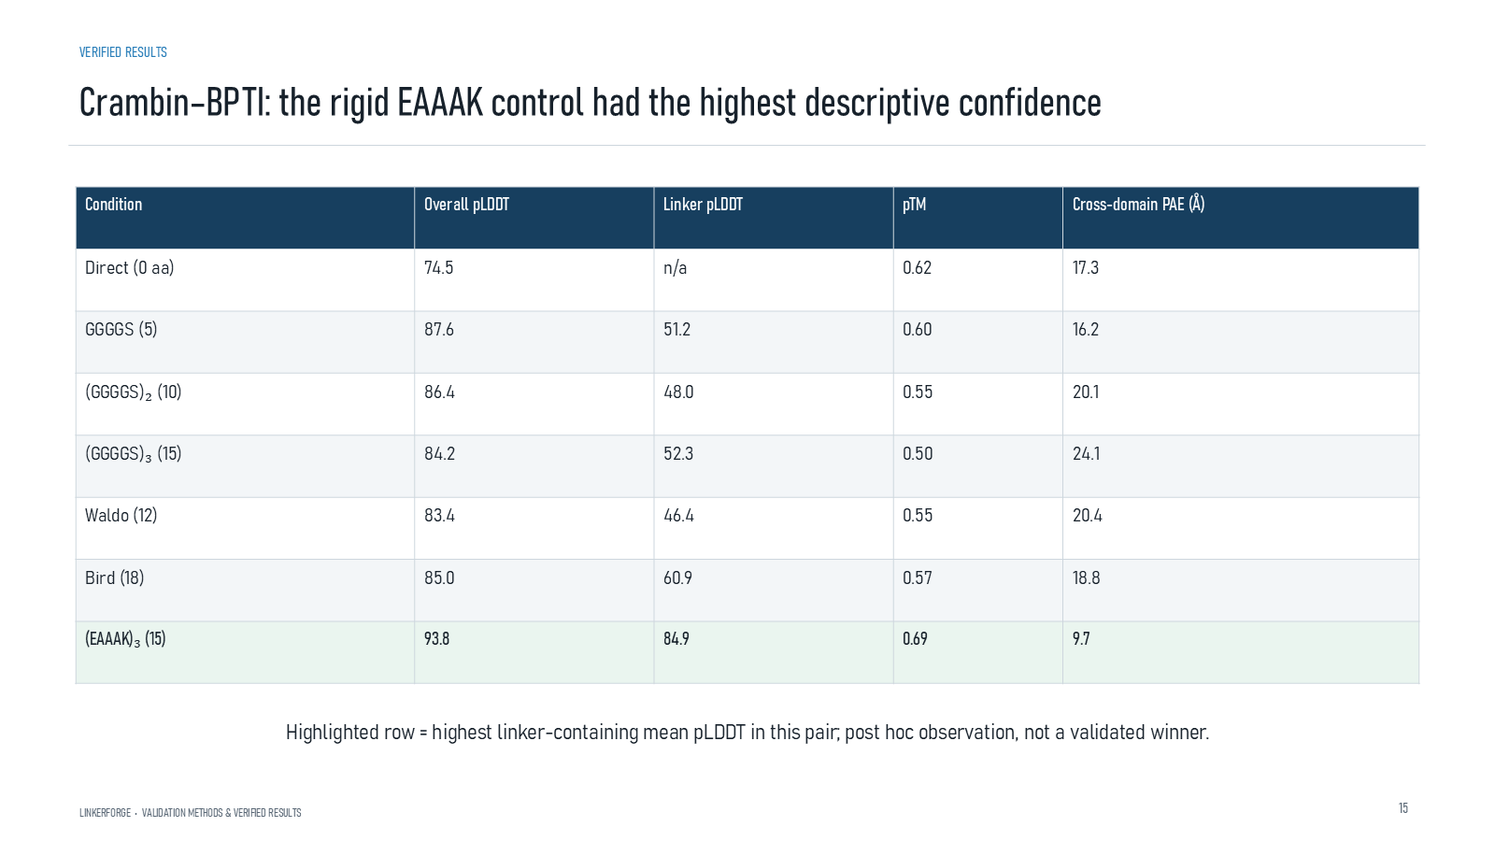
Revision 18 slide 62

Purpose and connection to the project
For Crambin-BPTI, EAAAK15 has the strongest linker-containing profile: pLDDT 93.8, linker pLDDT 84.9, pTM 0.69 and PAE 9.7 angstrom.
This structural section compares complete fusion constructs under matched prediction settings. Every metric answers a limited question: local confidence, global topology, relative domain placement, geometric preservation, clashes or short-run dynamics. None alone establishes expression, stability or activity.
Why this slide matters: It allows candidate and control sequences to be compared reproducibly while keeping confidence scores distinct from experimental outcomes.

Evidence and labels shown on the slide
The following visible elements carry the slide's scientific content. Their role and evidence level are explained in the presentation script below.
- VERIFIED RESULTS
- Crambin–BPTI: the rigid EAAAK control had the highest descriptive confidence
- LINKERFORGE • VALIDATION METHODS & VERIFIED RESULTS
- Highlighted row = highest linker-containing mean pLDDT in this pair; post hoc observation, not a validated winner.

Terms explained on this slide
LINKER: A linker is the peptide segment between joined domains. Its sequence and length can influence spacing, flexibility, orientation and exposure, but cannot guarantee function.
EAAAK: EAAAK repeats are used as helix-favouring spacers. The term rigid is relative: the peptide still fluctuates and its performance depends on the attached proteins.
PLDDT: pLDDT is AlphaFold local confidence for each residue on a 0 to 100 scale. It is not percent biological accuracy and does not establish domain orientation.
PTM: pTM is a zero-to-one confidence estimate for the global fold and relative topology. It does not prove that an interdomain pose is experimentally correct.
PAE: Predicted aligned error estimates positional uncertainty after alignment, in angstrom. Off-diagonal domain blocks are useful for interdomain confidence; PAE is not physical distance.

Detailed interpretation of the visual
Every Crambin-BPTI row across mean pLDDT, linker pLDDT, pTM and cross-domain PAE. EAAAK15 is highlighted because it leads the linker-containing conditions on this combined descriptive profile.
The object or dataset, comparison, axes, units, colours and layer dimensions define what the visual represents. The observed pattern is interpreted only within those definitions, preventing a prominent number or molecular rendering from being mistaken for broader biological proof.

Exact presentation script
This slide shows that for Crambin-BPTI, EAAAK15 has the strongest linker-containing profile: pLDDT 93.8, linker pLDDT 84.9, pTM 0.69 and PAE 9.7 angstrom.
This structural section compares complete fusion constructs under matched prediction settings. Every metric answers a limited question: local confidence, global topology, relative domain placement, geometric preservation, clashes or short-run dynamics. None alone establishes expression, stability or activity.
On this slide, the concrete evidence and labels shown are: VERIFIED RESULTS; Crambin–BPTI: the rigid EAAAK control had the highest descriptive confidence; LINKERFORGE • VALIDATION METHODS & VERIFIED RESULTS; and Highlighted row = highest linker-containing mean pLDDT in this pair; post hoc observation, not a validated winner. Together, these items establish exactly what was examined here, while retaining their individual evidence levels.
A linker is the peptide segment between joined domains. Its sequence and length can influence spacing, flexibility, orientation and exposure, but cannot guarantee function. EAAAK repeats are used as helix-favouring spacers. The term rigid is relative: the peptide still fluctuates and its performance depends on the attached proteins. pLDDT is AlphaFold local confidence for each residue on a 0 to 100 scale. It is not percent biological accuracy and does not establish domain orientation.
The reason this result belongs in the project is that it allows candidate and control sequences to be compared reproducibly while keeping confidence scores distinct from experimental outcomes.
The conclusion from this slide is deliberately limited. EAAAK is a post hoc descriptive leader for this pair only.

Likely examiner question
Question: Why highlight EAAAK15?
Defensible answer: Within the Crambin-BPTI panel it has the strongest combined descriptive confidence among linker-containing constructs. It was not generated by Version 1 and does not prove biological superiority.

Scientific claim boundary
EAAAK is a post hoc descriptive leader for this pair only.
This boundary is part of the scientific interpretation, not a weakness to hide. State it clearly so the audience can distinguish what was measured from what would require prospective or experimental validation.

Slide 63 Protein G repressor result table
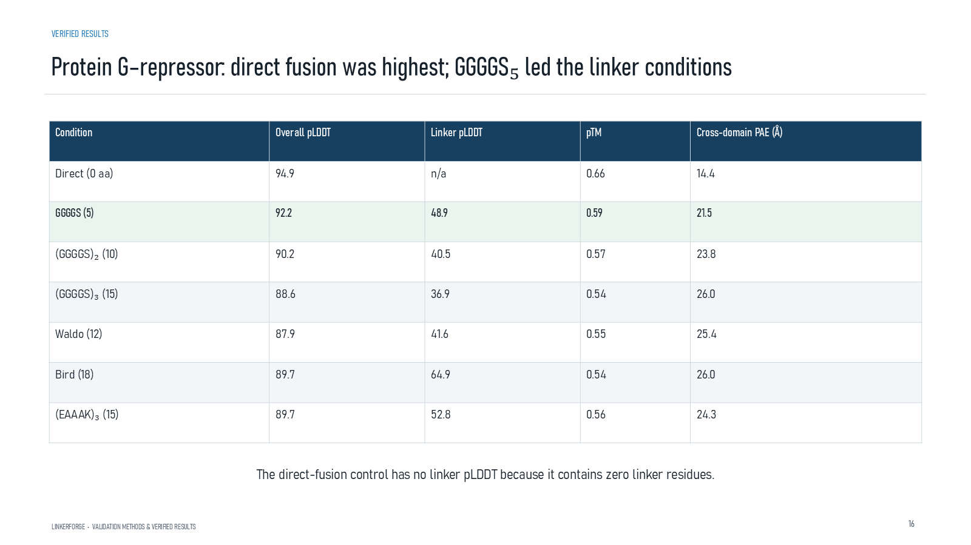
Revision 18 slide 63

Purpose and connection to the project
For Protein G-repressor, direct fusion is strongest overall and GGGGS leads the linker-containing rows. This opposes a universal EAAAK claim.
This structural section compares complete fusion constructs under matched prediction settings. Every metric answers a limited question: local confidence, global topology, relative domain placement, geometric preservation, clashes or short-run dynamics. None alone establishes expression, stability or activity.
Why this slide matters: It allows candidate and control sequences to be compared reproducibly while keeping confidence scores distinct from experimental outcomes.

Evidence and labels shown on the slide
The following visible elements carry the slide's scientific content. Their role and evidence level are explained in the presentation script below.
- VERIFIED RESULTS
- Protein G–repressor: direct fusion was highest; GGGGS₅ led the linker conditions
- LINKERFORGE • VALIDATION METHODS & VERIFIED RESULTS
- The direct-fusion control has no linker pLDDT because it contains zero linker residues.

Terms explained on this slide
LINKER: A linker is the peptide segment between joined domains. Its sequence and length can influence spacing, flexibility, orientation and exposure, but cannot guarantee function.
EAAAK: EAAAK repeats are used as helix-favouring spacers. The term rigid is relative: the peptide still fluctuates and its performance depends on the attached proteins.
PLDDT: pLDDT is AlphaFold local confidence for each residue on a 0 to 100 scale. It is not percent biological accuracy and does not establish domain orientation.

Detailed interpretation of the visual
The direct-fusion row is considered separately from linker-containing rows. Direct fusion is strongest overall, while GGGGS is the leading inserted-linker condition, showing domain-pair dependence.
The object or dataset, comparison, axes, units, colours and layer dimensions define what the visual represents. The observed pattern is interpreted only within those definitions, preventing a prominent number or molecular rendering from being mistaken for broader biological proof.

Exact presentation script
This slide shows that for Protein G-repressor, direct fusion is strongest overall and GGGGS leads the linker-containing rows. This opposes a universal EAAAK claim.
This structural section compares complete fusion constructs under matched prediction settings. Every metric answers a limited question: local confidence, global topology, relative domain placement, geometric preservation, clashes or short-run dynamics. None alone establishes expression, stability or activity.
On this slide, the concrete evidence and labels shown are: VERIFIED RESULTS; Protein G–repressor: direct fusion was highest; GGGGS₅ led the linker conditions; LINKERFORGE • VALIDATION METHODS & VERIFIED RESULTS; and The direct-fusion control has no linker pLDDT because it contains zero linker residues. Together, these items establish exactly what was examined here, while retaining their individual evidence levels.
A linker is the peptide segment between joined domains. Its sequence and length can influence spacing, flexibility, orientation and exposure, but cannot guarantee function. EAAAK repeats are used as helix-favouring spacers. The term rigid is relative: the peptide still fluctuates and its performance depends on the attached proteins. pLDDT is AlphaFold local confidence for each residue on a 0 to 100 scale. It is not percent biological accuracy and does not establish domain orientation.
The reason this result belongs in the project is that it allows candidate and control sequences to be compared reproducibly while keeping confidence scores distinct from experimental outcomes.
The conclusion from this slide is deliberately limited. Direct fusion can outperform inserted linkers on confidence metrics.

Likely examiner question
Question: What does slide 63 allow you to conclude?
Defensible answer: It supports the limited interpretation described above. The safe stopping point is: Direct fusion can outperform inserted linkers on confidence metrics.

Scientific claim boundary
Direct fusion can outperform inserted linkers on confidence metrics.
This boundary is part of the scientific interpretation, not a weakness to hide. State it clearly so the audience can distinguish what was measured from what would require prospective or experimental validation.

Slide 64 Ubiquitin GB1 result table
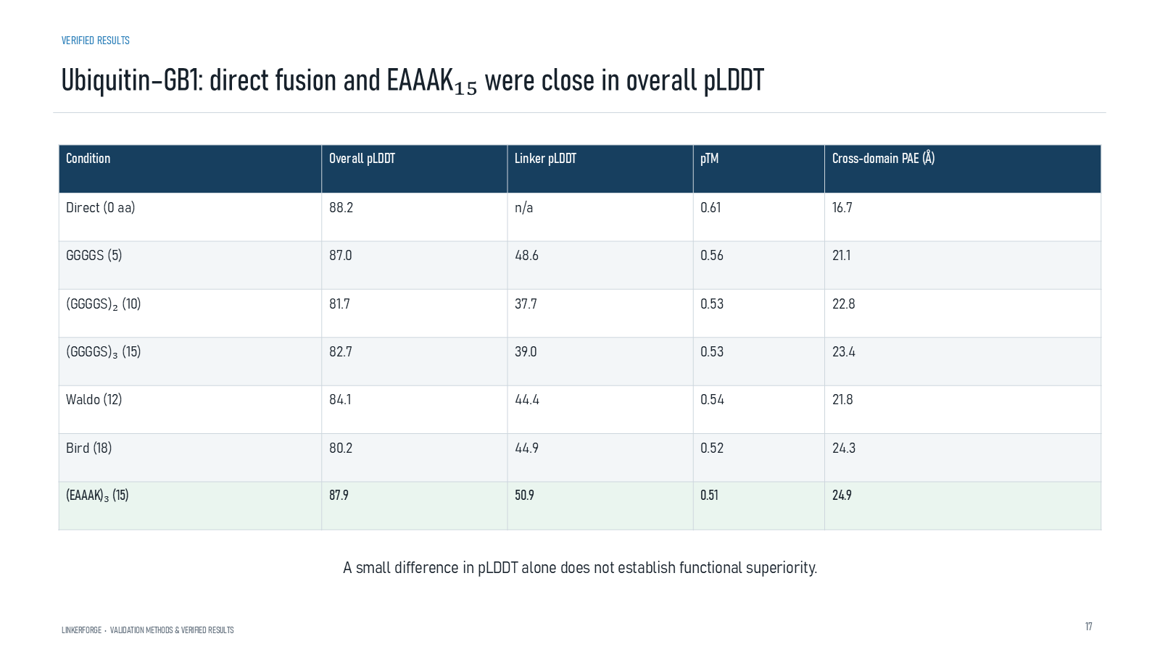
Revision 18 slide 64

Purpose and connection to the project
For Ubiquitin-GB1, direct fusion and EAAAK are close in mean pLDDT, but direct fusion has lower cross-domain PAE. One metric cannot decide superiority.
This structural section compares complete fusion constructs under matched prediction settings. Every metric answers a limited question: local confidence, global topology, relative domain placement, geometric preservation, clashes or short-run dynamics. None alone establishes expression, stability or activity.
Why this slide matters: It allows candidate and control sequences to be compared reproducibly while keeping confidence scores distinct from experimental outcomes.

Evidence and labels shown on the slide
The following visible elements carry the slide's scientific content. Their role and evidence level are explained in the presentation script below.
- VERIFIED RESULTS
- Ubiquitin–GB1: direct fusion and EAAAK₁₅ were close in overall pLDDT
- LINKERFORGE • VALIDATION METHODS & VERIFIED RESULTS
- A small difference in pLDDT alone does not establish functional superiority.

Terms explained on this slide
DOMAIN: A protein domain is a region expected to form a recognizable three-dimensional unit. Domain boundaries are structural or annotation claims, not simply changes in sequence composition.
LINKER: A linker is the peptide segment between joined domains. Its sequence and length can influence spacing, flexibility, orientation and exposure, but cannot guarantee function.
EAAAK: EAAAK repeats are used as helix-favouring spacers. The term rigid is relative: the peptide still fluctuates and its performance depends on the attached proteins.
PLDDT: pLDDT is AlphaFold local confidence for each residue on a 0 to 100 scale. It is not percent biological accuracy and does not establish domain orientation.
PAE: Predicted aligned error estimates positional uncertainty after alignment, in angstrom. Off-diagonal domain blocks are useful for interdomain confidence; PAE is not physical distance.

Detailed interpretation of the visual
Direct fusion is compared and EAAAK across both local confidence and interdomain PAE. Similar mean pLDDT does not erase the less favourable interdomain-confidence result.
The object or dataset, comparison, axes, units, colours and layer dimensions define what the visual represents. The observed pattern is interpreted only within those definitions, preventing a prominent number or molecular rendering from being mistaken for broader biological proof.

Exact presentation script
This slide shows that for Ubiquitin-GB1, direct fusion and EAAAK are close in mean pLDDT, but direct fusion has lower cross-domain PAE. One metric cannot decide superiority.
This structural section compares complete fusion constructs under matched prediction settings. Every metric answers a limited question: local confidence, global topology, relative domain placement, geometric preservation, clashes or short-run dynamics. None alone establishes expression, stability or activity.
On this slide, the concrete evidence and labels shown are: VERIFIED RESULTS; Ubiquitin–GB1: direct fusion and EAAAK₁₅ were close in overall pLDDT; LINKERFORGE • VALIDATION METHODS & VERIFIED RESULTS; and A small difference in pLDDT alone does not establish functional superiority. Together, these items establish exactly what was examined here, while retaining their individual evidence levels.
A protein domain is a region expected to form a recognizable three-dimensional unit. Domain boundaries are structural or annotation claims, not simply changes in sequence composition. A linker is the peptide segment between joined domains. Its sequence and length can influence spacing, flexibility, orientation and exposure, but cannot guarantee function. EAAAK repeats are used as helix-favouring spacers. The term rigid is relative: the peptide still fluctuates and its performance depends on the attached proteins.
The reason this result belongs in the project is that it allows candidate and control sequences to be compared reproducibly while keeping confidence scores distinct from experimental outcomes.
The conclusion from this slide is deliberately limited. A small pLDDT difference cannot establish functional superiority.

Likely examiner question
Question: What does slide 64 allow you to conclude?
Defensible answer: It supports the limited interpretation described above. The safe stopping point is: A small pLDDT difference cannot establish functional superiority.

Scientific claim boundary
A small pLDDT difference cannot establish functional superiority.
This boundary is part of the scientific interpretation, not a weakness to hide. State it clearly so the audience can distinguish what was measured from what would require prospective or experimental validation.

Slide 65 Highest confidence linker containing construct
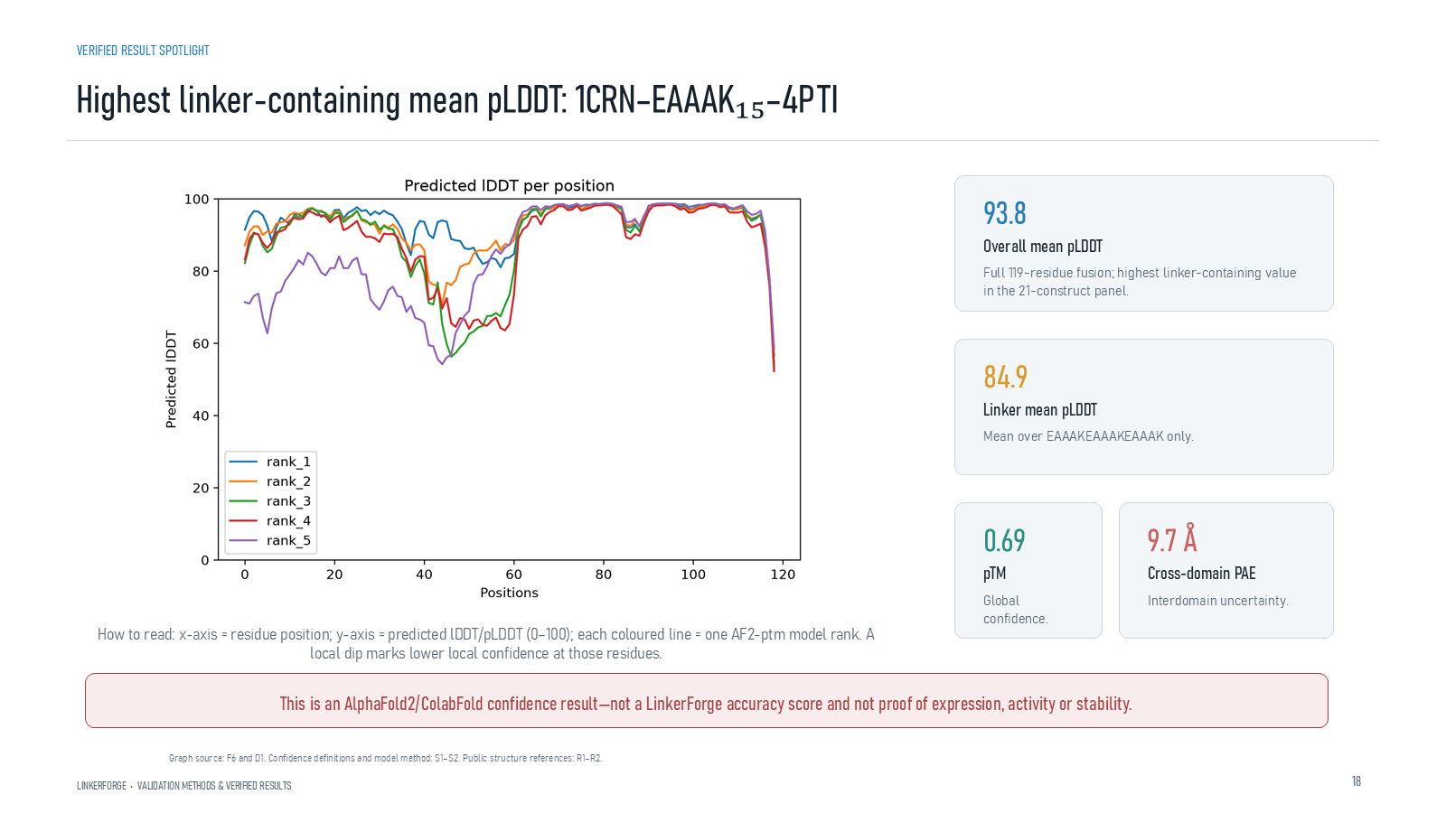
Revision 18 slide 65

Purpose and connection to the project
Explain the residue-confidence traces and the four headline values for the highlighted 119-residue construct. This is an AlphaFold confidence spotlight.
This structural section compares complete fusion constructs under matched prediction settings. Every metric answers a limited question: local confidence, global topology, relative domain placement, geometric preservation, clashes or short-run dynamics. None alone establishes expression, stability or activity.
Why this slide matters: It allows candidate and control sequences to be compared reproducibly while keeping confidence scores distinct from experimental outcomes.

Evidence and labels shown on the slide
The following visible elements carry the slide's scientific content. Their role and evidence level are explained in the presentation script below.
- VERIFIED RESULT SPOTLIGHT
- Highest linker-containing mean pLDDT: 1CRN–EAAAK₁₅–4PTI
- LINKERFORGE • VALIDATION METHODS & VERIFIED RESULTS
- Overall mean pLDDT
- Full 119-residue fusion; highest linker-containing value in the 21-construct panel.
- Linker mean pLDDT
- Mean over EAAAKEAAAKEAAAK only.

Terms explained on this slide
DOMAIN: A protein domain is a region expected to form a recognizable three-dimensional unit. Domain boundaries are structural or annotation claims, not simply changes in sequence composition.
LINKER: A linker is the peptide segment between joined domains. Its sequence and length can influence spacing, flexibility, orientation and exposure, but cannot guarantee function.
EAAAK: EAAAK repeats are used as helix-favouring spacers. The term rigid is relative: the peptide still fluctuates and its performance depends on the attached proteins.
ALPHAFOLD2: AlphaFold2 predicts protein coordinates and confidence from sequence. Its confidence outputs describe the predictor, not LinkerForge accuracy or experimental function.
COLABFOLD: ColabFold is a workflow that accelerates AlphaFold-style prediction, including MMseqs2-based sequence searches. It is the prediction runner used for the matched structural panel.
PLDDT: pLDDT is AlphaFold local confidence for each residue on a 0 to 100 scale. It is not percent biological accuracy and does not establish domain orientation.
PTM: pTM is a zero-to-one confidence estimate for the global fold and relative topology. It does not prove that an interdomain pose is experimentally correct.
PAE: Predicted aligned error estimates positional uncertainty after alignment, in angstrom. Off-diagonal domain blocks are useful for interdomain confidence; PAE is not physical distance.

Detailed interpretation of the visual
Trace pLDDT along residue number and locate the linker interval between the two domains. Use the summary values to distinguish whole-chain, linker-local, global and interdomain confidence.
The object or dataset, comparison, axes, units, colours and layer dimensions define what the visual represents. The observed pattern is interpreted only within those definitions, preventing a prominent number or molecular rendering from being mistaken for broader biological proof.

Exact presentation script
This slide explains the residue-confidence traces and the four headline values for the highlighted 119-residue construct. This is an AlphaFold confidence spotlight.
This structural section compares complete fusion constructs under matched prediction settings. Every metric answers a limited question: local confidence, global topology, relative domain placement, geometric preservation, clashes or short-run dynamics. None alone establishes expression, stability or activity.
On this slide, the concrete evidence and labels shown are: VERIFIED RESULT SPOTLIGHT; Highest linker-containing mean pLDDT: 1CRN–EAAAK₁₅–4PTI; LINKERFORGE • VALIDATION METHODS & VERIFIED RESULTS; Overall mean pLDDT; and Full 119-residue fusion; highest linker-containing value in the 21-construct panel. Together, these items establish exactly what was examined here, while retaining their individual evidence levels.
A protein domain is a region expected to form a recognizable three-dimensional unit. Domain boundaries are structural or annotation claims, not simply changes in sequence composition. A linker is the peptide segment between joined domains. Its sequence and length can influence spacing, flexibility, orientation and exposure, but cannot guarantee function. EAAAK repeats are used as helix-favouring spacers. The term rigid is relative: the peptide still fluctuates and its performance depends on the attached proteins.
The reason this result belongs in the project is that it allows candidate and control sequences to be compared reproducibly while keeping confidence scores distinct from experimental outcomes.
The conclusion from this slide is deliberately limited. 93.8 is pLDDT, not percent accuracy.

Likely examiner question
Question: What does slide 65 allow you to conclude?
Defensible answer: It supports the limited interpretation described above. The safe stopping point is: 93.8 is pLDDT, not percent accuracy.

Scientific claim boundary
93.8 is pLDDT, not percent accuracy.
This boundary is part of the scientific interpretation, not a weakness to hide. State it clearly so the audience can distinguish what was measured from what would require prospective or experimental validation.

Slide 66 PyMOL view of Crambin EAAAK BPTI
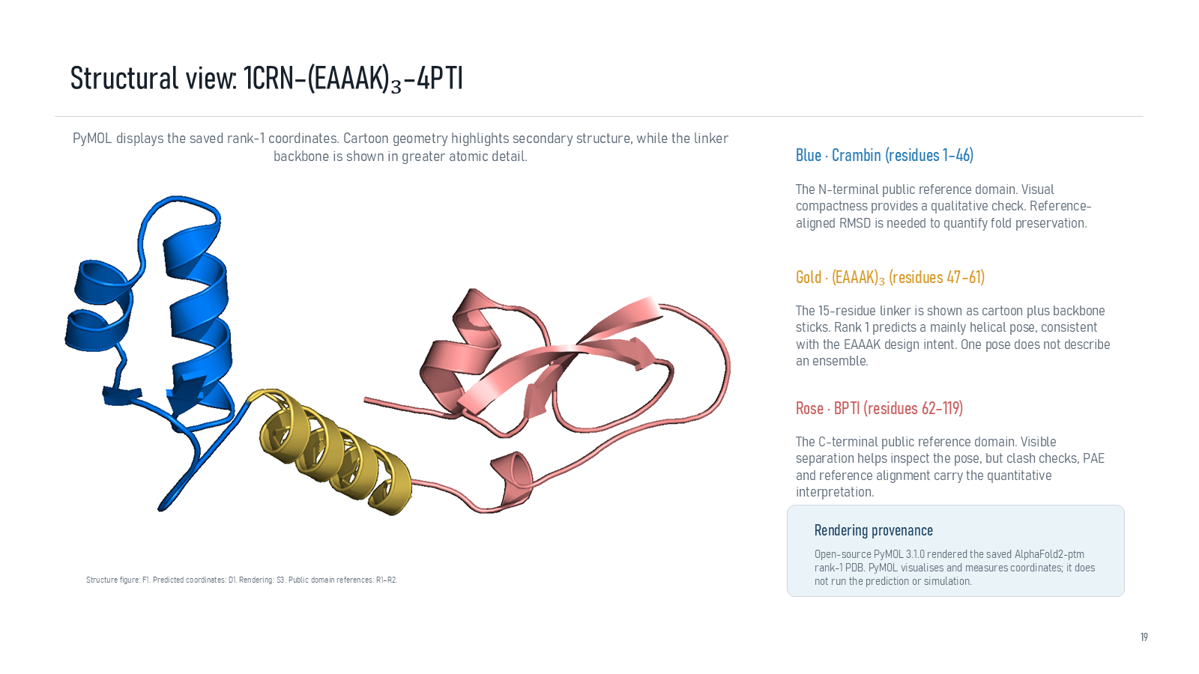
Revision 18 slide 66

Purpose and connection to the project
Use the PyMOL pose to identify Crambin, EAAAK15 and BPTI. The predicted helical linker agrees with design intent, but one pose is not a solution ensemble.
This structural section compares complete fusion constructs under matched prediction settings. Every metric answers a limited question: local confidence, global topology, relative domain placement, geometric preservation, clashes or short-run dynamics. None alone establishes expression, stability or activity.
Why this slide matters: It allows candidate and control sequences to be compared reproducibly while keeping confidence scores distinct from experimental outcomes.

Evidence and labels shown on the slide
The following visible elements carry the slide's scientific content. Their role and evidence level are explained in the presentation script below.
- Structural view: 1CRN–(EAAAK)₃–4PTI
- PyMOL displays the saved rank-1 coordinates. Cartoon geometry highlights secondary structure, while the linker backbone is shown in greater atomic detail.
- Blue · Crambin (residues 1–46)
- The N-terminal public reference domain. Visual compactness provides a qualitative check. Reference-aligned RMSD is needed to quantify fold preservation.
- Gold · (EAAAK)₃ (residues 47–61)
- The 15-residue linker is shown as cartoon plus backbone sticks. Rank 1 predicts a mainly helical pose, consistent with the EAAAK design intent. One pose does not describe an ensemble.
- Rose · BPTI (residues 62–119)

Terms explained on this slide
DOMAIN: A protein domain is a region expected to form a recognizable three-dimensional unit. Domain boundaries are structural or annotation claims, not simply changes in sequence composition.
LINKER: A linker is the peptide segment between joined domains. Its sequence and length can influence spacing, flexibility, orientation and exposure, but cannot guarantee function.
EAAAK: EAAAK repeats are used as helix-favouring spacers. The term rigid is relative: the peptide still fluctuates and its performance depends on the attached proteins.
PROVENANCE: Provenance is the recorded origin and transformation history of a datum, model, prediction or figure, including source identifiers, code revision and configuration.
ALPHAFOLD2: AlphaFold2 predicts protein coordinates and confidence from sequence. Its confidence outputs describe the predictor, not LinkerForge accuracy or experimental function.
PTM: pTM is a zero-to-one confidence estimate for the global fold and relative topology. It does not prove that an interdomain pose is experimentally correct.
PAE: Predicted aligned error estimates positional uncertainty after alignment, in angstrom. Off-diagonal domain blocks are useful for interdomain confidence; PAE is not physical distance.
RMSD: Root-mean-square deviation summarizes coordinate differences after alignment. It depends on atom selection and reference frame and does not directly measure retained function.

Detailed interpretation of the visual
The colour legend identifies the molecular components rather than guessing from shape: identify Crambin, the EAAAK15 helix and BPTI. The rendering is one predicted rank and not a dynamic ensemble.
The object or dataset, comparison, axes, units, colours and layer dimensions define what the visual represents. The observed pattern is interpreted only within those definitions, preventing a prominent number or molecular rendering from being mistaken for broader biological proof.

Exact presentation script
This slide uses the PyMOL pose to identify Crambin, EAAAK15 and BPTI. The predicted helical linker agrees with design intent, but one pose is not a solution ensemble.
This structural section compares complete fusion constructs under matched prediction settings. Every metric answers a limited question: local confidence, global topology, relative domain placement, geometric preservation, clashes or short-run dynamics. None alone establishes expression, stability or activity.
On this slide, the concrete evidence and labels shown are: Structural view: 1CRN–(EAAAK)₃–4PTI; PyMOL displays the saved rank-1 coordinates. Cartoon geometry highlights secondary structure, while the linker backbone is shown in greater atomic detail; Blue · Crambin (residues 1–46); The N-terminal public reference domain. Visual compactness provides a qualitative check. Reference-aligned RMSD is needed to quantify fold preservation; and Gold · (EAAAK)₃ (residues 47–61). Together, these items establish exactly what was examined here, while retaining their individual evidence levels.
A protein domain is a region expected to form a recognizable three-dimensional unit. Domain boundaries are structural or annotation claims, not simply changes in sequence composition. A linker is the peptide segment between joined domains. Its sequence and length can influence spacing, flexibility, orientation and exposure, but cannot guarantee function. EAAAK repeats are used as helix-favouring spacers. The term rigid is relative: the peptide still fluctuates and its performance depends on the attached proteins.
The reason this result belongs in the project is that it allows candidate and control sequences to be compared reproducibly while keeping confidence scores distinct from experimental outcomes.
The conclusion from this slide is deliberately limited. PyMOL visualizes and measures; it does not predict or simulate.

Likely examiner question
Question: What does slide 66 allow you to conclude?
Defensible answer: It supports the limited interpretation described above. The safe stopping point is: PyMOL visualizes and measures; it does not predict or simulate.

Scientific claim boundary
PyMOL visualizes and measures; it does not predict or simulate.
This boundary is part of the scientific interpretation, not a weakness to hide. State it clearly so the audience can distinguish what was measured from what would require prospective or experimental validation.

Slide 67 PAE heatmaps
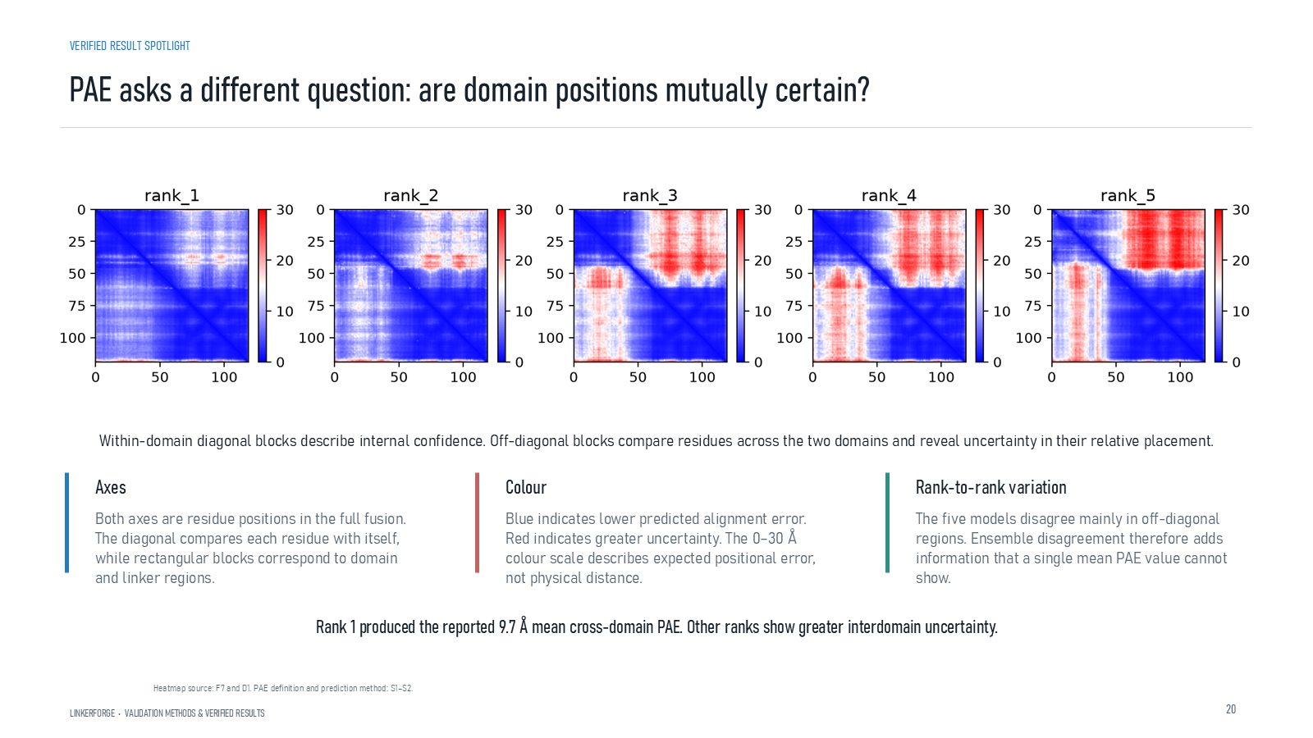
Revision 18 slide 67

Purpose and connection to the project
Read diagonal and off-diagonal PAE blocks. Rank-to-rank disagreement mainly concerns relative domain placement.
This structural section compares complete fusion constructs under matched prediction settings. Every metric answers a limited question: local confidence, global topology, relative domain placement, geometric preservation, clashes or short-run dynamics. None alone establishes expression, stability or activity.
Why this slide matters: It allows candidate and control sequences to be compared reproducibly while keeping confidence scores distinct from experimental outcomes.

Evidence and labels shown on the slide
The following visible elements carry the slide's scientific content. Their role and evidence level are explained in the presentation script below.
- VERIFIED RESULT SPOTLIGHT
- PAE asks a different question: are domain positions mutually certain?
- LINKERFORGE • VALIDATION METHODS & VERIFIED RESULTS
- Within-domain diagonal blocks describe internal confidence. Off-diagonal blocks compare residues across the two domains and reveal uncertainty in their relative placement.
- Both axes are residue positions in the full fusion. The diagonal compares each residue with itself, while rectangular blocks correspond to domain and linker regions.
- Blue indicates lower predicted alignment error. Red indicates greater uncertainty. The 0–30 Å colour scale describes expected positional error, not physical distance.
- Rank-to-rank variation

Terms explained on this slide
DOMAIN: A protein domain is a region expected to form a recognizable three-dimensional unit. Domain boundaries are structural or annotation claims, not simply changes in sequence composition.
LINKER: A linker is the peptide segment between joined domains. Its sequence and length can influence spacing, flexibility, orientation and exposure, but cannot guarantee function.
APS: Average precision score summarizes the precision-recall curve and is useful for imbalanced labels. It depends on the dataset and cannot be compared across unrelated tasks as a universal score.
PAE: Predicted aligned error estimates positional uncertainty after alignment, in angstrom. Off-diagonal domain blocks are useful for interdomain confidence; PAE is not physical distance.

Detailed interpretation of the visual
The diagonal contains low-error self-alignment blocks. Off-diagonal blocks compare positions across domains; warmer colours indicate greater uncertainty about relative placement.
The object or dataset, comparison, axes, units, colours and layer dimensions define what the visual represents. The observed pattern is interpreted only within those definitions, preventing a prominent number or molecular rendering from being mistaken for broader biological proof.

Exact presentation script
This slide shows that read diagonal and off-diagonal PAE blocks. Rank-to-rank disagreement mainly concerns relative domain placement.
This structural section compares complete fusion constructs under matched prediction settings. Every metric answers a limited question: local confidence, global topology, relative domain placement, geometric preservation, clashes or short-run dynamics. None alone establishes expression, stability or activity.
On this slide, the concrete evidence and labels shown are: VERIFIED RESULT SPOTLIGHT; PAE asks a different question: are domain positions mutually certain?; LINKERFORGE • VALIDATION METHODS & VERIFIED RESULTS; Within-domain diagonal blocks describe internal confidence. Off-diagonal blocks compare residues across the two domains and reveal uncertainty in their relative placement; and Both axes are residue positions in the full fusion. The diagonal compares each residue with itself, while rectangular blocks correspond to domain and linker regions. Together, these items establish exactly what was examined here, while retaining their individual evidence levels.
A protein domain is a region expected to form a recognizable three-dimensional unit. Domain boundaries are structural or annotation claims, not simply changes in sequence composition. A linker is the peptide segment between joined domains. Its sequence and length can influence spacing, flexibility, orientation and exposure, but cannot guarantee function. Average precision score summarizes the precision-recall curve and is useful for imbalanced labels. It depends on the dataset and cannot be compared across unrelated tasks as a universal score.
The reason this result belongs in the project is that it allows candidate and control sequences to be compared reproducibly while keeping confidence scores distinct from experimental outcomes.
The conclusion from this slide is deliberately limited. PAE is predicted error, not physical residue distance.

Likely examiner question
Question: Why can pLDDT be high while PAE is poor?
Defensible answer: A model may be confident in each domain's local fold while remaining uncertain about how those confident domains are positioned relative to one another.

Scientific claim boundary
PAE is predicted error, not physical residue distance.
This boundary is part of the scientific interpretation, not a weakness to hide. State it clearly so the audience can distinguish what was measured from what would require prospective or experimental validation.

Slide 68 Protected site example
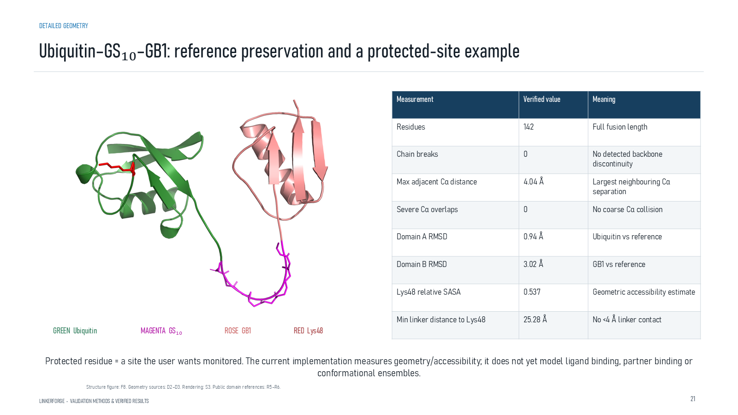
Revision 18 slide 68

Purpose and connection to the project
Explain the Ubiquitin-GS10-GB1 geometry and Lys48 protected-site example. The measurements support geometric separation in one pose, not retained function.
This structural section compares complete fusion constructs under matched prediction settings. Every metric answers a limited question: local confidence, global topology, relative domain placement, geometric preservation, clashes or short-run dynamics. None alone establishes expression, stability or activity.
Why this slide matters: It allows candidate and control sequences to be compared reproducibly while keeping confidence scores distinct from experimental outcomes.

Evidence and labels shown on the slide
The following visible elements carry the slide's scientific content. Their role and evidence level are explained in the presentation script below.
- DETAILED GEOMETRY
- Ubiquitin–GS₁₀–GB1: reference preservation and a protected-site example
- LINKERFORGE • VALIDATION METHODS & VERIFIED RESULTS
- GREEN Ubiquitin
- MAGENTA GS₁₀
- Protected residue = a site the user wants monitored. The current implementation measures geometry/accessibility; it does not yet model ligand binding, partner binding or conformational ensembles.
- Structure figure: F8. Geometry sources: D2–D3. Rendering: S3. Public domain references: R5–R6.

Terms explained on this slide
DOMAIN: A protein domain is a region expected to form a recognizable three-dimensional unit. Domain boundaries are structural or annotation claims, not simply changes in sequence composition.
LINKER: A linker is the peptide segment between joined domains. Its sequence and length can influence spacing, flexibility, orientation and exposure, but cannot guarantee function.
PROTECTED RESIDUE: A protected residue is a user-identified site that should remain spatially accessible or structurally preserved. The software can measure it only if numbering is mapped correctly.

Detailed interpretation of the visual
First locate the protected residue on the reference domain, then inspect its exposure and nearest-contact measurements in the fusion pose. Correct residue numbering is essential.
The object or dataset, comparison, axes, units, colours and layer dimensions define what the visual represents. The observed pattern is interpreted only within those definitions, preventing a prominent number or molecular rendering from being mistaken for broader biological proof.

Exact presentation script
This slide explains the Ubiquitin-GS10-GB1 geometry and Lys48 protected-site example. The measurements support geometric separation in one pose, not retained function.
This structural section compares complete fusion constructs under matched prediction settings. Every metric answers a limited question: local confidence, global topology, relative domain placement, geometric preservation, clashes or short-run dynamics. None alone establishes expression, stability or activity.
On this slide, the concrete evidence and labels shown are: DETAILED GEOMETRY; Ubiquitin–GS₁₀–GB1: reference preservation and a protected-site example; LINKERFORGE • VALIDATION METHODS & VERIFIED RESULTS; GREEN Ubiquitin; and MAGENTA GS₁₀. Together, these items establish exactly what was examined here, while retaining their individual evidence levels.
A protein domain is a region expected to form a recognizable three-dimensional unit. Domain boundaries are structural or annotation claims, not simply changes in sequence composition. A linker is the peptide segment between joined domains. Its sequence and length can influence spacing, flexibility, orientation and exposure, but cannot guarantee function. A protected residue is a user-identified site that should remain spatially accessible or structurally preserved. The software can measure it only if numbering is mapped correctly.
The reason this result belongs in the project is that it allows candidate and control sequences to be compared reproducibly while keeping confidence scores distinct from experimental outcomes.
The conclusion from this slide is deliberately limited. One pose cannot prove protected-site accessibility in all conformations.

Likely examiner question
Question: What does slide 68 allow you to conclude?
Defensible answer: It supports the limited interpretation described above. The safe stopping point is: One pose cannot prove protected-site accessibility in all conformations.

Scientific claim boundary
One pose cannot prove protected-site accessibility in all conformations.
This boundary is part of the scientific interpretation, not a weakness to hide. State it clearly so the audience can distinguish what was measured from what would require prospective or experimental validation.

Slide 69 Reference domain RMSD
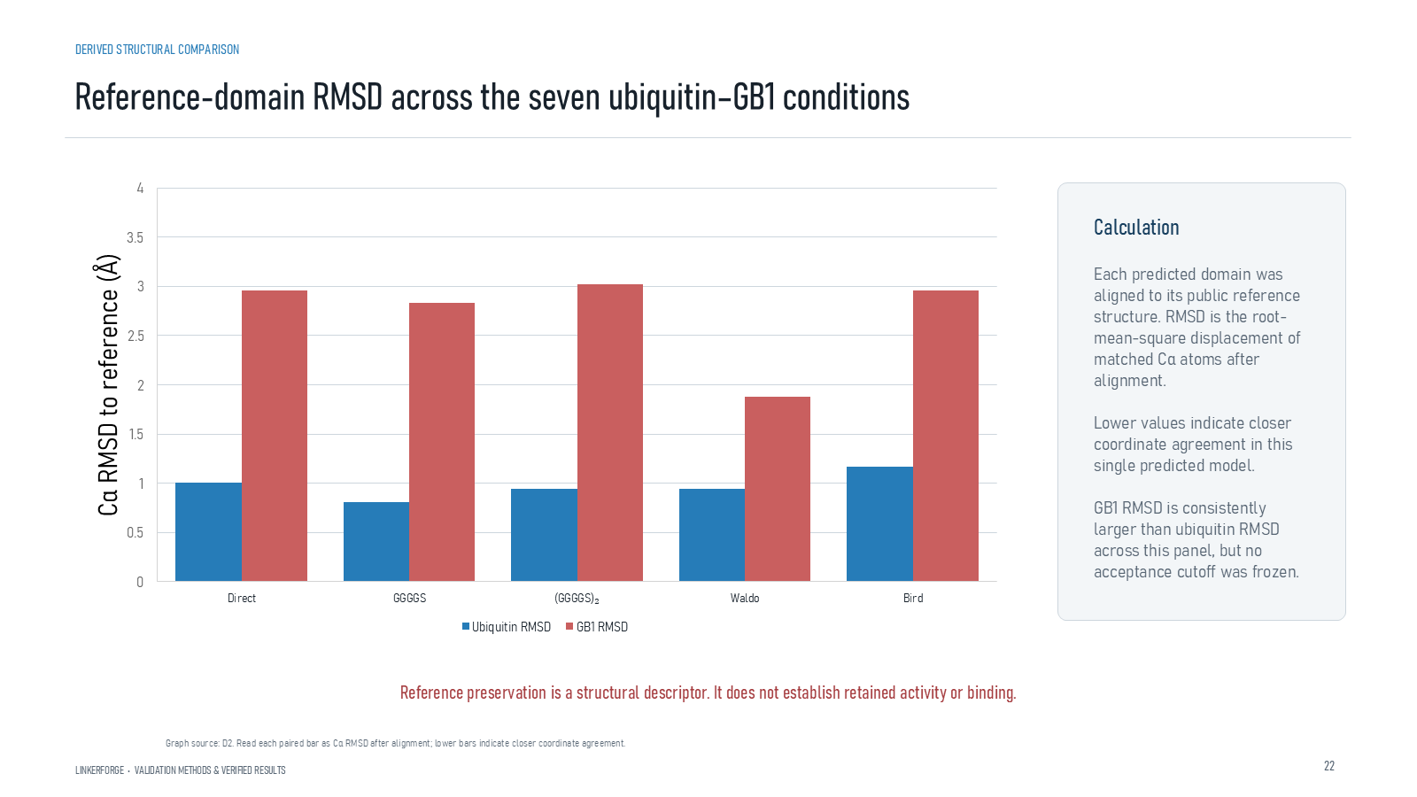
Revision 18 slide 69

Purpose and connection to the project
Explain separate-domain C-alpha alignment and RMSD. GB1 deviates more than ubiquitin, but no frozen acceptance cutoff exists.
This structural section compares complete fusion constructs under matched prediction settings. Every metric answers a limited question: local confidence, global topology, relative domain placement, geometric preservation, clashes or short-run dynamics. None alone establishes expression, stability or activity.
Why this slide matters: It allows candidate and control sequences to be compared reproducibly while keeping confidence scores distinct from experimental outcomes.

Evidence and labels shown on the slide
The following visible elements carry the slide's scientific content. Their role and evidence level are explained in the presentation script below.
- DERIVED STRUCTURAL COMPARISON
- Reference-domain RMSD across the seven ubiquitin–GB1 conditions
- LINKERFORGE • VALIDATION METHODS & VERIFIED RESULTS
- Each predicted domain was aligned to its public reference structure. RMSD is the root-mean-square displacement of matched Cα atoms after alignment. Lower values indicate closer coordinate agreement in this single predicted model. GB1 RMSD is consistently larger than ubiquitin RMSD across this panel, but no acceptance cutoff was frozen.
- Reference preservation is a structural descriptor. It does not establish retained activity or binding.
- Graph source: D2. Read each paired bar as Cα RMSD after alignment; lower bars indicate closer coordinate agreement.

Terms explained on this slide
DOMAIN: A protein domain is a region expected to form a recognizable three-dimensional unit. Domain boundaries are structural or annotation claims, not simply changes in sequence composition.
LINKER: A linker is the peptide segment between joined domains. Its sequence and length can influence spacing, flexibility, orientation and exposure, but cannot guarantee function.
RMSD: Root-mean-square deviation summarizes coordinate differences after alignment. It depends on atom selection and reference frame and does not directly measure retained function.

Detailed interpretation of the visual
RMSD is considered separately for each reference-aligned domain. A larger value indicates more coordinate deviation under the stated atom selection, not automatically loss of function.
The object or dataset, comparison, axes, units, colours and layer dimensions define what the visual represents. The observed pattern is interpreted only within those definitions, preventing a prominent number or molecular rendering from being mistaken for broader biological proof.

Exact presentation script
This slide explains separate-domain C-alpha alignment and RMSD. GB1 deviates more than ubiquitin, but no frozen acceptance cutoff exists.
This structural section compares complete fusion constructs under matched prediction settings. Every metric answers a limited question: local confidence, global topology, relative domain placement, geometric preservation, clashes or short-run dynamics. None alone establishes expression, stability or activity.
On this slide, the concrete evidence and labels shown are: DERIVED STRUCTURAL COMPARISON; Reference-domain RMSD across the seven ubiquitin–GB1 conditions; LINKERFORGE • VALIDATION METHODS & VERIFIED RESULTS; Each predicted domain was aligned to its public reference structure. RMSD is the root-mean-square displacement of matched Cα atoms after alignment. Lower values indicate closer coordinate agreement in this single predicted model. GB1 RMSD is consistently larger than ubiquitin RMSD across this panel, but no acceptance cutoff was frozen; and Reference preservation is a structural descriptor. It does not establish retained activity or binding. Together, these items establish exactly what was examined here, while retaining their individual evidence levels.
A protein domain is a region expected to form a recognizable three-dimensional unit. Domain boundaries are structural or annotation claims, not simply changes in sequence composition. A linker is the peptide segment between joined domains. Its sequence and length can influence spacing, flexibility, orientation and exposure, but cannot guarantee function. Root-mean-square deviation summarizes coordinate differences after alignment. It depends on atom selection and reference frame and does not directly measure retained function.
The reason this result belongs in the project is that it allows candidate and control sequences to be compared reproducibly while keeping confidence scores distinct from experimental outcomes.
The conclusion from this slide is deliberately limited. RMSD does not establish retained function.

Likely examiner question
Question: What does slide 69 allow you to conclude?
Defensible answer: It supports the limited interpretation described above. The safe stopping point is: RMSD does not establish retained function.

Scientific claim boundary
RMSD does not establish retained function.
This boundary is part of the scientific interpretation, not a weakness to hide. State it clearly so the audience can distinguish what was measured from what would require prospective or experimental validation.

Slide 70 Hydrogen aware overlaps and burial
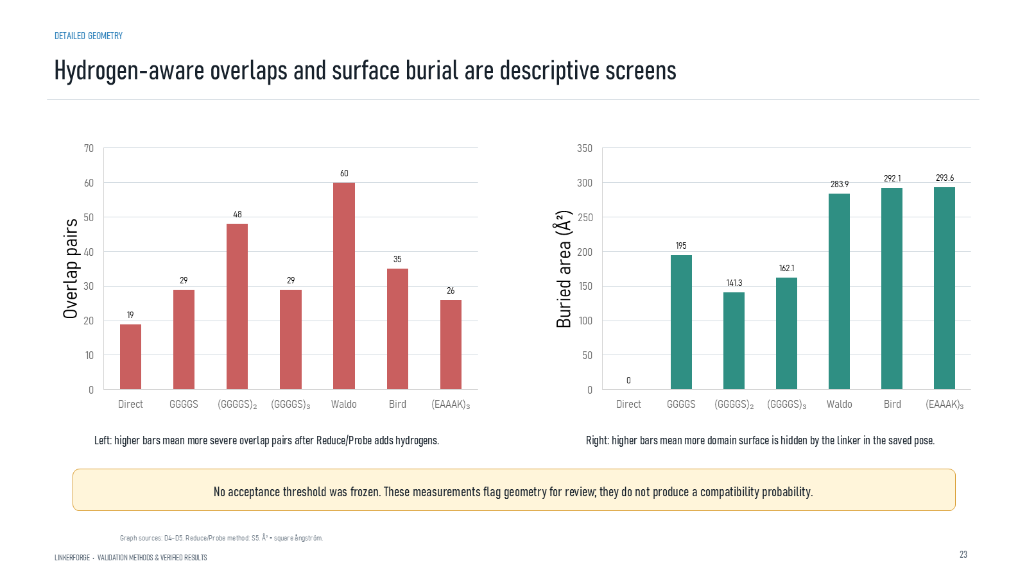
Revision 18 slide 70

Purpose and connection to the project
Treat severe overlaps and linker-related burial as review flags. Neither count is a calibrated compatibility probability.
This structural section compares complete fusion constructs under matched prediction settings. Every metric answers a limited question: local confidence, global topology, relative domain placement, geometric preservation, clashes or short-run dynamics. None alone establishes expression, stability or activity.
Why this slide matters: It allows candidate and control sequences to be compared reproducibly while keeping confidence scores distinct from experimental outcomes.

Evidence and labels shown on the slide
The following visible elements carry the slide's scientific content. Their role and evidence level are explained in the presentation script below.
- DETAILED GEOMETRY
- Hydrogen-aware overlaps and surface burial are descriptive screens
- LINKERFORGE • VALIDATION METHODS & VERIFIED RESULTS
- Left: higher bars mean more severe overlap pairs after Reduce/Probe adds hydrogens.
- Right: higher bars mean more domain surface is hidden by the linker in the saved pose.
- No acceptance threshold was frozen. These measurements flag geometry for review; they do not produce a compatibility probability.
- Graph sources: D4–D5. Reduce/Probe method: S5. Å² = square ångström.

Terms explained on this slide
DOMAIN: A protein domain is a region expected to form a recognizable three-dimensional unit. Domain boundaries are structural or annotation claims, not simply changes in sequence composition.
LINKER: A linker is the peptide segment between joined domains. Its sequence and length can influence spacing, flexibility, orientation and exposure, but cannot guarantee function.
APS: Average precision score summarizes the precision-recall curve and is useful for imbalanced labels. It depends on the dataset and cannot be compared across unrelated tasks as a universal score.
PROBE: Probe evaluates hydrogen-aware close contacts and overlaps. Severe overlap counts flag steric concerns but are not calibrated fusion-failure probabilities.

Detailed interpretation of the visual
Overlap counts and burial changes as flags requiring inspection. Confirm whether contacts involve the linker, a domain interface or an artefact before drawing conclusions.
The object or dataset, comparison, axes, units, colours and layer dimensions define what the visual represents. The observed pattern is interpreted only within those definitions, preventing a prominent number or molecular rendering from being mistaken for broader biological proof.

Exact presentation script
This slide treats severe overlaps and linker-related burial as review flags. Neither count is a calibrated compatibility probability.
This structural section compares complete fusion constructs under matched prediction settings. Every metric answers a limited question: local confidence, global topology, relative domain placement, geometric preservation, clashes or short-run dynamics. None alone establishes expression, stability or activity.
On this slide, the concrete evidence and labels shown are: DETAILED GEOMETRY; Hydrogen-aware overlaps and surface burial are descriptive screens; LINKERFORGE • VALIDATION METHODS & VERIFIED RESULTS; Left: higher bars mean more severe overlap pairs after Reduce/Probe adds hydrogens; and Right: higher bars mean more domain surface is hidden by the linker in the saved pose. Together, these items establish exactly what was examined here, while retaining their individual evidence levels.
A protein domain is a region expected to form a recognizable three-dimensional unit. Domain boundaries are structural or annotation claims, not simply changes in sequence composition. A linker is the peptide segment between joined domains. Its sequence and length can influence spacing, flexibility, orientation and exposure, but cannot guarantee function. Average precision score summarizes the precision-recall curve and is useful for imbalanced labels. It depends on the dataset and cannot be compared across unrelated tasks as a universal score.
The reason this result belongs in the project is that it allows candidate and control sequences to be compared reproducibly while keeping confidence scores distinct from experimental outcomes.
The conclusion from this slide is deliberately limited. No acceptance threshold converts overlap or burial into pass or fail.

Likely examiner question
Question: What does slide 70 allow you to conclude?
Defensible answer: It supports the limited interpretation described above. The safe stopping point is: No acceptance threshold converts overlap or burial into pass or fail.

Scientific claim boundary
No acceptance threshold converts overlap or burial into pass or fail.
This boundary is part of the scientific interpretation, not a weakness to hide. State it clearly so the audience can distinguish what was measured from what would require prospective or experimental validation.

Slide 71 DFLpred orthogonal check
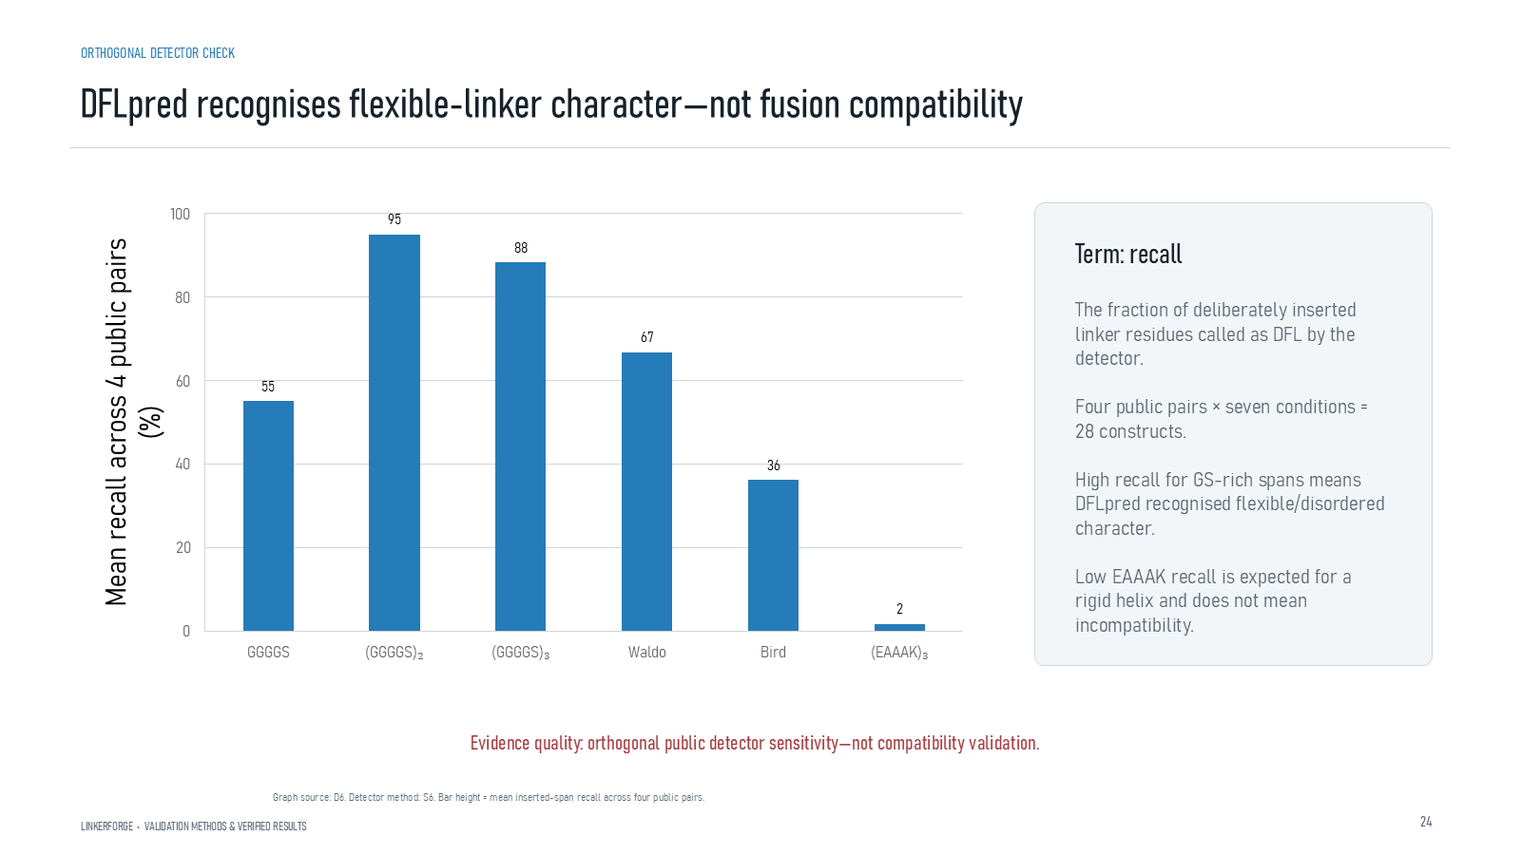
Revision 18 slide 71

Purpose and connection to the project
Explain DFLpred recall as inserted residues called flexible-linker residues. GS-rich sequences score high, while low EAAAK recall is expected for a helix.
This structural section compares complete fusion constructs under matched prediction settings. Every metric answers a limited question: local confidence, global topology, relative domain placement, geometric preservation, clashes or short-run dynamics. None alone establishes expression, stability or activity.
Why this slide matters: It allows candidate and control sequences to be compared reproducibly while keeping confidence scores distinct from experimental outcomes.

Evidence and labels shown on the slide
The following visible elements carry the slide's scientific content. Their role and evidence level are explained in the presentation script below.
- ORTHOGONAL DETECTOR CHECK
- DFLpred recognises flexible-linker character—not fusion compatibility
- LINKERFORGE • VALIDATION METHODS & VERIFIED RESULTS
- Term: recall
- The fraction of deliberately inserted linker residues called as DFL by the detector. Four public pairs × seven conditions = 28 constructs. High recall for GS-rich spans means DFLpred recognised flexible/disordered character. Low EAAAK recall is expected for a rigid helix and does not mean incompatibility.
- Evidence quality: orthogonal public detector sensitivity—not compatibility validation.
- Graph source: D6. Detector method: S6. Bar height = mean inserted-span recall across four public pairs.

Terms explained on this slide
LINKER: A linker is the peptide segment between joined domains. Its sequence and length can influence spacing, flexibility, orientation and exposure, but cannot guarantee function.
DFL: DFL means disordered flexible linker. It is a residue-label concept used by the detector and is not synonymous with every domain gap.
GS-RICH: GS-rich linkers contain many glycine and serine residues. Glycine permits backbone freedom and serine contributes polarity, but the label flexible is a design tendency rather than a guarantee.
EAAAK: EAAAK repeats are used as helix-favouring spacers. The term rigid is relative: the peptide still fluctuates and its performance depends on the attached proteins.
RECALL: Recall is TP divided by TP plus FN: among true positives, the fraction that is found.

Detailed interpretation of the visual
The y-axis is recall of inserted linker residues classified as flexible-linker residues by DFLpred. This is an orthogonal sequence-character check, not a fusion-compatibility score.
The object or dataset, comparison, axes, units, colours and layer dimensions define what the visual represents. The observed pattern is interpreted only within those definitions, preventing a prominent number or molecular rendering from being mistaken for broader biological proof.

Exact presentation script
This slide explains DFLpred recall as inserted residues called flexible-linker residues. GS-rich sequences score high, while low EAAAK recall is expected for a helix.
This structural section compares complete fusion constructs under matched prediction settings. Every metric answers a limited question: local confidence, global topology, relative domain placement, geometric preservation, clashes or short-run dynamics. None alone establishes expression, stability or activity.
On this slide, the concrete evidence and labels shown are: ORTHOGONAL DETECTOR CHECK; DFLpred recognises flexible-linker character—not fusion compatibility; LINKERFORGE • VALIDATION METHODS & VERIFIED RESULTS; Term: recall; and The fraction of deliberately inserted linker residues called as DFL by the detector. Four public pairs × seven conditions = 28 constructs. High recall for GS-rich spans means DFLpred recognised flexible/disordered character. Low EAAAK recall is expected for a rigid helix and does not mean incompatibility. Together, these items establish exactly what was examined here, while retaining their individual evidence levels.
A linker is the peptide segment between joined domains. Its sequence and length can influence spacing, flexibility, orientation and exposure, but cannot guarantee function. DFL means disordered flexible linker. It is a residue-label concept used by the detector and is not synonymous with every domain gap. GS-rich linkers contain many glycine and serine residues. Glycine permits backbone freedom and serine contributes polarity, but the label flexible is a design tendency rather than a guarantee.
The reason this result belongs in the project is that it allows candidate and control sequences to be compared reproducibly while keeping confidence scores distinct from experimental outcomes.
The conclusion from this slide is deliberately limited. DFLpred tests flexible-linker character, not fusion compatibility.

Likely examiner question
Question: Does DFLpred validate the designed linker?
Defensible answer: It checks whether inserted residues resemble flexible-linker labels. It cannot evaluate rigid linkers fairly and does not measure fusion compatibility, folding or function.

Scientific claim boundary
DFLpred tests flexible-linker character, not fusion compatibility.
This boundary is part of the scientific interpretation, not a weakness to hide. State it clearly so the audience can distinguish what was measured from what would require prospective or experimental validation.

Slide 72 OpenMM execution validation
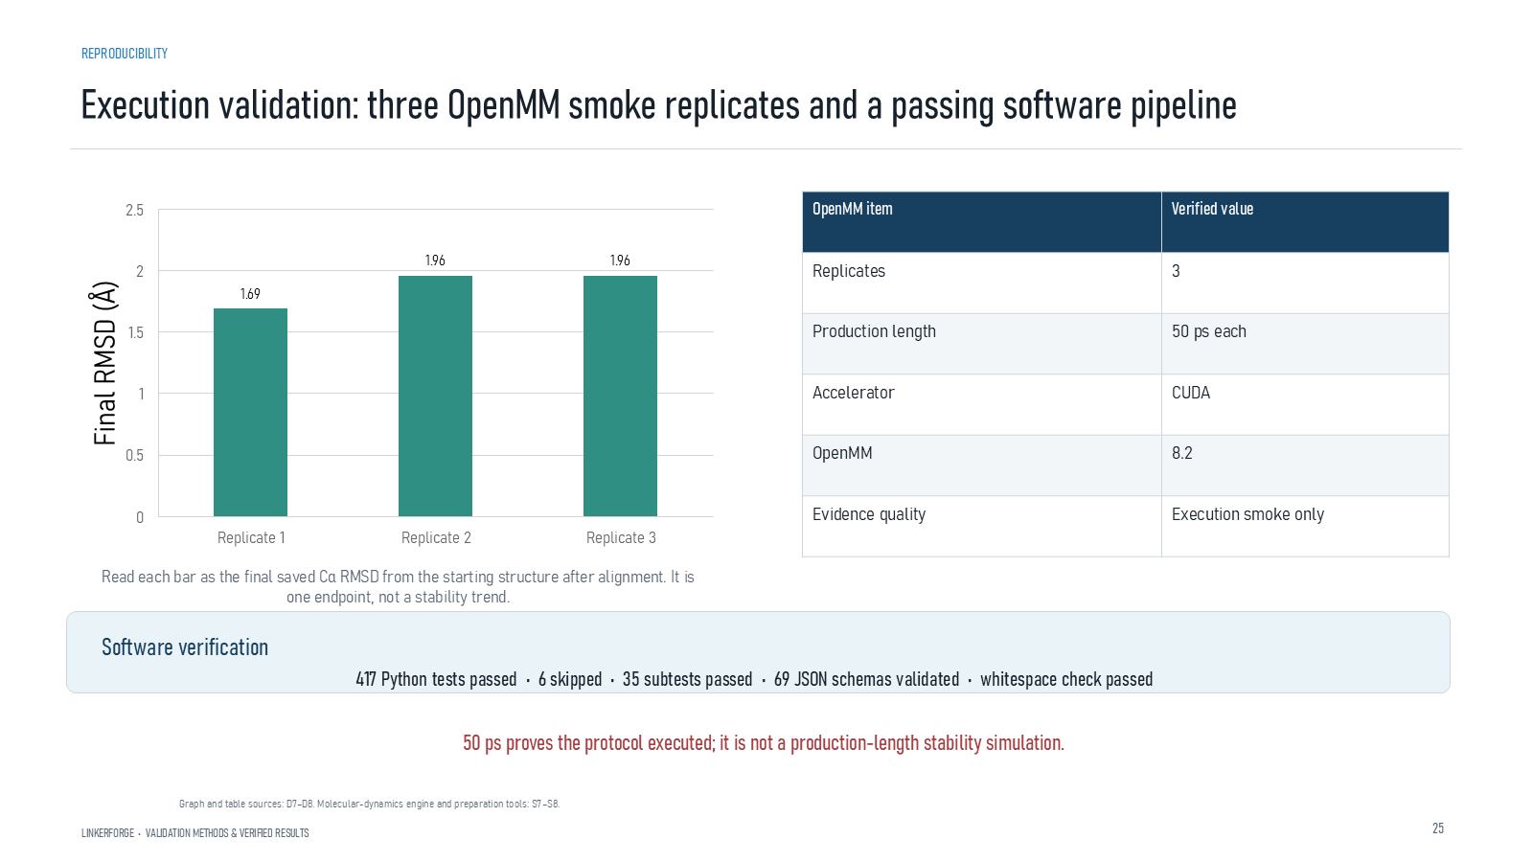
Revision 18 slide 72

Purpose and connection to the project
Present three 50 ps CUDA/OpenMM replicates and the software-test counts as execution evidence. Endpoint RMSD is not a stability result.
This structural section compares complete fusion constructs under matched prediction settings. Every metric answers a limited question: local confidence, global topology, relative domain placement, geometric preservation, clashes or short-run dynamics. None alone establishes expression, stability or activity.
Why this slide matters: It allows candidate and control sequences to be compared reproducibly while keeping confidence scores distinct from experimental outcomes.

Evidence and labels shown on the slide
The following visible elements carry the slide's scientific content. Their role and evidence level are explained in the presentation script below.
- REPRODUCIBILITY
- Execution validation: three OpenMM smoke replicates and a passing software pipeline
- LINKERFORGE • VALIDATION METHODS & VERIFIED RESULTS
- Read each bar as the final saved Cα RMSD from the starting structure after alignment. It is one endpoint, not a stability trend.
- Software verification
- 417 Python tests passed • 6 skipped • 35 subtests passed • 69 JSON schemas validated • whitespace check passed
- 50 ps proves the protocol executed; it is not a production-length stability simulation.

Terms explained on this slide
LINKER: A linker is the peptide segment between joined domains. Its sequence and length can influence spacing, flexibility, orientation and exposure, but cannot guarantee function.
RMSD: Root-mean-square deviation summarizes coordinate differences after alignment. It depends on atom selection and reference frame and does not directly measure retained function.
OPENMM: OpenMM is a molecular-dynamics engine. The reported three 50-picosecond runs verify execution and metric output, not equilibrium or long-term stability.

Detailed interpretation of the visual
The table reports execution facts: preparation, CUDA platform, trajectory completion and metric output. The small time scale prevents a stability conclusion.
The object or dataset, comparison, axes, units, colours and layer dimensions define what the visual represents. The observed pattern is interpreted only within those definitions, preventing a prominent number or molecular rendering from being mistaken for broader biological proof.

Exact presentation script
This slide presents three 50 ps CUDA/OpenMM replicates and the software-test counts as execution evidence. Endpoint RMSD is not a stability result.
This structural section compares complete fusion constructs under matched prediction settings. Every metric answers a limited question: local confidence, global topology, relative domain placement, geometric preservation, clashes or short-run dynamics. None alone establishes expression, stability or activity.
On this slide, the concrete evidence and labels shown are: REPRODUCIBILITY; Execution validation: three OpenMM smoke replicates and a passing software pipeline; LINKERFORGE • VALIDATION METHODS & VERIFIED RESULTS; Read each bar as the final saved Cα RMSD from the starting structure after alignment. It is one endpoint, not a stability trend; and Software verification. Together, these items establish exactly what was examined here, while retaining their individual evidence levels.
A linker is the peptide segment between joined domains. Its sequence and length can influence spacing, flexibility, orientation and exposure, but cannot guarantee function. Root-mean-square deviation summarizes coordinate differences after alignment. It depends on atom selection and reference frame and does not directly measure retained function. OpenMM is a molecular-dynamics engine. The reported three 50-picosecond runs verify execution and metric output, not equilibrium or long-term stability.
The reason this result belongs in the project is that it allows candidate and control sequences to be compared reproducibly while keeping confidence scores distinct from experimental outcomes.
The conclusion from this slide is deliberately limited. A 50 ps smoke test is not production stability evidence.

Likely examiner question
Question: What did the OpenMM runs prove?
Defensible answer: They proved that preparation, GPU execution, trajectory writing and metric extraction completed. Fifty picoseconds is far too short to claim equilibration or stability.

Scientific claim boundary
A 50 ps smoke test is not production stability evidence.
This boundary is part of the scientific interpretation, not a weakness to hide. State it clearly so the audience can distinguish what was measured from what would require prospective or experimental validation.

Slide 73 OpenMM traces through time
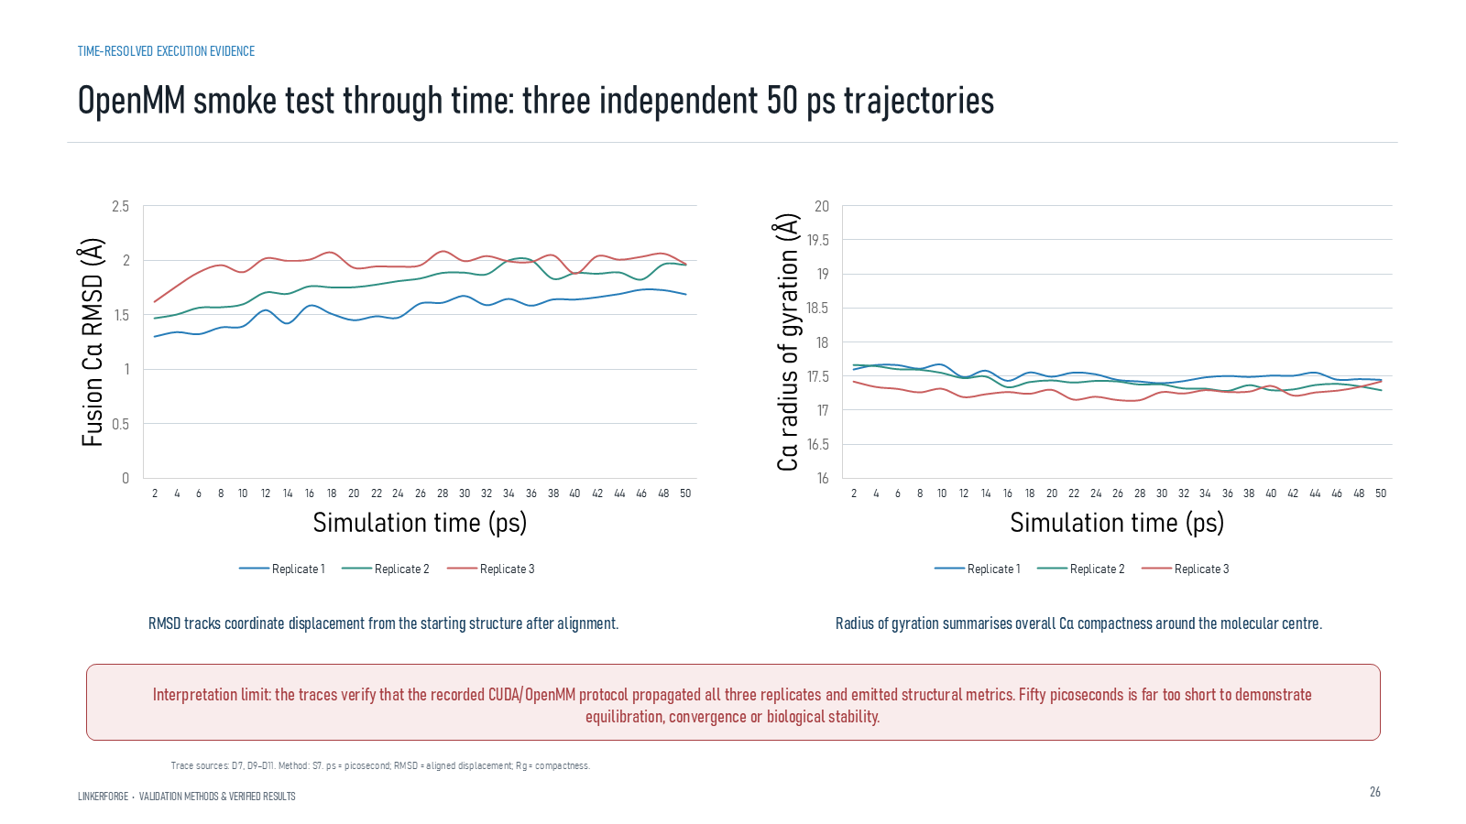
Revision 18 slide 73

Purpose and connection to the project
Explain RMSD and radius-of-gyration traces through time. Fifty picoseconds cannot establish equilibrium or convergence.
This structural section compares complete fusion constructs under matched prediction settings. Every metric answers a limited question: local confidence, global topology, relative domain placement, geometric preservation, clashes or short-run dynamics. None alone establishes expression, stability or activity.
Why this slide matters: It allows candidate and control sequences to be compared reproducibly while keeping confidence scores distinct from experimental outcomes.

Evidence and labels shown on the slide
The following visible elements carry the slide's scientific content. Their role and evidence level are explained in the presentation script below.
- TIME-RESOLVED EXECUTION EVIDENCE
- OpenMM smoke test through time: three independent 50 ps trajectories
- LINKERFORGE • VALIDATION METHODS & VERIFIED RESULTS
- RMSD tracks coordinate displacement from the starting structure after alignment.
- Radius of gyration summarises overall Cα compactness around the molecular centre.
- Interpretation limit: the traces verify that the recorded CUDA/OpenMM protocol propagated all three replicates and emitted structural metrics. Fifty picoseconds is far too short to demonstrate equilibration, convergence or biological stability.
- Trace sources: D7, D9–D11. Method: S7. ps = picosecond; RMSD = aligned displacement; Rg = compactness.

Terms explained on this slide
LINKER: A linker is the peptide segment between joined domains. Its sequence and length can influence spacing, flexibility, orientation and exposure, but cannot guarantee function.
RMSD: Root-mean-square deviation summarizes coordinate differences after alignment. It depends on atom selection and reference frame and does not directly measure retained function.
OPENMM: OpenMM is a molecular-dynamics engine. The reported three 50-picosecond runs verify execution and metric output, not equilibrium or long-term stability.
RADIUS OF GYRATION: Radius of gyration summarizes how far atoms are distributed around their center of mass. A stable short trace does not prove a converged ensemble.

Detailed interpretation of the visual
Each replicate independently before looking for agreement. RMSD and radius-of-gyration traces over 50 ps show that the pipeline ran, but the duration is too short for convergence analysis.
The object or dataset, comparison, axes, units, colours and layer dimensions define what the visual represents. The observed pattern is interpreted only within those definitions, preventing a prominent number or molecular rendering from being mistaken for broader biological proof.

Exact presentation script
This slide explains RMSD and radius-of-gyration traces through time. Fifty picoseconds cannot establish equilibrium or convergence.
This structural section compares complete fusion constructs under matched prediction settings. Every metric answers a limited question: local confidence, global topology, relative domain placement, geometric preservation, clashes or short-run dynamics. None alone establishes expression, stability or activity.
On this slide, the concrete evidence and labels shown are: TIME-RESOLVED EXECUTION EVIDENCE; OpenMM smoke test through time: three independent 50 ps trajectories; LINKERFORGE • VALIDATION METHODS & VERIFIED RESULTS; RMSD tracks coordinate displacement from the starting structure after alignment; and Radius of gyration summarises overall Cα compactness around the molecular centre. Together, these items establish exactly what was examined here, while retaining their individual evidence levels.
A linker is the peptide segment between joined domains. Its sequence and length can influence spacing, flexibility, orientation and exposure, but cannot guarantee function. Root-mean-square deviation summarizes coordinate differences after alignment. It depends on atom selection and reference frame and does not directly measure retained function. OpenMM is a molecular-dynamics engine. The reported three 50-picosecond runs verify execution and metric output, not equilibrium or long-term stability.
The reason this result belongs in the project is that it allows candidate and control sequences to be compared reproducibly while keeping confidence scores distinct from experimental outcomes.
The conclusion from this slide is deliberately limited. Short trajectories cannot establish equilibrium or convergence.

Likely examiner question
Question: What does slide 73 allow you to conclude?
Defensible answer: It supports the limited interpretation described above. The safe stopping point is: Short trajectories cannot establish equilibrium or convergence.

Scientific claim boundary
Short trajectories cannot establish equilibrium or convergence.
This boundary is part of the scientific interpretation, not a weakness to hide. State it clearly so the audience can distinguish what was measured from what would require prospective or experimental validation.

Slide 74 Application structure viewer
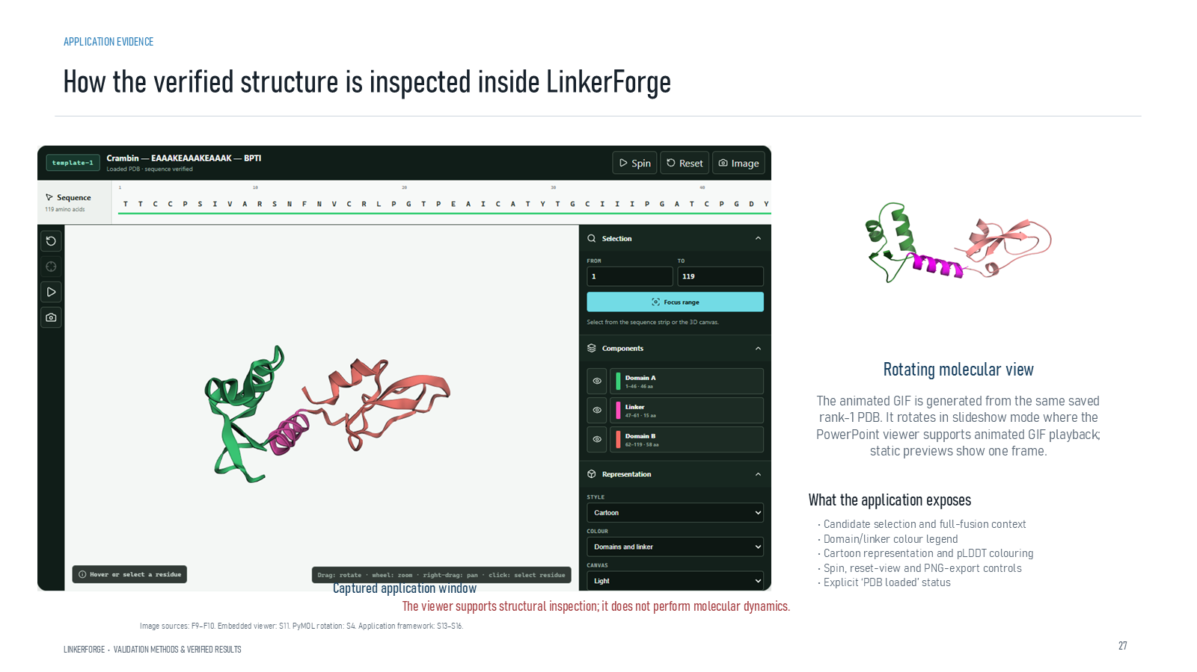
Revision 18 slide 74

Purpose and connection to the project
Show how the application presents candidate context, a molecular viewer, colour legend and export controls. The viewer does not perform molecular dynamics.
This structural section compares complete fusion constructs under matched prediction settings. Every metric answers a limited question: local confidence, global topology, relative domain placement, geometric preservation, clashes or short-run dynamics. None alone establishes expression, stability or activity.
Why this slide matters: It allows candidate and control sequences to be compared reproducibly while keeping confidence scores distinct from experimental outcomes.

Evidence and labels shown on the slide
The following visible elements carry the slide's scientific content. Their role and evidence level are explained in the presentation script below.
- APPLICATION EVIDENCE
- How the verified structure is inspected inside LinkerForge
- LINKERFORGE • VALIDATION METHODS & VERIFIED RESULTS
- Captured application window
- Rotating molecular view
- The animated GIF is generated from the same saved rank-1 PDB. It rotates in slideshow mode where the PowerPoint viewer supports animated GIF playback; static previews show one frame.
- What the application exposes

Terms explained on this slide
DOMAIN: A protein domain is a region expected to form a recognizable three-dimensional unit. Domain boundaries are structural or annotation claims, not simply changes in sequence composition.
LINKER: A linker is the peptide segment between joined domains. Its sequence and length can influence spacing, flexibility, orientation and exposure, but cannot guarantee function.
PLDDT: pLDDT is AlphaFold local confidence for each residue on a 0 to 100 scale. It is not percent biological accuracy and does not establish domain orientation.
PYMOL: PyMOL is used to render, inspect and measure structures. It does not generate the AlphaFold prediction or run the OpenMM simulation.

Detailed interpretation of the visual
The interface functions as a scientific record: candidate context, structure viewport, colour legend, confidence/geometry panels and export actions. The viewer displays saved coordinates; it is not the simulator.
The object or dataset, comparison, axes, units, colours and layer dimensions define what the visual represents. The observed pattern is interpreted only within those definitions, preventing a prominent number or molecular rendering from being mistaken for broader biological proof.

Exact presentation script
This slide shows how the application presents candidate context, a molecular viewer, colour legend and export controls. The viewer does not perform molecular dynamics.
This structural section compares complete fusion constructs under matched prediction settings. Every metric answers a limited question: local confidence, global topology, relative domain placement, geometric preservation, clashes or short-run dynamics. None alone establishes expression, stability or activity.
On this slide, the concrete evidence and labels shown are: APPLICATION EVIDENCE; How the verified structure is inspected inside LinkerForge; LINKERFORGE • VALIDATION METHODS & VERIFIED RESULTS; Captured application window; and Rotating molecular view. Together, these items establish exactly what was examined here, while retaining their individual evidence levels.
A protein domain is a region expected to form a recognizable three-dimensional unit. Domain boundaries are structural or annotation claims, not simply changes in sequence composition. A linker is the peptide segment between joined domains. Its sequence and length can influence spacing, flexibility, orientation and exposure, but cannot guarantee function. pLDDT is AlphaFold local confidence for each residue on a 0 to 100 scale. It is not percent biological accuracy and does not establish domain orientation.
The reason this result belongs in the project is that it allows candidate and control sequences to be compared reproducibly while keeping confidence scores distinct from experimental outcomes.
The conclusion from this slide is deliberately limited. An embedded viewer is not a simulation engine.

Likely examiner question
Question: What does slide 74 allow you to conclude?
Defensible answer: It supports the limited interpretation described above. The safe stopping point is: An embedded viewer is not a simulation engine.

Scientific claim boundary
An embedded viewer is not a simulation engine.
This boundary is part of the scientific interpretation, not a weakness to hide. State it clearly so the audience can distinguish what was measured from what would require prospective or experimental validation.

Slide 75 Detector and generator evidence separation
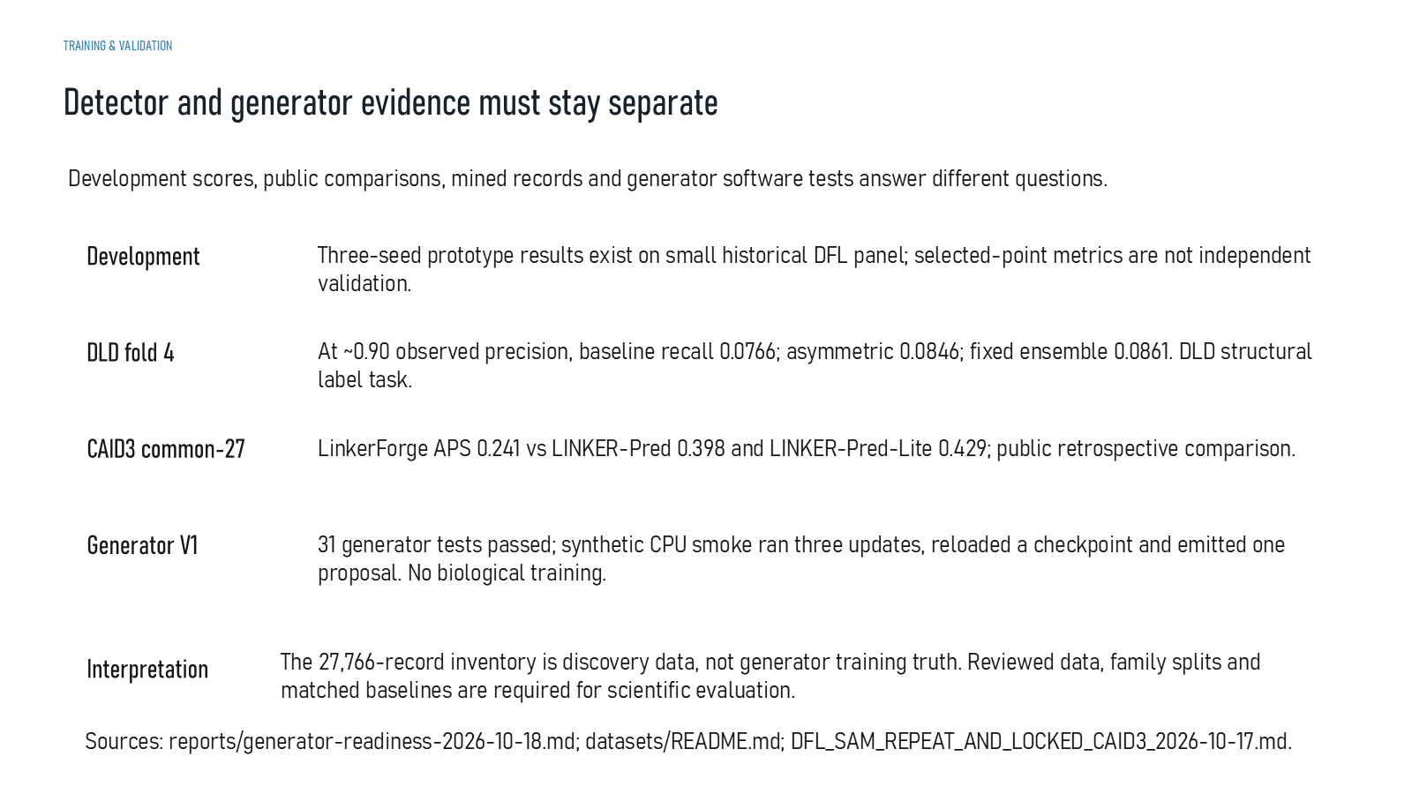
Revision 18 slide 75

Purpose and connection to the project
Keep development detector scores, DLD validation, public CAID3 comparison and generator smoke tests as separate evidence categories.
This results and limitations section integrates evidence without collapsing unlike tasks into one score. Historical detector development, DLD evaluation, retrospective CAID3 transfer, generator smoke tests and structural controls remain separate evidence streams.
Why this slide matters: It converts individual outputs into an honest project conclusion and explains why no superiority claim follows from the present evidence.

Evidence and labels shown on the slide
The following visible elements carry the slide's scientific content. Their role and evidence level are explained in the presentation script below.
- TRAINING & VALIDATION
- Detector and generator evidence must stay separate
- Development scores, public comparisons, mined records and generator software tests answer different questions.
- Three-seed prototype results exist on small historical DFL panel; selected-point metrics are not independent validation.
- At ~0.90 observed precision, baseline recall 0.0766; asymmetric 0.0846; fixed ensemble 0.0861. DLD structural label task.
- CAID3 common-27
- LinkerForge APS 0.241 vs LINKER-Pred 0.398 and LINKER-Pred-Lite 0.429; public retrospective comparison.

Terms explained on this slide
LINKER: A linker is the peptide segment between joined domains. Its sequence and length can influence spacing, flexibility, orientation and exposure, but cannot guarantee function.
DFL: DFL means disordered flexible linker. It is a residue-label concept used by the detector and is not synonymous with every domain gap.
PRECISION: Precision is TP divided by TP plus FP: among predicted positives, the fraction that is correct.
RECALL: Recall is TP divided by TP plus FN: among true positives, the fraction that is found.
APS: Average precision score summarizes the precision-recall curve and is useful for imbalanced labels. It depends on the dataset and cannot be compared across unrelated tasks as a universal score.
CAID3: CAID3 is a public disorder/linker benchmark. Once viewed, its labels and scores are retrospective and cannot be used to tune a supposedly untouched model.

Detailed interpretation of the visual
Name the dataset and task before quoting a value. Compare like with like, then state the limitation that prevents the result from supporting a broader claim.
The object or dataset, comparison, axes, units, colours and layer dimensions define what the visual represents. The observed pattern is interpreted only within those definitions, preventing a prominent number or molecular rendering from being mistaken for broader biological proof.

Exact presentation script
This slide keeps development detector scores, DLD validation, public CAID3 comparison and generator smoke tests as separate evidence categories.
This results and limitations section integrates evidence without collapsing unlike tasks into one score. Historical detector development, DLD evaluation, retrospective CAID3 transfer, generator smoke tests and structural controls remain separate evidence streams.
On this slide, the concrete evidence and labels shown are: TRAINING & VALIDATION; Detector and generator evidence must stay separate; Development scores, public comparisons, mined records and generator software tests answer different questions; Three-seed prototype results exist on small historical DFL panel; selected-point metrics are not independent validation; and At ~0.90 observed precision, baseline recall 0.0766; asymmetric 0.0846; fixed ensemble 0.0861. DLD structural label task. Together, these items establish exactly what was examined here, while retaining their individual evidence levels.
A linker is the peptide segment between joined domains. Its sequence and length can influence spacing, flexibility, orientation and exposure, but cannot guarantee function. DFL means disordered flexible linker. It is a residue-label concept used by the detector and is not synonymous with every domain gap. Precision is TP divided by TP plus FP: among predicted positives, the fraction that is correct.
The reason this result belongs in the project is that it converts individual outputs into an honest project conclusion and explains why no superiority claim follows from the present evidence.
The conclusion from this slide is deliberately limited. Scores from different tasks and datasets are not one leaderboard.

Likely examiner question
Question: What does slide 75 allow you to conclude?
Defensible answer: It supports the limited interpretation described above. The safe stopping point is: Scores from different tasks and datasets are not one leaderboard.

Scientific claim boundary
Scores from different tasks and datasets are not one leaderboard.
This boundary is part of the scientific interpretation, not a weakness to hide. State it clearly so the audience can distinguish what was measured from what would require prospective or experimental validation.

Slide 76 Detector results
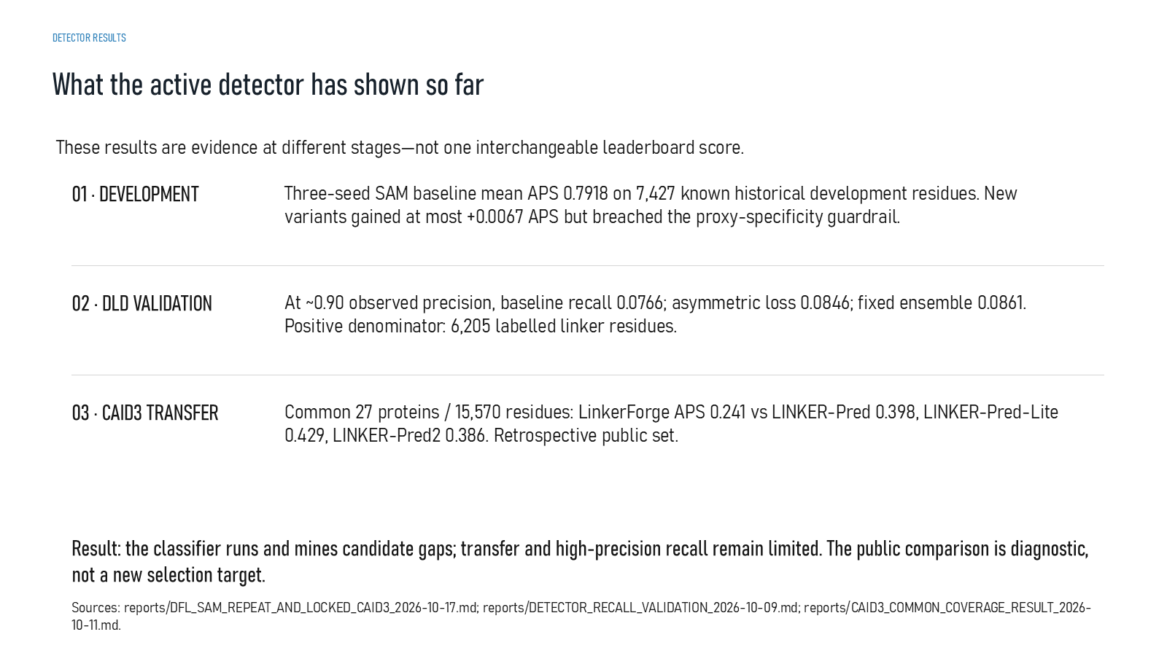
Revision 18 slide 76

Purpose and connection to the project
Explain APS 0.7918 on historical development, low recall at about 0.90 precision on DLD fold 4 and weaker retrospective CAID3 transfer. No superiority claim follows.
This results and limitations section integrates evidence without collapsing unlike tasks into one score. Historical detector development, DLD evaluation, retrospective CAID3 transfer, generator smoke tests and structural controls remain separate evidence streams.
Why this slide matters: It converts individual outputs into an honest project conclusion and explains why no superiority claim follows from the present evidence.

Evidence and labels shown on the slide
The following visible elements carry the slide's scientific content. Their role and evidence level are explained in the presentation script below.
- DETECTOR RESULTS
- What the active detector has shown so far
- These results are evidence at different stages—not one interchangeable leaderboard score.
- 01 · DEVELOPMENT
- Three-seed SAM baseline mean APS 0.7918 on 7,427 known historical development residues. New variants gained at most +0.0067 APS but breached the proxy-specificity guardrail.
- 02 · DLD VALIDATION
- At ~0.90 observed precision, baseline recall 0.0766; asymmetric loss 0.0846; fixed ensemble 0.0861. Positive denominator: 6,205 labelled linker residues.

Terms explained on this slide
LINKER: A linker is the peptide segment between joined domains. Its sequence and length can influence spacing, flexibility, orientation and exposure, but cannot guarantee function.
DFL: DFL means disordered flexible linker. It is a residue-label concept used by the detector and is not synonymous with every domain gap.
PRECISION: Precision is TP divided by TP plus FP: among predicted positives, the fraction that is correct.
RECALL: Recall is TP divided by TP plus FN: among true positives, the fraction that is found.
APS: Average precision score summarizes the precision-recall curve and is useful for imbalanced labels. It depends on the dataset and cannot be compared across unrelated tasks as a universal score.
CAID3: CAID3 is a public disorder/linker benchmark. Once viewed, its labels and scores are retrospective and cannot be used to tune a supposedly untouched model.

Detailed interpretation of the visual
Keep the three result blocks separate. Historical development metrics, DLD high-precision recall and retrospective CAID3 APS were produced on different tasks or datasets and cannot be averaged.
The object or dataset, comparison, axes, units, colours and layer dimensions define what the visual represents. The observed pattern is interpreted only within those definitions, preventing a prominent number or molecular rendering from being mistaken for broader biological proof.

Exact presentation script
This slide explains APS 0.7918 on historical development, low recall at about 0.90 precision on DLD fold 4 and weaker retrospective CAID3 transfer. No superiority claim follows.
This results and limitations section integrates evidence without collapsing unlike tasks into one score. Historical detector development, DLD evaluation, retrospective CAID3 transfer, generator smoke tests and structural controls remain separate evidence streams.
On this slide, the concrete evidence and labels shown are: DETECTOR RESULTS; What the active detector has shown so far; These results are evidence at different stages—not one interchangeable leaderboard score; 01 · DEVELOPMENT; and Three-seed SAM baseline mean APS 0.7918 on 7,427 known historical development residues. New variants gained at most +0.0067 APS but breached the proxy-specificity guardrail. Together, these items establish exactly what was examined here, while retaining their individual evidence levels.
A linker is the peptide segment between joined domains. Its sequence and length can influence spacing, flexibility, orientation and exposure, but cannot guarantee function. DFL means disordered flexible linker. It is a residue-label concept used by the detector and is not synonymous with every domain gap. Precision is TP divided by TP plus FP: among predicted positives, the fraction that is correct.
The reason this result belongs in the project is that it converts individual outputs into an honest project conclusion and explains why no superiority claim follows from the present evidence.
The conclusion from this slide is deliberately limited. The retrospective CAID3 result does not support superiority.

Likely examiner question
Question: Is the detector better than published methods?
Defensible answer: No superiority claim is supported. On the viewed CAID3 common-27 panel, the reported LinkerForge APS is lower than the cited LINKER-Pred baselines, and that benchmark is now retrospective.

Scientific claim boundary
The retrospective CAID3 result does not support superiority.
This boundary is part of the scientific interpretation, not a weakness to hide. State it clearly so the audience can distinguish what was measured from what would require prospective or experimental validation.

Slide 77 Why the complete system lacks biological validation
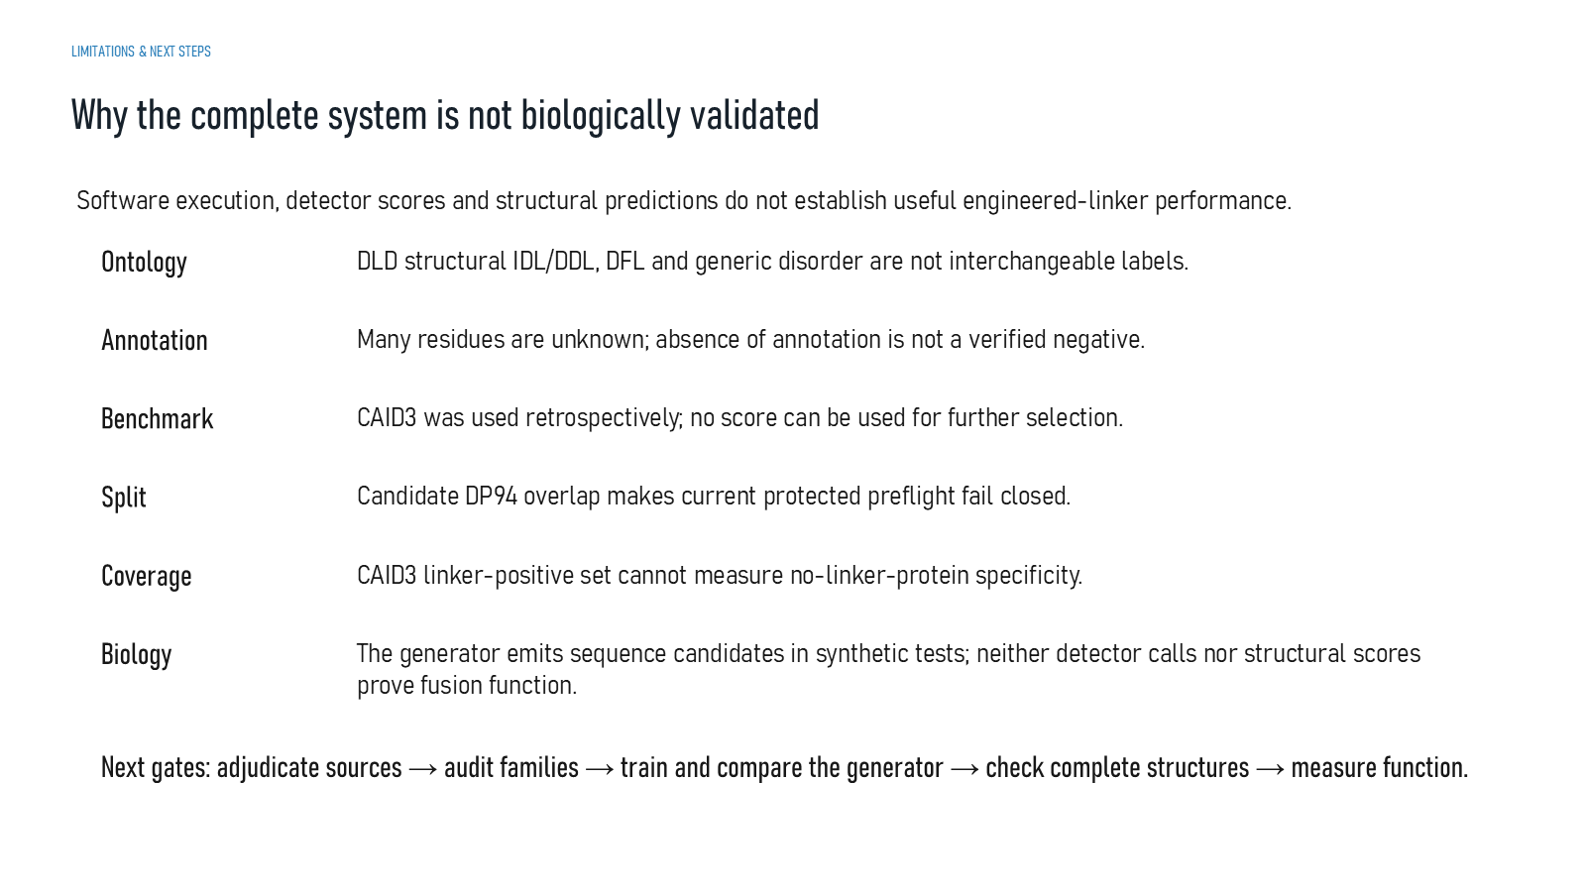
Revision 18 slide 77

Purpose and connection to the project
Summarise why ontology, unknown labels, spent benchmarks, split collisions, limited coverage and absent biology prevent a complete validation claim.
This results and limitations section integrates evidence without collapsing unlike tasks into one score. Historical detector development, DLD evaluation, retrospective CAID3 transfer, generator smoke tests and structural controls remain separate evidence streams.
Why this slide matters: It converts individual outputs into an honest project conclusion and explains why no superiority claim follows from the present evidence.

Evidence and labels shown on the slide
The following visible elements carry the slide's scientific content. Their role and evidence level are explained in the presentation script below.
- LIMITATIONS & NEXT STEPS
- Why the complete system is not biologically validated
- Software execution, detector scores and structural predictions do not establish useful engineered-linker performance.
- DLD structural IDL/DDL, DFL and generic disorder are not interchangeable labels.
- Many residues are unknown; absence of annotation is not a verified negative.
- CAID3 was used retrospectively; no score can be used for further selection.
- Candidate DP94 overlap makes current protected preflight fail closed.

Terms explained on this slide
LINKER: A linker is the peptide segment between joined domains. Its sequence and length can influence spacing, flexibility, orientation and exposure, but cannot guarantee function.
DFL: DFL means disordered flexible linker. It is a residue-label concept used by the detector and is not synonymous with every domain gap.
IDL: IDL is an independent-domain-linker class in the DLD structural task. It must not be silently relabelled as DFL truth.
DDL: DDL is a dependent-domain-linker class in the DLD structural task. It describes a structural relationship, not a fusion-success outcome.
CAID3: CAID3 is a public disorder/linker benchmark. Once viewed, its labels and scores are retrospective and cannot be used to tune a supposedly untouched model.

Detailed interpretation of the visual
Name the dataset and task before quoting a value. Compare like with like, then state the limitation that prevents the result from supporting a broader claim.
The object or dataset, comparison, axes, units, colours and layer dimensions define what the visual represents. The observed pattern is interpreted only within those definitions, preventing a prominent number or molecular rendering from being mistaken for broader biological proof.

Exact presentation script
This slide summarises why ontology, unknown labels, spent benchmarks, split collisions, limited coverage and absent biology prevent a complete validation claim.
This results and limitations section integrates evidence without collapsing unlike tasks into one score. Historical detector development, DLD evaluation, retrospective CAID3 transfer, generator smoke tests and structural controls remain separate evidence streams.
On this slide, the concrete evidence and labels shown are: LIMITATIONS & NEXT STEPS; Why the complete system is not biologically validated; Software execution, detector scores and structural predictions do not establish useful engineered-linker performance; DLD structural IDL/DDL, DFL and generic disorder are not interchangeable labels; and Many residues are unknown; absence of annotation is not a verified negative. Together, these items establish exactly what was examined here, while retaining their individual evidence levels.
A linker is the peptide segment between joined domains. Its sequence and length can influence spacing, flexibility, orientation and exposure, but cannot guarantee function. DFL means disordered flexible linker. It is a residue-label concept used by the detector and is not synonymous with every domain gap. IDL is an independent-domain-linker class in the DLD structural task. It must not be silently relabelled as DFL truth.
The reason this result belongs in the project is that it converts individual outputs into an honest project conclusion and explains why no superiority claim follows from the present evidence.
The conclusion from this slide is deliberately limited. Neither sequence calls nor structure confidence proves fusion function.

Likely examiner question
Question: What does slide 77 allow you to conclude?
Defensible answer: It supports the limited interpretation described above. The safe stopping point is: Neither sequence calls nor structure confidence proves fusion function.

Scientific claim boundary
Neither sequence calls nor structure confidence proves fusion function.
This boundary is part of the scientific interpretation, not a weakness to hide. State it clearly so the audience can distinguish what was measured from what would require prospective or experimental validation.

Slide 78 Label and evaluation limitations
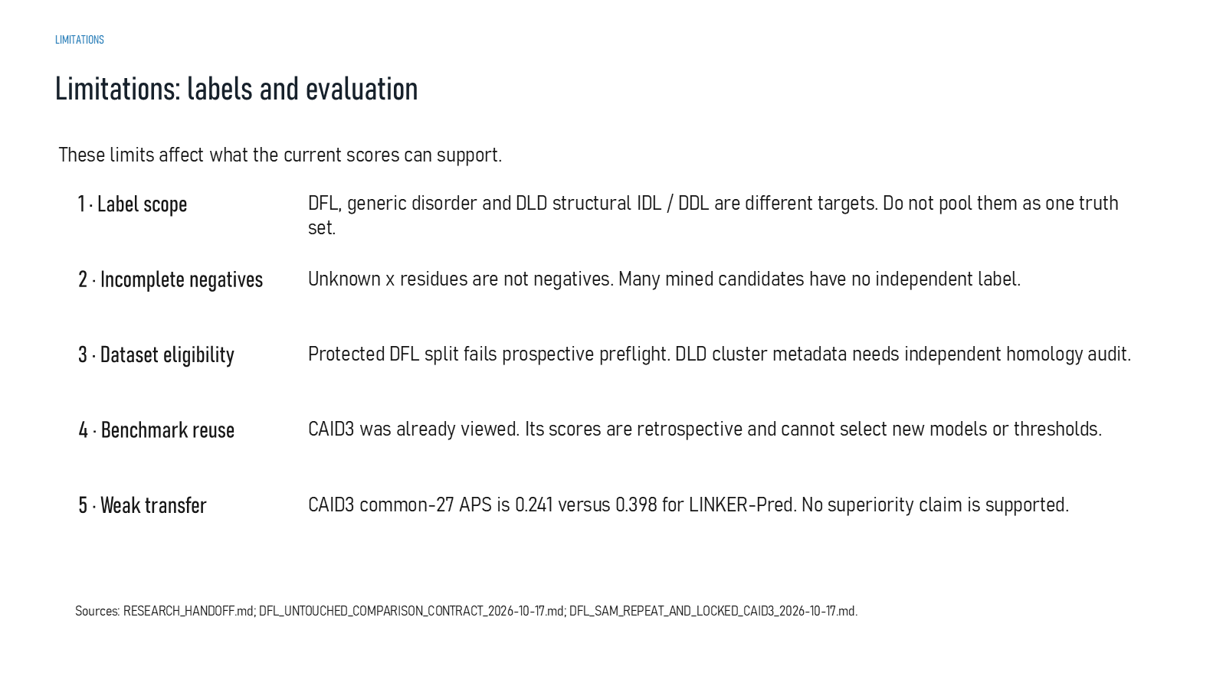
Revision 18 slide 78

Purpose and connection to the project
Focus on label scope, incomplete negatives, dataset eligibility, benchmark reuse and weak transfer. CAID3 results cannot guide another training round.
This results and limitations section integrates evidence without collapsing unlike tasks into one score. Historical detector development, DLD evaluation, retrospective CAID3 transfer, generator smoke tests and structural controls remain separate evidence streams.
Why this slide matters: It converts individual outputs into an honest project conclusion and explains why no superiority claim follows from the present evidence.

Evidence and labels shown on the slide
The following visible elements carry the slide's scientific content. Their role and evidence level are explained in the presentation script below.
- Limitations: labels and evaluation
- These limits affect what the current scores can support.
- 1 · Label scope
- DFL, generic disorder and DLD structural IDL / DDL are different targets. Do not pool them as one truth set.
- 2 · Incomplete negatives
- Unknown x residues are not negatives. Many mined candidates have no independent label.
- 3 · Dataset eligibility

Terms explained on this slide
LINKER: A linker is the peptide segment between joined domains. Its sequence and length can influence spacing, flexibility, orientation and exposure, but cannot guarantee function.
DFL: DFL means disordered flexible linker. It is a residue-label concept used by the detector and is not synonymous with every domain gap.
IDL: IDL is an independent-domain-linker class in the DLD structural task. It must not be silently relabelled as DFL truth.
DDL: DDL is a dependent-domain-linker class in the DLD structural task. It describes a structural relationship, not a fusion-success outcome.
APS: Average precision score summarizes the precision-recall curve and is useful for imbalanced labels. It depends on the dataset and cannot be compared across unrelated tasks as a universal score.
CAID3: CAID3 is a public disorder/linker benchmark. Once viewed, its labels and scores are retrospective and cannot be used to tune a supposedly untouched model.

Detailed interpretation of the visual
Name the dataset and task before quoting a value. Compare like with like, then state the limitation that prevents the result from supporting a broader claim.
The object or dataset, comparison, axes, units, colours and layer dimensions define what the visual represents. The observed pattern is interpreted only within those definitions, preventing a prominent number or molecular rendering from being mistaken for broader biological proof.

Exact presentation script
This slide focuses on label scope, incomplete negatives, dataset eligibility, benchmark reuse and weak transfer. CAID3 results cannot guide another training round.
This results and limitations section integrates evidence without collapsing unlike tasks into one score. Historical detector development, DLD evaluation, retrospective CAID3 transfer, generator smoke tests and structural controls remain separate evidence streams.
On this slide, the concrete evidence and labels shown are: Limitations: labels and evaluation; These limits affect what the current scores can support; 1 · Label scope; DFL, generic disorder and DLD structural IDL / DDL are different targets. Do not pool them as one truth set; and 2 · Incomplete negatives. Together, these items establish exactly what was examined here, while retaining their individual evidence levels.
A linker is the peptide segment between joined domains. Its sequence and length can influence spacing, flexibility, orientation and exposure, but cannot guarantee function. DFL means disordered flexible linker. It is a residue-label concept used by the detector and is not synonymous with every domain gap. IDL is an independent-domain-linker class in the DLD structural task. It must not be silently relabelled as DFL truth.
The reason this result belongs in the project is that it converts individual outputs into an honest project conclusion and explains why no superiority claim follows from the present evidence.
The conclusion from this slide is deliberately limited. Spent benchmark scores cannot select new models or thresholds.

Likely examiner question
Question: What does slide 78 allow you to conclude?
Defensible answer: It supports the limited interpretation described above. The safe stopping point is: Spent benchmark scores cannot select new models or thresholds.

Scientific claim boundary
Spent benchmark scores cannot select new models or thresholds.
This boundary is part of the scientific interpretation, not a weakness to hide. State it clearly so the audience can distinguish what was measured from what would require prospective or experimental validation.

Slide 79 Mining generation and biology limitations
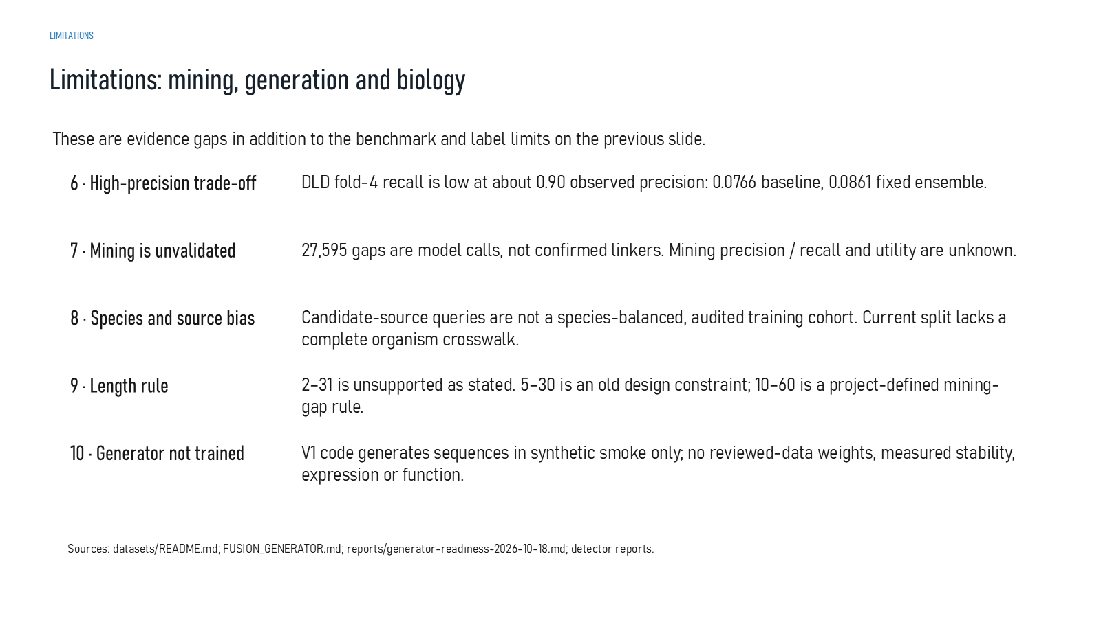
Revision 18 slide 79

Purpose and connection to the project
Focus on the high-precision recall trade-off, unvalidated mining, source bias, unsupported length wording and the absence of biologically trained generator weights.
This results and limitations section integrates evidence without collapsing unlike tasks into one score. Historical detector development, DLD evaluation, retrospective CAID3 transfer, generator smoke tests and structural controls remain separate evidence streams.
Why this slide matters: It converts individual outputs into an honest project conclusion and explains why no superiority claim follows from the present evidence.

Evidence and labels shown on the slide
The following visible elements carry the slide's scientific content. Their role and evidence level are explained in the presentation script below.
- Limitations: mining, generation and biology
- These are evidence gaps in addition to the benchmark and label limits on the previous slide.
- 6 · High-precision trade-off
- DLD fold-4 recall is low at about 0.90 observed precision: 0.0766 baseline, 0.0861 fixed ensemble.
- 7 · Mining is unvalidated
- 27,595 gaps are model calls, not confirmed linkers. Mining precision / recall and utility are unknown.
- 8 · Species and source bias

Terms explained on this slide
LINKER: A linker is the peptide segment between joined domains. Its sequence and length can influence spacing, flexibility, orientation and exposure, but cannot guarantee function.
PRECISION: Precision is TP divided by TP plus FP: among predicted positives, the fraction that is correct.
RECALL: Recall is TP divided by TP plus FN: among true positives, the fraction that is found.
APS: Average precision score summarizes the precision-recall curve and is useful for imbalanced labels. It depends on the dataset and cannot be compared across unrelated tasks as a universal score.

Detailed interpretation of the visual
Name the dataset and task before quoting a value. Compare like with like, then state the limitation that prevents the result from supporting a broader claim.
The object or dataset, comparison, axes, units, colours and layer dimensions define what the visual represents. The observed pattern is interpreted only within those definitions, preventing a prominent number or molecular rendering from being mistaken for broader biological proof.

Exact presentation script
This slide focuses on the high-precision recall trade-off, unvalidated mining, source bias, unsupported length wording and the absence of biologically trained generator weights.
This results and limitations section integrates evidence without collapsing unlike tasks into one score. Historical detector development, DLD evaluation, retrospective CAID3 transfer, generator smoke tests and structural controls remain separate evidence streams.
On this slide, the concrete evidence and labels shown are: Limitations: mining, generation and biology; These are evidence gaps in addition to the benchmark and label limits on the previous slide; 6 · High-precision trade-off; DLD fold-4 recall is low at about 0.90 observed precision: 0.0766 baseline, 0.0861 fixed ensemble; and 7 · Mining is unvalidated. Together, these items establish exactly what was examined here, while retaining their individual evidence levels.
A linker is the peptide segment between joined domains. Its sequence and length can influence spacing, flexibility, orientation and exposure, but cannot guarantee function. Precision is TP divided by TP plus FP: among predicted positives, the fraction that is correct. Recall is TP divided by TP plus FN: among true positives, the fraction that is found.
The reason this result belongs in the project is that it converts individual outputs into an honest project conclusion and explains why no superiority claim follows from the present evidence.
The conclusion from this slide is deliberately limited. The generator has no reviewed-data biological weights.

Likely examiner question
Question: What does slide 79 allow you to conclude?
Defensible answer: It supports the limited interpretation described above. The safe stopping point is: The generator has no reviewed-data biological weights.

Scientific claim boundary
The generator has no reviewed-data biological weights.
This boundary is part of the scientific interpretation, not a weakness to hide. State it clearly so the audience can distinguish what was measured from what would require prospective or experimental validation.

Slide 80 Current project conclusion
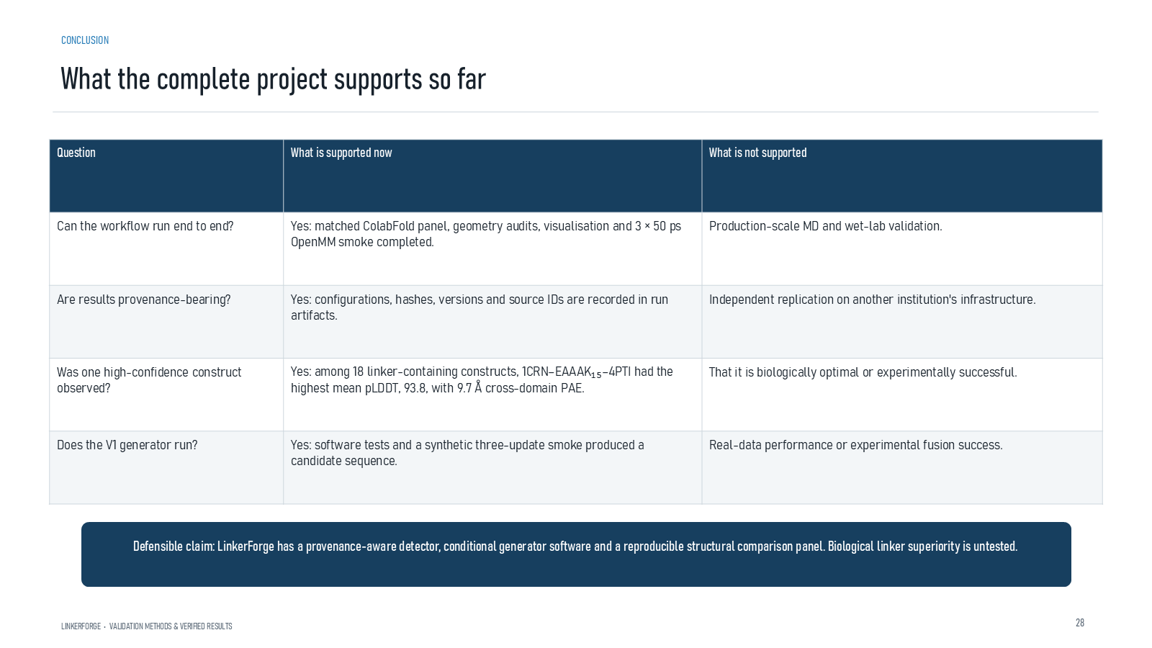
Revision 18 slide 80

Purpose and connection to the project
State the complete project claim: provenance-aware detector and generator software plus a reproducible structural panel. Biological linker superiority remains untested.
This results and limitations section integrates evidence without collapsing unlike tasks into one score. Historical detector development, DLD evaluation, retrospective CAID3 transfer, generator smoke tests and structural controls remain separate evidence streams.
Why this slide matters: It converts individual outputs into an honest project conclusion and explains why no superiority claim follows from the present evidence.

Evidence and labels shown on the slide
The following visible elements carry the slide's scientific content. Their role and evidence level are explained in the presentation script below.
- What the complete project supports so far
- LINKERFORGE • VALIDATION METHODS & VERIFIED RESULTS
- Defensible claim: LinkerForge has a provenance-aware detector, conditional generator software and a reproducible structural comparison panel. Biological linker superiority is untested.

Terms explained on this slide
LINKER: A linker is the peptide segment between joined domains. Its sequence and length can influence spacing, flexibility, orientation and exposure, but cannot guarantee function.
PROVENANCE: Provenance is the recorded origin and transformation history of a datum, model, prediction or figure, including source identifiers, code revision and configuration.

Detailed interpretation of the visual
The conclusion table moves from implemented asset to supported claim and then to unresolved claim. This is the strongest defensible project summary.
The object or dataset, comparison, axes, units, colours and layer dimensions define what the visual represents. The observed pattern is interpreted only within those definitions, preventing a prominent number or molecular rendering from being mistaken for broader biological proof.

Exact presentation script
This slide states the complete project claim: provenance-aware detector and generator software plus a reproducible structural panel. Biological linker superiority remains untested.
This results and limitations section integrates evidence without collapsing unlike tasks into one score. Historical detector development, DLD evaluation, retrospective CAID3 transfer, generator smoke tests and structural controls remain separate evidence streams.
On this slide, the concrete evidence and labels shown are: What the complete project supports so far; LINKERFORGE • VALIDATION METHODS & VERIFIED RESULTS; and Defensible claim: LinkerForge has a provenance-aware detector, conditional generator software and a reproducible structural comparison panel. Biological linker superiority is untested. Together, these items establish exactly what was examined here, while retaining their individual evidence levels.
A linker is the peptide segment between joined domains. Its sequence and length can influence spacing, flexibility, orientation and exposure, but cannot guarantee function. Provenance is the recorded origin and transformation history of a datum, model, prediction or figure, including source identifiers, code revision and configuration.
The reason this result belongs in the project is that it converts individual outputs into an honest project conclusion and explains why no superiority claim follows from the present evidence.
The conclusion from this slide is deliberately limited. The strongest current claim concerns integrated computational evidence, not biological superiority.

Likely examiner question
Question: What is the strongest publishable claim today?
Defensible answer: That LinkerForge implements a provenance-aware detector and conditional-generator workflow plus a reproducible matched structural panel, while explicitly separating confidence from biological validation.

Scientific claim boundary
The strongest current claim concerns integrated computational evidence, not biological superiority.
This boundary is part of the scientific interpretation, not a weakness to hide. State it clearly so the audience can distinguish what was measured from what would require prospective or experimental validation.

Slide 81 Evidence needed for complete validation
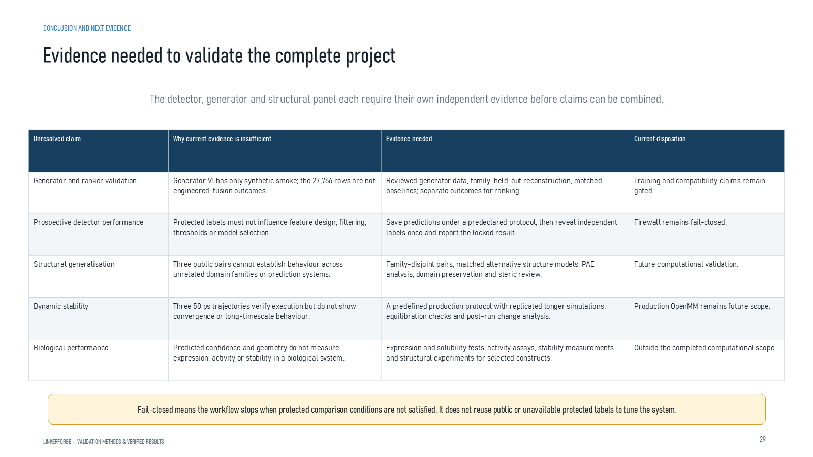
Revision 18 slide 81

Purpose and connection to the project
Map every unresolved claim to the specific evidence required: reviewed data, prospective detector testing, broader structure models, production dynamics and biological assays.
This results and limitations section integrates evidence without collapsing unlike tasks into one score. Historical detector development, DLD evaluation, retrospective CAID3 transfer, generator smoke tests and structural controls remain separate evidence streams.
Why this slide matters: It converts individual outputs into an honest project conclusion and explains why no superiority claim follows from the present evidence.

Evidence and labels shown on the slide
The following visible elements carry the slide's scientific content. Their role and evidence level are explained in the presentation script below.
- CONCLUSION AND NEXT EVIDENCE
- Evidence needed to validate the complete project
- LINKERFORGE • VALIDATION METHODS & VERIFIED RESULTS
- The detector, generator and structural panel each require their own independent evidence before claims can be combined.
- Fail-closed means the workflow stops when protected comparison conditions are not satisfied. It does not reuse public or unavailable protected labels to tune the system.

Terms explained on this slide
LINKER: A linker is the peptide segment between joined domains. Its sequence and length can influence spacing, flexibility, orientation and exposure, but cannot guarantee function.

Detailed interpretation of the visual
For each desired claim, read across to the missing dataset, experiment or prospective evaluation. The table is a validation plan, not a list of already completed work.
The object or dataset, comparison, axes, units, colours and layer dimensions define what the visual represents. The observed pattern is interpreted only within those definitions, preventing a prominent number or molecular rendering from being mistaken for broader biological proof.

Exact presentation script
This slide maps every unresolved claim to the specific evidence required: reviewed data, prospective detector testing, broader structure models, production dynamics and biological assays.
This results and limitations section integrates evidence without collapsing unlike tasks into one score. Historical detector development, DLD evaluation, retrospective CAID3 transfer, generator smoke tests and structural controls remain separate evidence streams.
On this slide, the concrete evidence and labels shown are: CONCLUSION AND NEXT EVIDENCE; Evidence needed to validate the complete project; LINKERFORGE • VALIDATION METHODS & VERIFIED RESULTS; The detector, generator and structural panel each require their own independent evidence before claims can be combined; and Fail-closed means the workflow stops when protected comparison conditions are not satisfied. It does not reuse public or unavailable protected labels to tune the system. Together, these items establish exactly what was examined here, while retaining their individual evidence levels.
A linker is the peptide segment between joined domains. Its sequence and length can influence spacing, flexibility, orientation and exposure, but cannot guarantee function.
The reason this result belongs in the project is that it converts individual outputs into an honest project conclusion and explains why no superiority claim follows from the present evidence.
The conclusion from this slide is deliberately limited. Future software work cannot replace missing outcome measurements.

Likely examiner question
Question: What does slide 81 allow you to conclude?
Defensible answer: It supports the limited interpretation described above. The safe stopping point is: Future software work cannot replace missing outcome measurements.

Scientific claim boundary
Future software work cannot replace missing outcome measurements.
This boundary is part of the scientific interpretation, not a weakness to hide. State it clearly so the audience can distinguish what was measured from what would require prospective or experimental validation.

Slide 82 What Phase 3 establishes
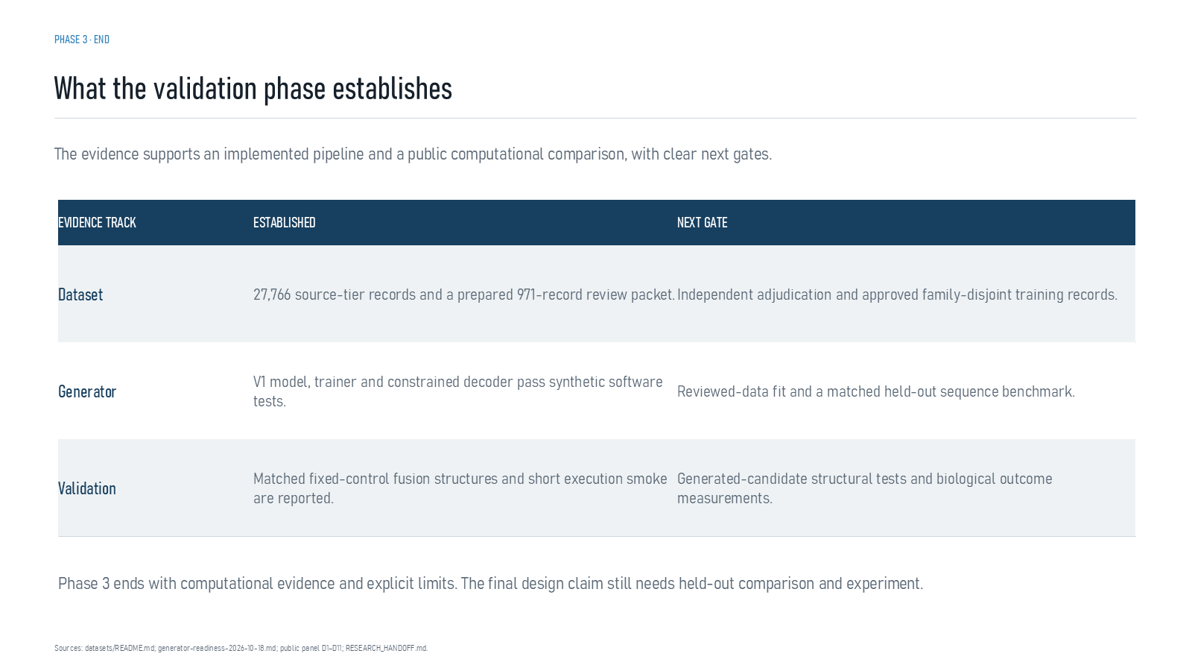
Revision 18 slide 82

Purpose and connection to the project
Close Phase 3 by separating established dataset, generator and validation outputs from their next gates.
This results and limitations section integrates evidence without collapsing unlike tasks into one score. Historical detector development, DLD evaluation, retrospective CAID3 transfer, generator smoke tests and structural controls remain separate evidence streams.
Why this slide matters: It converts individual outputs into an honest project conclusion and explains why no superiority claim follows from the present evidence.

Evidence and labels shown on the slide
The following visible elements carry the slide's scientific content. Their role and evidence level are explained in the presentation script below.
- PHASE 3 · END
- What the validation phase establishes
- The evidence supports an implemented pipeline and a public computational comparison, with clear next gates.
- Sources: datasets/README.md; generator-readiness-2026-10-18.md; public panel D1–D11; RESEARCH_HANDOFF.md.
- EVIDENCE TRACK
- 27,766 source-tier records and a prepared 971-record review packet.
- Independent adjudication and approved family-disjoint training records.

Terms explained on this slide
FAMILY-DISJOINT: A family-disjoint split keeps related protein families out of both training and evaluation, reducing memorization through homology.

Detailed interpretation of the visual
Name the dataset and task before quoting a value. Compare like with like, then state the limitation that prevents the result from supporting a broader claim.
The object or dataset, comparison, axes, units, colours and layer dimensions define what the visual represents. The observed pattern is interpreted only within those definitions, preventing a prominent number or molecular rendering from being mistaken for broader biological proof.

Exact presentation script
This slide closes Phase 3 by separating established dataset, generator and validation outputs from their next gates.
This results and limitations section integrates evidence without collapsing unlike tasks into one score. Historical detector development, DLD evaluation, retrospective CAID3 transfer, generator smoke tests and structural controls remain separate evidence streams.
On this slide, the concrete evidence and labels shown are: PHASE 3 · END; What the validation phase establishes; The evidence supports an implemented pipeline and a public computational comparison, with clear next gates; Sources: datasets/README.md; generator-readiness-2026-10-18.md; public panel D1–D11; RESEARCH_HANDOFF.md; and EVIDENCE TRACK. Together, these items establish exactly what was examined here, while retaining their individual evidence levels.
A family-disjoint split keeps related protein families out of both training and evaluation, reducing memorization through homology.
The reason this result belongs in the project is that it converts individual outputs into an honest project conclusion and explains why no superiority claim follows from the present evidence.
The conclusion from this slide is deliberately limited. Generated-candidate validation and biological outcomes remain open.

Likely examiner question
Question: What does slide 82 allow you to conclude?
Defensible answer: It supports the limited interpretation described above. The safe stopping point is: Generated-candidate validation and biological outcomes remain open.

Scientific claim boundary
Generated-candidate validation and biological outcomes remain open.
This boundary is part of the scientific interpretation, not a weakness to hide. State it clearly so the audience can distinguish what was measured from what would require prospective or experimental validation.

Slide 83 References and project records
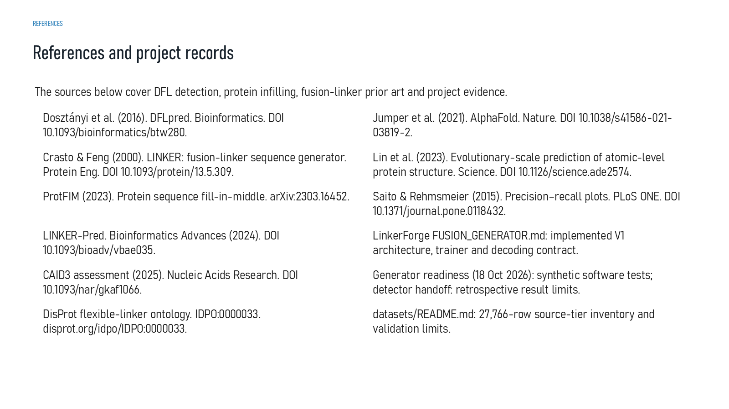
Revision 18 slide 83

Purpose and connection to the project
Use the reference list to support detection, infilling, fusion-linker prior art and project records. Do not read every citation aloud.
This reference section shows how claims, figures, software and run artifacts can be traced. Provenance makes the work auditable, but a well-recorded result is not automatically a biologically correct result.
Why this slide matters: It lets an examiner verify where numbers, images and scientific definitions came from and locate the exact next evidence gate.

Evidence and labels shown on the slide
The following visible elements carry the slide's scientific content. Their role and evidence level are explained in the presentation script below.
- The sources below cover DFL detection, protein infilling, fusion-linker prior art and project evidence.
- Dosztányi et al. (2016). DFLpred. Bioinformatics. DOI 10.1093/bioinformatics/btw280.
- Crasto & Feng (2000). LINKER: fusion-linker sequence generator. Protein Eng. DOI 10.1093/protein/13.5.309.
- ProtFIM (2023). Protein sequence fill-in-middle. arXiv:2303.16452.
- LINKER-Pred. Bioinformatics Advances (2024). DOI 10.1093/bioadv/vbae035.
- CAID3 assessment (2025). Nucleic Acids Research. DOI 10.1093/nar/gkaf1066.
- DisProt flexible-linker ontology. IDPO:0000033. disprot.org/idpo/IDPO:0000033.

Terms explained on this slide
LINKER: A linker is the peptide segment between joined domains. Its sequence and length can influence spacing, flexibility, orientation and exposure, but cannot guarantee function.
DFL: DFL means disordered flexible linker. It is a residue-label concept used by the detector and is not synonymous with every domain gap.
DDL: DDL is a dependent-domain-linker class in the DLD structural task. It describes a structural relationship, not a fusion-success outcome.
PRECISION: Precision is TP divided by TP plus FP: among predicted positives, the fraction that is correct.
RECALL: Recall is TP divided by TP plus FN: among true positives, the fraction that is found.
CAID3: CAID3 is a public disorder/linker benchmark. Once viewed, its labels and scores are retrospective and cannot be used to tune a supposedly untouched model.

Detailed interpretation of the visual
Use the slide as an audit trail: identify the artifact, source or software role and explain how it supports reproducibility without treating provenance as validation.
The object or dataset, comparison, axes, units, colours and layer dimensions define what the visual represents. The observed pattern is interpreted only within those definitions, preventing a prominent number or molecular rendering from being mistaken for broader biological proof.

Exact presentation script
This slide uses the reference list to support detection, infilling, fusion-linker prior art and project records. Do not read every citation aloud.
This reference section shows how claims, figures, software and run artifacts can be traced. Provenance makes the work auditable, but a well-recorded result is not automatically a biologically correct result.
On this slide, the concrete evidence and labels shown are: The sources below cover DFL detection, protein infilling, fusion-linker prior art and project evidence; Dosztányi et al. (2016). DFLpred. Bioinformatics. DOI 10.1093/bioinformatics/btw280; Crasto & Feng (2000). LINKER: fusion-linker sequence generator. Protein Eng. DOI 10.1093/protein/13.5.309; ProtFIM (2023). Protein sequence fill-in-middle. arXiv:2303.16452; and LINKER-Pred. Bioinformatics Advances (2024). DOI 10.1093/bioadv/vbae035. Together, these items establish exactly what was examined here, while retaining their individual evidence levels.
A linker is the peptide segment between joined domains. Its sequence and length can influence spacing, flexibility, orientation and exposure, but cannot guarantee function. DFL means disordered flexible linker. It is a residue-label concept used by the detector and is not synonymous with every domain gap. DDL is a dependent-domain-linker class in the DLD structural task. It describes a structural relationship, not a fusion-success outcome.
The reason this result belongs in the project is that it lets an examiner verify where numbers, images and scientific definitions came from and locate the exact next evidence gate.
The conclusion from this slide is deliberately limited. Citations support methods; project artifacts support the reported values.

Likely examiner question
Question: What does slide 83 allow you to conclude?
Defensible answer: It supports the limited interpretation described above. The safe stopping point is: Citations support methods; project artifacts support the reported values.

Scientific claim boundary
Citations support methods; project artifacts support the reported values.
This boundary is part of the scientific interpretation, not a weakness to hide. State it clearly so the audience can distinguish what was measured from what would require prospective or experimental validation.

Slide 84 Acknowledgements

Revision 18 slide 84

Purpose and connection to the project
Thank the guide, institution and team. Keep this slide brief and move to questions.
This reference section shows how claims, figures, software and run artifacts can be traced. Provenance makes the work auditable, but a well-recorded result is not automatically a biologically correct result.
Why this slide matters: It lets an examiner verify where numbers, images and scientific definitions came from and locate the exact next evidence gate.

Evidence and labels shown on the slide
The following visible elements carry the slide's scientific content. Their role and evidence level are explained in the presentation script below.
- ACKNOWLEDGEMENTS
- LinkerForge · Mini Project
- Kushagra Srivastava
- Ram Kankeshwar
- Hardik Tyagi
- Under the guidance of Chandrima Ghosh
- K. J. Somaiya College of Engineering (KJSSE)

Terms explained on this slide
LINKER: A linker is the peptide segment between joined domains. Its sequence and length can influence spacing, flexibility, orientation and exposure, but cannot guarantee function.

Detailed interpretation of the visual
Use the slide as an audit trail: identify the artifact, source or software role and explain how it supports reproducibility without treating provenance as validation.
The object or dataset, comparison, axes, units, colours and layer dimensions define what the visual represents. The observed pattern is interpreted only within those definitions, preventing a prominent number or molecular rendering from being mistaken for broader biological proof.

Exact presentation script
This slide acknowledges the guide, institution and team. Keep this slide brief and move to questions.
This reference section shows how claims, figures, software and run artifacts can be traced. Provenance makes the work auditable, but a well-recorded result is not automatically a biologically correct result.
On this slide, the concrete evidence and labels shown are: ACKNOWLEDGEMENTS; LinkerForge · Mini Project; Kushagra Srivastava; Ram Kankeshwar; and Hardik Tyagi. Together, these items establish exactly what was examined here, while retaining their individual evidence levels.
A linker is the peptide segment between joined domains. Its sequence and length can influence spacing, flexibility, orientation and exposure, but cannot guarantee function.
The reason this result belongs in the project is that it lets an examiner verify where numbers, images and scientific definitions came from and locate the exact next evidence gate.
The conclusion from this slide is deliberately limited. This acknowledgement slide contains no additional scientific claims.

Likely examiner question
Question: What does slide 84 allow you to conclude?
Defensible answer: It supports the limited interpretation described above. The safe stopping point is: Do not add new scientific claims during acknowledgements.

Scientific claim boundary
Do not add new scientific claims during acknowledgements.
This boundary is part of the scientific interpretation, not a weakness to hide. State it clearly so the audience can distinguish what was measured from what would require prospective or experimental validation.

Slide 85 Figure reading guide
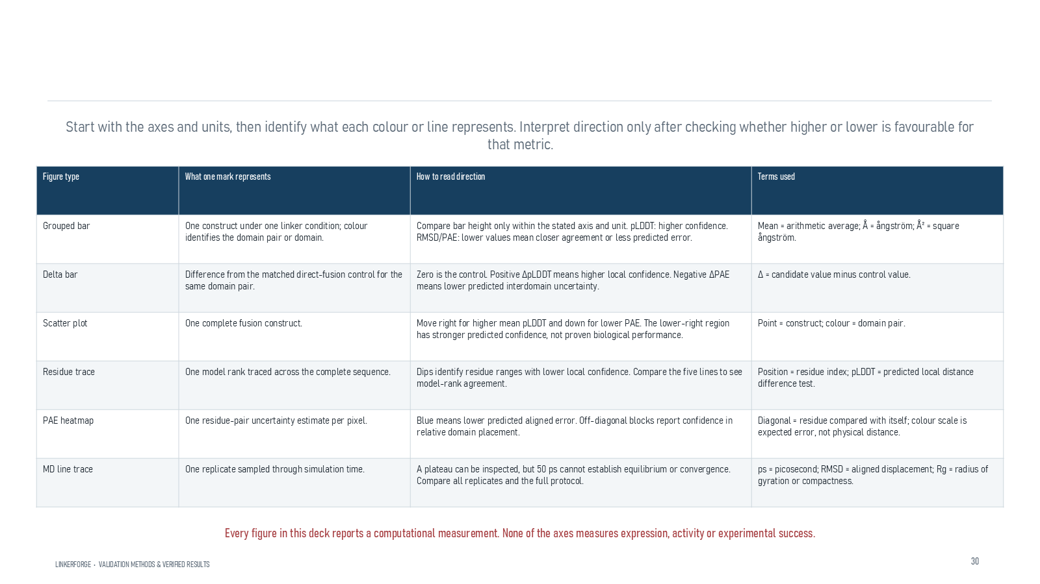
Revision 18 slide 85

Purpose and connection to the project
Use the graph guide to explain bars, deltas, scatter plots, residue traces, PAE heatmaps and MD traces by axes, units and one mark at a time.
This reference section shows how claims, figures, software and run artifacts can be traced. Provenance makes the work auditable, but a well-recorded result is not automatically a biologically correct result.
Why this slide matters: It lets an examiner verify where numbers, images and scientific definitions came from and locate the exact next evidence gate.

Evidence and labels shown on the slide
The following visible elements carry the slide's scientific content. Their role and evidence level are explained in the presentation script below.
- FIGURE-READING GUIDE
- How to read the result figures
- LINKERFORGE • VALIDATION METHODS & VERIFIED RESULTS
- Start with the axes and units, then identify what each colour or line represents. Interpret direction only after checking whether higher or lower is favourable for that metric.
- Every figure in this deck reports a computational measurement. None of the axes measures expression, activity or experimental success.

Terms explained on this slide
LINKER: A linker is the peptide segment between joined domains. Its sequence and length can influence spacing, flexibility, orientation and exposure, but cannot guarantee function.
APS: Average precision score summarizes the precision-recall curve and is useful for imbalanced labels. It depends on the dataset and cannot be compared across unrelated tasks as a universal score.
PAE: Predicted aligned error estimates positional uncertainty after alignment, in angstrom. Off-diagonal domain blocks are useful for interdomain confidence; PAE is not physical distance.

Detailed interpretation of the visual
Use the slide as an audit trail: identify the artifact, source or software role and explain how it supports reproducibility without treating provenance as validation.
The object or dataset, comparison, axes, units, colours and layer dimensions define what the visual represents. The observed pattern is interpreted only within those definitions, preventing a prominent number or molecular rendering from being mistaken for broader biological proof.

Exact presentation script
This slide uses the graph guide to explain bars, deltas, scatter plots, residue traces, PAE heatmaps and MD traces by axes, units and one mark at a time.
This reference section shows how claims, figures, software and run artifacts can be traced. Provenance makes the work auditable, but a well-recorded result is not automatically a biologically correct result.
On this slide, the concrete evidence and labels shown are: FIGURE-READING GUIDE; How to read the result figures; LINKERFORGE • VALIDATION METHODS & VERIFIED RESULTS; Start with the axes and units, then identify what each colour or line represents. Interpret direction only after checking whether higher or lower is favourable for that metric; and Every figure in this deck reports a computational measurement. None of the axes measures expression, activity or experimental success. Together, these items establish exactly what was examined here, while retaining their individual evidence levels.
A linker is the peptide segment between joined domains. Its sequence and length can influence spacing, flexibility, orientation and exposure, but cannot guarantee function. Average precision score summarizes the precision-recall curve and is useful for imbalanced labels. It depends on the dataset and cannot be compared across unrelated tasks as a universal score. Predicted aligned error estimates positional uncertainty after alignment, in angstrom. Off-diagonal domain blocks are useful for interdomain confidence; PAE is not physical distance.
The reason this result belongs in the project is that it lets an examiner verify where numbers, images and scientific definitions came from and locate the exact next evidence gate.
The conclusion from this slide is deliberately limited. No displayed axis measures expression or activity.

Likely examiner question
Question: What does slide 85 allow you to conclude?
Defensible answer: It supports the limited interpretation described above. The safe stopping point is: No displayed axis measures expression or activity.

Scientific claim boundary
No displayed axis measures expression or activity.
This boundary is part of the scientific interpretation, not a weakness to hide. State it clearly so the audience can distinguish what was measured from what would require prospective or experimental validation.

Slide 86 Scientific software
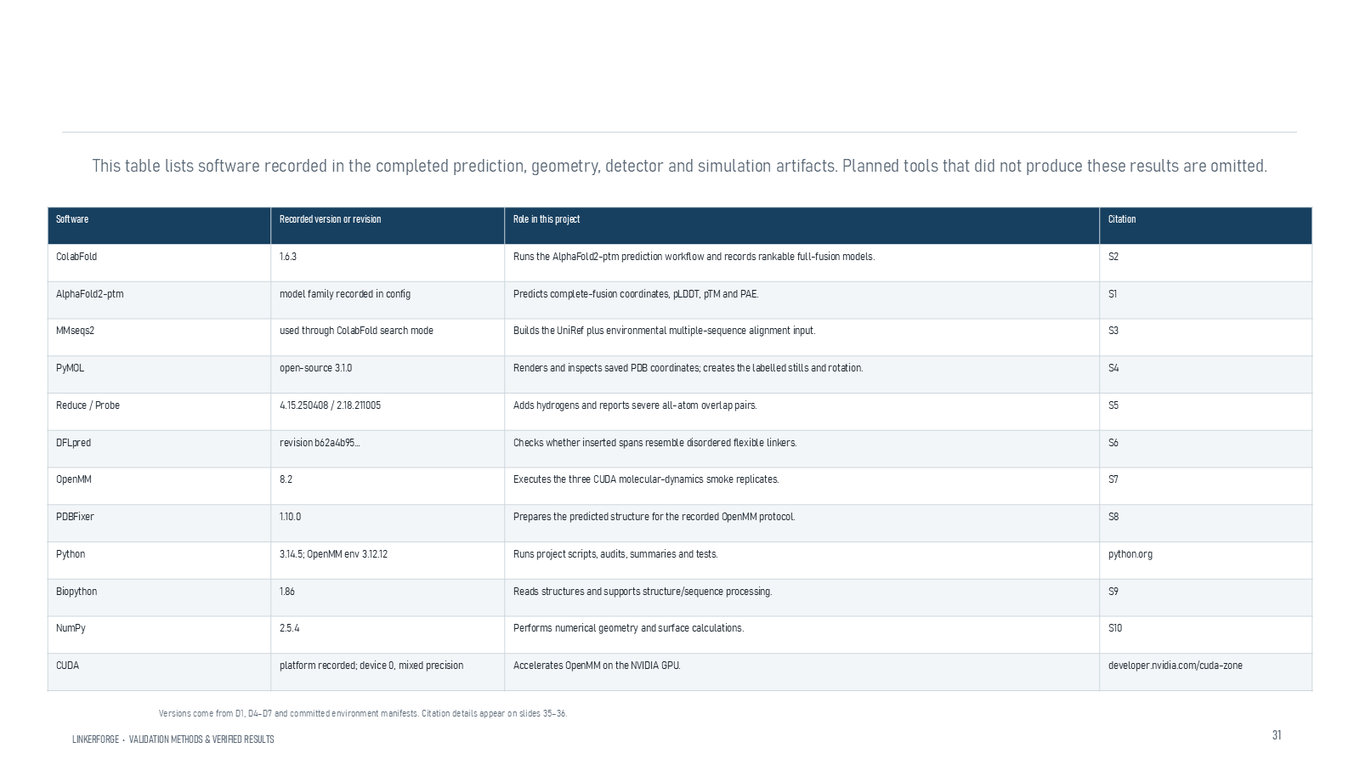
Revision 18 slide 86

Purpose and connection to the project
Identify the scientific role and recorded version of ColabFold, AF2-pTM, MMseqs2, PyMOL, Reduce, Probe, DFLpred, OpenMM and supporting Python tools.
This reference section shows how claims, figures, software and run artifacts can be traced. Provenance makes the work auditable, but a well-recorded result is not automatically a biologically correct result.
Why this slide matters: It lets an examiner verify where numbers, images and scientific definitions came from and locate the exact next evidence gate.

Evidence and labels shown on the slide
The following visible elements carry the slide's scientific content. Their role and evidence level are explained in the presentation script below.
- TOOLS AND SOFTWARE
- Scientific software used in the completed evidence
- LINKERFORGE • VALIDATION METHODS & VERIFIED RESULTS
- This table lists software recorded in the completed prediction, geometry, detector and simulation artifacts. Planned tools that did not produce these results are omitted.
- Versions come from D1, D4–D7 and committed environment manifests. Citation details appear on slides 35–36.

Terms explained on this slide
LINKER: A linker is the peptide segment between joined domains. Its sequence and length can influence spacing, flexibility, orientation and exposure, but cannot guarantee function.
DFL: DFL means disordered flexible linker. It is a residue-label concept used by the detector and is not synonymous with every domain gap.
COLABFOLD: ColabFold is a workflow that accelerates AlphaFold-style prediction, including MMseqs2-based sequence searches. It is the prediction runner used for the matched structural panel.
PTM: pTM is a zero-to-one confidence estimate for the global fold and relative topology. It does not prove that an interdomain pose is experimentally correct.
PROBE: Probe evaluates hydrogen-aware close contacts and overlaps. Severe overlap counts flag steric concerns but are not calibrated fusion-failure probabilities.
OPENMM: OpenMM is a molecular-dynamics engine. The reported three 50-picosecond runs verify execution and metric output, not equilibrium or long-term stability.
PYMOL: PyMOL is used to render, inspect and measure structures. It does not generate the AlphaFold prediction or run the OpenMM simulation.

Detailed interpretation of the visual
Use the slide as an audit trail: identify the artifact, source or software role and explain how it supports reproducibility without treating provenance as validation.
The object or dataset, comparison, axes, units, colours and layer dimensions define what the visual represents. The observed pattern is interpreted only within those definitions, preventing a prominent number or molecular rendering from being mistaken for broader biological proof.

Exact presentation script
This slide identifies the scientific role and recorded version of ColabFold, AF2-pTM, MMseqs2, PyMOL, Reduce, Probe, DFLpred, OpenMM and supporting Python tools.
This reference section shows how claims, figures, software and run artifacts can be traced. Provenance makes the work auditable, but a well-recorded result is not automatically a biologically correct result.
On this slide, the concrete evidence and labels shown are: TOOLS AND SOFTWARE; Scientific software used in the completed evidence; LINKERFORGE • VALIDATION METHODS & VERIFIED RESULTS; This table lists software recorded in the completed prediction, geometry, detector and simulation artifacts. Planned tools that did not produce these results are omitted; and Versions come from D1, D4–D7 and committed environment manifests. Citation details appear on slides 35–36. Together, these items establish exactly what was examined here, while retaining their individual evidence levels.
A linker is the peptide segment between joined domains. Its sequence and length can influence spacing, flexibility, orientation and exposure, but cannot guarantee function. DFL means disordered flexible linker. It is a residue-label concept used by the detector and is not synonymous with every domain gap. ColabFold is a workflow that accelerates AlphaFold-style prediction, including MMseqs2-based sequence searches. It is the prediction runner used for the matched structural panel.
The reason this result belongs in the project is that it lets an examiner verify where numbers, images and scientific definitions came from and locate the exact next evidence gate.
The conclusion from this slide is deliberately limited. Tool availability does not mean every planned stage was completed.

Likely examiner question
Question: What does slide 86 allow you to conclude?
Defensible answer: It supports the limited interpretation described above. The safe stopping point is: Tool availability does not mean every planned stage was completed.

Scientific claim boundary
Tool availability does not mean every planned stage was completed.
This boundary is part of the scientific interpretation, not a weakness to hide. State it clearly so the audience can distinguish what was measured from what would require prospective or experimental validation.

Slide 87 Application and reproducibility software
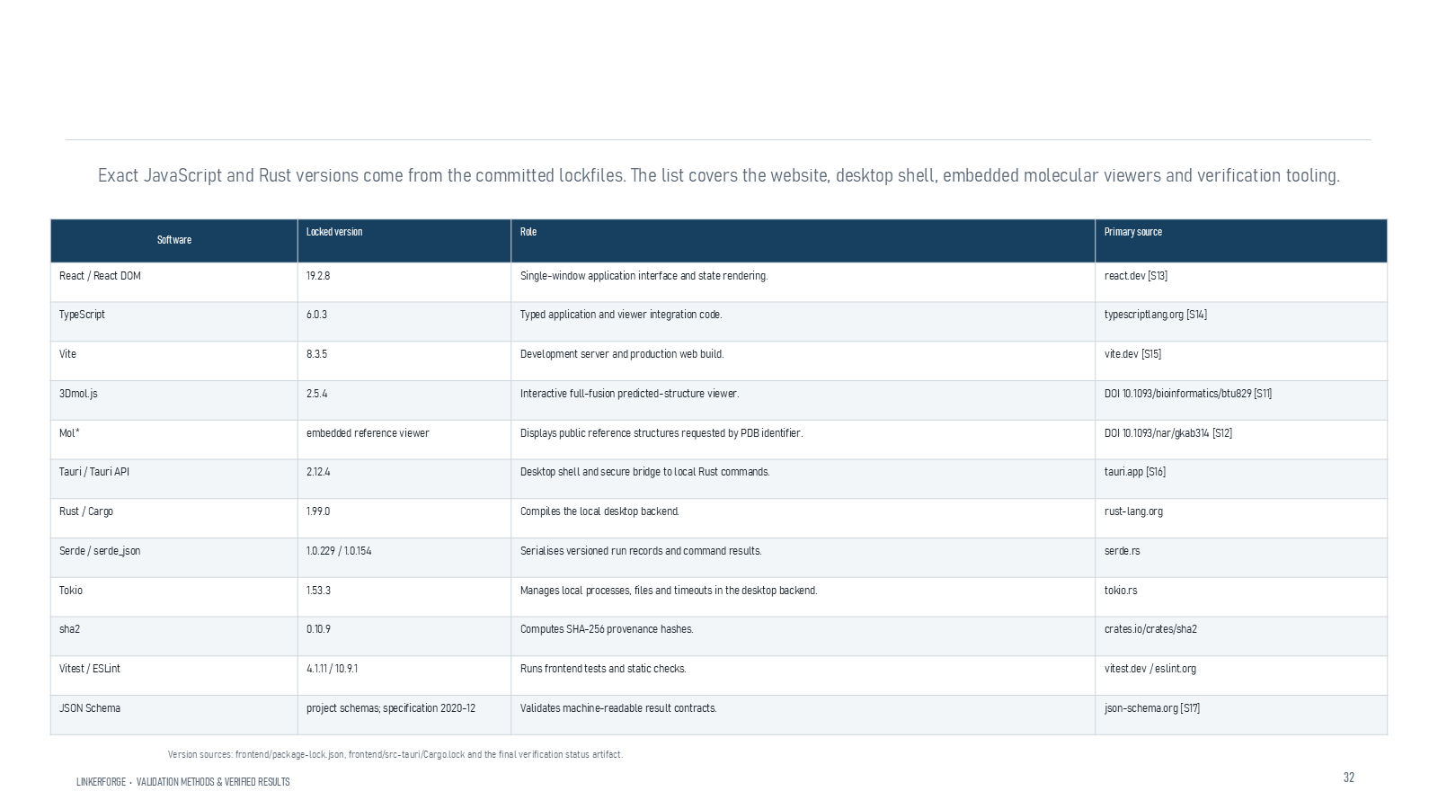
Revision 18 slide 87

Purpose and connection to the project
Identify the software roles of React, TypeScript, Vite, 3Dmol.js, Molstar, Tauri, Rust and validation libraries. These tools implement the application rather than biological evidence.
This reference section shows how claims, figures, software and run artifacts can be traced. Provenance makes the work auditable, but a well-recorded result is not automatically a biologically correct result.
Why this slide matters: It lets an examiner verify where numbers, images and scientific definitions came from and locate the exact next evidence gate.

Evidence and labels shown on the slide
The following visible elements carry the slide's scientific content. Their role and evidence level are explained in the presentation script below.
- TOOLS AND SOFTWARE
- Application and reproducibility software used
- LINKERFORGE • VALIDATION METHODS & VERIFIED RESULTS
- Exact JavaScript and Rust versions come from the committed lockfiles. The list covers the website, desktop shell, embedded molecular viewers and verification tooling.
- Version sources: frontend/package-lock.json, frontend/src-tauri/Cargo.lock and the final verification status artifact.

Terms explained on this slide
LINKER: A linker is the peptide segment between joined domains. Its sequence and length can influence spacing, flexibility, orientation and exposure, but cannot guarantee function.

Detailed interpretation of the visual
Use the slide as an audit trail: identify the artifact, source or software role and explain how it supports reproducibility without treating provenance as validation.
The object or dataset, comparison, axes, units, colours and layer dimensions define what the visual represents. The observed pattern is interpreted only within those definitions, preventing a prominent number or molecular rendering from being mistaken for broader biological proof.

Exact presentation script
This slide identifies the software roles of React, TypeScript, Vite, 3Dmol.js, Molstar, Tauri, Rust and validation libraries. These tools implement the application rather than biological evidence.
This reference section shows how claims, figures, software and run artifacts can be traced. Provenance makes the work auditable, but a well-recorded result is not automatically a biologically correct result.
On this slide, the concrete evidence and labels shown are: TOOLS AND SOFTWARE; Application and reproducibility software used; LINKERFORGE • VALIDATION METHODS & VERIFIED RESULTS; Exact JavaScript and Rust versions come from the committed lockfiles. The list covers the website, desktop shell, embedded molecular viewers and verification tooling; and Version sources: frontend/package-lock.json, frontend/src-tauri/Cargo.lock and the final verification status artifact. Together, these items establish exactly what was examined here, while retaining their individual evidence levels.
A linker is the peptide segment between joined domains. Its sequence and length can influence spacing, flexibility, orientation and exposure, but cannot guarantee function.
The reason this result belongs in the project is that it lets an examiner verify where numbers, images and scientific definitions came from and locate the exact next evidence gate.
The conclusion from this slide is deliberately limited. Application frameworks provide delivery, not biological validation.

Likely examiner question
Question: What does slide 87 allow you to conclude?
Defensible answer: It supports the limited interpretation described above. The safe stopping point is: Application frameworks provide delivery, not biological validation.

Scientific claim boundary
Application frameworks provide delivery, not biological validation.
This boundary is part of the scientific interpretation, not a weakness to hide. State it clearly so the audience can distinguish what was measured from what would require prospective or experimental validation.

Slide 88 Figure and image provenance
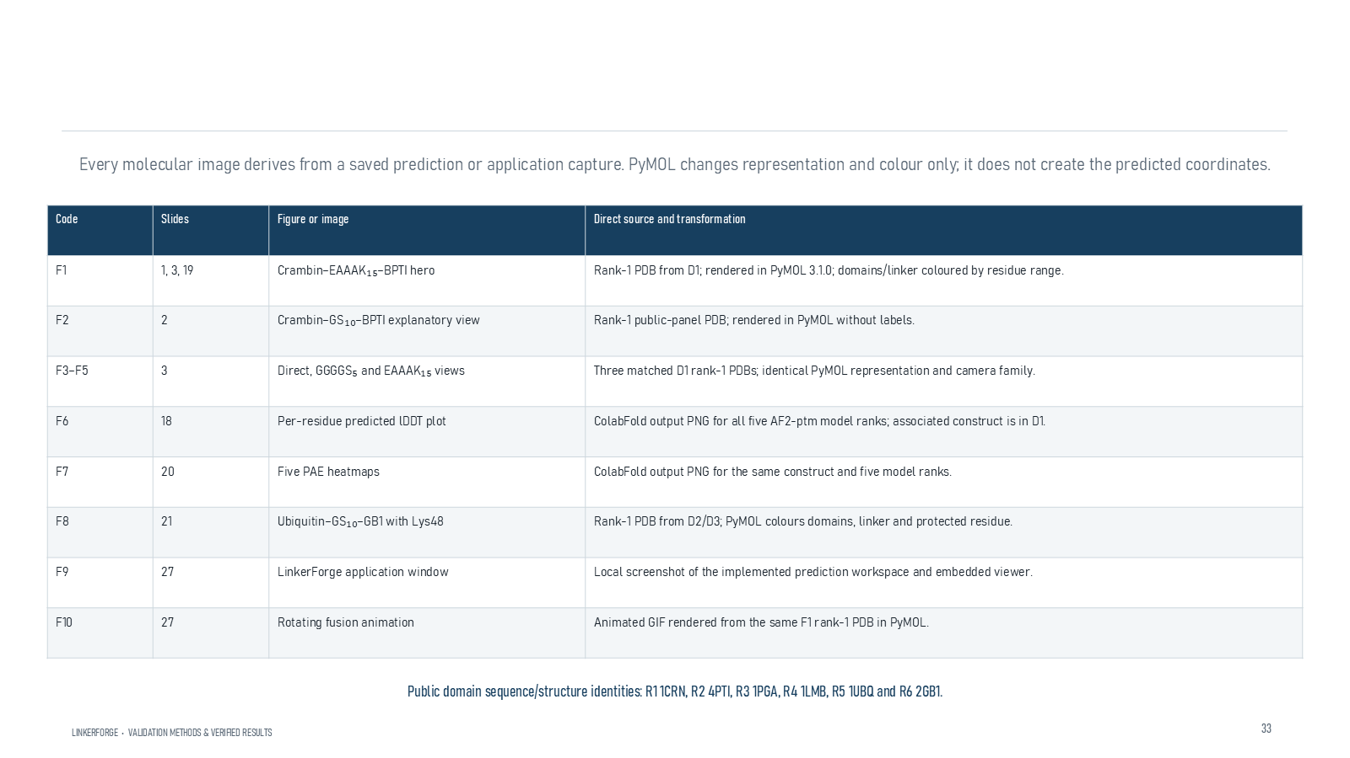
Revision 18 slide 88

Purpose and connection to the project
Explain how every molecular image traces to saved coordinates or an application capture. Rendering changes representation and colour, not the predicted coordinates.
This reference section shows how claims, figures, software and run artifacts can be traced. Provenance makes the work auditable, but a well-recorded result is not automatically a biologically correct result.
Why this slide matters: It lets an examiner verify where numbers, images and scientific definitions came from and locate the exact next evidence gate.

Evidence and labels shown on the slide
The following visible elements carry the slide's scientific content. Their role and evidence level are explained in the presentation script below.
- CITATIONS AND PROVENANCE
- LINKERFORGE • VALIDATION METHODS & VERIFIED RESULTS
- Every molecular image derives from a saved prediction or application capture. PyMOL changes representation and colour only; it does not create the predicted coordinates.
- Public domain sequence/structure identities: R1 1CRN, R2 4PTI, R3 1PGA, R4 1LMB, R5 1UBQ and R6 2GB1.

Terms explained on this slide
DOMAIN: A protein domain is a region expected to form a recognizable three-dimensional unit. Domain boundaries are structural or annotation claims, not simply changes in sequence composition.
LINKER: A linker is the peptide segment between joined domains. Its sequence and length can influence spacing, flexibility, orientation and exposure, but cannot guarantee function.
PROVENANCE: Provenance is the recorded origin and transformation history of a datum, model, prediction or figure, including source identifiers, code revision and configuration.
PYMOL: PyMOL is used to render, inspect and measure structures. It does not generate the AlphaFold prediction or run the OpenMM simulation.

Detailed interpretation of the visual
Use the slide as an audit trail: identify the artifact, source or software role and explain how it supports reproducibility without treating provenance as validation.
The object or dataset, comparison, axes, units, colours and layer dimensions define what the visual represents. The observed pattern is interpreted only within those definitions, preventing a prominent number or molecular rendering from being mistaken for broader biological proof.

Exact presentation script
This slide explains how every molecular image traces to saved coordinates or an application capture. Rendering changes representation and colour, not the predicted coordinates.
This reference section shows how claims, figures, software and run artifacts can be traced. Provenance makes the work auditable, but a well-recorded result is not automatically a biologically correct result.
On this slide, the concrete evidence and labels shown are: CITATIONS AND PROVENANCE; LINKERFORGE • VALIDATION METHODS & VERIFIED RESULTS; Every molecular image derives from a saved prediction or application capture. PyMOL changes representation and colour only; it does not create the predicted coordinates; and Public domain sequence/structure identities: R1 1CRN, R2 4PTI, R3 1PGA, R4 1LMB, R5 1UBQ and R6 2GB1. Together, these items establish exactly what was examined here, while retaining their individual evidence levels.
A protein domain is a region expected to form a recognizable three-dimensional unit. Domain boundaries are structural or annotation claims, not simply changes in sequence composition. A linker is the peptide segment between joined domains. Its sequence and length can influence spacing, flexibility, orientation and exposure, but cannot guarantee function. Provenance is the recorded origin and transformation history of a datum, model, prediction or figure, including source identifiers, code revision and configuration.
The reason this result belongs in the project is that it lets an examiner verify where numbers, images and scientific definitions came from and locate the exact next evidence gate.
The conclusion from this slide is deliberately limited. Provenance supports traceability rather than truth by itself.

Likely examiner question
Question: What does slide 88 allow you to conclude?
Defensible answer: It supports the limited interpretation described above. The safe stopping point is: Provenance supports traceability rather than truth by itself.

Scientific claim boundary
Provenance supports traceability rather than truth by itself.
This boundary is part of the scientific interpretation, not a weakness to hide. State it clearly so the audience can distinguish what was measured from what would require prospective or experimental validation.

Slide 89 Graph and measurement provenance
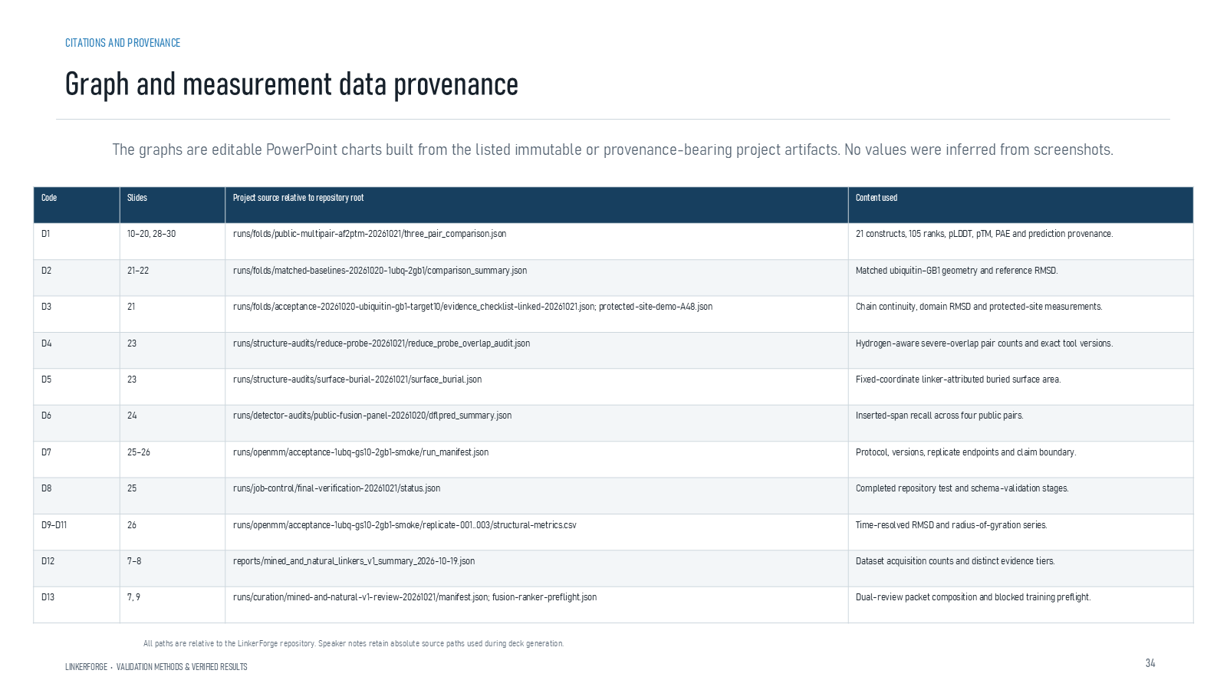
Revision 18 slide 89

Purpose and connection to the project
Explain how D codes trace each chart to persisted JSON or CSV artifacts. Values were not estimated from screenshots.
This reference section shows how claims, figures, software and run artifacts can be traced. Provenance makes the work auditable, but a well-recorded result is not automatically a biologically correct result.
Why this slide matters: It lets an examiner verify where numbers, images and scientific definitions came from and locate the exact next evidence gate.

Evidence and labels shown on the slide
The following visible elements carry the slide's scientific content. Their role and evidence level are explained in the presentation script below.
- LINKERFORGE • VALIDATION METHODS & VERIFIED RESULTS
- The graphs are editable PowerPoint charts built from the listed immutable or provenance-bearing project artifacts. No values were inferred from screenshots.
- All paths are relative to the LinkerForge repository. Speaker notes retain absolute source paths used during deck generation.
- CITATIONS AND PROVENANCE
- Graph and measurement data provenance

Terms explained on this slide
LINKER: A linker is the peptide segment between joined domains. Its sequence and length can influence spacing, flexibility, orientation and exposure, but cannot guarantee function.
PROVENANCE: Provenance is the recorded origin and transformation history of a datum, model, prediction or figure, including source identifiers, code revision and configuration.

Detailed interpretation of the visual
Use the slide as an audit trail: identify the artifact, source or software role and explain how it supports reproducibility without treating provenance as validation.
The object or dataset, comparison, axes, units, colours and layer dimensions define what the visual represents. The observed pattern is interpreted only within those definitions, preventing a prominent number or molecular rendering from being mistaken for broader biological proof.

Exact presentation script
This slide explains how D codes trace each chart to persisted JSON or CSV artifacts. Values were not estimated from screenshots.
This reference section shows how claims, figures, software and run artifacts can be traced. Provenance makes the work auditable, but a well-recorded result is not automatically a biologically correct result.
On this slide, the concrete evidence and labels shown are: LINKERFORGE • VALIDATION METHODS & VERIFIED RESULTS; The graphs are editable PowerPoint charts built from the listed immutable or provenance-bearing project artifacts. No values were inferred from screenshots; All paths are relative to the LinkerForge repository. Speaker notes retain absolute source paths used during deck generation; CITATIONS AND PROVENANCE; and Graph and measurement data provenance. Together, these items establish exactly what was examined here, while retaining their individual evidence levels.
A linker is the peptide segment between joined domains. Its sequence and length can influence spacing, flexibility, orientation and exposure, but cannot guarantee function. Provenance is the recorded origin and transformation history of a datum, model, prediction or figure, including source identifiers, code revision and configuration.
The reason this result belongs in the project is that it lets an examiner verify where numbers, images and scientific definitions came from and locate the exact next evidence gate.
The conclusion from this slide is deliberately limited. Editable charts remain accountable to their underlying data artifacts.

Likely examiner question
Question: What does slide 89 allow you to conclude?
Defensible answer: It supports the limited interpretation described above. The safe stopping point is: Editable charts remain accountable to their underlying data artifacts.

Scientific claim boundary
Editable charts remain accountable to their underlying data artifacts.
This boundary is part of the scientific interpretation, not a weakness to hide. State it clearly so the audience can distinguish what was measured from what would require prospective or experimental validation.

Slide 90 Primary scientific references
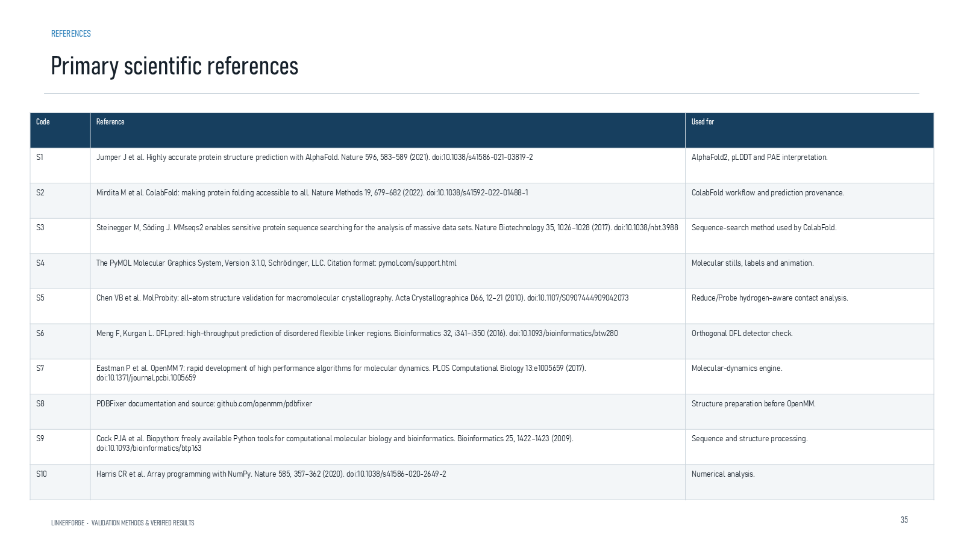
Revision 18 slide 90

Purpose and connection to the project
Use the primary references when asked about AlphaFold, ColabFold, MMseqs2, MolProbity, DFLpred, OpenMM, Biopython or NumPy.
This reference section shows how claims, figures, software and run artifacts can be traced. Provenance makes the work auditable, but a well-recorded result is not automatically a biologically correct result.
Why this slide matters: It lets an examiner verify where numbers, images and scientific definitions came from and locate the exact next evidence gate.

Evidence and labels shown on the slide
The following visible elements carry the slide's scientific content. Their role and evidence level are explained in the presentation script below.
- LINKERFORGE • VALIDATION METHODS & VERIFIED RESULTS

Terms explained on this slide
LINKER: A linker is the peptide segment between joined domains. Its sequence and length can influence spacing, flexibility, orientation and exposure, but cannot guarantee function.
DFL: DFL means disordered flexible linker. It is a residue-label concept used by the detector and is not synonymous with every domain gap.
COLABFOLD: ColabFold is a workflow that accelerates AlphaFold-style prediction, including MMseqs2-based sequence searches. It is the prediction runner used for the matched structural panel.
OPENMM: OpenMM is a molecular-dynamics engine. The reported three 50-picosecond runs verify execution and metric output, not equilibrium or long-term stability.

Detailed interpretation of the visual
Use the slide as an audit trail: identify the artifact, source or software role and explain how it supports reproducibility without treating provenance as validation.
The object or dataset, comparison, axes, units, colours and layer dimensions define what the visual represents. The observed pattern is interpreted only within those definitions, preventing a prominent number or molecular rendering from being mistaken for broader biological proof.

Exact presentation script
This slide uses the primary references when asked about AlphaFold, ColabFold, MMseqs2, MolProbity, DFLpred, OpenMM, Biopython or NumPy.
This reference section shows how claims, figures, software and run artifacts can be traced. Provenance makes the work auditable, but a well-recorded result is not automatically a biologically correct result.
On this slide, the concrete evidence and labels shown are: LINKERFORGE • VALIDATION METHODS & VERIFIED RESULTS. Together, these items establish exactly what was examined here, while retaining their individual evidence levels.
A linker is the peptide segment between joined domains. Its sequence and length can influence spacing, flexibility, orientation and exposure, but cannot guarantee function. DFL means disordered flexible linker. It is a residue-label concept used by the detector and is not synonymous with every domain gap. ColabFold is a workflow that accelerates AlphaFold-style prediction, including MMseqs2-based sequence searches. It is the prediction runner used for the matched structural panel.
The reason this result belongs in the project is that it lets an examiner verify where numbers, images and scientific definitions came from and locate the exact next evidence gate.
The conclusion from this slide is deliberately limited. A cited method does not validate this project's conclusions automatically.

Likely examiner question
Question: What does slide 90 allow you to conclude?
Defensible answer: It supports the limited interpretation described above. The safe stopping point is: A cited method does not validate this project's conclusions automatically.

Scientific claim boundary
A cited method does not validate this project's conclusions automatically.
This boundary is part of the scientific interpretation, not a weakness to hide. State it clearly so the audience can distinguish what was measured from what would require prospective or experimental validation.

Slide 91 Application confidence and public structure references
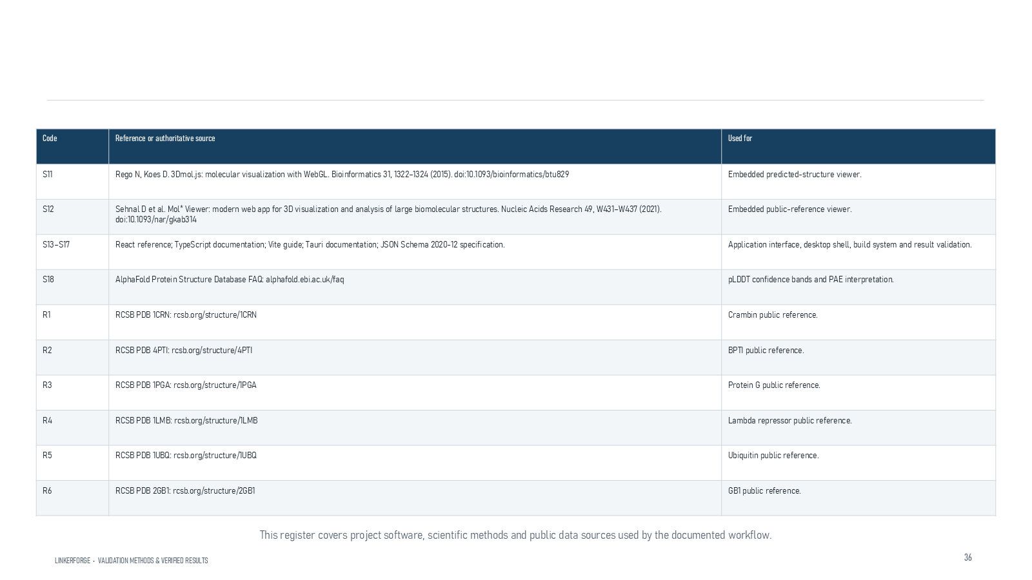
Revision 18 slide 91

Purpose and connection to the project
Use this register for web viewers, confidence guidance and the six public reference structures.
This reference section shows how claims, figures, software and run artifacts can be traced. Provenance makes the work auditable, but a well-recorded result is not automatically a biologically correct result.
Why this slide matters: It lets an examiner verify where numbers, images and scientific definitions came from and locate the exact next evidence gate.

Evidence and labels shown on the slide
The following visible elements carry the slide's scientific content. Their role and evidence level are explained in the presentation script below.
- Application, confidence guidance and public structures
- LINKERFORGE • VALIDATION METHODS & VERIFIED RESULTS
- This register covers project software, scientific methods and public data sources used by the documented workflow.

Terms explained on this slide
LINKER: A linker is the peptide segment between joined domains. Its sequence and length can influence spacing, flexibility, orientation and exposure, but cannot guarantee function.

Detailed interpretation of the visual
Use the slide as an audit trail: identify the artifact, source or software role and explain how it supports reproducibility without treating provenance as validation.
The object or dataset, comparison, axes, units, colours and layer dimensions define what the visual represents. The observed pattern is interpreted only within those definitions, preventing a prominent number or molecular rendering from being mistaken for broader biological proof.

Exact presentation script
This slide uses this register for web viewers, confidence guidance and the six public reference structures.
This reference section shows how claims, figures, software and run artifacts can be traced. Provenance makes the work auditable, but a well-recorded result is not automatically a biologically correct result.
On this slide, the concrete evidence and labels shown are: Application, confidence guidance and public structures; LINKERFORGE • VALIDATION METHODS & VERIFIED RESULTS; and This register covers project software, scientific methods and public data sources used by the documented workflow. Together, these items establish exactly what was examined here, while retaining their individual evidence levels.
A linker is the peptide segment between joined domains. Its sequence and length can influence spacing, flexibility, orientation and exposure, but cannot guarantee function.
The reason this result belongs in the project is that it lets an examiner verify where numbers, images and scientific definitions came from and locate the exact next evidence gate.
The conclusion from this slide is deliberately limited. Public reference structures are not experimental structures of the new fusion.

Likely examiner question
Question: What does slide 91 allow you to conclude?
Defensible answer: It supports the limited interpretation described above. The safe stopping point is: Public reference structures are not experimental structures of the new fusion.

Scientific claim boundary
Public reference structures are not experimental structures of the new fusion.
This boundary is part of the scientific interpretation, not a weakness to hide. State it clearly so the audience can distinguish what was measured from what would require prospective or experimental validation.

Slide 92 Validation chain
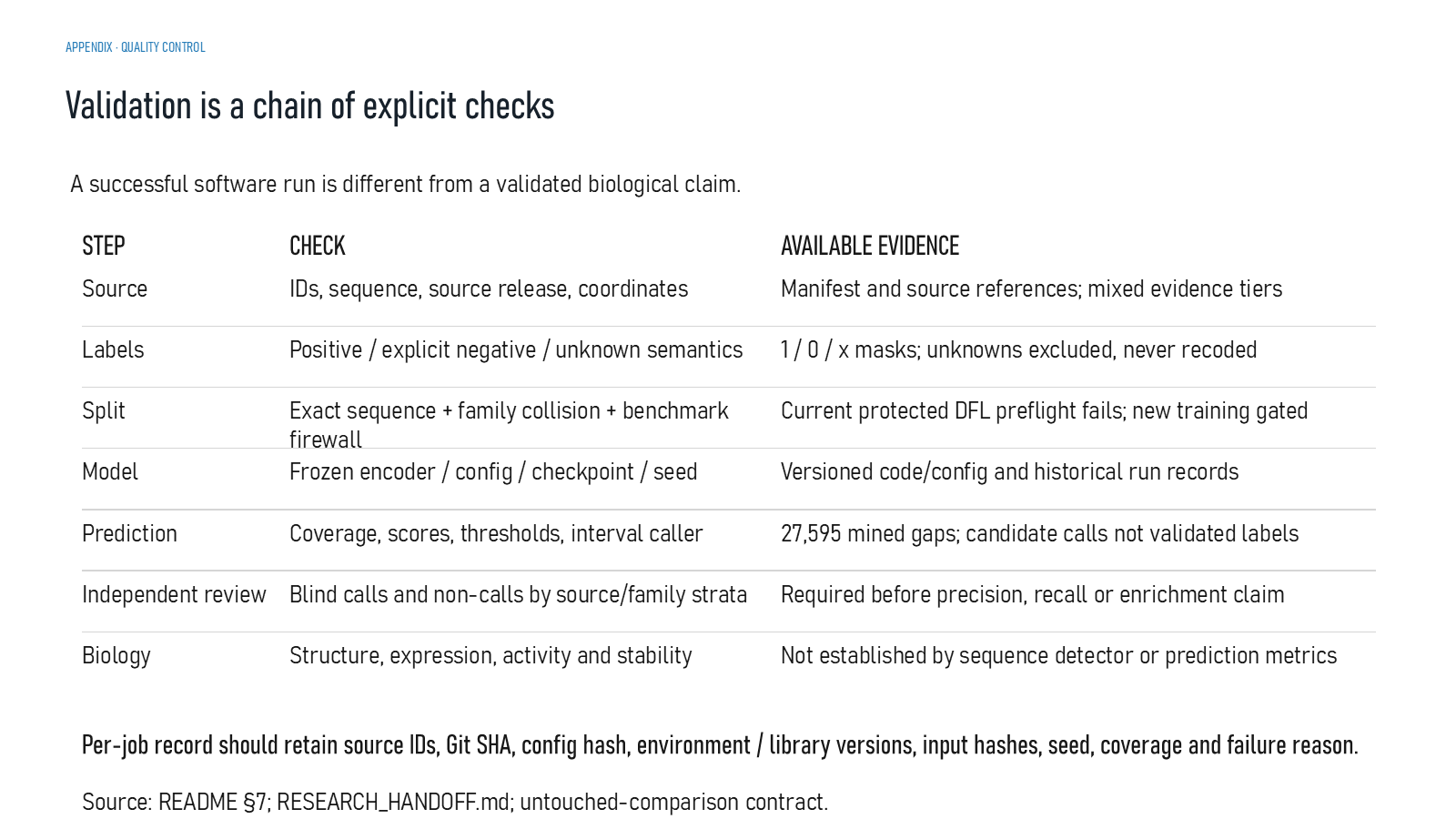
Revision 18 slide 92

Purpose and connection to the project
Explain the quality-control chain from source and labels through split, model, prediction, independent review and biology. A successful job is only one link.
This reference section shows how claims, figures, software and run artifacts can be traced. Provenance makes the work auditable, but a well-recorded result is not automatically a biologically correct result.
Why this slide matters: It lets an examiner verify where numbers, images and scientific definitions came from and locate the exact next evidence gate.

Evidence and labels shown on the slide
The following visible elements carry the slide's scientific content. Their role and evidence level are explained in the presentation script below.
- APPENDIX · QUALITY CONTROL
- Validation is a chain of explicit checks
- A successful software run is different from a validated biological claim.
- AVAILABLE EVIDENCE
- IDs, sequence, source release, coordinates
- Manifest and source references; mixed evidence tiers
- Positive / explicit negative / unknown semantics

Terms explained on this slide
DFL: DFL means disordered flexible linker. It is a residue-label concept used by the detector and is not synonymous with every domain gap.
PRECISION: Precision is TP divided by TP plus FP: among predicted positives, the fraction that is correct.
RECALL: Recall is TP divided by TP plus FN: among true positives, the fraction that is found.
APS: Average precision score summarizes the precision-recall curve and is useful for imbalanced labels. It depends on the dataset and cannot be compared across unrelated tasks as a universal score.

Detailed interpretation of the visual
The validation chain moves from source and coordinate checks through label review, family split, model, prediction, independent review and biological outcome. A break at any link limits the final claim.
The object or dataset, comparison, axes, units, colours and layer dimensions define what the visual represents. The observed pattern is interpreted only within those definitions, preventing a prominent number or molecular rendering from being mistaken for broader biological proof.

Exact presentation script
This slide explains the quality-control chain from source and labels through split, model, prediction, independent review and biology. A successful job is only one link.
This reference section shows how claims, figures, software and run artifacts can be traced. Provenance makes the work auditable, but a well-recorded result is not automatically a biologically correct result.
On this slide, the concrete evidence and labels shown are: APPENDIX · QUALITY CONTROL; Validation is a chain of explicit checks; A successful software run is different from a validated biological claim; AVAILABLE EVIDENCE; and IDs, sequence, source release, coordinates. Together, these items establish exactly what was examined here, while retaining their individual evidence levels.
DFL means disordered flexible linker. It is a residue-label concept used by the detector and is not synonymous with every domain gap. Precision is TP divided by TP plus FP: among predicted positives, the fraction that is correct. Recall is TP divided by TP plus FN: among true positives, the fraction that is found.
The reason this result belongs in the project is that it lets an examiner verify where numbers, images and scientific definitions came from and locate the exact next evidence gate.
The conclusion from this slide is deliberately limited. A chain of checks is only as strong as its unresolved gate.

Likely examiner question
Question: What does slide 92 allow you to conclude?
Defensible answer: It supports the limited interpretation described above. The safe stopping point is: A chain of checks is only as strong as its unresolved gate.

Scientific claim boundary
A chain of checks is only as strong as its unresolved gate.
This boundary is part of the scientific interpretation, not a weakness to hide. State it clearly so the audience can distinguish what was measured from what would require prospective or experimental validation.

Slide 93 Representative project runs
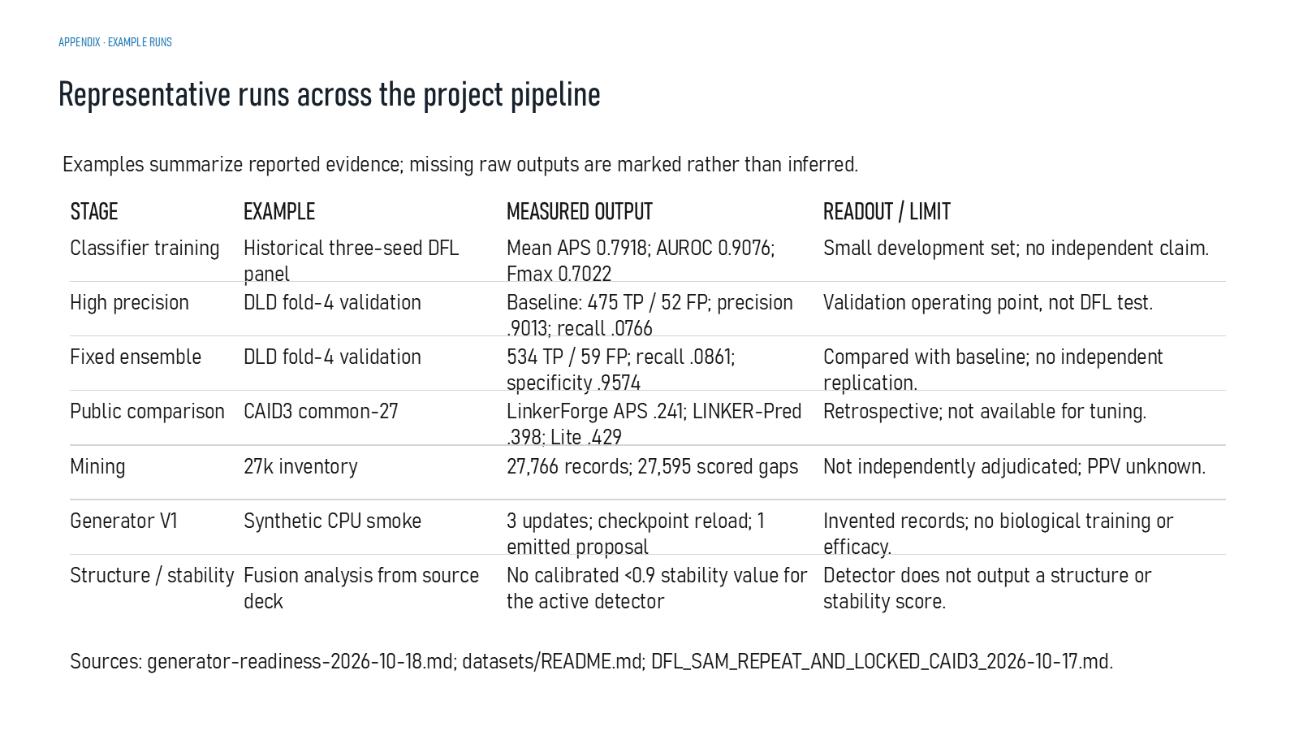
Revision 18 slide 93

Purpose and connection to the project
Use the run table to compare evidence types without combining them into one score. Each row includes its own limitation.
This reference section shows how claims, figures, software and run artifacts can be traced. Provenance makes the work auditable, but a well-recorded result is not automatically a biologically correct result.
Why this slide matters: It lets an examiner verify where numbers, images and scientific definitions came from and locate the exact next evidence gate.

Evidence and labels shown on the slide
The following visible elements carry the slide's scientific content. Their role and evidence level are explained in the presentation script below.
- APPENDIX · EXAMPLE RUNS
- Representative runs across the project pipeline
- Examples summarize reported evidence; missing raw outputs are marked rather than inferred.
- MEASURED OUTPUT
- READOUT / LIMIT
- Classifier training
- Historical three-seed DFL panel

Terms explained on this slide
LINKER: A linker is the peptide segment between joined domains. Its sequence and length can influence spacing, flexibility, orientation and exposure, but cannot guarantee function.
DFL: DFL means disordered flexible linker. It is a residue-label concept used by the detector and is not synonymous with every domain gap.
PRECISION: Precision is TP divided by TP plus FP: among predicted positives, the fraction that is correct.
RECALL: Recall is TP divided by TP plus FN: among true positives, the fraction that is found.
APS: Average precision score summarizes the precision-recall curve and is useful for imbalanced labels. It depends on the dataset and cannot be compared across unrelated tasks as a universal score.
AUROC: AUROC measures how often positives rank above negatives across thresholds. Under severe imbalance it may look optimistic, so APS and raw counts remain important.
FMAX: Fmax is the highest F1 value obtained across evaluated thresholds. It is a retrospective threshold summary, not a prospective guarantee.
CAID3: CAID3 is a public disorder/linker benchmark. Once viewed, its labels and scores are retrospective and cannot be used to tune a supposedly untouched model.

Detailed interpretation of the visual
Each run as a separate evidence record with its own input, output and limitation. Do not turn completion status into a common scientific score.
The object or dataset, comparison, axes, units, colours and layer dimensions define what the visual represents. The observed pattern is interpreted only within those definitions, preventing a prominent number or molecular rendering from being mistaken for broader biological proof.

Exact presentation script
This slide uses the run table to compare evidence types without combining them into one score. Each row includes its own limitation.
This reference section shows how claims, figures, software and run artifacts can be traced. Provenance makes the work auditable, but a well-recorded result is not automatically a biologically correct result.
On this slide, the concrete evidence and labels shown are: APPENDIX · EXAMPLE RUNS; Representative runs across the project pipeline; Examples summarize reported evidence; missing raw outputs are marked rather than inferred; MEASURED OUTPUT; and READOUT / LIMIT. Together, these items establish exactly what was examined here, while retaining their individual evidence levels.
A linker is the peptide segment between joined domains. Its sequence and length can influence spacing, flexibility, orientation and exposure, but cannot guarantee function. DFL means disordered flexible linker. It is a residue-label concept used by the detector and is not synonymous with every domain gap. Precision is TP divided by TP plus FP: among predicted positives, the fraction that is correct.
The reason this result belongs in the project is that it lets an examiner verify where numbers, images and scientific definitions came from and locate the exact next evidence gate.
The conclusion from this slide is deliberately limited. APS, recall and smoke-test completion are not compared as equivalent scores because they measure different tasks.

Likely examiner question
Question: What does slide 93 allow you to conclude?
Defensible answer: It supports the limited interpretation described above. The safe stopping point is: Do not compare APS, recall and smoke-test completion as equivalent scores.

Scientific claim boundary
Do not compare APS, recall and smoke-test completion as equivalent scores.
This boundary is part of the scientific interpretation, not a weakness to hide. State it clearly so the audience can distinguish what was measured from what would require prospective or experimental validation.

Slide 94 Required case records
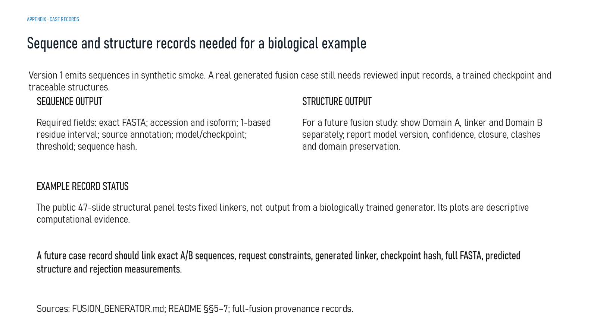
Revision 18 slide 94

Purpose and connection to the project
Explain the sequence and structure fields required for a future biologically trained case record. The public structural panel does not satisfy this case record.
This reference section shows how claims, figures, software and run artifacts can be traced. Provenance makes the work auditable, but a well-recorded result is not automatically a biologically correct result.
Why this slide matters: It lets an examiner verify where numbers, images and scientific definitions came from and locate the exact next evidence gate.

Evidence and labels shown on the slide
The following visible elements carry the slide's scientific content. Their role and evidence level are explained in the presentation script below.
- APPENDIX · CASE RECORDS
- Sequence and structure records needed for a biological example
- Version 1 emits sequences in synthetic smoke. A real generated fusion case still needs reviewed input records, a trained checkpoint and traceable structures.
- SEQUENCE OUTPUT
- Required fields: exact FASTA; accession and isoform; 1-based residue interval; source annotation; model/checkpoint; threshold; sequence hash.
- STRUCTURE OUTPUT
- For a future fusion study: show Domain A, linker and Domain B separately; report model version, confidence, closure, clashes and domain preservation.

Terms explained on this slide
DOMAIN: A protein domain is a region expected to form a recognizable three-dimensional unit. Domain boundaries are structural or annotation claims, not simply changes in sequence composition.
LINKER: A linker is the peptide segment between joined domains. Its sequence and length can influence spacing, flexibility, orientation and exposure, but cannot guarantee function.
PROVENANCE: Provenance is the recorded origin and transformation history of a datum, model, prediction or figure, including source identifiers, code revision and configuration.

Detailed interpretation of the visual
One future case moves from exact domain sequences and attachment sites through the approved checkpoint, generated linker, full fusion prediction and outcome evidence.
The object or dataset, comparison, axes, units, colours and layer dimensions define what the visual represents. The observed pattern is interpreted only within those definitions, preventing a prominent number or molecular rendering from being mistaken for broader biological proof.

Exact presentation script
This slide explains the sequence and structure fields required for a future biologically trained case record. The public structural panel does not satisfy this case record.
This reference section shows how claims, figures, software and run artifacts can be traced. Provenance makes the work auditable, but a well-recorded result is not automatically a biologically correct result.
On this slide, the concrete evidence and labels shown are: APPENDIX · CASE RECORDS; Sequence and structure records needed for a biological example; Version 1 emits sequences in synthetic smoke. A real generated fusion case still needs reviewed input records, a trained checkpoint and traceable structures; SEQUENCE OUTPUT; and Required fields: exact FASTA; accession and isoform; 1-based residue interval; source annotation; model/checkpoint; threshold; sequence hash. Together, these items establish exactly what was examined here, while retaining their individual evidence levels.
A protein domain is a region expected to form a recognizable three-dimensional unit. Domain boundaries are structural or annotation claims, not simply changes in sequence composition. A linker is the peptide segment between joined domains. Its sequence and length can influence spacing, flexibility, orientation and exposure, but cannot guarantee function. Provenance is the recorded origin and transformation history of a datum, model, prediction or figure, including source identifiers, code revision and configuration.
The reason this result belongs in the project is that it lets an examiner verify where numbers, images and scientific definitions came from and locate the exact next evidence gate.
The conclusion from this slide is deliberately limited. A future case must connect exact inputs, checkpoint, output sequence and structure evidence.

Likely examiner question
Question: What does slide 94 allow you to conclude?
Defensible answer: It supports the limited interpretation described above. The safe stopping point is: A future case must connect exact inputs, checkpoint, output sequence and structure evidence.

Scientific claim boundary
A future case must connect exact inputs, checkpoint, output sequence and structure evidence.
This boundary is part of the scientific interpretation, not a weakness to hide. State it clearly so the audience can distinguish what was measured from what would require prospective or experimental validation.

Slide 95 Questions and discussion

Revision 18 slide 95

Purpose and connection to the project
Use the three prompts to discuss what evidence would convert Version 1 from implemented software into a validated design method.
This reference section shows how claims, figures, software and run artifacts can be traced. Provenance makes the work auditable, but a well-recorded result is not automatically a biologically correct result.
Why this slide matters: It lets an examiner verify where numbers, images and scientific definitions came from and locate the exact next evidence gate.

Evidence and labels shown on the slide
The following visible elements carry the slide's scientific content. Their role and evidence level are explained in the presentation script below.
- Questions & Answers
- What evidence would turn the Version 1 generator into a validated design method?
- Discussion prompts
- Which mined records can pass independent review for generator training?
- How should two-flank infilling compare with templates and retrieval?
- Which structure and biological tests should decide whether a linker works?

Terms explained on this slide
LINKER: A linker is the peptide segment between joined domains. Its sequence and length can influence spacing, flexibility, orientation and exposure, but cannot guarantee function.

Detailed interpretation of the visual
Use the slide as an audit trail: identify the artifact, source or software role and explain how it supports reproducibility without treating provenance as validation.
The object or dataset, comparison, axes, units, colours and layer dimensions define what the visual represents. The observed pattern is interpreted only within those definitions, preventing a prominent number or molecular rendering from being mistaken for broader biological proof.

Exact presentation script
This slide uses the three prompts to discuss what evidence would convert Version 1 from implemented software into a validated design method.
This reference section shows how claims, figures, software and run artifacts can be traced. Provenance makes the work auditable, but a well-recorded result is not automatically a biologically correct result.
On this slide, the concrete evidence and labels shown are: Questions & Answers; What evidence would turn the Version 1 generator into a validated design method?; Discussion prompts; Which mined records can pass independent review for generator training?; and How should two-flank infilling compare with templates and retrieval?. Together, these items establish exactly what was examined here, while retaining their individual evidence levels.
A linker is the peptide segment between joined domains. Its sequence and length can influence spacing, flexibility, orientation and exposure, but cannot guarantee function.
The reason this result belongs in the project is that it lets an examiner verify where numbers, images and scientific definitions came from and locate the exact next evidence gate.
The conclusion from this slide is deliberately limited. The discussion is centred on the next evidence required rather than treating the project as biologically complete.

Likely examiner question
Question: What does slide 95 allow you to conclude?
Defensible answer: It supports the limited interpretation described above. The safe stopping point is: Frame answers around the next evidence needed rather than claiming completion.

Scientific claim boundary
Frame answers around the next evidence needed rather than claiming completion.
This boundary is part of the scientific interpretation, not a weakness to hide. State it clearly so the audience can distinguish what was measured from what would require prospective or experimental validation.

Part Three Presentation speech
The full speech below covers the whole scientific story in approximately 45 to 60 minutes, depending on how long you pause on diagrams and tables. Slides 83 to 94 work best as references or appendix material unless your assessors require every slide. A shorter route follows the full speech.

Slides 1 to 6 Research question, prior art and scope
Good morning. Our mini project is LinkerForge, a computational workflow for studying and proposing peptide linkers between protein domains. The structure on the cover is a fixed public control from our structural panel. It is not a sequence produced by a biologically trained generator.
The central problem is that linker choice depends on the two fusion partners, yet validated outcome data are sparse. Our aim is to build and evaluate a system that mines natural linker evidence, detects candidate linker spans, proposes exact-length sequences for a chosen domain pair and checks complete fusion structures under one recorded protocol.
We do not claim that detection or generation is new by itself. DFLpred and LINKER-Pred detect linker-like residues, LINKER generated fusion-linker sequences, ProtFIM demonstrated two-sided protein infilling and CAID3 benchmarks linker prediction. Our novelty is therefore a hypothesis about connecting these activities through provenance, family-aware data gates and matched structural evaluation.
The workflow starts with source records, curation and an evidence gate. It then detects candidate spans, reviews them, generates proposals, screens complete fusions and reports results with provenance. Today, the detector and generator software are implemented at different validation levels. Biological fusion performance remains future evidence.
The proteins named in the project serve different purposes. Historical detector records are identified through DisProt, mining queries cover several taxa, public structures such as Crambin, BPTI and Protein G support structural examples, and sfGFP-mCherry remains a long-term demonstration. Appearance in the project does not mean inclusion in detector training.

Slides 7 to 17 Biological foundations
DNA encodes an amino-acid sequence, and the chain folds into local secondary structure and complete tertiary structure. Domains are assigned on the folded architecture. A sequence between adjacent domain boundaries is only a candidate linker until its identity and evidence are checked.
A fusion protein forms one covalently continuous chain from the N-terminus of Domain A, through the linker, into Domain B and finally to the free C-terminus. Flexible GS-rich linkers aim to permit relative motion. Repeated EAAAK aims to produce a more persistent helical spacer. These are design tendencies rather than guarantees.
The workflow first asks whether attachment ports and candidate length are geometrically feasible. It then predicts the complete fusion and examines confidence, chain continuity, clashes, domain preservation and protected-site accessibility. These are computational assessments. They do not guarantee expression or function in vivo.
The project uses several databases for different purposes. DisProt provides curated disorder and DFL annotation. UniProt and UniRef supply sequences and homology context. InterPro and Pfam map domain families. CATH and PDB provide experimental structures and structural-domain boundaries. DLD supplies structural IDL and DDL labels. AlphaFold Database entries remain a separate predicted tier.

Slides 18 to 36 Dataset construction and curation
The database stage determines what the detector may learn. Positive residues, explicit negatives and unknown positions remain distinct. Unknown residues are masked, not converted into negatives, and DLD structural labels remain separate from DFL labels.
Mining takes a source sequence, produces per-residue scores, extracts candidate gaps and sends both calls and non-calls to review. The 27,595 model-scored gaps are candidate intervals, not verified DFLs. Together with natural records and templates, the inventory contains 27,766 rows.
A candidate interdomain gap requires two distinct, adjacent and non-overlapping domains. We reject terminal tails because they lack a second anchor, and internal loops because both flanks remain inside the same domain. We also reject overlap, nested domains and unresolved coordinate conflicts.
The project uses a 10-to-60-residue gap window for prospective interdomain mining and an older 5-to-30-residue constraint for fusion design. These are scope rules. We cannot describe two-to-thirty-one as a literature-validated biological range.
The inventory contains 6,556 high-score mined gaps, 21,039 provisional gaps, 91 CATH or PDB natural spans, 57 DisProt DFL spans and 23 published templates. A separate 40-protein specificity panel is not included. The review packet contains 971 records for each of two independent curators, but completed adjudication is not documented. Therefore, scientific generator training remains gated.

Slides 37 to 41 DFL detector
The active detector uses frozen ESM-2 t12 35M embeddings. Every residue receives a 480-dimensional contextual vector. A compact three-layer convolution head uses kernel widths one, five and one with channels 480 to 50 to 5 to 1, producing one logit per residue.
The width-one layers mix features at the same position, while the width-five layer adds local sequence context without changing residue alignment. Only the CNN head is trained. Masked binary cross entropy uses sourced positives and explicit negatives, while unknown positions and padding are ignored.
A sigmoid converts the logit into a residue score. A separate threshold and contiguous-span rule call candidate intervals. The current prospective mining cutoff is unset because historical thresholds cannot be transferred automatically.
Any new training must pass source, exact-sequence, family and benchmark-registry preflight. Selection uses only a new family-disjoint development cohort. Weights, thresholds and evaluator must be frozen before protected labels are revealed.

Slides 42 to 53 Version 1 generator
We now move from detecting candidate natural spans to proposing a linker for a specified domain pair. Version 1 receives the C-terminal flank of Domain A, the N-terminal flank of Domain B, a supplied length and optional sequence constraints.
The prompt places both flanks before the first generated linker residue. The native model is a four-layer, eight-head causal transformer with hidden width 256 and 20 amino-acid output logits. It starts from random weights. An optional frozen pretrained-backbone route with LoRA-style projections exists, but no compatible pretrained protein checkpoint has been selected or biologically tested.
The training task reconstructs a known-length linker. The loss applies only to free linker residues. Prompt tokens, padding and forced motif positions are ignored. Length is supplied, so exact length is not evidence of learned length prediction.
The training code performs preflight, deterministic collation, AdamW optimisation, gradient checks and provenance-preserving checkpoints. Thirty-one generator tests passed. The executed smoke test used invented records, made three CPU updates, reloaded a checkpoint and emitted one proposal. This verifies software execution, not biological usefulness.
The future benchmark will compare the conditional infiller with length-matched frequency, flank-context retrieval and a cited template library using the same held-out records and call budget. Decoding records every rejected attempt. Passing alphabet, motif and length rules does not prove folding or function.
Detection, generation and structural evaluation must remain separate. The public structural panel that follows tests fixed linker controls, not output from a biologically trained Version 1 generator.

Slides 54 to 61 Structural metrics and matched design
The structural panel uses AlphaFold2 through ColabFold. pLDDT measures local confidence per residue. pTM summarizes global topology confidence. PAE estimates relative positional uncertainty after alignment. Cross-domain PAE focuses on uncertainty between Domain A and Domain B.
Geometry metrics answer different questions. C-alpha continuity screens for backbone gaps. RMSD measures coordinate difference after alignment. SASA and burial describe solvent exposure. Reduce and Probe screen hydrogen-aware contacts. Protected-site distances monitor selected residues. OpenMM propagates coordinates through simulated time.
The matched comparison contains three public domain pairs and seven conditions per pair, giving 21 complete constructs. Five AF2-pTM outputs per construct give 105 predictions. Every condition used the same ColabFold protocol, one seed and no templates. The five ranks are related predictions rather than independent experiments.
The bar chart shows that mean pLDDT depends on both linker and domain pair. Delta charts compare each inserted linker with the matched direct fusion. The scatter plot shows why local confidence and interdomain uncertainty must be read together.

Slides 62 to 74 Structural results and application
For Crambin-BPTI, EAAAK15 gave the strongest linker-containing confidence profile: mean pLDDT 93.8, linker pLDDT 84.9, pTM 0.69 and cross-domain PAE 9.7 angstrom. For Protein G-repressor, direct fusion was strongest, while short GGGGS led the inserted-linker conditions. For Ubiquitin-GB1, direct fusion and EAAAK were close in mean pLDDT but differed in cross-domain PAE. These results show partner dependence.
The highlighted 1CRN-EAAAK15-4PTI model contains 119 residues. Its confidence trace shows local confidence for five AF2-pTM ranks. PyMOL displays Crambin in blue, the linker in gold and BPTI in rose. The mainly helical pose agrees with EAAAK design intent, but one predicted pose does not represent a solution ensemble.
The PAE heatmaps show lower uncertainty in blue and higher uncertainty in red. Off-diagonal disagreement indicates uncertainty in relative domain placement. PAE is expected error, not physical distance.
The Ubiquitin-GS10-GB1 example monitors Lys48 as a protected residue. It had zero detected chain breaks, ubiquitin RMSD 0.94 angstrom, GB1 RMSD 3.02 angstrom, relative SASA 0.537 and minimum linker distance 25.28 angstrom. This supports geometric separation in one pose, not preserved biological function.
Hydrogen-aware overlap and burial values are descriptive review flags without validated pass-fail thresholds. DFLpred recognizes flexible-linker character, not compatibility. Its low recall for EAAAK is expected because EAAAK is designed as a helix.
Three OpenMM replicates of 50 picoseconds completed on CUDA. Their traces verify execution and metric output. Fifty picoseconds cannot establish equilibration, convergence or long-term stability. The application viewer exposes the saved structures and confidence context but does not perform dynamics.

Slides 75 to 82 Detector results, limitations and conclusion
The detector, generator and structural results must not be combined into one performance score. Historical detector development reached mean APS 0.7918 on a small panel. On DLD fold 4 at about 0.90 observed precision, recall was 0.0766 for the baseline and 0.0861 for the fixed ensemble. On the retrospective CAID3 common-27 comparison, LinkerForge APS was 0.241, below LINKER-Pred at 0.398 and LINKER-Pred-Lite at 0.429.
These results show that the classifier runs and can mine candidate gaps, but transfer and high-precision recall remain limited. CAID3 has already been viewed and cannot guide another training round. The protected split also fails the current prospective firewall.
Other limitations include incomplete negative labels, unadjudicated mined candidates, source and species bias, project-defined length windows and the absence of biologically trained generator weights. The structural panel uses three public pairs and one structure-model family, while the OpenMM runs are execution tests.
The strongest defensible conclusion is that LinkerForge contains a provenance-aware detector, conditional generator software and a reproducible structural comparison panel. It does not establish biological linker superiority.
The next evidence gates are independent source adjudication, family-disjoint reviewed generator data, held-out sequence benchmarking, generated-candidate structural tests, longer replicated dynamics where justified and experimental measurements for claims about biological performance.

Slides 83 to 95 References and appendix
The remaining slides document sources, software, image provenance and underlying data artifacts. The reference slides support method definitions, while the D-coded project artifacts support the reported numerical values.
The quality-control appendix shows that validation is a chain from source and label semantics through family split, model identity, prediction, independent review and biology. A successful software job satisfies only one link.
The example-run table keeps APS, high-precision recall, mining counts, generator smoke and structure results separate because they use different units and evidence levels. The future case-record slide defines the sequence, checkpoint, structure and measurement fields required for a real generated-fusion example.
In conclusion, the work provides a traceable computational foundation. To become a validated design method, Version 1 needs approved biological records, a frozen held-out comparison against matched baselines and structural and experimental evidence tied to the exact generated sequences. Thank you.

Shorter 25 minute presentation route
If the allotted time is about 25 minutes, use slides 1-6, 9-10, 18-19, 23-24, 33-41, 42-53, 54-61, 65-76, 80-82 and 95 as the main path. Treat slides 7-8, 11-17, 20-22, 25-32, 62-64, 66-74 and 83-94 as detailed evidence or backup. Do not delete them; refer to them when an examiner asks for definitions, exact tables, provenance or software versions.

Part Four Difficult viva and examiner questions
Answer in four steps: give the direct answer, identify the evidence, state the limitation and name the next evidence required.

What is LinkerForge in its current state?
It is a computational research prototype containing a DFL residue detector, conditional linker-generator software and a separate full-fusion structural-evaluation workflow. These components have different validation levels and cannot yet support a claim of biological linker superiority.

What is the main research gap?
Existing work already covers linker detection, fusion-linker generation and protein-sequence infilling. LinkerForge tests whether curated natural evidence, two-flank generation, matched structural evaluation and provenance can be connected for context-specific fusion design. That integration remains a hypothesis until an independent comparison validates it.

What has actually been implemented?
The frozen-ESM-2 plus CNN detector, source-stratified inventory, Version 1 transformer, trainer, constrained decoder, software tests, fixed-control ColabFold panel, geometry audits, viewers and short OpenMM smoke workflow are implemented. Reviewed-data generator training and biological validation are not.

Why are there three evidence streams?
The detector classifies residues in natural proteins. The generator proposes a new sequence for a chosen domain pair. The structural panel evaluates complete fusion predictions. Their outputs and validation targets differ.

Did the structural panel validate Version 1?
No. The panel compares fixed direct, GS, Waldo, Bird and EAAAK controls. It is separate from biologically trained generator output because no such trained checkpoint currently exists.

What is a DFL?
A disordered flexible linker is an annotated sequence region expected to provide flexible connection between domains. It is not identical to every sequence gap, every disordered loop or the DLD structural IDL and DDL categories.

What is the difference between IDL and DDL?
They are DLD structural classes. An independent-domain linker connects domains that can fold or operate independently, while a dependent-domain linker relates domains with stronger structural dependence. They are not automatically DFL labels.

Why is an unknown residue not a negative?
Absence of annotation does not demonstrate ordered or non-linker status. Treating unknown residues as negatives would create label noise and could reward the model for missing genuine but unannotated linkers.

Why reject terminal tails?
A terminal tail has only one domain anchor. An interdomain linker requires a distinct domain on both sides.

Why reject an internal loop?
Both flanks remain inside the same domain. Flexibility or disorder alone does not make the sequence an interdomain bridge.

Why reject overlapping domains?
A usable gap requires a physically and annotationally distinct interval. Overlap or nesting creates ambiguous boundaries and may represent no physical clearance between units.

Why are 5-30 and 10-60 both present?
They belong to different project scopes. Five to thirty residues is the older fusion-design constraint. Ten to sixty residues is the prospective natural interdomain mining window. Neither is a universal biological law.

Is 2-31 a valid biological length range?
No. If it denotes coordinates, positions 2 through 31 contain 30 residues. If it denotes lengths, it does not match the frozen project rules. Revision 18 explicitly rejects it as a literature-validated biological range.

What exactly are the 27766 records?
They are mixed evidence records: 27,595 model-mined gaps, 91 CATH or PDB natural spans, 57 DisProt DFL spans and 23 literature templates. They are not 27,766 experimentally successful fusion linkers.

Can the 27766 rows train the generator?
Not directly. Mined candidates require review, source verification and family auditing. Scientific training must use approved A-linker-B records with explicit evidence tier, sequence hash and split assignment.

What does the 971-record packet do?
It provides a stratified set for two independent curators. It can improve identity and provenance labels, but completed adjudication is not documented and it cannot create missing fusion outcomes.

Why two curators?
Independent reviews reduce shared influence and allow agreement to be assessed. Adjudication then resolves disagreements after both reviews are complete.

What is a family-disjoint split?
Related protein sequences and domain families remain on one side of the train-development-test boundary. This reduces memorisation and makes generalisation claims more meaningful.

Why use ESM-2?
ESM-2 supplies contextual residue representations learned from protein sequences. Freezing it reduces the number of trainable parameters and makes the small classifier head easier to audit. It does not guarantee good linker detection.

What does 35M mean in ESM-2 35M?
It refers approximately to the parameter count of the selected ESM-2 model. Revision 18 uses the t12 35M variant and extracts a 480-dimensional vector per residue.

Why a 1-5-1 CNN?
The first width-one convolution mixes features at each residue. The width-five layer sees a local neighbourhood of plus or minus two positions. The last width-one layer maps those features to one residue logit while preserving alignment.

What is a logit?
A logit is the model's unbounded raw output before sigmoid conversion. It is not a probability unless calibration and interpretation conditions are established.

What is masked binary cross entropy?
It trains on sourced positive and explicit negative residues while excluding unknown positions and padding. This prevents missing annotation from becoming a false negative label.

Why separate scoring and span calling?
The neural network scores each position. A versioned threshold and interval rule decide which contiguous residues form a call. This separation makes the operating point explicit and auditable.

What is APS?
Average precision summarizes the precision-recall curve. It is especially useful for imbalanced data, but values from different datasets, label definitions or coverage cannot be compared as one leaderboard.

What is Fmax?
Fmax is the maximum F1 score across thresholds. It reflects a chosen operating trade-off and is not an untouched prospective result if the same data influenced selection.

Why is high-precision recall low?
Maintaining about 0.90 observed precision requires a strict threshold, so the detector identifies only a small fraction of positives. DLD fold-4 recall improved from 0.0766 to 0.0861 in the fixed ensemble but remained limited.

Is the detector better than LINKER-Pred?
No superiority claim is supported. On the retrospective CAID3 common-27 set, LinkerForge APS was 0.241, below LINKER-Pred 0.398 and LINKER-Pred-Lite 0.429.

Why can CAID3 no longer guide training?
Its results have been viewed. Using them to choose architectures or thresholds would turn the test into development feedback and invalidate a future untouched claim.

What does fail closed mean?
The workflow stops when required registries, hashes, family exclusions or benchmark-isolation conditions fail. It refuses to weaken scientific safeguards merely to run another model.

What is the Version 1 generator?
It is a causal transformer that reads both attachment-adjacent domain flanks and supplied control tokens before generating an exact-length linker sequence.

Why call it fill in middle?
The missing linker lies between a prefix from Domain A and a suffix from Domain B. The prompt exposes both sides before generation, so the model fills the middle context.

Does Version 1 predict linker length?
No. Length is supplied as an input and generation emits exactly that many residues. Zero length error would therefore be by construction.

What is causal self attention?
At each generated position, attention can use the earlier prompt and previously generated linker tokens but cannot look at future linker residues.

What does pre norm mean?
Layer normalization occurs before attention and feed-forward sublayers. Residual connections add each sublayer output back to its input.

What are attention heads?
Each head learns a different weighted view of earlier token representations. Version 1 uses eight heads per block.

Why 20 output logits?
The decoder selects among the 20 canonical amino acids at each free linker position.

What is LoRA?
Low-rank adaptation adds small trainable projection updates around a frozen backbone. LinkerForge implements an optional route, but no compatible pretrained protein checkpoint has been selected or biologically tested.

Was ProtFIM used as the generator checkpoint?
No. ProtFIM motivates the two-flank infilling idea. Revision 18 and the repository state that no compatible pretrained protein checkpoint has been selected and that transfer from ProtFIM is untested.

What did the generator smoke test prove?
It proved that software could train for three CPU updates on invented records, save and reload a checkpoint and emit one constraint-compliant proposal. It did not prove biological sequence quality.

What is constrained decoding?
The decoder samples residues under an allowed alphabet, fixed length, optional motif placement, forbidden junction motifs, duplicate checks and a bounded attempt budget. Every rejection is recorded.

Why record rejected attempts?
They reveal failure modes and coverage. Hiding failed attempts would make a method appear more reliable than it is.

What baselines will the generator face?
Length-matched training frequency, flank-context retrieval and a source-audited template library, all under an equal-call protocol on family-held-out records.

Why one candidate and one attempt per baseline?
Equal call budgets prevent one method from gaining an advantage by sampling many more sequences. Missing and rejected calls count against coverage.

What is pLDDT?
AlphaFold predicted local distance difference test is local confidence per residue on a 0-to-100 scale. It is not experimental accuracy or a LinkerForge success score.

What is pTM?
A zero-to-one estimate of confidence in global topology. It does not isolate linker quality or prove correct domain packing.

What is PAE?
Predicted aligned error estimates uncertainty in one residue's position after alignment on another. It is reported in angstrom but is not physical distance.

How can pLDDT be high while PAE is high?
Each domain can be locally well predicted while their relative orientation remains uncertain.

Why is EAAAK15 highlighted?
It had the highest mean pLDDT among the 18 linker-containing constructs in the fixed public panel. The selection is post hoc and descriptive, not a validated winner.

Did any direct fusion score higher than the highlighted construct?
Yes. The Protein G-repressor direct-fusion control reached mean pLDDT 94.9. The highlighted result is explicitly the highest linker-containing construct.

Why is the result partner dependent?
The same sequence produced different confidence and PAE patterns with different domain pairs. Attachment geometry and partner context influence the predicted structure.

What is RMSD?
Root-mean-square deviation measures coordinate difference after aligning matched atoms. Lower values mean closer agreement with the chosen reference, not preserved biological function.

What is SASA?
Solvent-accessible surface area estimates how much surface a solvent-sized probe can reach. Relative SASA can help monitor whether a protected site remains exposed in one pose.

Does the Lys48 result prove function?
No. It shows geometric separation and partial accessibility in one predicted pose. It does not simulate a conformational ensemble, partner binding or ubiquitin activity.

What do Probe overlaps mean?
After Reduce places hydrogens, Probe flags severe close contacts. Counts support manual review but lack a frozen universal pass-fail threshold here.

Why is DFLpred recall low for EAAAK?
DFLpred detects disordered flexible-linker character. EAAAK is intended to form a helix, so low DFL recall is expected and does not imply incompatibility.

What did the OpenMM runs prove?
They proved that preparation, CUDA execution, replication and metric extraction completed for three 50 ps runs. They did not prove equilibrium or stability.

Why is 50 ps too short?
The system may still be relaxing from its prepared start, and relevant conformational changes usually occur over much longer times. Stable-looking short traces are insufficient for convergence.

Why use PyMOL and an embedded viewer?
PyMOL supports reproducible selections, measurements and figures. The embedded viewer supports convenient application use. Neither predicts structures or performs molecular dynamics.

Is LinkerForge better than current generators?
The workflow is broader in provenance and integrated evaluation, but predictive superiority has not been established. A matched family-held-out comparison and biological outcomes are still required.

What is the strongest claim you can make?
LinkerForge has implemented, provenance-aware detector and generator software and a reproducible matched structural comparison workflow. It does not yet prove the biologically best linker.

What would make Version 1 scientifically validated?
Reviewed family-audited training records, a frozen held-out benchmark against matched baselines, reproducible training across predeclared seeds, complete-fusion checks tied to generated sequences and appropriate biological outcome measurements.

What would make the project publishable?
A software or methods report can accurately present the implementation and negative results if artifacts are reproducible and limitations remain explicit. Strong design-performance claims require prospective family-disjoint evaluation and biological evidence.

Part Five Glossary and claim boundary
Term | Meaning in Revision 18
Adjudication | Resolution of disagreements after independent reviewers complete their labels.
AF2-pTM | AlphaFold2 configuration that produces coordinates plus pTM and PAE confidence outputs.
APS | Average precision, the area under the precision-recall curve.
C-alpha | The alpha carbon used as one backbone reference atom per amino-acid residue.
Causal transformer | A model that predicts the next token using the prompt and earlier generated tokens.
ColabFold | Workflow that makes AlphaFold-family prediction accessible and uses MMseqs2 for sequence search.
Compatibility | Whether a linker is suitable for a specific pair under defined structural and biological outcomes.
Constrained decoding | Generation under fixed length, alphabet, motif and rejection rules.
Cross entropy | Training loss that penalizes low probability assigned to the observed target residue.
DFL | Disordered flexible linker.
DDL | Dependent-domain linker in the DLD structural task.
Domain | A protein region expected to form a recognisable folded structure.
Evidence tier | A category that records whether evidence is mined, natural, curated, engineered or predicted.
Family disjoint | Related proteins are kept on only one side of a data split.
Fail closed | Stop when scientific preconditions fail rather than bypass them.
Fill in middle | Generate a missing sequence between a prefix and a suffix that are both supplied in context.
Fmax | Maximum F1 score over thresholds.
Fusion protein | One continuous amino-acid chain that joins two protein regions.
IDL | Independent-domain linker in the DLD structural task.
Linker | A peptide encoded between fusion partners.
Logit | An unbounded raw model score before sigmoid or softmax conversion.
LoRA | Low-rank trainable updates added around selected frozen-model projections.
Masked loss | A loss that excludes unknown, padding or forced positions.
MSA | Multiple sequence alignment used to capture evolutionary information.
PAE | Predicted aligned error, an estimate of relative positional uncertainty.
pLDDT | AlphaFold local-confidence score per residue on a zero-to-one-hundred scale.
Precision | Fraction of predicted positives that are true positives.
Prospective evaluation | Freeze the method before revealing protected outcomes.
Protected residue | A residue selected for monitoring because accessibility may matter to function.
Provenance | Source, processing, version, configuration and hash history of a result.
pTM | AlphaFold confidence in global topology on a zero-to-one scale.
Recall | Fraction of true positives that the method finds.
RMSD | Reference-aligned root-mean-square coordinate deviation.
SASA | Solvent-accessible surface area.
Smoke test | A short software execution test rather than full scientific validation.
Specificity | Fraction of verified negatives correctly rejected.
Unknown x | A residue without eligible positive or negative annotation, excluded from supervised loss.

Exact phrases to avoid
Avoid: Our generator produced the 93.8 pLDDT fusion.
Use: The fixed-control structural panel produced a Crambin-EAAAK15-BPTI prediction with mean pLDDT 93.8.
Avoid: LinkerForge achieved 93.8 percent accuracy.
Use: AlphaFold2 reported mean pLDDT 93.8 for one construct.
Avoid: The 27766 records are training proteins.
Use: The 27,766 rows form a mixed-evidence source inventory.
Avoid: The mined gaps are verified linkers.
Use: The mined gaps are computational candidates awaiting independent review.
Avoid: The generator is trained.
Use: The generator code passed synthetic software tests; biological training remains gated.
Avoid: EAAAK is the best linker.
Use: EAAAK15 had the highest linker-containing mean pLDDT for one public pair under the fixed protocol.
Avoid: DFLpred validated compatibility.
Use: DFLpred recognized flexible-linker character in the inserted spans.
Avoid: OpenMM proved stability.
Use: Three 50 ps OpenMM runs validated execution of the simulation workflow.
Avoid: The detector beats LINKER-Pred.
Use: The retrospective common-27 comparison did not support superiority.
Avoid: The protected benchmark failed because the model was poor.
Use: The protected preflight failed because independence conditions were not satisfied.

Thirty second conclusion
LinkerForge connects a residue-level natural-linker detector, an implemented two-flank conditional generator and a matched full-fusion structural workflow. The software and public computational panel are reproducible and provenance-aware, but the generator lacks approved biological training and the detector lacks a fresh family-certified prospective benchmark. The project therefore supports an integrated computational-method claim, not biological linker superiority.

Source map
Primary presentation source: M:\ChatGPT\Parsea\LinkerForge_Story_Reordered_2026-10-26_Revision_18_FinalBS.pptx
Repository sources checked: README.md; FUSION_GENERATOR.md at commit 7a4ccc2; RESEARCH_HANDOFF.md; literature/DFL_UNTOUCHED_COMPARISON_CONTRACT_2026-10-17.md; datasets/README.md.
The repository sources were used to clarify technical meaning and claim boundaries. Revision 18 remains the controlling slide order and presentation source.

