allblacks.com  
Site creation and content migration

Technical Proposal – Richard Ware, Datacom

# Overview

The Japanese version of New Zealand Rugby’s flagship website ([jp.allblacks.com](https://jp.allblacks.com)) has been built with a new design and on a SilverStripe CMS platform.

The English version of the site ([allblacks.com](https://allblacks.com)) is currently unsupported and built on top of a custom version of a ColdFusion CMS, with a Microsoft SQL Server database and a static cache in Azure.

This decision to build the Japanese site before the English site was made because it is low volume, low traffic and low profile. This document proposes a technical approach for migrating the site architecture and content from the current English language version of [allblacks.com](https://allblacks.com) to the new SilverStripe platform.

# Scope

## Sites

The current ColdFusion CMS enables editors to manage content on the following websites: -

* [allblacks.com](https://allblacks.com)
* [superrugby.co.nz](https://superrugby.co.nz)
* [mitre10cup.co.nz](https://mitre10cup.co.nz)
* [heartlandchampionship.co.nz](https://heartlandchampionship.co.nz)

There have also been discussions on whether [https://www.farahpalmercup.co.nz](https://www.farahpalmercup.co.nz/) could also be managed by the new CMS

## Functionality

### Site Structure

The site is mainly static but does include a [Team All Blacks](http://www.allblacks.com/TeamAllBlacks/Home) membership area. There are approximately 30,000 content items on allblacks.com, the vast majority of which are news articles.

### App

An RSS feed is exposed for content on the All Blacks mobile app.

### Stats Hub

Player and Team stats (including but not limited to age, height, weight, games played, points scored etc.) are rendered in different areas of the site. This data can come from multiple sources: -

* CMS
* [Opta Sports](https://www.optasports.com/)
* [stats.allblacks.com](http://stats.allblacks.com/)

Individual stats will be configured from any of these sources in a ***Stats Hub***.

### Game Day Experience

There are plans to provide a rich *Game Day Experience* to include live commentary, stats and links to social media.

Here is an example from the BBC Sport site: -

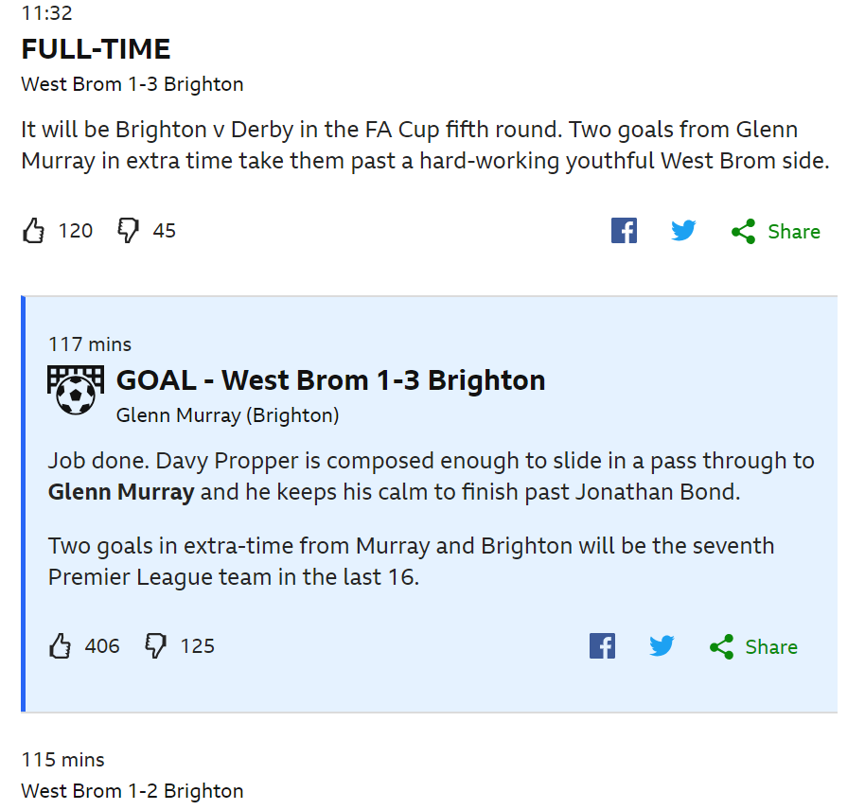

Figure 1 - BBC Sport example

## Phases

The recommended approach is to go live with a minimum viable product after identifying the minimum required to get the site(s) on the new platform. This will give NZR a supported architecture and CMS on the new platform and give all stakeholders an opportunity to learn from smaller incremental pieces of work. Discussions with New Zealand Rugby are required to establish: -

* the number of old archived news articles that need to be migrated for MVP
* all other pages required for the new site
* whether all websites (including <https://www.farahpalmercup.co.nz>) need to be on new CMS for MVP
* if MVP can exclude the stats hub – i.e. can MVP have a restricted set of stats (for players and teams) manually entered in the CMS
* if Game Day Experience can be included in a later phase

# Our Proposal

## Considerations

In contrast to jp.allblacks.com, the English version of the allblacks.com website is high profile and high volume. The traffic is very spikey; squad announcements and match reviews can result in huge spikes. The upcoming World Cup (in September, October and November) will increase profile and traffic.

## Current Architecture

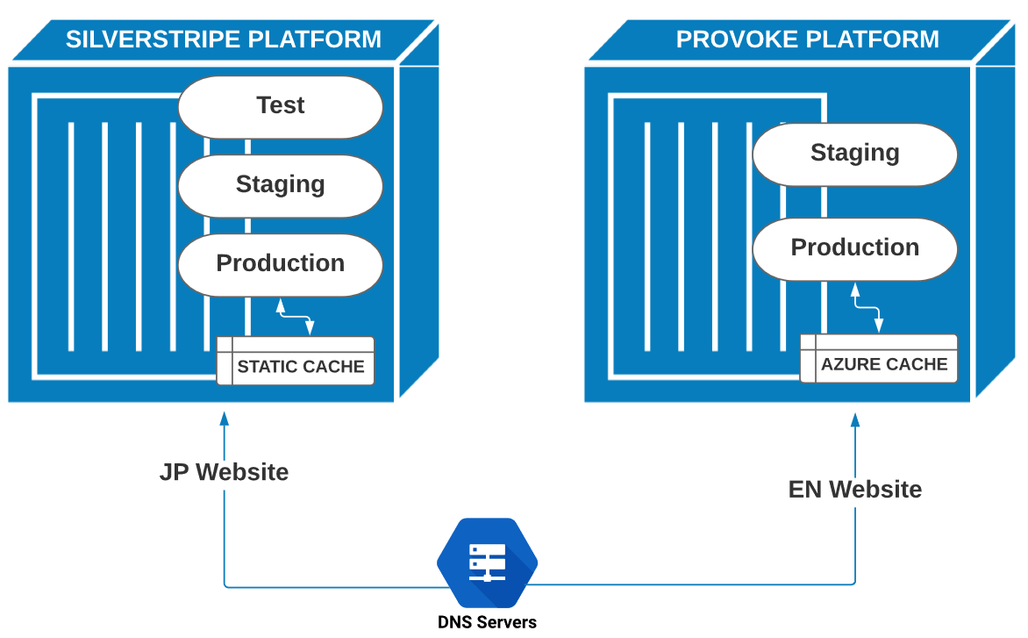

Figure 2 - Current Architecture

* The English website is hosted by Provoke.
* The Japanese website has been built to handle multiple languages (it was built with the English site in mind) but currently only handles Japanese content.
* Traffic for the English site is directed to the Provoke servers, traffic for the Japanese site is directed to the SilverStripe platform stack.

## Planned Architecture

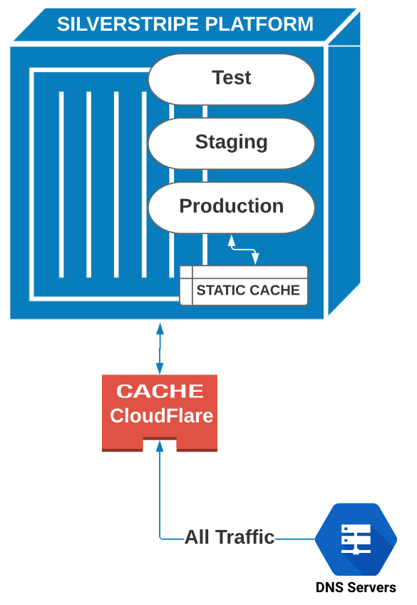

Figure 3 - Planned Architecture

The new SilverStripe platform will handle both the English and Japanese content. Content items will be created and edited in SilverStripe and can be English-only, Japanese-only or both. A larger SilverStripe platform (more disk, memory and CPU) will be required to handle the additional volumes. In addition to the static cache, a CDN is required to handle the high-volume spikes. After consultation with SilverStripe, it was decided that CloudFlare would be a good CDN for the platform.

## Migration Strategy

### News Articles

Most of the content are news articles. NZR embarked on a content migration Proof of Concept last year. A small number of news articles were successfully migrated from the Provoke Microsoft SQL Server database to a test SilverStripe environment. However, higher volumes will hit PHP memory limits, so we need to consider the following options: -

1. Running in small batches
2. Pushing jobs to a queue, to be consumed by background tasks
3. Converting the JSON to YAML files for SilverStripe [Populate](https://github.com/dnadesign/silverstripe-populate) jobs.

### Home Page

Already supported in new platform

### News Pages

Already supported in new platform but might need additional metadata tagging and re-design for exclusive columns

### Video Pages

Already supported in new platform but might need additional metadata tagging

### Team Pages

Already supported in new platform but should add team specific news and videos (based on metadata tagging)

### Player Pages

Already supported in new platform but should add team specific news and videos (based on metadata tagging)

### Fixture/Results Pages

Already supported in new platform but should be included for all teams (not just All Blacks)

### Ticket Page

Requires a re-design

### Redirects

HTTP 301 redirects will be used for all content that has been moved. The news articles will follow a very regular pattern: -

<http://allblacks.com/News/33677/ngani-laumape-extends-time-in-new-zealand>

will be migrated to: -

<http://allblacks.com/news/ngani-laumape-extends-time-in-new-zealand>

These redirects will be configured by the [silverstripe-redirectedurls](https://github.com/silverstripe/silverstripe-redirectedurls) module​ or a simple .htaccess mod_rewrite rule. 301 redirects are SEO-friendly and will handle external links (including bookmarked links) and links within news articles.

### Environments

Development of the new site will be carried out on a new SilverStripe platform, with the old platform handling the JP traffic. This new platform can be configured with a CDN and tested (including performance testing). Once ready, the DNS servers will be changed to point all traffic to the new site. There will be no complicated deployment scripts – just switch over to the new stack when we know everything is working. This could be described as a one-off blue/green deployment (<https://docs.cloudfoundry.org/devguide/deploy-apps/blue-green.html>).