Question and Answers

1. When start meeting, Please say greeting and say this.

I'm a Senior Full-stack Web developer with over 8 years of commercial experience providing digital solutions for my clients with 100% satisfaction.

⮩ Reasons to hire me

✓ I have over 8 years of commercial experience - I accomplished over 30 jobs of small or large one so far.

✓ I'm always learning and following the latest development standards. I provide high-quality and well-tested products.

✓ I provide realistic deadlines that I always met.

✓ I work on both Mac, Linux and Windows. I also try my work on iPhone and Android phones. This way, you can be sure that your website or app shall display appropriately on any device.

✓ I'm flexible with my working hours because I'm a full-time freelancer.

✓ I'm available daily. You will know the current status of the job because I contact you with updates frequently.

✓ I believe good communication is the key to a successful project. That's why I always respond promptly.

I am looking for a remote job now and if you are interested please contact me.

I speak English and French and prefer French website development.

Thanks.

1. She will ask about you. Your name, age, address, phone etc. You can answer yourself.
2. Where did you know us? I heard about your company from Mohamed.
3. What’s your hourly rate? 45$/hour
4. Please explain work history? Please share me your previous work.

Your work history is in Linkedin. You can say this one by one.



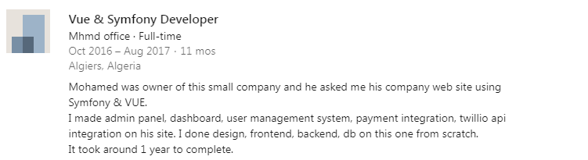

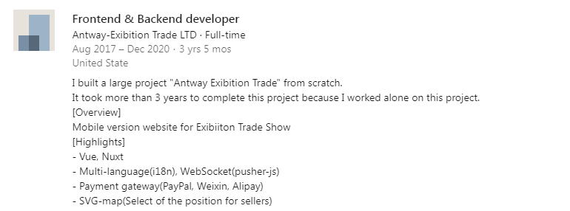

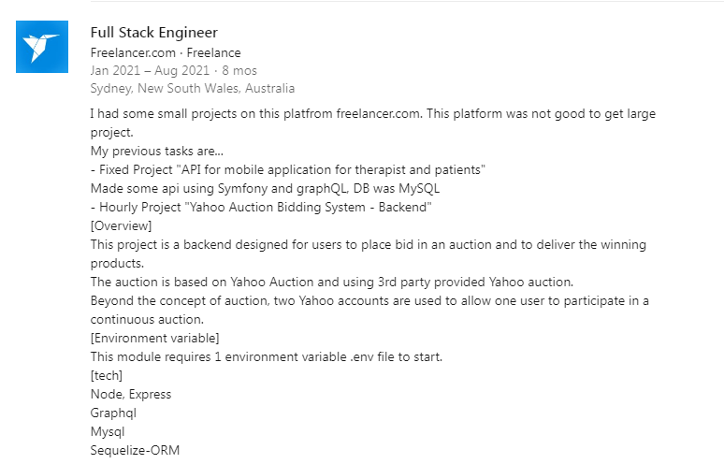

1. What is your skills?

✓ VueJs, Nuxt, ReactJS, Redux, Angular, React Native, Ionic, Chart.js, d3.js

✓ PHP, Symfony, Laravel, Cake, CodeIgniter

✓ Node.js, Express.js, Typescript, TypeORM

✓ RestAPI, GraphQL

✓ Javascript, jQuery, jQuery UI, jQuery Mobile

✓ HTML5/CSS3, SASS/LESS, Bootstrap 3 and 4

✓ Postgres, MySql, MongoDB

✓ APIs - Facebook, Twitter, Google API, Google Maps, Google Analytics, Dropbox, Twilio

✓ Asana, Jira, Trello

✓ Git, Bitbucket

✓ Photoshop and SEO

1. What is your Javascript Level (0-10)? I can say Level 10 as an expert.
2. What is your Javascript experience?

I worked more than 8 years on Javascript. I mastered Pure Javascript, Jquery. Also I am very excellent on Vue, React, Angular, Ionic, React Native, NodeJs, Express.Js

1. What’s your Vue Level (0-10)? I can say Level 10 as an expert.
2. What is your Vue experience?

I mastered almost vue libraries so can implement anything on frontend.

I also mastered Vuex, Element-UI, Bootstrap-Vue, Vuetify.

I am also very good at Nuxt.js

1. Do you know Nuxt? Level (0~10)? Yes 10
2. Do you know React? Level (0~10)? Yes 9
3. Do you know React Native? Level (0~10)? Yes 9
4. Do you know Angular? Level (0~10)? Yes 9
5. Do you know Ionic? Level (0~10)? Yes 9
6. Do you know NodeJs? Level (0~10)? Yes. 10
7. Do you know Bootstrap? Level (0~10)? Yes 10
8. Do you know Typescript? Level (0~10)? Yes 10
9. What is your PHP level (0~10)? Expert Level 10
10. What is your PHP experience

I worked on PHP for 10 years. PHP is my main skill. I mastered Symfony Framework, Laravel Framework.

1. Do you know Symfony? Level (0~10)? Yes Level 10
2. What is your Symfony Experience.

I mastered Symfony DDD patern, repository, service, DAO, doctrine, ORM.

I can write backend with Symfony and very good at Twig.

1. Do you know Laravel? Level (0~10)? Yes Level 10
2. What is your Laravel experience?

Laravel is very good MVC framework and I mastered composer packages and ORM.

1. Do you know Docker? Level (0~10)? Yes Level 9
2. Do you know Git? Level (0~10)? Yes Level 10
3. Do you know GraphQL? Level (0~10)? Yes Level 10
4. Do you know RestAPI? Level (0~10)? Yes Level 10
5. Do you know MySQL? Level (0~10)? Yes Level 10
6. Do you know MongoDB? Level (0~10)? Yes Level 9
7. Do you know Html, Css? Level (0~10)? Yes Level 10
8. Do you know Scss? Level (0~10)? Yes Level 10
9. Are you good at teamwork? Yes. I prefer teamwork.
10. Do you know Asana and Jira? Yes, I usually used them.
11. Can you work full time? Sure I can work on weekend also.
12. How much time can you work per day? I can work 10+hours per day.
13. Your computer system? I have 2 computers and one is Linux, one is Windows
14. Your computer RAM ? 32GB, 16GB
15. Which payment method do you prefer? transferwise
16. Do you work at office? No. I work at home.
17. Can you work on Paris time zone? Yes. Sure.
18. Can you share your git profile? https://github.com/OrionDev418?tab=repositories