**TempleInn.com**

The purpose of this document is to describe the TempleInn.com website, its purpose and intended audience, utilization scenarios, and other aspects such as its organization and structure, elements of style, etc. It is to be used as a planning and elaboration tool for the Term project to be developed as part of the WDD 230 course.

This site is going to be called **TempleInn**. As the name indicates, it will a hotel chain hosting general authorities and members of the church from all over the world who will attend temple sessions.

The **Temple Inn & Suites** is a hotel chain that builds and manages specialized hotel accommodations near temple locations of The Church of Jesus Christ of Latter-day Saints around the world. The company caters to temple workers, patrons, and their families by providing specialized services and accommodations that meet the needs of those patrons. The hotel accommodations and services are available to anyone willing to abide by the terms and policies outlined by the company.

The overall goal of the website is to promote and provide information about the specialized services that this hotel chain offers to meet the needs of temple patrons who come to serve in the temple or who participate in events such as sealings, weddings, receptions, and youth trips.

The target audience of the TempleInn.com web site is described below:

**Who:** General authorities of the church travelling around the world for church assignments, members of the church who visits the temple, Temple workers, patrons and their families

**Age:** People of all ages including families with kids

**Technology:** The site maybe accessible by phone, iPad, laptops and desktops. It will be child friendly and appropriate for people of all ages.

**Motivation:** Improve patronage of temples around the world and provide comfort and shelter for general authorities, temple workers, patrons, and members all around the world

This section describes the basic structure of the **TempleInn.com** website.

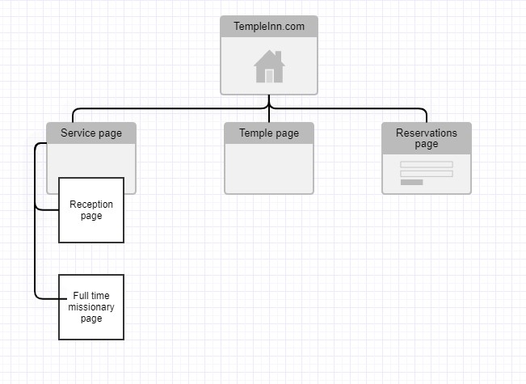

Figure 1 - **TempleInn.com** Site Map, demonstrating the structure of the site.

This section describes the visual and aesthetic plan for the TempleInn.com web site.

Describes the background, text, links, accent(s), highlights, and logos of the **TempleInn.com** web.

|  |  |  |  |  |  |
| --- | --- | --- | --- | --- | --- |
| **Primary color:** | #e2fcef  #e2fcef | #0d2c54  #0d2c54 | #FFFFFF  #FFFFFF | #AFBFC0  #AFBFC0 | #0D1821  #0D1821 |

Describes the fonts, font sizes, styles, and line height used in the **SOAtheory.com** web site.

Table shows user the color, size, and font used in each of the areas of the page template.

|  |  |
| --- | --- |
| **Object/Item** | **Font Size** |
| **Default Paragraph Text** | Heebo  Weight:Normal 15  Style:Normal |
| **Heading Level 2 (h2)** | Prompt 20 |
| **Heading Level 3 (h3)** | Heebo  Weight: Bold 18 |

Style: Normal

Prompt

**Navigation Anchor Selected** Weight: Normal 5

Style: Normal

Prompt

**Navigation Anchor Unselected** Weight: Normal 15

Style: Normal

This section contains examples describing the layout of the website for the various formats supported.

# Desktop and Laptop

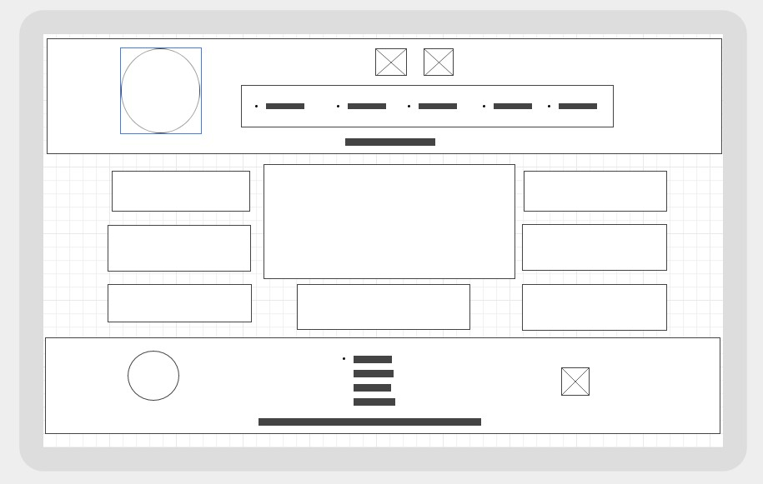

Figure 5 - Desktop/Laptop Layout

# Tablet (Portrait)

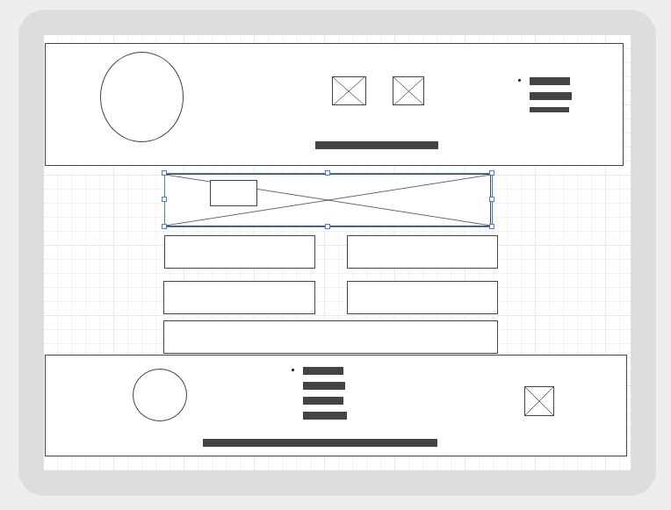

# Smartphone

