**Aritra Chatterjee**

**Address:** Plot Number 51, Hanuman Nagar,

Kondapur, Hyderabad 500084.

**Mobile:** 877 702 3674/801 778 1327 **email Id**: [richie.chatterjee31@gmail.com](mailto:richie.chatterjee31@gmail.com)

**External Link**: [GIT HUB Click me](https://github.com/richie312) [Online Profile click me](https://richie31.shinyapps.io/Resume/)

# **Professional Summary**

A professional in the field of Data Science and dev ops with more than 7 years of experience. Exposure in Deep Learning & ML Algorithms , Rest Api using web application framework like Flask, shiny. Exposure in Cloud Infrastructure Automation using cloud services like (AWS, Azure) including cloud formation. Continuous Development using Jenkins. Container building using docker and Unit Testing.

### Skillset

Languages: Python , R, Javascript and Html.

Database: Exposure in SQL, MySQL and PostgreSQL.

WebApplicationFramework: Flask and Dash (For Python). Shiny (for R),

Cloud Infrastructure & Components: AWS and Azure. Including Cloud Formation using cloud template. Exposure in components like EC2, S3, ECS, lambda, Cloud Watch logs. Good Exposure in boto3 and aws cli.

CI/CD Infrastructure: Jenkins (jenkinsfile) and Docker (dockerfile) for containerization.

Sample API Project With Swagger Docs and Proper Documentation.

Jenkin Link: <http://jenkins.nirvikalpa-projects.com/>

API Swagger: <http://api.nirvikalpa-projects.com/>

API Docs: <http://api.nirvikalpa-projects.com/docs>

### 2020/03 TO PRESENT: L&t InfotecH (Client S&P Global).

* Planned, designed and implemented automated framework which takes json template as an input and applies transformation on dataset to generate the report in json which finally feeds the predefined tableau dashboard.
* It’s a generic data-quality rule based framework deployed in aws elastic container service(on demand) triggered by AWS lambda upon cloud watch logs of predecessor job which provides system argument information in terms of rules.json location(s3 bucket), dataset location (db information) with other metadata details to this pipeline.
* Automated Data Quality Report on Timeliness, Consistency and Accuracy using ML algorithm (Outlier; Anamoly Detection). Automated report using jupyter notebook and output in html report. Legacy automated report system also deployed in aws ecs container. Pandas as data transformation library.

### 2019/09 to 2020/03: CAPITAL NUMBERS.

* Resume Match with Naïve Bayes Algorithm for automatic best match for any given resume. Rasa Chatbot Assistant for NOC Team, which help them to automate the internal customer service and Jira ticket Integration.
* Implemented Online Compiler for 14 different languages for inhouse project using sphere engine api, url creation (flask). Proper API Documentation(click on this link) using Rmarkdown/Swagger framework.
* Implemented Web Crawler with scrapy framework in python and scheduled the recrawl with cron jobs for specific domain frequency. Implementation is in Flask Framework.

### 2019/01 to Present: GSPANN Technologies.

* Involved in Chatbot project , develop components like automated text pop up with the help of word embedding. Intent redierection model.
* Complete Azure Automation including Scaling in and out for cost optimisation with Python. Aws automation using boto3 with Python.
* Developed Dash Application (Flask web application framework for python), which predict the features of an Image with Dress Type and other related feature like size, sleeve type. Use of Keras with CNN multi feature image classification.
* Colour Detection of an image(dress) using OpenCV by defining the colour ranges (256 different colours, by web scraping the RGB colour channels from specific URL and then converting to BGR). Use of library like beautiful soup(web scrape) and then building the model from scratch to detect the colour.

### 2018/07 to 2018/09: Colt India pvt ltd.

* Consulted the company on Customer Churn management in their network lease line connection business. Find out the main reasons for churn from multiple data source. Find out the spread of maximum churn location wise (Visual, network graph and leaflet). The work was confined to Descriptive and Predictive Analytics. Prescriptive Analytics was out of scope.
* Use of Random Forest and Deep Neural network (Simple, fully connected) with keras to predict the customer churn and help management to take appropriate action.
* Complete Descriptive and Predictive Statistical Reporting using markdown and in HTML format.
* Developed Shiny application with the help of leaflet to show the location wise dispersion of customer and their network. Use of network Graph and various other graphical representation.

### 2012-17: Analytics & Modelling Analyst; Accenture India

* Worked in Employee Attrition project, Workplace Survey Text Mining Project, IT Infrastructure Component like Database, Application Performance Project. Predicting the maximum occurrence of events/Incidents (probable) and resource allocation according to the spread of the events (given the resource constraint).
* **Exposure in Natural Language processing**. Was engaged in Text mining projects for over a period of 6 months in Accenture to help them to build automated Survey Reports. Feature engineering and Sentiment analysis. Tokenisation, n-gram, word cloud.
* **Algorithms / Techniques:** Image Recognition Using Tensorlfow(High End API: Keras), Naive Bayes, Cluster Method (K means and Hierarchical), Logistic Regression, Gradient Boosting Method , Regression, Time Series (ARIMA), Random Forrest, Decision Tree, Bagging.
* **Data Mgmt & Visualisation** R and Python. Shiny and Dash web application Framework.

Exposure to AWS web application hosting on linux operating system**.**

### **2011-2012:** IT OPeration ASSOCIATE; **IBM GPS India**

* Manage the infrastructure support team, multiple vendors, and Client. Delivery of agreed services to the client by utilizing Resource and Capabilities at an optimal level to maintain the ITIL standard aligned with Client requirement.

### **2009-2011:** Freelancer

* Worked as freelancer with Evelyn, Chegg India in the domain of academics writing. Worked with as freelancer with Upwork in the domain of Analytics.

### click on the images to open the application

Developed Web Application in Shiny, R & CSS

Model App Weather Application

[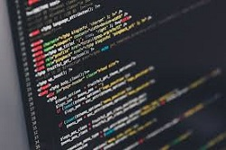](https://richiekalpa.shinyapps.io/Model_App/) [[](https://richienirvikalpa.shinyapps.io/WeatherApp/)](https://richienirvikalpa.shinyapps.io/WeatherApp/)

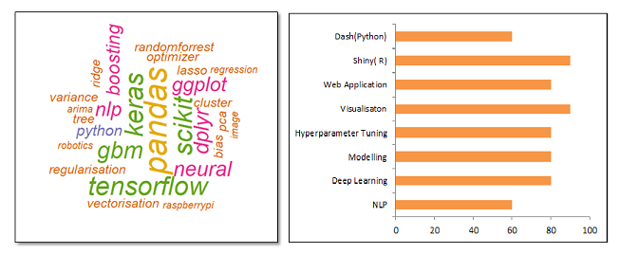

### **Personal Projects (2017 & 2018)**

Below are the articles which were posted on Analytics Vidya & R Codes. Won two of the competition, Hackathon(2018, Jan) and Blogathon (April, 2017).

[Comparative Stock Analysis-Vol 1 (Analytics Vidya)](https://www.analyticsvidhya.com/blog/2017/09/comparative-stock-analysis/)

[Comparative Stock Analysis-Vol2 (Analytics Vidya)](https://www.analyticsvidhya.com/blog/2017/10/comparative-stock-market-analysis-in-r-using-quandl-tidyverse-part-i/)

Ensemble Model App: Application involves almost automated predictive modelling using ensemble technique excluding the variable selection. It takes care of imputation, shows the correlogram, confusion matrix, and other statistical graph for the models. It can give you estimate that which model to use for the data quickly.

Weather Application: It uses the open weather API and data from National Oceanic Atmospheric Administration (NOAA) to show the temperature records and other statistical analysis on past historical weather data. Special Thanks to the NOAA for making the data available in the public domain.

Raspberry Pi (IOT) and Robotics: Made robot(motor car) with raspberry pi. It is deployed with temperature sensor, ultrasonic distance sensor and raspberry pi cam module. This robot can move wirelessly. The program to control the robot is written in python. Next move is to write function in python in order to make the car self driven.

The Robot has ability to detect object and tell the distance. It also shows the temperature and humidity data. The robot is also deployed with cam module which enables it to control it wirelessly. All functions are written in python.

### **Academics and Job Time Line**

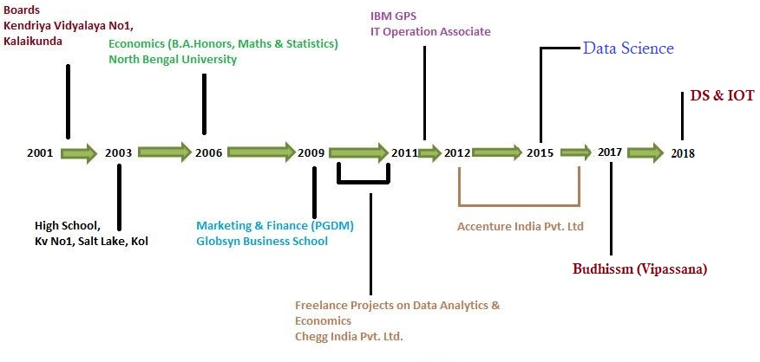

|  |  |
| --- | --- |
| **GAP** | **Reason** |
| 2009/03 to 2011/04 | Worked as Freelancer with Chegg India, Evelyn, myWriting,Netscribe in academic writing(Economics, Finance and Statistics undergraduate courses). |
| 2017/03 to 2017/06 | Studies in Budhissm/Vipassana Practice. This involves extensive travelling and time allocation (each course 11 days). So Far 7 Courses. Also involved in trekking. Worked in Green Trail Project and as Assistant Trek leader of IndiaHikes. More Information is provided on last page of the resume in Personal Details Section. |
| 2017/11 to 2018/06 | Machine Learning Studies. During this time also involved in Freelancing most involved Shiny Application Development work, Build Robot with raspberry pi. |

### **CertificatioN**

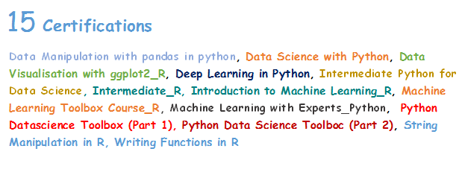

### **Special Interest: Buddhism**

**2017 Feb to 2017 Dec**: Studies in Theraveda Bhuddhism(Hinya Tradition). Took time off for intense meditation in order to understand the subtler aspects of mind and its direct effect on human behavior.Deeper study in mind and matter phemenon.

Went to remote meditation (Vipassana) camp across the country in order to study.

Dhamma Shikkara (Mcleod Ganj), Dhamma Ganga(Kolkata),Dhamma Sikkim (Near Gangtok), Dhamma Sineru (Upper Samdong, Sikkim), Dhamma Bodhi (BodhGaya),

Dhamma Sringar (Kathmandu, Nepal)

### **Personal Detail**

**Date of Birth**- 31st October 1985

**Age**: 33 years & 4 months.

**Email Id**: [richie.chatterjee31@gmail.com](mailto:richie.chatterjee31@gmail.com), [richie.nirvikalpa@gmail.com](mailto:richie.nirvikalpa@gmail.com)

**PAN Number**: APTPC7093M

**Voter ID**: ARO2397909

**Passport**: P933859

### **Hobbies**

**Trekking and interest in robotics**

* Trekked and climbed Stok Kangri (which is considered as the highest non-technical summit in India) in July 2016. Altitude is 6150 mtrs (20678 Feet)
* I have trekked to Goechala (16000 feet) to witness the mighty Kanchenjunga in 2015.
* Trekked in Roopkund in 2017.
* Green Trail internship with India Hikes.
* Kedarkantha Peak in December 2020.
* For robotics project please visit personal project section.