|  |  |
| --- | --- |
|  |  |

Streamlining College Cafeteria Operations: A Web  
Portal for Efficient Bulk Order Management

Mritunjay Ojha1, Christine John2, Tacita Thomas Eluvathingal3, Aafreen Khan4, and  
Serena Albert5  
1-5Fr. Conceicao Rodrigues Institute of Technology, Vashi, Navi Mumbai, Maharashtra  
400703

Email: [mritunjay.ojha@fcrit.ac.in](mailto:mritunjay.ojha@fcrit.ac.in), [john.christine737@gmail.com](mailto:john.christine737@gmail.com), [tacitathomas06@gmail.com](mailto:tacitathomas06@gmail.com), [khan.aafreen2611@gmail.com](mailto:khan.aafreen2611@gmail.com), [serenaalbert526@gmail.com](mailto:serenaalbert526@gmail.com)

**Abstract**— Efficient management of bulk orders in college cafeterias is paramount for ensuring timely service and customer satisfaction. In this paper, we address the challenge of manual and time-consuming order requisition processes by presenting a web-based solution tailored for cafeteria operations. Our system automates the process of placing orders, simplifying the steps involved in requisitioning bulk orders, such as form filling and approval procedures. It streamlines menu planning by dynamically generating daily menus based on requisition data. Additionally, it automates the billing process by generating invoices for cafeteria transactions, reducing manual calculations and expediting the billing cycle. Rigorous testing, including unit, integration, system, and user acceptance testing, validates the system's functionality and reliability. Our findings demonstrate significant improvements in order processing time and accuracy, leading to enhanced operational efficiency and user satisfaction. This research contributes valuable insights into the design and implementation of web-based cafeteria management systems, offering practical solutions for improving service delivery in educational institutions.

Index Terms**—** **Cafeteria management, Operational efficiency, Web-based portal and Performance optimization.**

I. Introduction

Efficient management of bulk orders in college cafeterias poses a significant challenge, often resulting in inefficiencies and delays in service delivery. The current manual process of placing bulk order requisitions involves cumbersome steps, including form filling, approvals from department heads, and coordination with the principal. This antiquated process not only consumes time but also introduces the risk of errors and delays, thereby hindering cafeteria operations.

In response to this challenge, this paper proposes the development of a web-based bulk order management system tailored specifically for college cafeterias. The primary objectives of this system are threefold: to streamline the requisition process by providing a user-friendly web portal for creating and managing bulk orders, to automate event management through integration with a calendar system, and to empower administrators with tools for better planning and preparation.

Named the "Agnel Cafeteria Portal," the envisioned system aims to revolutionize cafeteria operations by offering a seamless digital solution for bulk order requisitions. By leveraging technology and automation, the portal seeks to enhance efficiency, accuracy, and customer satisfaction in cafeteria services [1]. This paper provides an in-depth exploration of the design, implementation, and testing of the Agnel Cafeteria Portal, highlighting its potential to transform the way college cafeterias manage bulk orders and deliver exceptional service during college events.

II. Literature Review

Following is a table depicting a comparison of research papers and related works:

Table I. Literature survey comparison table

|  |  |  |  |
| --- | --- | --- | --- |
| SR NO. | Paper Title | Author’s Name | Functionalities |
| 1. | A Model for the Efficient Implementation of Portals [1] | Abdullah S. et al. | Proposed a model for the complete implementation and service delivery of portals. The model has two parts that describe the overall performance and the entire framework of portal implementation |
| 2. | Determinants Affecting User Satisfaction with Campus Portal Services in Korea [2] | Hyung Seok Lee et al. | Assessed the relationships between end-user satisfaction with campus portal services |
| 3. | Usability Evaluation of a University Portal Website [3] | Barbara S. Chaparro | University faculty, staff, and student users were asked  to complete representative search tasks and provide feedback on the portal's  usability. |
| 4. | Design of a Multifunctional Web Portal for College Departmental Activities [4] | Prof. Omkar. S. Vaidya | Sharing of all the soft copies of lecture notes, all available useful e-books of every subject, all subject's old question papers, syllabus copies, practical titles and all the material that any student wants during his engineering. |
| 5. | Placement Management System for Campus Recruitment [5] | Ajeena Sunny et al. | Find the list of eligible students attending the drives. manages the details of student records, placement training, and different placements happening in and out of the college. The student can upload their information. |
| 6. | Usability Testing of a Customizable  Library Web Portal [6] | Steve Brantley et al | The usability study assessed three key areas:   * Customization of a personal library web page. * Comprehension of resource categories established by librarians. * Effective management of discipline-specific content within the portal. |
| 7. | A Survey Paper on College Community Web Portal [7] | Subhash Nalawade et al. | AI-based book listing and student community-based web application. Buying and selling books Analysis of attendance and results. |
| 8. | Online Food Ordering System for College Canteen [8] | Rupali B. Kale | Android application for the canteen, with features like View menu, Order food, Payments, LED display and QR code scan. |
| 9. | Implementing Customizable Online Food Ordering System Using Web Based Application [9] | Varsha Chavan et al. | Food Pre-Order System for Dine-In using Web Based Application. |
| 10. | Canteen Automation System with Payment Gateway [10] | Prashant Avhad et al. | An automated web-based system which can maintain, manage and process orders of customers in a speedy way. |
| 11. | A Framework for Modernization of College Utilities [11] | Veom Nohria et al. | Web portal to handle canteen and stationery. |
| 12. | Web Based Attendance Management System [12] | Sahar Hassan et al. | Web portal for attendance which provides monthly and overall attendance data analysis. |
| 13. | Automation of Students Information System Using PHP [13] | Dr.N. Ranjith | Web portal for overall student information:   * Automated result analysis. * Tracking grade and performance. * Placement information |
| 14. | Design of an Academic Wed portal providing E-facilities [14] | Chaitrali S. Dangare et al. | Development of web portal for E-Submission, E-Alerts, E-Learning, E-Examination, E-Records, E-Result. |
| 15. | Online College Portal [15] | Tejaswini Chavan et al. | Simple interface for the maintenance of student-faculty information also the creation and management of accurate, updated information regarding a student's academic career. |
| 16. | Next Generation Web for Alumni Web Portal [16] | Marmik Patel et al. | Three types of users can register themselves into the alumni portal, (1) Alumni (2) Students (3) Faculty. Provides one-click access to the student’s profile, job portal, newsletter, Events, alumni activities, achievements, galleries.  Faculties can post articles about different innovations, advancement of an item etc. |

III. System Architecture and Design

## A. Description of the System Components

The Agnel Cafeteria Portal comprises several essential components, each serving a specific function to streamline cafeteria operations efficiently:

1. Requisition Management Module: This module empowers users to efficiently handle bulk order requisitions. Users can create new requisitions, view existing ones, make necessary edits, and save requisitions for future reference.
2. Menu Planning Module: The Menu Planning Module plays a crucial role in optimizing cafeteria operations by automating the generation of daily menus. It leverages requisition data to dynamically create menus tailored to the available ingredients and customer preferences.
3. Billing and Invoicing Module: This module automates the billing process for cafeteria transactions, providing a seamless and efficient way to generate invoices. It consolidates information from various orders and transactions to produce single or combined bills, simplifying financial management for both cafeteria staff and customers.
4. Calendar Integration: The Calendar Integration feature synchronizes approved requisitions with a calendar system, enabling efficient event scheduling and resource allocation. By automatically updating the calendar with relevant information from approved orders, cafeteria staff can effectively plan and coordinate activities such as meal preparation, staffing, and event setup.
5. Email Reminder System: The Email Reminder System enhances communication and facilitates timely preparation and delivery of orders by sending automated email reminders for upcoming events and requisition deadlines. This proactive approach helps users stay informed about important dates and deadlines, reducing the risk of missed or delayed orders.

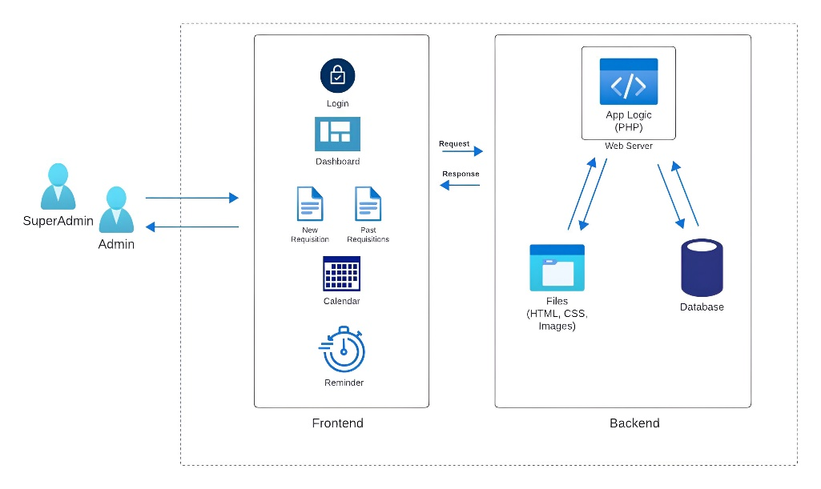  
Figure 1. Architecture Diagram

## B. User Interface Design Principles

The user interface of the Agnel Cafeteria Portal has been meticulously crafted to prioritize simplicity and intuitiveness [2]. Leveraging principles of user-centered design, the interface ensures maximum ease of use, catering to users with varying levels of technical proficiency. Special attention has been given to designing clear navigation paths, intuitive form layouts, and prominent call-to-action buttons [3]. Furthermore, the user interface has been specifically tailored to accommodate users with zero technical knowledge, ensuring accessibility and usability for all stakeholders involved in cafeteria operations. By adhering to these design principles, the Agnel Cafeteria Portal aims to enhance user satisfaction and efficiency in managing bulk orders within college cafeterias.

IV. Implementation

The Agnel Cafeteria Portal caters to the needs of two distinct user roles: admin and super admin, with the latter possessing elevated privileges for system management and oversight [4]. Among its core functionalities, the portal facilitates streamlined requisition management, allowing users to create, view, edit, and save bulk order requisitions seamlessly. Additionally, the system boasts a timetable generation feature, enabling administrators to generate daily menus based on requisition data. Furthermore, the portal automates the billing process, generating single or combined bills for cafeteria transactions. To ensure timely event management and user engagement, an email reminder system is integrated, sending personalized reminders for upcoming events, requisition deadlines, and order modifications.

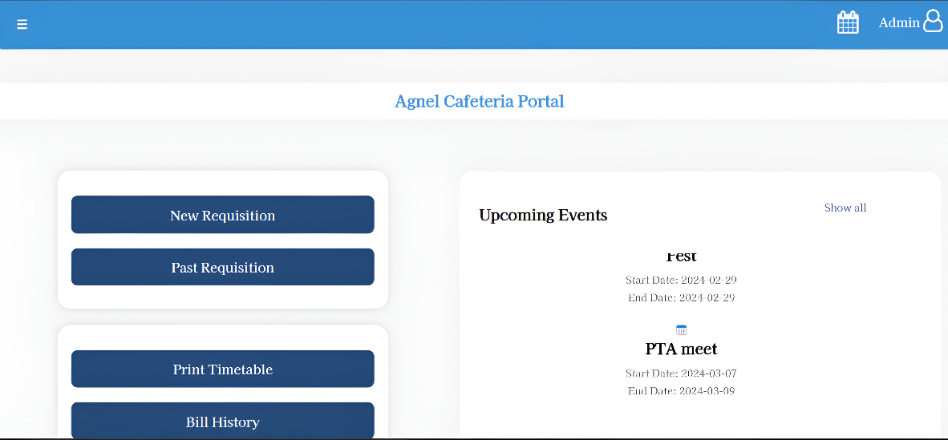

## Figure 2. Dashboard

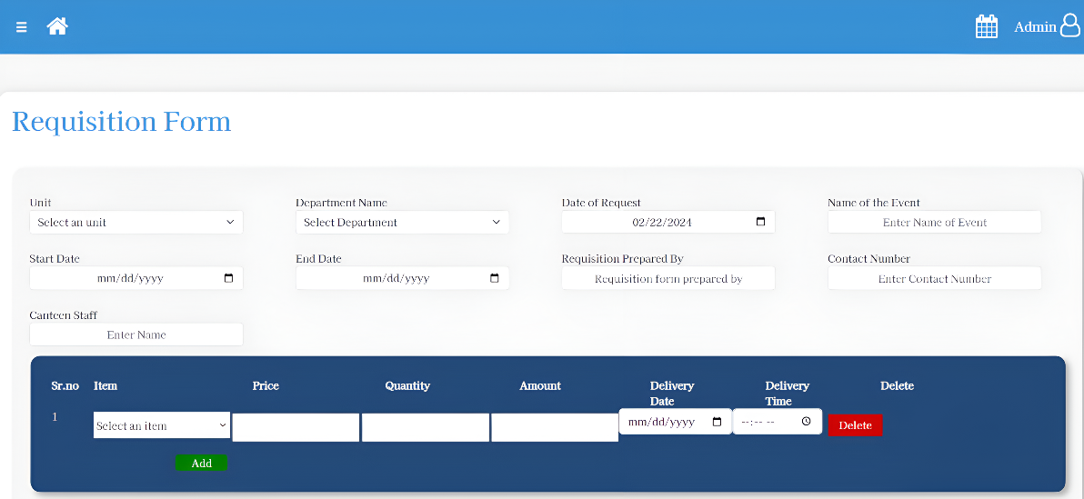

## Figure 3. New Requisition

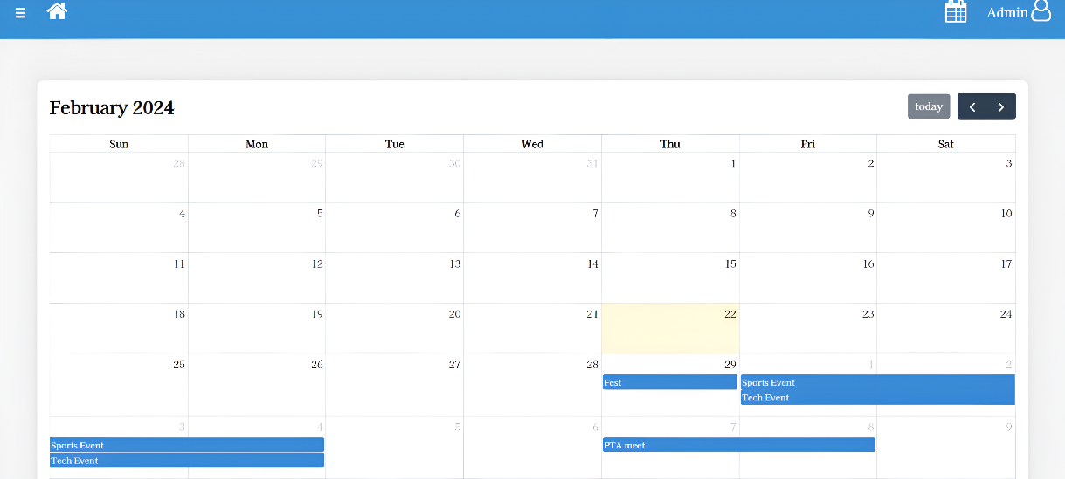

## Figure 4. Calendar

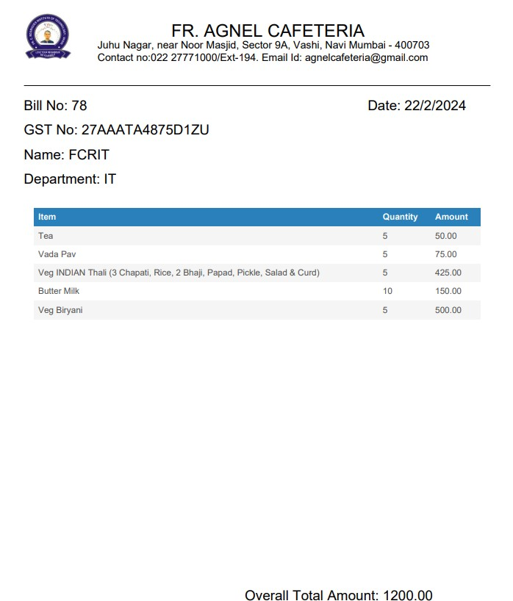

## Figure 5. Bill Generation

## 

The implementation of the Agnel Cafeteria Portal leverages a blend of technologies and frameworks, including HTML, CSS, JavaScript, PHP, and PHPMailer, to deliver a robust and user-friendly system. Key features and functionalities are meticulously designed and implemented to meet the specific requirements of cafeteria operations, providing a seamless experience for users. Throughout the implementation process, various challenges were encountered, ranging from technical complexities to user interface design considerations. However, with diligent problem-solving and iterative development approaches, these challenges were successfully addressed, resulting in a functional and efficient cafeteria management system.V. Performance Optimization Techniques and Testing Methodology

To optimize the performance of the Agnel Cafeteria Portal, several techniques have been implemented [5]. First and foremost, secure coding practices have been employed to enhance system security and efficiency. This includes the use of prepared statements and protection against SQL injection attacks, mitigating the risk of unauthorized access and data corruption. Additionally, rigorous data validation techniques have been implemented to ensure the integrity and reliability of user inputs, further enhancing system robustness. Furthermore, asynchronous processing techniques have been employed to improve system responsiveness and scalability. By executing tasks asynchronously, the system ensures that processes are carried out in the correct order, minimizing bottlenecks and maximizing resource utilization. These performance optimization techniques collectively contribute to the seamless operation and enhanced user experience of the Agnel Cafeteria Portal.

The testing methodology employed for the Agnel Cafeteria Portal encompasses a comprehensive approach to ensure the reliability and functionality of the system [6]. The testing process begins with an overview of the system's requirements and objectives, followed by the design and execution of test cases tailored to validate  
each aspect of the system's functionality.

## VI. Results and Analysis

The Agnel Cafeteria Portal underwent rigorous testing to evaluate its performance, functionality, and efficiency. Performance metrics and benchmarks were established to measure key aspects of system operation, including response times, throughput, and resource utilization. Analysis of testing results revealed significant improvements in system performance compared to traditional/manual processes. Response times were notably reduced, with tasks such as requisition management and menu generation completed in a fraction of the time previously required. Throughput also increased, allowing the system to handle a higher volume of concurrent users and requests without degradation in performance. Moreover, the system's reliability and stability were confirmed through extensive stress testing and fault tolerance analysis.

Comparison with traditional/manual processes highlighted the transformative impact of the Agnel Cafeteria Portal on cafeteria operations. Manual tasks such as requisition management and billing, which previously required significant time and effort, were now automated, resulting in streamlined processes and improved accuracy. The portal's integration with a calendar system and email reminder functionality further enhanced event management and communication, ensuring timely preparation and delivery of orders.

## C. User Feedback

The feedback survey indicates that users find the portal user-friendly (rated 4 out of 5). However, opinions on ease of use are divided: Some respondents rated it as 4 out of 5, while others gave it a 5 out of 5.  
  
  
 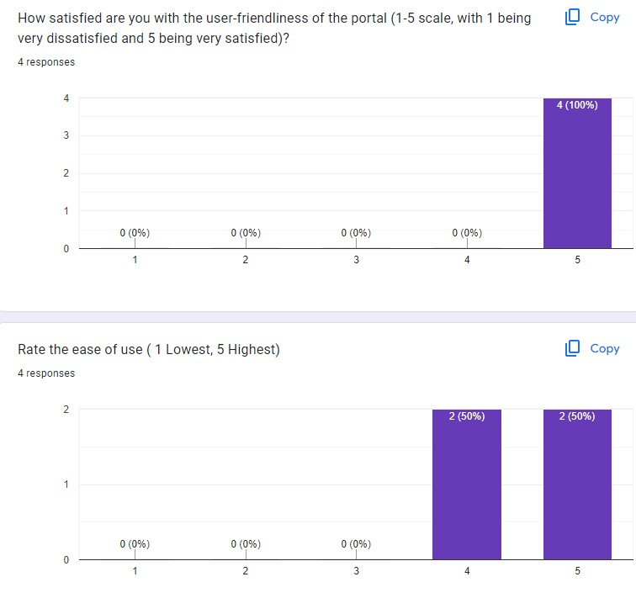 Figure *6*. Bar Chart Showing User Response

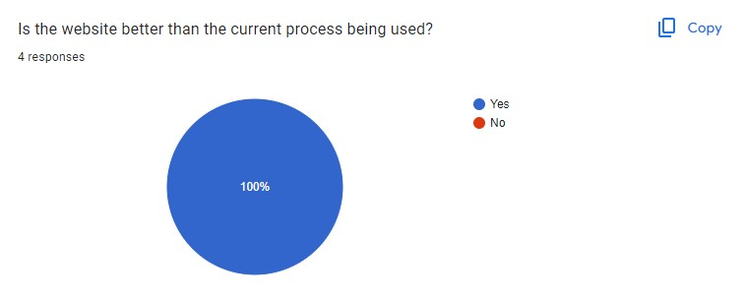  
Figure *7*. Pie Chart Depicting User Feedback

All respondents believe that the website is better than the current process. This unanimous agreement suggests that the website has been well-received. In summary, while users appreciate the user-friendliness, ensuring consistent ease of use has significantly enhanced their overall experience.

## VII. Conclusion

In conclusion, the Agnel Cafeteria Portal represents a significant advancement in cafeteria management systems, offering a comprehensive solution for bulk order management and event coordination. The results of testing and analysis demonstrate the system's effectiveness in improving operational efficiency, reducing manual effort, and enhancing user satisfaction. By automating key processes and leveraging technology, the portal not only addresses existing challenges but also sets a new standard for cafeteria operations in educational institutions.

Moving forward, the contributions of this research to the field of cafeteria management systems are significant. The Agnel Cafeteria Portal serves as a model for future developments in the industry, showcasing the potential of technology to revolutionize traditional processes and enhance service delivery. Potential future research directions include further optimization of system performance, integration of additional features such as inventory management and analytics, and exploration of user-centric design principles to enhance usability and accessibility. Overall, the Agnel Cafeteria Portal represents a promising advancement in cafeteria management technology with far-reaching implications for the future of food service operations in educational institutions.

##### References

1. A. S. Al-Mudimigh, Z. Ullah, and B. Shahzad, "A model for the efficient implementation of portals," Computer Engineering and Technology (ICCET), Jan. 2010, doi: 10.1109/iccet.2010.5485596.
2. H. S. Lee, Y. H. Choi, and N. O. Jo, "Determinants Affecting User Satisfaction with Campus Portal Services in Korea," The Journal of Internet Banking and Commerce, vol. 14, no. 1, pp. 1–18, Jan. 2009, [Online].
3. Chaparro, Barbara, "Usability Evaluation of a University Portal Website," 2008.
4. Vaidya, O., and Bakshi, T. (2017). Design of a Multifunctional Web Portal for College Departmental Activities. International Research Journal of Engineering and Technology.
5. Ajeena Sunny, Aneena Felix, Angelin Saji, Christina Sebastian, Praseetha V.M, "Placement Management System for Campus Recruitment," International Journal of Innovative Science and Research Technology.
6. S. Brantley, A. Armstrong, and K. M. Lewis, "Usability testing of a customizable library web portal," College \& Research Libraries, vol. 67, no. 2, pp. 146–163, Mar. 2006, doi: 10.5860/crl.67.2.146.
7. Subhash Nalawade, Diksha Rajput, Kushal Patel, Aryakumar Patel, Rutuja Bansode, "A Survey Paper on College Community Web Portal," International Journal for Research in Applied Science \& Engineering Technology.
8. R. B. Kale, R. K. Balwade, and V. B. Gawai, "Online food ordering system for college canteen," SAMRIDDHI: A Journal of Physical Sciences, Engineering and Technology, vol. 12, pp. 64–68, Nov. 2020, doi: 10.18090/samriddhi.v12is2.13.
9. V. S. Chavan, P. Jadhav, S. Korade, and P. Teli, "Implementing Customizable Online Food Ordering System Using Web Based Application," International Journal of Innovative Science, Engineering \& Technology, Jan. 2015, [Online].
10. P. Avhad, H. Bhanushali, K. Bhatt, and M. Rathod, "Canteen Automation System with Payment Gateway," Social Science Research Network, Jan. 2020, doi: 10.2139/ssrn.3568597.
11. Nohria, V., Maurya, R., Suraj, S., and Jain, S. P. (2023). A Framework for Modernization of College Utilities. 2023 International Conference on Computational Intelligence, Communication Technology and Networking (CICTN).
12. Hassan, Sahar and Zubair, Mohd. (2015). Web-based Attendance Management System.
13. Ranjith, D. (2023). AUTOMATION OF STUDENTS INFORMATION SYSTEM USING PHP. Dogo Rangsang Research Journal, 13(02), 94–97.
14. Yalagi, Pratibha and Chaitrali, and Dangare, Chaitrali. (2013). DESIGN OF AN ACADEMIC WEB PORTAL PROVIDING E-FACILITIES. International Journal of Computer Science Engineering and Information Technology Research (IJCSEITR). 3. 85-90.
15. Tejaswini Chavan, Deb Dutta, Michelle Gomez, and Alvino Vaz, “Online College Portal,” \textit{International Journal of Current Engineering and Technology}.
16. M. M. Patel, D. Rami, and M. Soni, “Next generation Web for alumni web portal,” in \textit{Lecture notes on data engineering and communications technologies}, 2019, pp. 179–189. doi: 10.1007/978-3-030-28364-3\_16.
17. A. Kamma "A Study On Online College Admission Management System "International Journal of Research in Engineering, Science and Management Volume-3, Issue-5, May-2020.
18. Sharma, P. et al. (2016). College Automation System. International Journal for Innovative Research in Science and Technology.
19. R. Shewale, P. Chodhary, S. Powale, S. Chimankar, and A. Umale, “Training and placement web portal,” {Research Journal of Science and Technology}, vol. 7, no. 2, p. 111, Jan. 2015, doi: 10.5958/2349-2988.2015.00013.3.