NAVICAT SETUP DATABASE CONNECTION

Click on Connection and Select POSTGRES SQL :

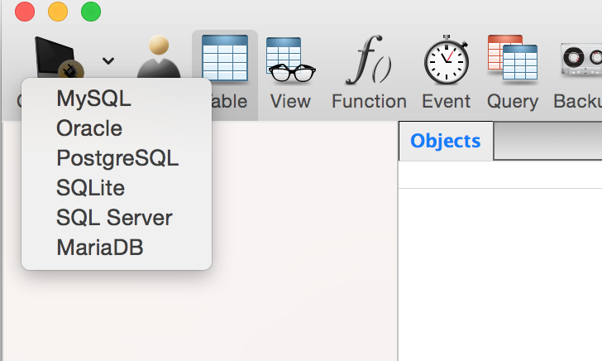

Next Enter Following Details in General Tab of connection

Hostname : vital.poly.edu

Port :5432

Default Database: vlab

Username :postgres

Password: xxxxxxxx

Select Save Password

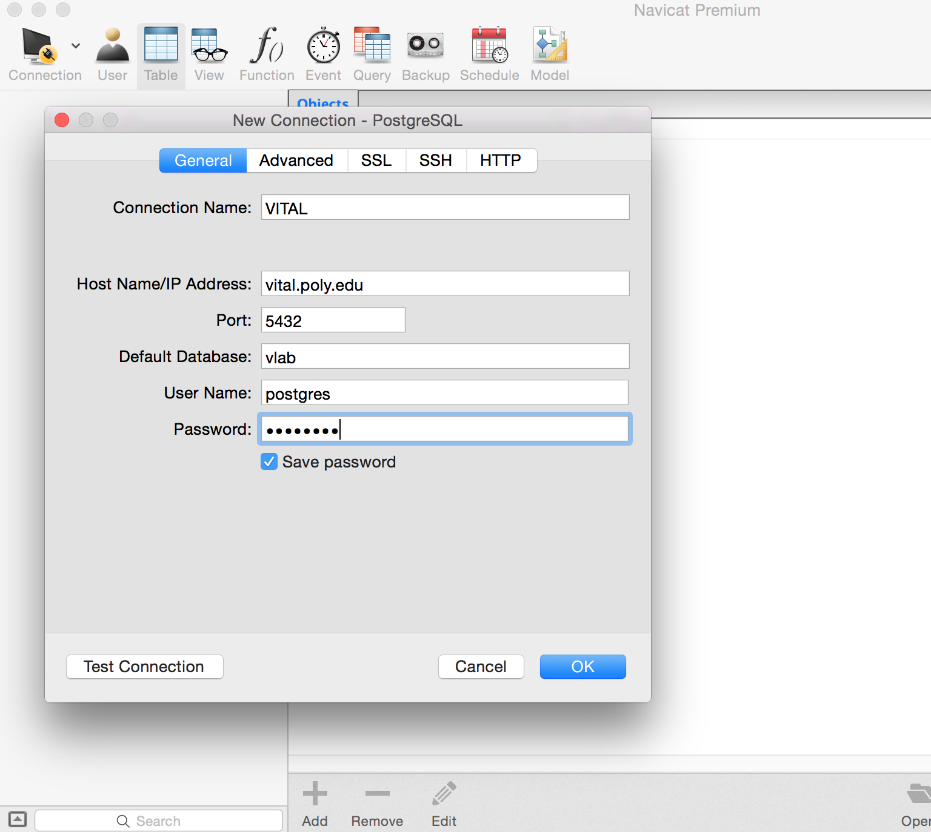

Go to SSH tab and enter following details

Hostname : vital.poly.edu

Port 59990

Username /Pass:[Your usename/Pass]

Select save password.

