Psychopomps of Soluna

Richard Jiang

9/24/2016

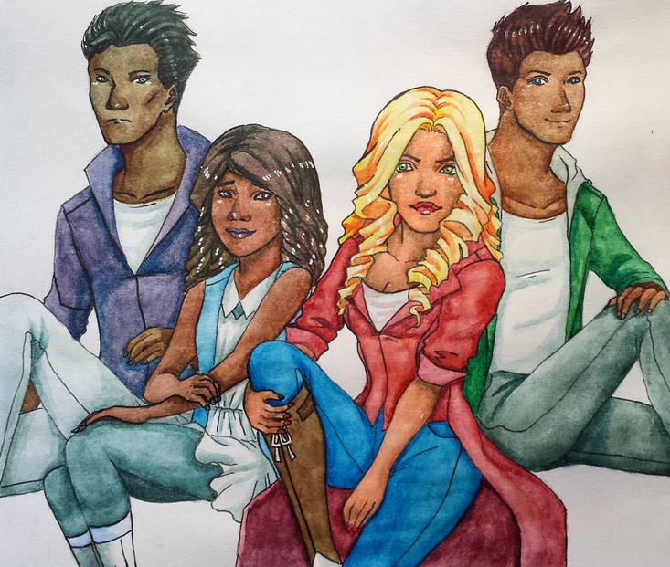

Table of Contents

1. Story/Theme Information 3
2. General Look and Feel 3
3. Summary of Gameplay 4
4. Information Architecture and mock-ups
5. Specification of Specific Features 5
6. Timeline to Complete 7
7. Concept Art 8

**Game Summary**

Psychopomps of Soluna is a tactical RPG using a grid-based system where you control characters and move them through a battle field to defeat enemies. Characters have stats and skills to aid them in battle. The battle system is turn-based and the order of turns is randomly selected during the start of a room transition.

**Story/Theme Information**

Soluna is a city that sits on the fault-line between the afterlife and Earth. Souls travel here in order to pass on. However, the area surrounding Soluna is full of corrupt energy. As a result, souls who do not move on in time will eventually corrupted, becoming blood-thirsty ghosts. Psychopomps, people imbued with special powers and weapons were created to make sure their numbers do not swell. The game begins with Claretta Martone, the main character and a Psychopomp, and the other Psychopomps as they go up against four powerful and recently awakened ghosts. The target audience is people around 15 and up.

**General Look and Feel**

The game will be a tactical roleplaying game like Fire Emblem. The game is set on a grid-based environment and take turns against the game AI in order to beat the game. It is basically like a game of chess, where the player and enemy both have characters that they can move around with unique states and abilities.

The art style is semi-realistic with a stylized approach. The sprites and backgrounds of the game itself will look 8-bit and have a retro-looking style. The story takes place in modern times, but the ghosts may look more historical designs since some of them have been dead for a while and just couldn’t move on. They will look very unique and surreal.

Art style -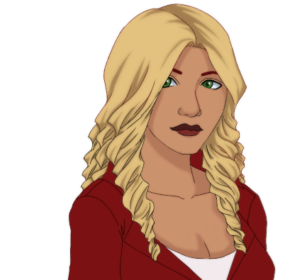

In-game art style - 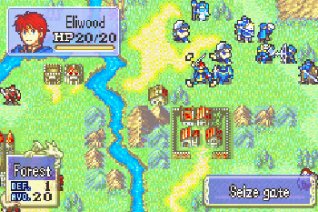

**Summary of Gameplay**

When the game starts up, the player will be brought to a title screen and prompted to hit a button to start the game. When the button is pressed, the player will be brought to the save file screen and asked if they wish to create a new one.

The game will start and the opening cut-scene will start. Then the player will be brought to the overview room, where the game-board is. The level starts and the player’s characters and the enemies will be assigned turn orders. When it is one of the player character’s turn, the player will be prompt to perform an action such as move or attack (if the character is in range). The same goes for the enemy’s turn.

When it is the player’s turn, they can select the character and a menu with options will pop up. The character can move, rest, attack or skip turn. To beat the level, the player will be given a certain task, such as finding the boss enemy and killing it or getting rid of all the enemies on screen. 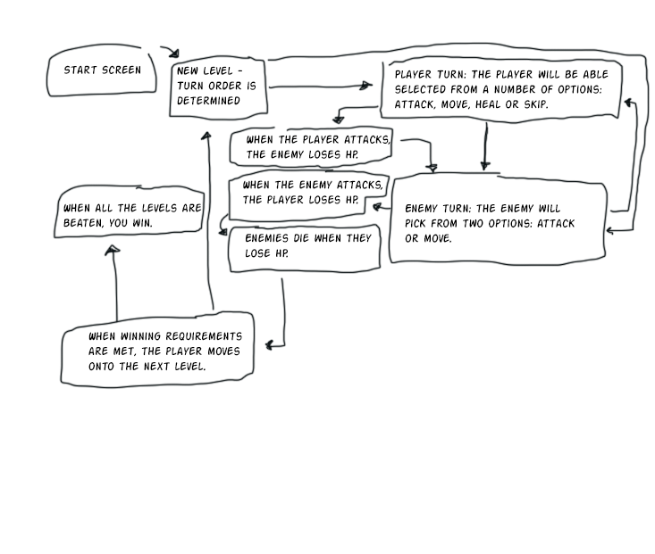

**Specification for Specific Features**

Grid-Based System

* The characters will move through a grid-based system, meaning each step is considered one 64 by 64 pixel square.
* Terrain – Different types of terrain will be implemented if there is time. Terrain will cause trouble for the players and monsters such as slowing them down or poisoning them. Players should use these to their advantage.

Turn Order

* At the start of the level, a turn order will be initiated, with the faster characters given priority movement over the slower ones.

Player Characters

* Character Menu – When a character is selected, a menu with all the options for the character will appear. The plater will be able to check the stats and health of the character.
* Movement – When it is the player character’s turn and they are selected with a left-click, an area indicating how much the character can move will appear and when any part of that area is right-clicked, the character will move there.
* Attack – When a selected player character is close in range to an enemy, they will be allowed to attack. Player will select the attack option then left-click the enemy to attack it.
* Stats – The player character will be given different stats such as Hit Points, Attack, Defense, Speed, Magic, and Magic Resist.

Enemies

* AI – Enemies will have simple AI so that they can move and attack the player characters.
* Movement - Enemies have the same movement as player characters. When it is their turn, they will move a selected number of steps in an area just like the player characters.
* Attack – When an enemy is in range and it is their turn they will attack a randomly selected player character.
* Stats – Enemies will have the same stats as the player characters, as in they will have Hit Points, Attack, Defense, Speed, Magic and Magic Resist.

**Timeline**

Weekly Breakdown of Tasks

* Week 1
  + Decide on idea and concept.
  + Pick a genre of game based on that concept.
* Week 2
  + Concept art starts.
  + Finalize concept.
* Week 3
  + Begin programming character movement and game board mechanics.
* Week 4
  + Program enemy AI and terrain.
  + Finalize art and sprites.
* Week 5
  + Refine game.
  + Create cut-scenes
* Week 6
  + Play-test
  + Refine game
  + Finish art and sprites. If there is time, bonus costumes will be implemented.

**Concept Art**

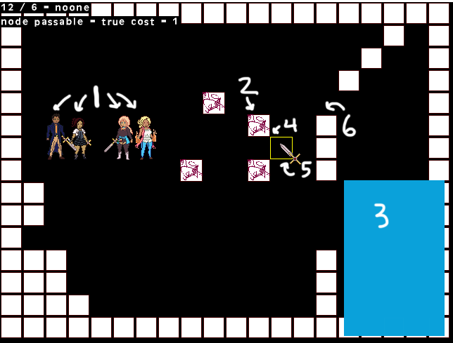

Game Interface and UI.

1. Player Characters
2. Enemies
3. Character Menu (options for Attack, Movement, Rest, and Skip will be added)
4. Grid Square
5. Cursor
6. Walls that are non-passable.

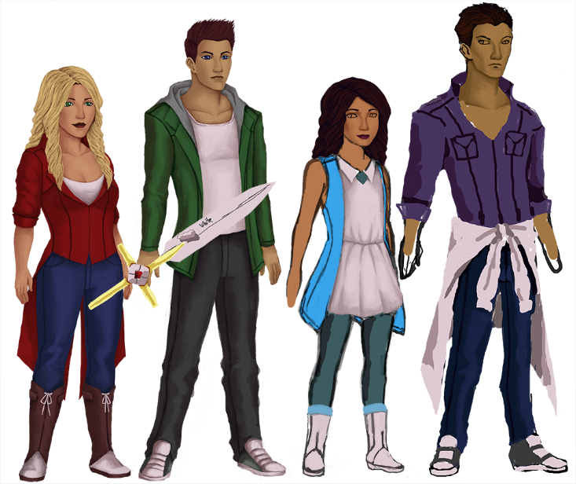

The four Psychopomps (from left to right): Claretta, Freed, Marisol, Roland.

Sprite Base (Female)



Boss Ghost Concept Sprites