



   KSS



Promoting Positive Relationships Policy

Contents

Our School Charter , Nurture and ABC page 3
RA vision page 4
RQ conversations and questions page 5
GCC PPR policy and whole school structure page 6
Department strategies page 7
Meeting Learners’ Needs Through Staged Intervention page 8
PPR in the classroom page 9
Key Classroom Strategies: 1. Phone Policy page 10
Phone policy: Scottish Government Guidance page 11
Key Classroom Strategies: 2. Target Setting; 3. Thirty second
intervention; 4. Thinking Space page 13
Seemis referrals page 14
Monitoring and support page 15
Wider School Support pages 16-18
Appendix 1: Staged Intervention Framework and Triangle page 19
Appendix 2: Transition Meeting Minutes page 20
Appendix 3: Corridor Card for Pupils page 21
Appendix 4: Seemis referrals support page 22
Appendix 5: Department Support Card page 23
Appendix 6: PTPC Weekly Support Card page 23
Appendix 7: PTPC Daily Monitoring Card page 24
Appendix 8: DHT Daily Monitoring Card page 24
Appendix 9: Thinking Space Reflection Sheet – option 1 page 25
Appendix 10: Thinking Space Reflection Sheet – option 2 page 26
Appendix 11: Thinking Space Reflection Sheet – option 3 page 27
Appendix 12: Supporting Success at KSS page 28
Appendix 13: Faculty PPR Pyramid page 29
Appendix 14: Thirty Second Intervention Script page 30
Appendix 15: PPR Timeline 2024-26 page 31
Appendix 16: PPR Strategy Group Members 2024-25 page 32

Our School Charter

Our school charter has been developed in consultation with pupils, parents and staff. The charter takes into account the key principles of nurture and seeks to ensure that staff and young people are able to learn together, work together and succeed together.


- Be kind
- Give our best
- Be honest
- Respect others
- Be responsible
- Include everyone

Across the school, we support young people to behave in a way that aligns with the charter and to understand the importance of working together to create a school where everyone feels safe and welcome and is able to reach their full potential.

Nurture

As a Unicef Rights Respecting School, we strive to create a place where the values of the school reflect our commitment to children’s rights and where all staff and partners take responsibility for developing effective relationships.

The Six Principles of Nurture:

- Children’s learning is understood developmentally.
- The classroom offers a safe base.
- Nurture is important for the development of self-esteem
- Language is understood as a vital means of communication
- All behaviour is communication
- Transitions are significant in the lives of children

All Behaviour is Communication and Restorative Approaches

All staff are trained to understand that All Behaviour is Communication (ABC) and to work alongside young people to resolve issues. We are currently implementing ways to ensure Restorative Approaches (RA) support young people to address conflict and seek resolution.
VISION

All staff understand the theory behind Restorative Approaches, and feel confident implementing this at the heart of every interaction in our school. Every young person, staff member, and parent/carer feels valued, heard, and respected.

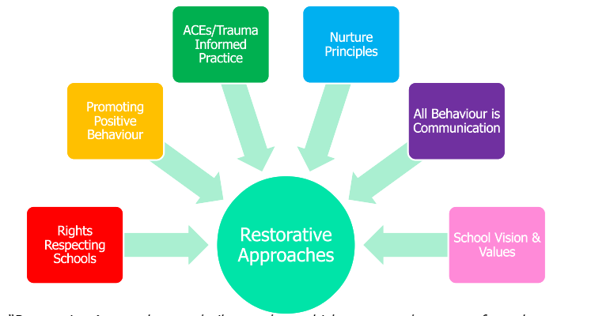

WHY IS THIS IMPORTANT?

“Culture and ethos, linked to shared vision and values of an education setting, are key determinants in maintaining positive relationships and wellbeing. The mental, emotional, social, and physical wellbeing of everyone within a learning community can be positively developed by fostering a safe, caring, supportive, purposeful environment that enables the development of relationships based on mutual respect. Learning through the health and wellbeing aspects of the curriculum reinforces and develops the knowledge and understanding, skills, capabilities, and attributes which children need for mental, emotional, social, and physical wellbeing now and in the future. Wellbeing is a key determinant for attainment.”
Promoting Positive Relationships and Behaviour in Educational Settings – Education Scotland
“Restorative Approaches are built on values which separate the person from the behaviour. They promote accountability and seek to repair any harm caused in a situation.”

Restorative Conversations
1. Everyone has a different perspective on any given experience or issue.
2. Thoughts influence feelings.
3. Conflict and wrongdoing impact on people and cause harm - this harm must be repaired.
4. In the event of harm being caused, everyone will have similar needs.
5. Those affected or harmed need to find a way forward for themselves.
These key principles underpin every restorative conversation by emphasising relationship building, accountability and community. Understanding these principles is paramount to a meaningful conversation between those who caused harm and those who harm has been caused to, and allow those involved to reflect and share their experiences building empathy and promoting healing.
A restorative conversation can take place at any time in response to any situation where ‘harm’ has been caused. A restorative conversation can take place anywhere in the school that is convenient at that time. Ideally, a room in school should be identified that is open, airy, quiet, welcoming and comfortable.
As Restorative Practices are a whole-school approach, they can be facilitated by anyone within the school community who has been trained in this approach. This can include: Senior management, Class Teachers, Support Assistants, Janitor(s), Dinner School staff and the young people themselves through Peer Mediation. Parents should always be involved in the restorative process where necessary.
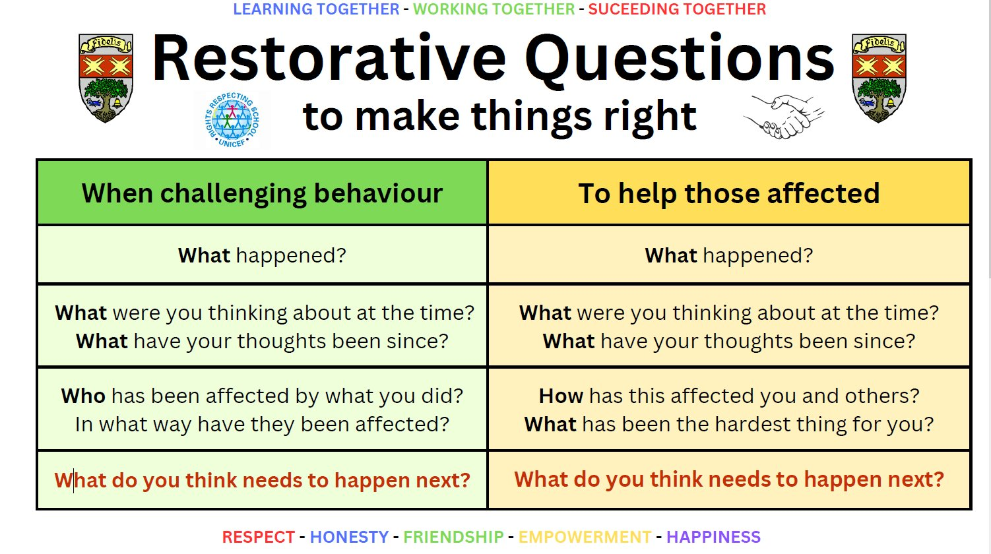

Glasgow City Council’s Promoting Positive Behaviour Policy

By committing to promoting the Knightswood Secondary School Charter and the Nurture principles, we are able to uphold the key concepts outlined in Glasgow City Council’s Promoting Positive Behaviour Policy:

- To educate the whole child and develop their personal and social skills to ensure their own well being and that of others are maximised

- To provide safe and stimulating learning environments for all children and young people that enable them to reach their full potential and become successful learners, effective contributors, responsible citizens and confident individuals

- To ensure children and young people have regular opportunities to develop an understanding of their rights and responsibilities

- To develop an awareness of consequence in children and young people

- To develop a desire in all children and young people to participate positively and contribute at all times.

Whole School Structure

Each pupil belongs to a House Group, led by a Principal Teacher Pastoral Care. The Principal Teacher Pastoral Care offers counselling and support where a pupil is failing to achieve their best in class or where wellbeing needs are identified. House groups are then assigned to Depute Headteachers who maintain an overview of pupils’ needs and support mechanisms.

Arran: Ms McLelland/ Ms Di Rollo BGE Arran and Tiree: Ms Docherty
Tiree: Mrs Gray BGE Bute and Skye: Mrs Seagrave
Bute: Mr Deveney BGE Harris and Islay: Mrs McCreaner
Skye: Mr Shields SP Harris, Skye and Islay: Mr Oakes
Harris: Mrs Schimmel SO: Arran, Bute and Tiree: Mr Hood
Islay: Mrs Adams

Department
Strategies

Meeting Learners’ Needs through Staged Intervention

In line with Glasgow City Council policy and effective teaching and learning, all teachers lay the foundation for effective relationships by ensuring pupils’ needs are known and understood. The class teacher completes the staged intervention triangle for each class to reflect the level of support pupils require. Further information about each pupil’s needs can be found in the Pupil Plans. The Pupil Plan outlines the key needs of a pupil and identifies successful strategies to help teachers to meet these needs.

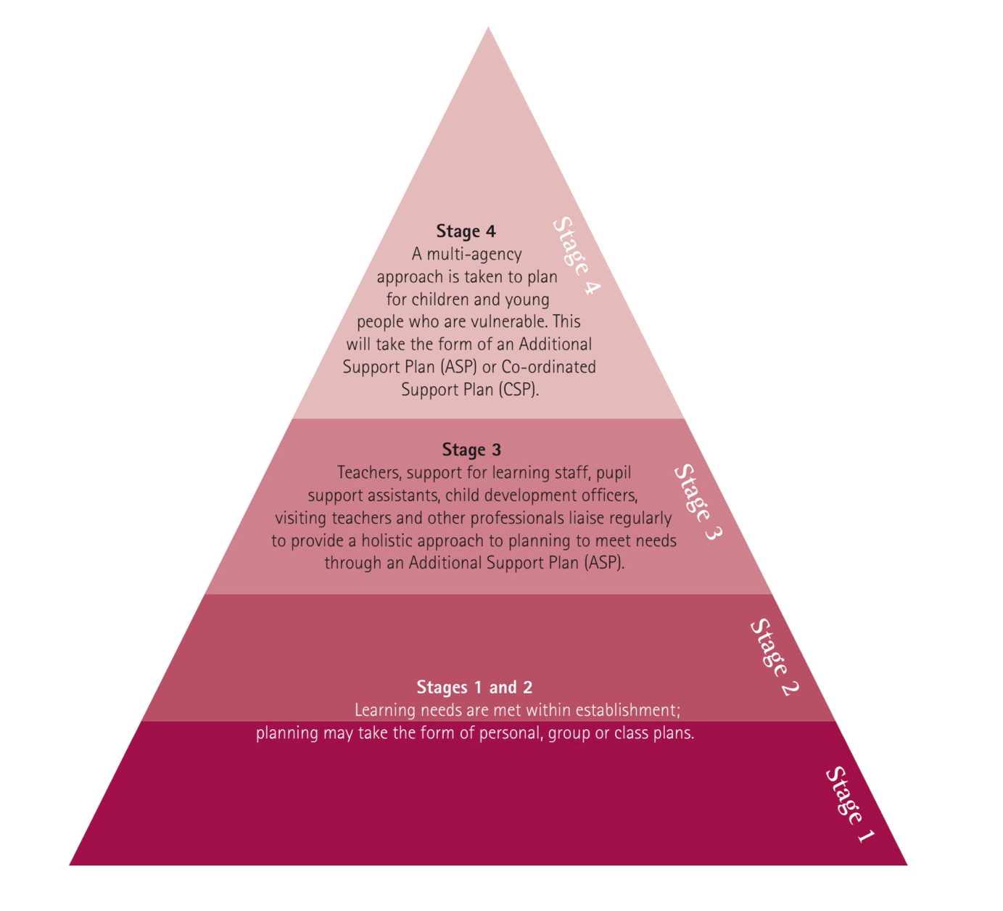
The class teacher completes the triangle annually and at points of transition and should review this regularly (Appendix One). See Appendix Two for an example of a Transition meeting template which can be used to support discussion where a class in moving from one teacher to another.

Promoting Positive Behaviour in the Classroom: please see Supporting Success at KSS and Faculty PPR Pyramid
- Refocus pupil: rephrase instructions; provide help etc.
Break down task
Write time in jotter
Reminder of Charter
1:1 chat
Contact PT to inform them
Provide copy of reflection sheet
Issue work and resources
Write targets in jotter
Seat change
Thinking Space
Set specific targets (v. short term)

Classroom monitoring card

1st restorative conversation (target-setting in classroom)

Re-direct to targets or Charter

Pupil afforded time to reflect using the Charter Exit Card
Restorative conversation in corridor: thirty second intervention script (Appendix Two)

2nd restorative conversation (target setting outside classroom)

Complete Seemis referral (Appendix Three)

- Swearing in class: addressed through a discussion of the school values / charter.
- Swearing directly at staff (verbal abuse): PT NOTIFIED IMMEDIATELY. PT notifies DHT immediately to allow for timeous action. Information should then be copied into a Seemis referral which is sent to PT in the first instance. Thinking Space can be utilised to allow time to address concerns.
Key Classroom Strategies:

- Phone Policy

Across the school, pupils are helped to focus on teaching and learning and to give their best in lessons by ensuring that phones are not in use in the classroom. Pupils are instructed to:

- Switch phones off.
- Store phones in bags.
- Place bags at the front or back of the classroom or under desks
* please check the specifics of your department’s policy*
- Where a pupil does not have a bag or jacket, the phone should be placed on the teacher’s desk.

On the first occasion a pupil requires reminded about phone policy, the phone may be stored as directed above.

Where a pupil uses the phone again, the phone should be placed on the teacher’s desk for the remainder of the period.

Where a pupil chooses not to co-operate with the classroom teacher, they should be informed that this is likely to result in the PT confiscating the phone for a full day. Pupil phones should be placed in the school office at the first opportunity.

Any pupil found to be in corridors, toilets or social areas during class time using a mobile phone will have the phone placed in the school office immediately.

The need for PT support can be communicated by phone or using a Seemis referral.

Alignment with Scottish Government Advice

Our KSS Mobile Phone Policy is in line with recent guidance published by the Scottish Government “Mobile Phones: Guidance for Scotland’s Schools” (August 2024). More details available here: https://www.gov.scot/publications/mobile-phone-guidance-scotlands-schools/pages/5/

Extracts from this guidance can be found below:

“The approach to what constitutes respectful and responsible use of mobile phones should be informed by the consideration of the full range of relevant rights under the UNCRC in light of their local circumstances, with acting in the best interests of the child as a key consideration.”

“In order to give effect to the respect for the views of the child, policies relating to respectful and responsible use of mobile phones should be developed through engagement with the whole school community – pupils, staff, parents and carers. This is the most effective means of ensuring two-way engagement with, and commitment to, the policy.”

And

“Policies should set out clear expectations of what standards of behaviour are expected from all members of the school community, including pupils, staff, parents and carers as well as what action will be taken when such expectations are not met.”

Survey Results at KSS

The most recent survey of the PPR Policy regarding mobile phones for staff and students at KSS was completed in June 2024 and October 2024. The following views were expressed:

June 2024:

Staff:
- 87% of staff agreed the PPR policy reduced conflict
- 83% of staff felt it improved pupil focus on learning

Students:
- 57% of students felt that storing bags, jackets and phones results in less disruption to learning and teaching
- 50% of students agreed the policy made it easier to focus on learning

Pupils further made the following supportive comments regarding the PPR policy:
- “You get less distracted”
- “We can focus on learning and not be interrupted”
- “You are not tempted to go on your phone”

October 2024:

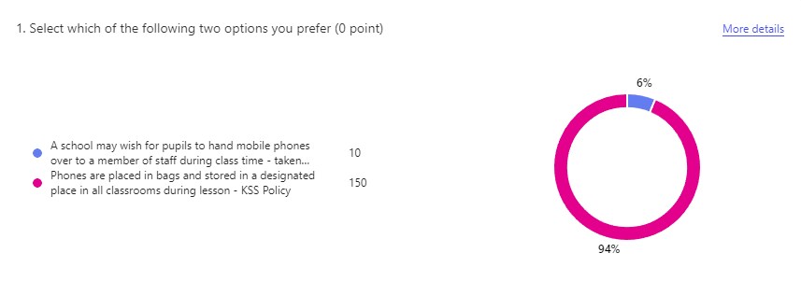
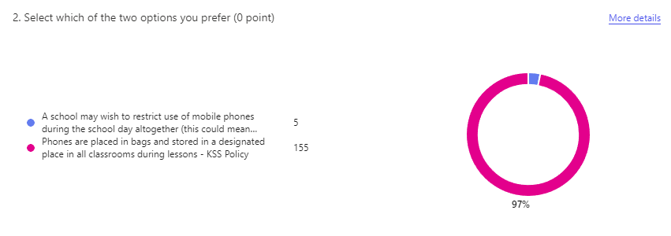

EAL Learners
EAL learner may be permitted to use their mobile phone translation tools during lessons with the class teacher’s permission while they await allocation of an iPad.
This should be closely monitored by the class teacher and school procedures should be followed if young people misuse their phone.

Other Classroom Strategies, continued:

- Target Setting

Short term targets support improvement. Pupils may be directed to the Charter to help address behaviour which is not in line with school values or set work-related targets.

- Thirty Second Intervention

To support a successful return to class, the thirty second intervention script can be used to help pupils to understand how to bring about improvement. In advance of the conversation, pupils should be issued with a Corridor Card which identifies what successful behaviour looks like (Appendix Three).

- Thinking Space

Within departments or faculties, arrangements will be in place to provide a pupil with a Thinking Space when required. This is to allow a pupil an opportunity to reflect or to create distance from an issue in the classroom and to allow the work of their class to continue without interruption.

The priority should be to allow teaching and learning to continue. To this end, the pupil moving elsewhere should be provided with the appropriate resources to continue to focus on the aims of the lesson.

Additionally, to support a consideration of how best to bring about improvement, a pupil should be provided with a Thinking Space reflection sheet. Three versions of the Thinking Space reflection sheet are available and the teacher is best placed to decide which one should be issued based on Pupil Plans and knowledge of a pupil’s needs. If a pupil is not known to the member of staff issuing the Thinking Space document, the ASN database should be consulted to ensure a pupil’s literacy needs are taken into account.
It may be appropriate to make use of a ‘Time In’ Box or Mindfulness resources at this stage. HIVE senior staff can support and advise regarding appropriate resources.

The target set by a pupil can then be used to support a successful return to class.

Appendices Nine, Ten and Eleven.
Seemis Referrals

A referral is an opportunity to invite additional support for a pupil and document concerns for information or further action. As outlined above, there are many support mechanisms which should be employed at classroom level before a teacher seeks further support for a pupil. Where intervention has not supported improvement in line with the KSS Charter, concerns may be shared using the Seemis referral system (Appendix Five). This allows Subject PTs to plan how best to meet pupil needs and help pupils to demonstrate improvement.
Staff should be aware that referrals may be shared with pupils and parents/ carers/ others and that parents/ carers/others can request to view copies of referrals held on the system.

Suggested template for referral completion:

- Identify behaviour not in line with charter. Use Charter specific language.
- Outline classroom interventions used to support improvement. Be objective and avoid emotive language.
- Outline pupil response.
- Include any other relevant information.
Example
Kevin was not able to demonstrate respect for others during today’s lesson. He needed support to enter the classroom and was encouraged to do so and remove his hood. Kevin sat in a seat of his own choosing. He was encouraged to move. Written and verbal instructions were shared to allow all pupils to engage with the lesson; Kevin removed his phone from his pocket and began to play a game/ watch videos. I moved to Kevin and spoke quietly, encouraging him to respect others by complying with school phone policy and writing the date and title in his jotter to begin (I checked he had all resources and understood the task). I repeated this three times and moved away to allow Kevin time to change his behaviour. Kevin was not able to change his behaviour. Seeing no alternative, I invited him to stand outside. He did so, then returned, then left. He refused to make use of the Thinking Space which was set up.

Monitoring and Support

Additional support is provided to pupils who require greater structure to help bring about improvement.

Department Support Card

A Principal Teacher, in consultation with the class teacher, may determine additional targets and support are required. The Department Support Card asks pupils to focus on one aspect of the Charter and work to demonstrate progress across an agreed period of time.

The Department Support Card should be shared with the relevant Depute Headteacher at the end of each week. It can be placed in the pigeonhole of the DHT in the jotter store or a copy can be sent electronically.

Wider
School
Support

Support for Pupils at Whole School Level

A wide range of support mechanisms are in place across the school to meet the needs of all learners and ensure all learners are all achieving. Working in partnership, young people who may benefit from additional support are discussed at the weekly Kiim (Knightswood Inclusion and Intervention Meeting) before being allocated targeted support from the range available. The Pupil Support spreadsheet should be consulted for further information about provision and participation.

The Support Spreadsheet is located in the Pupil Support folder in the shared Staff Area. It is a comprehensive overview of young people’s needs and learning profiles and is used to support planning for effective learning and teaching.

Knightswood Internal Support Directory

This document can be found in the Staff Area and provides a comprehensive overview of the support available to pupils to allow staff to identify resources to improve outcomes for our young people. Partners who contribute to our targeted support include:
- Farebears
- Action for Children
- MCR
- Active Schools
- Campus Police Officer

The Hive Handbook

To access The Hive Handbook, which outlines core universal strategies and targeted intervention for young people, please refer to the Pupil Support folder in the Shared Area.

Pastoral Care Weekly Support Card
Where there are concerns across multiple subject areas, a weekly support card across all subjects may offer a pupil the most appropriate level of assistance. This card mimics the format of the Department Support Card. This will invite parental involvement to seek solutions in partnership with home.

Pastoral Care Daily Support Card
Where increased contact with a pupil is deemed to be of benefit, a Daily Support Card may be implemented. This will afford a pupil an opportunity to discuss and review progress towards meeting their target once a day and invite parents/ carers to review their child’s progress regularly.

Depute Headteacher Daily Support Card
The Depute Headteacher Daily Support Card is an indication that a pupil requires sustained and focussed assistance to bring about improvement.

Appendices Five, Six, Seven and Eight

Duty Support

A system of Duty Support is available for exceptional circumstances where a PT deems it appropriate or where the PT is unavailable to deal with an emergency classroom situation. All other aspects of disruption to teaching and learning can be managed by using the Department Thinking Space.

It may be necessary to seek support beyond the department where there has been a violent incident. Duty Support can be accessed by phoning the school office.

Charter Champions

Each week, teachers are invited to nominate up to four pupils who have demonstrated behaviour outlined in the KSS Charter. Each teacher has Charter Cards which should be presented to the chosen pupils; at this stage the class teacher should discuss with the pupil the behaviour for which they are being recognised. On the last day of the school week, pupils present their Charter Cards to the Headteacher who is able to celebrate these Champions by recognising their achievements, discussing their Charter success and sharing rewards
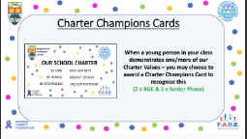

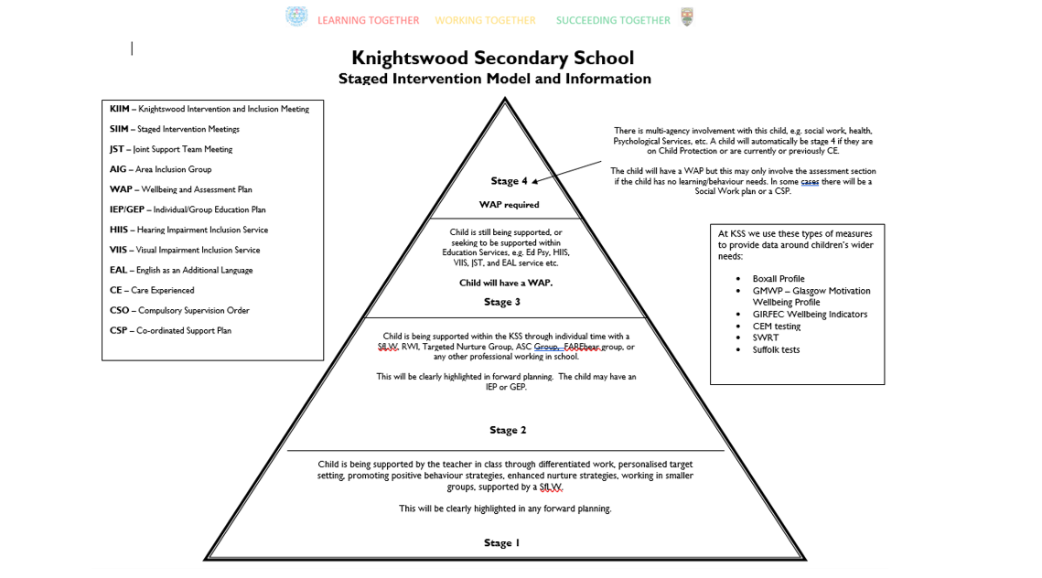
Appendix One: Staged Intervention Information

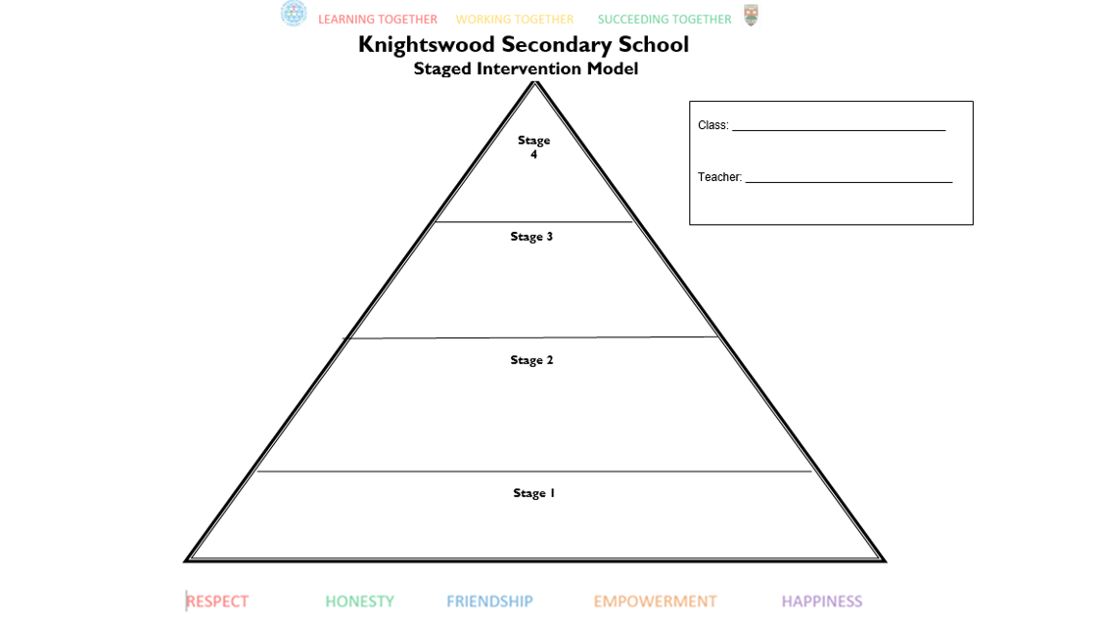

Appendix Two: Transition Meeting Minutes

Class: | yes | no
Has the staged intervention triangle been shared and explained?
Register
CEM info- 20/60/20
Location of current tracking/ viewing of pupils working levels
Seating plans
Peer issues highlighted
Allergy information (if applicable)
Teaching and learning has class covered so far and planned next steps?
Handover records of work
Staff handover of classes
Information sharing


Please sign and store in the Quality assurance folder:
Date: _____________________
Previous teacher _____________________________________________
New teacher: ____________________________________________

Appendix Three: Corridor Card for pupils

What does our charter look and sound like?
BE KIND  - Speak politely to pupils and teachers.  - Share resources.  - Say well done to classmates.  - Offer help.  - Respond positively to others. | GIVE OUR BEST  - Use class time to complete work.  - Do better today than you did yesterday.  - Listen when others are speaking.  - Use feedback to improve.  - Work to meet success criteria. | BE HONEST  - Use mistakes as an opportunity to improve.  - Be open about needing help.  - Apologise if you get it wrong.  - Think about what to do differently next time.
RESPECT OTHERS  - Use a classroom voice.  - Choose the right language for the right setting.  - Take turns.  - Be reasonable in response to reasonable requests.  - Think about how your actions affect others. | BE RESPONSIBLE  - Turn up on time.  - Bring the right equipment.  - Follow instructions.  - Take care of your resources.  - Be organised. | INCLUDE EVERYONE  - Be willing to work with any of your classmates.  - Be willing to sit beside any of your classmates.  - Respond positively to others.  - Speak kindly to others.



Appendix Four: Seemis Referrals Support

- Log in to Seemis.
- Launch Click and Go.
- Select Application then Behaviour then Referral System then Create and Manage Referrals.
- Select Create a New Referral.
- Type the pupil’s surname into the relevant field before selecting New List.
- Click in the pupil’s name.
- Complete the prompts at the foot of the screen: Date of Incident; In Class or Out with Class.
- Select Proceed if Teacher and Location information is accurate.
- Select Reasons for generating the referral from those provided.
- Provide a description of the incident, following the recommended template outlined in the policy.
- Share to Middle Management: select PT’s name from list.

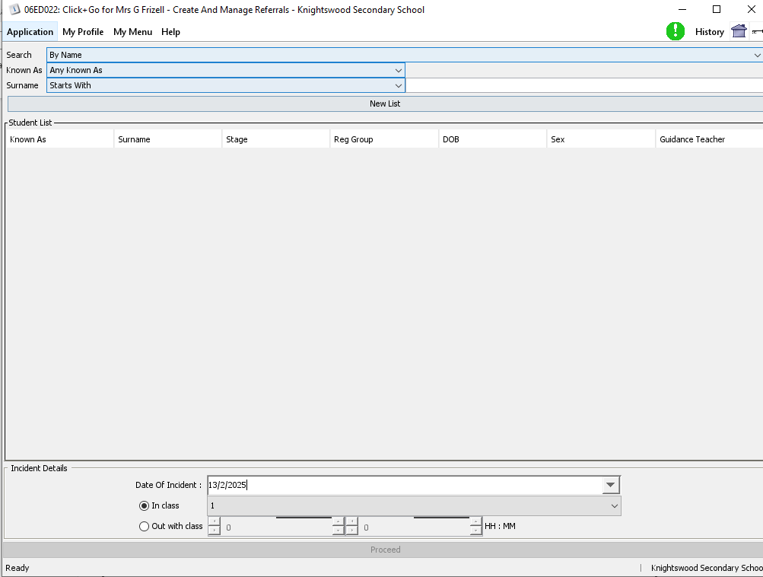

Appendix Five: Department Support Card
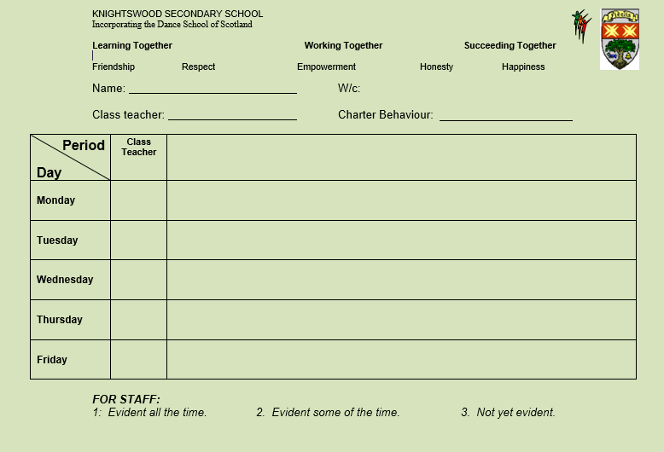

Appendix Six: PTPC Weekly Support Card

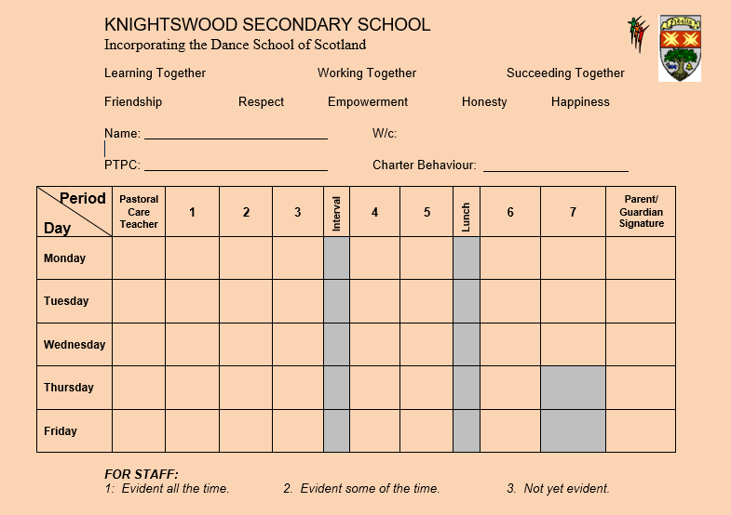

Appendix Seven: PTPC Daily Monitoring Card

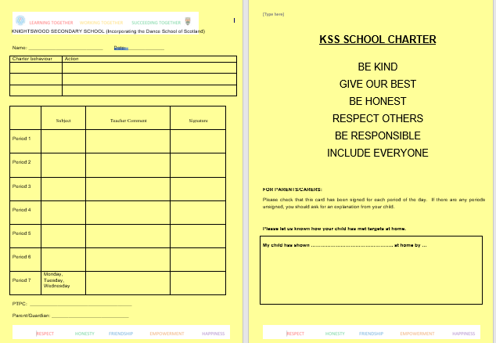

Appendix Eight: DHT Daily Monitoring Card

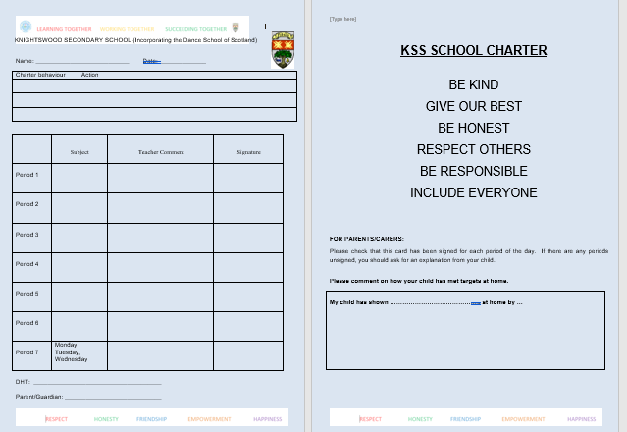
Appendix Nine

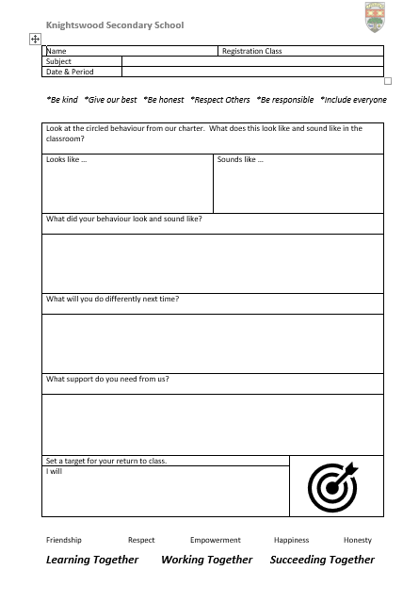

Appendix Ten

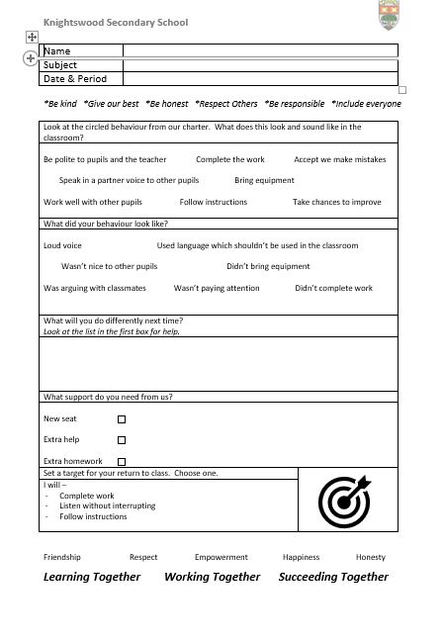

Appendix Eleven
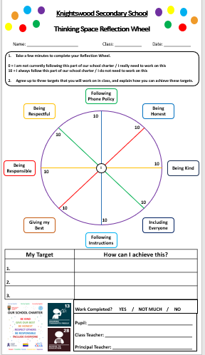

Appendix Twelve

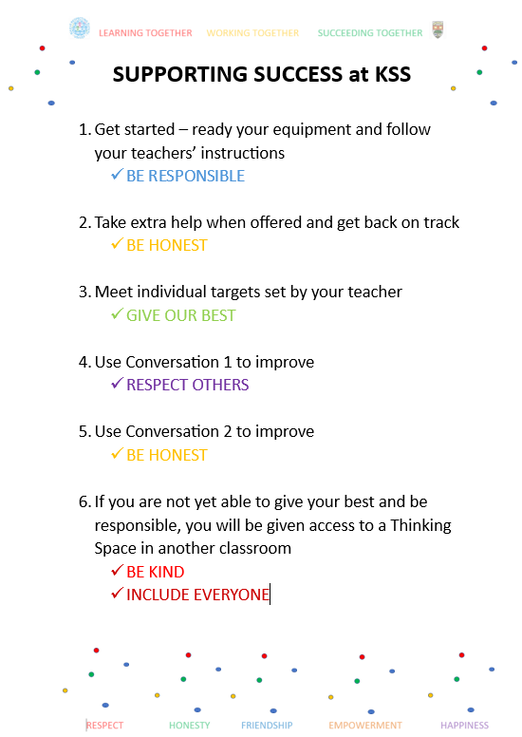

Appendix Thirteen

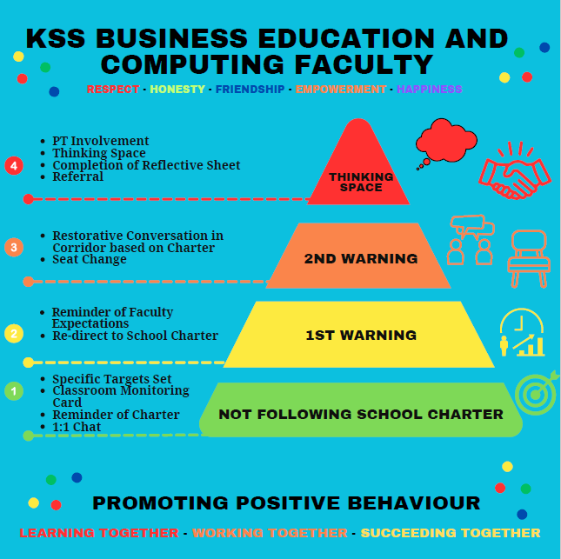

Faculty PPR Pyramids for display will be shared with PTs for distribution.

Appendix Fourteen

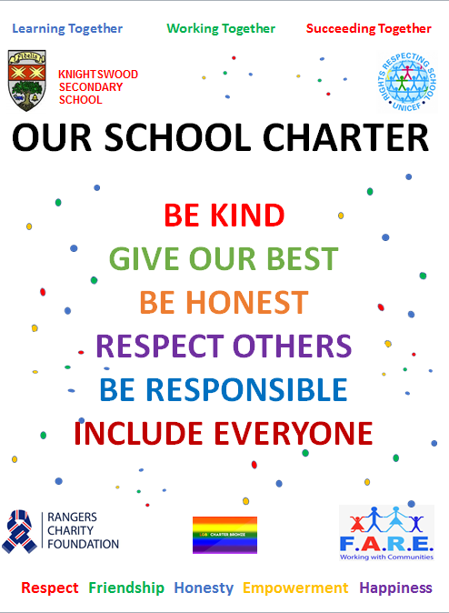
Knightswood Secondary’s 30 Second Scripted Intervention
1. I have noticed that you are…. (describe the behaviour that you wish to address)

2. You are not following our school charter, which says… (identify the aspect of the charter that relates best to the behaviour)

3a) What should this look like in our school? OR
3b) Describe what this should look like to the young person

4. Earlier this period / this week / this month, you were… (describe an example of a time when the young person you are talking engaged positively in class)

5. This is who I need to see today. Let’s get back on track.

Appendix 15: Timeline 24/25

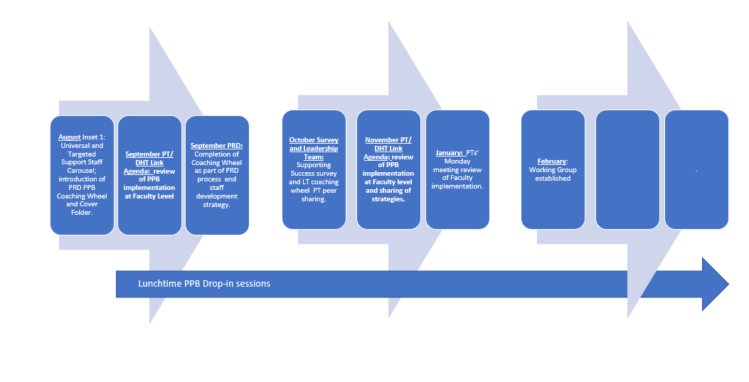
Aug and Oct Strategy Group met: SG policy and RA
Policy reviewed and updated
June 24
Jan 2025: Consultation with SLT and MLT
Feb 2025: Consultation with wider staff at Inset 4. RA Inset session.
March 2025: Launch with pupils and parent/carers
May 2025: RA Inset session.
June 2025: Review with strategy group

Appendix Sixteen
Members of the Promoting Positive Behaviour Working Group (From December 2024)
G Frizell
C Grubb
L Chase
N Farmer
J Oakes
S Airdrie
L Seagrave
F Shepherd

