**CURRICULUM VITAE**

Tel.: 0244784605/0268680395 e-mail: frnkowusu6@gmail.com

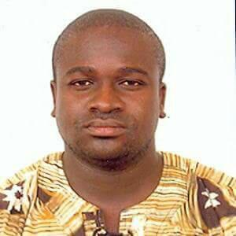**PERSONAL DATA**

Surname : Owusu

First name : Frank

Date of birth : 12th September, 1981

Sex : Male

Home town : Esiam - Bremang

Region : Central

Nationality : Ghanaian

Marital Status : Married

**ACADEMIC QUALIFICATION**

**Institution Attended With Years**

2008 – 2010 Kwame Nkrumah University of Science Technology, Kumasi

2003 – 2006 University of Education, Winneba

1997 – 1999 Tamale Secondary School, Tamale

1994 – 1996 New Oxford J. S. S, Kumasi

**Qualifications (Certificates)**

Masters of Science (Industrial Mathematics)

Bachelor of Education (Mathematics)

Senior Secondary Certificate Examination (S.S.C.E)

Basic Education Certificate Examination (B.E.C.E)

**WORKING EXPERIENCE**

2005 – 2006 Internship, Mathematics Tutor St. Louis Training College

2006 – 2007 National Service, Mathematics Tutor St. Louis Training College

2008 – Date Mathematics Tutor St. Louis College of Education

2011 – Date Mathematics Course Tutor UCC- CoDE

2012- 2018 Mathematics Course Tutor UCC – Bed. Basic Edu. (Sandwich)

**POSITIONS HELD**

2004 – 2005 Audit Board Chairman (Amu Hall) University of Education, Winneba

2004 – 2005 Entertainment Board Chairman (Amu Hall) University of Education, Winneba

2008 – Date Academic Counselor, St. Louis College of Education, Kumasi

2011 – 2014 Unit Head, Mathematics Department St. Louis College of Education, Kumasi

2018 – Date Head of Department, Mathematics/ICT St. Louis College of Education. Kumasi

**SOCIAL LIFE**

Patron, Pentecost Students and Associate St. Louis College of Education

Member, Men’s Welfare Club St. Louis College of Education

Secretary, Progressive Transport Owners Association (PROTOA)-Abrepo Junction Branch, Kumasi

**REFEREES**

1. The Principal

St. Louis College of Education

Kumasi

2.Mr. Solomon Sarfo

The Vice Principal

St. Louis College of Education

Kumasi