Kasia

Customer Specification

Product Owner: Richmond Ko

Revision History:

|  |  |  |  |
| --- | --- | --- | --- |
| Date | Details | Person | Version |
| August 9, 2014 | Document created | Richmond Ko | 1.0 |
| August 14, 2014 | Added more collections and main features and functions | Richmond Ko | 1.1 |
| August 20, 2014 | Added comments from customers | Richmond Ko | 1.2 |

1. **System Flow**

Company selection:

1. LYL
2. ELMC
3. Olympic Maju
4. Inter-Asia Molasses

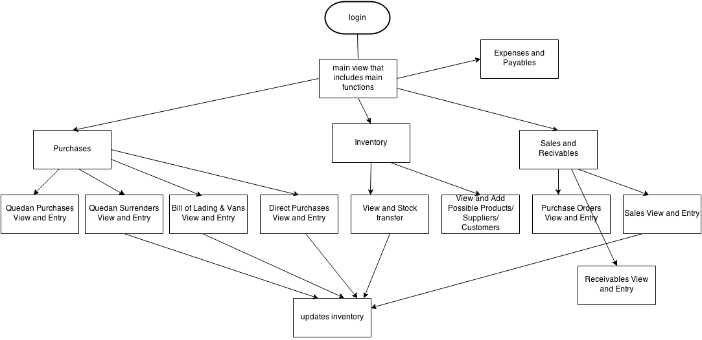

1. **Collections and Entries**

The system shall have the following collections/entries:

1. Products
2. Suppliers/Agents
3. Customer
4. Salesman
5. Quedan Purchases
6. Quedan Surrenders
7. Direct Purchases
8. Bill of Lading and Vans
9. Purchase Orders
10. Sales
11. Receivables (from product sales and other receivables)
12. Payables
13. **Products Collection**

The products collection shall have the following fields in each entry:

1. Item Code
2. Item Name
3. Type
   1. Refine
   2. Wash
   3. Raw
   4. Misc
4. Central Name
5. Origin
6. Class Type
7. Unit Cost
8. Liens (Dynamic array of liens, can be 0 to many)
9. **Suppliers/Agents Collection**

The suppliers/agents shall have the following fields in each entry:

1. Supplier Code
2. Supplier Name
3. Supplier Type
   1. Supplier
   2. Agent
4. **Customers Collection**

The customers collection shall have the following fields in each entry:

1. Customer Code
2. Customer Name
3. Address
4. Telephone Numbers
5. Tin #
6. **Salesman Collection**

The salesman collection shall have the following fields in each entry:

1. Salesman Code
2. Salesman Name
3. **Quedan Purchases Entry**

The quedan purchases collection shall have the following fields in each entry:

1. Date
2. Supplier (referenced from the supplier/agents collection)
3. Product (referenced from the products collection)
4. Unit Cost (referenced from the products collection)
5. Total Bags (computed from subentries)
6. Total Amount (computed from subentries)
7. Total Liens (computed from subentries)

Each entry in quedan purchases collection shall have the following sub-entry fields that can be one or more entries:

1. Sub-entry #
2. Quedan #
3. No. of Bags
4. Kilos
   1. Piculs
   2. Producer
   3. Planter
   4. Status
   5. Liens
      1. Sub liens will depend on the product’s liens entered in products collection
      2. Example: STAB FEE, SMF, CONFED, LUZODFED etc.
   6. Date Issued
   7. Week Ended
   8. Total Lien

Example entry:

|  |  |
| --- | --- |
| Date | 03/30/2007 |
| Agent | DELMAX TRADING CORP |
| Product | CADP-B DON PEDRO “B” RAW SUGAR |
| Unit Cost | 1.00 |

|  |  |
| --- | --- |
| # | 1 |
| Quedan # | A-000612 |
| Bags | 2.06 |
| Kilos | 103 |
| Piculs | 1.63 |
| Producer | SUMAGUE DALMACIO |
| Planter |  |
| Status | Processing |
| Date Issue | 12/02/2006 |
| Week Ended | 11/26/2006 |
| Liens | |  |  | | --- | --- | | STAB FEE | 1.63 | | SMF | 0.16 | | SRAMP | 0.82 | | OTHERS | 1.0 | |
| Total Lien | 101.4 |

1. **Quedan Surrenders Entry**

The quedan surrender collection shall have the following fields in each entry:

1. In-Transit #
2. Date
3. From Product (referenced from products collection)
   1. Quantity
4. To Product (referenced from products collection) -0
   1. Quantity
5. Reference #
6. **Direct Purchases Entry**

The direct purchases collection shall have the following fields in each entry:

1. Date
2. Supplier (referenced from suppliers collection)
3. Product (referenced from products collection)
4. Quantity
5. Unit Cost (referenced from products collection)
6. Commission Rate
7. Total Unit Cost
8. Misc. Fees
   1. Liens
   2. Insurance
   3. Storage
   4. Penalty
9. Witholding tax
10. Commission Amount
11. Payable
    1. Gross
    2. Net
12. Reference #
13. Remark
14. **Bill of Lading and Vans Entry**

The bill of lading and vans collection shall have the following fields in each entry:

1. Date
2. Supplier (referenced from suppliers collection)
3. Shipping Line
4. Vessel
5. Voyage
6. Bill of Lading #
7. Each entry shall have one or more sub-entries with the following fields in each subentry:
   1. #
   2. Van #
   3. Product (referenced from products collection)
   4. Description (referenced from products collection)
   5. Reference # (referenced from quedan surrenders/direct purchase collection)
   6. Quantity
8. Total Quantity
9. **Purchase Orders Entry**

The purchase orders collection shall have the following fields in each entry:

1. Purchase Order #
2. Date
3. Customer (referenced from customers collection)
4. Product (referenced from products collection)
5. Purchase Order Quantity
6. Served (computed by the system, this is the quantity that has been delivered to customer)
7. Balance (computer by the system, =Purchase Order Quantity – Served)
8. Unit Cost
9. **~~Withheld Expanded w/Tax? (y/n) (what is the meaning of this?)~~**
10. ~~%EWT~~
11. **~~With VAT Divide by 1.X? (y/n) (what is the meaning of this?)~~**
12. ~~%VAT~~
13. **~~Cancelled? (y/n) (maybe instead of this we can just delete the entry? Or do the user need record of cancelled POs?)~~**
14. **Sales Entry**

The Sales collection shall have the following fields in each entry:

1. Delivery Order #
2. Date
3. Customer (referenced from customers collection)
4. Product(referenced from products collection)
5. Purchase Order # (referenced from purchase orders collection)
6. Invoice #
7. Delivery Receipt #
8. R=Ref, V=Van, D=Damage
9. Reference # (referenced from quedan surrenders/direct purchase/bill of lading and vans collection)
10. Quantity
11. Unit Price
12. Amount
13. Salesman (referenced from salesman collection)
14. Commission rate
15. Commission amount (computed by system)
16. Withheld Expanded w/Tax? (y/n)
17. %EWT
18. With VAT Divide by 1.X? (y/n)
19. %VAT
20. EWT Amount
21. **Receivables Entry**

The Receivables collection shall have the following fields in each entry:

1. Type (advances/overpayment from customer, receivables collection, other checks received
2. If type is advances overpayment from customer:
   1. Date Received
   2. Customer
   3. Check bank
   4. Branch
   5. Check #
   6. Check Date
   7. Check Amount
   8. Unapplied Balance
3. If type is receivable collection:
   1. ~~Date~~
   2. ~~Customer (referenced from customers collection)~~
   3. ~~Each entry shall have one or more (what to pay) sub-entries with the following fields in each subentry:~~
      1. ~~#~~
      2. ~~Transaction Type~~
      3. **~~D.O.# or Adv # (what is Adv #?)~~**
      4. ~~D.O. Date~~
      5. **~~Item (from products collection?)~~**
      6. ~~Qty~~
      7. ~~Price~~
   4. ~~Total amount to pay~~
   5. Each entry shall have one or more (actual payment check entry)sub-entries with the following fields in each subentry:
      1. #
      2. Bank
      3. Branch
      4. Check #
      5. Check Date
      6. Amount
   6. Total amount of payment (checks)
4. If type is other checks received
   1. Date received
   2. Customer
   3. Check Bank
   4. Branch
   5. Check No.
   6. Check Date
   7. Check Amount
5. **Payables Entry**

The Payables collection shall have the following fields in each entry:

1. Type (Shipping Charges/Tolling, Advances/Overpayment to supplier, Payables payment/apply advances, other checks issued)
2. If type is shipping charges/tolling:
   1. Date
   2. Supplier (referenced from supplier collection)
   3. Document #
   4. Amount
   5. Remark
3. If type is advances/overpayment to supplier:
   1. Date paid
   2. Supplier
   3. Check Bank
   4. Branch
   5. Check #
   6. Check Date
   7. Check Amount
   8. Unapplied Balance
4. If type is Payables payment/apply advances:
   1. Date
   2. Supplier
   3. Each entry shall have one or more (what to pay) sub-entries with the following fields in each subentry:
      1. #
      2. Transaction Type
      3. D.O.# or Adv #
      4. D.O. Date
      5. Item
      6. Qty
      7. Price
   4. Total amount to pay
   5. Each entry shall have one or more (actual payment check entry)sub-entries with the following fields in each subentry:
      1. #
      2. Bank
      3. Branch
      4. Check #
      5. Check Date
      6. Amount
   6. Total amount of payment (checks)
5. If type is other checks issued
   1. Date paid
   2. Supplier
   3. Check Bank
   4. Branch
   5. Check No.
   6. Check Date
   7. Check Amount
6. **Main Functions/Summary**
7. Purchases entry
   1. Quedan Purchase entry
      1. Quedan Surrender entry
   2. Direct Purchases entry
   3. Bill of Lading and Vans entry
8. Stock Transfer (maybe this can be the main inventory view and can transfer stocks from there)
   1. Date
   2. From
      1. Product
      2. R=Ref, V=Van, D=Damage
      3. Ref #
      4. Qty
   3. To
      1. Product
      2. R=Ref, V=Van, D=Damage
      3. Ref #
      4. Qty
   4. Remarks
9. Sales entry
   1. Purchase order entry
   2. Sales entry
   3. Receivables entry
10. Payables entry
11. **Reports**
    1. Product Quantity on-hand (inventory view?)
    2. Customer receivables (receivables view, filter: customer)
    3. Supplier payables (payables view, filter: supplier)
    4. Bill of Lading Sales (bill of lading view)
    5. Direct Purchase Sales (direct purchase view)
    6. Damaged Vans (included in inventory view?)