P-Controller Design Document

Kevin Nguyen, Richard Nguyen

I. Overview
Develop a control system to ensure the robot movement is precise and accurate (straight tracking + turning). A proportional (P) and proportional-derivative (PD) controller were tested and evaluated.

II. Control objective
The goal is to minimize angular error, as small errors can significantly affect the robot’s localization over many iterations.

Desired criteria:
- < 0.5 angular error,
- Settling time < 800 ms (time for 1 ft from calibration model)

III. Control architecture
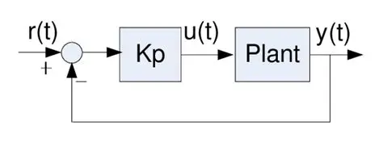
r(t) = desired heading angle
y(t) = current heading angle
u(t) = voltage input

IV. P Controller algorithm
Gains Solved: KP_STRAIGHT = 20, KP_TURN = 1
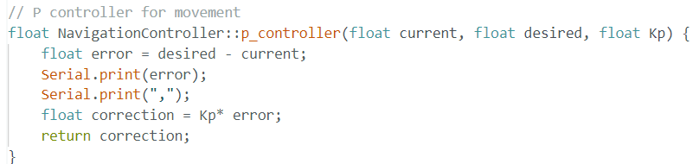

V. gain tuning procedure
P-Controller for Straight Tracking (Kp = 1, 2, 4, 8, 16, 20):
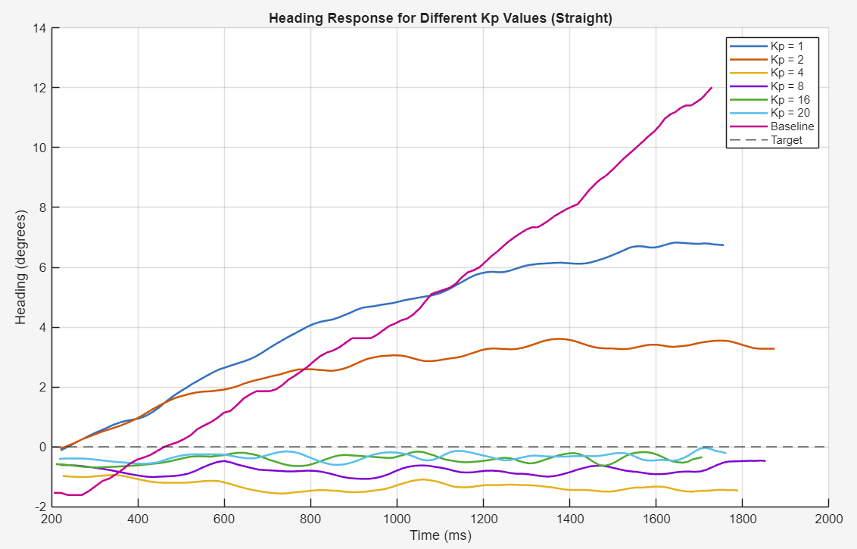
Found Kp = 20 was the best gain to keep the desired target heading of 0 degrees. It met the desired criteria, and no further work was required.

P-Controller for turning (Kp = 1, 2, 4):
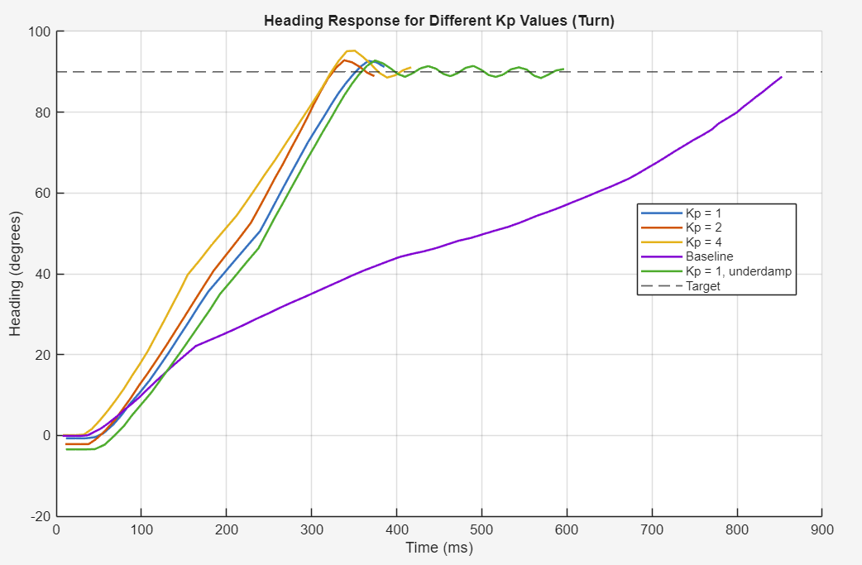
Found Kp = 1 was reliable in reaching the desired target of the 90-degree turn. However, there are times when it starts oscillating because of the tight error tolerance. Increased error tolerance from 0.2 to 0.3.

Effect of P-Controller on voltage input:
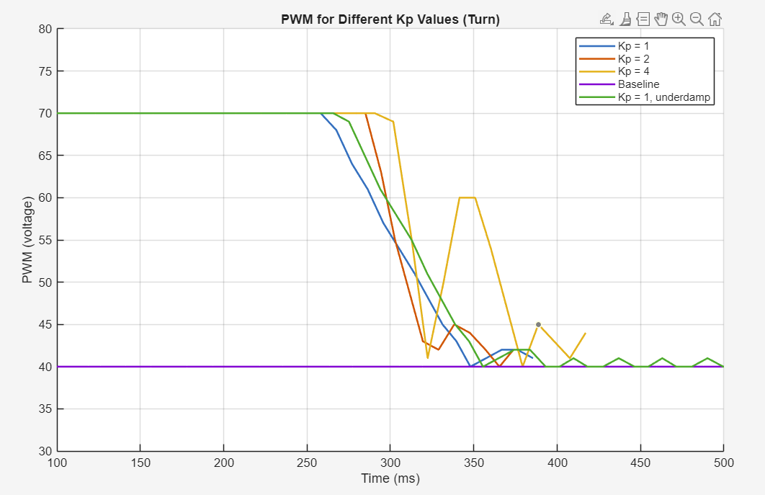
Constrained motor PWM ranges from 40 to 70. Minimum PWM is the lowest value it can reliably turn. Max PWM was constrained to ensure it doesn’t cause excessive tire slip.

VI. Discussion
The P controller exhibited overshoot in the turn response. However, adding a derivative controller did not improve performance for this robot. The additional computation reduced the control loop frequency from 100 Hz to 20 Hz, increasing the settling time from ~400 ms to ~900 ms under the same parameters due to fewer correction steps. Additionally, motor constraints limited the PD controller’s effectiveness: approximately 50% of the initial response was saturated at 70 PWM and 30% of the final response at 40 PWM, leaving the PD controller effective for only ~20% of the response. Therefore, the PD controller was unnecessary for the desired performance.

VII. limitation/future improvements
Add wheel encoder to gain more accurate speed and position of the robot (combine data with IMU for sensor fusion) and remove the open loop timing from my calibration model.
Improve motors to have a wider range of control for the controllers.
Optimize the control loop or get better hardware to run at high frequency.

