**Users guide for GRC online ordering of system**

**1. from your browser (Internet Explorer, Mozilla Firefox, Google Chrome, Opera,)**

Type in the link below:

<http://my.iita.org/accession2>

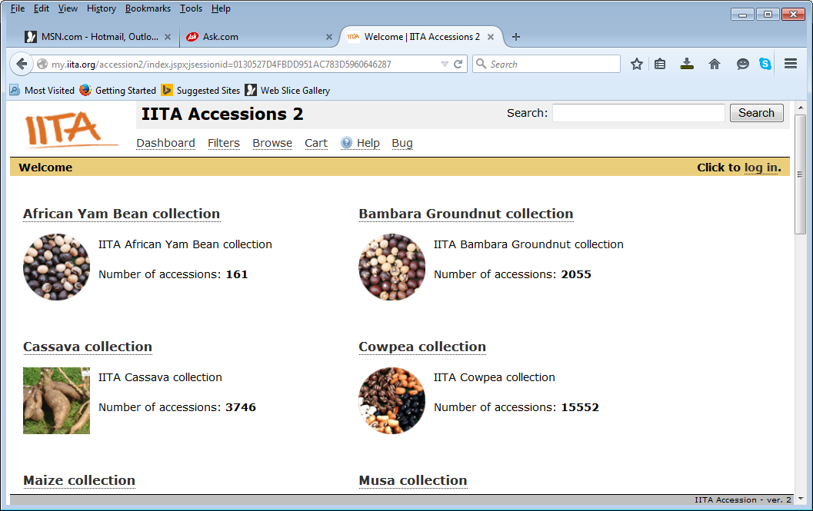

The dashboard opens up for you with the collections.

**2. Click on the needed crop to display the submenus**

Eg. Cowpea

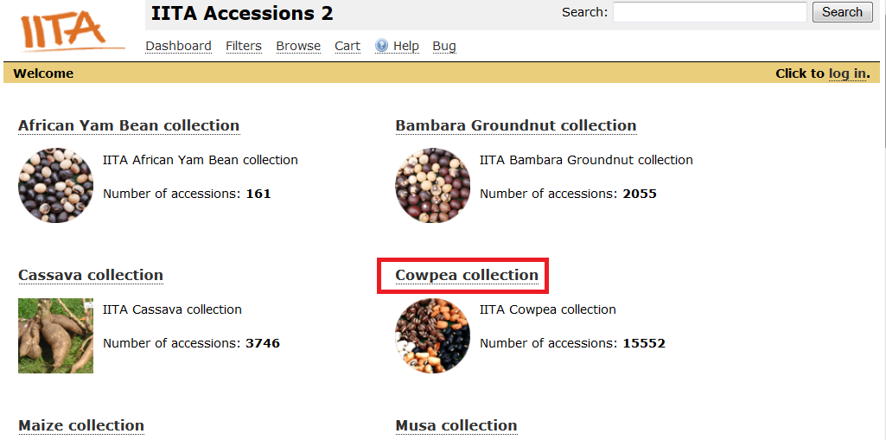

The following submenus are listed:

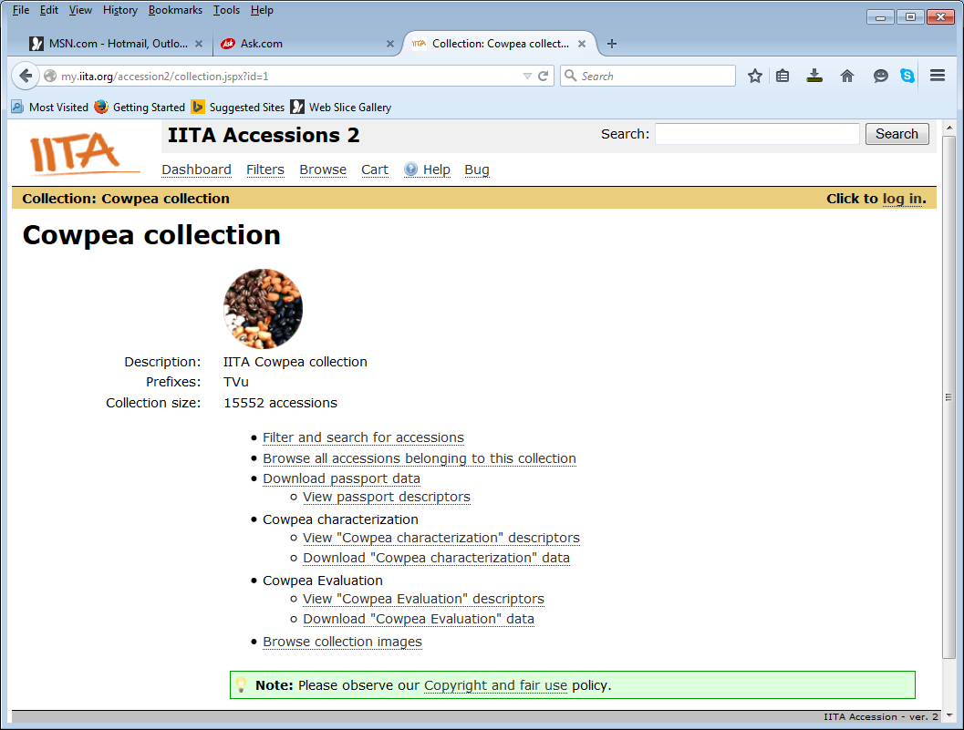

**3. To view the basic list of cowpea accessions, click on Browse all accession belonging to this collection**

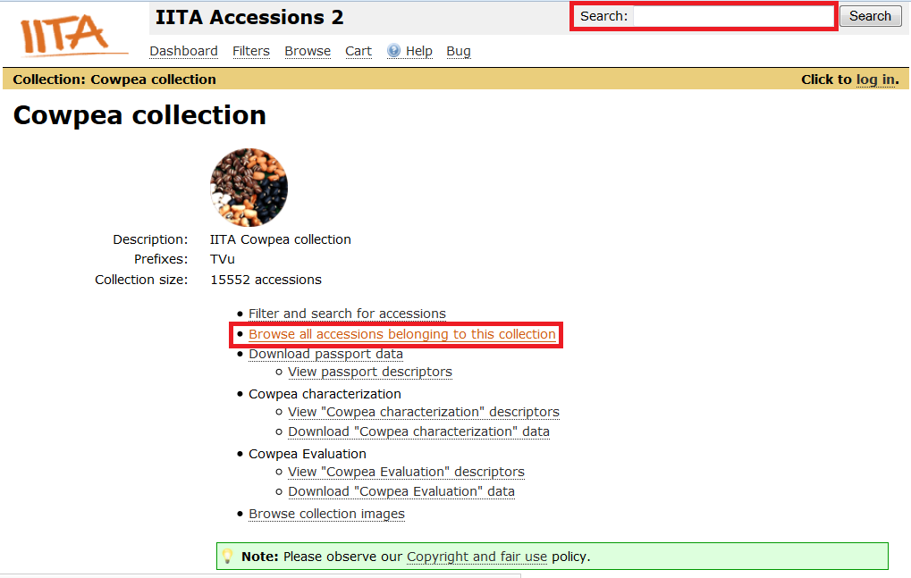

If you are searching for a particular accession name, type in the search textbox and click search button to display the passport data related to that accession.

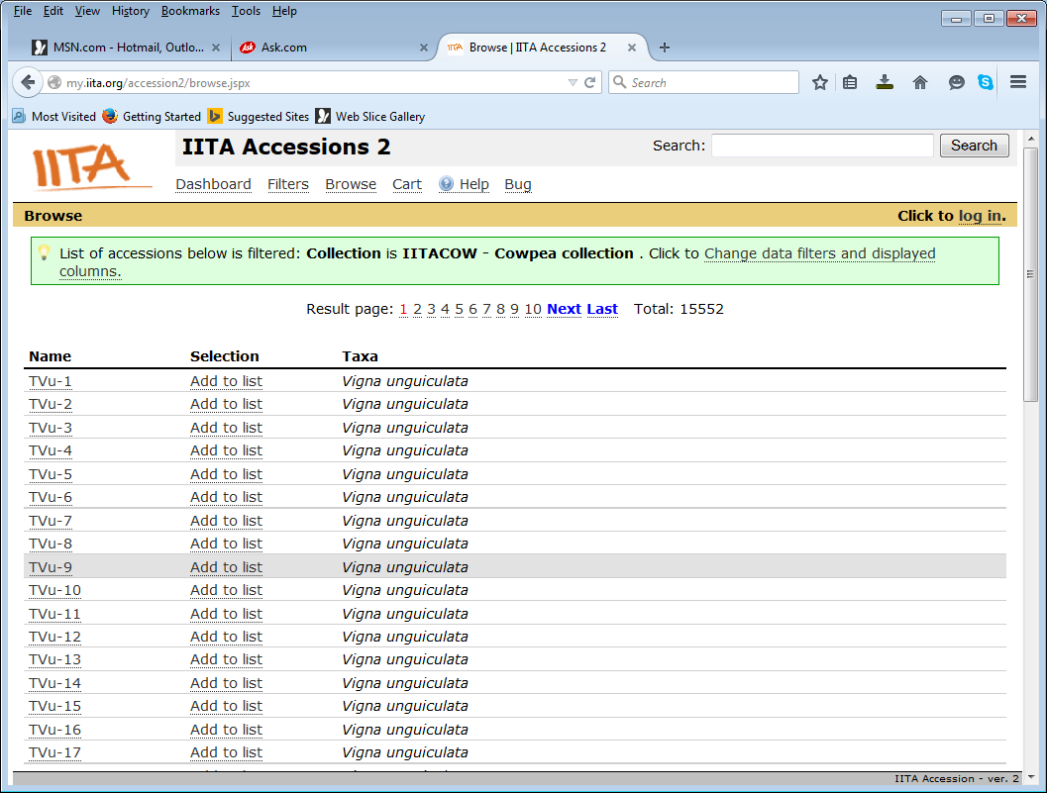

**4. Adding germplasm to your cart for request**

Either displaying all the accessions belonging to a collection or searching for accessions one by one,

You need to click on Add to list to add your material to the cart.

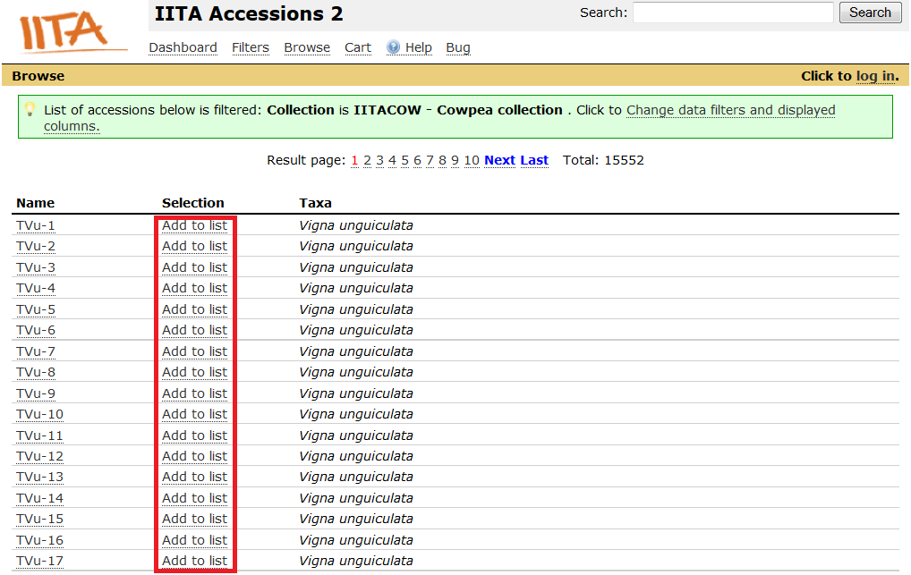

After you have clicked to add the material needed, the status will become like this:

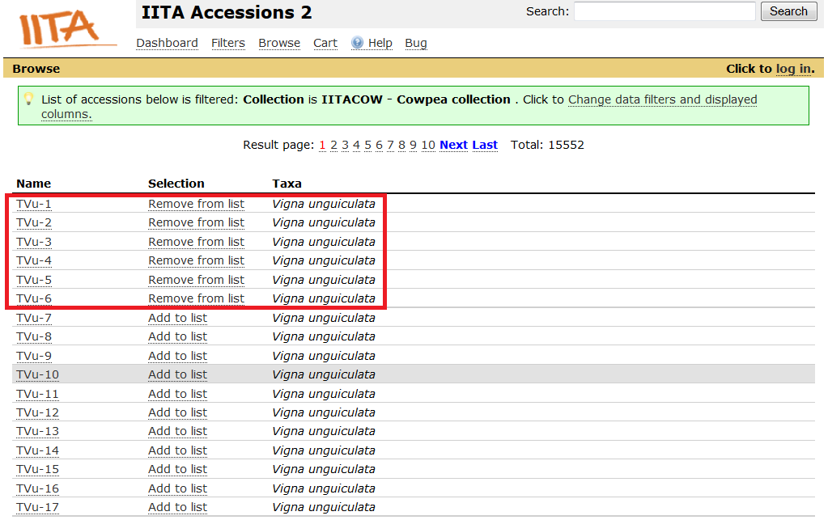

This is the selected material. You can remove from the list if not needed anymore.

**5. After selecting the material to be ordered, click on Cart to view your selected list**

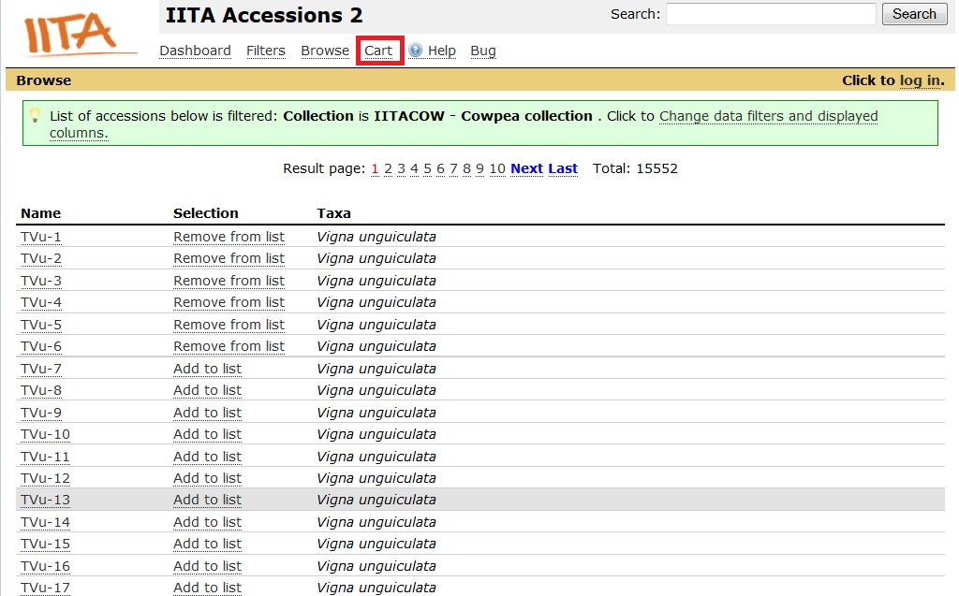

Your selected list is shown like this:

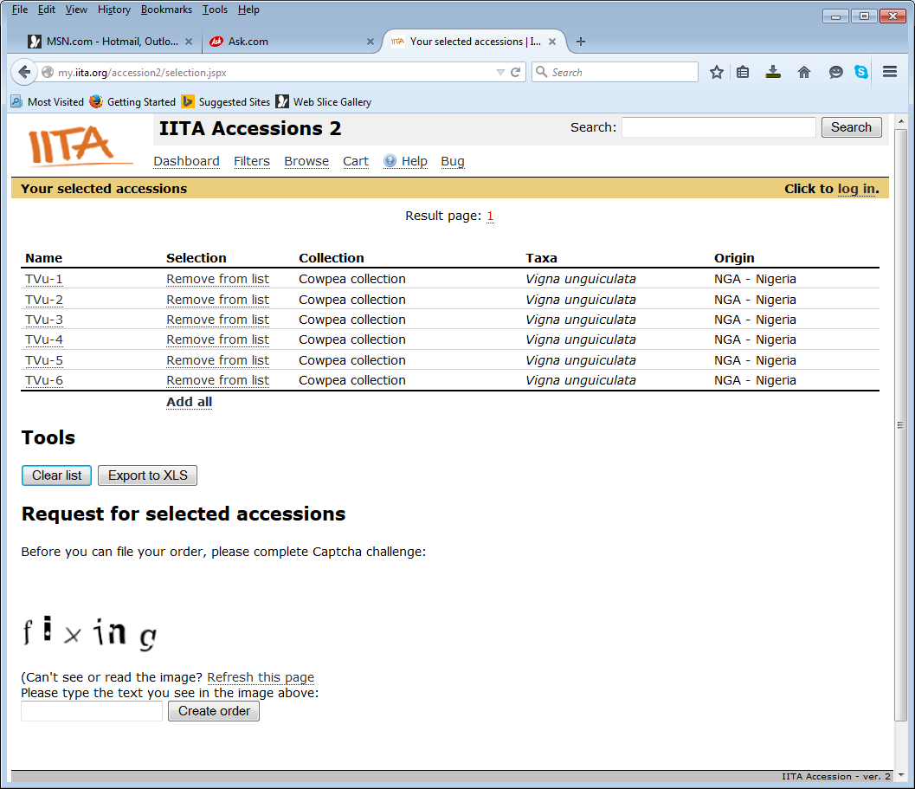

Before you can file your order, type in the Create order textbox the captcha code displayed and click on Create order button

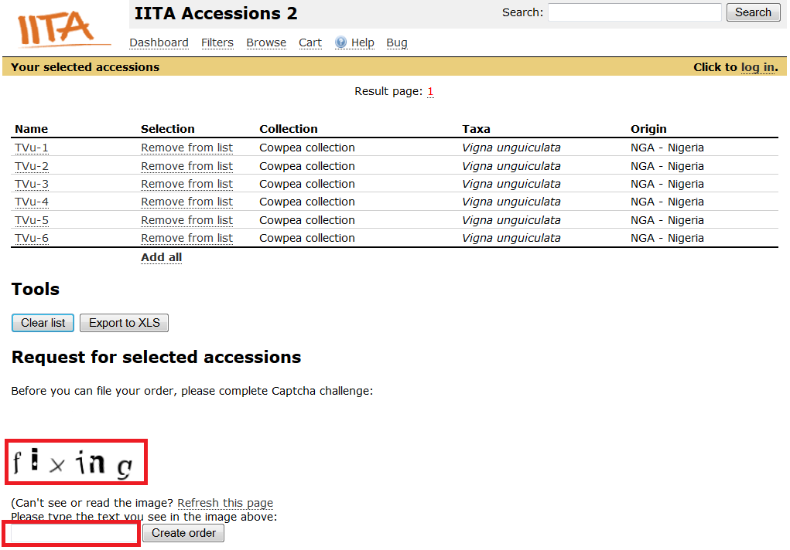

**6. Read and accept the SMTA (Standard Material Transfer Agreement)**

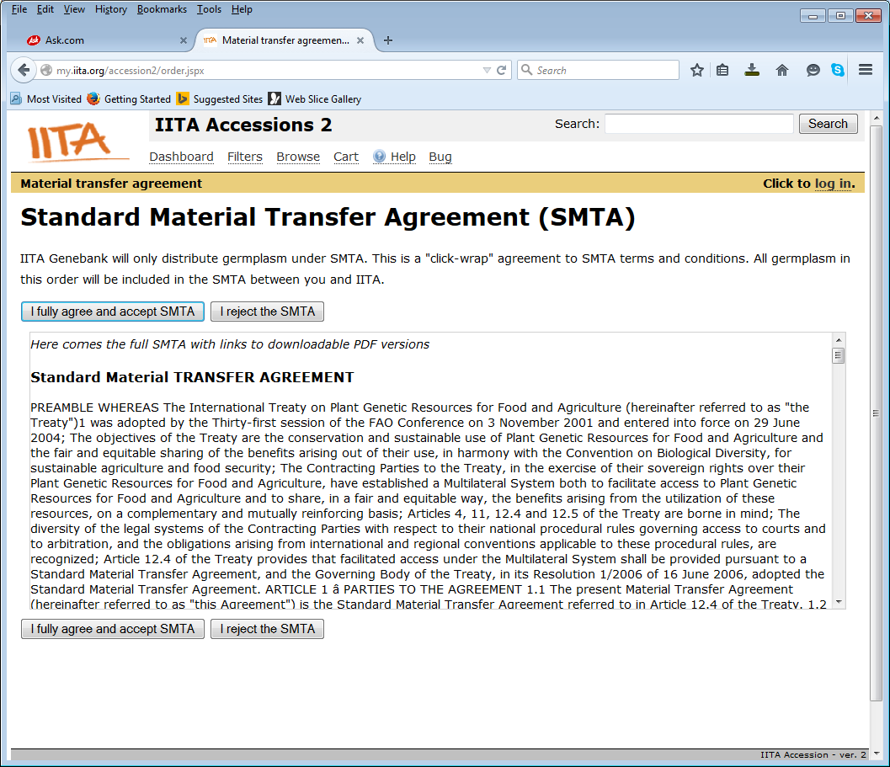

After accepting the SMTA, a form is displayed for you.

**To complete your order, fill in all the information in form**

-Last name, First name, E-Mail address, Organization, Organization type, shipping address, Country, purpose of use, project description

-Click on Submit order button to send your request.

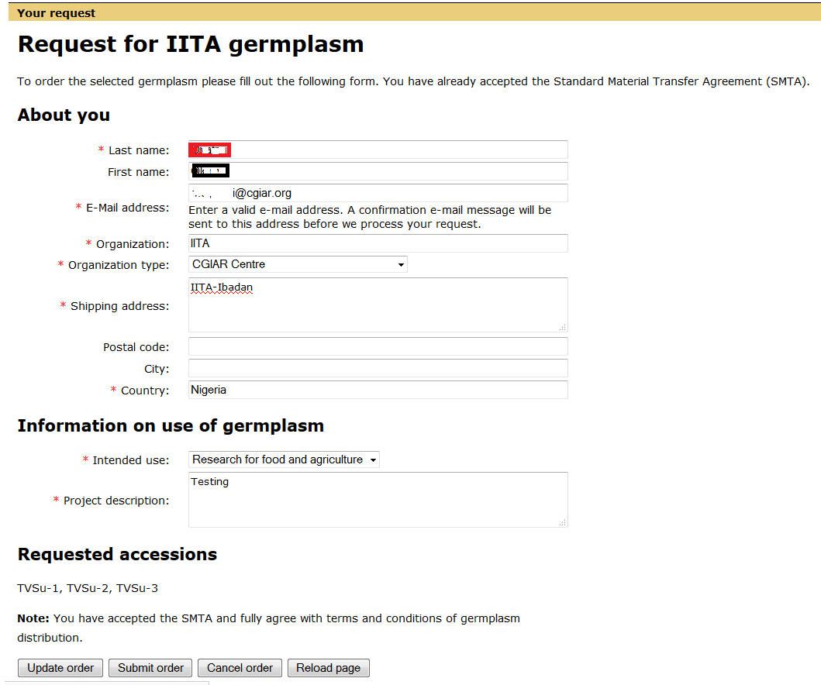

***NB: After submitting your request, you will receive a notification about your request and will be asked to click on a link to validate your order.***

**7. A part from this the online ordering system** (<http://my.iita.org/accession2/>)

As a requester you will be asked to register on easy-SMTA, a PID will be generated for you, kindly send that PID to Emily who is in charge of assisting you in obtaining the requested material.

<https://mls.planttreaty.org/itt/index.php>