EndNote Documentation

**Windows OS:**

1. Access your home folder on CGRB.
   1. You can use WinSCP or files. To download WinSCP, go [here](https://winscp.net/eng/download.php).
   2. Once you’ve arrived at your home directory, create a folder for your new citation project. [Optional]
      1. Ex: If I name the folder ReferenceManager, my new path becomes: /raid1/home/pharmacy/dsouzak/ReferenceManager

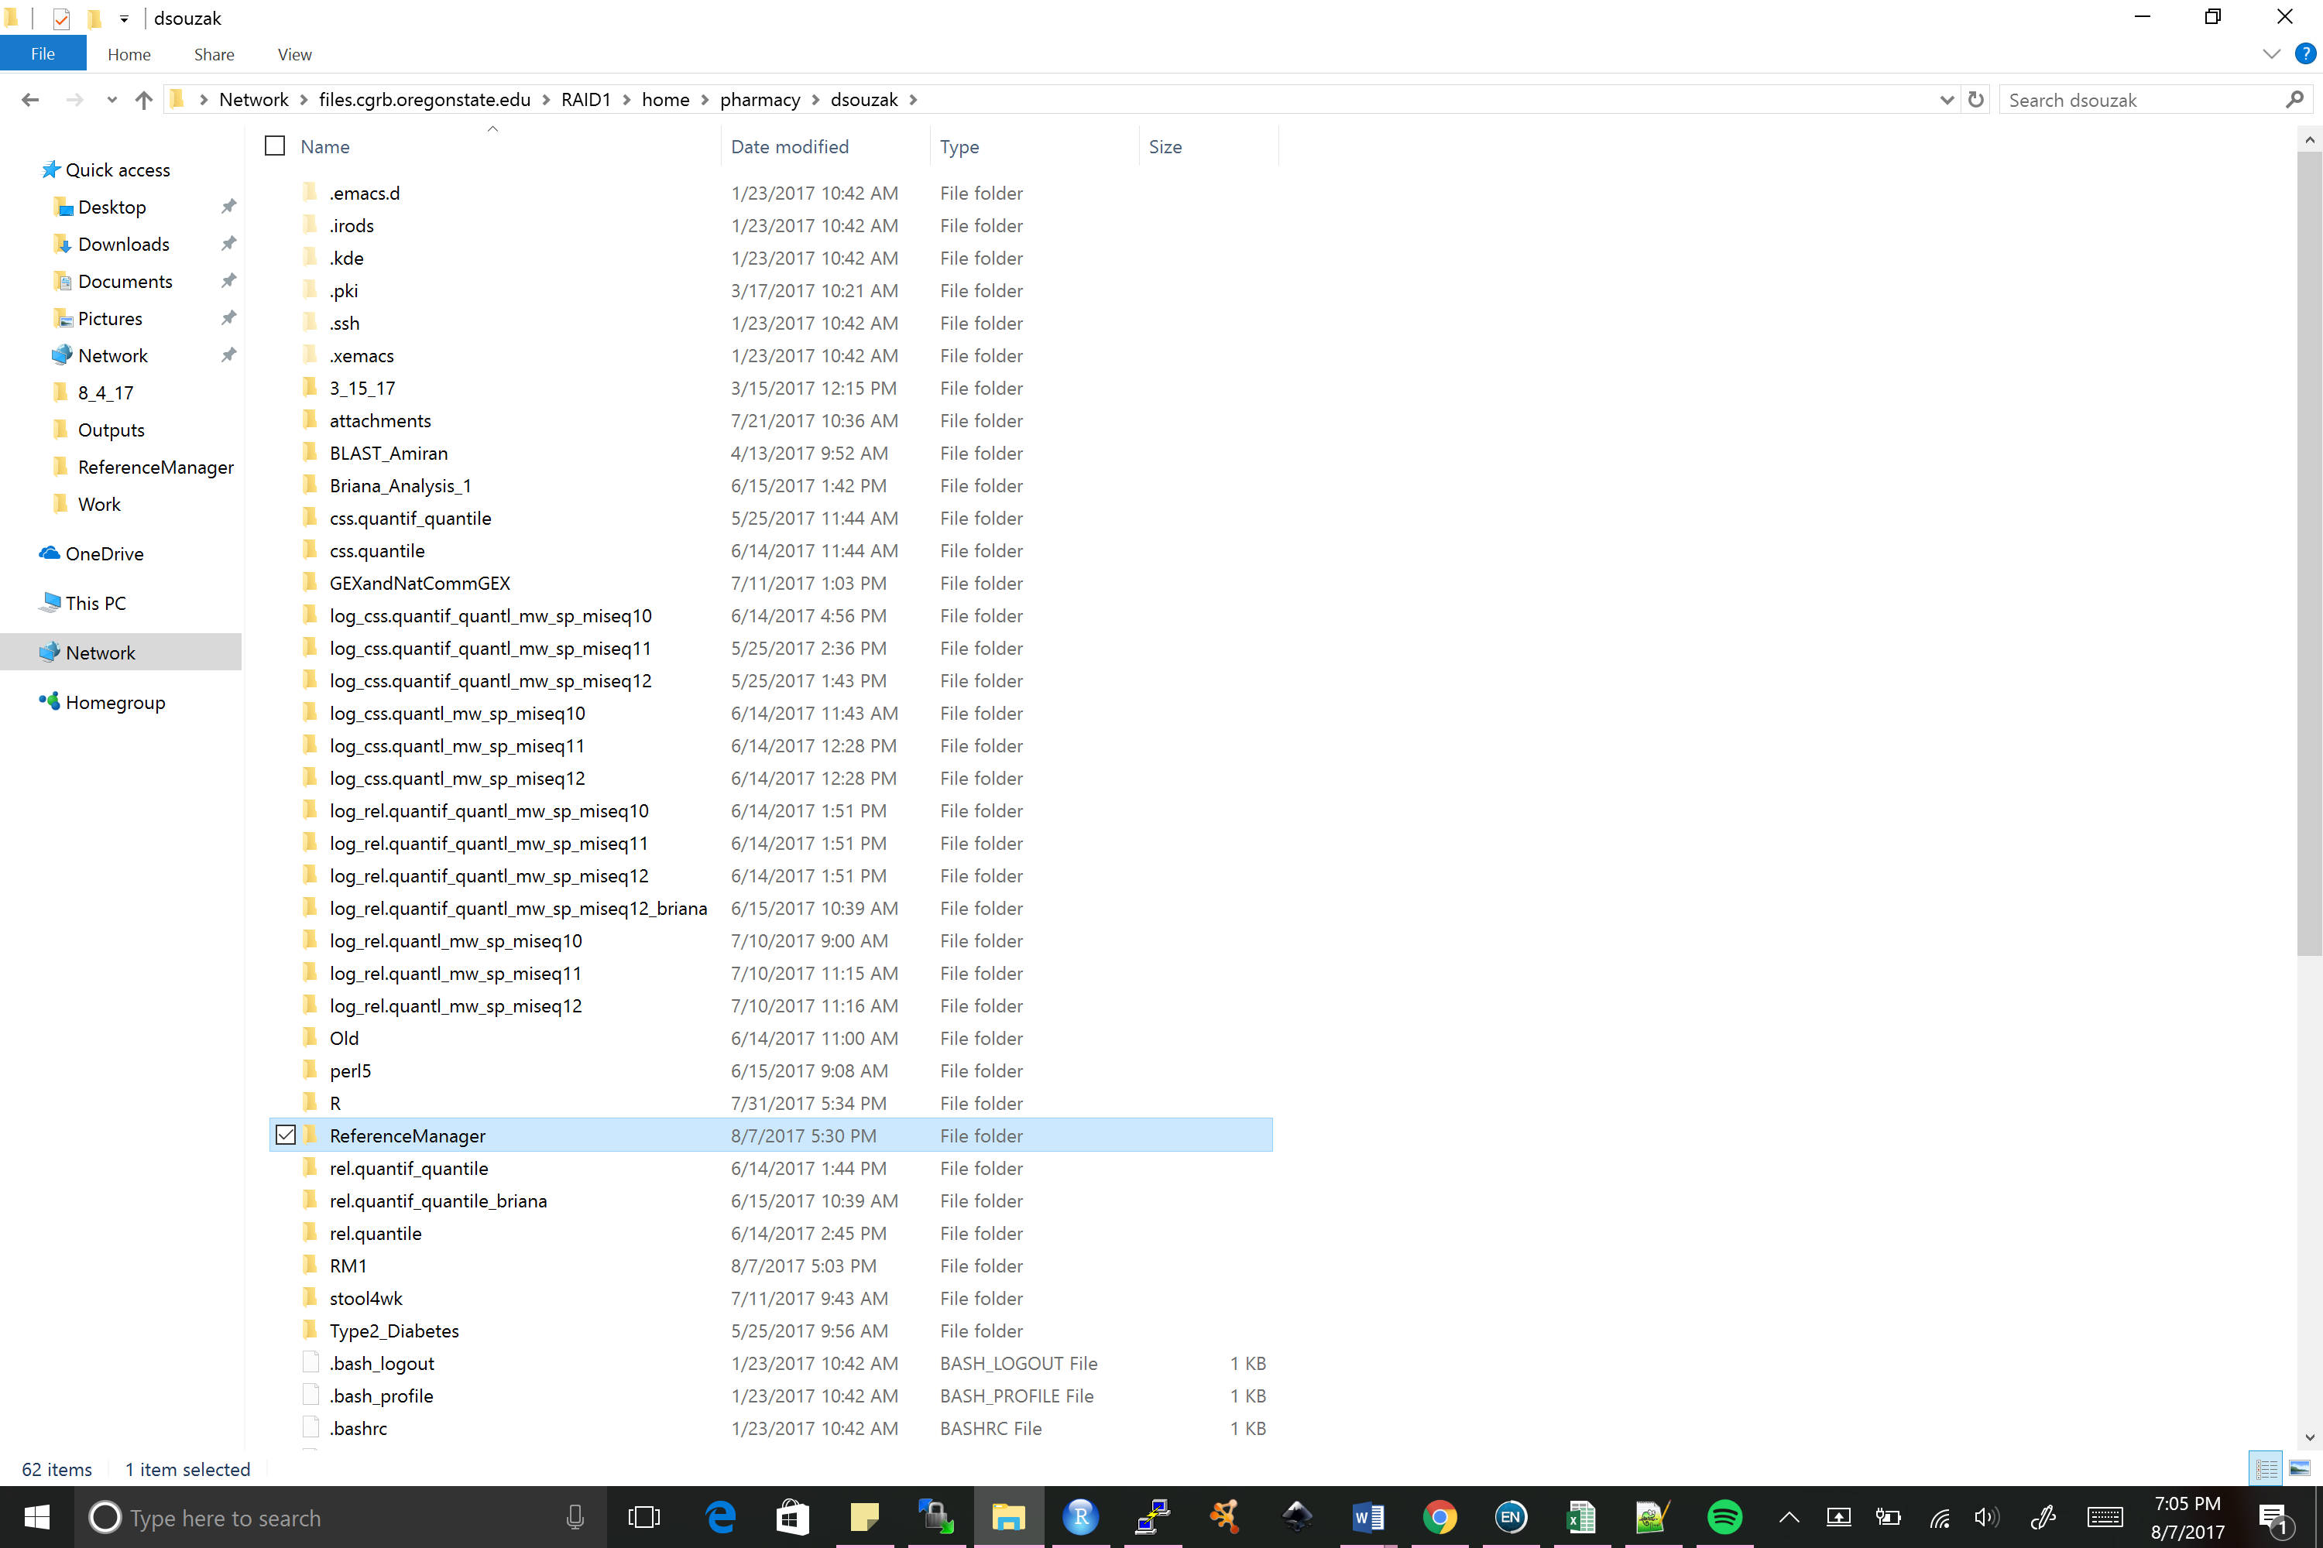

1. Convert your manuscript from a docx to a txt format. The script works off the txt format.
2. Save your manuscript in the txt format and the R script to your new folder. This is optional, but the following example continues with the manuscript file in the new folder.

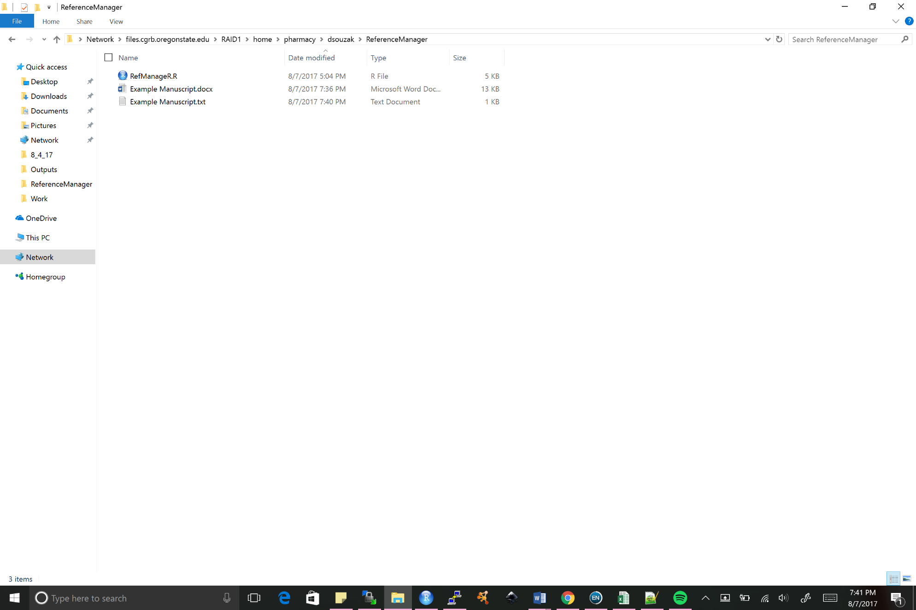

1. Open a terminal and access the CGRB server.
   1. You can use PuTTY, an SSH client. To download PuTTY, go [here](https://www.chiark.greenend.org.uk/~sgtatham/putty/latest.html).
      1. Once downloaded, start a new session.
         1. Host Name: shell.cgrb.oregonstate.edu
         2. Port: 732
         3. Connection Type: SSH
         4. After clicking open, enter your CGRB login credentials.

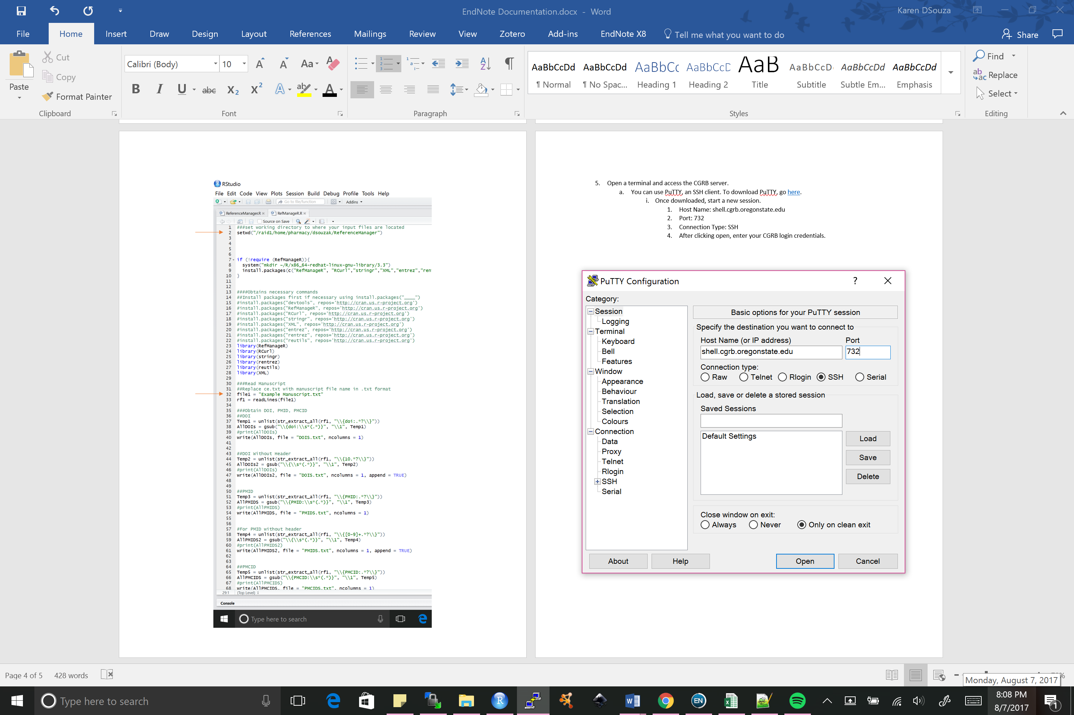

1. Enter your CGRB credentials!
2. Set your working directory in the terminal. Use cd to change your directory.
   1. Ex: cd /raid1/home/pharmacy/dsouzak/ReferenceManager/
3. Run the script using: Rscript RefManageR.R Manuscript.txt

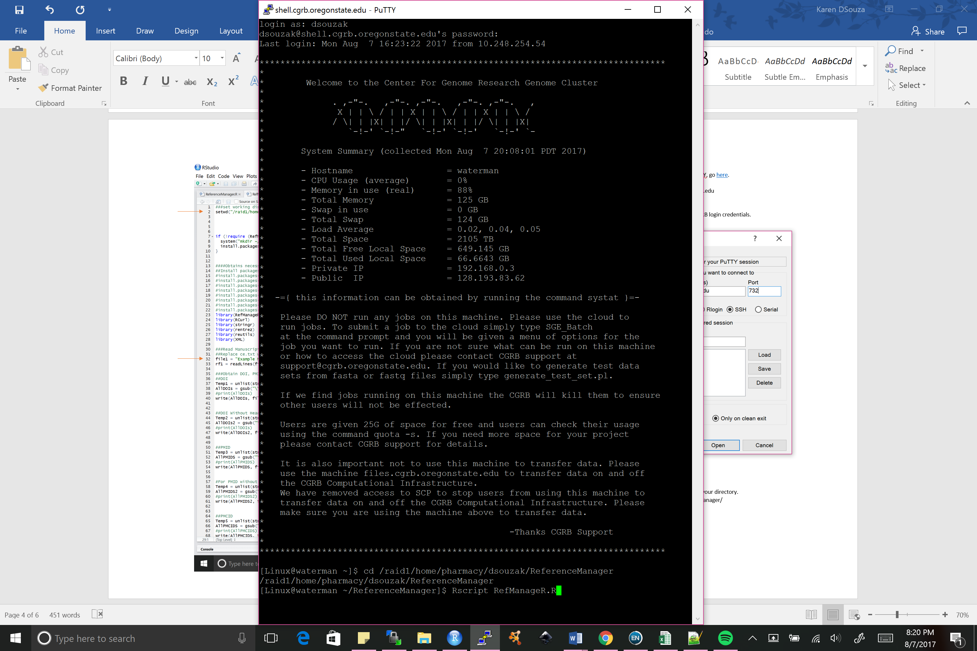

1. 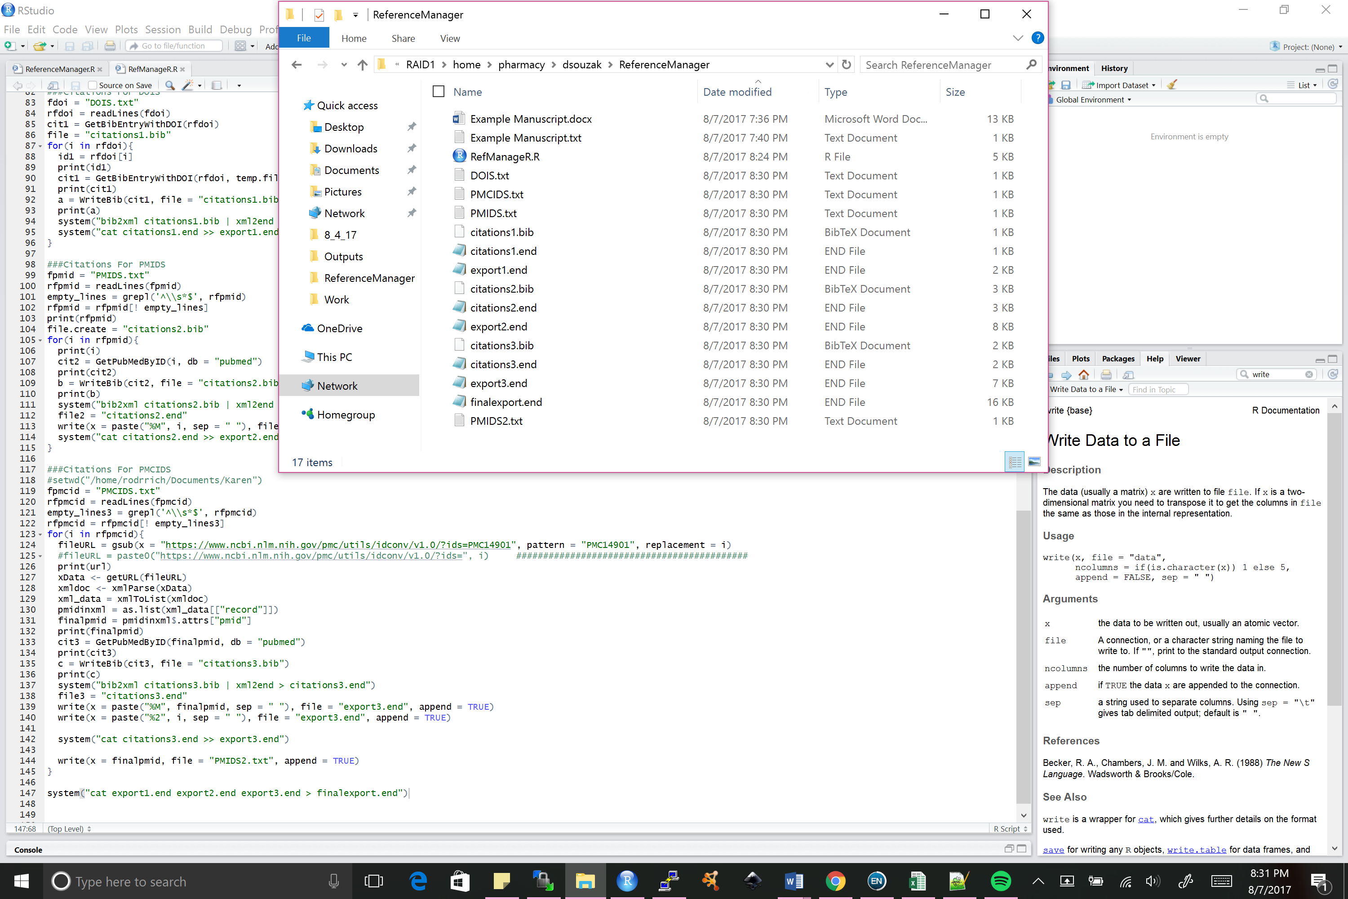Your folder should look like the following:
2. In EndNote, you can create a new library, if you wish.
3. To import your citations, go to: Files > Import > File…

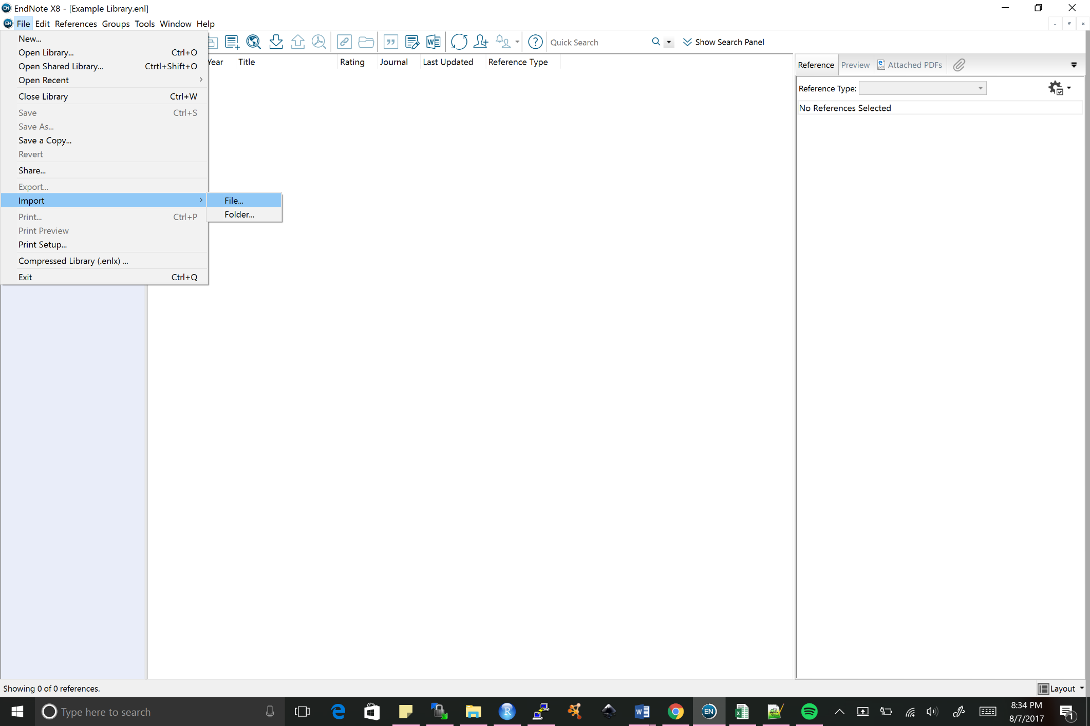

1. Click Choose…, and click “finalexport.end”. For “Import Options”, choose “EndNote Import”. Discard duplicates per your discretion.

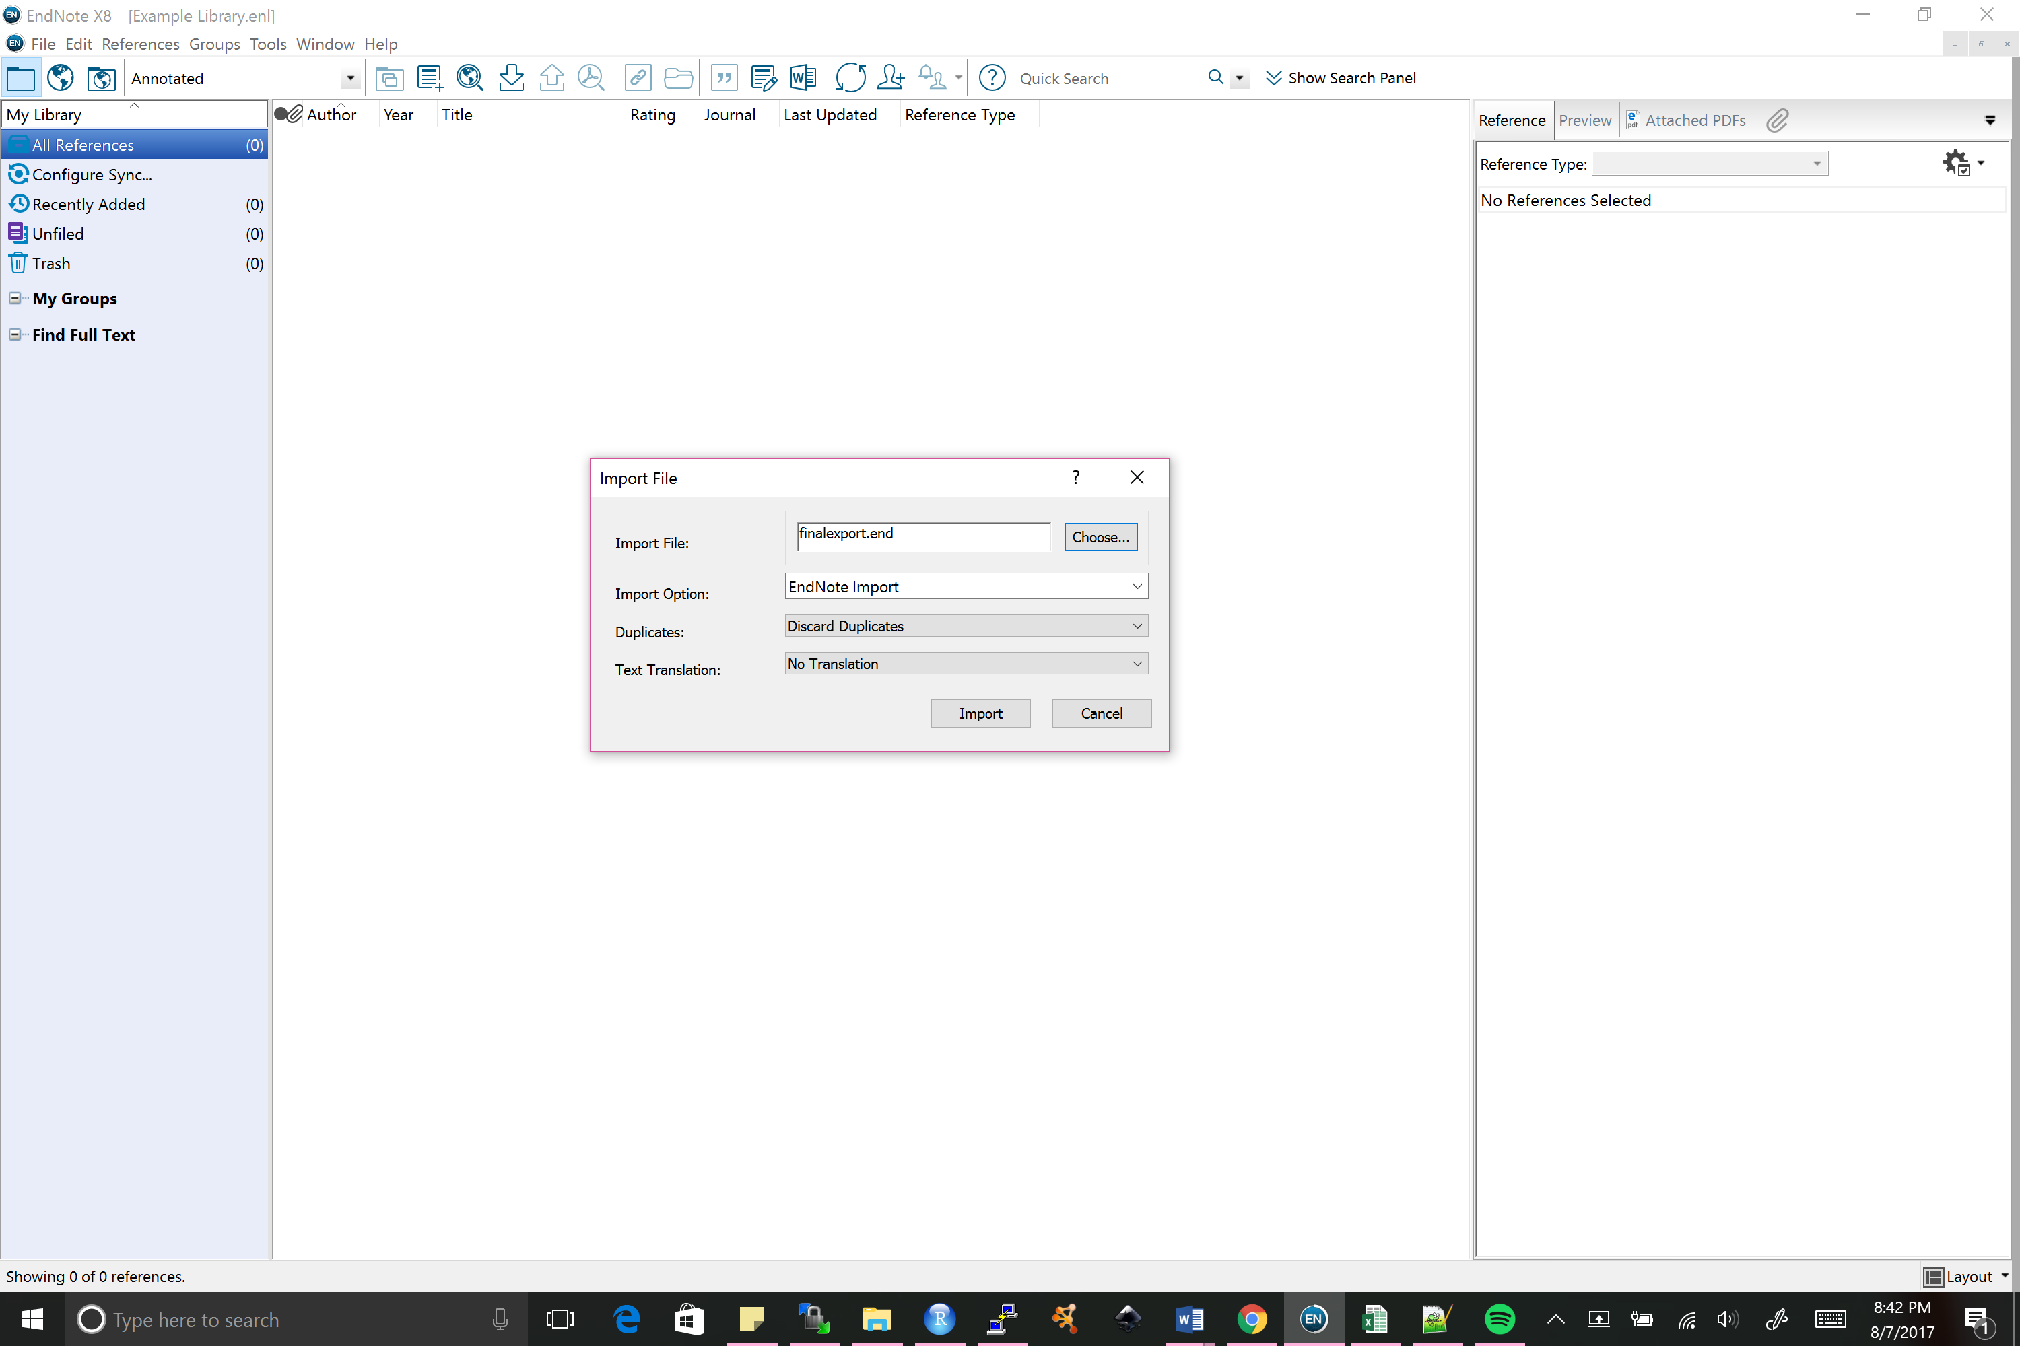

1. 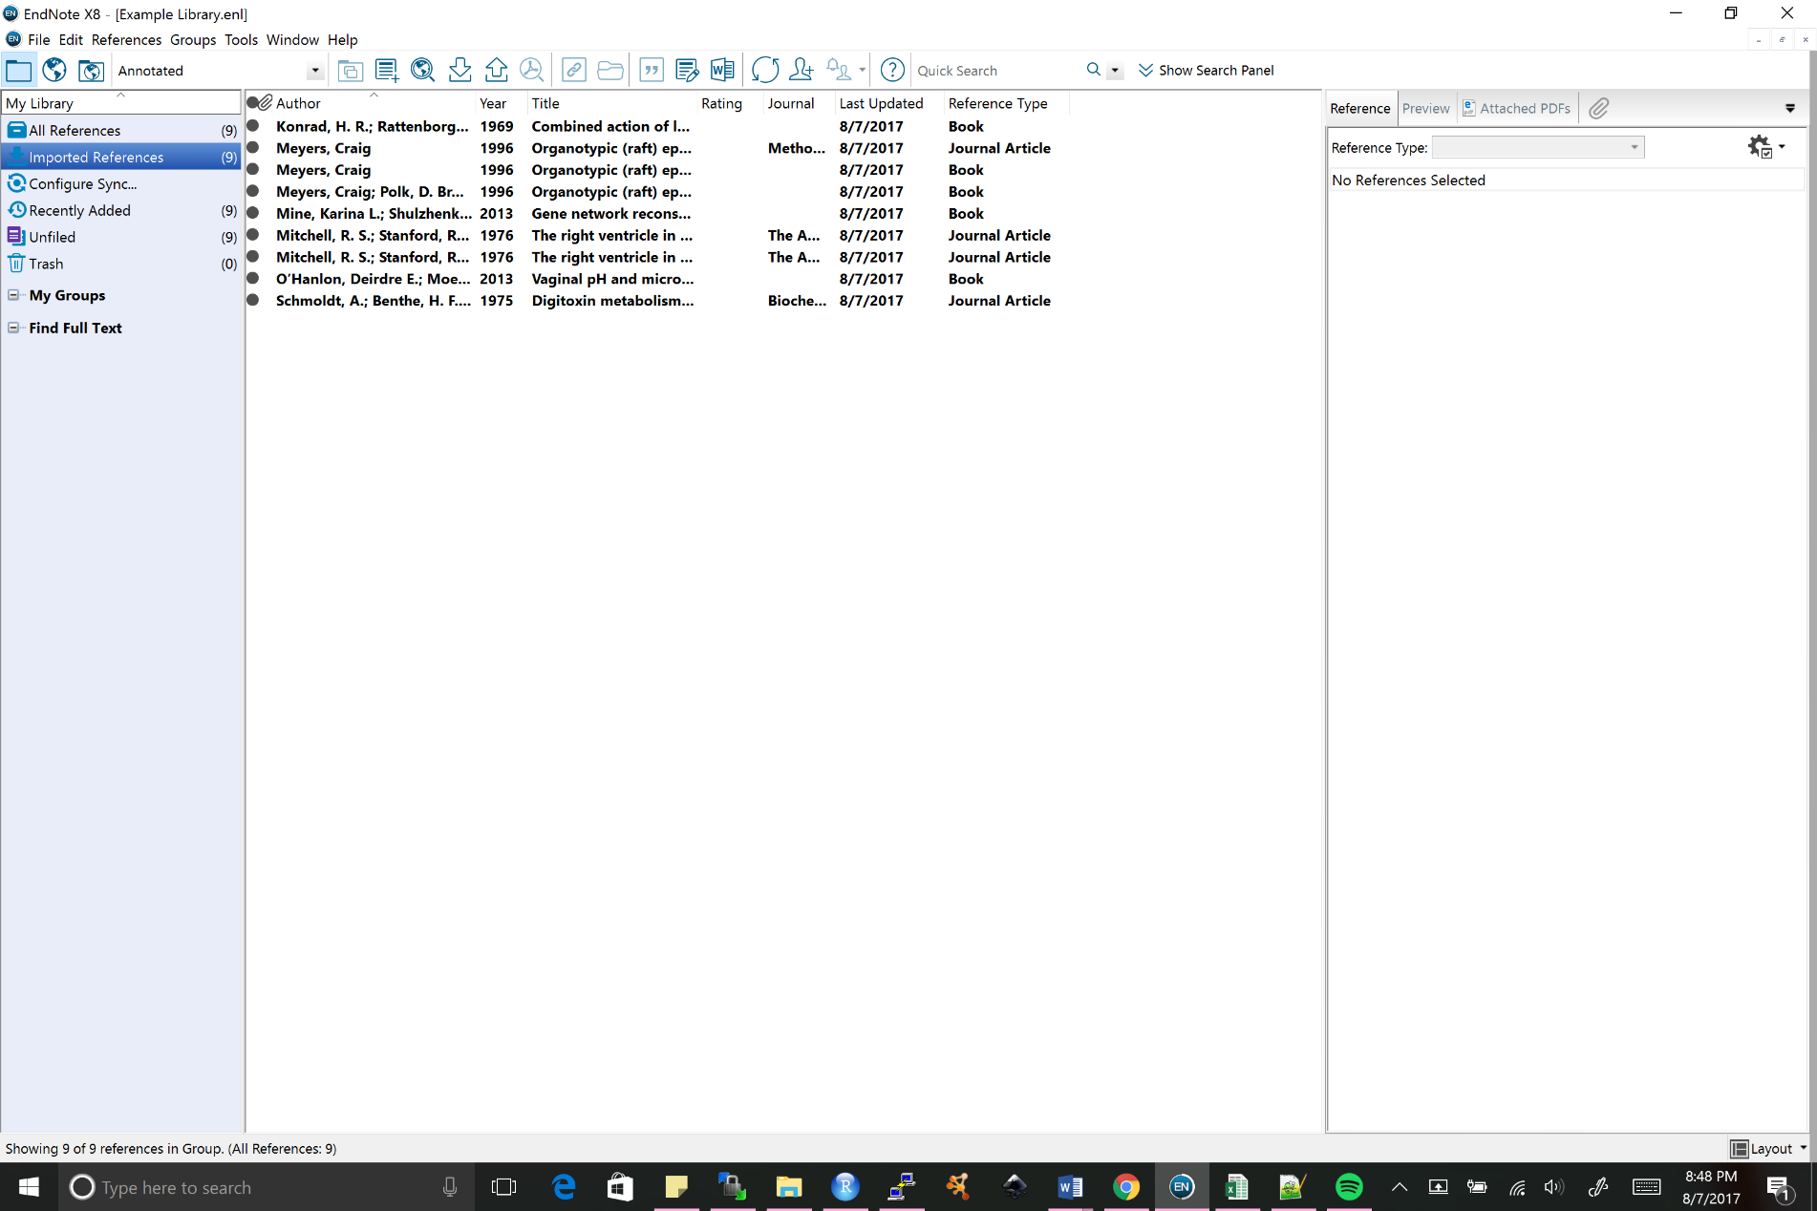Your final library should look like the following:
2. Importing Citations Back Into EndNote
   1. Open EndNote X8 Tab
   2. Set style to preference
   3. Turn instant formatting on