**Unit Test Plan**

Project Number: OF-3392

*Review days between Statement Generation and Past Due Notice*

# Test Plan / Results

The issue is that customers which have never received a statement before were receiving statements which reflected that they had overdue amounts. This could occur when the statement was issued/generated more than thirty days after the due date of an individual line item. The changes for OF-3392 are intended to prevent such line items from contributing to a sum of overdue amounts.

To test and demonstrate this functionality:

1. Identify an customer which satisfies the following criteria:  
   balance outstanding is not zero  
   has never received a statement before.
2. Choose a “statement as-of date” which is more than thirty days after the due dates of the individual line items ordered by the aforementioned customer.
3. Execute a statement run for the customer  
   Under the “Receivables Manager” responsibility, execute the “LWX AR Consolidated Statement Generation Program “request; this requires four parameters, show in the following example: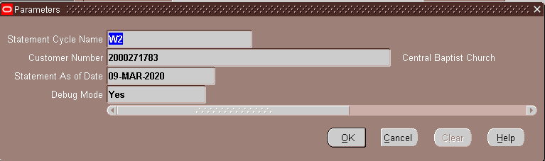  
     
   N.B. The statement cycle parameter must be determined for the customer in question. It may be necessary to alter the statement cycle’s date (and the date of all other statement cycles to a different date.)  
     
   Use the “statement as-of date” determined/chosen in step 2, above, and be sure to set the “Debug Mode” parameter to “Yes.”
4. The generated statement itself, and the output and log data, should show that the customer has no overdue amounts, even though the statement as-of date dictates that the amount in question ought to be counted as due before the statement due date.  
   (The program internally substitues the customer-record’s creation-date for the statement-date, and this can be seen in the log output, in a line beginning with the text “Last Statement Date Determined:”.)