**Unit Test Plan**

Project Number: OF-3393

*Address is Rejected in Statement Process*

# Test Plan / Results

The issue arose when customers didn’t have addresses for which a valied geocode existed. This change to the statement generation process creates process log entries which provide warning messages when the geocode is missing, and allows the statement generation process to proceed nonetheless. Formerly, the statement generation process would not generate a statement if the geocode data were missing.

To test and demonstrate this functionality:

1. Identify an customer which satisfies the following criteria:  
   balance outstanding is not zero  
   the customer’s address does not possess a valid geocode
2. Choose a “statement as-of date” which is more than thirty days after the due dates of the individual line items ordered by the aforementioned customer.
3. Execute a statement run for the customer  
   Under the “Receivables Manager” responsibility, execute the “LWX AR Consolidated Statement Generation Program “request; this requires four parameters, show in the following example: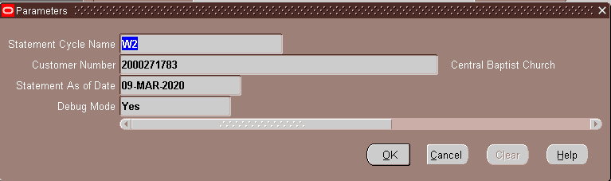  
     
   N.B. The statement cycle parameter must be determined for the customer in question. It may be necessary to alter the statement cycle’s date (and the date of all other statement cycles to a different date.)  
     
   Use the “statement as-of date” determined/chosen in step 2, above, and be sure to set the “Debug Mode” parameter to “Yes.”
4. The generated statement itself, and the output and log data, should show that the customer statement has been generated, and the log should show a warning message indicating that the geocode data are missing. The warning text is:  
    *** Warning: missing geocode data