UCF Overview Notes v102922
Richard Todd
Test Engineering Services

Description
The UniConsole app is an application framework with a management console. It provides the following functionality:
-
1. A multi-tabbed console for text output
2. Plugin management & intermodule communication using interfaces
4. A path manager that provides pre-configured paths to all modules

Purpose
The framework is intended to be used for quick-turn and interactive development as follows.
1. A framework to build applications using re-usable components (shared libraries)
2. A development environment where prototype code can be loaded within a module and controlled from an interactive command line interface

Design Features

The
framework includes the following features
1. Plugin module development where common functionality is contained in the framework which does not require recompilation
2. Interactive / command line execution of module methods.
3. A common interface to external instrumentation and IO channels that include TCP, UDP, file and serial IO.
4. An embedded database that contains IO channel configurations.
5. An embedded database the contains test specifications, limits and measurement values.

User Interfaces
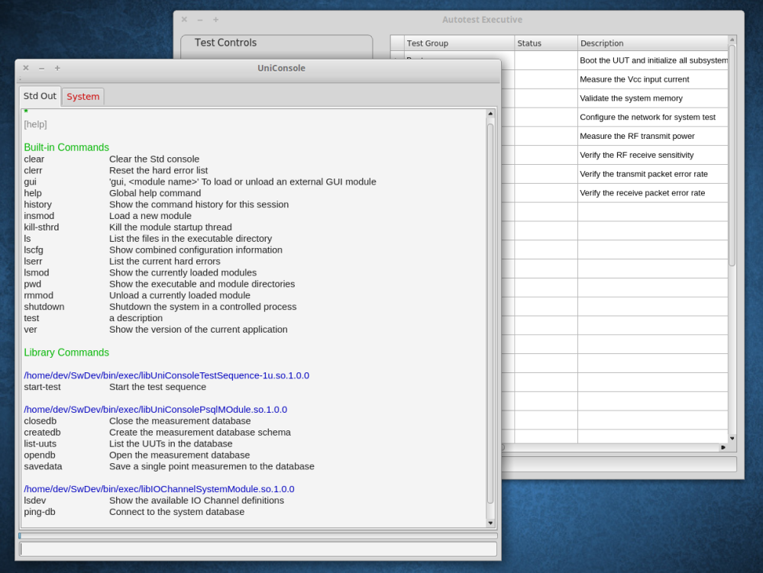

UCF Introduction Notes v102922
Richard Todd
Test Engineering Services

Organization

Startup

The framework can be started from the command line , script or desktop icon.

Linux

/home/dev/ucfroot/bin/UniConsole -p /home/dev/ucfroot/opt/dash/

FCT

Windows

:

c:\ucfroot\bin\UniConsole -p c:\ucfroot\opt\dash\

FCT
Where:
1. ‘-p <pathname>’ specifies the path to the plugin module to be loaded.
2. 'FCT' is the last element in the specified path and defines the test profile name.
3. Test profile names are used to index test specifications, limits and measurement data.
4. All shared libraries in './FCT' will be loaded on framework startup.

Interactive Station Control

On startup, the first window to be opened is the ‘Management Interface’ console.

All test functions and sequences can be interactively called using the command line interface.
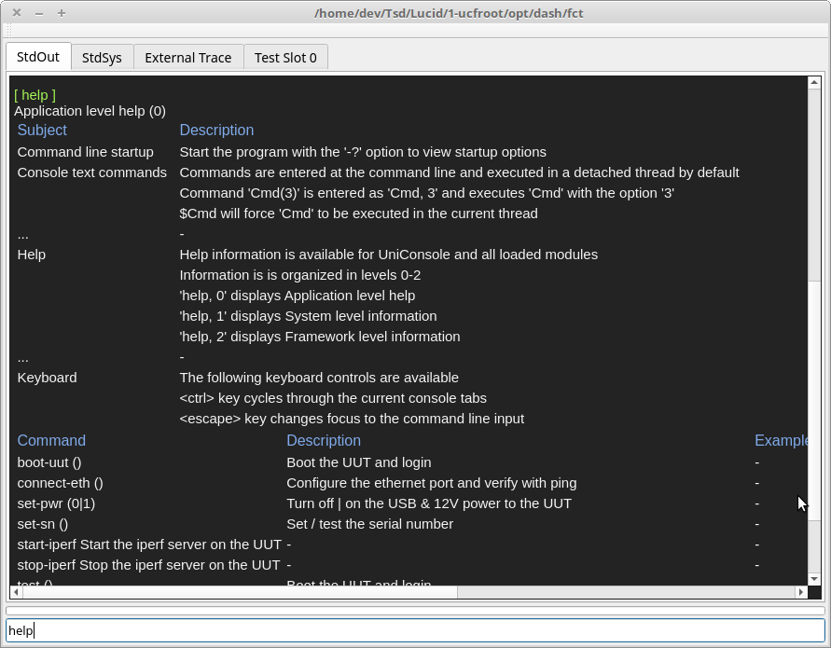

UCF Test Procedure Notes v102922

Richard Todd

Test Engineering Services

Overview
Automated tests can be executed from either the command line input, or using a GUI test executive.

Command Line Test Sequence

1. Select the desktop icon to start the framework.

2. Insert a reference unit into the test fixture.

3. Start a test sequence using one of the following command line options:
-

•

Type ‘StartTest' to start a single test sequence

•

Type ‘n*StartTest’ to start a test sequence that will repeat ‘n’ times
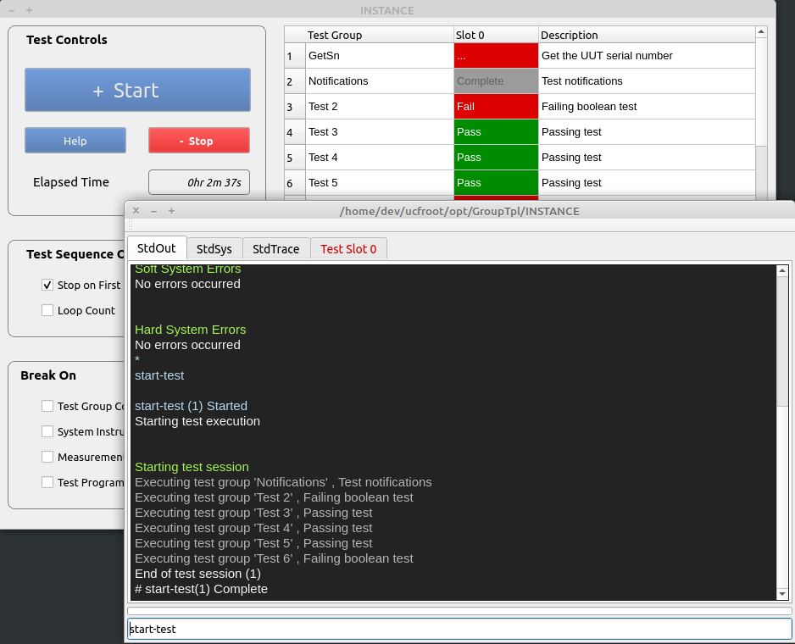

GUI Test Sequence

1. Select the desktop icon to start the framework.

2. Insert a reference unit into the test fixture.

3. Select the ‘Start’ button, or enter ‘+’ from the numeric keypad.
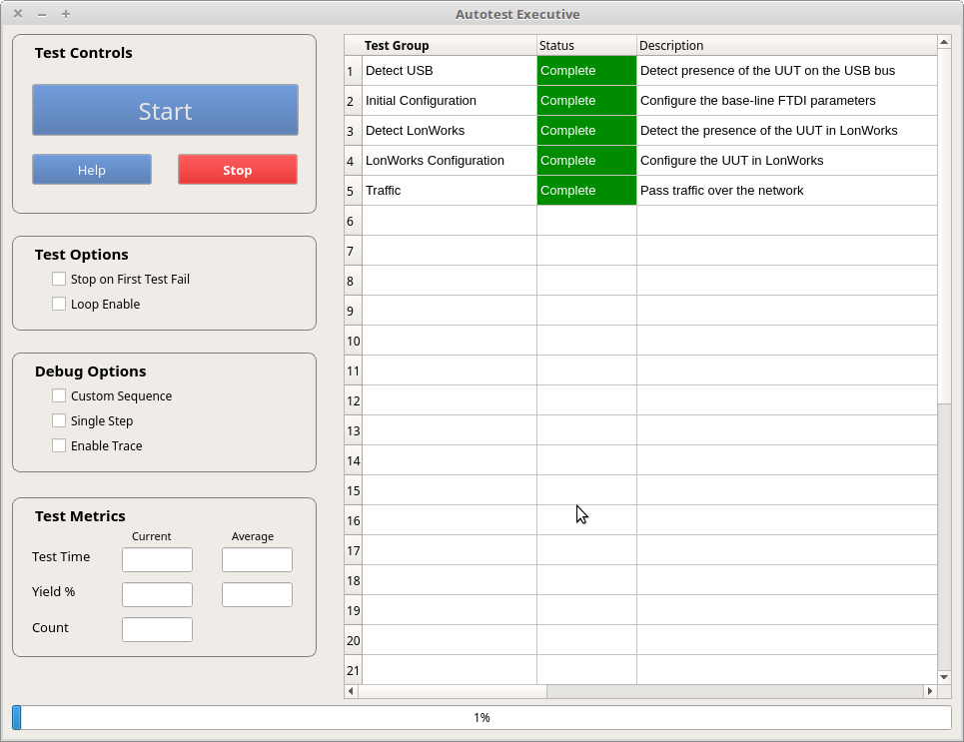
The ‘Status’ column will display test status for each test step .
◇ ‘Complete’ displayed in a green box indicates the test step completed successfully.
◇ ‘Fail’ displayed in a red box indicates a test step failure.
Additional diagnostic information may be displayed in the console window
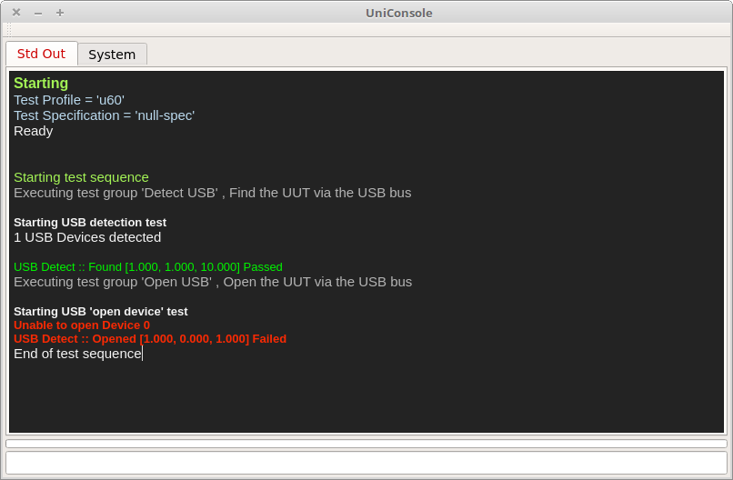

3. Follow any instructions displayed by the test executive.

4. At the end of the test, a dialog will be displayed that specifies the test ‘pass / fail ‘ status
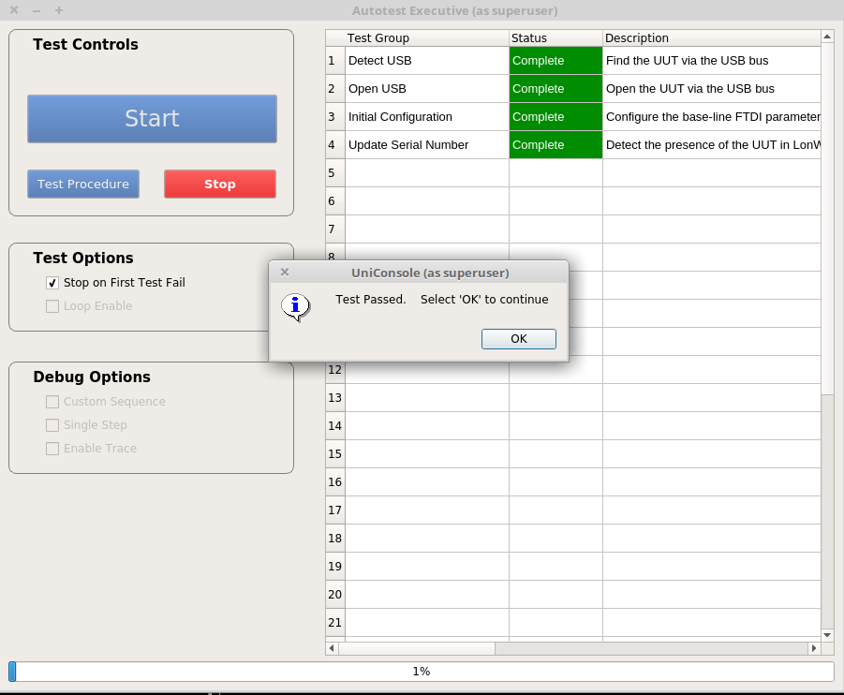

5. Remove the UUT from the fixture.

6. Repeat steps 5.1 to 5.5 for each unit under test.

UCF Configuration Notes v102922
Richard Todd
Test Engineering Services

Description
T

his document defines the UniConsole Framework configuration options and the required directory structure and file organization.

Common Terminology

The following section specifies the meaning of critical terms used in this document.
ID | Term | Definition
1 | UCF | The UniConsole Framework software package
2 | UCF app | The application that is created when the UCF loads a specified Profile
3 | UCF plug-in | A shared library that has been built using the UCF template module
4 | SDS | The standard directory structure
5 | Profile | A user named directory that identifies a group of plug-in modules that create a UCF app. See SDS Definition -> <Profile>.
6 | Profile Group | A user named directory that contains 1 or more ‘Profiles’ that share common configuration databases.
7 | IO Channel | An IO channel enables the application to communicate with external devices and systems using TCP, UDP, File and Serial IO.
8 | Symbolic Link | An alias for a directory path or filename
9 | Test Specification | A version controlled document that specifies the measurement parameters and pass/fail limits to be used in a test UCF app.

Configuration Options

The following UCF options are configured using a combination of directory structures and embedded sqlite databases.

Code modifications are not required.

UCF Startup Options

UCF startup options are displayed using ‘UniConsole(.exe) -h’

1. Profile directory location

2.

Common configuration directory

3.

UCF app light or dark GUI background

4. UCF app font size

5. Common profile library(s) load/no-load

6. Debug mode to ignore initialization errors

7. Management Interface horizontal and vertical window size

Profile Content

1. UCF plugins added or deleted to modify UCF app functionality.

2. Test specifications can be associated with each profile.

Test Specifications

1. Name and revision.

2. Measurement parameter names.

3. Pass/Fail limits for each measurement parameter.

System IO

1. Default IO channel configurations for all profiles.

2. Specialized IO Channel configurations located in Profile Grou ps that override defaults.

3. Path and filename aliases.

Test Executive Options

1. The manufacturer's name and location of the test station.

2. The number of units to be tested concurrently.

3. Manual UUT serial number verification enable / disable.

Required Tools

The UCF is configured using a combination of the following tools and methods.

1.

Modification of the UCF startup command line options using a text editor

2.

Organization of UCF plug-in modules using OS specific methods to copy /move files.

3.

Editting of embedded Sqlite databases using the ‘DB Browser for Sqlite’ application.

Directory Structure

The framework is organized in a standardized directory structure that contains all releases and versions of UCF related modules and databases.
ucfroot/
│
├── opt
│ └── <Profile Group>
│ ├── ExtSystemIO.sdb
│ ├── CommonLibs
│ │ ├── module1.so
│ │ └── modulen.so
│ └── <Profile>
│ ├── LastTest.log
│ └── libTplModule.so
└── bin
└── <ReleaseName>
├── UniConsole (.exe)
│
├── IOConfig
│ ├── BaseSystemIO.sdb
└── StaticModules
├── CommandLineProcessor.so
└── libIOChannelSystemModule.so

Directory and File Organization

The files are organized in the following manner:

<Profile>
Profiles define a unique UCF application. Each profile is user defined sub-directory that contains 1 or more UCF plug-in modules.
UCF app functionality can be modified by adding or deleting UCF plug-ins in this directory.
The name of the directory is used to index all application specific data either used or created by the application.
1. Test specifications and limits.
2. Test measurement data.

<Profile Group>
A <Profile Group> is a user-defined directory that contains a family of ‘Profiles’ that share common resources. A ‘Profile Group’ contains
1. 1 or more <Profile> subdirectories.
2. An IOChannel database that is common to all ‘Profile’ subdirectories (ExtSystemIO.sdb).
3. Common shared libraries that will be used by all ‘Profiles’

<ReleaseName>
The <ReleaseName> directory contains a specific version of the UniConsole Framework. ‘<ReleaseName>’ is named appropriately to identify
the UCF version that it contains. The directory contains the following elements:
1. The UniConsole(.exe) executable
2. An embedded IO Channel database that contains default IO channel configuration data for all ‘Profiles’ and ‘Profile Groups’ (BaseSystemIO.sdb).
3. Plug-in modules that are part of the base UCF application.

Test Executive Configuration Data
The UCF test executive uses the following embedded databases to define critical test parameters and logs.
'

/

var/lib/ucf/' or ‘c:\ucfroot\var\lib\

’

│

├──

MeasurementDb.sdb

├──

Static.sdb

├──

TestFixtureIndex.sdb

├──

TestLimits.sdb

└──

UniConsole.log

Static.sdb
Defines the name and location of the company where the station is located. Test measurement data is trace-able to this data.

TestLimits.sdb
Contains test specification and test limit data indexed by the test ‘Profile’ name.
1. Test specification names and versions
2. The test specification used by each ‘Profile’
3. The parameters and test limits defined by each test specification

TestFixtureIndex.sdb
Contains test fixture serial numbers and a real-time insertion count.

MeasurementDb.sdb
Contains test parameter measurements that are trace-able to
1. Test sequence date and time
2. Test station location & name, fixture ID
3. The test specification and DUT type
4. UUT serial number

UniConsole.Log

This text based log file

that contains system level information for each UCF instance.

1. UCF startup and shutdown

2. All system soft error information

3. All system hard error information

4. Test fixture ID

5. Test sequnce start

UCF Test Executive Configuration Notes v102922

Richard Todd

Test Engineering Services

Requires libTeSequencer.(so | dll) v112922 or later.

Description

This document outlines the necessary steps to configure the UCF test executive framework.

Configuration Information

The following information must be configured to insure measurement data trace-ability.

The ‘DB Browser for Sqlite’ application is used to configure the required information in the following order.

-

1) The manufacturer's name and location of the test station

2) Test specifications, parameters and limits for each test profile

3) The number of units to be tested concurrently

4) Manual UUT serial number verification

Configuration Databases

The configuration databases are located in ‘~/ucfroot/var/lib/’ or c:\ucfroot\var\lib' directories.
-

◇ Static.sdb contains manufacturer ID and location information

◇ TestLimits.sdb contains test specifications and limits used by each framework profile

◇ Base/ExtSystemIO.sdb contains system variables

Configuration Process

The following process is used to configure the test executive.

Manufacturing ID
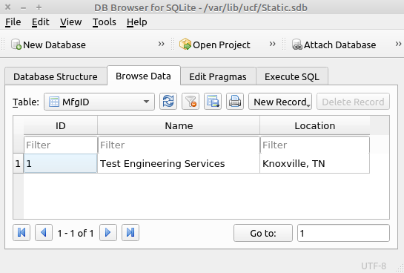

1.

‘Name’ is the name of the manufacturing company.

2.

‘Location’ is the location of the manufacturing company.

3.

Only the first record is used. All additional entries will be ignored.

Test Specification(s)

Any number of test specifications can be set in the TestLimits::TestSpecIndex table.
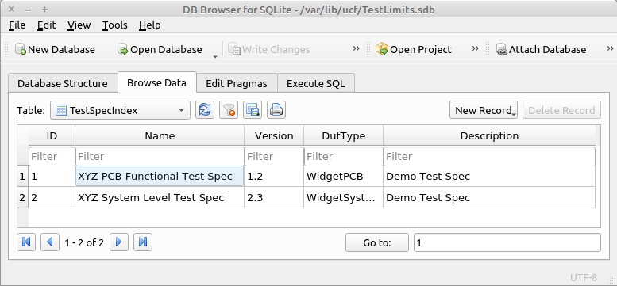

1.

‘ID’ is the numeric identifier used to reference each test specification

2.

‘Name’ is the name of the test specification

3.

‘Version’ is the version of the test specification. Multiple versions can be specified

4.

‘DutType’ is the name/type of UUT to be tested

5.

‘Description’ is a brief description of the test specification

Test Profile Maps(s)

T

he test profile map table specifies which test specification will be used for each framework profile.
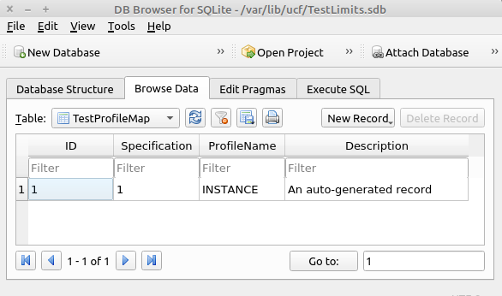
1. ‘Specification’ corresponds to a test specification ID defined in TestLimits::TestSpecIndex
2. ‘ProfileName’ is the last element in the file path specified when starting the UniConsole framework.
-
Example UCF startup command: ./bin/UniConsole(.exe) -p /home/dev/ucfroot/opt/GroupTpl/INSTANCE (INSTANCE is the profile name)

Test

Limits
The test profile map table specifies which test specification will be used for each framework profile.
This table will be automatically populated the first time the test sequence is executed and will use the the
default values specified in the test program ( ->SaveMeasurement(namespace, parameter, lolimit, hilimit).
Subsequent calls to ->SaveMeasurement(...) will not update the test limits.
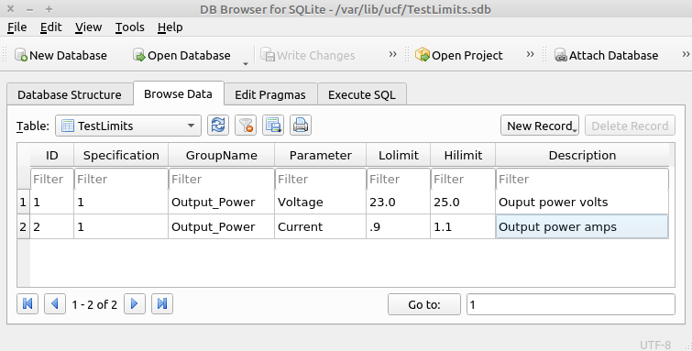
1. ‘Specification’ corresponds to a test specification ID defined in TestLimits::TestSpecIndex.
2. ‘GroupName' is a category or namespace.
3. ‘Parameter’ is the name of a specific measurement.
4. ‘Lolimit’ is the lower pass/fail threshold. Passing values are >= ‘Lolimit’.
5. ‘Hilimit’ is the upper pass/fail threshold. Passing values are <= 'Hilimit.

Slot Count & Verify Serial Number
The framework is capable of testing 1-16 UUT's concurrently and can require that a serial number be manually entered at the start
of a test sequence.
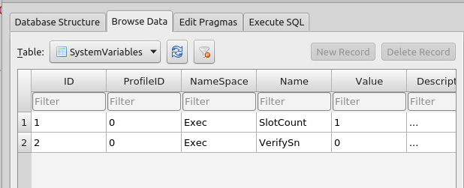
1. ‘ProfileID’ is not used.
2. ‘NameSpace’ = ‘Exec’
3. ‘Name’ = ‘SlotCount’ | ‘VerifySn’
4. ‘SlotCount’ is the number of units to be tested concurrently (1-16)
5. ‘VerifySn’ enable/disables manual input of a serial number at the start of a test sequence.

This is an older version of the database scheme.
Used with all up to and including performance studio
~~~~~~~~~~~~~~~~~~~~~~~~~~~~~~~~~

UCF Configuration Notes v102922

Richard Todd

Test Engineering Services

Requires StdIOChannelSystem(.so | dll) v112922 or later.

Description

The UCF framework provides builtin support for configuring, writing to, and reading from common IO stream types.

-

◇ TCP client and server

◇ UDP client and server

◇ RS232

◇ TTY/ACM

◇ Local files

-

The following types of IO stream configurations are supported

-

▪ Global configurations that are common to all profiles

▪ Local configurations that are common to a specific profile group

-

Local configurations will always override global configurations of the same name.

Data Locations

System variables are stored in sqlite databases.

-

◇ Local variables are stored in the ‘SystemsVariable’ table in

(

./opt/<Profile Family Name>/ExtSystemIO.sdb

)

-

◇ Global variables are stored in the ‘SystemsVariable’ table in

(

./bin/<Release Name>/BaseSystemIO.sdb

)

ucfroot-

<version>

├── bin

│ ├──

Uniconsole.AppImage || Uniconsole.exe

│ └── IOConfig

│ └──

BaseSystemIO.sdb

(global)

└── opt

└── <GroupName>

├──

<ProfileName 1>

├──

<ProfileName n>

└──

ExtSystemIO.sdb

(local)

Configuring IO Channel Definitions

IO stream configurations are created and updated using the sqlitebrowser utility.
-
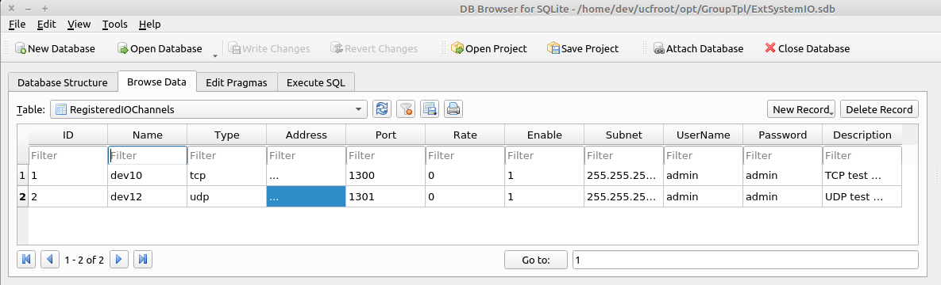

IO Stream Types

The IO stream type name is case-insensitive.

-

1. file = std::fsream

2. tty (ACM) = virtual com port, no baud rates involved

3. serial = rs232 type serial port

4. tcp = TCP client

5. tcp-s = TCP server

6. udp = UDP client

7. udp-s = UDP server

Type Specific Field Definitions
-
Label | File | TTY | Serial | TCP / UDP | TCP/UDP Server | Note
ID |  |  |  |  |  | Unused
Name | dev1-n | dev1-n | dev1-n | dev1-n | dev1-n | Channel name used by the application program(s)
Type | file | tty | serial | tcp | tcp-s / udp-s | IO type specification
Address | <filename> | <ttyACMn> | <ttyUSBn / COM n> | <ip address> | <ip address> | Text based address
Offset |  |  |  |  |  | Any required numeric address offset info
Port |  |  |  | socket port# | socket port# | Port specification
Rate |  |  | <baud rate> |  |  | Numeric communication speed
Enable | <0|1> | <0|1> | <0|1> | <0|1> |  | 1 to enable the IO channel, else 0
Subnet |  |  |  | <subnet mask> | <subnet mask> | Host subnet
UserName |  |  |  | <usr> | <usr> | Host user name
Password |  |  |  | <pswd> | <pswd> | Host password

Notes: 1. IO stream names are defined as DEV0-DEV23.

The naming scheme is used for internal IO stream organization and names are case-insensitive.

2. All IO stream definitions are loaded on framework startup.

3. IO streams use the API defined in ‘iStdIOChannelSystem.hpp’ and iIOChannelDevice.hpp' to use an IO stream.

-

▪ iStdIOChannelSystem::RegisterIOChannelDevice(...)

▪ iStdIOChannelSystem::GetTmpIOChannelDevice(...)

▪ iIOChannelDevice::Open()

▪ iIOChannelDevice::Write(...)

▪ iIOChannelDevice::Read()

▪ iIOChannelDevice::Close()

Description

The UCF framework provides builtin support for configuring, writing to, and reading from common IO stream types.

-

◇ TCP client and server

◇ UDP client and server

◇ RS232

◇ Local files

-

The following types of IO stream configurations are supported

-

▪ Global configurations that are common to all profiles

▪ Local configurations that are common to a specific profile group

-

Local configurations will always override global configurations of the same name.

Data Locations

System variables are stored in sqlite databases.

-

◇ Local variables are stored in the ‘SystemsVariable’ table in

(

./opt/<Profile Family Name>/ExtSystemIO.sdb

)

-

◇ Global variables are stored in the ‘SystemsVariable’ table in

(

./bin/<Release Name>/BaseSystemIO.sdb

)

ucfroot-

<version>

├── bin

│ ├──

Uniconsole.AppImage || Uniconsole.exe

│ └── IOConfig

│ └──

BaseSystemIO.sdb

(global)

└── opt

└── <GroupName>

├──

<ProfileName 1>

├──

<ProfileName n>

└──

ExtSystemIO.sdb

(local)

Configuring IO Channel Definitions

IO stream configurations are created and updated using the sqlitebrowser utility.
-
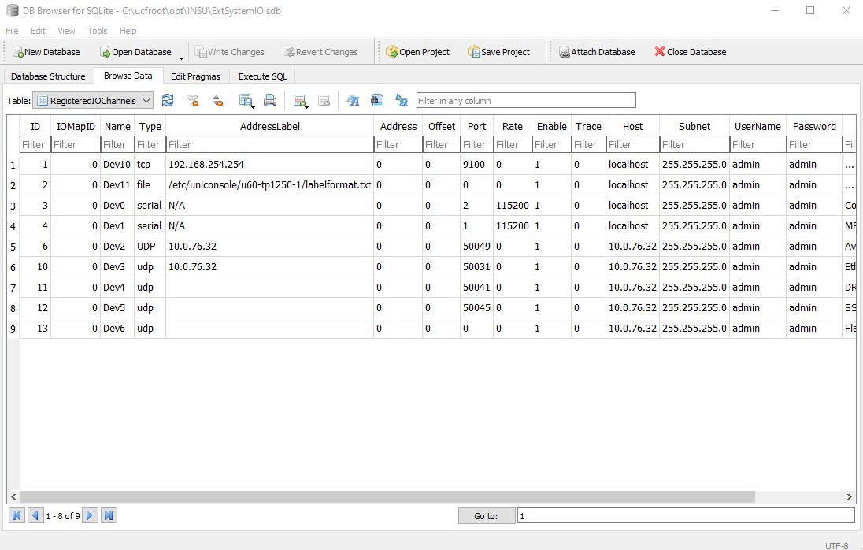

IO Stream Types

The IO stream type name is case-insensitive.

-

1. file = std::fsream

2. serial = rs232 type serial port

3. tcp = TCP client

4. tcp-s = TCP server

5. udp = UDP client

6. udp-s = UDP server

Type Specific Field Definitions
-
Label | File | Serial | TCP / UDP Client | TCP / UDP Server | Note
ID |  |  |  |  | Unused
IOMapID |  |  |  |  | Unused
Name | dev0-n | dev0-n | dev0-n | dev0-n | Channel name used by the application program(s)
Type | file | serial | tcp / udp | tcp / udp | IO type specification
AddressLabel | <filename>
Address |  | <ttyUSBn / COM n> |  |  | Text based address
Offset |  |  |  |  | Any required numeric address offset info
Port |  | 1-n | socket port# | socket port# | Port specification
Rate |  | <baud rate> |  |  | Numeric communication speed
Enable | <0|1> | <0|1> | <0|1> | <0|1> | 1 to enable the IO channel, else 0
Trace
Host |  |  | <ip address> | <ip address> | Host IP address (local host works)
Subnet |  |  | <subnet mask> | <subnet mask> | Host subnet
UserName |  |  | <usr> | <usr> | Host user name
Password |  |  | <pswd> | <pswd> | Host password

Notes: 1. IO stream names are defined as DEV0-DEV23.

The naming scheme is used for internal IO stream organization and names are case-insensitive.

2. All IO stream definitions are loaded on framework startup.

3. IO streams use the API defined in ‘iStdIOChannelSystem.hpp’ and iIOChannelDevice.hpp' to use an IO stream

-

▪ iStdIOChannelSystem::RegisterIOChannelDevice(...)

▪ iStdIOChannelSystem::GetTmpIOChannelDevice(...)

▪ iIOChannelDevice::Open()

▪ iIOChannelDevice::Write(...)

▪ iIOChannelDevice::Read()

▪ iIOChannelDevice::Close()
Note: ‘TheSystem->RegisterIOChannelDevice(1,"The MBC serial interface")’, ‘1’ refers to DEV1.

UCF System Variable Development Notes v102922
Richard Todd
Test Engineering Services
Requires StdIOChannelSystem(.so | dll) v112922 or later.

Description
This document defines the use of UCF system variables.
System variables provide an alternative to hardcoded system configuration values.
-
The following types of variables are supported
◇ Global variables that are common to all profiles
◇ Local variables that are common to a specific profile group
-
Local variables will always override global variables of the same name.

Data Locations
System variables are stored in sqlite databases.
-
◇ Local variables are stored in the ‘SystemsVariable’ table in
(./opt/<Profile Family Name>/ExtSystemIO.sdb)
-
◇ Global variables are stored in the ‘SystemsVariable’ table in
(./bin/<Release Name>/BaseSystemIO.sdb)

Configuring System Variables
System variables are created and updates using the sqlitebrowser utility.
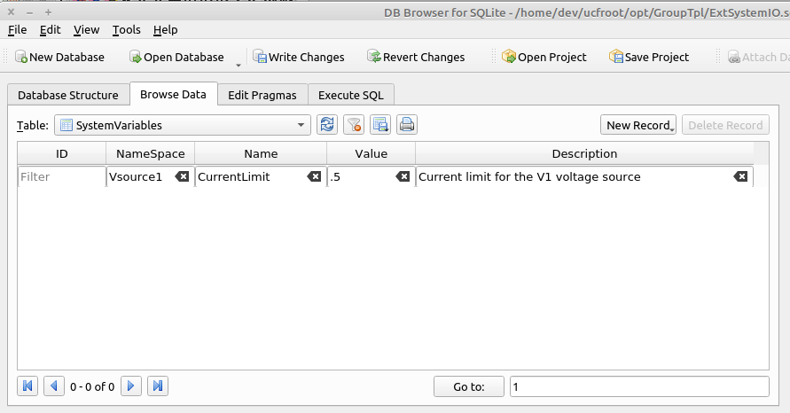

Reading System Variables
-
The value(s) for system variables are read programmatically using the
‘GetSystemVariable(...)’ functions defined in iStdIOChannelSystem.hpp
-
Example 1:
bool status=TheSystem->GetSystemVariable(..);
where iStdIOChannelSystem *TheSystem { }
Example 2:
int TplModule::TestSystemVariables(CmdParam msg) {
std::string ns, name, value, desc;
char cvalue[256];
memset(cvalue,0,256);
TokenString params(msg,',');
if (params.GetTokenCount() > 3) {
params.GetToken(1, ns);
params.GetToken(2, name);
params.GetToken(3, value);
params.GetToken(4, desc);
TheSystem->SetDefaultSystemVariable(ns.c_str(), name.c_str(), value.c_str(), desc.c_str());
TheSystem->GetSystemVariable(ns.c_str(), name.c_str(),cvalue,256);
}
return(1);
}
Extended

