User Interface Reference

This section describes the design and operation of the ‘Management’ and ‘Test Executive’ user interfaces.

The Management Interface

The management interface is designed to provide command line control of the test application. The command line input of the management interface is used to manually control & configure the framework, application system, and application test execution.

System Message Display
System IO Trace Display
Window Title Bar

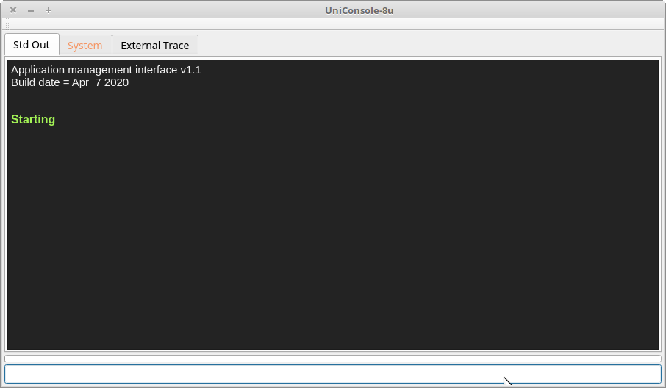
Progress Bar
Window Close Icon
Command Line Input
Standard Message Display

Management Interface Elements

The ‘Management Interface’ provides the following visual components:

ID | Element | Description
1 | Std Out | ‘Std Out’ is a tabbed display used to display general purpose messages from the application.  Default text messages from either UniConsole or a plugin application are displayed with colors used to indicate type.  - White = normal  - Green = pass  - Red = error
2 | System | ‘System’ is a tabbed display used to display application startup messages as well as hardware subsystem related messages.  System level text messages from either UniConsole or a plugin application are displayed with colors used to indicate type.  - White = normal  - Green = pass  - Red = error
3 | External Trace | ‘External Trace’ is a tabbed display used to optionally display messages between the application and external processes and devices. This display is primarily used for debug support.
4 | Command Line Input | Text commands are invoked by entering them in this input followed by a ‘carriage return’.
5 | Window Title Bar | The name of the loaded profile is displayed here.
6 | Window Close Icon | Selecting the ‘X’ will close the window if the application is idle.  If the application is not in an idle state (no commands are executing), the ‘shutdown’ command must be used to terminate the application.

The Test Executive Interface
Test Group Name(s)
Test Group Status
Test Group Descriptions
Test Profile Name

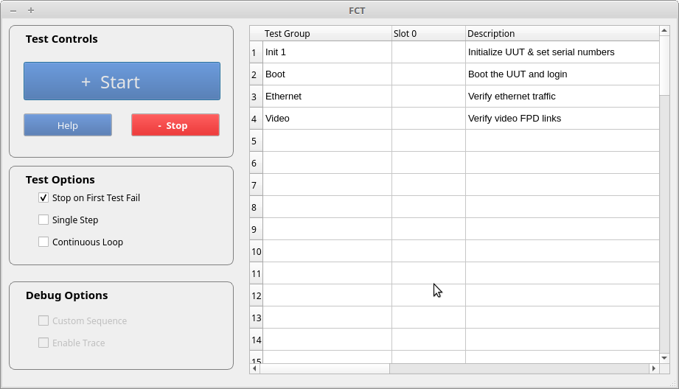
Start Button
Help Button
Stop Button
Go-nogo Checkbox
Single-step
Checkbox
Continuous Loop
Checkbox

Linux notes
- For executing external programs, encapsulating commands in a script that specifies unbuffered output to stdout, can be best.

‘stdbuf -o0 /usr/bin/iperf3 -s >&1’ where ‘stdbuf -o0’ disables output buffering.

