In the Wallet page, add a “PeerOK Society” section .

At the bottom footer section, add a “Partner” to the footer and add the corresponding static page that is used to explain how it works.

#### Referral code:

For the referral code: create a new table to store referral code, and the corresponding user's ID and month.

Ref Code User ID month/year

XeGiOX 12235 03/21

When user click a button, “Generate Sharing Code”, to generate sharing code and sharing URL:

Generate a six digit referral code

Store this code in the table, together with user's ID and month and year this code is generated.

An example of sharing URL:

Peerok.com/XeGiOX

Recycling Code older than one year: In the table, the referral code should be an index and unique in the table. So when generating the code, it needs to be unique. If the code already exists in the table, check if that old code has been more than 1 year old. If that is less than 1 year old, generate another string. If that is longer than 1 year old, delete that record and save the new record.

The referral code is valid for a max of one year.

#### Mentorship

1. A user, BB, may signup using the link with Referral code of AA, or the user BB, may enter his Ref code of AA in his setting page:

Then, AA is recorded as mentor of BB and the signup date.

BB is a group member of AA

1. A user may send a request with a note to change his mentor:

New mentor will receive this request.

It has to be accepted by the new mentor.

1. Mentor can submit a “Kick-Out Request” of user AA. All group members, except AA, should vote on it within one week (mentor already voted). If more than 49% voted members within this week chooses yes, AA is kicked out from this group.

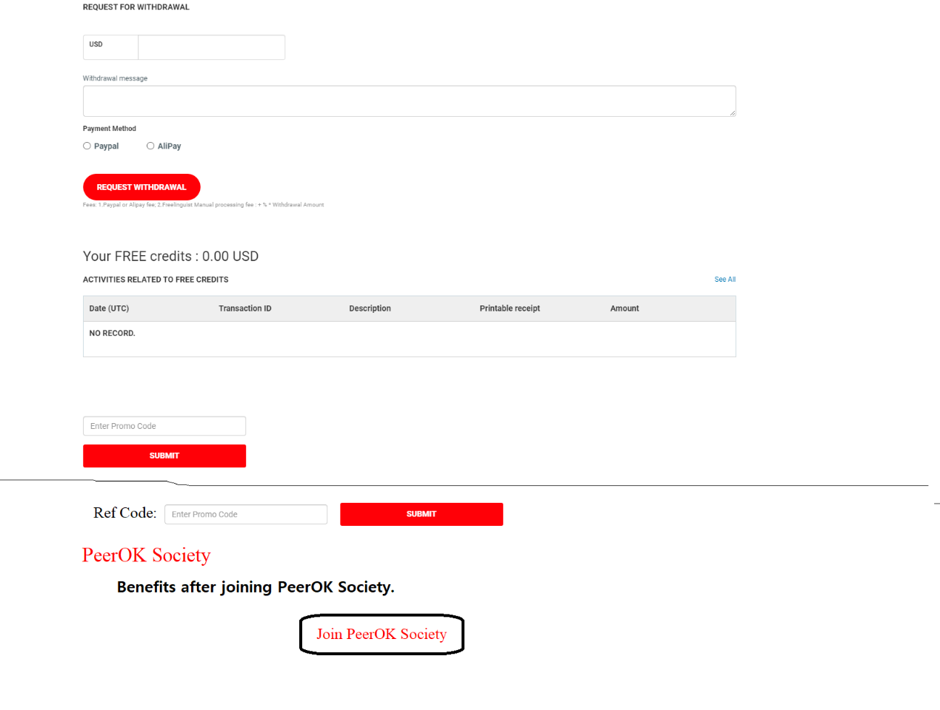

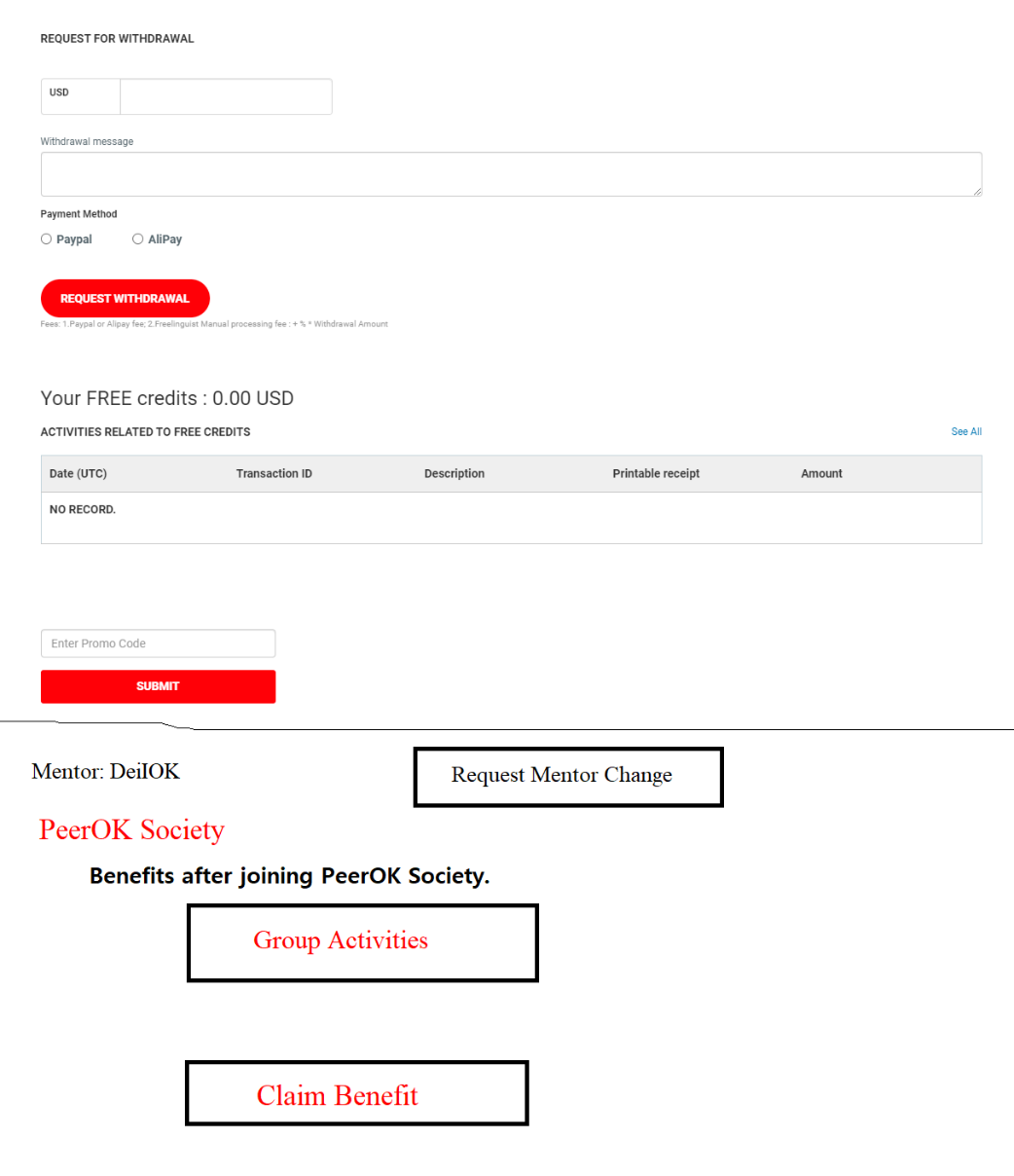

#### SignUp for Society Membership

A user clicks “Join PeerOK Society” (check if user has a mentor) in his freelancer profile page to apply and enjoy all the benefit:

Every month: Basic bonus payment + commission of work done by group members.

The application has to be approved by his Mentor.

Monthly benefit as a Society member: user can click a button, “Claim Benefit”, once every month to claim this benefit payment.

Always effective:

Type 0: Work Bonus, only given if user has joined PeerOK Society.

z% of (own monthly freelance earnings or client spending + Mentor’s Last Month Commission / # of group members)

1/3 paid if:

1. Post at least 4 new content for sale in this month.
2. **And** Complete at least one job in this month as either freelancer or client.

1/3 paid if:

1. Have hired at least one new group member that has completed at least one job in this month as either freelancer or client.

1/3 paid if:

1. Mentor’s group have hired at least two new group members that have completed at least one job in this month as either freelancer or client.

Type 1: Unlimited Commission Payment:

x% of the monthly freelance earnings of each direct group member +

y% of the monthly freelance earnings of all **users whose mentors are the direct group member of this director (one level down, 2 levels total)**

½ paid if:

1. Post at least 4 new content for sale in this month.
2. **And** Complete at least one job in this month as either freelancer or client.

½ paid if:

1. Have hired at least one new group member that has completed at least one job in this month as either freelancer or client.

x%: for all users

y%: only for directors or above (at least 100 members in total)

An example:

Earnings in Feb x%(x=3) y% (y=1) Type 1 Payment

AA (has 500 BB members): 100 500*300*3%=9*500=4500 30*500*1%=30*5=150 4500+150=4650

BB (has 30 CC members): 300 30*500*3%=15*30=450 450

CC(has 5 DDD members): 500 5*1000*3%=30*5=150 150

DD (no member): 1000 0 0

During a promotion period configured by admin user like 03/10/2021-05/30/2022:

Type 2: Activity bonus: 10$ (add “$10” to the Wallet balance and record this transaction in Wallet.)

Requirement:

1. Post at least 4 new content for sale in this month.
2. **And** Complete at least one job (project/contest/content) in this month as either freelancer or client.

Type 3: Group Growth bonus:

Requirement: need to relate to # of group members

1. Post at least 4 new content for sale in this month.
2. **And** Complete at least one job (project/contest/content) in this month as either freelancer or client.

**Payment bonus:**

How to Earn 3400 USD every month during the promotion period

|  |  |
| --- | --- |
| # of new direct group members in the last month that have:   1. posted 4 new contents (no need to sell) 2. **or** completed one job (completed!) | Payment Bonus |
| 2 | 2 |
| 6 | 7 |
| 20 | 24 |
| 70 | 90 |
| 230 | 330 |
| 480 | 720 |
| 990 | 1600 |
| 2000 | 3400 |

User can click “Group Activities” button to view two tables:

1. Achieved Activity bonus / Group Growth bonus/Commission for this month.
2. List of group members
3. All the jobs completed by all his group members so far in this month.
4. List of content posted by all the group members this month.

The following two tables can be examples.

Name Job Completed Date Potential Commission

Jim I need a java dev 03/09/2021 23.50

Name Content Posted Date Rating

Jim A beautiful logo 03/08/2021 35

Future work: when a group member has completed a job, send an email/chat notification to his mentor notifying his commission amount for this job.

#### Society Promotion

A user is promoted to a society director if he has more than 100 members (including all sub members of members):

He can name the society, **which should be approved by admin user. A new admin page is needed to approve/reject this request.**

The society name is displayed to the freelancer profile page of all his members (both his own and client’s view).

The director himself: in this profile page (both own and viewed by others), display his title “Director of XXX Soc”.

All is clear now? Yes, so far

Ok! Let me know when more may need to be discussed later.

Can we go through those two tables displayed below ?

Sure. Which two tables.

New things the gui will need:

1. New admin options for settings x% and y%
2. The admin page for directors and other group issues that may arise in the future
3. The new static page which explains the mentoring concept
4. The buttons and display in the user profile
5. The new things to show in the wallet

Group members reward for having a mentor:

1. Normal group members:

can get a much less percentage of the group rewards. So if the mentor got x%, then the member could get > x% for the sum of the earnings in that group. For example if x was 3%, then w could be 0.5% or 0.2% or something. This would make users want to join large groups that are productive, and also make them want to help their group earn more as a unit. Also, it would provide a way for mentors to get new members from inside the website, instead of finding members outside the website

1. The admins should be able to set a formula for the group member percentage %w to grow or shrink as the size of the group changes. Ability to add in math formula to fine tune this, or at least parameters to a curve or line (can be unchanging too)

Potential Future Work

Make the implementation to be future proof. Later, if this works well, we may further upgrade the functionality

For example, we have director. Later, we may implement director’s director-> Regional Director/Vice President/President/ etc. Besides, these director may later be allowed to organize activities for his members etc. So, just make the implementation be future compatible.

Ok, and I will make it flexible about the rates too, so additional rates and rate rules can be applied