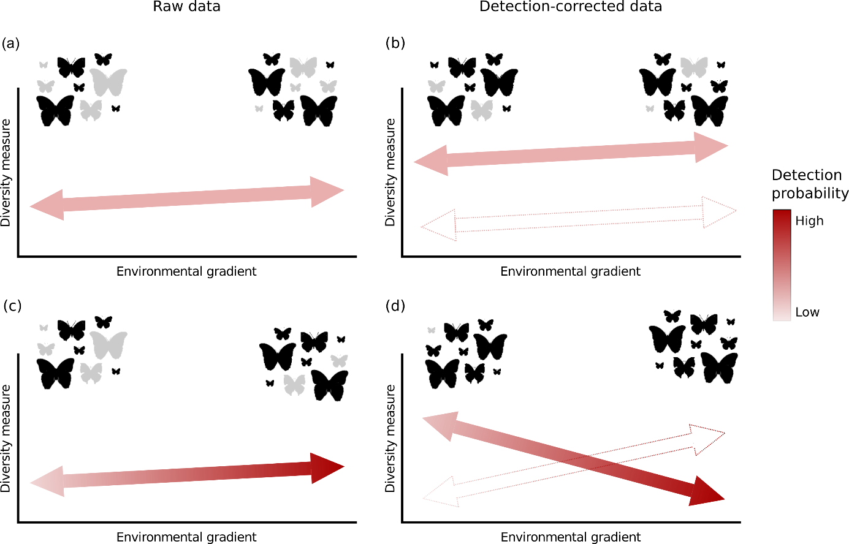

**Figure 1**. Schematic example of how imperfect detection can affect the observed diversity pattern of assemblages. If the detection is constant along the environmental gradient (a), the raw data can be used to calculate the diversity measures, because the detection-corrected data will only change the intercept of the relation between diversity measure and environmental gradient (b). In this case, the observed pattern not change. On the other hand, if there is asymmetry in the detection probability along the environmental gradient (c), then the imperfection detection should be account for calculate the diversity measures, because the undetected species/individuals will affect both the intercept and the slope of the relation between diversity measure and environmental gradient (d). Under this scenario, the observed pattern can change of magnitude and direction, leading with an erroneously interpretation of the process that generate such diversity pattern., (c), the raw data can be used to calculate the diversity measures, because the detection-corrected data will only change the intercept of the relation between diversity measure and environmental gradient (d). Detected and undetected species/individuals are represented by black and gray shadows, respectively. Dashed arrows indicate the other possibility of diversity pattern when imperfect detection is accounting in analyses.



**Figure 2.** Species-specific prediction of expected abundance as a function of the mean temperature for canopy (a) and understory (b), and prediction of detection probability as a function of the sampling months (November-2016 to March-2017) for canopy (c) and understory (d) for fruit-feeding butterflies survey in an Araucaria forest in southern Brazil. Each line represents one of the 35 observed species, highlight the specie with higher probability of detection in each stratum. The y-axis was transformed by square-root to better visualizing the patterns of expected abundance and detection probability.



**Figure 3.** Relationship between functional traits and detection probability of species of the for fruit-feeding butterflies survey in an Araucaria forest in southern Brazil, performed with phylogenetically independent contrasts (PICs). (a) Regression showing a positive effect of aspect ratio in detection probability for canopy species; (b) Regression showing a positive effect of abdomen mass in detection probability for understory species; Red line indicates the regression line constructed based in the parameters estimated by OLS model for each stratum.

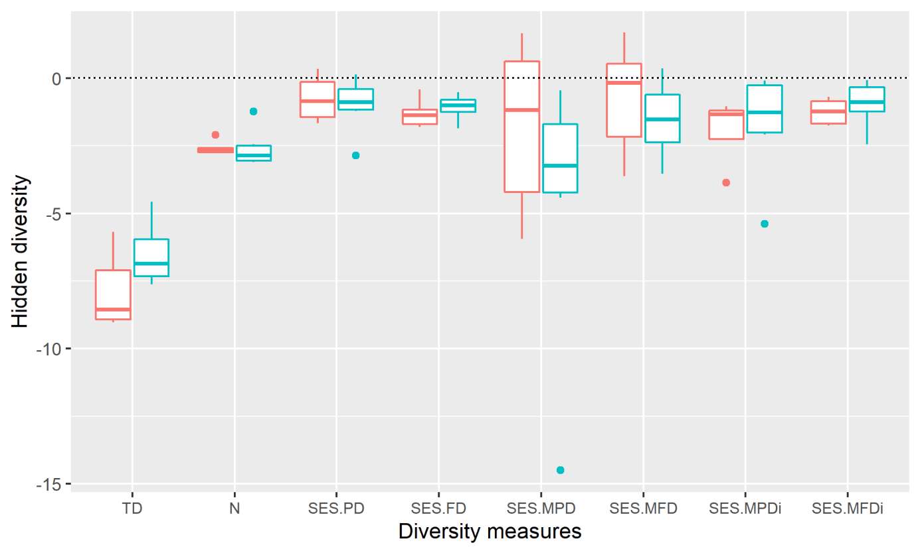

**Figure 4.** The magnitude of the effect of imperfect detection (hidden diversity) over the multiple dimensions of the community diversity measures. Red and blue boxplots represent the hidden diversity for canopy and understory, respectively. TD – taxonomic diversity; SES.PD – standardized effect size of phylogenetic diversity; SES.FD – standardized effect size of functional diversity; SES.MPD – standardized effect size of mean-pairwise phylogenetic diversity and SES.MFD – standardized effect size of mean-pairwise functional diversity. The subscript *i* indicates the incidence-based analysis instead of abundance-weighted. Dotted line represents the zero intercept for hidden diversity.