**Supplementary information**

**Appendix 1**

Code for the hierarchical Bayesian N-Mixture model

sink("model_Nmixture.txt")

cat("model

{

# Community priors (with hyperparameters) for species-specific parameters

for(k in 1:nspec){

alpha.can[k] ~ dnorm(mu.alpha.can, tau.alpha.can) # Random intercept for detectability - canopy

alpha.und[k] ~ dnorm(mu.alpha.can, tau.alpha.can) # Random intercept for detectability - understory

beta.can[k] ~ dnorm(mu.beta.can, tau.beta.can) # Random intercept for abundance - canopy

beta.und[k] ~ dnorm(mu.beta.und, tau.beta.und) # Random intercept for abundance - understory

beta1[k] ~ dnorm(mu.beta1, tau.beta1) # Random slopes for abundance

alpha1[k] ~ dnorm(mu.alpha1, tau.alpha1) # Random slopes detection

}

# Hyperpriors for community hyperparameters

# abundance model - intercept

mu.beta.can ~ dnorm(0, 0.0001)

tau.beta.can <- pow(sd.beta.can, -2)

sd.beta.can ~ dunif(0, 1)

mu.beta.und ~ dnorm(0, 0.0001)

tau.beta.und <- pow(sd.beta.und, -2)

sd.beta.und ~ dunif(0, 1)

mu.beta1 ~ dnorm(0, 0.0001)

tau.beta1 <- pow(sd.beta1, -2)

sd.beta1 ~ dunif(0, 1)

# detection model - intercept

mu.alpha.can ~ dnorm(0, 0.0001)

tau.alpha.can <- pow(sd.alpha.can, -2)

sd.alpha.can ~ dunif(0, 1)

mu.alpha.und ~ dnorm(0, 0.001)

tau.alpha.und <- pow(sd.alpha.und, -2)

sd.alpha.und ~ dunif(0, 1) ## sd

# detection model - slopes

mu.alpha1 ~ dnorm(0, 0.0001)

tau.alpha1 <- pow(sd.alpha1, -2)

sd.alpha1 ~ dunif(0, 1)

# Ecological model for true abundance (process model)

for(k in 1:nspec){

for (i in 1:nsite){

N[i,k] ~ dpois(lambda[i,k]) # latent abundance of each species in each site

log(lambda[i,k]) <- beta.can[k]*(1-Strata[i]) + beta.und[k]*Strata[i] + beta1[k]*Temp[i]

# Compute presence/absence matrix z (for N > 0) from latent abundance

z[i,k] <- step(N[i,k]-1) # returns TRUE if N >= 1

}

}

# Observation model for replicated counts

for(k in 1:nspec){

for (i in 1:nsite){

for (j in 1:nrep){

yc[i,j,k] ~ dbin(p[i,j,k], N[i,k])

logit(p[i,j,k]) <- alpha.can[k]*(1-Strata[i]) + alpha.und[k]*Strata[i] +

alpha1[k]* DAT[i,j]

}

}

}

# Other derived quantities

for(k in 1:nspec){

mlambda.can[k] <- exp(beta.can[k]) # Expected abundance on natural scale for canopy

mlambda.und[k] <- exp(beta.und[k]) # Expected abundance on natural scale for understory

logit(mp.can[k]) <- alpha.can[k] # Mean detection on natural scale for canopy

logit(mp.und[k]) <- alpha.und[k] # Mean detection on natural scale for understory

}

for (i in 1:nsite) {

Nsite[i] <- sum(z[i,]) # Number of occurring species at each site

}

}

",fill = TRUE)

sink()

**Appendix 2**

Code to perform the hidden diversity

# comm= the observed community data

# phy= the phylogenetic tree

# trait= the trait matrix of quantitative and/or binary data

# N= an array of the posterior sample in the format n.site X n.spec X n.samp

# binary= a logical TRUE/FALSE argument for presence of binary traits in data

# abundance.wheighted= a logical TRUE/FALSE argument for wheighted MPD for abundance data

hidden.diversity<- function(comm, phy, trait, N, binary, bundance.weighted, runs){

n.site <- dim(N)[1] # n.site= the number of sites

n.samp <- dim(N)[3] # n.samp= the number of posterior sampling

# transforming N in binary data (y)

y <- N

for (i in 1: dim(y)[3]) {

b = which(y[,,i] > 0)

y[,,i][b] = 1

y[,,i][-b] = 0

}

# for trait data

if(binary == TRUE){

bin<- vector()

for(i in 1:ncol(trait)){

bin[i]<- is.integer(trait[, i])

}

con.t<- which(bin == F)

bin.t<- which(bin == T)

t.dist<- ade4::dist.ktab(ade4::ktab.list.df(list(log(trait[, con.t]),

ade4::prep.binary(trait[, bin.t],

col.blocks=ncol(trait[, bin.t])))),

type = c("Q", "B")) # create a dist matrix, considering mixed-variables

} else {t.dist<- ade4::dist.ktab(ade4::ktab.list.df(list(log(trait))), type = "Q")}

tree.func <- hclust(d = t.dist, method = "average") # clustering using UPGMA

tree.func <- ape::as.phylo(tree.func)

pd.ses<- array(NA, dim = c(n.site, 2, n.samp))

fd.ses<- array(NA, dim = c(n.site, 2, n.samp))

mpd.ses<- array(NA, dim = c(n.site, 2, n.samp))

mfd.ses<- array(NA, dim = c(n.site, 2, n.samp))

dist.phylo <- cophenetic(phy)

dist.func <- cophenetic(tree.func)

comm.p <- SYNCSA::organize.syncsa(comm, phylodist = dist.phylo)$community

comm.f <- SYNCSA::organize.syncsa(comm, phylodist = dist.func)$community

# calculating the estimated taxonomic diversity (TD)

y.sum<- apply(y, c(1,3), sum) # sum the rown for each posterior sample smple

td.est<- cbind(apply(y.sum, 1, mean), apply(y.sum, 1, sd)) # mean of

colnames(td.est)<- c("Ric.est", "SD")

# calculating the estimated abundance

N.obs<- apply(comm, 1, sum)

N.est<- cbind(apply(apply(N, c(1,3), sum), 1, mean),

apply(apply(N, c(1,3), sum), 1, sd))

colnames(N.est)<- c("N.est", "SD")

# calculating the phylogenetic diversity (SES.PD)

pd.obs<- picante::ses.pd(comm.p, phy, null.model = "phylogeny.pool", runs = runs)

for (i in 1:n.samp){

temp<- picante::ses.pd(N[,,i], tree, null.model = "phylogeny.pool", runs = runs)

pd.ses[,1,i] <- cbind(temp[,2])

pd.ses[,2,i] <- cbind(temp[,6])

}

pd.est<- cbind(apply(pd.ses, c(1,2), mean, na.rm=T), apply(pd.ses, c(1,2), sd, na.rm=T))

colnames(pd.est)<- c("PD.est","SES.PD.est","PD.est.sd","SES.PD.est.sd")

## calculating the mean phylogenetic diversity (SES.MPD)

mpd.obs <- picante::ses.mpd(comm.p, dist.phylo, abundance.weighted = abundance.weighted, runs = runs)

for (i in 1:3){

temp<- picante::ses.mpd(N[,,i], dist.phylo, abundance.weighted = abundance.weighted, runs=runs)

mpd.ses[,1,i] <- cbind(temp[,2])

mpd.ses[,2,i] <- cbind(temp[,6])

}

mpd.est<- cbind(apply(mpd.ses,c(1,2), mean, na.rm=T), apply(mpd.ses, c(1,2),sd, na.rm=T))

colnames(mpd.est)<- c("MPD.est","SES.MPD.est","MPD.est.sd","SES.MPD.est.sd")

# calculating the functional diversity (SES.FD)

fd.obs <- picante::ses.pd(comm.p, tree.func, null.model = "phylogeny.pool", runs = runs)

for (i in 1:n.samp){

temp<- picante::ses.pd(N[,,i], tree.func, null.model = "phylogeny.pool", runs = runs)

fd.ses[,1,i] <- cbind(temp[,2])

fd.ses[,2,i] <- cbind(temp[,6])

}

fd.est<- cbind(apply(fd.ses,c(1,2), mean, na.rm=T), apply(fd.ses,c(1,2),sd, na.rm=T))

colnames(fd.est)<- c("FD.est","SES.FD.est","FD.est.sd","SES.FD.est.sd")

## calculating the mean functional diversity (SES.MFD)

mfd.obs<- picante::ses.mpd(comm.f, dist.func, abundance.weighted = abundance.weighted, runs = runs)

for (i in 1:n.samp){

temp<- picante::ses.mpd(N[,,i], dist.func, abundance.weighted = abundance.weighted, runs = runs)

mfd.ses[,1,i] <- cbind(temp[,2])

mfd.ses[,2,i] <- cbind(temp[,6])

}

mfd.est<- cbind(apply(mfd.ses,c(1,2), mean, na.rm=T), apply(mfd.ses,c(1,2),sd, na.rm=T))

colnames(mfd.est)<- c("MFD.est","SES.MFD.est","MFD.est.sd","SES.MFD.est.sd")

## calculating the hidden diversity

hidden.td<- (pd.obs[,1]-td.est[,1])/td.est[,2]

hidden.N<- (N.obs-N.est[,1])/N.est[,2]

hidden.pd<- (pd.obs[,6]-pd.est[,2])/pd.est[,4]

hidden.fd<- (fd.obs[,6]-fd.est[,2])/fd.est[,4]

hidden.mpd<- (mpd.obs[,6]-mpd.est[,2])/mpd.est[,4]

hidden.mfd<- (mfd.obs[,6]-mfd.est[,2])/mfd.est[,4]

return(list(Hidden.diversity= cbind(hidden.td, hidden.N, hidden.pd, hidden.fd, hidden.mpd, hidden.mfd),

TD= data.frame(Ric.obs= pd.obs[,1], td.est),

N= data.frame(N.obs, N.est),

PD= data.frame(PD.obs= pd.obs[,2], SES.PD.obs= pd.obs[,6], pd.est),

FD= data.frame(FD.obs= fd.obs[,2], SES.FD.obs= fd.obs[,6], fd.est),

MPD= data.frame(MPD.obs= mpd.obs[,2], SES.MPD.obs= mpd.obs[,6], mpd.est),

MFD=data.frame(MFD.obs= mfd.obs[,2], SES.MFD.obs= mfd.obs[,6], mfd.est)))

}

**Appendix 3**



**Figure A1.** Community distribution of mean abundance (a) and detection probability (b) among species of fruit-feeding butterflies, based on the estimates of the model parameters (μβ.can, sdβ.can, μα.can, sdα.can, μβ.und, sdβ.und, μα.und, sdα.und). Red colors represent the mean parameters for canopy (μβ.can= 5.616 and μα.can= 0.028), and the blue colors represents mean parameters for understory (μβ.und= 5.789 and μα.und= 0.635). The vertical lines are constructed based in mean distribution for 1,000,000 random samples.

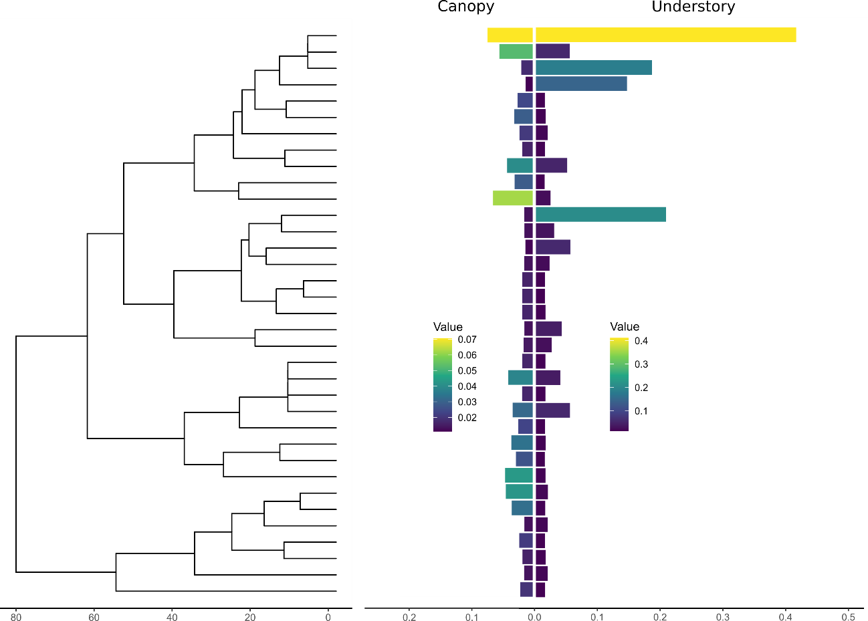

**Figure A2.** Distribution of the detection probability of species of the fruit-feeding butterflies throughout the phylogenetic tree for each stratum. The tree was pruned considering only butterflies species sampled at the Araucaria forest in southern Brazil.