Task 1: Which Linux tools would you use in your terminal to find out answers for the following use cases? Send us the screenshot with MAC address

- List the processes running on your machine

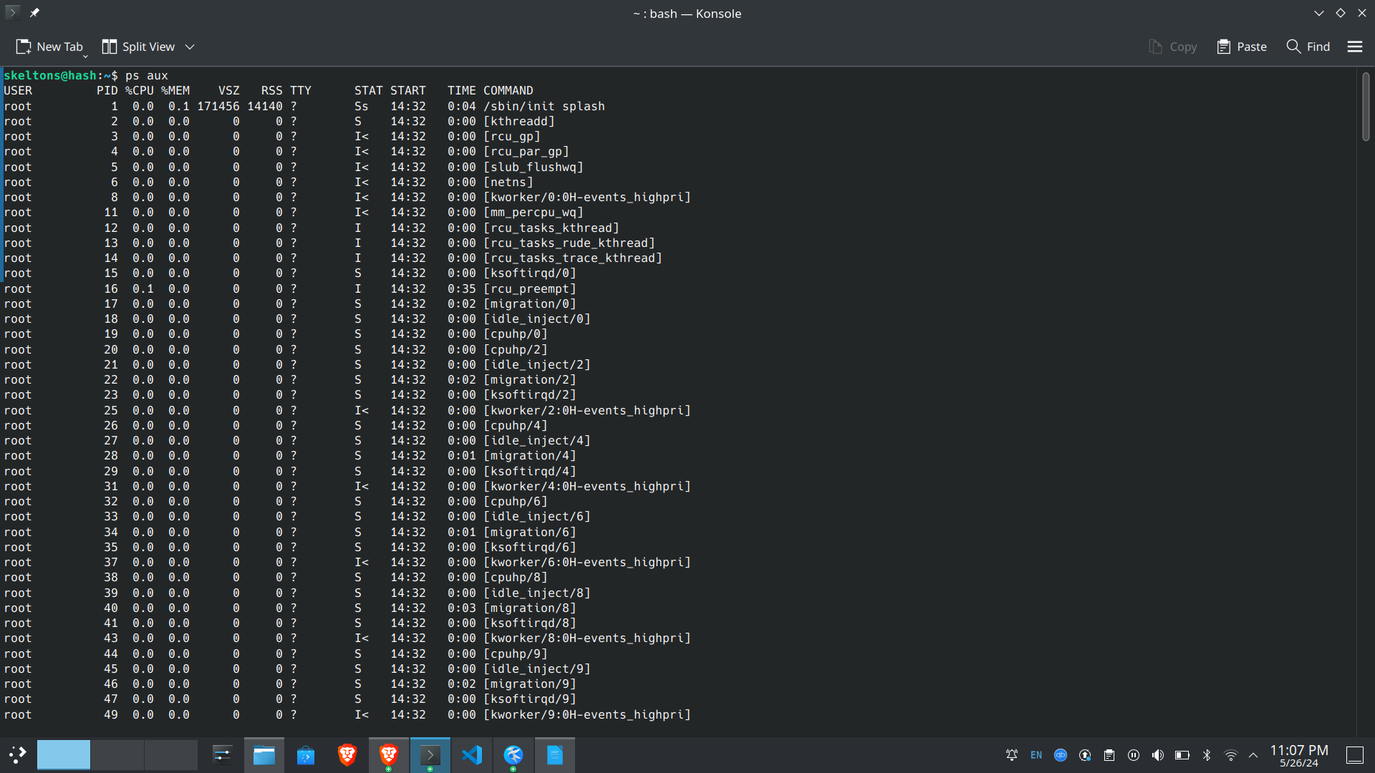
- List the open sockets on your machine (to which process are using them, through which ip address and port number they are communicating)

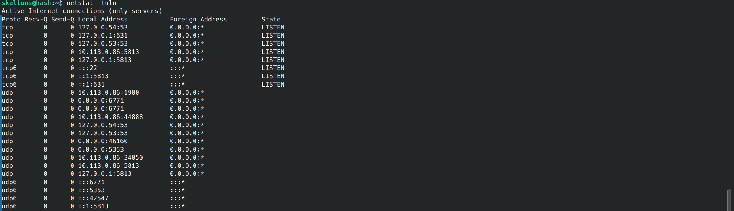
- List the processes running on your machine

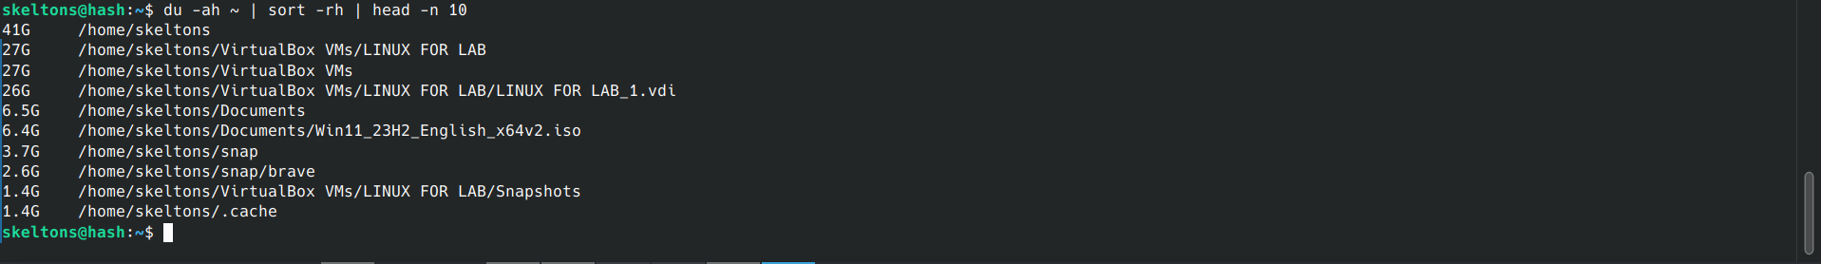
- List all the files (descending order) occupying the most space in your home directory.

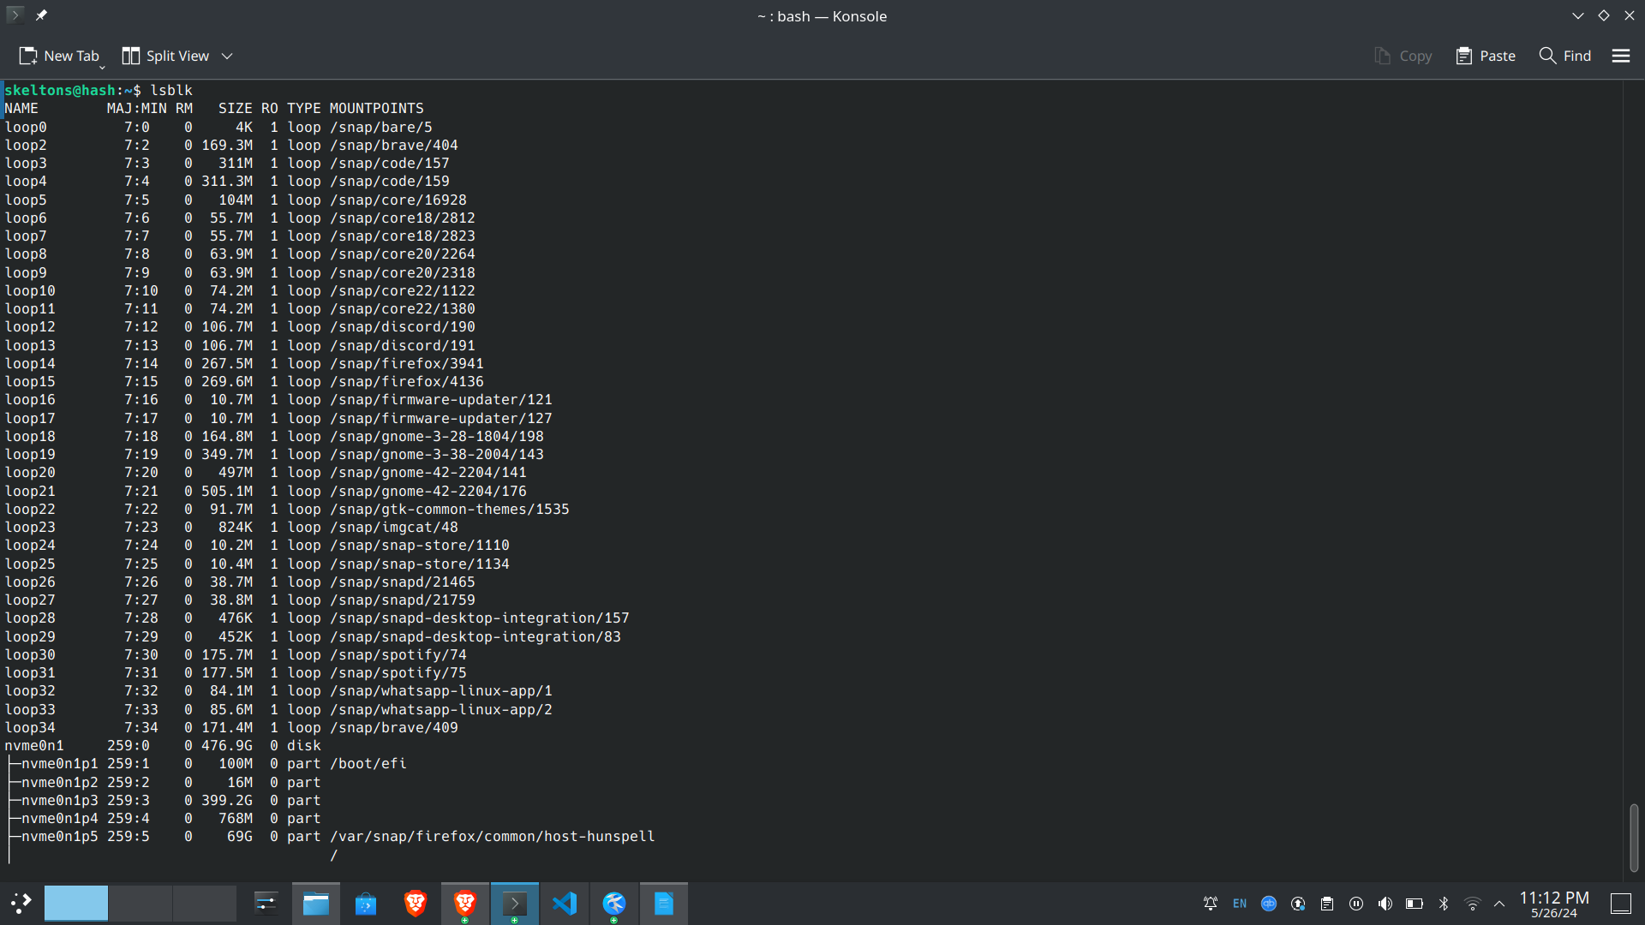
- List the partition information.

- Which device file is mounted inside your guest machine root folder (denoted as / )?
- On a Linux terminal how would you copy a text file’s content into your clipboard?

