Nonlinear models in R

Table of Contents

### Load libraies for plots and data analysis  
library(tidyr)  
library(ggplot2)  
library(sjPlot)

## Learn more about sjPlot with 'browseVignettes("sjPlot")'.

library(sjmisc)

##   
## Attaching package: 'sjmisc'

## The following object is masked from 'package:tidyr':  
##   
## replace_na

library(sjlabelled)  
library(MASS)  
library(tidyverse)

## -- Attaching packages --------------------------------------------------------------------------------- tidyverse 1.3.0 --

## v tibble 3.0.0 v dplyr 0.8.5  
## v readr 1.3.1 v stringr 1.4.0  
## v purrr 0.3.4 v forcats 0.5.0

## -- Conflicts ------------------------------------------------------------------------------------ tidyverse_conflicts() --  
## x tibble::add_case() masks sjmisc::add_case()  
## x forcats::as_factor() masks sjlabelled::as_factor()  
## x dplyr::as_label() masks sjlabelled::as_label()  
## x dplyr::filter() masks stats::filter()  
## x purrr::is_empty() masks sjmisc::is_empty()  
## x dplyr::lag() masks stats::lag()  
## x sjmisc::replace_na() masks tidyr::replace_na()  
## x dplyr::select() masks MASS::select()

library(caret)

## Loading required package: lattice

##   
## Attaching package: 'caret'

## The following object is masked from 'package:purrr':  
##   
## lift

library(leaps)  
library(glmnet)

## Loading required package: Matrix

##   
## Attaching package: 'Matrix'

## The following objects are masked from 'package:tidyr':  
##   
## expand, pack, unpack

## Loaded glmnet 4.0

# load response variables  
  
### Read data for specific gene expression  
dat1 <- read.csv(file="ENSG115944.csv" )  
  
# STR data for locus of interest  
dat2 <- read.csv(file="ENS115944STRup2.csv",header=FALSE )  
  
  
dat3 <- merge(dat1,dat2,by.x="Gene",by.y="V1")  
  
  
#We only want the one locus. Drop all other levels from factor variables.  
dat4 <- droplevels(dat3)  
  
  
varit <- 3:67  
numcols <- ncol(dat4)-2  
resultsout <- NULL  
# bring response and STR information together.  
for (i in varit) {  
#### Want the STR value to numeric not factor  
dat4[,i] <- as.numeric(as.character(dat4[,i]))  
dat4[,i+numcols] <- dat4[,i]**2  
  
}  
  
  
dat5 <- aggregate(dat4[,3:ncol(dat4)],by=list(dat4$Gene,dat4$Response),FUN=sum,na.rm=TRUE)  
  
names(dat5)[1:2] <- c("Gene","y")  
  
dat6 <- dat5  
  
varit <- 3:67  
numcols <- ncol(dat5)-2  
# bring response and STR information together.  
for (i in varit) {  
#### Want the STR value to numeric not factor  
dat6[,i+numcols] <- dat6[,i]*dat6[,i+65]  
  
}  
  
  
agglm <- lm(y ~ .,dat=dat5[,2:ncol(dat5)])  
  
agglm2 <- lm(y ~ V30+V31+V47+V96+V114,dat=dat5[,2:ncol(dat5)])  
  
agglmf <- lm(y ~ V30+V31*V96+V47*V114,dat=dat5[,2:ncol(dat5)])  
  
  
  
  
  
SSTotal <- var( dat5$y ) * (nrow(dat5)-1)  
  
 SSE <- sum( agglm2$resid^2 )  
SSreg <- SSTotal - SSE  
BICreg <- BIC(agglm2)  
  
 SSEf <- sum( agglmf$resid^2 )  
SSregf <- SSTotal - SSEf  
BICregf <- BIC(agglmf)  
  
  
SSTotal

## [1] 63.24711

SSE

## [1] 46.00067

SSEf

## [1] 45.26927

SSreg

## [1] 17.24644

SSregf

## [1] 17.97784

BICreg

## [1] 324.1929

BICregf

## [1] 331.2608

#resultsout <- rbind(resultsout,cbind(i,BICreg,BICregf,SSTotal,SSreg,SSE,SSregf,SSEf))

full.model <- lm(y ~ .,dat=dat6[,2:ncol(dat6)])  
# Stepwise regression model  
step.model <- stepAIC(full.model, direction = "both",   
 trace = FALSE)  
  
BIC(step.model)

## [1] 382.1433

thestep <- lm(formula = y ~ V4 + V18 + V20 + V30 + V31 + V38 + V48 + V51 +   
 V59 + V73 + V83 + V84 + V88 + V95 + V96 + V97 + V101 + V109 +   
 V117 + V118 + V125 + V135 + V153 + V154 + V159 + V162 + V169 +   
 V174 + V179 + V190 + V142, data = dat6[, 2:ncol(dat6)])  
  
summary(thestep)

##   
## Call:  
## lm(formula = y ~ V4 + V18 + V20 + V30 + V31 + V38 + V48 + V51 +   
## V59 + V73 + V83 + V84 + V88 + V95 + V96 + V97 + V101 + V109 +   
## V117 + V118 + V125 + V135 + V153 + V154 + V159 + V162 + V169 +   
## V174 + V179 + V190 + V142, data = dat6[, 2:ncol(dat6)])  
##   
## Residuals:  
## Min 1Q Median 3Q Max   
## -0.90914 -0.20946 -0.00221 0.22220 1.43389   
##   
## Coefficients:  
## Estimate Std. Error t value Pr(>|t|)   
## (Intercept) 0.378808 0.064004 5.919 1.28e-08 ***  
## V4 -0.525092 0.171874 -3.055 0.002536 **   
## V18 -0.128741 0.058972 -2.183 0.030117 *   
## V20 0.805926 0.248962 3.237 0.001399 **   
## V30 -0.108599 0.026758 -4.059 6.92e-05 ***  
## V31 -0.212672 0.117736 -1.806 0.072270 .   
## V38 0.092832 0.050327 1.845 0.066482 .   
## V48 -0.201828 0.088610 -2.278 0.023732 *   
## V51 0.228535 0.155551 1.469 0.143247   
## V59 0.154097 0.091413 1.686 0.093307 .   
## V73 -0.205572 0.087537 -2.348 0.019766 *   
## V83 0.049659 0.020898 2.376 0.018371 *   
## V84 -0.049348 0.020825 -2.370 0.018692 *   
## V88 0.177177 0.077951 2.273 0.024023 *   
## V95 0.032839 0.014321 2.293 0.022817 *   
## V96 0.009865 0.002503 3.940 0.000110 ***  
## V97 0.164085 0.077348 2.121 0.035039 *   
## V101 0.092816 0.053853 1.723 0.086243 .   
## V109 -0.054985 0.020805 -2.643 0.008828 **   
## V117 0.281840 0.159830 1.763 0.079265 .   
## V118 -0.009544 0.006687 -1.427 0.154956   
## V125 0.093701 0.063997 1.464 0.144621   
## V135 0.232253 0.089491 2.595 0.010106 *   
## V153 0.080775 0.031630 2.554 0.011353 *   
## V154 0.004307 0.002882 1.494 0.136561   
## V159 -0.015398 0.004269 -3.607 0.000386 ***  
## V162 -0.020138 0.010823 -1.861 0.064162 .   
## V169 -0.004385 0.002405 -1.823 0.069670 .   
## V174 -0.012147 0.005975 -2.033 0.043297 *   
## V179 0.144379 0.041647 3.467 0.000637 ***  
## V190 0.016194 0.010847 1.493 0.136930   
## V142 -0.014435 0.004176 -3.457 0.000660 ***  
## ---  
## Signif. codes: 0 '***' 0.001 '**' 0.01 '*' 0.05 '.' 0.1 ' ' 1  
##   
## Residual standard error: 0.3899 on 214 degrees of freedom  
## Multiple R-squared: 0.4856, Adjusted R-squared: 0.411   
## F-statistic: 6.516 on 31 and 214 DF, p-value: < 2.2e-16

SSEstep <- sum( thestep$resid^2 )  
SSregstep <- SSTotal - SSEstep  
BICregstep <- BIC(thestep)  
  
  
  
thestep1 <- lm(formula = y ~ V4 + V18 + V20 + V30 + V38 + V48 +   
 V59 + V73 + V83 + V84 + V88 + V95 + V96 + V101 + V109 +   
 V117 + V135 + V153 + V159 + V169 +   
 V174 + V179 + V142, data = dat6[, 2:ncol(dat6)])  
  
plot(predict(thestep1),dat6[,"y"],main=paste0("SS:",round(SSTotal,2)," REG: ",round(SSregstep,2)," ER: ",round(SSEstep,2)," BIC: ",round(BICregstep,2)))

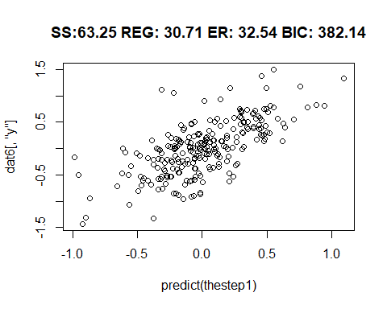

SSEstep1 <- sum( thestep1$resid^2)  
SSregstep1 <- SSTotal - SSEstep1  
BICregstep1 <- BIC(thestep1)  
  
  
xvals <- seq(-24,24,length.out=246)  
  
plot(xvals,dat6[,"y"],type="p",col="green",main=paste0("SS:",round(SSTotal,2)," REG: ",round(SSregstep1,2)," ER: ",round(SSEstep1,2)," BIC: ",round(BICregstep1,2)))  
lines(xvals,predict(thestep1),type="p",col="red")

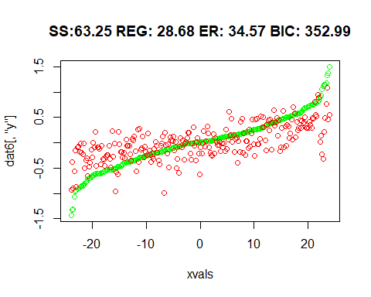

SSTotal

## [1] 63.24711

SSEstep

## [1] 32.5365

SSEstep1

## [1] 34.56684

SSregstep

## [1] 30.71062

SSregstep1

## [1] 28.68027

BICregstep

## [1] 382.1433

BICregstep1

## [1] 352.9917

So what’s the bottom line? In general, it might be best to use AIC and BIC together in model selection. For example, in selecting the number of latent classes in a model, if BIC points to a three-class model and AIC points to a five-class model, it makes sense to select from models with 3, 4 and 5 latent classes. AIC is better in situations when a false negative finding would be considered more misleading than a false positive, and BIC is better in situations where a false positive is as misleading as, or more misleading than, a false negative.

Add a new chunk by clicking the *Insert Chunk* button on the toolbar or by pressing *Ctrl+Alt+I*.

When you save the notebook, an HTML file containing the code and output will be saved alongside it (click the *Preview* button or press *Ctrl+Shift+K* to preview the HTML file).

The preview shows you a rendered HTML copy of the contents of the editor. Consequently, unlike *Knit*, *Preview* does not run any R code chunks. Instead, the output of the chunk when it was last run in the editor is displayed.