Evaluation B #1

1.
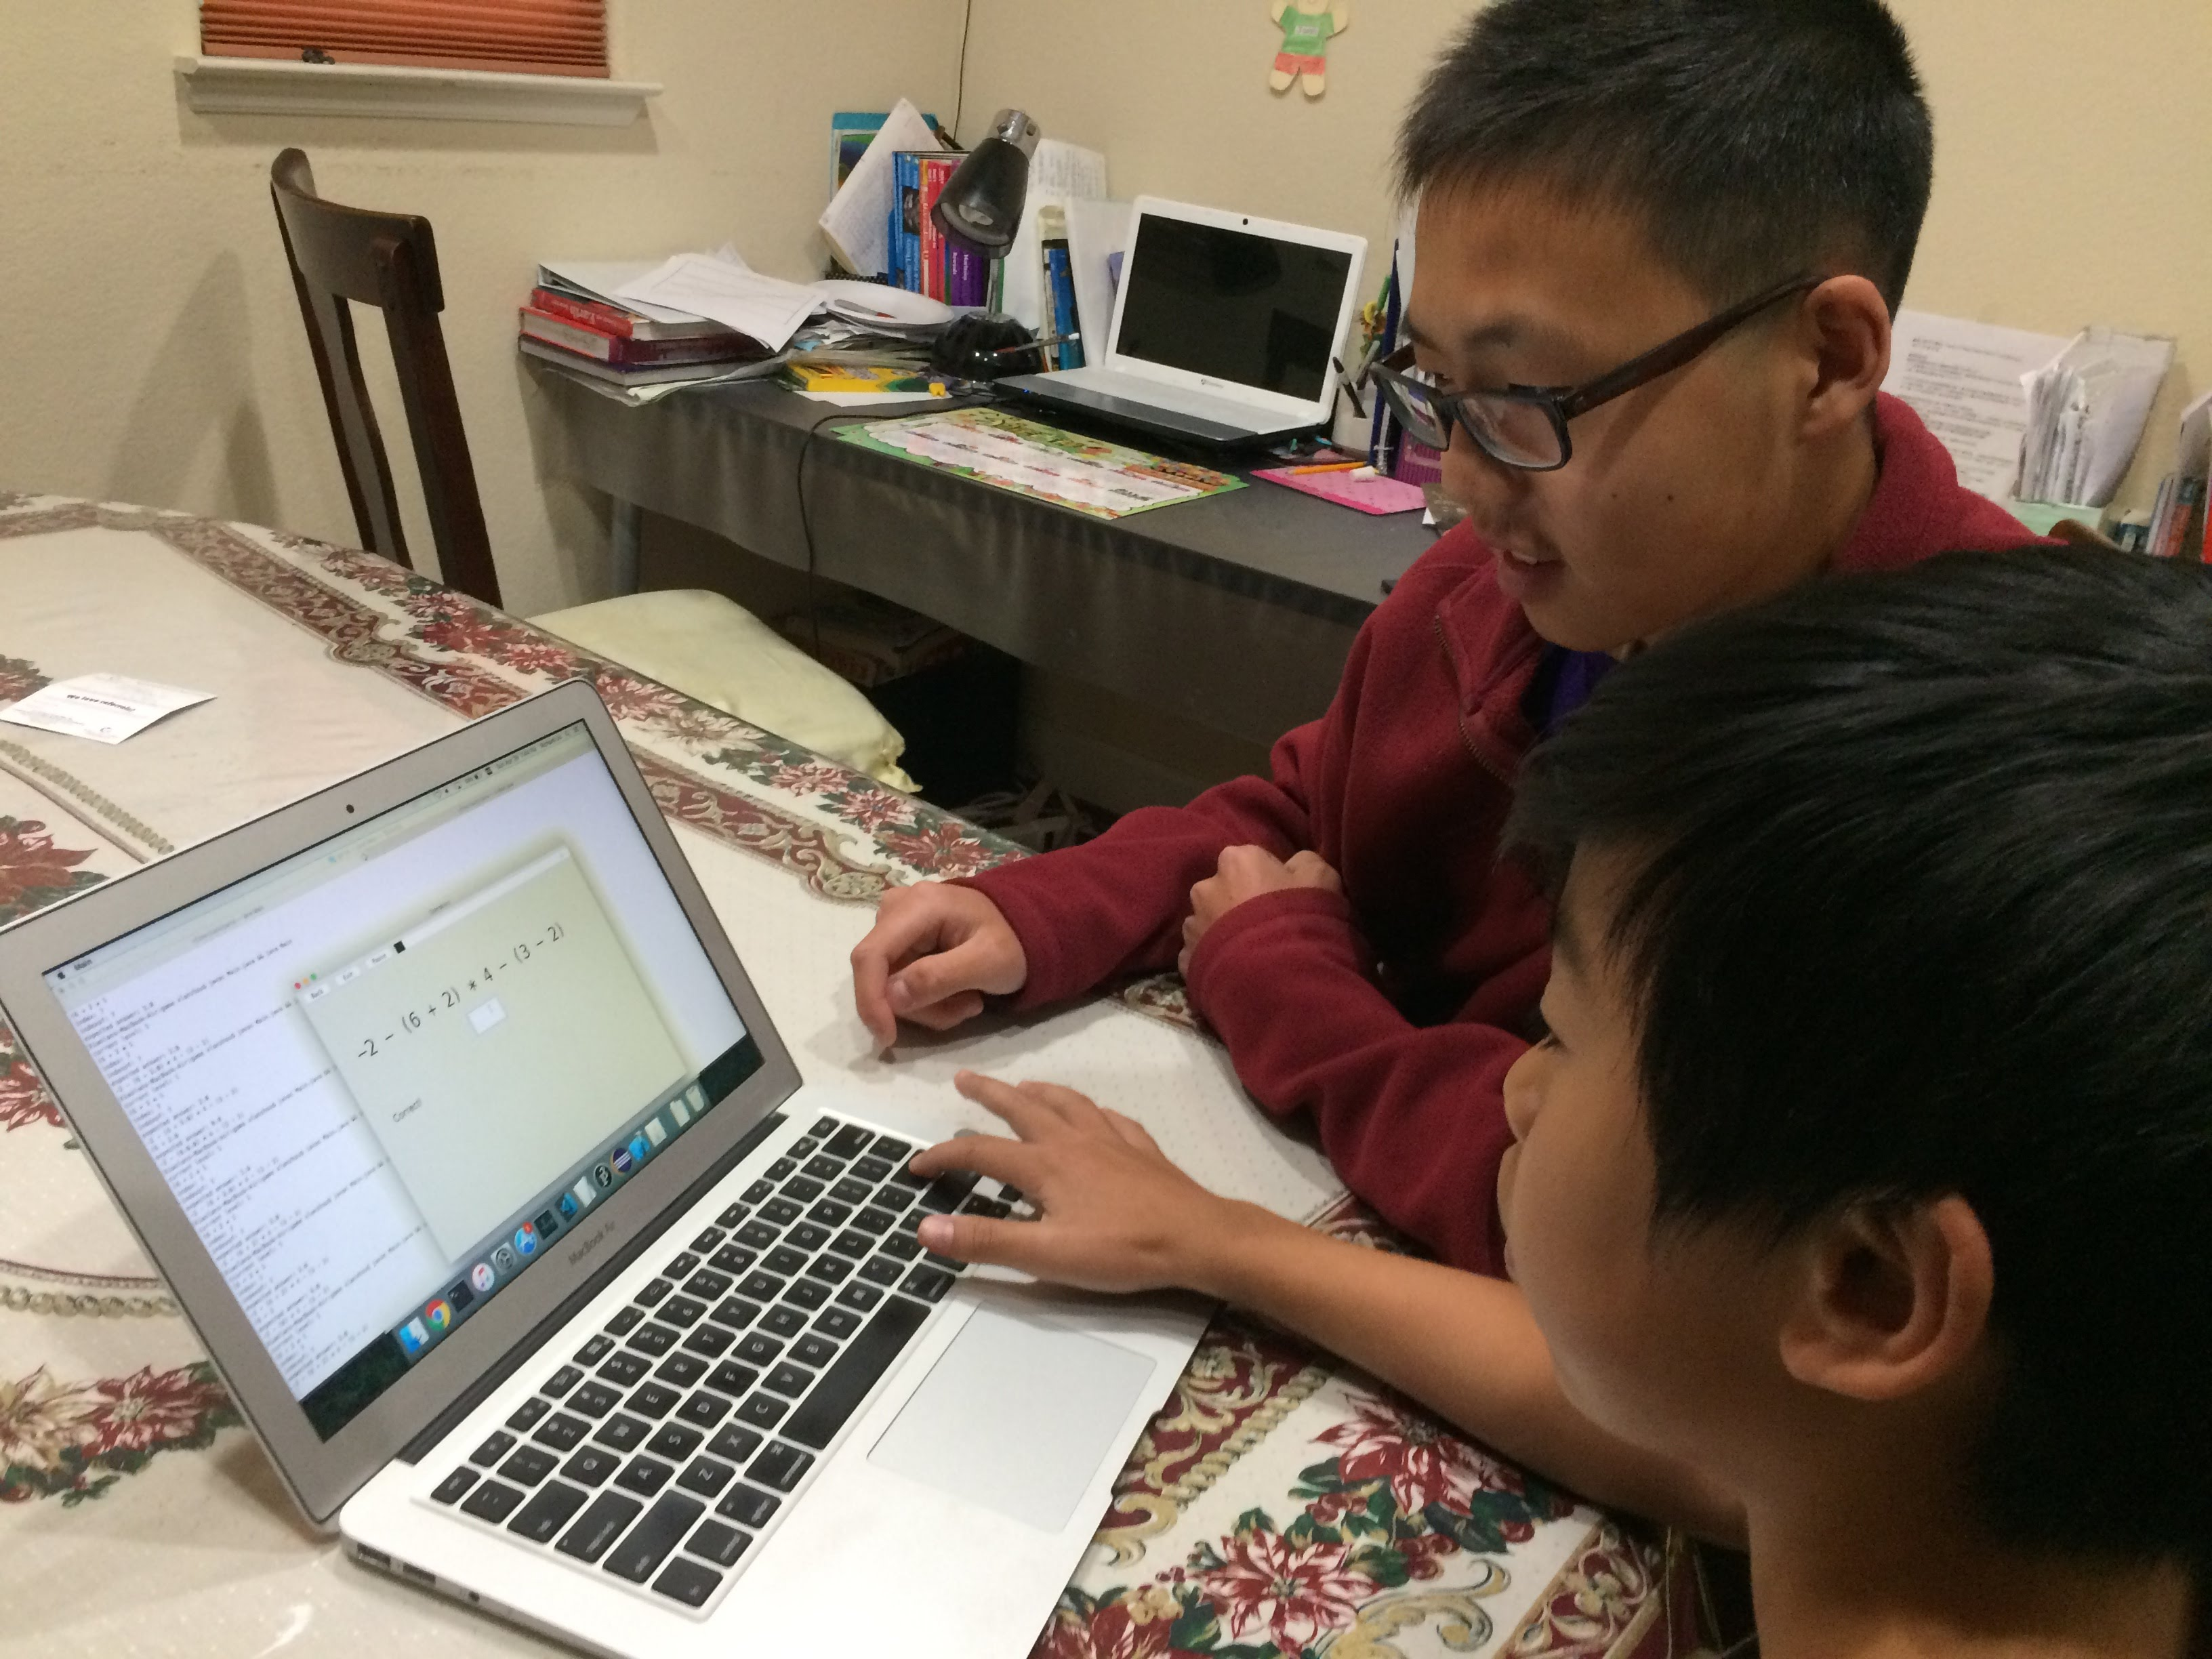
Operators, played by Jason Chen on 4/29/2018

2.
Jason finished the first level easily and started on the second level. He earned the full 1000 points for the first level, as he did not make any mistakes. He was not very excited about the game. He clicked through the menu and levels nonchalantly and finished the math questions quite easily. Jason was a little frustrated and confused with the first level, as he did not know what "Click on an operator" meant. He did not behave abnormally or in a particular manner.

3a.
The user was not very excited to play the game. I believe this is due to a lack of colorful graphics. He was confused on the game play page as to what "Click on an operator" meant. I would make it more clear that this game was about the order of operations and require users to walk through the instructions before playing. I will also add colorful graphics to make the game more fun and interesting.

3b.
The user appeared to learn from the helpful error messages I provided. I will add more error messages for more types of mathematical errors (negative sign before parenthesis applies to all numbers in the parenthesis, etc.), as well as more difficult problems.

