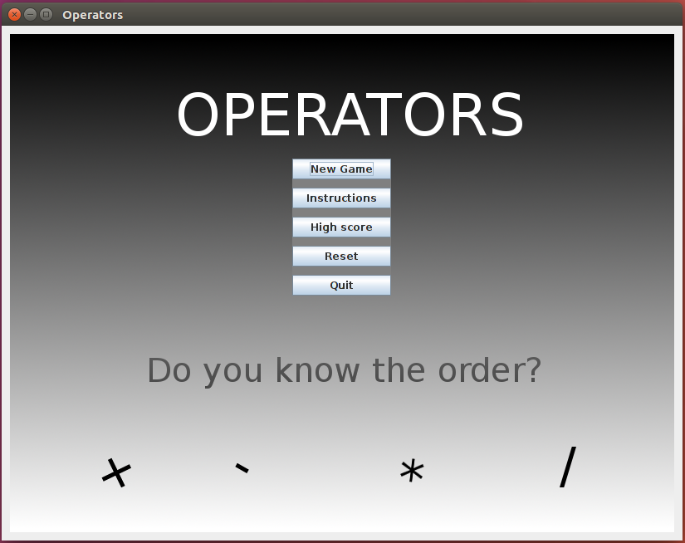  The game starts off from the home screen, where the user can select a menu. | 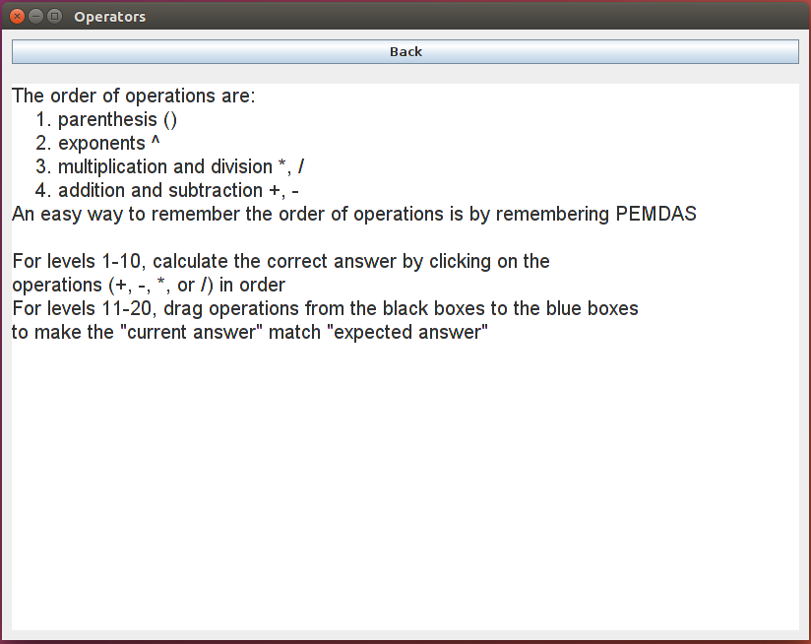  The instructions panel teaches the player how the order of operations work and how to play
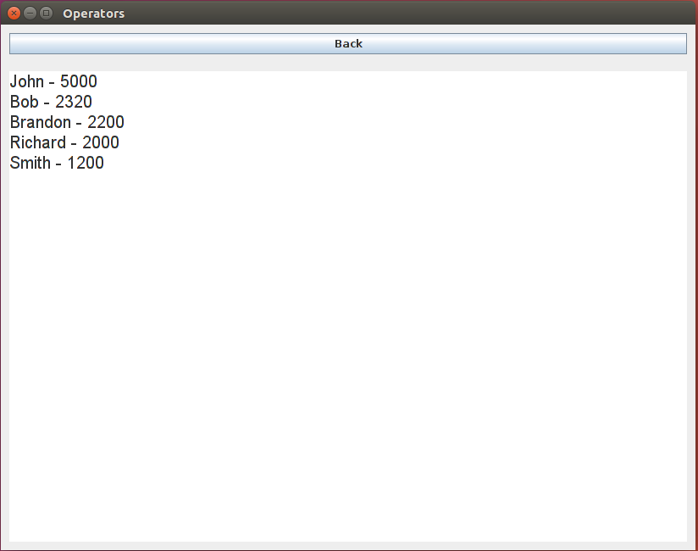  The player can also see previous high scores of other players. | 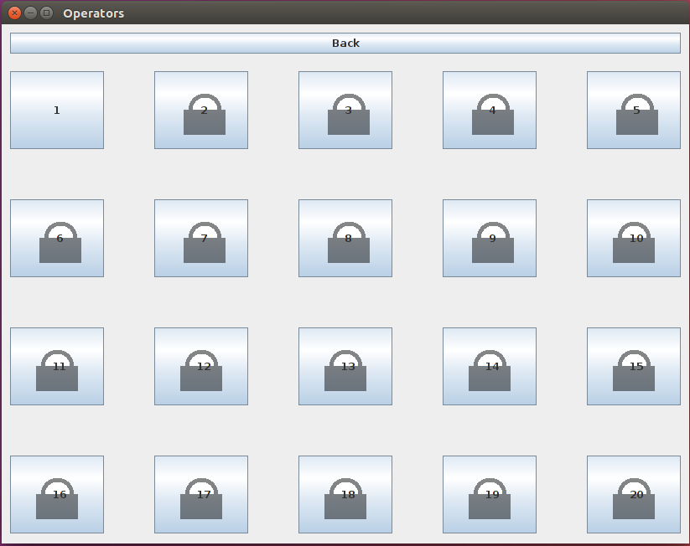  After the player clicks New Game from the home screen, they can choose a level. Only the first level is unlocked at first.
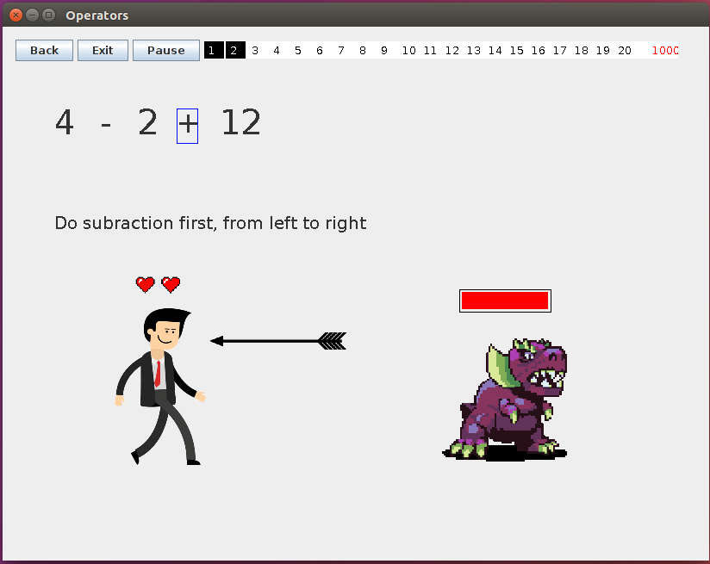  The user plays by clicking on operations. If they get the order wrong, they will loose health and points and be hit by an arrow. | 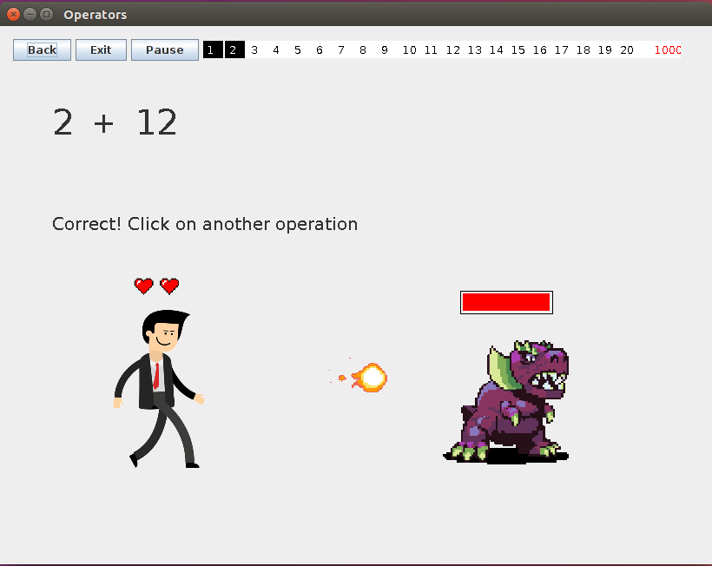  If they get the answer right, the will shoot a fireball at the enemy, which will loose health

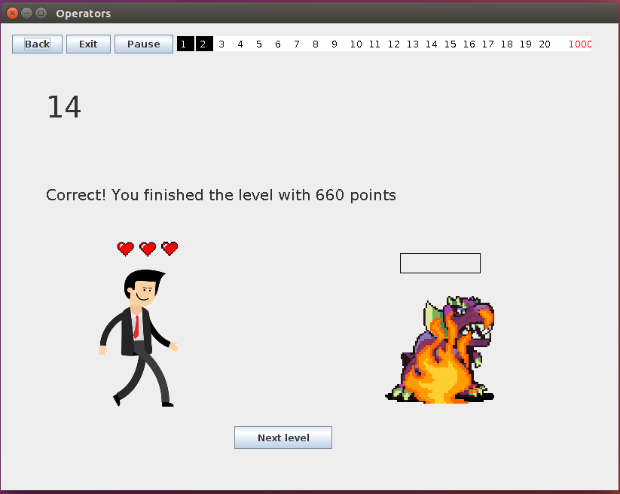  Once they are done with the level, they can move onto the next level. | 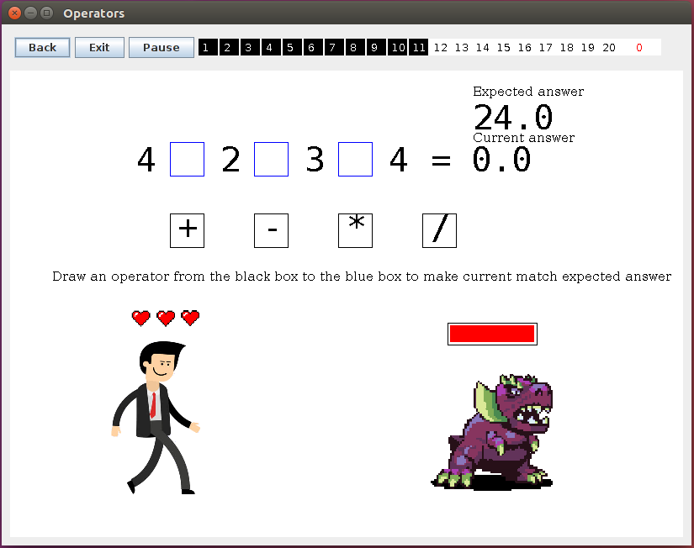  For levels 11-20, the game play is a little different.
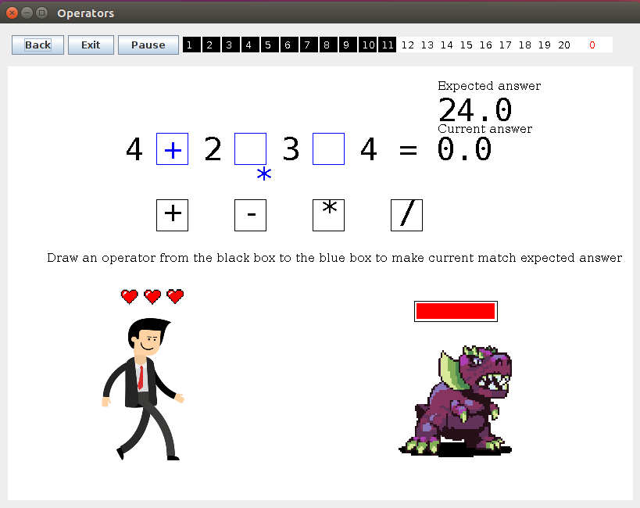  The user drags operators to make the expected answer. Once they get the answer, they will be able to move onto the next level | 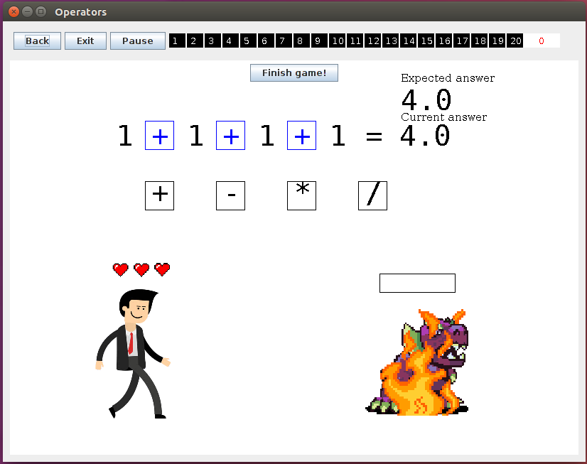  Once the user finishes all the levels, they can enter in their high score
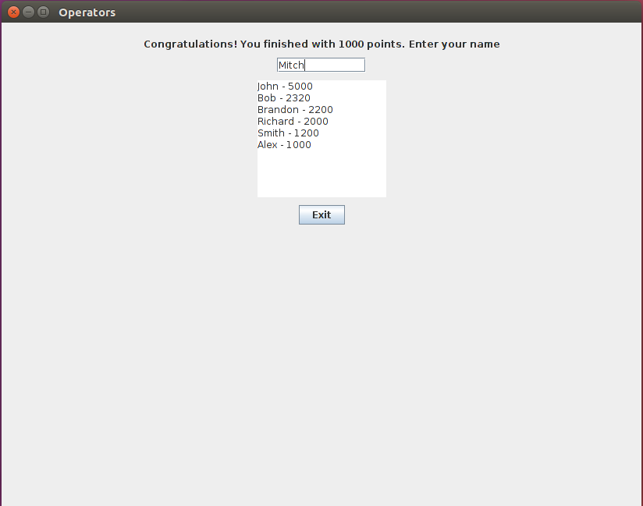  They type in their name and their high score will be stored onto a text file. | 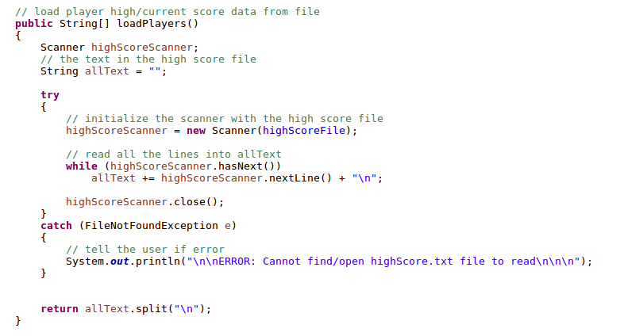  I used Scanners and Files to load the high score data, which is returned in a String array.

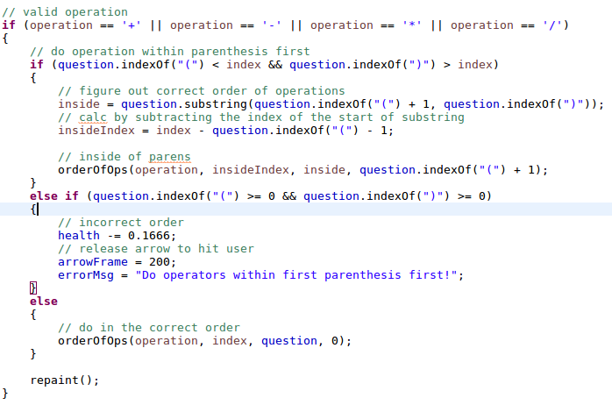  I used String methods (substring and indexOf) to get the portion of the question within the parenthesis that the player should solve first. | 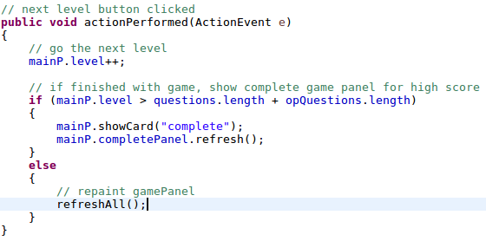  After the “Next” button is clicked the player moves on to the next level. Once they complete all levels, they are presented with the opportunity to enter in their high score.
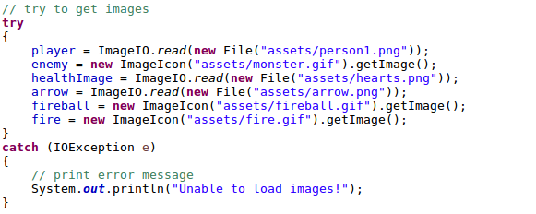  Here I loaded images from my assets folder as well as gifs using ImageIcon. GIFs allow for moving images, which capture the player’s attention. | 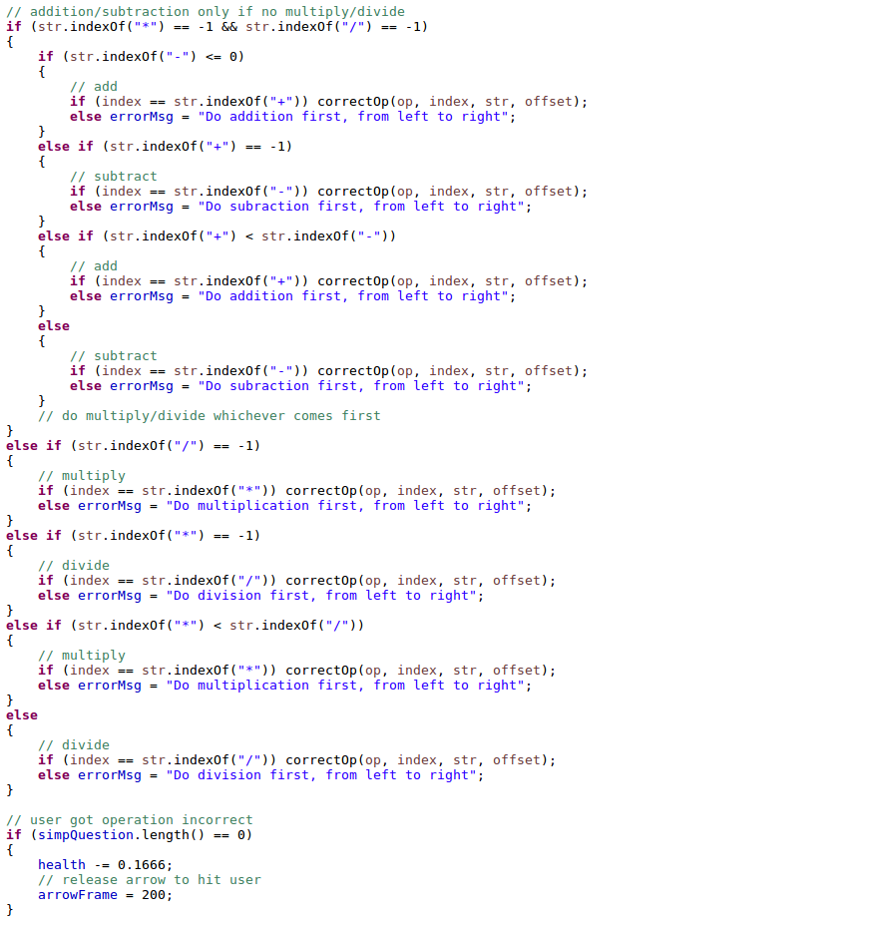  I implemented many if/else statements for the complex order of operations logic.
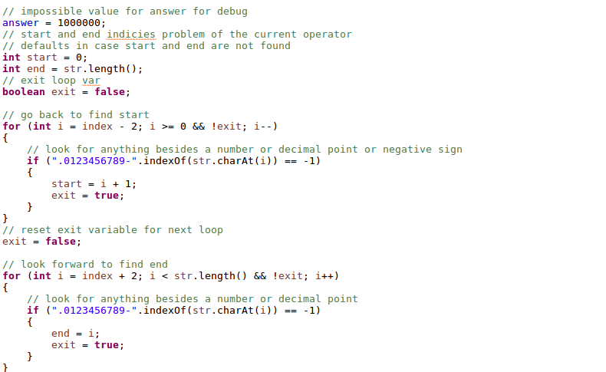  Here I use a combination of for loops and if statements to find the beginning and the end of the the current sub problem the user is solving | 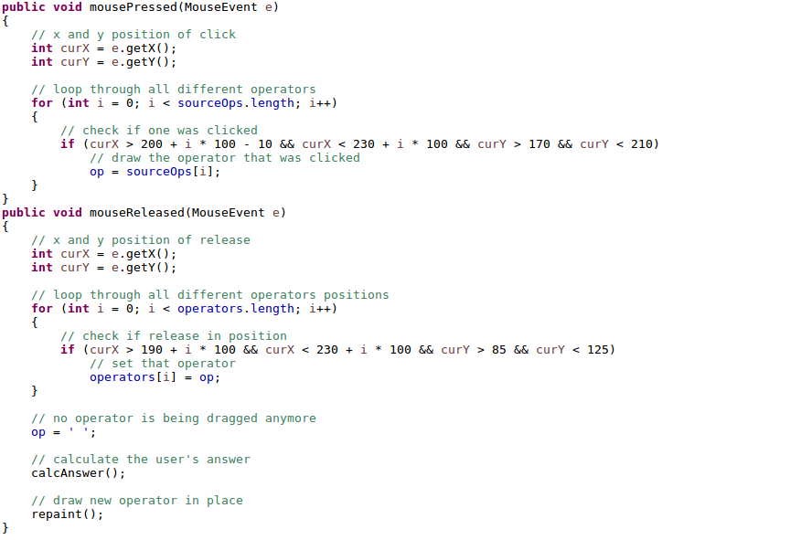  I used many mouse methods such as mousePressed, mouseReleased, etc. to implement smooth dragging of operators in the late levels (levels 11-20).

