

**TriWeather.com**

**Site Plan**

Site Name

This site is going to be called triweather.com.

Site Purpose

It is intended to provide accurate current weather information and forecasts. This information will be specific to the following locations: Preston, Soda Spring, and Fish Haven.

This website will also provide the user with a quality Storm Center and a nice collection of our best pictures in different weather conditions.

Target Audience and Scenarios

Our target audience is triathletes and public in general who like to exercise outdoors.

Personas

Javier Gomez  
 35 years old  
 $120,000   
 Silver medalist at the 2012 London Olympics  
 Winner of five ITU Triathlon World Championships  
 Winner of three ITU World Cups  
 World titles for Ironman 70.3   
 World titles for Xterra Triathlons

 Laura Johnson  
 45 years old  
 $80,000  
 Nurse  
 She is a mother of 3 children  
 She strives to balance her family, job, and health

Visitors will access the site whenever they feel like going to exercise outdoors or when planning days before. They are likely to use their mobile phone to get into the website.

Site Map

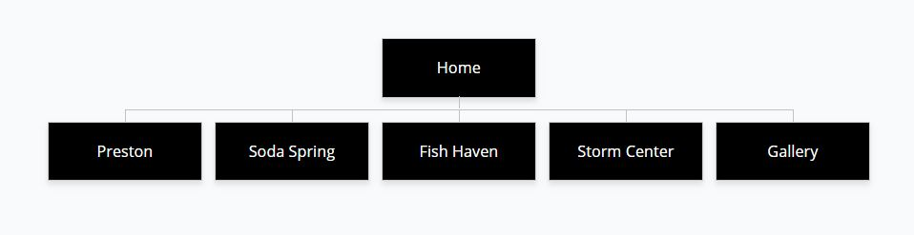

Color Scheme

I will be using black, white, and red. These colors are characteristic and known to represent the Ironman Triathlon Race.

Typography

I will be using the Comic Sans MS Font across the website.