DVM Discovery

Hands-On & Flexible Learning of
Digital Voltmeter Circuits

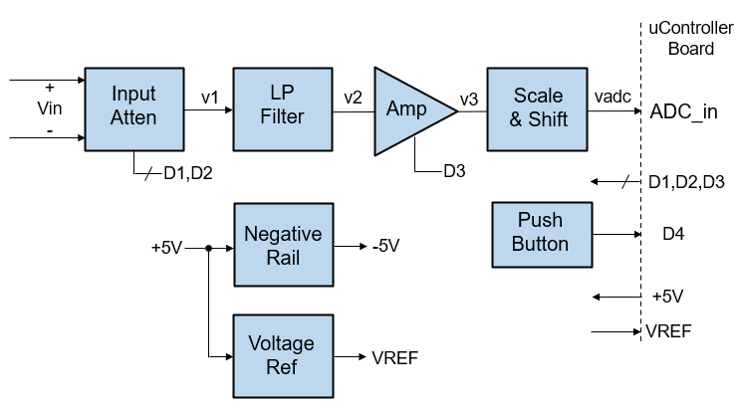

Contents
1 Intro 2
2 Overview 2
3 Block Diagram 3
4 Schematic 4
5 Voltage Range Setup 10
6 DVM Basic - 2 Ranges, Unipolar Input 11
7 DVM Advanced - 3 Ranges, Bipolar Input 13
8 Make it! 15
9 Bonus Sections 19

Intro
The DVM Discovery Board allows students, engineers and DIYers to quickly build and experiment with a variety of Digital Voltmeter Circuits. Hands-on learning of real-world circuits boosts understanding and intuition!
- Easy-to-use experimenter board
- Solderless headers allow quick component changes.
- Multiple circuit design options
  - 1 to 3 Customizable Voltage Ranges
  - Unipolar (pos input only) or Bipolar (pos/neg input)
  - Range Select: Manual or Auto
  - Precision Mode (voltage reference option)
- Simple Interface to uController Boards (ex: Arduino UNO)
- Excel Toolkit calculates component values, ranges and resolution.

Overview
The DVM Discovery provides flexible circuitry for a multi-range voltmeter and easy uController interface. You can quickly build and explore many measurement options.
YELLOW boxes show solderless headers for easy component changes!
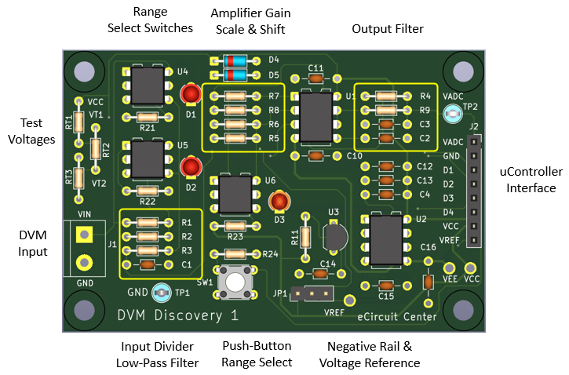
- Input Divider: Standard & High-Voltage Range option
- Amplifier: Low-Voltage Range option
- Negative Rail: Bipolar Input option
- Voltage Reference: Precision Mode option
- Push-Button Range Select
- LED Indicators - Digital Output Level

Block Diagram
The basic blocks allow for flexible build / design options. Customize for desired functionality as well as your learning goals.


Schematic
The DVM Discovery is created using straightforward circuits and standard parts. They provide practical real-world applications of classic circuits. You can also deep dive into the theory of these foundational circuits as well.

Input Divider, Analog Mux, Low-Pass Filter
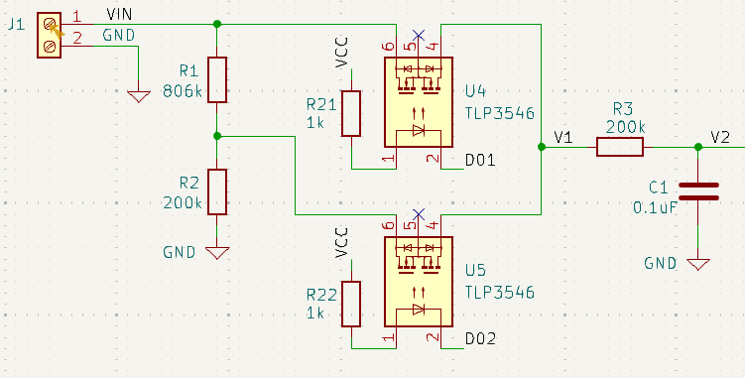
Input Voltage Divider
- The R1, R2 Divider scales down high voltages to the +5V max of the ADC input.
Kdiv = V1 / Vin = R2 / (R1+R2)
Analog Mux
- Solid-State Relays U4 and U5 create an Analog Mux
  - Normal Voltage Range: U4 connects Vin directly to V1.
  - High Voltage Range: U5 connects the Divider tap to V1.
Low-Pass Filter
- R3, C1 create a low-pass filter: fc = 1 / (2 * pi* R3 * C1)
- Reduces unwanted 60Hz, radio interference and protects against input spikes.

Amplifier with Selectable Gain
You can configure U1 as a selectable gain amplifier or a unity-gain buffer.
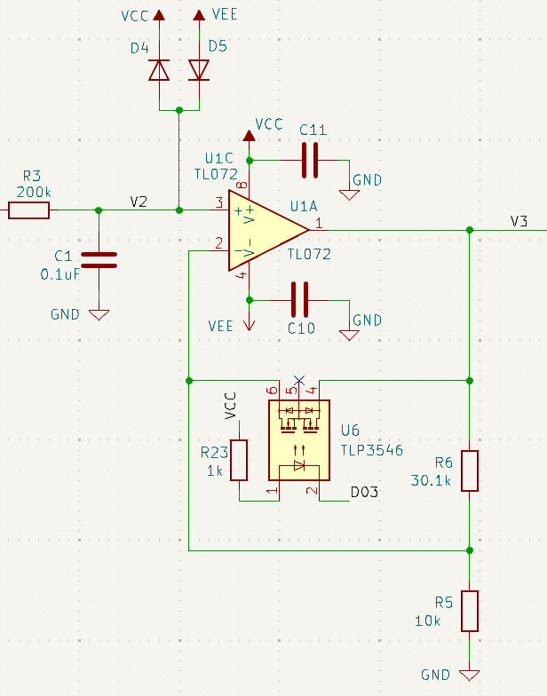
Selectable Gain Amplifier
- Unity Gain Amplifier - U6 Switch ON
  - U6 shorts U1 output to negative input.
- Gain Amplifier - U6 Switch OFF
  - Ka = V3 / V2 = R6 / R5 + 1
Unity-Gain Amplifier
- U6 not used.
- R5 = short (or < 100 ohms)
- R6 = open
Input Protection
- Schottky Diodes D4, D5 limit V2 to within VCC and VEE keeping U1’s pins under their MAX voltage input rating.

Scale & Shift, Buffer
You can scale and shift a bipolar input (-5V to 5V) to a unipolar one (0V to 5V) using a simple two resistor network R7, R8!
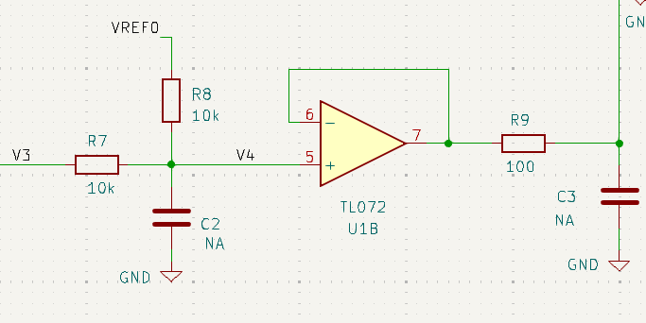
Scale and Shift
$$Kscale=\frac{V4}{V3}=\frac{R8}{R7+R8}$$
$$Voffset=VREF0∙\frac{R7}{R7+R8}$$

Unipolar Input Mode – No Scale or Shift
- Input: V3 = 0 to 5V Range
- Output: V4 = 0 to 5V Range
  - R7 = 1k, R8 = open
  - Scale: Kscale = 1 (Unity Gain)
  - Shift: Voffset = 0V
Bipolar Input Mode - Scale & Shift
- Input: V3 = -5V to 5V Range
- Output: V4 = 0 to +5V Range
  - R7 = 10k, R8 = 10k, VREF0 = +5.0V
  - Scale: Kscale = R8 / (R7+R8) = 0.5
  - Shift: Voffset = Vref0 * R7 / (R7+R8) = +2.5V
  - V4 = V3*0.5 + 2.5V
Optional Low-Pass Filters
- R7||R8 and C2: fc = 1 / (2 * π * R7||R8 * C2)
- R9 and C3: fc = 1 / (2 * π * R10 * C3)

Buffer and External Interface
Output Buffer
- U1B buffers the medium impedance at node V4 and drives the Microcontroller’s ADC input.
- R9 can provide isolation from capacitive load if driving long cables / wires to ADC input.
- C3 (and R9) can provide addition low-pass filtering.
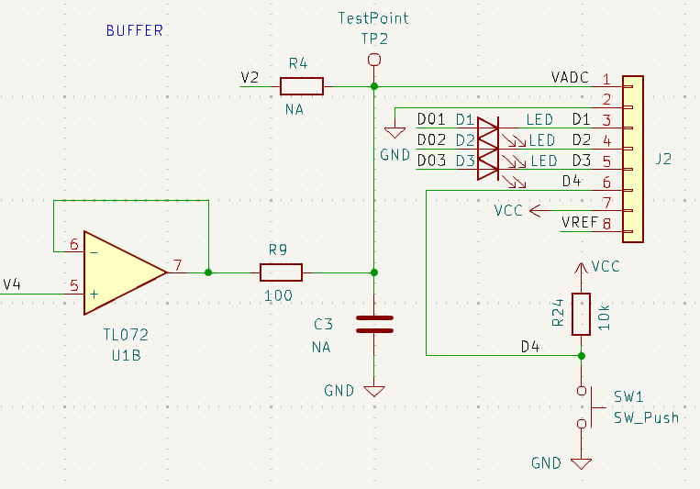
Microcontroller Interface
- Connector J2 allows easy access to external controller or computer.
Signals | Controller Signal | Description
VCC, GND | Power | Power for DVM PCB
D1, D2, D3 | Digital Outputs | Solid-State Switch Control  Low State – Turns ON U4, U5, U6
D4 | Digital Input | Push-Button State for Range Select.
ADC | Analog Input A0 | Voltmeter Reading
VREF | Analog Input (A1) | Reference Voltage for Precision Mode

Pushbutton
- SW1 for external input to manually select Vrange.
LED Indicators - Digital LO & Switch ON
- LEDs (D1,D2,D3) light up when digital outputs (D1,D2,D3) are driven LO turning Opto-Switches (U4,U5,U6) ON.

Negative Rail
You’ll need a negative supply to power U1 for bipolar inputs.
- U2 is a Switched-Capacitor Converter that creates a negative voltage (VEE) from a positive input voltage (VCC).
- U2’s internal switches alternatively charge C15 to VCC then deliver the charge to C16.
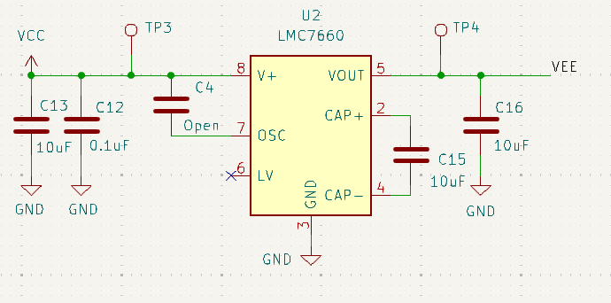

Voltage Reference
A precise voltage reference enables you to measure in Precision Mode.
- U7 is an IC that behaves like a precision 2-terminal Zener Diode.
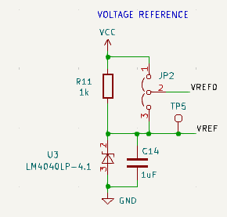
- VREF0 drives the Scale and Shift Network
  - VREF0 = VCC = +5V (JP1: 1-2)
  - VREF0 = VREF = +4.096V (JP1: 2-3)

Precision Mode Options
- Connect VREF to an ADC input.
You can measure this precision voltage and apply a Gain correction to all VIN readings.
- Connect VREF directly to the Vref pin of the controller’s ADC.
The ADC automatically scales the measurements to this reference.

Input Test Levels
A simple resistor string provides 3 handy on-board voltages for testing multiple ranges. For RT1 = RT2 = 10k and RT3 = 1k you get the following levels.
- VCC = +5V Supply.
- VT1 = VCC * (RT2+RT3) / (RT1+RT2+RT3)
= 2.619V
- VT2 = VCC * (RT3) / (RT1+RT2+RT3)
= 0.238V
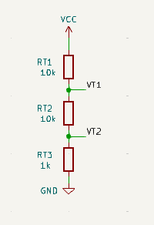

Create any two test voltages that you might need!

Voltage Range Setup

Ranges (Default)
Range | Vrange | Vrange Max | Overrange (%)
Standard | 4V | 5V | 25%
High | 20V | 25V | 25%
Low | 1V | 1.25V | 25%

Voltage Range, Gains and Digital Outputs
Voltage Range | Divider Gain | Amplifier Gain | Analog Switches | Digital Outputs
Standard | 1.0 | 1.0 | U4 = ON  U6 = ON | D1 = LO  D3 = LO
High | R2 / (R1+R2) | 1.0 | U5 = ON  U6 = ON | D2 = LO  D3 = LO
Low | 1.0 | R6 / R5 + 1 | U4 = ON | D1 = LO

NOTE: LED’s D1, D2, D3 turn ON when digital outputs D1, D2, D3 go LO!

Signal Levels
Polarity | VIN | V4 | VADC
Unipolar | 0V  to +Vrange_max | 0V to +5V | 0V to +5V  0V at VIN = 0
Bipolar | -Vrange_max to +Vrange_max | -5V to +5V | 0V to +5V  2.5V at VIN = 0

Software Calculation of VIN
Polarity | VIN | Ktot | Calc VIN from ADCword
Unipolar | 0 to +Vrange_max | Kdiv*Kamp | VIN = (ADCword / 1024 * VREF) / Ktot
Bipolar | -Vrange_min to +Vrange_max | Kdiv*Kamp*Kscale | VIN = (ADCword / 1024 * VREF – VREF / 2) / Ktot

DVM Basic - 2 Ranges, Unipolar Input
Let’s take our DVM for a test drive! Build this voltmeter to get some hands-on experience with multi-ranges. You’ll get to apply some real-world testing of your house-hold batteries.
Description
- Ranges: +4V, +20V
- Input: Unipolar (Pos input only)
- Range Select: Manual Push-Button
- Low-Pass Filter: 8 Hz
- Overrange: 25% (+5V, +25V)

Install Components (See DVM Basic in Make it! Section)
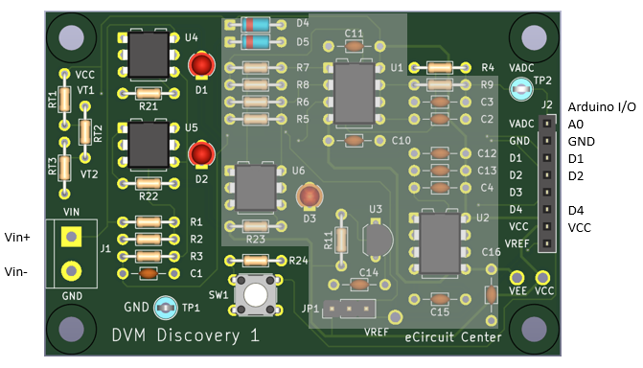

Install Components on 4-Pin Solderless Headers
- R1 = 825k, R2 = 200k (Input Divider)
- R3 = 200k, C1 = 0.1uF (Low-Pass Filter)
- R4 = 1k (connect to VADC)
Option: Solder components above directly on PCB without headers.

Connect Arduino UNO to DVM Discovery
Arduino | Description | Discovery | Description
A0 | Analog ADC Input | VADC | Measured Voltage Signal
D11, D12 | Digital Outputs | D1, D2 | Opto-Switch Control and LEDs
D4 | Digital Input | D4 | Push-Button Logic State
+5V, GND | Power | VCC, GND | Power for Switches, Amp, etc.

Check Out
- Connect Arduino USB to PC or Laptop
- Use a DVM to verify +5.0V between Testpoints VCC and GND.
Run Code
- Download the file: DVM_discovery_basic_1.ino
- Start the Arduino IDE and Open the file listed above.
- Hit the Upload and Run buttons.
- Press pushbutton repeatedly and verify that LEDs D1 and D2 alternately turn ON and OFF.
Test Voltage
- Press the push-button to select the 4V Range.
LEDs: D1 = ON, D2 = OFF
- Connect the VIN Test Clip (RED) to VT1 (2.69V).
- Read voltage at Arduino Serial Monitor on the PC screen.
- Very the reading is within +/-0.05V
- Press the push button to select the 20V Range.
LEDs: D1 = OFF, D2 = ON
- Read voltage.
- Very the reading is within +/-0.1V
Test 1.5V and 9V Batteries
- Connect a 1.5V or 9V battery’s + and -leads to VIN and GND.
- Select the 4V or 20V Range.
- Check 1.5V health - between 1.1V and 1.5V
- Check 9V health - between 7.5V and 9V.

DVM Advanced - 3 Ranges, Bipolar Input
Let’s extend the capabilities of our DVM to 3 Voltage Ranges and measure both
+/- input polarities!
Description
- Ranges: ±1V, ±4V, ±20V
- Input: Bipolar (Pos & Neg Voltages)
- Range Select: Manual Push-Button
- Low-Pass Filter: 8 Hz
- Overrange: 25% (±1.25V, ±5V, ±25V)

Install Components (See DVM Advanced in Make it! Section)
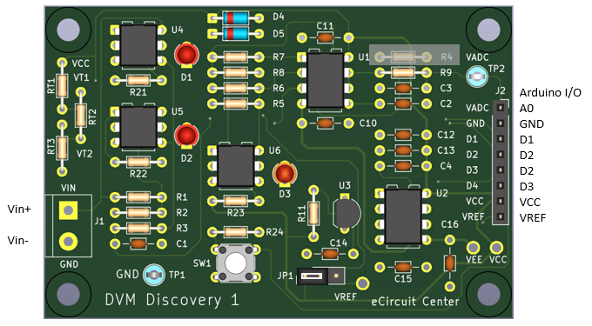
Install Components on 4-Pin Solderless Headers
- R1 = 825k, R2 = 200k (Input Divider)
- R3 = 200k, C1 = 0.1uF (Low-Pass Filter)
- R5 = 10k, R6 = 30.1k (Amplifier)
- R7 = 10k, R8 = 10k (Scale and Shift)
- R9 = 1k (connect to VADC)
Option: Solder components above directly on PCB without headers!

Jumpers
- JP1:1-2 (VREF0 = +5V)

Connect Arduino UNO to DVM Discovery
Arduino | Description | Discovery | Description
A0 | Analog ADC Input | VADC | Measured Voltage Signal
D11, D12, D13 | Digital Outputs | D1, D2, D3 | Opto-Switch Control and LEDs
D4 | Digital Input | D4 | Push-Button Logic State
+5V, GND | Power | VCC, GND | Power for Switches, Amp, etc.

Check Out
- Connect Arduino USB to PC or Laptop
- Use a DVM to verify +5.0V between Testpoints VCC and GND.
- Verify -5.0V between VEE and GND.
- Verify +4.906V between VREF and GND.
Run Code
- Download the file: DVM_discovery_3range_bipolar_1.ino
- Start the Arduino IDE and Open the file listed above.
- Hit the Upload and Run button.
- Press pushbutton repeatedly and verify that LEDs D1, D2, D2 turn ON and OFF.
4V Range
- Press the push-button to select the 4V Range.
LEDs: D1 = ON, D2 = OFF, D3 = ON
- Connect the VIN Test Clip (RED) to VT1 (2.619V).
- Read voltage at Arduino Serial Monitor on the PC screen.
- Verify the reading is within +/-0.05V
20V Range
- Press the push button to select the 20V Range.
LEDs: D1 = OFF, D2 = ON, D3 = ON
- Connect the VIN Test Clip (RED) to VT1 (2.619V).
- Verify the reading is within +/-0.1V
1V Range
- Press the push button to select the 1V Range.
LEDs: D1 = ON, D2 = OFF, D3 = OFF
- Connect the VIN Test Clip (RED) to VT2 (0.238V).
- Verify the reading is within +/-0.05V

Make it!
Here’s the parts list for the Basic and Advanced DVMs.
- Modify and build for your own learning goals.
- Install only parts needed for your design.
- All Resistors: 1/4W, 5% unless noted.
- All Capacitors: Ceramic, >25V

DVM Basic - 2 Ranges, Unipolar Input
PASSIVES
R1 | 1 | 825k | 1% for precision | Install group on 4-pin headers
R2 | 1 | 200k | 1% for precision
R3 | 1 | 200k
C1 | 1 | 0.1uF
R4 | 1 | 1k |  | Install group on 4-pin headers
R9 | 1 | Open
C3 | 1 | Open |  | Optional low-pass filtering
C2 | 1 | Open |  | Optional low-pass filtering
R21, R22 | 2 | 1k
RT1, RT2 | 2 | 10k
RT3 | 1 | 1k
D4, D5 | 2 | Diode | 1N5711
D1, D2 | 2 | LED Yel | LTL-4253 | Any color you prefer.

INTEGRATED CIRCUITS
U4, U5 | 2 | Opto-Isolated  Solid-State Switch | TLP592 type  or equivalent | Ron < 10 ohms

HARDWARE
R1 - C1  R4 - C3 | 4 | 4-pin Socket Header for components | SSW-104-01-T-S | Install on both sides of component groups.
U4, U5 | 4 | 3-pin female break-away  socket strip |  | Install on both sides for opto switches.
J2 | 1 | 8-pin Socket Header | SSW-108-01-T-S
J1 | 1 | 2-pin  Terminal Block screw type |  | Optional: Solder test leads (spring or alligator clips) directly to J1 pads.
TP1 | 1 | TestPoint | 5011

DVM Advanced - 3 Ranges, Bipolar Input
PASSIVES
C10, C11, C12 | 3 | 0.1uF |  | All caps Ceramic, >25V
C13, C14, C15, C16 | 2 | 10uF
R1 | 1 | 825k | 1% for precision | Install group on 4-pin headers
R2 | 1 | 200k | 1% for precision
R3 | 1 | 200k
C1 | 1 | 0.1uF
R5 | 1 | 10k | 1% for precision | Install group on 4-pin headers
R6 | 1 | 30.1k | 1% for precision
R7 | 1 | 10k | 1% for precision
R8 | 1 | 10k | 1% for precision
R4 | 1 | Open |  | Install group on 4-pin headers
R9 | 1 | 1k
C3 | 1 | Open |  | Optional low-pass filtering
C2 | 1 | Open |  | Optional low-pass filtering
R11, R21, R22, R23 | 4 | 1k
RT1, RT2 | 2 | 10k
RT3 | 1 | 1k
D4, D5 | 3 | Diode | 1N5711
D1, D2, D3 | 3 | LED Yel | LTL-4253 | Any color you prefer.

INTEGRATED CIRCUITS
U1 | 1 | Op Amp | LMC6082IN/NOP8 | Dual op amp, rail-to-rail output,  +/-7.5V supply max, DIP
U2 | 1 | Negative Rail Charge Pump | AD7660NP
U3 | 1 | Voltage Reference Shunt | LM4040xx
U4, U5, U6 | 3 | Opto-Isolated  Solid-State Switch | TLP592 type  or equivalent | Ron < 10 ohms

HARDWARE
R1 - C1  R5 - R8  R4 - C3 | 6 | 4-pin Socket Header for components | SSW-104-01-T-S | Install on both sides of component groups.
U1, U2 | 2 | DIP-8 Socket | 4808-3000-CP
U4, U5, U6 | 6 | 3-pin female break-away  socket strip |  | Install both sides for opto switches.
J2 | 1 | 8-pin Socket Header | SSW-108-01-T-S
J1 | 1 | 2-pin  Terminal Block screw type |  | Optional: Solder test leads (spring or alligator clips) directly to J1 pads.
JP1 | 1 | 3-pin Header | TSW-103-08-T-S | 1 Shunts needed  SNT-100-BK-T
TP1 | 1 | TestPoint | 5011

Bonus Sections

Revision & Notes
DVM Discovery User’s Guide: Rev 1a
The DVM Discovery provides real-world hands-on experiences to developing skills, understanding and intuition about measurement topologies.
Rick Faehnrich
https://www.linkedin.com/in/rick-faehnrich-2671a911/

Learning Styles
Dive in any way that propels your learning with Self-Directed or Guided Learning (or a combination of both).
- Self-Directed Learning - Explore circuits entirely on your own.
- Guided Examples – Follow a walk-through of two DVM implementations:
  - 2-Range, Unipolar Input
  - 3 Range, Bipolar Input
- Mixed Mode - Get ideas from the Guided examples and follow-through on your own.

Arduino Software
Here's the fast track steps of running a C program (sketch) on your Arduino Board.
- Download and install the Arduino IDE Software.
https://www.arduino.cc/en/software
- Connect UNO Board to your computer
https://docs.arduino.cc/hardware/uno-rev3/
- Open the Arduino IDE Software.
- Select Board Name
Select UNO from drop down menu.
- Copy the program (sketch) to your Arduino folder and Open it.
DVM_discovery_basic_1.ino
- Click Compile Button
Generates executable code, checks for errors.
- Click the Upload Button
Uploads compiled code into UNO and begins running.
- Click the Serial Monitor
Window displays output from PrintSerial statement.

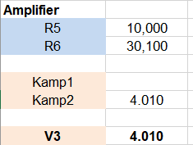
Excel DVM Design Calculator
A handy Design and Analysis Toolkit.
https://ecircuitcenter.com/DVM1/dvm-discovery.html
- Calculate gains, signal levels and ADC digital values.
- Modify, customize for your own projects.

KiCAD Software
KiCad is a free and open-source software suite that provides a complete EDA toolset including schematic capture, PCB layout, 3D visualization, and circuit simulation. https://www.kicad.org/

GitHub
The DVM Discovery Bd is an open-source project intended to make op amp learning as accessible and affordable as possible. You can down load the documentation and KiCAD project files at https://github.com/rick-ecircuit (Available soon...)

Feedback eCircuitCenter
Feedback on eCircuit Center
- How is the DVM Discovery Bd helpful for you?
- What needs clarity?
- Other comments, suggestions?
Send your thoughts on the feedback form at eCircuit Center.
https://ecircuitcenter.com/contact.htm
eCircuit Center strives to provide informal, hands-on and fun experiences that lead to a deeper, more intuitive understanding of circuit design and analysis.

The Power of Play
- Key to analog success: play, play, play with circuits!
- Analog circuits appear more inviting (and less intimidating) when playing and tinkering.
- Learning and passion grow when you
  - Ask “what if” questions
  - Play with component values - Predict the outcome!
  - Small discoveries and learning fuel motivation and the joy of learning.

