Shop and Inventory Tutorial

Setting up a Shop in Unity Editor
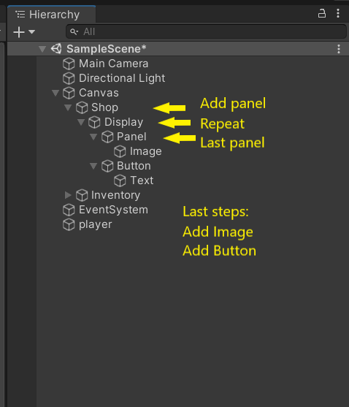

The “Shop” are “Panels” as arranged in screen-shot.
1) Hierarchy pane > right-click > UI > Panel. (Canvas is auto-added). Resize and position as needed.
A) Rename “Panel” to “Shop.”
B) Disable “image” component.
2) Right-click on “Shop” and “UI > Panel.” Rename to “Display.”
3) Right-click on “Display,” “UI > Panel.” Resize as needed.
4) Right-click on “Panel” and “UI > Image.”
A) Drag an .png file from Pictures in File Explorer to Assets pane in Unity.
B) Click .png file in Assets. In Inspector pane, change from Default to Sprite.
C) Click Image, drag .png file to “Source Image” in “Image” component.
5) Right-click on “Display”, “UI > Button.” Position button as needed.
A) Button has “Text” child. Click it.
B) Find “Text” Component. Rename “Button” to “Buy”
6) Final results:

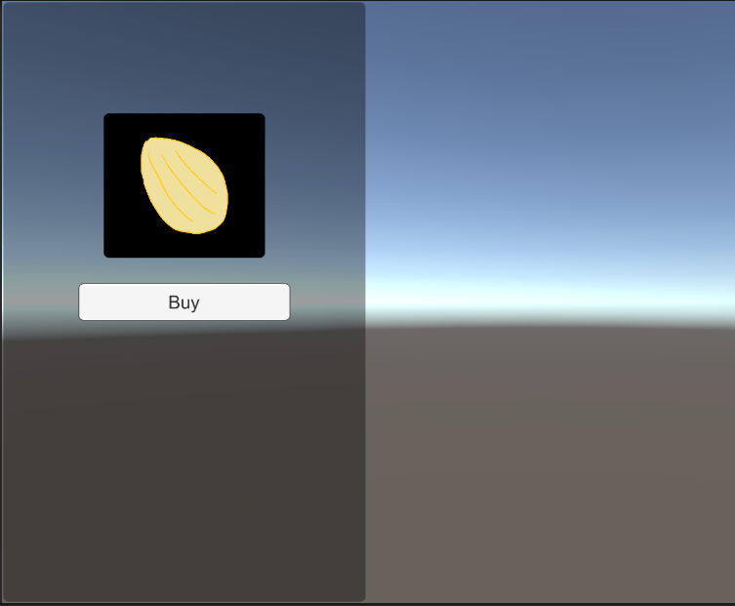

In this tutorial, panels are resized to preferences.

Color and transparency of panels are set to preferences.

Panels can be anchored using “Rect Transform > sketch”.

For the inventory tutorial, see page 3.

Setting up Inventory in Unity Editor
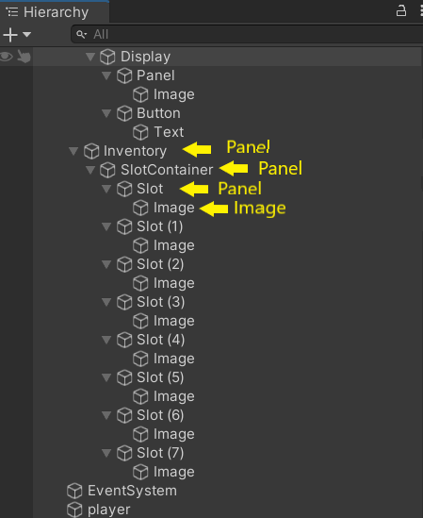

1) Right-click on Canvas, “UI > Panel”, disable image component, rename to “Inventory”
2) Add panels as indicated in screen-shot, adjust color and size to preference.
3) When “Slot” panel is created, add image to it. Then duplicate “Slot” as many times as needed.
4) Add “grid layout group” component.
A) Adjust cell size to preference.
B) Adjust other values to preference.
5) Grid layout group settings for this tutorial are included in screen-shot on page 4.
6) Disclaimer: Unity through no fault of Unity Technologies occasionally produces unexpected results
A) This is not a glitch.
B) Unity updates and changes from year to year.
C) This tutorial is a guide:
I) Users are more than capable of achieving results with experimentation.
II) We encourage their freedom of expression.

Grid layout group settings

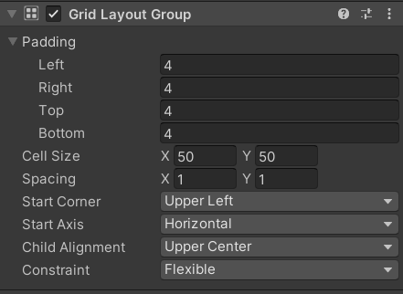

Final results:

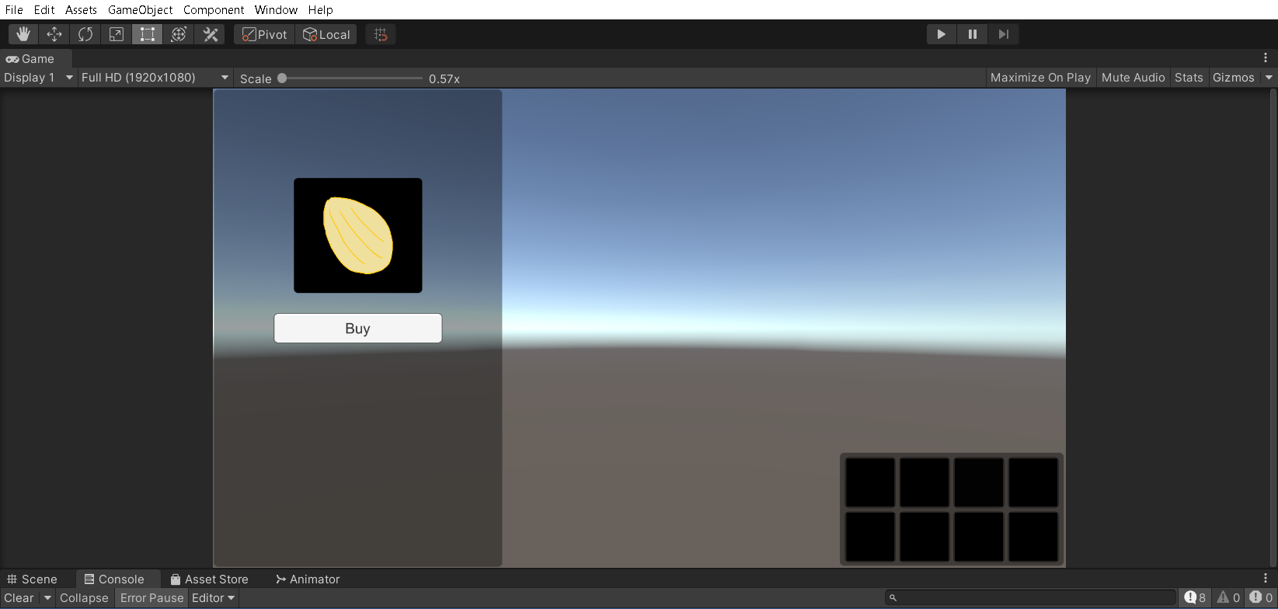
The process of making this work is simplified as much as possible.

Follow instructions on next page to achieve a working shop and inventory.

Make it Work:

1) In hierarchy pane, add a 3D object (a square or a capsule). Rename: “player”
2) Create C# script in Assets pane. Add it to “player” (hint: drag and drop it on “player”)
A) For this tutorial, we named C# script “player_inventory.cs”
B) This makes it possible to execute step 4 with no errors.
3) Open script in editor of preference. For this tutorial, we used Visual Studio Code Editor.
4) We added code to this tutorial. See page 6.
A) If desired, use it by copying code to script in editor.
5) Save and return to Unity Editor. Click on “player” in hierarchy pane.
A) In inspector pane, locate “player” script component.
B) Drag “slot container” from hierarchy to “slotContainer” in script component.
6) Click the button you created for the “Shop” tutorial.
A) Locate button component.
B) Locate OnClick().
C) Drag “player” to “None (Object)”
D) Go to “No Function” and “player_inventory” > “AddItem (gameobject)”
E) Drag “Panel” from “Shop” to “None (GameObject)”
7) Press player in Unity to test out the Shop and Inventory.

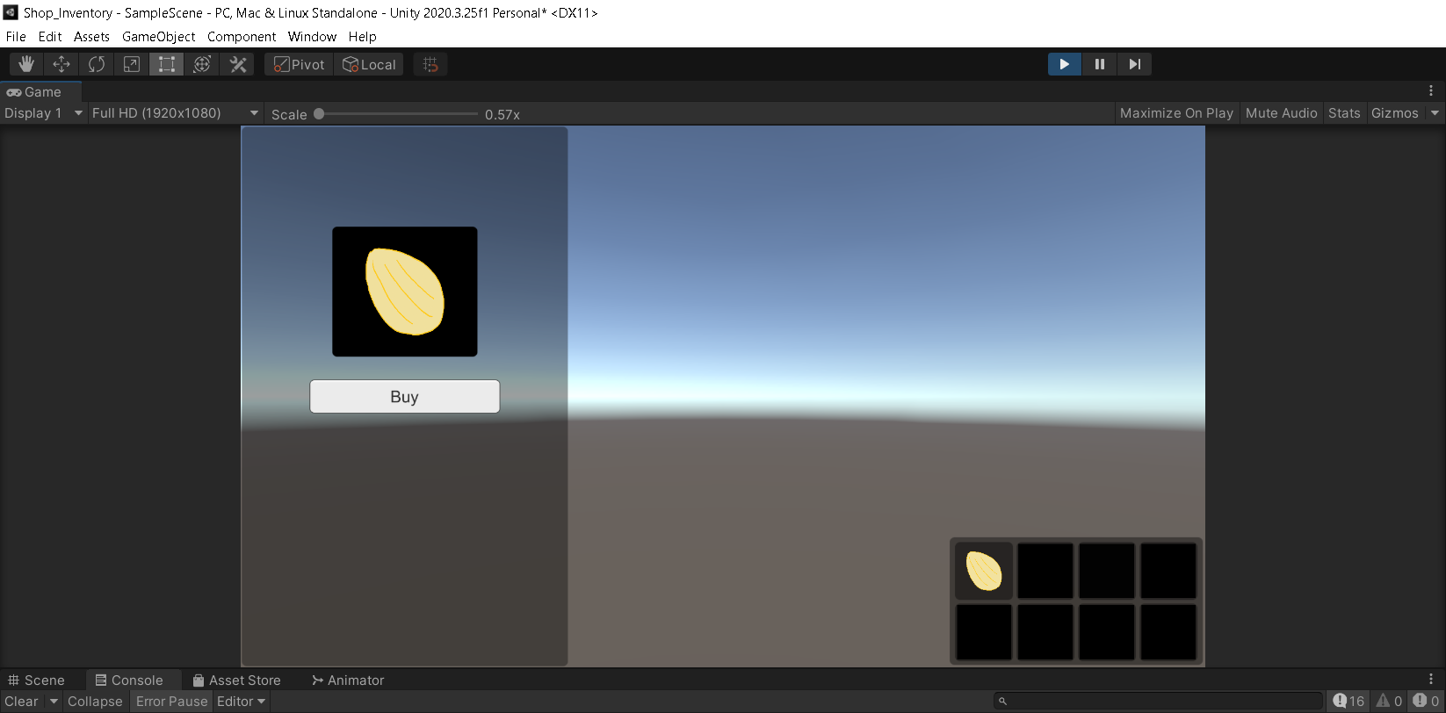
As seen in screen-shot, pressing the “Buy” button fills a slot in the inventory created for this tutorial.

Image is a “Short-Bread” cookie created in Paint 3D by author of this tutorial.

// C# Script for Player Inventory
using System.Collections;
using System.Collections.Generic;
using UnityEngine;
using UnityEngine.UI;

public class player_inventory : MonoBehaviour
{
public GameObject slotContainer;
private int slotCount = 8;
private GameObject slot;
private GameObject slotImage;

public void AddItem(GameObject itemPanel){
GameObject image;
Sprite icon;

image = itemPanel.transform.GetChild(0).gameObject;
icon = image.GetComponent<Image>().sprite;

for(int i = 0; i < slotCount; i++){
slot = slotContainer.transform.GetChild(i).gameObject;
slotImage = slot.transform.GetChild(0).gameObject;
if(slotImage.GetComponent<Image>().sprite == null){
slotImage.GetComponent<Image>().sprite = icon;
slotImage.GetComponent<Image>().color = new Color32(255,255,255,255);
break;
}
}
return;
}

}

