Section 1

The Activity Diagram
Guide to notation:
Activity Diagrams
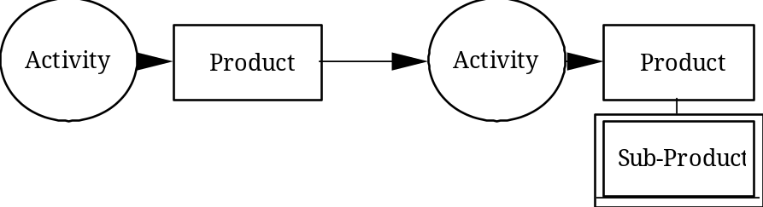
Activity Diagrams are used to describe a complex system in terms of smaller functional components called Activities. An Activity represents a dynamic process during which objects are manipulated and transformed, giving rise to a Product. The Product of one Activity can be required for another Activity to function. The circles represent Activities; the boxes represent the Products. A Product can be represented together with its sub-products. Such partitioning is discussed more fully in the guide to Concept Diagrams.
Each Activity can be analysed separately. One of the uses of an Activity Diagram is that it can provide an architecture for the analysis of a complex process. Activities can also be analysed in terms of their interaction, through the Products they exchange.
The result of such analysis is represented in the Concept Diagrams of Section 2 (which illustrate the necessary properties of the Activities and Products) and in the Event Diagrams of Section 3 (which illustrate the causal sequence of events both within Activities and during the exchange of Products between Activities).
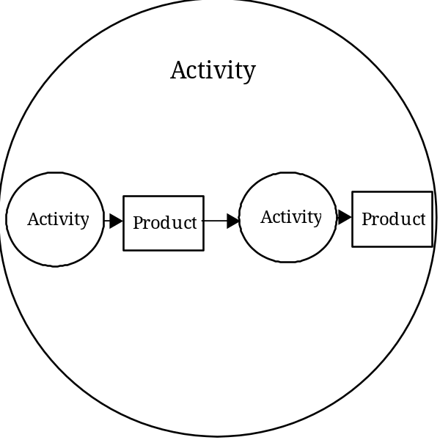
The arrows shown on Activity Diagrams show only the direction of production and use. They do not represent the sequence in which Activities run. Activities often run concurrently. The representation of several Activities within another Activity illustrates the coordination of the subordinate Activities as part of the process of the overall Activity.
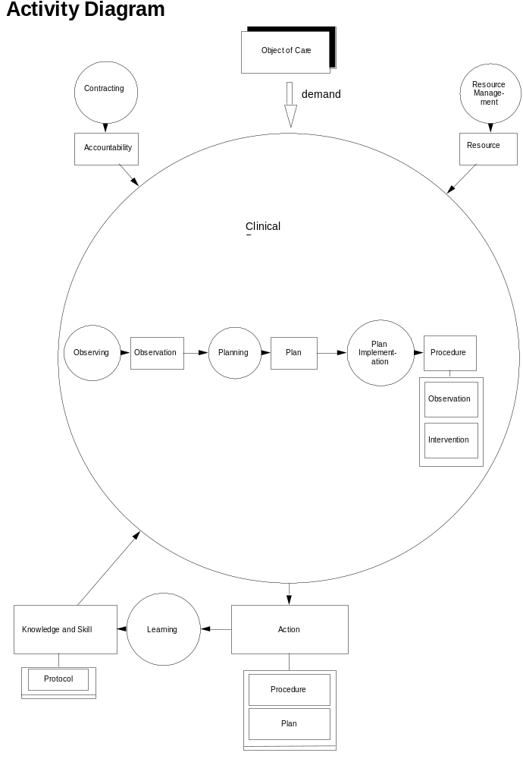

The Activity Diagram
The Activity Diagram assists in defining the scope of the project’s work. It illustrates the clinical activities that we have found it useful to distinguish. During work on the Clinical Process Model the activities have been considered separately as well as in terms of the interactions between activities.
As emphasised in the Introduction, the object of care can be an individual person or a population (including groups of people such as family groups), in other words any person(s) who can become the focus of clinical care. The object of care makes demands on the clinical process (represented in the diagram by the large arrow and shadowed box). It is understood that the demand made on the clinical process by the object of care is for the maintenance and enhancement of good health, as well as for care required as a result of ill-health.
The activity of observing, results in the observations that are the basic materials of clinical assessment. Moreover, such assessment is itself regarded as being an act of observation.
The activity of planning arises from the observations made, and generates clinical plans to meet the object of care’s requirements, to overcome, palliate or prevent clinical problems, or to make further observations. Planning defines the procedures to be used and their inter-relationships.
Plan implementation comprises the performance of procedures, which will be the interventions necessary for the clinical needs identified, and the observations required for further clinical assessment or for monitoring progress. The observations that lead to planning can be of a wish to continue in good health; and the interventions performed when plans are implemented can be intended to enhance health, as well as protect or restore it.
The activities of observing, planning, and plan implementation, constitute the clinical process, and their products (observations, plans, and procedures) are all regarded as clinical actions.
The activities of the clinical process all make demands on clinical knowledge and skills, and on the authority (in the form of accountabilities) and resources necessary for the use of those skills.
Beyond the scope of this project to date is any detailed consideration of the process of clinical learning, but it is recognised that as clinical procedures are performed on the basis of what clinicians understand to be possible, so clinical knowledge and skills are acquired through an accumulation of experience and experimentation.

Section 2

The Concept Diagram

The components of the Concept Diagram and their relations to each other are described in stages. Each stage of the description is supported by an illustration. The illustration does not however necessarily depict all the Concepts to which those in the illustration are related. For a complete view at any stage, reference should be made to the fold-out illustration of the whole Concept Diagram which is included inside the back cover of Volume 1. The Glossary of Concept Names (Volume 2) also illustrates each Concept in turn, together with all the other Concepts to which it is related.
Concept Names
A brief description of each Concept is given in the Glossary of Concept Names (Volume 2), as well as details and an illustration of all the other Concepts to which it is related. The Glossary also contains cross-references to all significant mentions made of each Concept in Section 2.
Words and phrases used as Concept Names are not used in any other context in Section 2. Thus every time a Concept Name is used in Section 2 it is referring to the Concept. When reference is made to a combination of two Concepts the Name used is simply a combination of the two 'parent' Names. (Explained in more detail in the Notation Guide).
Concept Names are distinguished in Section 2 by use of a font that is slightly different to that of the main text, eg observations and interventions.
Clinical Examples
¶All paragraphs that deal with clinical examples to support the Concept Diagram are indented as this one, and lead with the character ¶. Single examples in the main text are in parentheses.
Guide to notation: Concept Diagrams

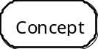 A concept represents a collection of objects that share one or more defining properties.

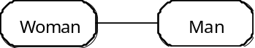 One form of relation between concepts is illustrated by a line directly from one concept to another. The relation is named: in this case it could be ‘married to’. The number of objects that can be related between concepts is determined by the type of line used to illustrate the relation (broken, solid, with or without a ‘crows foot’):

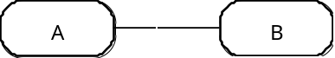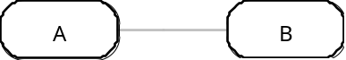
Each A must be related to one B Each A may be related to one B
Each B must be related to one A Each B may be related to one A

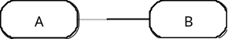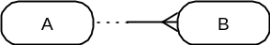
Each A may be related to one B Each A may be related to one or many B
Each B must be related to one A Each B must be related to one A

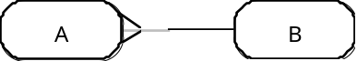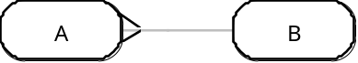
Each A may be related to one B Each A may be related to one B
Each B must be related to one or many A Each B may be related to one or many A

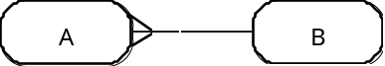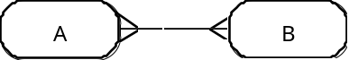
Each A must be related to one B Each A must be related to one or many B
Each B must be related to one or many A Each B must be related to one or many A
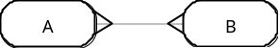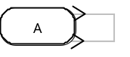
Each A may be related to one or many B Each A may be related to one or many A
Each B may be related to one or many A

The property of a relation that determines the number of objects that can or must be related between two concepts is known as the ‘cardinality’ of the relation. Each relation has two cardinalities: one cardinality is from A to B and determines how many B can or must be related to A; the other cardinality is from B to A and determines how many A can or must be related to B.

Each of the directions that a relation runs in (from A to B, and from B to A) has a name as well as a cardinality. In the illustrations in Section 2 only one name is used (that which best conveys the ‘meaning’ of the relation); both names are found, along with the cardinalities, in the Glossary of Concept Names (Volume 2).
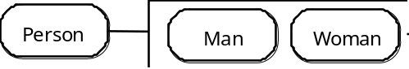 Within a collection of objects, sub-collections can be identified by additional distinguishing properties. The concepts representing the sub-collections are called subtypes. The ‘parent’ concept is called the supertype. The subtypes illustrated here are the only possible alternatives of the supertype. The box they are represented in is therefore called a complete partition. The line from a supertype concept to the box that represents the partition of subtype concepts is always solid and ends at the edge of the box.
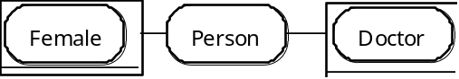 If the subtypes illustrated are not comprehensive, then a box with a double line for its bottom edge is used. This is called an incomplete partition. Incomplete partitions need not be mutually exclusive. A person can be female and a doctor, but not all doctors are female, nor vice versa. In the document such combinations are referred to by using both titles, eg. 'female doctor'.
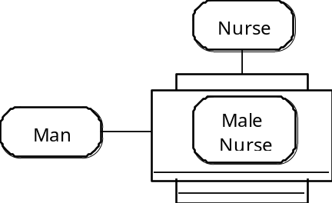 A concept can represent a collection of objects that are also members of two supertype concepts. Each male nurse is also a member both of the set ‘man’ and the set ‘nurse’.
Summary
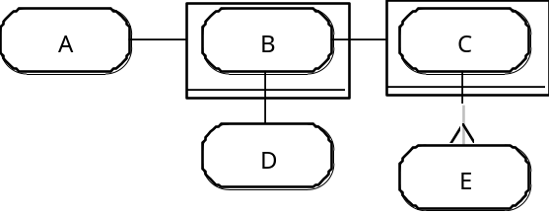
B is a subtype of A.
C is a subtype of B.
Each B must be related to one D. Each C must be related to one or many E.
Each D must be related to one B. Each E may be related to one C.
Each illustration in Section 2 does not necessarily depict all the relations of the concepts represented (they are found in the Global Concept Diagram which folds out from inside the back cover of Volume 1). In certain cases, to limit the number of concepts being described at any one point, a ‘short-cut’ through the model is marked in the illustrations by means of a diagonal line. Thus, adapting the illustration above:
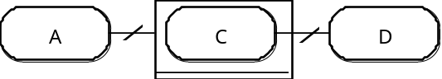
All objects represented by C are also members of the collection of objects represented by B. Therefore:
C is a subtype of A.
Each C must be related to one D.

2.1 Action

2.1.1 Timepoint & Location
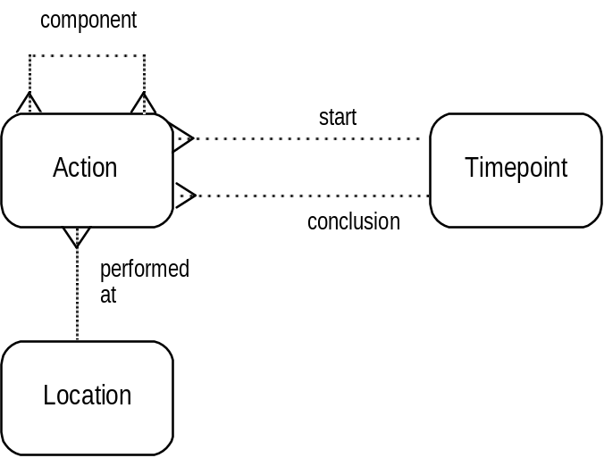
We consider the clinical record to be concerned with actions, clinical acts carried out within health care. An action is carried out at a location.
An action can be complex, made up of a number of different component actions. If all the component actions are performed at the same location then the location of the parent action is also that of all its component actions.
If a complex action is performed at a number of different locations, then one separate location is recorded for each component action that is subordinate to the parent action.
Start and conclusion timepoints can be ascribed to an action, recording when the action began and ended. These timepoints mark the timespan of an action. There is no provision within the model as yet for other examples of timepoint, such as those that would allow the recording of the time actually spent on an action, where that differs from the timespan.

2.1.2 Object of Care & Procedure
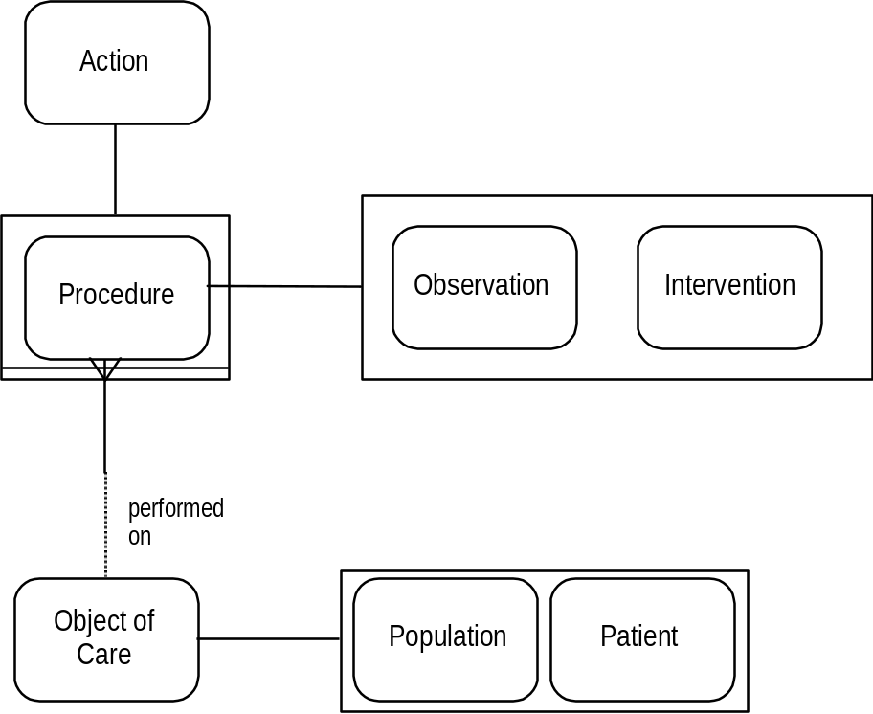
Actions include observations of an object of care’s state of health, and interventions that attempt and/or risk a change to that state of health (physical, mental, social, etc). The actions of observation and intervention are grouped together as clinical procedures. They are focused on individual objects of care.
Objects of care, as already emphasised in the Introduction, represent populations as well as single patients. Modelling work has been done by ourselves and others on representing means of defining populations (such as family groups defined by consanguinity and other ties, including role within the group). The work is not complete enough however to incorporate into the current version.

2.1.3 Protocol
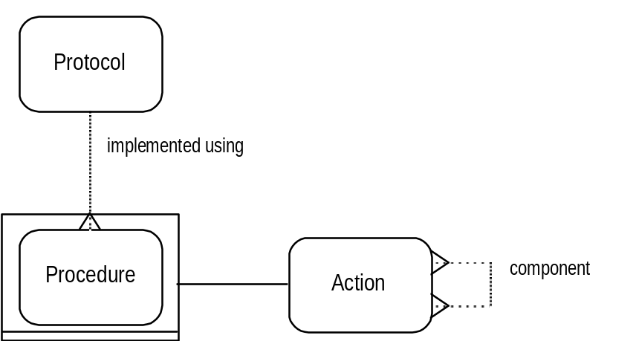
It is considered that procedures are performed as an expression of what the clinician understands it is possible to do. This may be the clinical knowledge of how to observe or measure a particular characteristic, or of how to intervene in an attempt to achieve a particular end. The representation of this understanding in the Cosmos model hinges around protocols.
The performance of any procedure is regarded as being the implementation of one or more distinct protocols. Individual protocols can be defined and distinguished by a number of properties (circumstances of use, expected outcome, necessary resources, etc) and these properties can be referred to when planning and scheduling procedures. The representation of these properties in the Concept Diagram is considered in Section 2.4.
The term protocol has been chosen rather than ‘technique’ because its popular use carries a sense of etiquette, an understanding of how things should be done. A narrower usage is sometimes found in clinical care to describe how complex, but well-defined and tightly-bounded procedures should be performed (eg chemotherapy regimes). Protocols in the model have this capability, but can also represent less complex tasks (eg taking the blood pressure).
¶ An immunisation programme has protocols that determine both the identification and enrolling of subjects for immunisation, as well as the actual immunisation procedure itself (injection, etc).
As an action, a procedure can be made up of a number of component procedures. The composing of a complex procedure for a particular object of care, using a number of possibly unrelated protocols, is the subject of clinical planning, described in Section 2.6. Because a complex procedure can be customised for an object of care, there will not necessarily be a protocol for the overall procedure that has been customised. The relation between procedure and protocol is not therefore mandatory.

2.1.4 Accountability
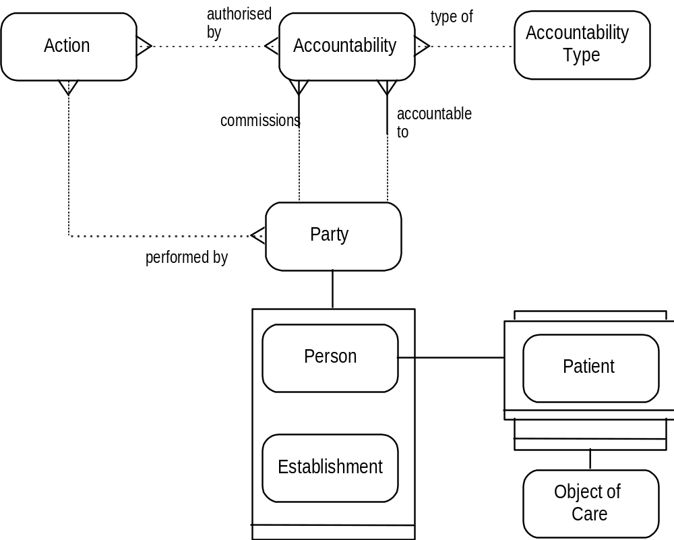
The authority under which an action is to be performed is represented by an accountability. An accountability is an agreement that authorises the carrying out of an action. It is set up between two parties. One party commissions the other; that second party is accountable to or responsible to the first for actions undertaken with the authority of that accountability. An involved party can be an establishment (such as a hospital, health authority, or laboratory) or an individual person, including a patient.
(Each patient is both a person and an object of care).
¶Accountabilities are intended to cover a wide range of agreements, eg:
• the appointment of an employee at a particular establishment (hospital consultant for instance).
• a patient’s registration with a GP.
• the formal consent requested of patients for particular procedures.
An accountability can be an example of an accountability type. The accountability type defines what form of agreement has been reached (eg a particular agreement between patient and doctor is of the type ‘registration with a GP’).
A single accountability can also describe the circumstance of a clinician or an establishment being responsible for the care of a patient over a period of time (defined for instance by a particular illness, however prolonged).
That single overall accountability governs the entire period during which the clinician or establishment has a responsibility towards the patient, however slight, and however prolonged the intervals between consultations.
During this period of time, there can be a number of separate consultations, both outpatient and inpatient. Each consultation is not only governed by that single overall accountability, but can itself involve a number of other accountabilities to cover admissions and/or particular procedures. Each of those accountabilities is confined to the limits of the individual consultation.
Thus, governed by that single overall accountability can be multiple, concurrent accountabilities, distinct with respect to the procedures authorised.
When the patient is recorded as having left the clinician’s care without a provision for further consultation having been defined (whether open, or for a particular appointment) then the single overall accountability ceases. (In some clinical practices a patient’s file is left ‘open’ for a defined period of time, in case a further consultation is required by the patient or clinician.)
¶For example, an accountability is opened for a patient with diabetes mellitus to attend a local hospital. This accountability covers all consultations made at the hospital with respect to the patient’s diabetes, regardless of changes to hospital personnel (consultants, clinic nurses, etc). Each consultation can involve other accountabilities to govern, for instance, inpatient admissions, day-case diagnostic procedures, etc. The overall accountability usually remains open until the patient’s death, or transfer to another diabetic department.
¶A patient’s death can lead to a number of accountabilities being established:
• the clinician can be required by the coroner to perform an autopsy.
• the clinician can organise bereavement counselling for the patient’s relatives.
• authorisation can be sought from the relatives for organ donation.
¶A patient’s registration with a GP is represented as an accountability that is opened on registration, remains open for any consultation the patient is able to make, and closes only when the patient is removed or removes her/himself from the GP’s list.
¶In terms of the model the various NHS Acts are seen as being accountabilities with respect to the populations for which health care is available. The provision of care to any group or individual that belongs to one of the defined populations is governed by that accountability.
Specific acts of care directed at defined populations can require further authorisation, eg immunisation programmes, screening programmes, etc.
More than one accountability can govern the performance of an action: the patient’s formal consent, the hospital appointment of the clinician, the contract which will determine payment, the necessary qualifications and accreditations of the clinician.
A record of any, all, or none of these can be regarded as necessary. As stated in the introduction, the model is not intended to be prescriptive, but rather to cater for a record that is as detailed or as limited as the circumstances require it to be.

2.1.5 States of Action
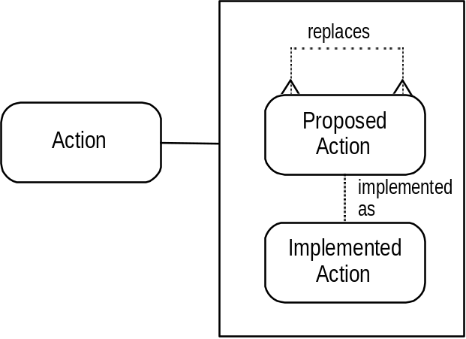
A record can be required of actions at any stage: when they are being planned, and whether they were carried out or not. These states are described by actions having been:
• proposed.
• or implemented.
Before a proposed action is implemented, it is possible that an alternative action is selected, in which case it replaces the previously proposed action. The replaced proposed action has in effect been withdrawn. The action that replaces it can be a positive intention to do nothing.
The details of a proposed action can vary significantly from those of its complementary implemented action. It may have turned out that the action was performed at a different time, or by a different clinician, etc. The differences can be very important, so the proposed action is kept intact, establishing a relationship between it and the implemented action that resulted, if any.
Of course a record can be made of an implemented action without there being any need to record its having been proposed. It is not obligatory that for every implemented action there should be a record of its complementary proposed action.
At any one time there can be a record of proposed actions that have yet to be implemented. They are distinct from proposed actions that have been replaced, never to be implemented.
We regard the two types of action (proposed and implemented) as being sufficient to start a description of all the possible different stages in the evolution of an action. Each type will itself have different possible states in which it can be recorded:
• the records of proposed actions will accumulate details of resources to be used, expected timepoints, performers, etc. There is no distinction made in this model between different states of scheduling, other than by providing for a record of the arrangements as they are made.
• the states of implemented actions are also determined by the relationships placed around them:

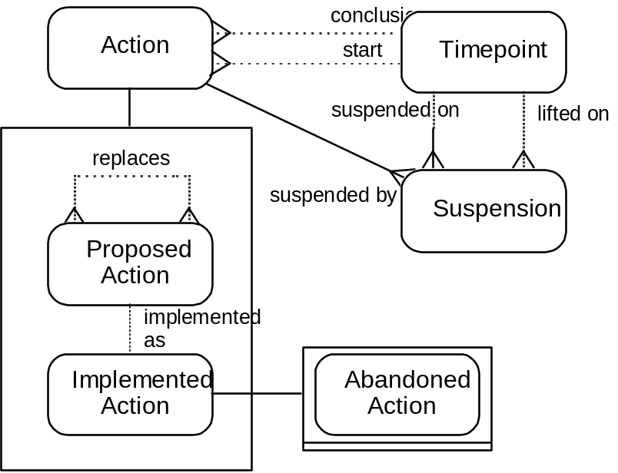
When an action is initiated, it is recorded as an implemented action with a start timepoint. (Implemented action might have been better referred to as 'implementation': the latter can bear the sense of an active process that has been initiated but not concluded, while the former suggests an already completed process. However the former has been retained to carry the title 'action' through the various subtypes.)
When an action is concluded, it is recorded as an implemented action with a conclusion timepoint. An implemented action must have either a start timepoint or a conclusion timepoint, (or both), since these are the only properties used in the model to determine whether actions have ended or not. The conclusion timepoint is recorded even if it is simply a default value, in cases where all that is known is that the action has concluded, and not the actual timepoint.
An action has been completed when it has been seen through to its previously designated end, accommodating any ‘legitimate’ divergence that was allowed for at the outset.
In any other circumstance of concluding an action, it is said to have been abandoned.
An abandoned action must have been replaced (through its proposed action). As described above, the action that replaces it can be a positive intention to do nothing further.
Any implemented action that has concluded without being replaced or abandoned has therefore by definition been completed. As stated above, its conclusion timepoint must be recorded, even if, in cases where the actual timepoint is not known (simply that it was 'in the past'), it is a default value.
Actions can be suspended, before being initiated in the case of proposed actions and before being concluded in the case of implemented actions. The suspension has its own timepoints, that of the date of suspension, and that of the date of re-activating the action. Actions can be suspended and re-activated any number of times. Rather than being re-activated they can be replaced by other actions (including the ‘do nothing’ action) or abandoned.
¶The usefulness of suspension is illustrated by patients held on a transplant waiting list. Whilst on the list a patient’s proposed transplant can be suspended from time to time due to episodes of illness, infection etc.
¶The states of action described above are illustrated by considering a procedure, an intervention such as a drug infusion:
• its prescription beforehand will have been recorded as a proposed action.
• it may be intended to last for 24 hours or more, in which case a record will be made of its start timepoint (when it is implemented), its conclusion timepoint to be recorded later.
• if the patient’s condition unexpectedly changes, in a way not catered for in the original plan, then the infusion can be suspended, and subsequently re-started, replaced or abandoned.
• if the rate of infusion is altered in a way determined beforehand, then the action is still completed as planned.
Those actions that are repeated whenever a defined set of circumstances occurs or time interval has elapsed are considered in Section 2.6.2.

2.2 Accountability

2.2.1 Accountability as Action
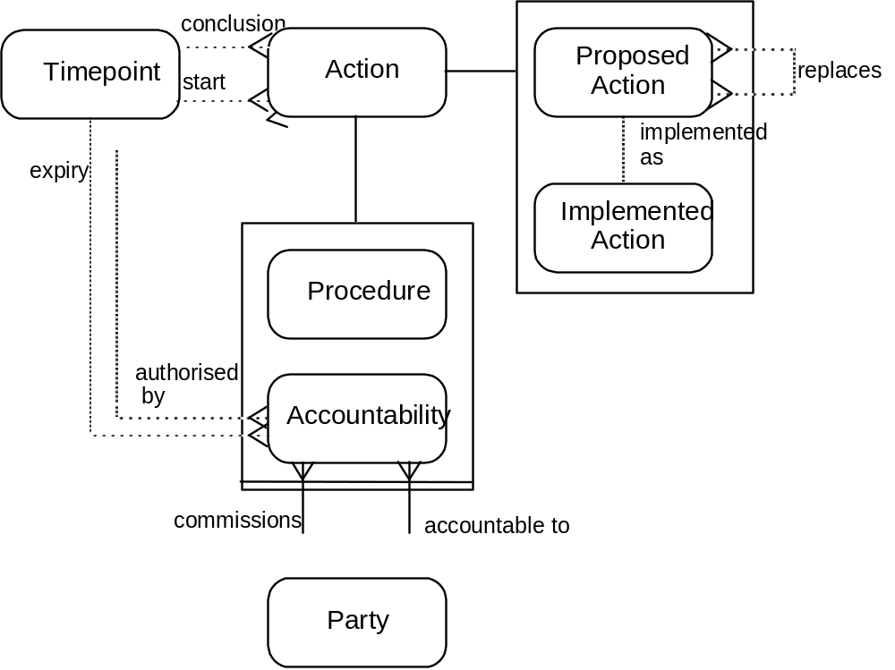
In addition to recording the type of an accountability, it is useful to be able to record whether an accountability was agreed to or declined, who proposed it, when these events occurred, and upon what authority an accountability was established or refused. By treating accountability as a sub-type of action, alongside procedure, those requirements are met by the various sub-types of action and their relationships.
Establishing an agreement is therefore represented as an action. The process itself involves proposing the details of an accountability, and agreeing to them or abandoning the action:
• when an accountability is recorded as being proposed, it is a proposal to initiate the process of setting up the accountability that is recorded. It might be the plan of action reached after clinical assessment of a particular patient (a note of the form - Plan: refer to X - is a record of a proposed accountability).
• the process of establishing the accountability is initiated by communicating with the party that is to be commissioned (by referral letter, for example).
• the party to which the patient has been referred can accept or decline the referral, so that the process is either completed or abandoned.
• if abandoned, the action of establishing the accountability can be replaced, with a different party to be commissioned.
• once completed, an accountability is in place: the process of agreeing to the arrangement has been concluded. Thus the timepoints of action (start and conclusion) are used to record the initiation of the process of setting up an accountability and the conclusion of that process, successful or not.
• accountability has a further relationship to timepoint, that of the date of its expiry.
Including accountability as an action caters for the view of it as a process. The substance of an accountability, what it is a contract for, is found in the relations that are established as a result of that process. These relations can be to:
the specific actions for which the accountability represents the authority,
the performer,
timepoint,
and location.
Thus the process of setting up an accountability is one that involves an accumulation of the detail of the accountability in the record.
¶The referral of a patient by a GP to a hospital consultant involves an attempt to set up a new accountability. At the time of the GP first noting this as part of his plan for the patient, it can be recorded as a proposed accountability. The process of trying to gain the acceptance of the consultant is then initiated by some form of communication, and the referral then completed (by its being accepted) or abandoned (by its being declined).
From a completion can be inferred a further accountability between patient and consultant: once the consultant has accepted the referral, he/she has a duty of care with respect to the details of the referral, that usually has little professional or legal responsibility attached to it at first, but that becomes more substantial as soon as the consultation takes place and the patient is more directly involved.
Should the patient decline to take up the referral or to continue with it, then it will have been closed (see also 3.2.3).
To summarise:
• accountability represents the process of setting up an authority for the performance of certain actions, whether this succeeds or fails.
• the intention to set up an accountability (for example the plan to refer a patient) is recorded as a proposed accountability.
• one party commissions the other, who is to be held responsible for actions undertaken with the authority of the accountability.
• the substance of the accountability is represented by the actions specified (including details of timepoint, location, and performer), and the commissioning and responsible parties.
• an accountability is initiated when the request is communicated by the commissioning party.
• it is completed if the terms of the accountability are agreed to.
• it is abandoned if they are declined.
• an expiry timepoint is recorded when the accountability is closed.

2.2.2 Post & Clinical Scope
It is possible to establish accountabilities, the details of which do not involve specific individual actions, but which are concerned with the provision of services of a general type (for example, contracts that are placed for the performance of a certain number of hip replacements, or the appointment of a consultant surgeon to perform renal transplants. The latter example is really part of a job description, itself part of a contract). The influence of contracts on clinical decisions is felt increasingly.
We have also sought to be able to cater for more precise definitions of those tasks clinicians of any given grade can be expected or allowed to undertake, and those not. In the continuing education that is a major part of careers in both medicine and nursing, the degree and level of responsibility change with time and the different stages reached.
The balance between providing a clinical service and being trained or educated has to be considered in the representation of the clinical process. Both the constraints and the opportunities that that balance defines, directly affect the planning and provision of health care.
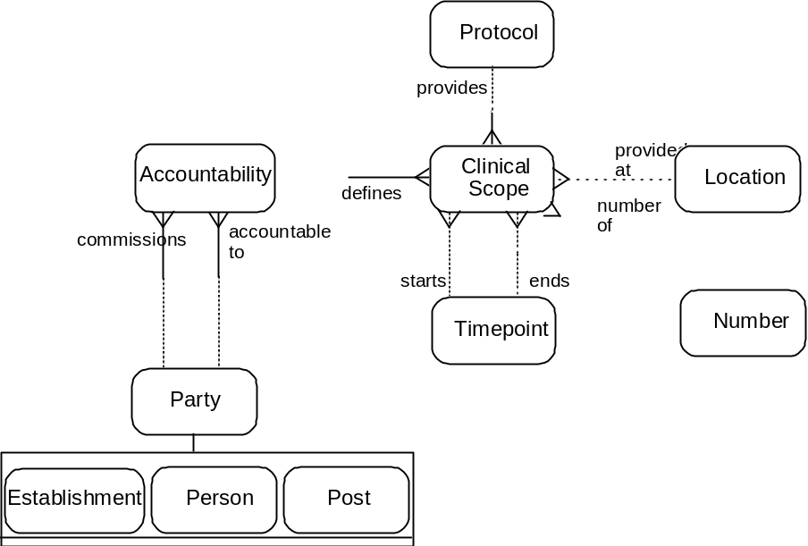
An establishment determines the posts that are available and necessary to its operation. This relationship between a post and its establishment is represented by an accountability.
The accountability between an establishment and a post governs the clinical scope of the post. The clinical scope defines the protocols that the post-holder will be employed to provide. For each protocol specified, the required period of availability can be described, as well as the number of times it can be used. The post-holder can be employed to provide different services at different locations, depending on the facilities available and the local requirements. An accountability can therefore determine a number of clinical scopes.
The other posts that each post-holder will be both responsible to and responsible for within the establishment, are defined by accountabilities between the posts.
The accountability between an establishment and a post therefore governs the latter’s position within the hierarchy of the organisation, and also the clinical scope of the post (in short, the job description).
Job appointments are accountabilities, contracting the employee to the terms of the post.
¶ For example the post of ‘consultant transplant surgeon’ is held (through the appropriate accountability) by the establishment of a particular hospital. That accountability defines the clinical scope, that of providing a transplant service. The post carries details (through a number of accountabilities) of the other posts within the organisation that are part of that hierarchy (whether linear or of more complex managerial or cooperative structures).
Clinical scopes can be expanded or reduced, and the hierarchy of responsibility can be altered. Such changes can be marked by agreeing on a new job description, and recorded appropriately.
Clinical scopes can be used to define the role of sub-departments within an organisation as well as the individuals within it.
The use of clinical scopes can be extended to other organisations to which work is contracted. Thus a single establishment can determine accountabilities with a number of other establishments, which are responsible to it for the provision of a number of services or protocols, determined by the clinical scopes of each particular contract.

2.3 Observation

2.3.1 Observation as Action
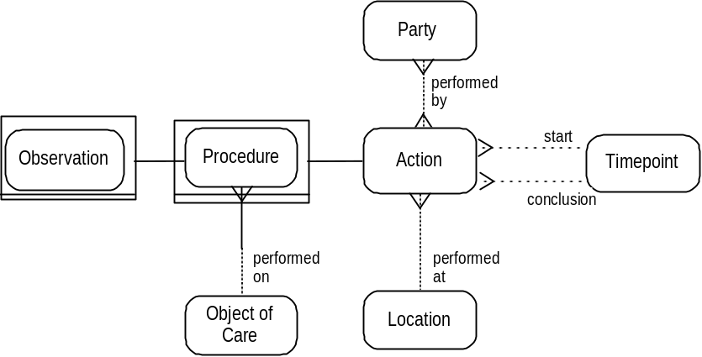
The basic materials of clinical assessment are the observations achieved through questioning, examining, and investigating the object of care, true for both patients and populations. Such assessment is itself an act of observation and the details of this type of action, such as location, performer, and timepoint are usually recorded.

2.3.2 Observation: Timepoints
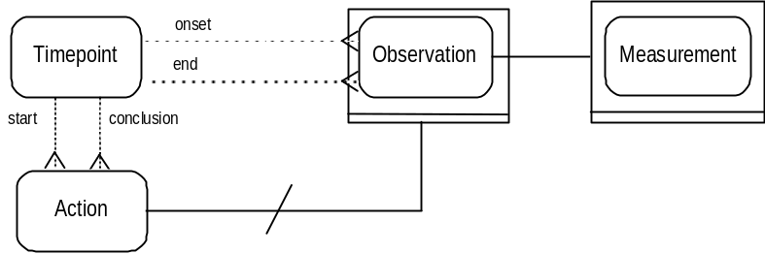
The timepoints of an action apply to the actual performance of the action. In the case of measurement, which is a sub-type of observation, they apply to the physical act of measurement, for instance the moment a sample is put through some analytical machine. This requires that there are further timepoints on observation itself: those defining the period over which whatever is measured actually applied to the object of care. They are known as the timepoints of ‘onset’ and ‘end’. They can also be used when recording in the present (the timepoints on action) that a patient had a particular disease or condition in the past (the timepoints on observation).
¶A patient has had an epileptic seizure at home. A record is made of it at the hospital. The observation is of a seizure. The timepoints of the action of observing are those of the hospital attendance. The onset and end timepoints of the observation are those of the seizure itself.
At the same hospital attendance a record is made of the patient’s diabetes mellitus. The onset timepoint is that of the onset of diabetes. There is no end timepoint. The timepoints of the action of observing are again those of the hospital attendance.

2.3.3 Observation Concept
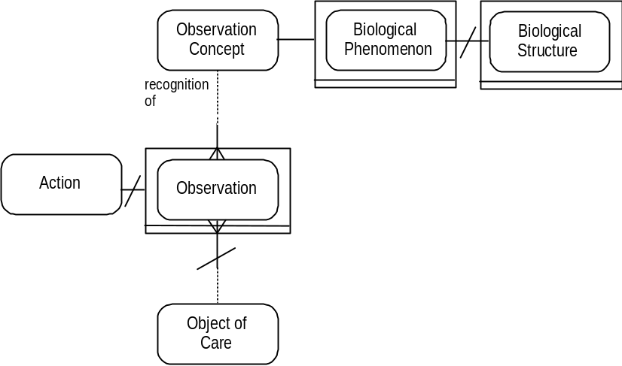
Records of clinical observations are based on what the performer understands can be observed. This may seem unnecessary to state, but it has allowed us to begin to model the clinical knowledge of what can be observed, much as has been the case with protocols as representations of how things can be done.
The action of observing is the noting or recognising that certain characteristics do or do not pertain to an object of care.
We represent these characteristics in two forms that correspond, broadly, to:
• the phenomenological patterns that have been recognised and incorporated into clinical knowledge.
• the assigning of significance to such patterns.
Within the model therefore, clinical knowledge is represented in terms of the observation concepts that clinicians hold in relation to biological phenomena.
It is intended that biological phenomena should include representations of physiological and pathological structures and functions, not only human but also of other organisms of clinical relevance. Pathological signs and symptoms are represented as biological phenomena.
Patients are described as ‘demonstrating’ certain signs or ‘having’ certain symptoms or diseases. Clinicians have ordered their understanding of clinical phenomena so that the observations that are made draw on the observation concepts established by the Activity of Clinical Learning (Section 1). Each observation ‘must have’ an observation concept that it draws on with respect to the object of care. Observations are recorded therefore as actions (with all necessary details of performance - Section 2.1) that establish how an observation concept is drawn on with respect to the object of care. The different types of observation that can be made (absent, present, hypothetical, etc) are described from Section 2.3.7 onwards.
The process of observation can also be that of ascertaining the quantity that applies to a particular phenomenon, in other words measurement.
¶A phenomenon such as glucose exists as a structure, determined within the realm of chemistry. As a component of another structure, blood, glucose can reflect pancreatic function. The understanding of the biology of glucose amounts to part of the knowledge of biological phenomena that clinicians hold.
¶Similarly, the cells and tissues (and the pattern of their distribution) that make up the histological picture of membranous glomerulonephritis, are biological structures.
Biological phenomena are regarded as including the social phenomena that are required for clinical care. It is intended that representations of family structures, housing requirements, etc, will be possible within a broad understanding of biological phenomena.
In addition to biological phenomena, observation concepts comprise those concepts that clinicians hold of disease and the significance of the phenomenological patterns that have been incorporated into clinical knowledge.
¶A certain pattern of histological phenomena can be identified as membranous glomerulonephritis. The observation concept membranous glomerulonephritis represents a disease process with consequences that can be described.
¶Similarly, measurement of blood glucose, the fact that it can be high or low, that some pathological importance can be attached to the amount of it in the blood, these views are the observation concepts that are held by clinicians.
The observing of phenomena or patterns not already represented in clinical knowledge falls within the Activity of Clinical Learning. The nature of clinical understanding is not such that observation concepts represent only those things known with absolute certainty. The view taken in this model is that observations are made on the basis of understanding that ranges from certainty to speculation. The body of observation concepts is therefore constantly and subtly changing. The manner in which this happens and the means by which it might be represented is not within the scope of the project’s work on the clinical process and the clinical record, and is not the subject of this report.

2.3.4 Knowledge Concept
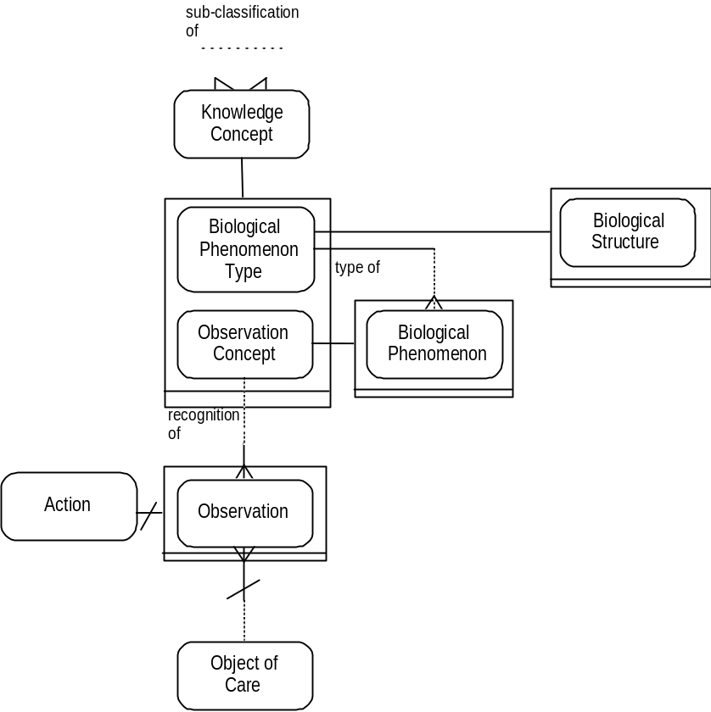
In the case of some biological phenomena there are a number of possible, different manifestations in individuals, (“polymorphisms” such as hair or eye colour, blood group, etc), that are all regarded as ‘normal’. For these phenomena the action of observation is simply the determining of which type the individual is. The possible forms of a particular type are represented as biological phenomena. The type of which they are forms is represented as a biological phenomenon type. Biological phenomenon types are used to represent the features of which biological phenomena are the possible forms that can be observed. Observations are made to determine which form is manifested in the object of care.
• In the above example hair colour is a biological phenomenon type.
• The different possible forms of the biological phenomenon type (brown hair, black hair, etc) are its biological phenomena.
• The manifestations of those forms are observed in specific individuals (Fred’s black hair, etc).
¶There are a number of possible blood groups that can be observed. They are represented as biological phenomena. The blood groups A, B, AB, and O, are forms of the biological phenomena type (biological structure) ‘ABO blood group’. Without such a representation the understanding that blood group B was an alternative possible phenomenon to blood group O would be missing from the representation of clinical knowledge.
¶Similarly, there are many polymorphisms of a biological structure such as the HLA Class I glycoprotein, ‘HLA-B’ (eg B7, B8, B14, B27, B44). Each of these polymorphisms is a biological phenomenon, with a relationship to the biological phenomenon type, ‘HLA-B’.
Observations are therefore drawn from observation concepts (which can be biological phenomena), but not from biological phenomenon types which are used to represent the ‘collections’ of the polymorphisms that are themselves represented as biological phenomena.
¶It would not make sense to make an observation that an individual was HLA-B, or ABO. The observation is that the individual is HLA-B8, or blood group B, which are represented as biological phenomena.
Observation concept and biological phenomenon type are knowledge concepts. There is a relationship from knowledge concept to itself, such that one knowledge concept can be a type of another. This allows sub-classifications to be represented.
¶In the case of observation concept this makes it possible to represent Type 1 diabetes and Type 2 diabetes as sub-classifications of the observation concept diabetes mellitus. It is possible therefore to make an observation of diabetes mellitus, or of one of its sub-classifications, Type 1 or Type 2. Further sub-classifications, of Types 1 and 2 for instance, can be represented, and observations made of them. The level of detail is solely determined by whatever is found appropriate and necessary in the clinical setting.
In a similar way, the biological phenomena, blood groups A1 and A2, can be represented as sub-classifications of blood group A. It is possible therefore to make an observation of blood group A, or of one of its sub-classifications, A1 or A2.
Representing sub-classifications in this way ensures, for instance, that all individuals established as being blood group A1 are implicitly recognised as belonging to the set of individuals who are blood group A.
¶In the case of biological phenomenon types, HLA-B can be represented as a sub-classification of HLA Class I, itself part of the Major Histocompatibility Complex (MHC).
Thus the relationship from knowledge concept to itself allows sub-classifications to be represented. In contrast, the relationship from biological phenomenon type to biological phenomenon is such that biological phenomena are the possible forms in which biological phenomenon types can be observed.

2.3.5 Associative Function
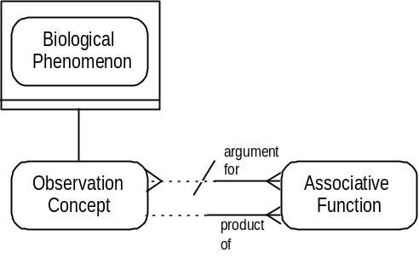
An observation entails the use of the performer’s clinical knowledge to say something about an object of care. In this way the observer can relate what has been noted about the object of care to the rest of his knowledge. The knowledge of what kind of associations can be drawn between observations is represented by the associative function. Observation concepts and biological phenomena supply the terms of the argument to the function, and the product of applying the function is an observation concept. Associations can be:
• causal - diabetes mellitus causes diabetic nephropathy.
• identifiers - the biological phenomena that make up the pattern of membranous glomerulonephritis identify the disease process membranous glomerulonephritis; there is a World Health Organisation definition of the random or fasting blood glucose levels that identify diabetes mellitus.
• predictors of disease risk - HLA B27 and ankylosing spondylitis.
• uncertain, empirical links that have been established as part of clinical knowledge - between diabetes mellitus and coeliac disease, for instance.
In a sense the associative function is acting as if it is a protocol for the association of biological phenomena and observation concepts. The function represents the knowledge of how to ‘compute’ the links. It can be a Boolean function, a complex mathematical function, or a probability distribution, etc.
The product of an associative function must always be an observation concept. Such observation concepts represent the result of determining the significance of a combination of biological phenomena and/or other observation concepts. The function can be simple (determining that a certain level of blood glucose is high/normal/low), or complex diagnostic reasoning.
¶In the case of membranous glomerulonephritis, a collection of histological findings (biological phenomena) forms the argument to the associative function that identifies the clinical condition (observation concept) membranous glomerulonephritis. The recognition of the pattern is represented by the associative function.

2.3.6 Associated Observation
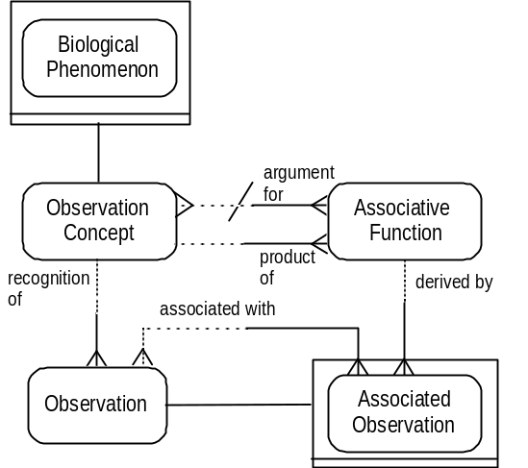
Those observations which are associated with others, that are for instance the evidence for others, are known as associated observations. The relationship between an associative function and an associated observation establishes what type of association has been drawn and how. As emphasised in Section 2.3.3 with respect to observation concepts, the representation of clinical knowledge cannot be static. Speculation about previously unrecognised associative functions must be allowed for within the representation of clinical knowledge.

2.3.7 Types of Observation: Active, Rejected, Hypothesis
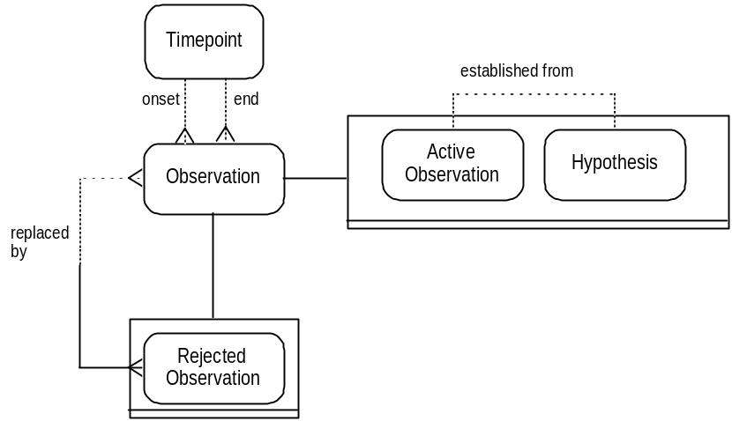
The set of observations that a clinician might need to use in assessing the state of health of a patient comprises:
• those observations that are of characteristics currently found in the object of care.
• observations that applied to the object of care in the past, since they can be of conditions that carry risk of future complications, or that are of some other relevance, diagnostic for instance.
• observations for which evidence is incomplete, but which nevertheless are used to determine care.
This collection of observations is represented by active observations.
Those active observations that are past observations and those that are current are distinguished from each other by the presence or absence of an end timepoint (as discussed earlier, the end timepoint on an observation is the point at which the characteristic ceased to apply to the object of care).
Just as described for the conclusion timepoint of implemented action (2.1.5) the end timepoint of an active observation can simply be a default value, in cases where all that is known is that the observation is of a past characteristic, and not the actual timepoint of its ceasing to apply to the object of care.
During clinical assessment those observations that are currently relevant can be extracted from the complete set of active observations. There can be a number of extracts made, each made up of observations of past and present characteristics, including if necessary those about which there is still uncertainty. One of the customisations to be decided on with clinicians (when designing a system that uses the model as its logical base), is the manner in which such extracts are made by and presented to the clinician.
In addition, there are observations that are not actively used in patient care, but which are recorded as proposed explanations for existing characteristics of an object of care. Such observations are represented as hypotheses, and they can be used as the basis for further investigation. When a hypothesis is tested, sufficient evidence may be acquired for it to become an active observation. In that case, as for proposed and implemented actions, the hypothesis (and crucially, all its detail) is retained, with a link made to the observation made active from it. If, on the other hand, evidence is acquired that refutes the hypothesis, then the hypothesis is further classified as a rejected observation.
¶If a patient complains of thirst, weight loss, and polyuria, these characteristics are recorded as active observations of biological phenomena. The hypothesis that the patient has diabetes mellitus can be tested by measuring the fasting or random blood glucose. If high, an active observation of diabetes mellitus can be made.
If, however, the blood glucose profile is normal, even on more detailed testing, such observations would refute the hypothesis that the patient has diabetes and the hypothesis would be a rejected observation.
A hypothesis is not an observation that has already been made, about which there is however a degree of uncertainty (the project recognises the importance of recording uncertainty and has begun work, initially based on set theory, to be included in later versions of the model). Nor is a hypothesis a conjecture about characteristics that might apply to an object of care in the future. It is a proposition put forward on the basis of existing observations in an attempt to explain those observations.
Active observations can themselves be rejected if they are found to be incorrect at a later date. In this way the history of such observations is retained, but they are clearly marked as not applying to the object of care, and as never having been true. This distinction can get lost in paper records.
Rejected observations are not observations of those conditions that affected the object of care in the past, that were once true, but that no longer apply (like a broken arm that has completely healed); rather they are observations that have never been true, but which were once suspected (hypothesis) but subsequently disproved, or once thought to have been proved (active) but later refuted.
Should an observation that has been rejected, subsequently be found to have been correct after all, a record is made of what is in effect a new observation. Thus observation A is rejected, replaced by observation B (which is simply the observation that A is not correct). When further evidence is acquired that A is in fact correct, observation B is then itself rejected, replaced by observation C. Observation C is of the same characteristic as A (the same observation concept in other words), but has been made at a different timepoint, with different associated observations as evidence, etc.

2.3.8 Projection
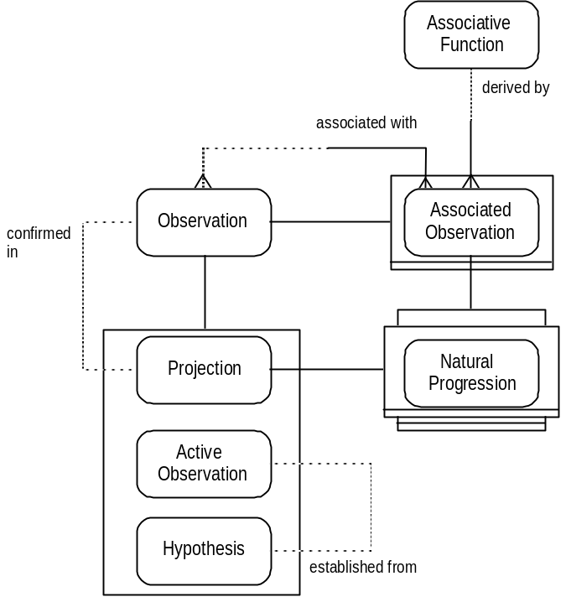
Observations can be made of states of health that might apply in the future. Such observations are represented as projections. Projections can be made, for example, on the basis of the natural history of a disease process, its natural progression.
The natural progression of a clinical condition is recorded as a result of considering an associative function that represents the association between the condition and its consequences. It can be important to make a record of such consequences.
¶If a patient has had rheumatic fever, or consequent rheumatic valve disease, the risk of endocarditis may need to be recorded as determining both how the patient should be treated and what precautionary measures can be taken.
• it can be that the predicted consequences of a disease process do actually occur, or are suspected to have occurred, in which case an active observation or hypothesis is made, which is linked to the previous projection.
• it can be that a risk is altered in some way so that an extension to the projection is made, in the form of a new projection, linked to the old one. A projection, therefore, can be linked to any other observation, whilst the record of the projection is preserved.

2.3.9 Types of Observation - Summary
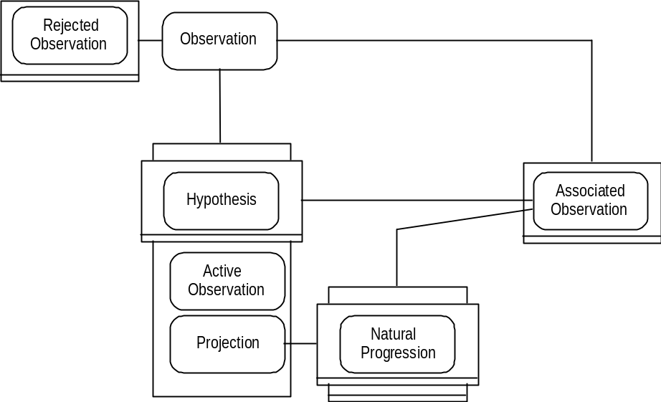
Both hypotheses and natural progressions only result from considering existing observations. Therefore they are always associated observations. The hypothesis is made to account for existing characteristics. The observation of natural progression is made to record consequences the object of care faces. When a record is made of the possible natural progression of a particular condition in an object of care it is also always a projection.
In summary, an observation can be classified as being in one and only one of the mutually exclusive states - active observation, hypothesis, or projection. Any observation can be rejected in the record, and any observation can be associated with other observations. Active observations represent the set of all observations from which extracts can be made when the object of care's state of health is actively being assessed. At any one time some active observations will be ‘in use’ and others will be ‘dormant’.

2.3.10 Observation Protocol
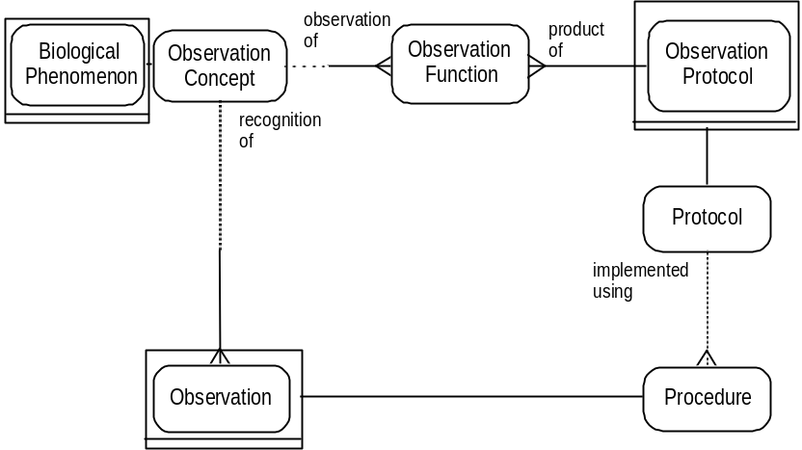
As procedures, observations can have protocols which are used in order to establish whether or not certain observation concepts pertain to the object of care.
A single observation protocol can have a number of different observation concepts that it can be used to investigate. In terms of clinical investigations, the sensitivity and specificity of the protocol will depend on which observation concept it is being used for.
¶Ultrasonography is effective at picking up the phenomenon of dilated calyces seen in renal transplant obstruction, but very poor when renal transplant rejection is being considered.
These differences are represented in the observation function. An observation protocol can have a number of observation functions, each determining the usefulness of the protocol when employed to investigate a particular observation concept.

2.3.11 Measurement
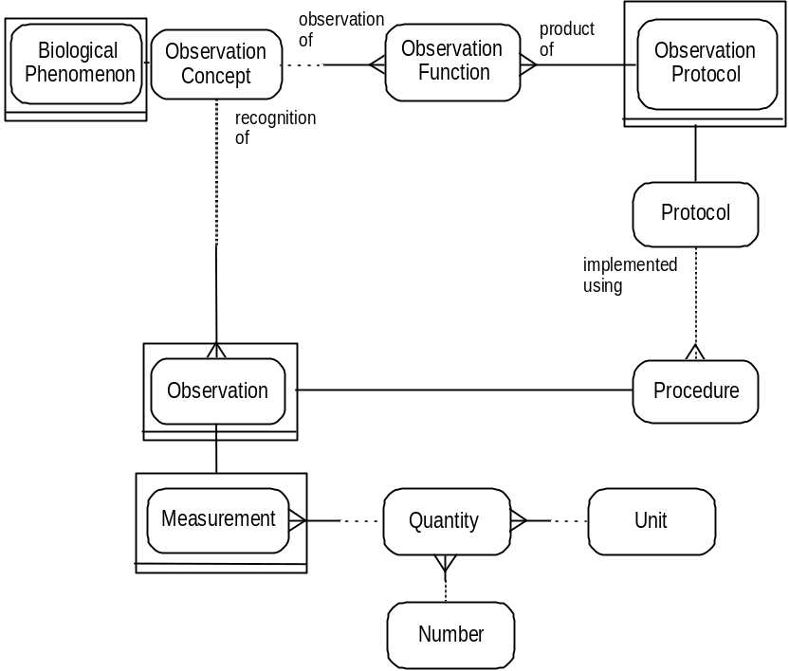
Measurement represents the action of defining a value for a biological phenomenon, whatever the form of the quantity (results can be given simply as + or -). The precision and accuracy that observation protocols are subject to when they are carried out, are conveyed by the observation function.
A measurement itself carries no judgement as to the significance of its quantity. The significance of particular measurements is determined by the observation concepts that relate to the measured phenomenon.

2.3.12 Measurement: Range
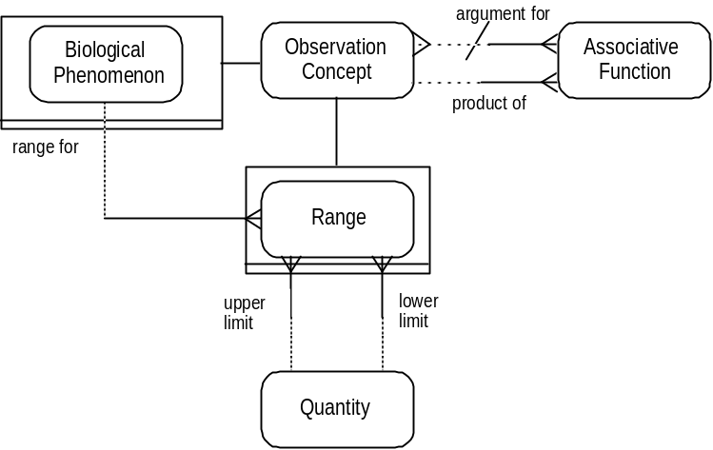
A range defines the upper and lower limits of those values that are regarded as normal, high, low, etc, with respect to a given individual object of care. A range is the concept that is held of the significance of a phenomenon’s quantity; its limits are not the confidence limits of an individual measurement. A range is specific for the biological phenomenon that is being measured, and a record can be made of the range a measurement falls in.
Ranges are dependent on the characteristics of the group to which the object of care being considered belongs (age, sex, race, disease conditions, etc). This dependence is represented by associative functions. The relevant characteristics form the ‘argument’ of the function and the range is the ‘product’.
Ranges can also form part of the argument for associative functions, as in a previous example, where a particular range of the phenomenon glucose identifies the disease diabetes mellitus.

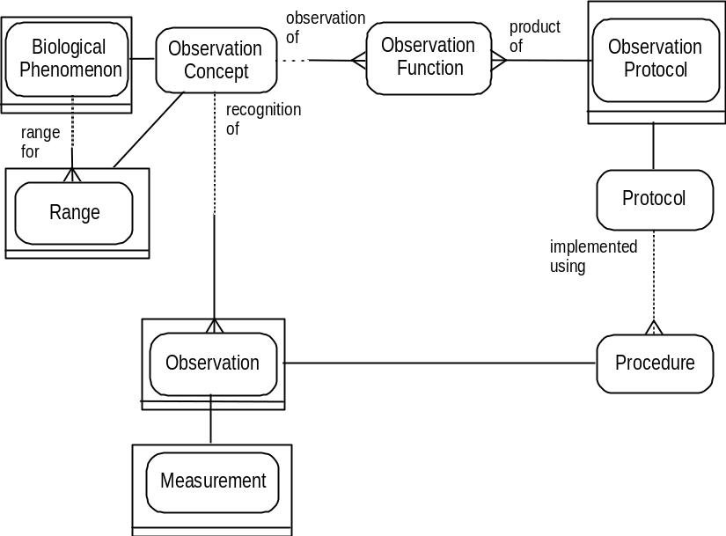
A measurement is the quantification of a biological phenomenon. By comparison with the limits of a particular range, a significance can also be applied to the measurement. A single measurement has links therefore to the phenomenon of which it is the recorded quantity, and to the range of which its quantity is a member. This is achieved by virtue of the relationship to observation concept from observation, of which measurement is a sub-type.

2.3.13 Differential
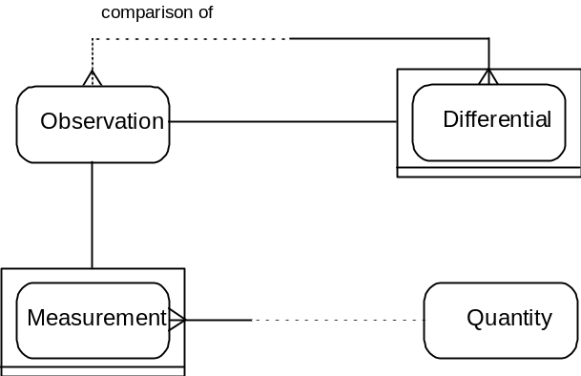
Measurements can be involved in comparative observations, that we have called differentials, where two or more measurements at different points in time are compared with each other. The establishing of some or no difference between measurements is an act of observation in its own right, to be recorded.
The differential can itself be a measurement. The measurement can be of the amount of or the rate of change. The means of measuring the differential is determined by a protocol, as for any other measurement.
Differentials can also be established between observations that are not measurements. A record can be made of the deterioration or improvement in a particular condition (‘deteriorating pneumonia’, ‘worsening angina’), an observation that can have great significance both for the suspected aetiology of a disease, and in indicating a need for change in treatment.
Such differentials are not measurements, but qualitative judgements. Unless and until effective scales of measurement are devised for such judgements, there will have to be provision for differentials without quantity.

2.3.14 Measurement, Absence & Presence
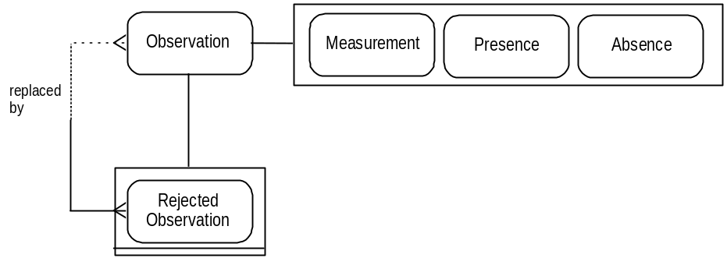
Observations that are not measurements record either the presence or absence of observation concepts and biological phenomena, with respect to an object of care.
The protocols for such observations can be different depending on whether, for instance, a diagnosis is being sought or excluded. The observation protocol defines whether the investigation is to confirm the absence or presence of the observation concept.
As discussed in 2.3.7, an observation noting the presence of a particular clinical condition can be rejected at a later date, replaced by an observation of its absence (or vice versa).
¶An initial diagnosis of diabetes mellitus can be made on the basis of a single blood glucose measurement. However a later blood glucose profile can prove to be entirely normal. The presence of diabetes is therefore rejected, replaced by an observation confirming its absence.

2.3.15 Outcome
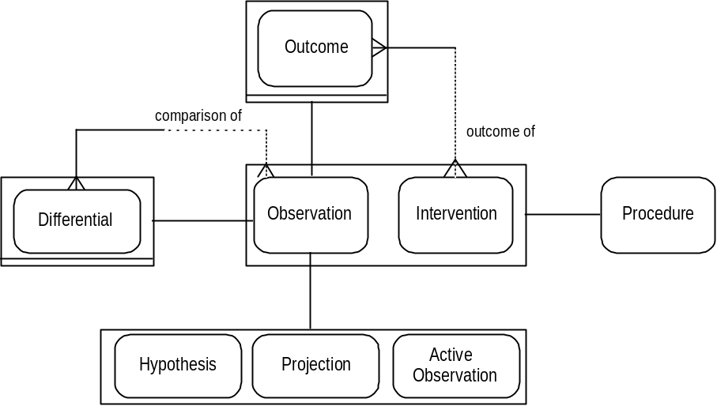
Observations can be made of characteristics that are judged to have come about as the result of an intervention. Such observations are represented as the outcome(s) of the intervention.
The classifying of a characteristic as an outcome is a discrete observation in its own right, and the circumstances of the action (such as who made the observation, and with what authority) can be recorded.
An observation that is classified as an outcome can be a differential between observations (before and after the intervention, for instance). The observing of a differential at a fixed time after an intervention can be represented as a protocol of outcome measurement.
The recording of an outcome either involves classifying an existing observation as the outcome of an intervention, or results from a fresh observation of a characteristic that is judged to be the consequence of the intervention.
The observations that are classified as outcomes can be:
• active observations.
• hypotheses (from which active observations can be established).
• outcome projections.
It can be important to record outcomes that are projected as a result of a proposed intervention, whether they be the hoped for result, or the side effects that can occur. Outcome projections can include states of health that are desired not as an alternative to ill-health, but as a continuation or enhancement of good health (eg different circumstances of childbirth, effective and well-tolerated contraception, etc).

2.3.16 Outcome Function
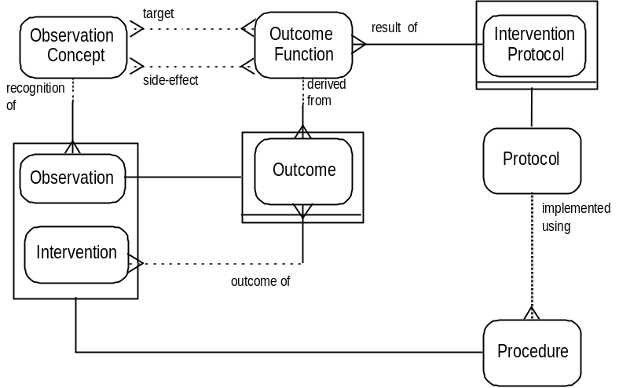
Generally, outcomes can be described because the relevant characteristics are known to be possible consequences of using a particular intervention. This is a further example of clinical knowledge. Such knowledge can be used in the model to classify intervention protocols. The sets of observation concepts that can occur as the result of using a specific intervention protocol are defined by the outcome functions. As emphasised with respect to both observation concepts (Section 2.3.3) and associative functions (Section 2.3.6), the representation of clinical knowledge cannot be static. Speculation about previously unrecognised outcome functions must be allowed for.
Each intervention protocol can have a number of outcome functions, which in turn define the observation concepts that belong to that set, be those observation concepts the desired result (target), or the possible (or inevitable) side effects. The outcome of an intervention protocol can be a set of targets and side effects (chemotherapy for instance, with remission and hair loss).
¶For example, the British Medical Association and the Pharmaceutical Society of Great Britain publish in the British National Formulary (BNF) known important consequences of using prescribable drugs. The consequences include both the targets and side effects.
Each individual outcome or set of outcomes can have a likelihood of being achieved that is part of its outcome function (which can be a probability function).

2.4 Protocol
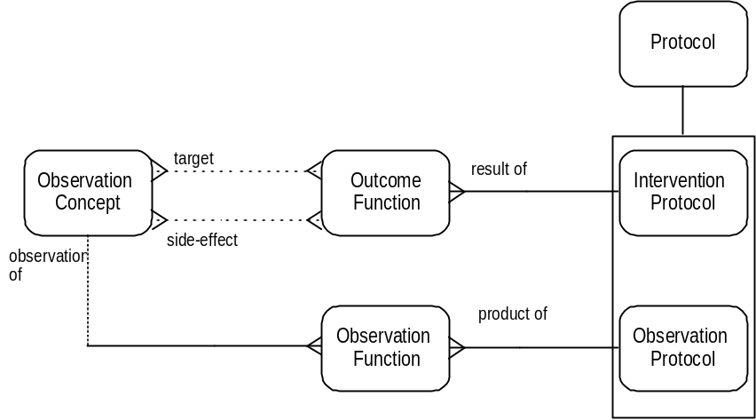
Protocols are of two types:
• observation protocols are used either to establish whether or not given observation concepts are demonstrated by the object of care, or to quantify biological phenomena. The appropriateness and usefulness of the protocol for the purpose is defined by the observation function.
• intervention protocols are used in attempts to influence the state of health of the object of care, generally to improve it, preserve it, or limit its deterioration. The probability of success is defined by the outcome function, which also determines the side effects associated with the protocol’s use.
An observation protocol is designed for a purpose very different from that of an intervention protocol. The former is used solely to collect information about the characteristics of an object of care. Such information is recorded in the observation concepts established as pertaining to the object of care. In contrast, the result of using an intervention protocol is recorded as those observations classified as the outcome of the intervention. There are, however, many observation protocols that require or risk a change to the state of a patient, that are in a sense ‘interventional’. Likewise, many intervention protocols involve, by design, acts of observation. The means by which this is represented is described in the following section.

2.4.1 Parent & Component Protocols
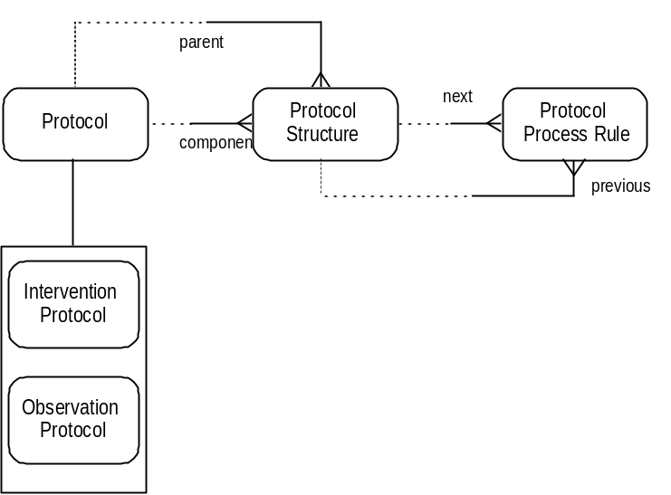
If necessary, protocols can be broken down into two or more component protocols (‘sub’ protocols).
A parent protocol determines a number of protocol structures, each of which identifies a component protocol. Thus component protocols are ‘listed’ by the protocol structures held by the parent protocol.
The sequence in which component protocols are to be implemented is determined by protocol process rules. Each rule describes the conditions under which each component protocol should be activated.
A rule can determine the components that are contingent on ‘legitimate’ divergences from the ideal outcome:
¶If expected side effects occur in chemotherapy, anaemia of a certain degree for instance, then transfusion can be used. If not, the transfusion protocol need not be activated.
The legitimate divergences can include an action to do nothing further (a ‘stop function’), or even an action to stop and wait.
Component protocols can themselves be sub-divided:
¶Induction of anaesthesia is a component of general anaesthesia, which itself is a component of the protocol cardiothoracic surgery.
The parent protocol determines the overall classification of a complex protocol.
¶A diagnostic gastroduodenoscopy is an observation protocol. Its sole purpose is to demonstrate the presence or absence of certain observation concepts. However, it is made up of a number of component protocols that intend or risk a change to the state of health of the patient: the sedative injection; the insertion of the endoscope.
The goal is to observe the stomach and duodenum. The parent protocol is therefore an observation protocol. However, those component protocols that enable the observation to take place are intervention protocols. In one case a physical change of state is intended (sedation); in the other it is risked (inhalation, perforation, etc, caused during insertion of the endoscope).
Thus components of an observation protocol can be intervention protocols, and those of an intervention protocol can be observation protocols.
This construction provides a means of sharply distinguishing procedures that are intended to be therapeutic from those that are intended to be diagnostic, whilst retaining all those features that they have in common.

2.4.2 Protocols - Distinguishing features
Protocols can be described in terms of:
• what is expected and risked by the use of a protocol (2.3.10/16: observation and outcome functions).
• how protocols can be assembled from component protocols (2.4.1: protocol process rules and structures).
In addition, the following sections consider:
• the circumstances of and restrictions on the use of a protocol (2.4.3).
• the resources necessary for implementation of a protocol (2.4.4).
• who is authorised to use those resources (2.4.6/7).
• the anatomical site of their use (2.4.8).

2.4.3 Start Function
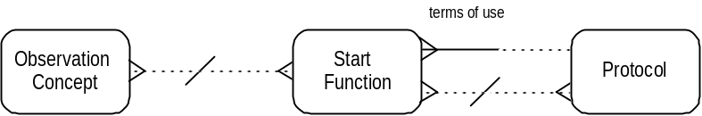
The circumstances of a protocol’s use are often known as the indications and contra-indications.
¶The BNF (referred to in 2.3.16) lists the conditions for which a drug can be used, as well as those in which its use is unsafe (pregnancy, infancy, organ failure, etc). Some of the circumstances that determine a drug’s use are very simple, and some very complex.
Each set of circumstances is represented by a start function (a Boolean expression, a set of simple mappings, etc). It is the start function that determines whether the circumstances allow or prohibit the use of a protocol. The circumstances of use are a set of observation concepts, such as the existing pathological conditions.
In addition, the possible influence of the simultaneous use of other protocols must be considered (drug interactions for instance). Thus the protocols that are currently being applied, or that the use of which is planned, also form part of the argument for the start function.
In this way, all the circumstances and restrictions of protocol application can be described, if desired.

2.4.4 Resource type
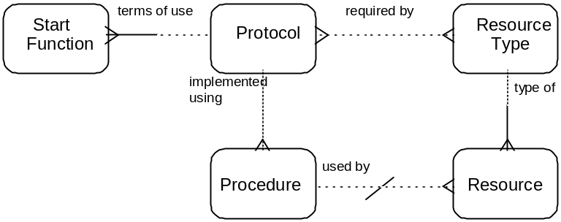
A protocol can be partially characterised by the resource types that are required for its implementation.
¶For example, all those protocols that require use of a fibre-optic endoscope can be grouped together as endoscopic protocols.
Equally, all those protocols that are used as treatment for gallstones can be brought together; as can endoscopic protocols for gallstones.
Resource types are reflected in the resources that are used when procedures are performed.
Within a particular establishment a resource type can be a single piece of equipment, for instance. It is part of the clinical ‘know how’ held by the establishment that the implementation of a given protocol requires this piece of equipment. The actual piece of equipment is a resource that can be handled as all other resources, but it is the only example possible of the resource type. (In addition to the possible case of there only being one resource of that type available, it can be that there is only one that the clinician is prepared to use.)

2.4.5 Intervention & Sample
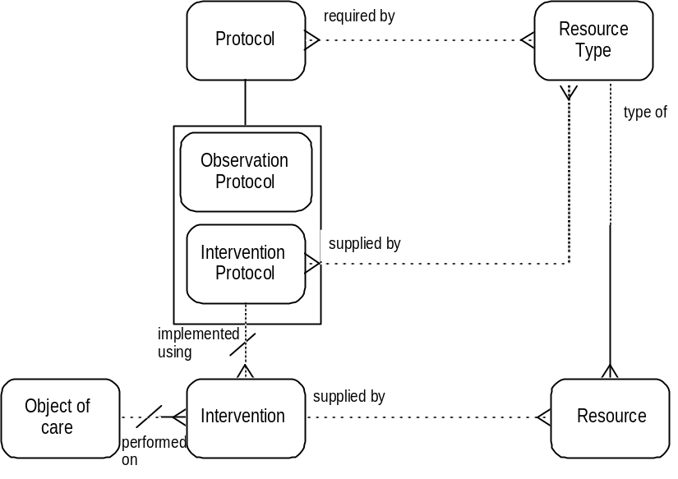
Resource type is also used to represent the types of sample taken from patients that are used for a variety of protocols, such as pathology analyses, etc.
When blood is taken from a patient for the purpose of making one or more measurements, the taking of blood, although subordinate to the observation protocols for the measurements, has risks that are those of an intervention protocol.
What is more, this intervention protocol, as well as its risks, has a purpose that is distinct from others: it is used to obtain from the patient material (a sample) that is to be used in the measurement. In other words the sample is a resource used in a measurement made on the patient, and the intervention protocol used to obtain the sample is the means by which the measurement is possible.
This construction conforms to the ‘sample-centred’ view of pathology laboratories.
The measurement is made on the patient, by means of the sample (resource). The patient identity is available to the lab through the record made of the intervention that produced the sample.
If the identity of the patient is confined to certain clinicians, access to the record of the sample-taking intervention can be restricted to those clinicians, while the focus of the laboratory on the sample is retained.
¶In some clinical practices, the duty of confidentiality with respect to the identity of patients with HIV infection is extended to laboratory staff. In other clinical practices the sample identity is kept distinct from the patient identity, the link retained by the referring clinician by means of a record of the sample-taking intervention.
Some characteristics of patient-derived resources can be described, without the observations being of relevance to the patient. In the case of organs taken for transplantation much of the information required is information about the donor (blood group, HLA type, etc) and is recorded as such. However it can be necessary to record features of the organ that are no longer of relevance to the donor record, including the length of the vessels taken, their condition, subsequent modification, etc. These details can be recorded by classifying the resource as also being an object of care.
A donated organ can be classified as:
• a resource obtained by a specific intervention performed on the donor and available for use in a transplant intervention for a recipient.
• and also an object of care on which observations can be made and on which interventions can, if necessary, be performed (eg the use of particular anti-coagulants when taking units of blood donated for transfusion).

2.4.6 Accountability Type
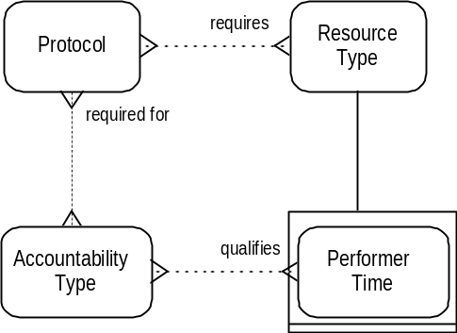
Resource type is also used to represent the time required at a particular location and the human resources of performer time. A much fuller representation of resources, and how they are handled, is found in CBS Version 2.
There may be constraints as to the type of performer, such as the qualifications and accreditations necessary, the position held; in other words the necessary authority. These requirements are represented by the accountability types of a protocol. Performer time can be qualified by the accountability type that the performer must hold.
Accountability types are also used to represent the consents, contracts, etc, that are needed to go ahead with the implementation of a protocol. Knowledge of these is used when planning to use a protocol, or checking that everything necessary is in place.

2.4.7 Skill
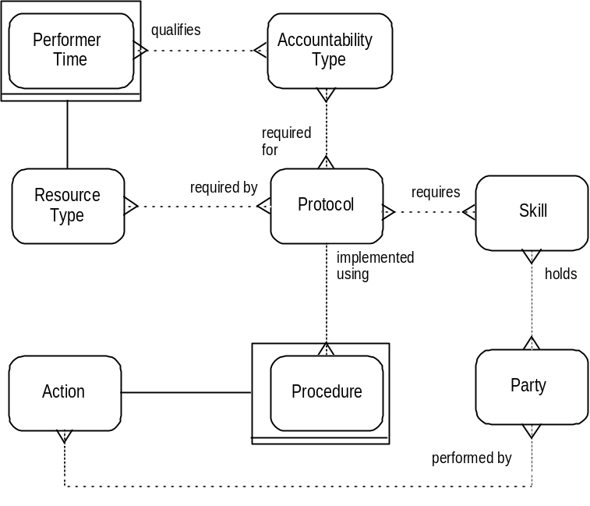
In addition to the accountability type it may be necessary for a performer to hold, the skill or skills that are necessary for implementation of the protocol can also be specified. An individual can have reached the necessary level of seniority to meet the general qualification requirement to perform a particular protocol but not have the actual skill required. The ability to perform a protocol is seen as distinct from the authority to perform it.
It is possible, therefore, to record the skills, as well as the qualifications, that are held by a party (person or establishment).

2.4.8 Protocol: Anatomical Site
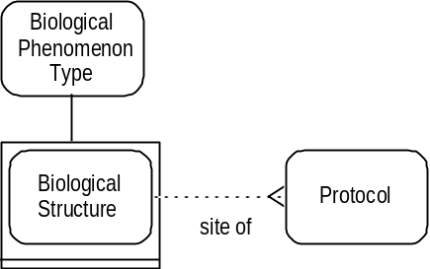
The final means of characterising a protocol is by the anatomical site at which the protocol is to be performed, represented as a biological structure. The anatomical site of a protocol is not necessarily the site of the pathology, but rather that directly involved in the protocol:
¶endoscopic procedures in the treatment of gall bladder disease usually involve the common bile duct and its opening, rather than the gall bladder.
¶the insulin treatment of diabetes mellitus, a pancreatic disease, is generally by injection into the subcutaneous tissues, the ‘site’ of the protocol as opposed to the pancreas.
The site of the pathology (as opposed to the site of protocol use) is represented instead by the observation concepts of the start function (the pancreatic disease, diabetes mellitus, is an indication for using the intervention protocol, insulin treatment).

2.4.9 Protocol Summary
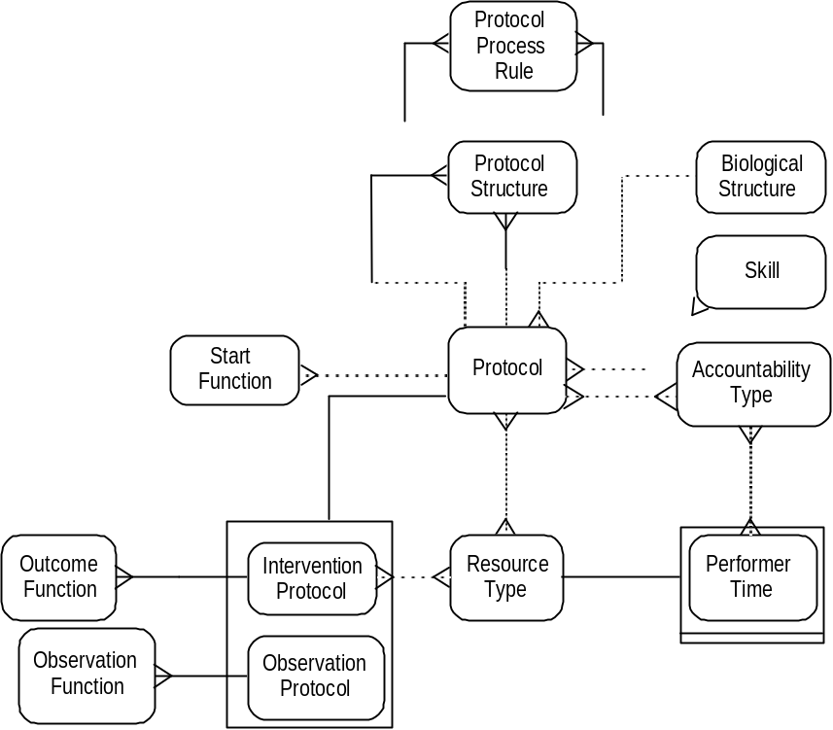
In summary, a protocol can be described through:
• its component protocols and the protocols of which it is part.
• its indications and contra-indications.
• the results desired and risked.
• the resources, authorities and skills necessary for its performance.
• and its anatomical site.

2.5

Knowledge Level & Operational Level
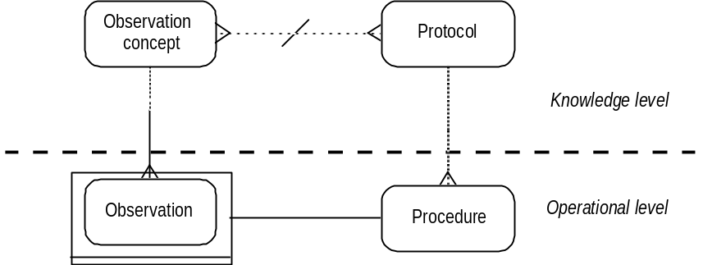
The group of concepts representing what clinicians understand can be done, or looked for, is called the knowledge level, and those that provide the basis for the clinical record represent the operational level. There are two main links:
• the relation from observation to observation concept and biological phenomena (the knowledge of what can be observed - signs, symptoms, disease, etc).
• and the relation from procedure to protocol (the knowledge of what can be done or measured, what questions can be asked).

2.5.1 Knowledge Function
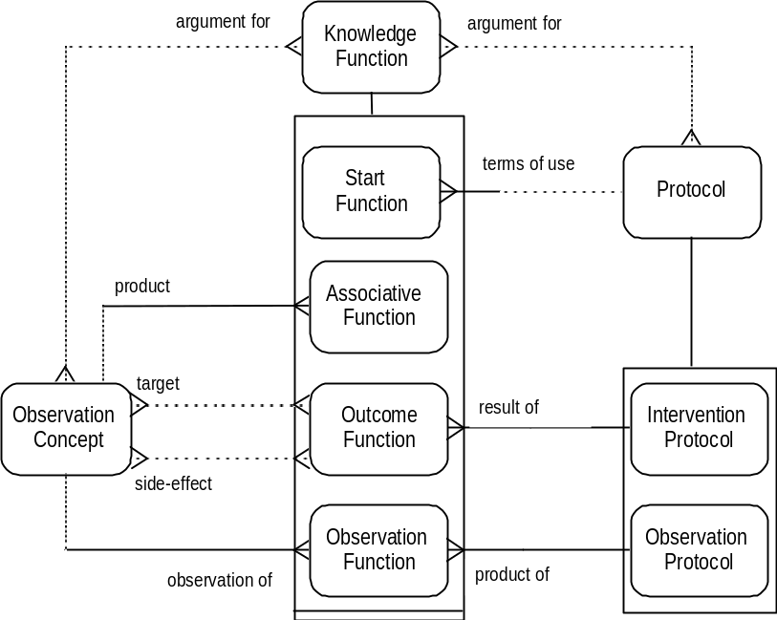
The various functions represented within the model are all knowledge functions. Knowledge functions determine the circumstances in which the concepts of the knowledge level can be combined. The functions take as terms for their arguments specific sets of observation concepts and protocols. The consequences of different clinical conditions (represented by observation concepts) co-existing and of the simultaneous use of different protocols can be defined by knowledge functions.
Knowledge functions can be selected on the basis of what the clinician is trying to achieve:
• associative functions are designed to assess or account for existing clinical conditions, or to make projections about future clinical conditions (2.3.5/8).
• start functions represent the indications and contra-indications to the use of protocols (2.4.3).
• outcome functions define the possible consequences of implementing an intervention protocol (2.3.16).
• observation functions determine the observation concepts that an observation protocol can be used to investigate (2.3.10).
As stated, they all take as terms for their arguments specific sets of observation concepts and/or protocols.
There can be interactions between intervention protocols (drug interactions, etc).
¶The concurrent implementation of an intervention protocol can interfere with observation protocols as well (the spurious effect of various drug treatments on assessing thyroid function, for instance).
Likewise, certain observation concepts can alter outcome functions (diabetes mellitus is no longer regarded as a contra-indication to dialysis or renal transplantation, but it certainly affects the outcome).

2.6 Planning

2.6.1 Parent & Component Procedures
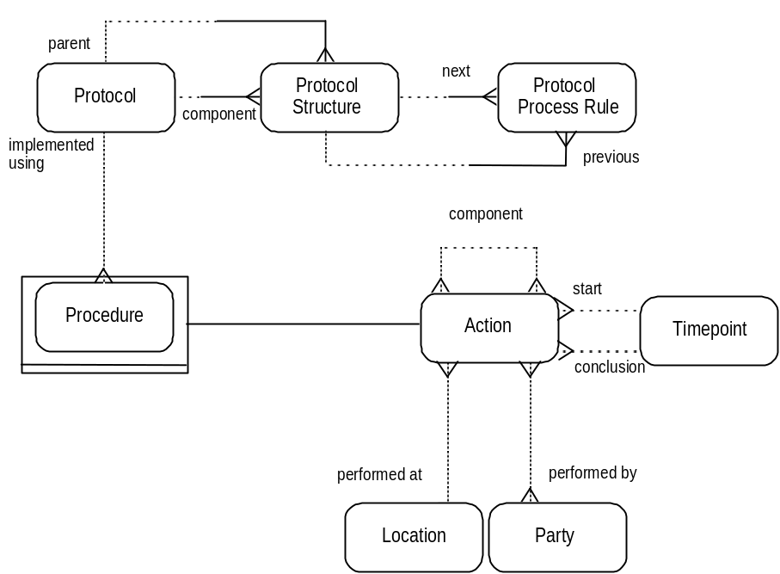
When complex protocols are being implemented it is often sufficient to simply record the overall procedure, and none of its component parts. If basic details of the component procedures are required, but nothing more (anaesthetic details in the surgical record; details of those assisting), then the component procedures (as component actions) can be recorded as subordinate to the parent procedure. Indeed, all the details of a single outpatient consultation can be recorded in this way, so that there is a single record only, of time, performer, location, etc, with the component procedures simply recorded as establishing links to those observation concepts and biological phenomena that were noted, and those actions that were planned for the future.

2.6.2 Plan Process Rule
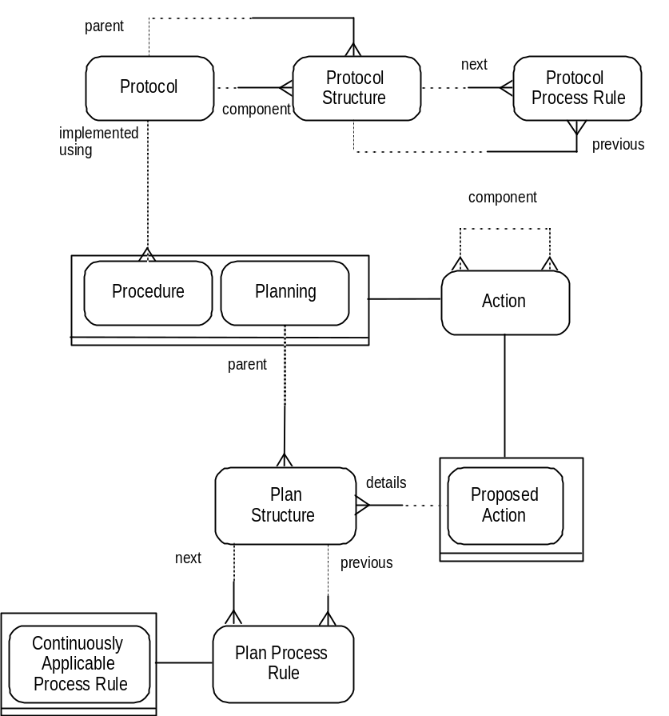
Planning offers the opportunity for recording actions (as proposed actions) in advance of their being performed, and for ‘choreographing’ all actions that are planned for a patient, including actions proposed by different parties.
As part of the planning process a number of plan structures can be created. Each structure identifies a single proposed action. The proposed action can be a new one, or an existing one that may have been proposed as part of a previous planning process. (A proposed action can therefore be a component of a number of plan structures, resulting from both the original and any subsequent planning processes).
Thus all the component proposed actions required as a result of planning are ‘listed’ in terms of the plan structure associated with each one.
The sequence in which proposed actions are to be implemented is determined by plan process rules. Each rule describes the conditions under which each component proposed action (identified by a single plan structure) is to be activated.
Rules can be created for proposed actions (through the relevant plan structures) that are contingent on ‘legitimate’ divergences from the ideal outcome.
The rules can be simple mappings, Boolean expressions, etc.
The rules can derive from protocol process rules; they can even be a direct translation of them (useful for booking all the stages of a course of chemotherapy, say). However, they can also take components from a number of different protocols and draw them into an integrated set of plan structures and process rules.
¶Any patients with multiple pathology, or being admitted to hospital for investigation of a number of differential diagnoses, will have planned for them a number of distinct protocols, and the efficient planning of these is the essence of good in-patient management. Thus the rules can govern proposed actions that derive from different, and unrelated protocols.
¶There can be a number of people, or teams, involved in making plans for a patient. Attempted integration of these plans may reveal conflicts and/or duplications. Further planning can lead, iteratively if necessary, to the creation of new rules which resolve those conflicts and/or duplications.
The planning process that has resolved other plans, will govern rules from those different plans. In addition, planning for the activity of an individual department may well involve rules governing actions proposed for different patients.
For repetitive actions (such as regular long-term medication), or for proposed actions that are always to be triggered in a particular set of circumstances (eg, antibiotic pre-medication for dental treatment of patients with rheumatic valve disease), a special type of process rule is required, the continuously applicable process rule. In this way a single rule can specify a repetitive activity, whether regular or irregular, to be performed whenever the defined time interval has elapsed, or the relevant circumstances have occurred.

2.6.3 The ‘Result’ of Planning
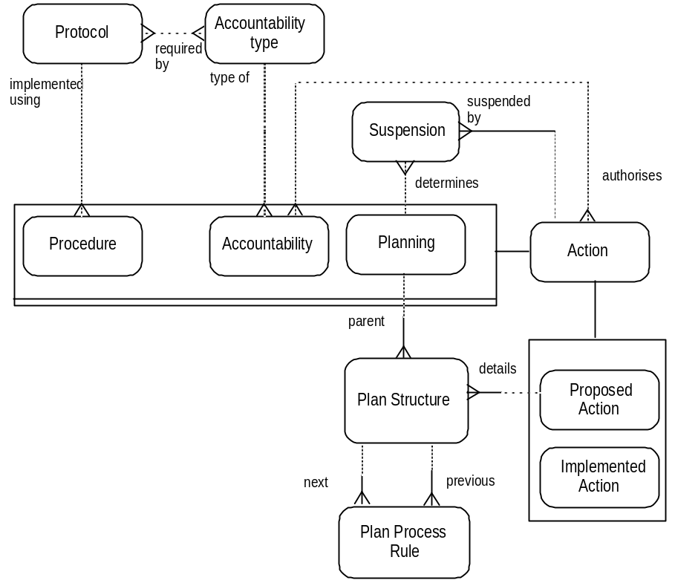
The substance of a clinical plan is made up of the proposed actions identified by the plan structures created, and the rules that determine (via the plan structures) the circumstances of implementation. The action of planning is to propose these actions and the rules that govern the implementation of them.
The actions that are proposed can take the form of:
• procedures.
• proposed accountabilities, as determined by consideration of the accountability types necessary for the selected protocol.
• proposals for further planning sessions (case conferences, ward rounds, etc).
¶As a planning action, a ward round can result in proposed actions that are themselves planning actions, for instance a case conference at a later date.
The state that proposed actions are in, the extent to which they are scheduled or otherwise, is a reflection of those links that have been established for them, such as performer, proposed timepoint, location, etc. The establishing of such links is part of the process of planning.
When planning a proposed action, the protocol that is required may already be covered by an existing clinical scope. An accountability therefore already exists to provide authority for the implementation of the action, and a new one is not required.
¶A contract to perform transplant surgery provides the authority (that is the necessary accountability) for all transplant actions (interventions) performed within the terms of the contract.
Suspensions can be decided upon as the result of a planning process and the responsibility for and timepoint of the decision to implement a suspension can be recorded.

2.6.4 Booking and Using Resources
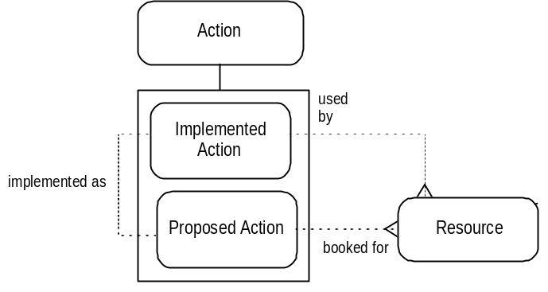
Information about the resource types detailed for a protocol can be used to plan for and book the necessary resources.
The resources required for the implementation of a proposed action can be identified from the resource types defined by the protocol for that action. If necessary the resources so identified can be formally booked for that action.
The resources used in an implemented action are recorded by means of a different relationship.
As stated earlier, CBS Version 2 contains a much more detailed representation of resource management.

2.6.5 Starting to Plan
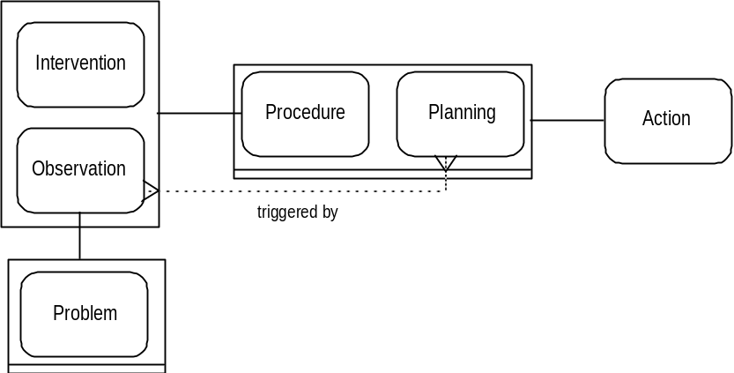
Any observation made of an object of care can be classified a problem. It is simply a matter of the view of the person making the observation (including the patient). One of the ‘uses’ of a problem is as a trigger for planning. There are other types of observation that can lead to planning:
• hypotheses can lead to attempts to collect further evidence from the patient.
• projections can lead to consideration of interventions to pre-empt their occurrence.
• some natural progressions that are projected can be of desired states, such as a positive experience of childbirth, rather than simply a neutral, or damage-limited one.

2.6.6 Planning: Clinical Scope
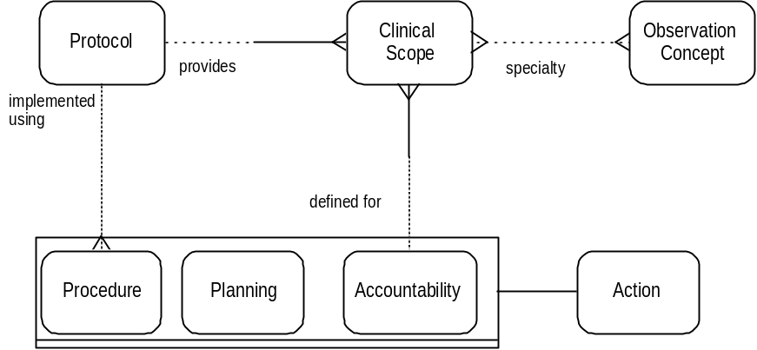
The planning that leads from observation, involves the consideration either of those protocols that are available in the given circumstances, or of targets that are to be established to act as guides to the most appropriate course of actions.
When planning results in the transfer of responsibility to another clinician, as described previously in the case of referral, then the clinical scope of that clinician can be defined by the terms of referral (accountability):
• as already described for clinical scope, the protocol(s) to be provided can be determined.
• in addition, the diagnostic area to be considered can be defined in terms of observation concepts.

Section 3

The Event Diagram

Event Names
Event Diagrams represent the causal sequence of Events within and between Activities. Each Event represents the creation or modification of objects represented by Concepts. Events are named on the basis of both the Concept Name and the manipulation that the Event represents.
Where Concept Names are used in the illustrations, the first letter of each word is upper case.
eg: Event Name: Observation Rejected
Event Name: Hypothesis made
Some of the Concept Names used are based on two subtypes of a Concept, where the object referred to is an example of both subtypes. Thus an Action that is both a Proposed Action and a Procedure is referred to as a Proposed Procedure.
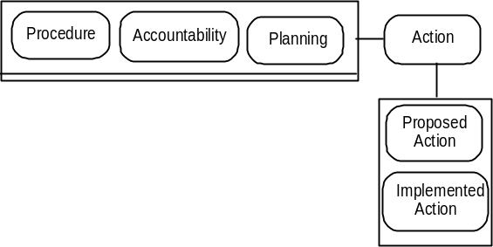
Guide to notation: Event Diagrams

Events are illustrated in hard-edged boxes.
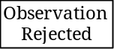 In this case the event marks the classifying of an observation as rejected, and the creation of a relation to the observation that has replaced it.

Events can be subtyped, as described for Concepts. The partitions are complete or incomplete and are illustrated as for Concept partitions.
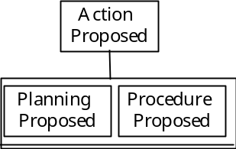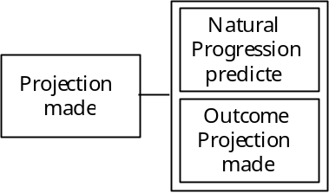

Events are triggered by other Events. An Event may be triggered on every occurrence of its trigger Event.
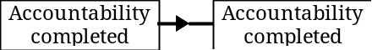 In this case the completion of one accountability always triggers the completion of another.

There can be a logical filter between Events, that determines that an Event is triggered only in certain circumstances. Commonly in this model the circumstances are those determined by clinicians.
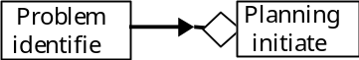

If the event is simply marking a logical filter that determines a ‘fork’ in the pathway, then the box is left blank.
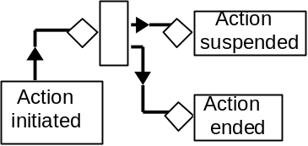

A clock icon is used to represent logical filters that determine the time that must pass before an Event is triggered.
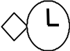

The Event Diagram
The Activities defined in Section 1 as constituting the Clinical Process (Observing, Planning, and Plan Implementation) have been used as a format for the Event Diagram. As described in Section 1, Activity Diagrams do not represent the sequence in which Activities necessarily run. Activities often run concurrently, and an Activity Diagram can illustrate the coordination of subordinate Activities as part of the process of an overall Activity. The causal sequence of Events that determines such coordination can be described in Event Diagrams.
In Section 3.1 the consequences of completing observations are described, both the clinical assessments (including diagnoses) that can be constructed or rejected, and the triggers to further action that are provided.
The means by which such triggers are translated into action are considered in Section 3.2, with descriptions of the making and implementation of plans.

3.1 Observation

3.1.1
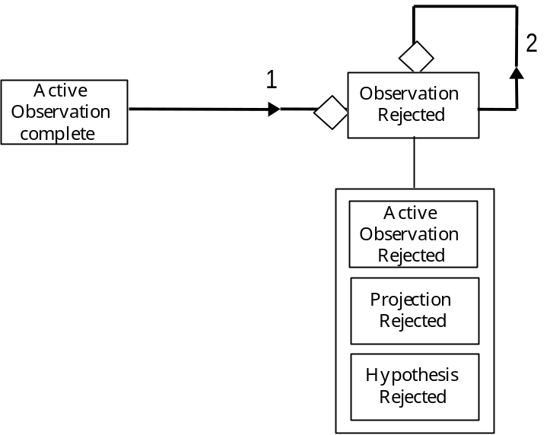
1 Whenever active observations are successfully completed a number of events can occur:
• further observations or interventions can be proposed (3.1.2).
• planning can be initiated (3.2.1).
• the observations may lead to other, already recorded observations being rejected. This would be the case if a new piece of evidence refuted a hypothesis in a differential diagnosis. The process of excluding diagnoses is often used in clinical investigation, and those observations accumulate as rejected observations.
2 As discussed in 2.3.7, any type of observation may be rejected, including those that had been previously thought to be true. Such a reversal of the record may well lead to other observations, hitherto ‘dependent’ on the now discarded observation, being themselves rejected.

3.1.2
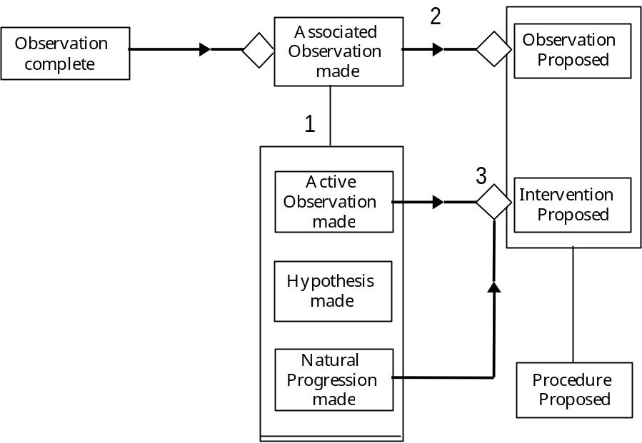
1 Completed observations of any type may lead to new associated observations being established:
• active observations ( eg the recording of a new diagnosis).
• projections of the natural progression of newly diagnosed diseases.
• and hypotheses put forward on the basis of evidence collected that far.
2 Each of these types of associated observation may lead to more observations being proposed, to look for further evidence, or to monitor the natural progression predicted.
3 In addition, both active observations (whether associated observations or not) and the natural progressions predicted, may lead to interventions being proposed, in the former case to treat existing conditions, and in the latter to pre-empt them.

3.1.3
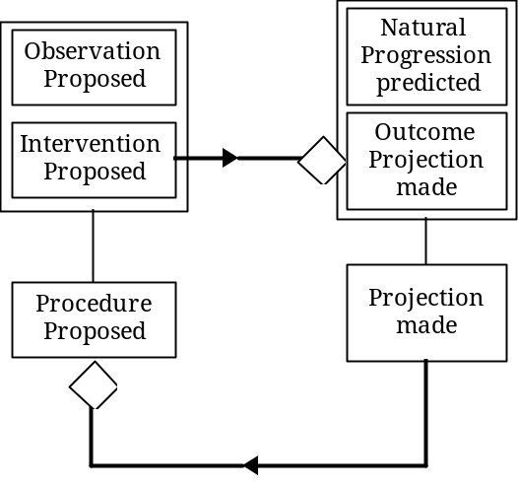
On proposing an intervention, it may be appropriate to record the outcome projections for the intervention. As with projected natural progressions, outcome projections may lead to proposed procedures, to monitor the appearance of the outcomes, and to take precautionary measures.

3.1.4
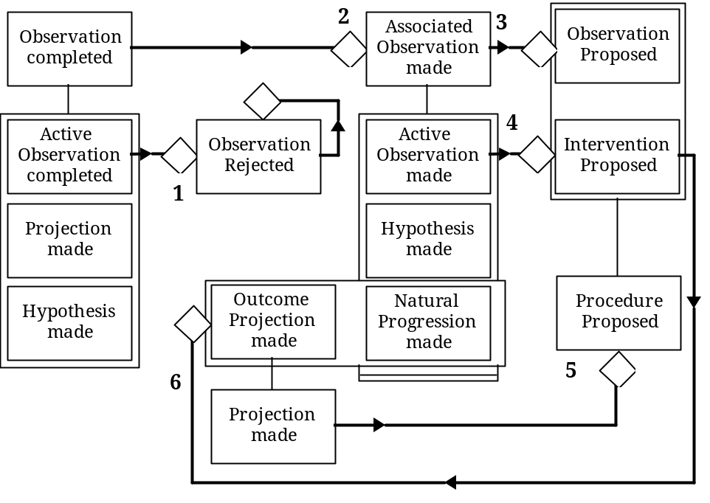When put together, the flow of information and decisions can be seen to be dependent on the knowledge functions described in 1.5.1.
1 and 2 involve associative functions determining whether evidence confirms or refutes the various propositions made.
3, 4 and 5 use start functions to determine intervention and observation protocols appropriate to the circumstances.
6 is concerned with the use of outcome functions to record whatever outcome projections are necessary.

The Activity of Observing is completed by implementation of the proposed procedures (described in the following section - 3.2). The cycle is re-initiated on completion of all those procedures that are observations (1 and 2).
Section 3.2.2 describes how the sequence of proposed actions that have been created as part of a plan is put into effect. As each of those proposed actions that is an observation is completed the Events described above are triggered.

3.2 Planning & Implementation

3.2.1 Planning
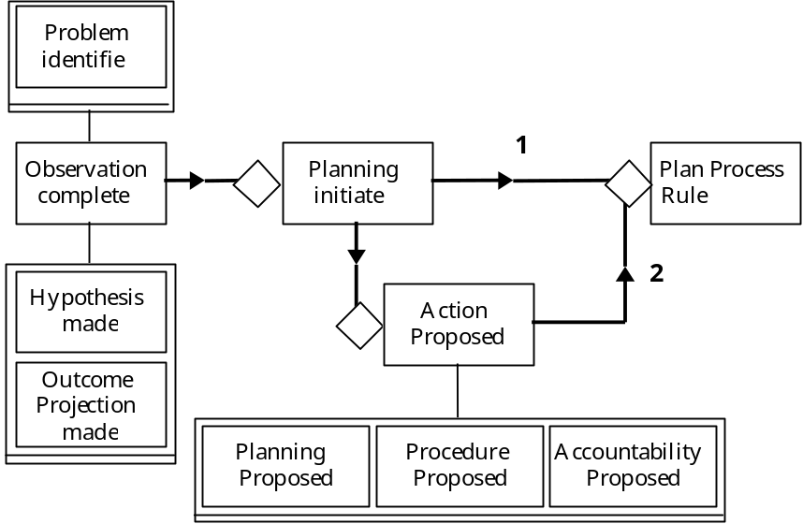
A number of observation types can lead to planning being initiated:
• identification of problems.
• hypotheses that lead to the search for further evidence.
• outcome projections, in an attempt to enhance a patient’s state of health, to avoid side effects, etc.
1 The process of planning may include looking into existing proposed actions, in case they already satisfy the current requirement (leading directly to the creation of new process rules).
2 As new proposed actions are put forward they can be incorporated into process rules.
The creation of process rules is followed by the initiation of the proposed actions governed by them. This is described in the following section.

3.2.2 Implementation
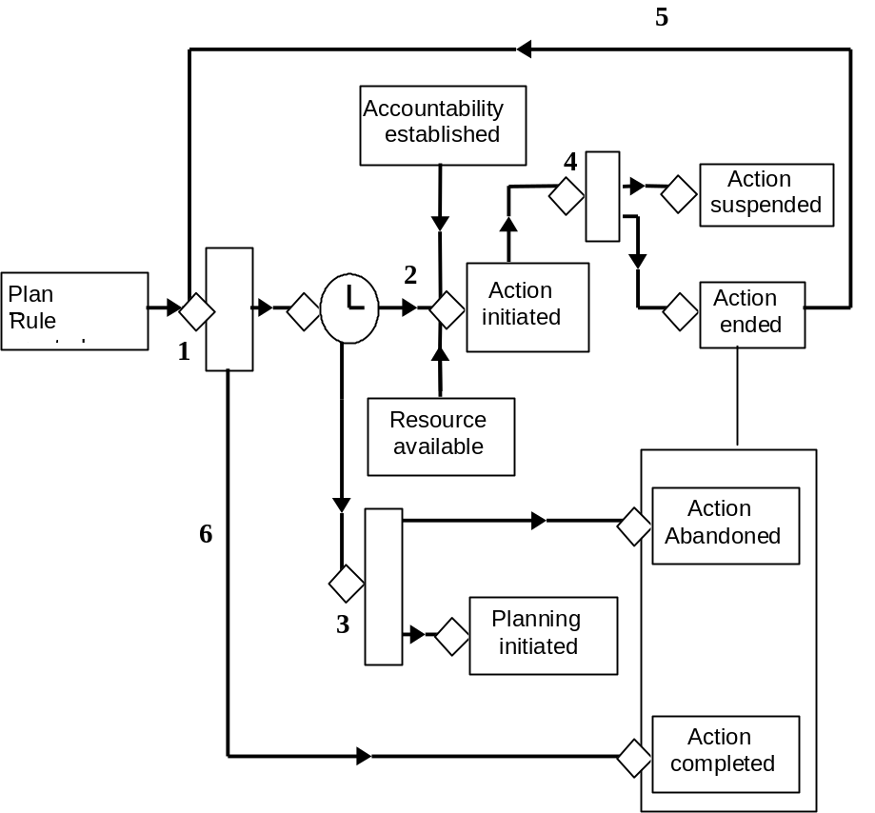
1 The purpose of process rules is to dictate the sequence of implementation. The selection of the first/next action is represented here by a logical filter event box.
2 The first/next action to be initiated has been determined. With the appropriate resources and accountabilities in place, the action can be initiated on time (the clock icon).
3 If the time for an action’s being carried out elapses without the necessary resources or accountabilities in place, the action can be abandoned and further planning initiated (this can lead to a new action being proposed to replace that which failed to be initiated).
4 Once initiated, an action will be completed, or abandoned or suspended either due to unforeseen circumstances or if failure of the protocol occurs.
5 The process rules are examined for the next action, if there is one. (The plan may specify observations to review the previous actions that have been performed.)
6 If no further actions are dictated by the process rules, then the overall parent action is completed. In this way the set of actions that make up the plan are completed, although individual contingency actions may themselves not have been performed (because not required on that particular occasion).

3.2.3 Referral
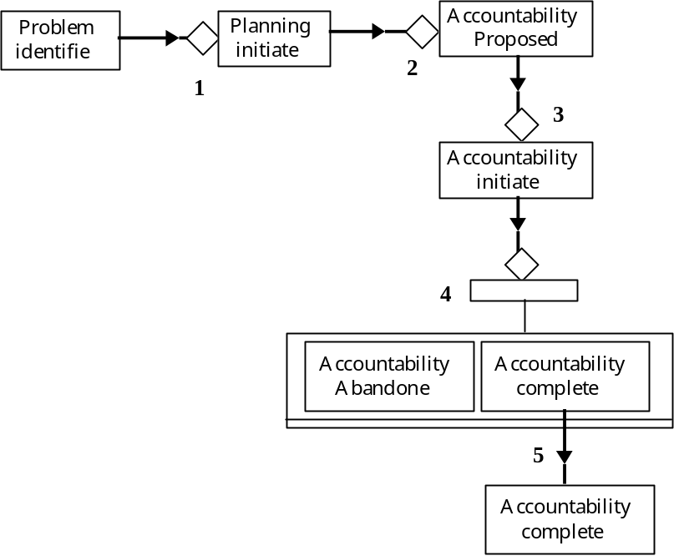
The processes of planning and implementing actions is illustrated here by the example of referral (Section 2.2.1) from a GP to a hospital consultant.
1 On identifying a patient’s problems the GP starts to plan a course of action with the patient.
2 A referral (accountability) to a hospital consultant is proposed, and recorded in the notes [Plan - refer to Dr X].
3 The process of referring the patient is initiated by some form of communication to the consultant.
4 On receiving the referral request, the consultant either agrees (in which case the referral [accountability] process is completed successfully), or declines (the referral is abandoned).
5 As discussed in Section 2.2.1, as soon as the consultant accepts the referral (accountability completed), then a degree of responsibility exists between consultant and patient - in other words a further accountability is completed (between the consultant and patient), that becomes more substantial on first direct contact and consultation with the patient.

