Glossary of Concept Names

________________________

All concept names are listed in the glossary.
Each concept is illustrated with all the other concepts to which it is directly related and with which it is partitioned.
A brief textual description of the concept is given with cross-references to the main references to the concept in Section 2.
Each entry also includes details of all direct relations between the concept being described and all others.
The content of each entry is described more fully in the Guide to the Glossary overleaf.
Guide to Glossary of Concept Names

Each entry includes:
• concept name
• cross-references to all main references in Section 2
• illustration of all concepts to which it is directly related
• brief textual description
• a list of any supertypes as: <supertype name>
• a list of any subtypes as: [subtype name]
• a list of the names of all directly related concepts
• the name of each of those relations
• the cardinality of each of those relations as follows:
(0/1) | meaning: | min:0 | max:1
(0/*) |  | min:0 | max:unlimited
(1/1) |  | min:1 | max:1
(1/*) |  | min:1 | max:unlimited
(2/*) |  | min:2 | max:unlimited

Structure of each glossary entry:

Concept Name | Cross-reference to Section 2

Brief textual description  <supertype>  [subtype] | Illustration

{relation name} | (cardinality) | name of related concept
Supertypes & Subtypes
A concept represents a collection of objects that share one or more defining properties.
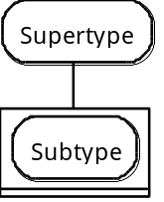 Within a collection of objects, sub-collections can be identified by additional distinguishing properties. The concepts representing the sub-collections are called subtypes. The ‘parent’ concept is called the supertype.
Cardinality
The property of a relation between two concepts that determines the number of objects that can or must be related between two concepts is known as the cardinality of the relation. Each relation has two cardinalities:
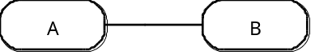 one cardinality is from A to B and determines how many B can or must be related to A; the other cardinality is from B to A and determines how many A can or must be related to B.
Each cardinality has a lower and an upper bound. A cardinality of (1,2) from A to B signifies that each A must be related to a minimum of 1 and a maximum of 2 B.

Relation names
Each of the directions that a relation runs in (from A to B, and from B to A) has a name as well as a cardinality. The name is derived from the purpose of the relation.

These terms are described more fully in the fold-out guide at the beginning of Section 2.

Glossary of Concept Names

Abandoned Action | 2.1.5

An action that has been stopped before its previously designated end. An abandoned action must have been replaced by another action.  <Implemented Action> | 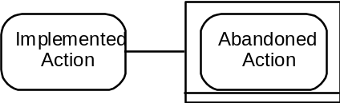

Absence | 2.3.14

An observation of the absence of an observation concept with respect to an object of care.  <Observation> | 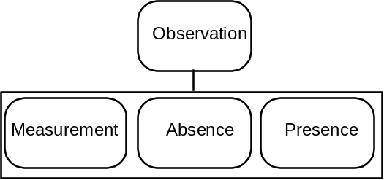

Accountability | 2.1.4, 2.2

The relationship between two parties that provides authorisation for an action to be carried out and/or defines a clinical scope.  Accountability is itself an action, so that the various stages of coming to an agreement can be registered. The substance of an accountability, what the agreement has been set up for, is held in the relationships established to the actions or clinical scopes authorised.  <Action> | 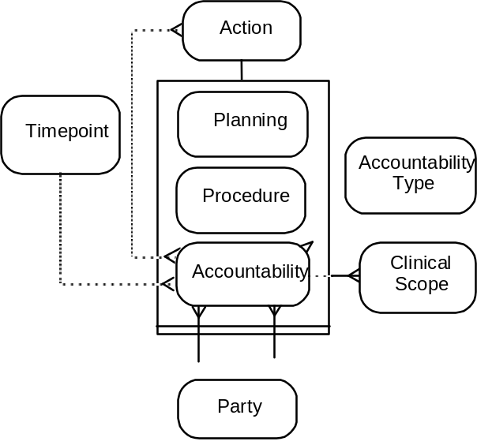

{commissioned by} | (1/1) | Party
{holds responsible} | (1/1) | Party
{authorises} | (0/*) | Action
{expiry} | (0/1) | Timepoint
{example of} | (0/1) | Accountability Type
{defines} | (0/*) | Clinical Scope

Accountability Type | 2.4.6

The general terms under which an accountability can be classified. It defines the nature of an accountability that is expected to be required if a protocol is to be implemented. | 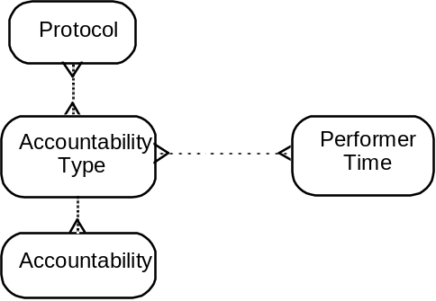

{type} | (0/*) | Accountability
{qualifies} | (0/*) | Performer Time
{required for} | (0/*) | Protocol

Action | 2.1, 2.6

Any act carried out within the health care process.  Any action with a conclusion timepoint cannot be suspended.  [Accountability]  [Planning]  [Procedure]  [Proposed Action]  [Implemented Action] | 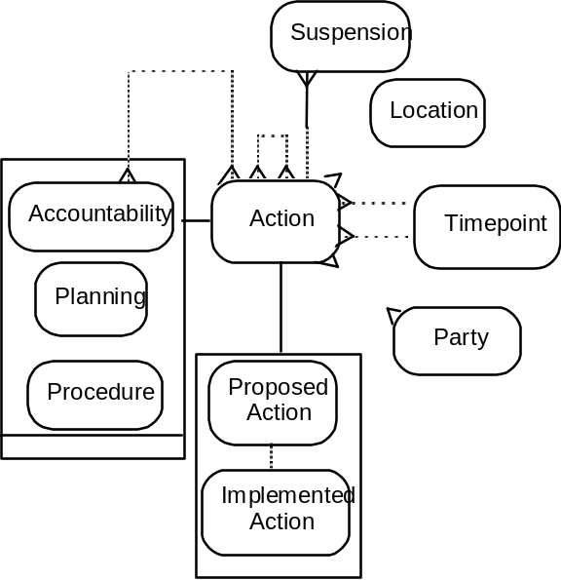

{performed at} | (0/1) | Location
{start} | (0/1) | Timepoint
{conclusion} | (0/1) | Timepoint
{authorised by} | (0/*) | Accountability
{performed by} | (0/*) | Party
{parent action} | (0/*) | Action
{component action} | (0/*) | Action
{suspended by} | (0/*) | Suspension

Active Observation | 2.3.7-9

Any observation that might be used in assessing the state of health of an object of care. As well as observations of the current state of health, they may include observations of past states of health and those for which evidence is incomplete.  <Observation> | 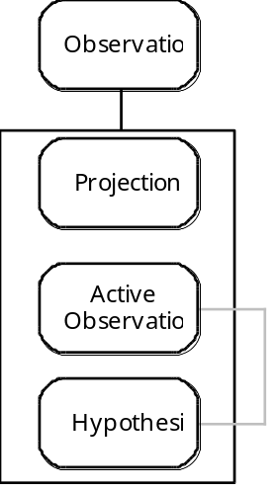

{established from} | (0/1) | Hypothesis

Associated Observation | 2.3.6/8/9

An observation that has a defined relation to one or more other observations. The nature of this relation is defined by an associative function. An associative function defines what type of association has been drawn and how.  If associated observations are established from associative functions, a constraint rule exists: the associated observations must correspond to the observation concepts determined by the associative function.  <Observation>  [Natural Progression]  [Hypothesis] |  |  | 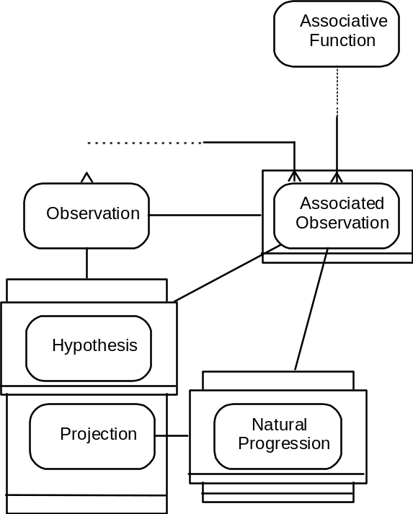
{associated with} | (1/*) | Observation
{derived by} | (1/1) | Associative Function

Associative Function | 2.3.5/6/8/12, 2.5.1

The knowledge of what kind of associations can be drawn between observations, and how. The function may be a mathematical function, a Boolean relation, a simple mapping, etc.  <Knowledge Function> | 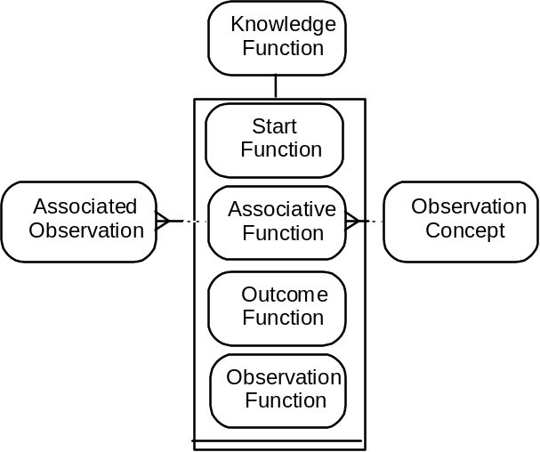

{function for} | (1/1) | Observation Concept
{association type} | (0/*) | Associated Observation

Biological Phenomenon | 2.3.3-6

A representation of the physiological, psychological, pathological and social structures and functions of which clinical observations are made.  <Observation Concept> | 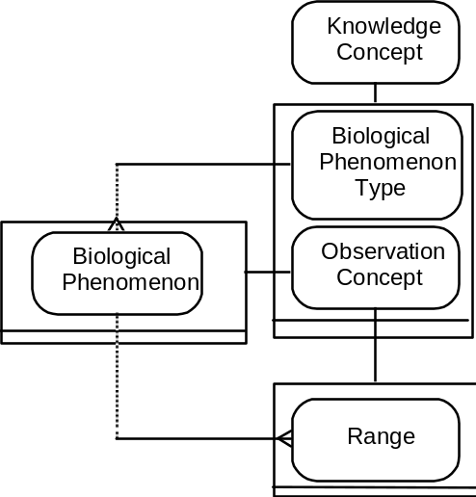

{example of} | (0/1) | Biological Phenomenon Type
{range of} | (0/*) | Range

Biological Phenomenon Type | 2.3.4

The recognised types of which biological phenomena are the manifestations.  <Knowledge Concept>  [Biological Structure] | 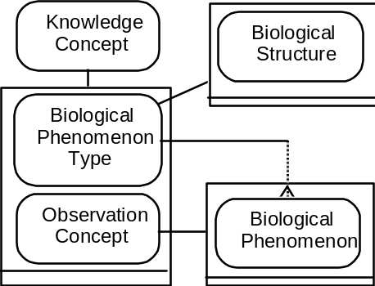

{type of} | (1/*) | Biological Phenomenon

Biological Structure | 2.3.3/4, 2.4.8

An arrangement of organic parts. (A set of interconnected organic parts)  <Biological Phenomenon Type> | 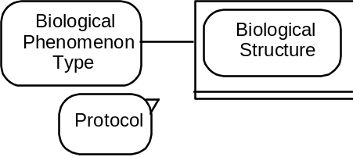

{site of} | (0/*) | Protocol

Clinical Scope | 2.2.2, 2.6.6

The protocol to be provided by a party, as determined by an accountability. For an individual person clinical scopes form part of a job description. An accountability can detail a number of clinical scopes. A specialised area of clinical interest can be defined for a clinical scope in one or more observation concepts. | 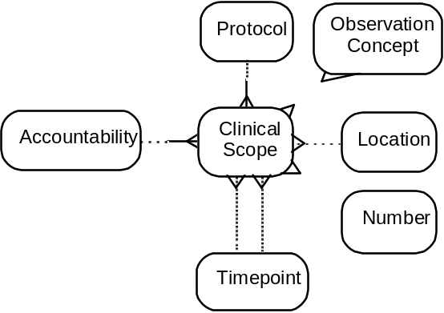

{defined for} | (1/1) | Accountability
{provides} | (1/1) | Protocol
{number of} | (0/1) | Number
{specialise in} | (0/*) | Observation Concept
{starts} | (0/1) | Timepoint
{ends} | (0/1) | Timepoint
{provided at} | (0/1) | Location

Continuously Applicable Process Rule | 2.6.2

A process rule for repetitive actions that are initiated whenever a defined set of circumstances has occurred or time interval has elapsed.  <Plan Process Rule> | 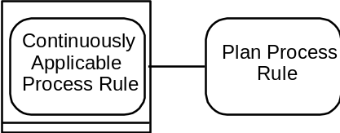

Differential | 2.3.13

A comparison between two or more observations, that may be measurements (includes rate of change).  <Observation> | 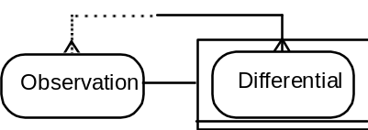

{comparison of} | (2/*) | Observation

Establishment | 2.1.4, 2.2.2

An organised body maintained for a purpose. An establishment can be anything from a laboratory or clinical team, to a nation state.  (Establishment does not represent the complement of employees held by an organisation.)  <Party> | 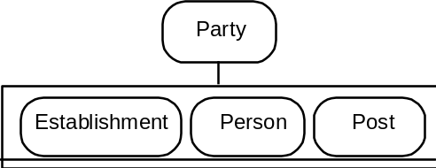

Hypothesis | 2.3.7-9

A proposition made from other observations as a basis for further investigation.  <Associated Observation> | 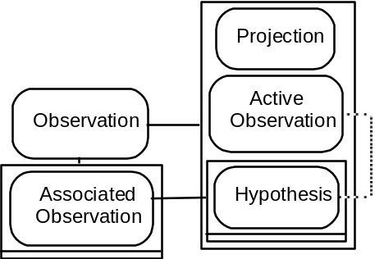

{realised in} | (0/1) | Active Observation

Implemented Action | 2.1.5, 2.6.4

An action that has been initiated and may have ended (whether completed or abandoned). It can represent the implementation of a proposed action, from which it can differ in a number of details (performer, date, etc).  An implemented must have either a start or a conclusion timepoint (or both).  <Action>  [Abandoned Action] | 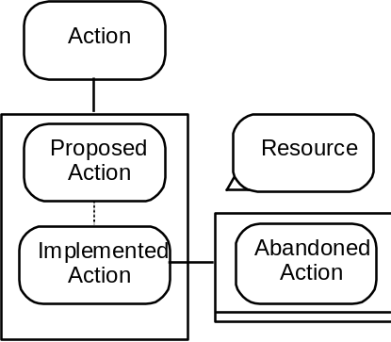

{implementation of} | (0/1) | Proposed Action
{uses} | (0/*) | Resource

Intervention | 2.1.2, 2.3.15/16, 2.4.5

An action that attempts or risks a change to the state of health of an object of care.  The protocol for an intervention must be an intervention protocol.  <Procedure> | 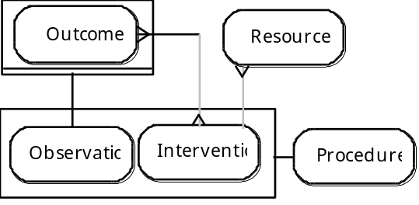

{results in} | (0/*) | Outcome
{supplies} | (0/*) | Resource

Intervention Protocol | 2.3.16, 2.4, 2.4.5

A protocol that determines a course of action that attempts or risks a change in the state of health of an object of care.  The implementation of an intervention protocol must be an intervention.  <Protocol> | 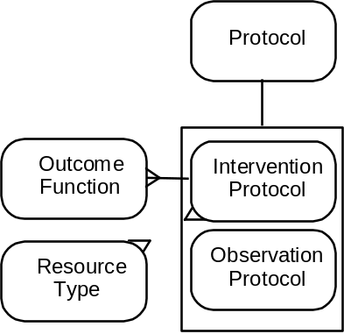

{results in} | (1/*) | Outcome Function
{supplies} | (0/*) | Resource Type

Knowledge Concept | 2.3.4

Collectively these are the concepts that clinicians hold of the physiological, psychological, pathological, and social structures and functions that can be observed in clinical care. Included are classifications of those concepts and the patterns that they have been recognised to form.  [Biological Phenomenon Type]  [Observation Concept] | 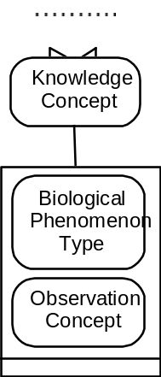

{classification of} | (0/*) | Knowledge Concept
{sub-classification of} | (0/*) | Knowledge Concept

Knowledge Function | 2.5.1

The collection of processes by which the effects of combinations of particular states of health and/or use of certain protocols can be judged. A constraint rule exists, such that a knowledge function must have at least one term as its argument, either observation concept or protocol.  [Start Function]  [Associative Function]  [Outcome Function]  [Observation Function] |  |  | 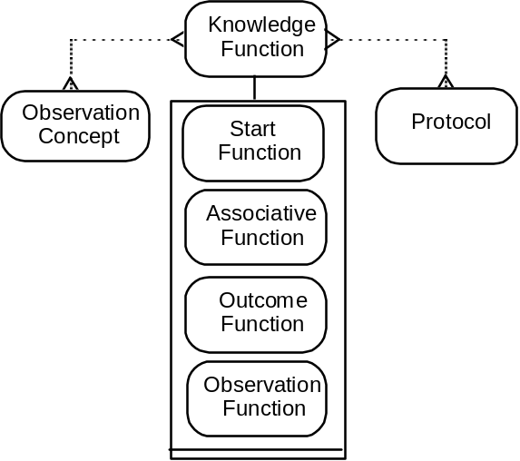
{function for} | (0/*) | Observation Concept
{function for} | (0/*) | Protocol

Location | 2.1.1, 2.2.2

The geographical place where actions or protocols are being, have been, or are to be carried out. | 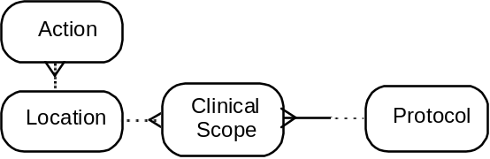

{location for} | (0/*) | Clinical Scope
{site for} | (0/*) | Action

Measurement | 2.3.2/11-14

An observation with a quantitative result.  <Observation> | 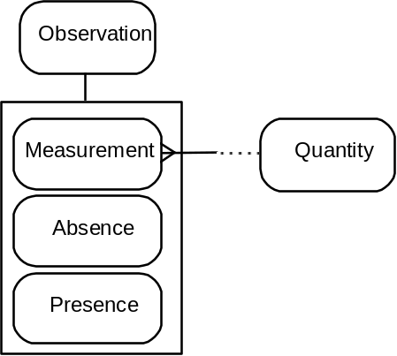

{has} | (1/1) | Quantity

Natural Progression | 2.3.8/9

A projected observation of the possible results of the natural progression of particular states of health.  <Associated Observation>  <Projection> | 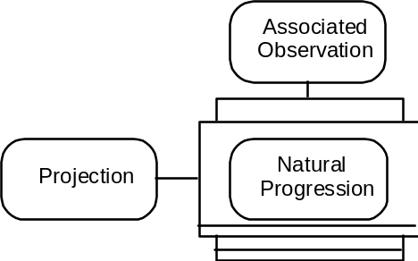

Number | 2.2.2, 2.3.11

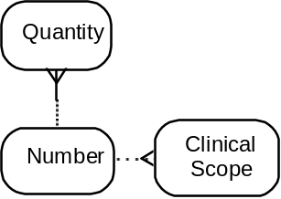

{numerical value} | (0/*) | Quantity
{numerical value} | (0/*) | Clinical Scope

Object of Care | 2.1.2/3

The focus of attention of the clinical process. Objects of care place a demand on the clinical process, and procedures are carried out with the object of care as the focus.  [Patient]  [Population] | 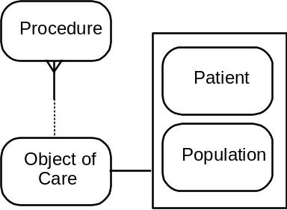

{focus of} | (0/*) | Procedure

Observation | 2.1.2, 2.3

The action of recognising that a particular observation concept pertains to or has been found to be absent from an object of care, or is found in a certain quantity. A constraint rule exists such that protocols used for observations must be observation protocols.  <Procedure>  [Absence]  [Active Observation]  [Associated Observation]  [Differential]  [Hypothesis]  [Measurement]  [Outcome]  [Presence]  [Problem]  [Projection]  [Rejected Observation] |  |  | 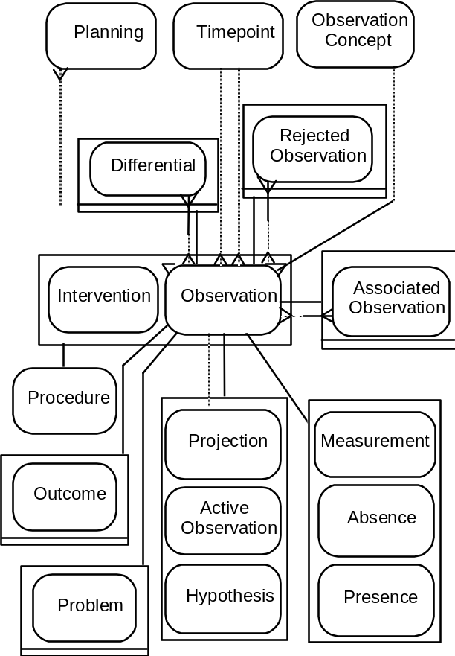
{onset} | (0/1) | Timepoint
{end} | (0/1) | Timepoint
{associated to} | (0/*) | Associated Observation
{compared in} | (0/*) | Differential
{trigger for} | (0/*) | Planning
{replaces} | (0/*) | Rejected Observation
{confirms} | (0/1) | Projection
{recognition of} | (0/1) | Observation Concept

Observation Concept | 2.3, 2.5.1, 2.6.6

The characteristics of objects of care that clinicians know can be observed about or of biological phenomena.  <Knowledge Concept>  [Biological Phenomenon]  [Range] | 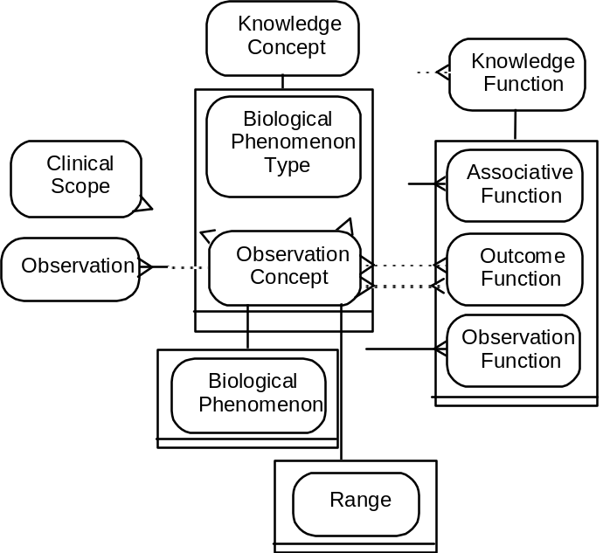

{noted in} | (0/*) | Observation
{target of} | (0/*) | Outcome Function
{side effect of} | (0/*) | Outcome Function
{product of] | (0/*) | Associative Function
{argument for} | (0/*) | Knowledge Function
{specialty} | (0/*) | Clinical Scope
{observed by} | (0/*) | Observation Function

Observation Function | 2.3.10, 2.5.1

Observation functions serve to associate observation protocols with the different observation concepts that can be observed to be present or absent, or measured, with respect to an object of care, by implementation of the protocol.  <Knowledge Function> | 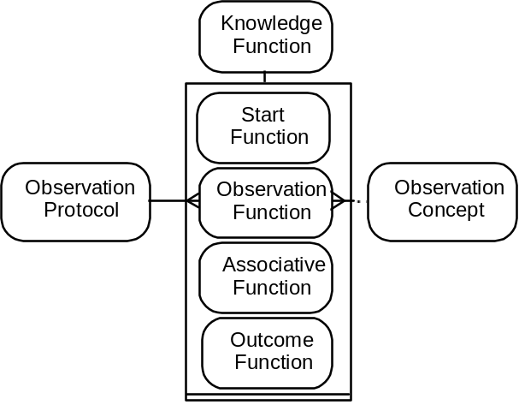

{product of} | (1/1) | Observation Protocol
{observation of} | (1/1) | Observation Concept

Observation Protocol | 2.3.10, 2.4

A protocol that determines the course of action that can be used to determine the absence or presence of given observation concepts, or to quantify them. The implementation of an observation protocol must be an observation.  <Protocol> | 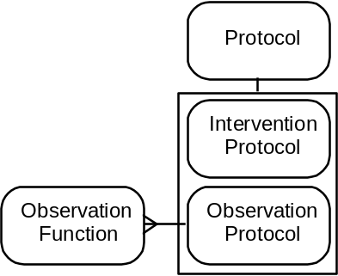

{results in} | (1/*) | Observation Function

Outcome | 2.3.15/16, 2.5.1

An observation of an object of care's state of health that the observer determines is the result of an intervention.  <Observation> | 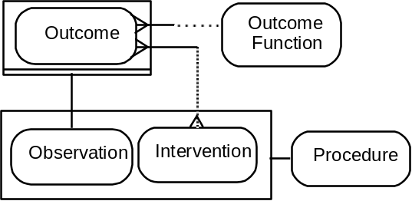

{outcome of} | (1/*) | Intervention
{derived from} | (1/1) | Outcome Function

Outcome Function | 2.3.16, 2.5.1

Outcome functions serve to associate intervention protocols with the different sets of observation concepts that may occur as a result of implementation of the protocol. The sets of observation concepts can be made up of target states of health and/or side effects.  An outcome function must have at least one target or side effect.  <Knowledge Function> | 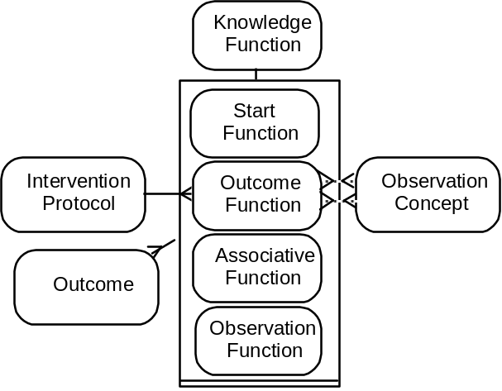

{result of} | (1/1) | Intervention Protocol
{target} | (0/*) | Observation Concept
{side effect} | (0/*) | Observation Concept
{occurs in} | (0/*) | Outcome

Party | 2.1.4, 2.2.2, 2.4.7

A person or establishment, or a post within an establishment.  [Person]  [Establishment]  [Post] | 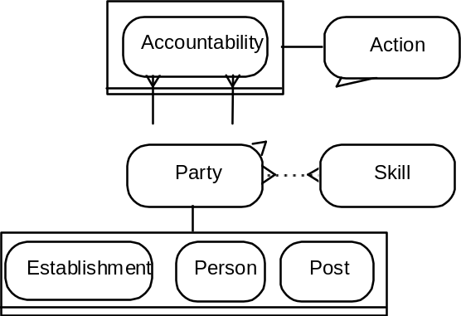

{commissions} | (0/*) | Accountability
{accountable to} | (0/*) | Accountability
{performs} | (0/*) | Action
{holds} | (0/*) | Skill

Patient | 2.1.2/4

A person who is also an object of care.  <Object of Care>  <Person> | 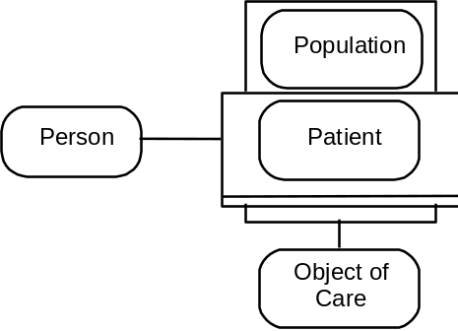

Performer Time | 2.4.6

The requirement for a party’s time for the performance of a protocol. It can be qualified by the accountability the party must hold to be able to perform the protocol.  <Resource Type> | 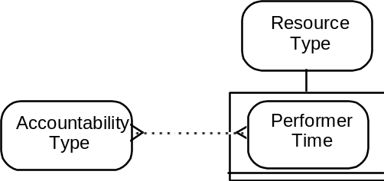

{qualified by} | (0/*) | Accountability Type

Person | 2.1.4

An individual human being.  <Party>  [Patient] | 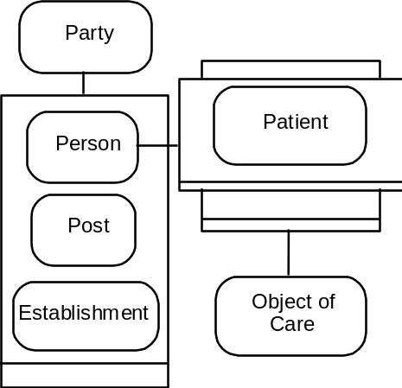

Planning | 2.6

The process of creating a set of plan structures to satisfy a demand made by or on behalf of objects of care.  <Action> | 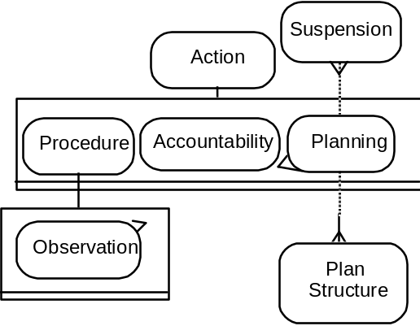

{triggered by} | (0/*) | Observation
{parent} | (0/*) | Plan Structure
{determines} | (0/*) | Suspension

Plan Process Rule | 2.6.2/3

The rules determine the circumstances (including time intervals) of initiating and ending actions that are part of the plan structure.  [Continuously Applicable Process Rule] | 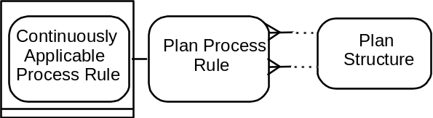

{next} | (1/1) | Plan Structure
{previous} | (1/1) | Plan Structure

Plan Structure | 2.6.2/3

Refers to the component proposed actions determined by the process of planning. | 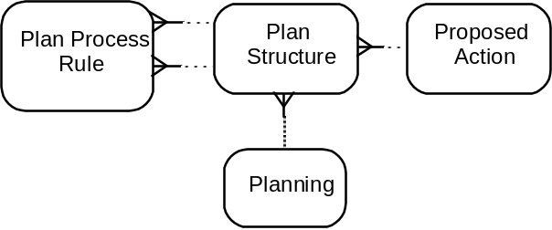

{part of} | (1/1) | Planning
{details} | (1/1) | Proposed Action
{initiated by} | (0/*) | Plan Process Rule
{trigger for} | (0/*) | Plan Process Rule

Population | 2.1.2

A group of persons distinguished by a defined characteristic, eg nationality, race, disease type, family ties.  <Object of Care> | 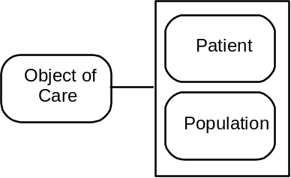

Post | 2.2.2

Determines the position within an establishment’s structure that a post-holder will take, and the clinical scope.  A post must be accountable to an accountability of which the commissioning party is its establishment.  <Party> | 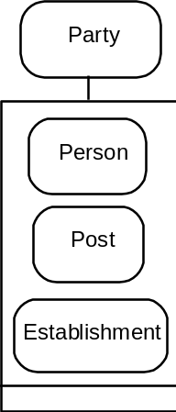

Presence | 2.3.14

An observation that has positively confirmed the presence of an observation concept with respect to an object of care.  <Observation> | 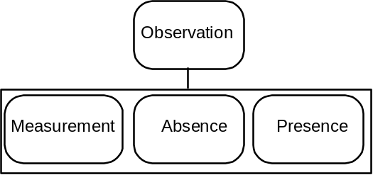

Problem | 2.6.5

An observation the observer classes as one it would be preferable did not apply to the object of care.  <Observation> | 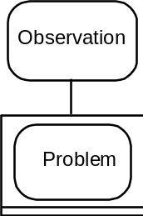

Procedure | 2.1.2/3, 2.6.1

Actions that are focused on an object of care, either observations of the state of health, or interventions that attempt or risk a change to that state of health.  <Action>  [Intervention]  [Observation] | 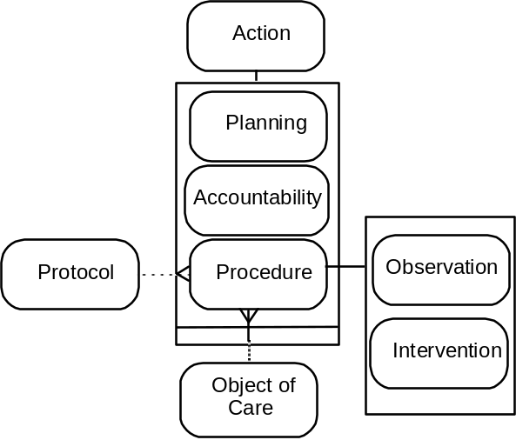

{performed on} | (1/1) | Object of Care
{implemented using} | (0/1) | Protocol

Projection | 2.3.8/9

A record of observations that may apply in the future, whether due to the natural progression of the state of health, or due to planned interventions.  <Observation>  [Natural Progression] | 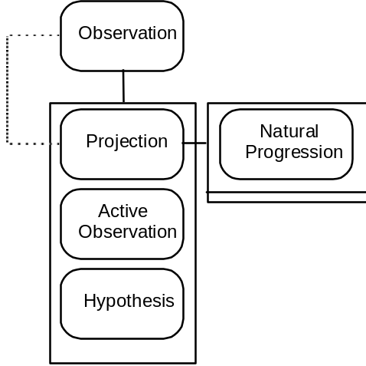

{confirmed in} | (0/1) | Observation

Proposed Action | 2.1.5, 2.6.2-4

An action that is planned for implementation at a later date.  <Action> |  |  | 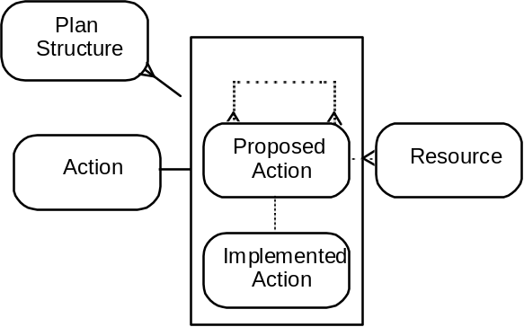
{implemented as} | (0/1) | Implemented Action
{replaces} | (0/*) | Proposed Action
{replaced by} | (0/*) | Proposed Action
{booked} | (0/*) | Resource
{detailed by} | (0/*) | Plan Structure

Protocol | 2.1.3, 2.2.2, 2.3.10, 2.4, 2.5.1, 2.6.1/2

Protocols represent the clinical knowledge of how to observe or measure a particular phenomenon, or of how to intervene to achieve a particular end.  [Intervention Protocol]  [Observation Protocol] | 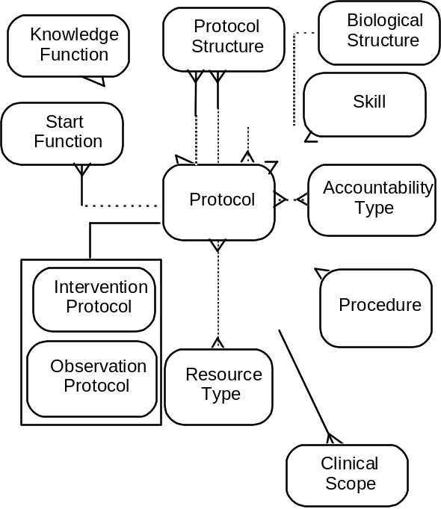

{implemented in} | (0/*) | Procedure
{requires} | (0/*) | Resource Type
{requires} | (0/*) | Accountability Type
{requires} | (0/*) | Skill
{parent} | (0/*) | Protocol Structure
{component} | (0/*) | Protocol Structure
{site of} | (0/1) | Biological Structure
{terms of use} | (0/*) | Start Function
{argument for} | (0/*) | Knowledge Function
{provision for} | (0/*) | Clinical Scope

Protocol Process Rule | 2.4.1/2, 2.6.1/2

A rule that determines the circumstances (including time intervals) of initiating and ending component protocol use. | 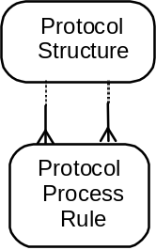

{next} | (1/1) | Protocol Structure
{previous} | (1/1) | Protocol Structure

Protocol Structure | 2.4.1/2, 2.6.1/2

Refers to a component protocol of a parent protocol. | 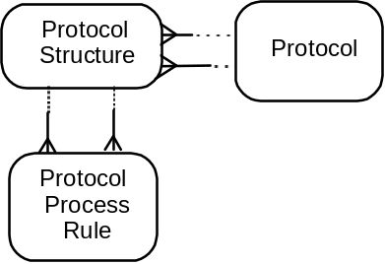

{part of} | (1/1) | Protocol
{details} | (1/1) | Protocol
{initiated by} | (0/*) | Protocol Process Rule
{trigger for} | (0/*) | Protocol Process Rule

Quantity | 2.3.11/12

The numerical value of a measurement, with specified units. | 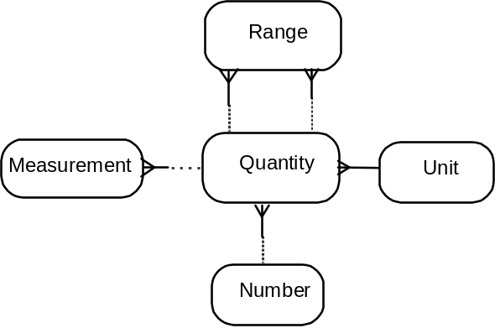

{quantity of} | (0/*) | Measurement
{unit of} | (1/1) | Unit
{number of} | (1/1) | Number
{upper limit} | (0/*) | Range
{lower limit} | (0/*) | Range

Range | 2.3.12

An observation concept expressed in terms of a scope in quantity of a single biological phenomenon. A range may be given any name that seems appropriate, but it is still defined by its biological phenomenon and upper and lower bounds.  <Observation Concept> | 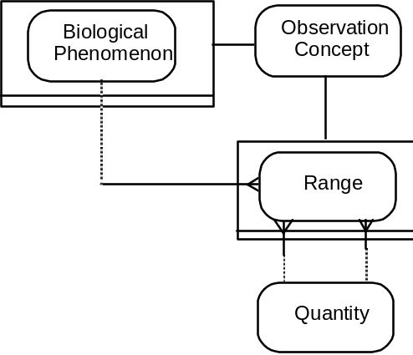

{bound by above} | (1/1) | Quantity
{bound by below} | (1/1) | Quantity
{range for} | (1/1) | Biological Phenomenon

Rejected Observation | 2.3.7/9/14

Observations either that have been shown to have never been true, or that were once suspected but subsequently shown not to be true.  <Observation> | 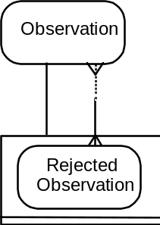

{replaced by} | (1/*) | Observation

Resource | 2.4.5, 2.6.4

Whatever is or will be made use of in carrying out a specific action. | 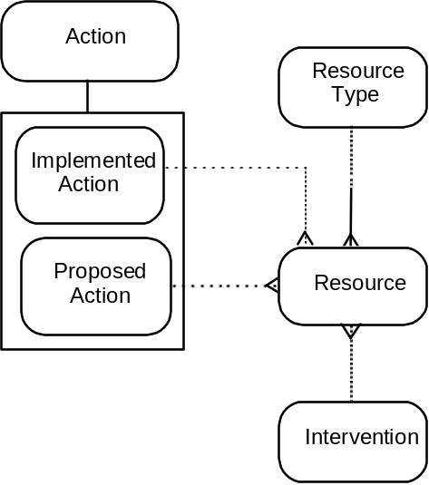

{used by} | (0/1) | Implemented Action
{supplied by} | (0/1) | Intervention
{example of} | (1/1) | Resource Type
{booked for} | (0/1) | Proposed Action

Resource Type | 2.4.4-6

The general term under which a resource can be classified. It defines the nature of a resource that is expected to be required if a protocol is to be implemented.  [Performer Time] | 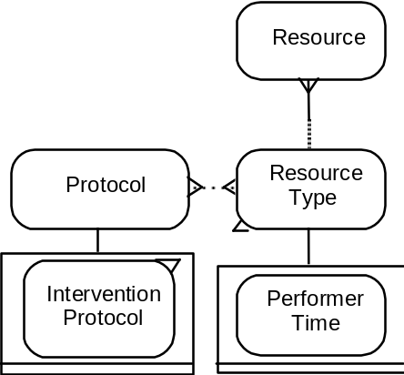

{required by} | (0/*) | Protocol
{type of} | (0/*) | Resource
{supplied by} | (0/*) | Intervention Protocol

Skill | 2.4.7

The practical ability involved in performing a protocol. | 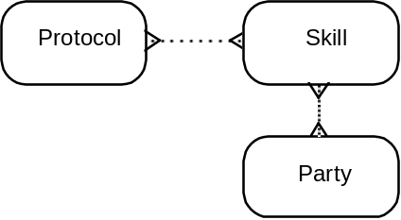

{held by} | (0/*) | Party
{required for} | (0/*) | Protocol

Start Function | 2.4.3, 2.5.1

The indications and contra-indications to protocol use.  <Knowledge Function> | 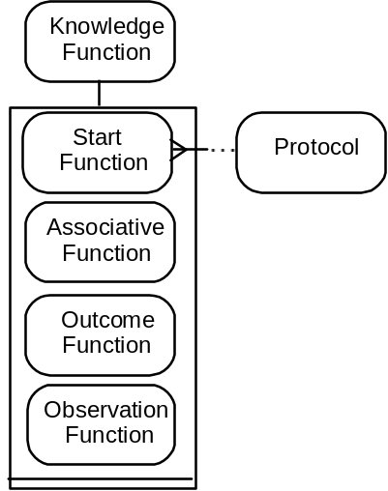

{determines use} | (1/1) | Protocol

Suspension | 2.1.5, 2.6.3

The process of suspending an action. | 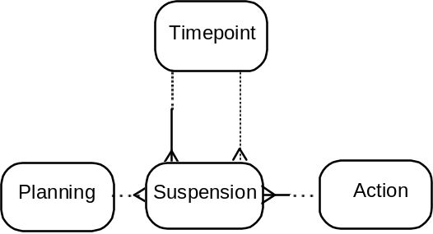

{suspended on} | (1/1) | Timepoint
{lifted on} | (0/1) | Timepoint
{suspends} | (1/1) | Action
{planned by} | (0/1) | Planning

Timepoint | 2.1.1/5, 2.2.1/2, 2.3.2

 |  |  | 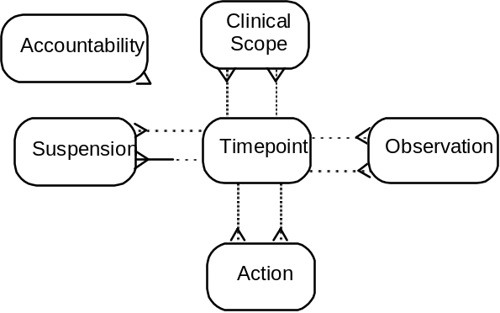
{start time} | (0/*) | Action
{time of conclusion} | (0/*) | Action
{time closed} | (0/*) | Accountability
{time of onset} | (0/*) | Observation
{time of end} | (0/*) | Observation
{time of suspension} | (0/*) | Suspension
{time lifted} | (0/*) | Suspension
{time of start} | (0/*) | Clinical Scope
{time of end} | (0/*) | Clinical Scope

Unit | 2.3.11

The established reference for given measurements. | 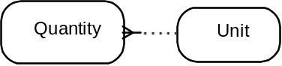

{unit for} | (0/*) | Quantity

