AVANI

Annual Report

2003 - 2004

P O Tripuradevi, via Berinag, Dist Pithoragarh, Uttaranchal 262531
Phone: 05964 244943
Email: avani@sancharnet.in
Website: www.avani-kumaon.org

Table of Contents

1. Introduction 2

2. Development and Dissemination of 3
Solar Energy in the Villages
2.1 Solar Photovoltaics
2.2 Solar Water Heaters
2.3 Mechanical Workshop

3. Promotion of Traditional Craft to 6
Enhance Livelihood Options
3.1 Capacity Building of Local Team
3.2 Structure of a Producer Organisation
3.3 Product Design and Marketing
3.4 Appropriate Technology in Textiles

4. Women’s Empowerment 9
4.1 Self Help Groups
4.2 Girl Child Education

5. Rain Water Harvesting 10

6. Organic Farming, Vermicomposting 11
and Biodiversity Conservation

7. Summarised Financial Report 12

8. Our Funders 13

1. Introduction

This year has seen Avani’s increased collaboration with the government agencies. Avani has taken the help of Uttaranchal Renewable Energy Development Agency (UREDA) for solar electrification of remote villages.
Avani has also been registered with the Development Commissioner Handicrafts (DCH) and is now ready to log into various developmental schemes of DCH. During the International Year of Fresh Water (2003), we collaborated with the Ministry of Water Resources, Government of India, to build rain water harvesting systems under the aegis of the Global Rain Water Harvesting Collective (GRWHC).

We participated in the rural electrification program of the Ministry of Non Conventional Energy Sources (MNES) to solar electrify eight remote villages in collaboration with UREDA. Through the solar demonstration program of UREDA, we were able to help very poor families of different villages to access solar technology.These families could buy equipment on easy instalments through provision of soft loans from the village maintenance fund.

Avani has also brought about a major policy shift in terms of local capacity building for management of technology at the village level. We have been able to convince the state government to invest more in training rural youth to look after the solar installations. As a result, UREDA and the Department of Rural Development, Government of Uttaranchal have collaborated with Avani to provide financial assistance for a three month training of 24 rural youth as solar technicians.

These youth are undergoing training at Avani’s solar workshop in Tripuradevi, following which, they will be able to earn their livelihood by maintaining and servicing solar energy appliances installed in and around their villages.

Rural youth, trained at our mechanical workshop at Tripuradevi, are manufacturing low cost solar water heaters regularly. Six of these water heaters were installed at the Kumaon Mandal Vikas Nigam guest house located in the heart of the wild life santuary of Binsar.

We hope that this trend will continue as more guest houses adopt the use of solar water heaters instead of carbon based fuels, thus saving on green house gas emissions.

During this year, we have also collaborated with the DCH to get identity cards issued to weavers working with Avani.

This will help the weavers to access various welfare schemes of DCH, such as grants for worksheds and housing for the artisans. These weavers were also insured for their life under Jan Shree Jivan Bima Yojana.

Following are the details of the activities undertaken by Avani in the year 2003 -2004:

2. Development and Dissemination of Solar Technology

  - Solar Photovoltaics

Avani has been working with the dissemination of solar technology in the villages of Kumaon since 1997. Avani started its journey as the Kumaon chapter of the SWRC, Tilonia, Rajasthan. During the course of its work in past seven years, Avani has taken solar lighting to 1216 families in more than 70 villages.

Through a network of village level solar committees, Avani has created a management system that ensures that these solar units are in working order. These committees have collected a village fund that enables them to replace batteries and panels when needed. The committees have also sent a youth from their village to Avani for training as a solar technician.

Today these committees are self-reliant and have collected a fund of Rs 25,99,579 since 1997. They have trained technicians who monitor and maintain the solar installations every month. These committees are performing the role of rural banks where they provide soft loans to very poor families to enable them to purchase solar systems. The focus has been on local capacity building at all levels to increase the self sufficiency of a village community.

All the systems installed by Avani are functioning well.

Following the success of this community managed solar programme, the government has collaborated with Avani to solar electrify remote rural households and also to train youth to maintain these systems.
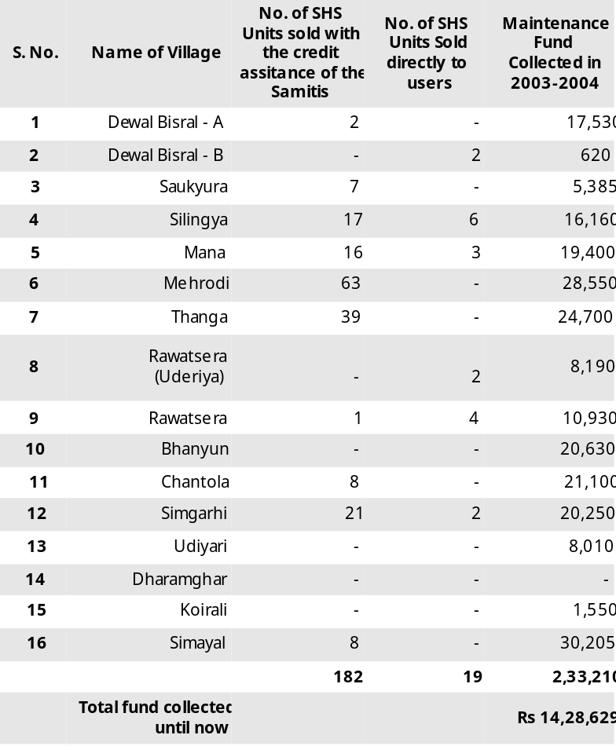

A. Avani has installed 693 solar home lighting systems (SHS) in
64 villages in collaboration with UREDA and sold 43 lanterns.

- 182 of these systems were sold through 10 existing village committees who gave a soft loan of Rs 10,00,452 from their fund to assist the solar electrification of 182 very poor families. Out of these, 117 are general caste and 65 are very poor scheduled caste. These families will return the money to the samitis in easy installments.

- 19 SHS units were sold to users from six existing villages and 79 SHS units were sold to users from 48 newly integrated villages.

- 413 SHS systems and three distilled water units for batteries were installed in eight new villages of Pithoragarh district
- under the rural electrification scheme of UREDA.

A total of Rs 25,99,579 has been collected as a maintenance fund in 23 village samitis until 2004.
The details of the eight new villages are given in Table 1 (p5)
The villages have also contributed a total of Rs 46,186 towards the salary fund of the solar technicians.

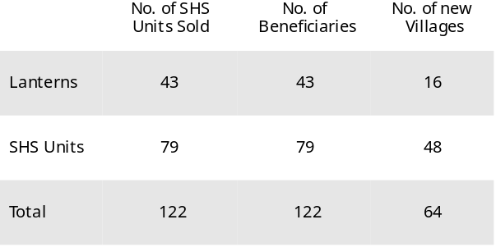

- In this year 21 youth have been trained as solar technicians and 24 more youth are

currently under training.

Seven out of these 21 technicians are women, which is a precedent in the area where traditionally women do not handle tools.
These technicians maintain all the systems installed by Avani, assemble solar lanterns and lamps and conduct trainings for new people in solar technology.

C. The Akshay Urja Mahila Samuhas trained last year in Mehrodi and Thanga have sold a total of 30 systems and have earned Rs 200 per system.

- Two more women’s groups in Digoli and Sukna have been trained to repair and maintain solar systems.

- Two power plants of 500Wp capacity each have been installed in Digoli and Sukna field centres to run spinning wheels for silk and wool spinning.

- Each of these four women’s groups has been given a revolving fund of Rs 10,000 with the assistance of UREDA to buy and sell solar systems.

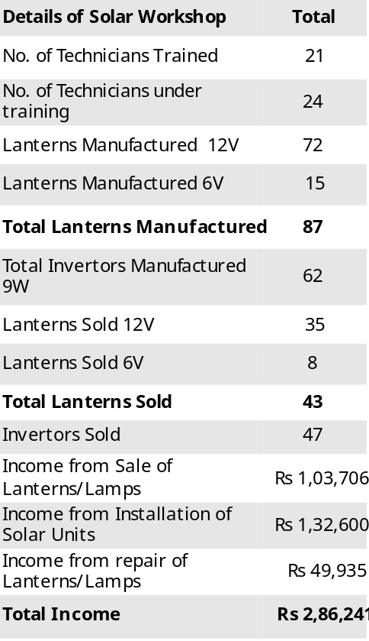

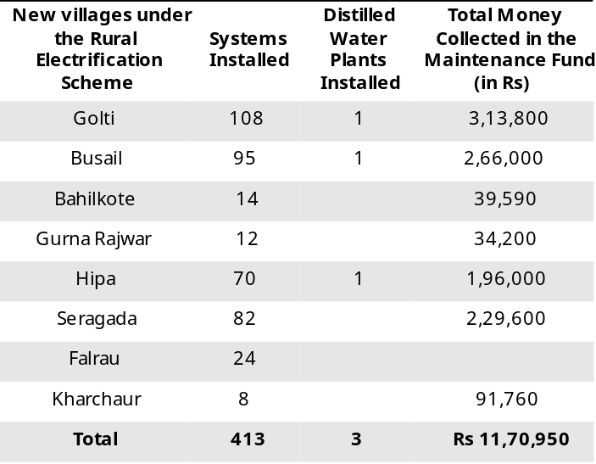

D. A calendering machine used for the finishing of textiles produced by Avani in different village centres has been established at Tripuradevi.
This machine operates largely on solar power.
The income of the mechanical workshop from solar water heaters and calendering in this year is Rs 1,07,946.

  - Solar Water Heaters (SWH)

Avani has also worked on the thermal applications of solar energy like solar water heaters. This would help to reduce the consumption of wood for heating water. We are promoting the use of these solar heaters in tourist rest houses. A complete mechanical workshop run by local youth at Tripuradevi has started manufacturing solar water heaters on a regular basis. In this year, our mechanical workshop has trained six technicians to manufacture solar water heaters. They have manufactured 12 SWHs in this year. Out of these, six have been sold to Kumaon Mandal Vikas Nigam guest house at the wild life sanctuary at Binsar.

One water heater has also been installed at the Avani centre for natural dyeing. This has substantially reduced the consumption of other fuels for heating water and has made our process of production of textiles more environmentally friendly.

The details of the SWH manufactured in 2003-2004 are as follows:

Total SWHs made 12
SWH sold 6
Income from sale of 6 SWH Rs 1,02,000

2.3 Mechanical Workshop (MW)

The mechanical workshop at Tripuradevi manufactures solar water heaters as well as roof trusses, windows, doors, staircases, winders, dormers, stools, tables, beds, iron cages for gas cylinders, sign boards, grills, plumbing, LPG gas fitting. The MW has also established power plants at Digoli and Sukna.
The income of the MW from all these activities was Rs 29,124.

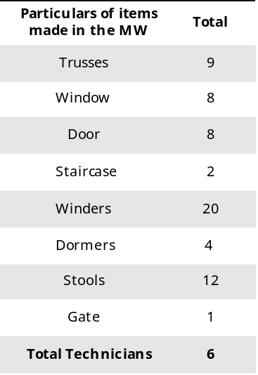

3. Promotion of Traditional Craft to Enhance
Livelihood Options

Avani has been working with the promotion and preservation of traditional craft to create livelihood opportunities for four years now. We initiated work with the traditional craftspeople from the Shauka community who are traditionally weavers.
We have also worked extensively on the transfer of the traditional skill of weaving and spinning to other disadvantaged communities.

Avani works with 466 artisans in 42 villages.

We work through field level training centres that have been established in the artisan villages. The whole process is decentralised and hopes to provide employment without displacement of the artisans from their homes. An overview of this program is given in Table 2 (p8).

In this year, two new field centres have been started at the villages of Chankana and Berinag. Six field centres are located at the following villages:

1. Dharamghar District Pithoragarh
(for villages of Simgarhi, Saukyura, Dharamghar,
Dhura, Chipchia, Lamjhingra, Mehrodi)
2. Digoli District Bageshwar
(Mana, Digoli, Matkoli, Dhaulani)
3. Sukna District Pithoragarh
(Ghangal, Sukna, Dhaulani)
4. Tripuradevi District Pithoragarh
(Bhandarigaon, Manipur, Rai Aagar, Berinag)
5. Chankana District Pithoragarh
(Chankana)
6. Berinag District Pithoragarh (part time)
(Berinag)

We have organised the artisans into producer groups or Dastakari Sangathans so that this enterprise can be slowly managed by the community. The capacity building of these village groups has been a focus area. Intensive trainings have been conducted by our training team at Avani to enhance the understanding of the Dastakari Sangathans and to bring in issues of ownership of this enterprise.

The artisans we are working with are from socially and economically disadvantaged sections of the society.

Women who had no source of earning have now gained a skill and are earning their own living.

The participation of the Bora Kuthalia community is the maximum in this program. They are traditional weavers and spinners of natural plant fibres on waist looms. But with the influx of plastics in all spheres of life, their ropes and sacks are not much in demand. This has led to the slow disappearance of the skill. Most of their villages are located 3-4 hours walk from any roadhead.

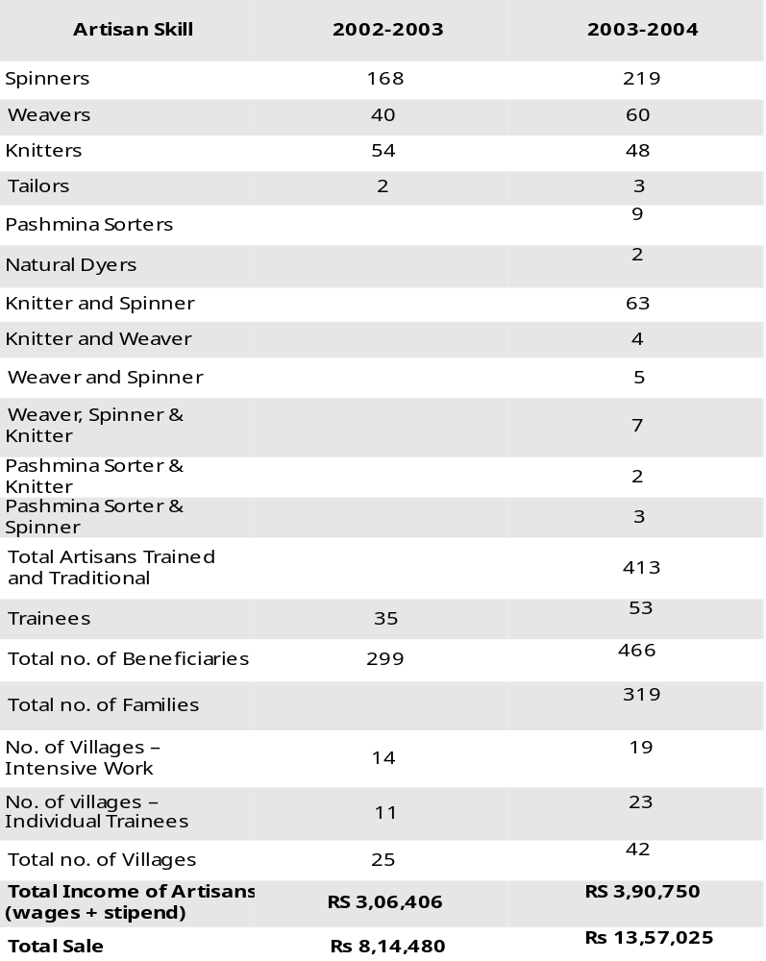

With this program, livelihood opportunities have reached some of the poorest families living in remote villages.
A reliable source of income has enabled these families to purchase solar systems for their homes.
Most of the artisans devote part time to activities like spinning or weaving. The earning from these activities is supplementary income for the artisans.

Out of 466 beneficiaries the community-wise breakup is as follows:
Women Men Total
Bhotia (Shauka) 20 4 24
Bora Kuthalia 304 56 360
Scheduled Castes 21 2 23
General Castes 57 2 59
Total 402 64 466

With improvement in their financial situation, the women also feel empowered to take decisions and fight for what they feel is right.

We have also introduced the spinning of silk in our area. The spinning wheels are powered by solar energy. Such solar powered spinning wheels are functional at Tripuradevi, Digoli, and Sukna. We are working with the spinning of oak tussar, mulberry, wool and pashmina fibres.
We have established two small solar power plants at Sukna and Digoli centres. This enables the centres to have lighting and also to run two spinning wheels. The details of the spinning wheels provided to the spinners in this year are as follows:
Bageshwar Charkha 9
Solar powered Motorised Charkha 6
Pedal charkha for silk 3
Pedal/Motorised charkha for silk 4
Total no. of spinning wheels 22

The newly trained weavers are now working on frame looms introduced by us, that enable them to make wider fabrics. In all we have installed 33 frame looms, out of which five were made in the past year.

3.1 Capacity Building of the Local Team

This program is managed entirely by a local team of supervisors. To enable this team to function optimally:
-This team of community workers and production supervisors is given regular training to assist them to implement their work.

- A monthly meeting is held at the central level to analyse the performance of every centre, the difficulties faced by each field team and the data management at the field centres.

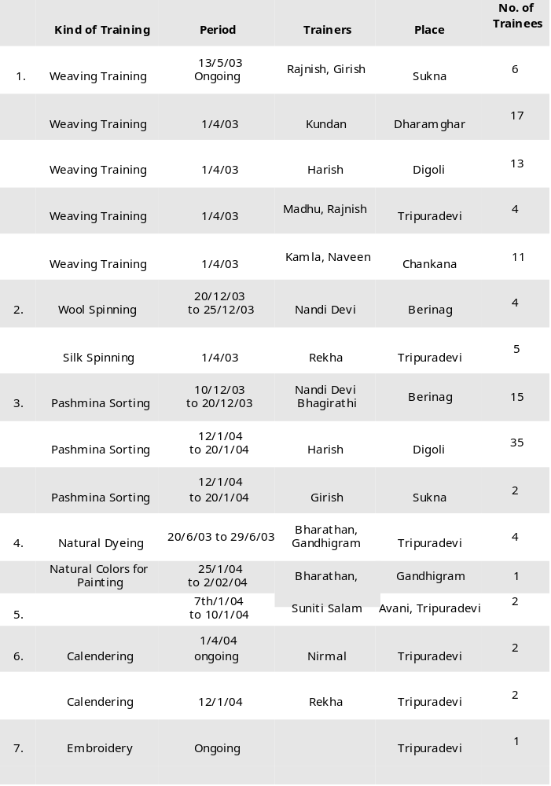
- Extensive production formats have been developed that collate monthly data related to production, wages and impact of every field centre. These meetings also act as a forum for conflict resolution.
- Two trainings for trainers (TOT) were held for Avani team by Udyogini, an organisation from Delhi.
Following the training of the Avani supervisory team, a training of the producer groups in the villages of Digoli, Chankana, Sukna, Dharamghar and Tripuradevi was conducted by our team of trainers. The issues that were taken up, included all aspects related to enterprise management.
- The tools of training included easy games, small group discussions and case studies. The discussions were held in the local language.

3.2 Structure for a Producer Organisation

Avani has been in the process of organising the artisans into Dastakari Sangathans. These groups will then be slowly federated into an association. To finalise the structure of this association, there are continuous discussions with other people who have the experience of any form of organised people’s initiative that is non-exploitative and values each member equally. This has helped us to crystallise our ideas and finalise a structure for the federation of Dastakari Sangathans. In another year’s time we will be in a position to present a structure for this producer association.

3.3 Product Design and Marketing

A new range of products is created every year to maintain the market enthusiasm. There has been a lot of appreciation for the product design and colors that we have used.

- The use of natural dyes has given our products a uniqueness and class that has brought better marketing options.
- The brand name of Avani is now being associated with good quality products.
- The products are now standardised in terms of quality control measures. - We are replicating certain products and blends that have sold well and are continuing to create new blends.
- The measurements, tightness of fabric, selvage, color uniformity, all these standards are being implemented in our products.
- Blends of silk and wool and of pure silks blended together have had a very good response.
- We have been able to access new marketing channels this year and have worked on orders from different stores.

- Avani has participated in six exhibitions this winter.

- To explore the local marketing channels, Avani sold its products through two resorts in Almora. Encouraged by the sales, Avani will keep its goods regularly at these resorts.

Our total sales this year have been Rs 13,57,025, which is much higher than last year’s sale of Rs 8,14,480.

The list of retail stores that sold Avani’s products in the last year follows:
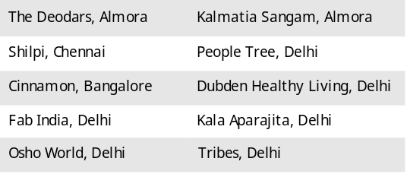

3.4 Appropriate Technology in Textiles
The use of appropriate technology in the production of textiles has been a very important part of our work. We have tried to make our process of production as environment friendly as possible. We have used many devices powered by solar in our production.

Solar Water Heaters

Solar water heaters manufactured at Avani have been installed for preheating of water for natural dyeing.

Solar powered silk spinning wheels
With the installation of two small solar power plants at two field centres, it is now possible to operate motorised spinning wheels. This has enabled the silk spinners to spin on a regular basis.

Calendering Machine
We have now installed a solar powered calendering machine for the final finishing of our products. Calendering gives an added lustre to the product and adds a touch of elegance.

Dyeing workshop
A proper workshop for natural dyeing has been constructed along with a solar drying room. This has made the process of dyeing more effective and easy to handle. The drying room is not yet functional due to some operational problems. We have also started making organic natural colors for painting for children.
The Digoli field centre has also taken up the dyeing activity in the village itself. Simple dyes like eupetorium, walnut hulls and myrobolan are now being used to dye different materials in Digoli itself.

4.1 Self Help Groups
At present, Avani is working with 15 women’s groups. The women meet regularly and are using their savings to give small loans to each other.
These groups have also become a strong forum for women to get together and share their concerns.
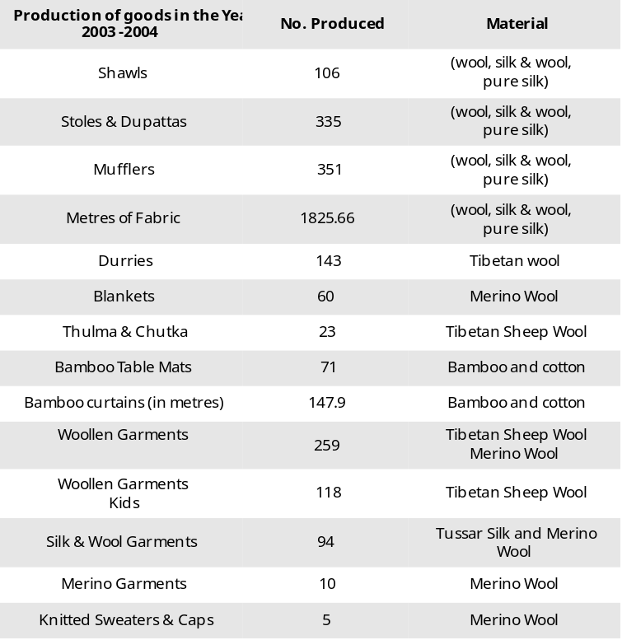
For example, in Digoli village, members of four women Self Help Groups (SHG) that have been formed by Avani, campaigned for their woman candidate who happened to be a member of the SHG. She stood for the village pradhan and was competing against the wife of the earlier, very influential pradhan. She won because of the campaigning of the women members.
Two womens’ groups of Mehrodi and Thanga earned Rs 3,000 each from the sale of 30 solar systems. Two more women’s groups at Sukna and Digoli have been given a revolving fund of Rs 10,000 each for sale and purchase of solar systems. They will be provided with 15 solar systems each, that will be for sale in surrounding villages.
The total collection of these groups including the UREDA grant and income from sale is Rs 97,649.

4.2 Girl Child Education

Avani continues to support five girl children from Mehrodi, Simgarhi and Saukyura in their education. These girls belong to very poor families and usually would be taken out of school after 5th class. This support ensures their eduction upto the 10th std at least.

Avani , through individual donations, bears the yearly expense on books, school dresses and tuition fees of these students. The expenditure on the education of these five students this year is Rs 3,943.

For the first time we have had a commitment from an individual donor to support six girls every year.

The details of the 15 women’s groups are given below:
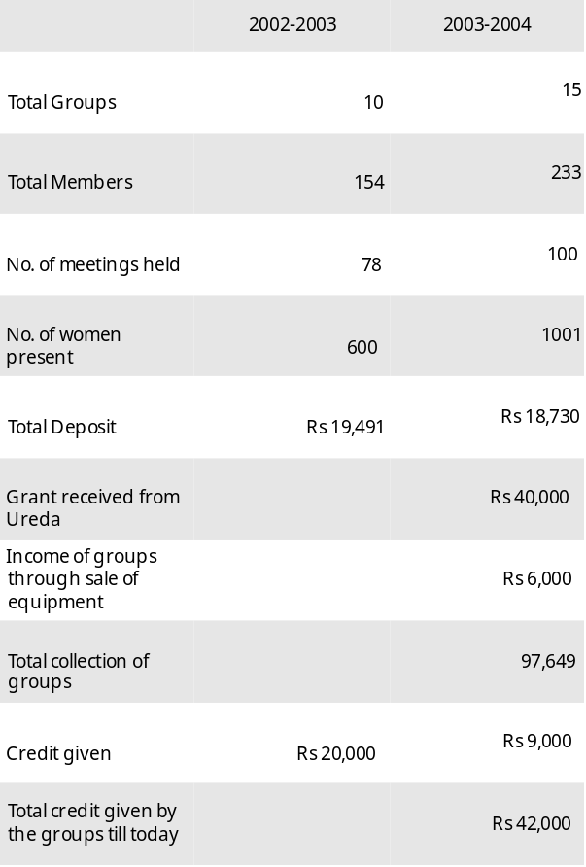
5. Rainwater Harvesting
Water scarcity is a major problem in the hills. The perennial water springs are a major victim of deforestation, and any technology to harvest the water from these springs fails to provide water during spring and summer months.

Rainwater harvesting is a technology that allows harvesting and consumption of water to happen within the household.

This is in keeping with our axiom of conservation.
If the emphasis can shift from distribution to conservation in solving the problems, rainwater harvesting provides a very effective technical solution to this problem.

Rainwater harvesting systems are proving to be a very simple solution to the water problem as it catches the water where it falls.

A rainwater harvesting system was built a few years ago at our centre at Tripuradevi. This system can collect 270,000 liters of roof run of rainwater which is lifted to overhead tanks with a solar water pump. This water is then filtered through a slow sand filter for drinking purposes.

This water harvesting system is partially meeting our drinking water requirements as well as for washing and dyeing of wool and silk yarn. This has generated a lot of interest among the local communities in rainwater harvesting as an option for meeting water requirements in the area.

During year 2003, the UN International Year of Fresh Water, building of five rainwater harvesting systems in different schools was initiated under the aegis of Global Rainwater Harvesting Collective with financial support from Ministry of Water Resources, Government of India.

These rainwater-harvesting systems will be of 30,000 liters capacity each and will provide drinking water to about 200 school children. The construction of these tanks has been initiated with the participation of the village communities.

The work is nearing completion and this monsoon should see more demonstration of rainwater harvesting for the community.

Further work on disseminating this technology in the villages will be taken up in the coming years.

6. Organic Farming, Vermicomposting and Biodiversity

Conservation
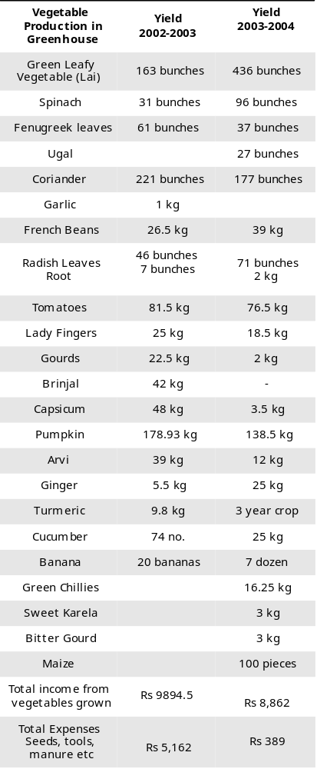

Our work on the demonstration farm at AVANI campus focuses on the collection, cultivation and propagation of indigenous seed varieties, and mixed farming. The use of chemicals for pesticides and fertilizers is completely prohibited.

The use and recycling of crop residue, organic manure by vermicomposting, and other improved composting methods, regeneration of soil through natural processes is an integral part of our work.

The protection of land from free grazing and wild fires along with plantation of new saplings has already resulted in establishment of some native flora on this land. Some of these are Oak, Rhododendron, Cedar, Cypress, Tun and some fodder trees.

The results would only be available in a few years as the land on which we have started the farm is impoverished for decades and it would take a few years for the soil to regenerate itself.

Vegetable cultivation is also one of the important aspects of wholesome nutrition in the family. Due to paucity of water and very cold winters, this has not become popular in the ridge top habitations. As a demonstration, a green house has been built at Tripuradevi.

This green house provides vegetables for our community kitchen. The vegetable beds in this green house are manured with vermicompost which is also prepared at the AVANI centre.

The yield of vegetables is shown in the table.

7. Summarised Financial Report

Presented below is the summarised financial report for Avani for the year 2003-2004.

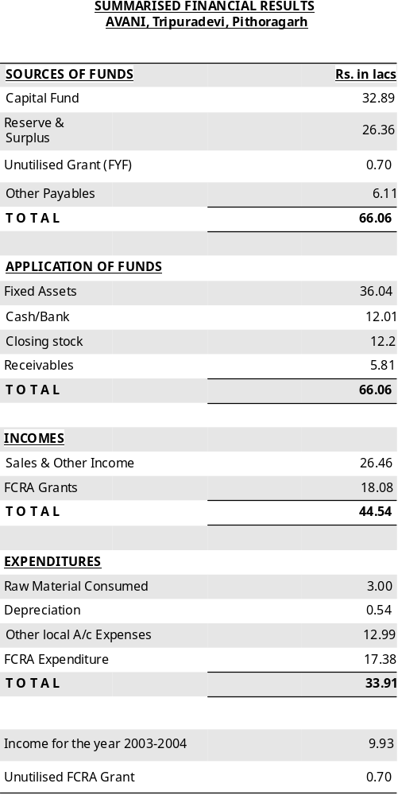

8. Our Funders

The organisations that have supported Avani in its work during the past year are:

Find Your Feet, London

Uttaranchal Renewable Energy Development Agency (UREDA), Dehradun

Department of Rural Development and Social Welfare, Government of Uttaranchal.

Ministry of Water Resources, New Delhi.

We would like to thank all the organisations, volunteers, well wishers and friends who have helped Avani in its work and have provided the moral support for us to continue our work.

