Structured Gold Forward
with Knock-Out Barriers

Product Development Memorandum

Derivatives Structuring Desk

February 2026

Prepared By: Ricky Sun / ULTIPA

CONFIDENTIAL

TO: Product Committee, Alphabank S.A.
FROM: Derivatives Structuring Desk
DATE: February 2026
RE: Pricing and Risk Analysis — Zeus Gold Group AG Hedging Facility

MARKET UPDATE — February 26, 2026
This memorandum has been updated with market data as of February 26, 2026. Gold has moved to $5,203/oz (from $4,900 on Feb 1), EUR/USD to 1.181, and realized gold volatility has risen to 41%. The position reversal is now firmly established with Z Group PV at EUR +64M.

Executive Summary
This memorandum presents our analysis of a proposed structured hedging facility for Zeus Gold Group AG (“Z Group”). The product combines exposure to LBMA gold prices with automatic termination features linked to EUR/USD exchange rate movements.
We have developed a comprehensive pricing framework validated through multiple methodologies. Our analysis identifies several structural considerations that warrant discussion before proceeding to term sheet finalization.
Transaction Summary
Parameter | Specification
Notional Principal | EUR 500,000,000
Reference Asset | LBMA Gold PM Fixing (USD/oz)
Strike Price | USD 4,600 per troy ounce
Tenor | 2 years (March 2026 — February 2028)
Knock-Out Barriers | EUR/USD < 1.05 or EUR/USD > 1.25
Settlement | Cash settled in EUR at prevailing EUR/USD rate

Key Findings
Metric | Result
Z Group Present Value | EUR +64 million
Alphabank Present Value | EUR −64 million
Knock-Out Probability | 64%
Expected Contract Duration | 12 months
Forward Moneyness | 113.1%

The positive present value for Z Group reflects gold’s surge above the strike price, placing the forward at 113% moneyness. The 64% knock-out probability is driven primarily by the upper barrier’s proximity to current EUR/USD spot (5.8% distance), representing a fundamental reversal from earlier market conditions where the lower barrier dominated.

1 Transaction Overview
Zeus Gold Group, a Frankfurt-headquartered jewelry manufacturer, seeks to hedge its USD-denominated gold procurement costs while managing EUR/USD translation risk. The proposed facility would run for two years commencing March 2026.

1.1 Settlement Mechanics
At settlement time τ (maturity or knock-out, whichever occurs first), with LBMA gold fixing at price P:
Z Group Payoff = N × (Pτ − K) / K
Alphabank Payoff = N × (K − Pτ) / K
where:
• N = 500,000,000 EUR (notional principal)
• K = 4,600 USD/oz (strike price)
• Pτ = LBMA Gold PM fixing at settlement

1.2 Knock-Out Mechanism
The contract terminates immediately upon the first occurrence of:
Xₜ < L or Xₜ > U
where Xₜ denotes the EUR/USD rate, L = 1.05 (lower barrier), and U = 1.25 (upper barrier).
The stopping time is defined as:
τₖₒ = inf{t ≥ 0 : Xₜ ∉ (L, U)}
Settlement occurs at τ = min(T, τₖₒ) where T = 2 years.

2 Mathematical Framework

2.1 Stochastic Model
Both underlying assets follow geometric Brownian motion under the risk-neutral measure ℚ.
Gold Price Dynamics (USD):
dSₜ/Sₜ = (r_USD − q) dt + σ_S dWₜ⁽¹⁾
EUR/USD Exchange Rate:
dXₜ/Xₜ = (r_EUR − r_USD) dt + σ_X dWₜ⁽²⁾
Correlation Structure:
ᴼ[dWₜ⁽¹⁾ · dWₜ⁽²⁾] = ρ dt

2.2 Parameter Estimates
Parameter | Symbol | Value | Source
Gold spot | S₀ | USD 5,203/oz | yfinance live (GC=F, Feb 2026)
EUR/USD spot | X₀ | 1.181 | yfinance live (EURUSD=X, Feb 2026)
USD risk-free rate | r_USD | 3.6% | 13-week T-bill (^IRX)
EUR risk-free rate | r_EUR | 2.0% | ECB deposit rate (configured)
Gold volatility | σ_S | 41% | EWMA (λ=0.94, GC=F)
EUR/USD volatility | σ_X | 6.2% | EWMA (λ=0.94, EURUSD=X)
Correlation | ρ | −0.30 | 126-day rolling (fallback)
Gold convenience yield | q | 3.6% | Futures term structure (GC=F vs GCJ26.CMX)

2.3 Risk-Neutral Valuation
The present value under the EUR risk-neutral measure:
V₀ = ᴼᵠ[e^(−r_EUR · τ) · Payoffτ]
The path-dependent barrier feature precludes closed-form solutions, necessitating Monte Carlo methods.

3 Numerical Implementation

3.1 Simulation Methodology
We employ Monte Carlo simulation with the following specifications:
Parameter | Value | Rationale
Simulation paths | 100,000 | Adequate precision for indicative pricing
Time steps | 504 | Daily monitoring over 2 years
Random seed | Fixed | Reproducibility
Variance reduction | Antithetic + Control | ~60% error reduction

Discretization Scheme
Asset prices are simulated using the exact log-normal solution:
Sₜ₊Δₜ = Sₜ · exp[(μ_S − σ_S²/2)Δt + σ_S√Δt · Z₁]
Xₜ₊Δₜ = Xₜ · exp[(μ_X − σ_X²/2)Δt + σ_X√Δt · Z₂]
where Z₁, Z₂ are correlated standard normals generated via Cholesky decomposition:
Z₂ = ρ Z₁ + √(1−ρ²) Z⊥

3.2 Variance Reduction
Two techniques are implemented to improve computational efficiency:
Antithetic Variates: For each path with innovations {Zₜ}, we also simulate the reflected path {−Zₜ}. The negative correlation between paired paths reduces variance.
Control Variate: The vanilla gold forward (without barriers) serves as a control:
V̂_adj = V̂_exotic + β(V_vanilla^analytical − V̂_vanilla)
where β is the optimal control coefficient estimated from sample covariance.
Combined, these techniques reduce standard errors by approximately 60%.

4 Pricing Results

4.1 Base Case Valuation
Metric | Value
Z Group Present Value | EUR +63,968,230
Alphabank Present Value | EUR −63,968,230
Standard Error | EUR 896,173
95% Confidence Interval | [+62.2M, +65.7M]

4.2 Barrier Analysis
Metric | Value
Overall Knock-Out Rate | 64.2%
Lower Barrier Breaches | 27.3%
Upper Barrier Breaches | 36.9%
Average Time to Knock-Out | 0.98 years (11.8 months)

The barrier breach profile has shifted dramatically compared to earlier market conditions. The upper barrier now accounts for the majority of knock-outs (37% vs 27% lower), reflecting the EUR/USD spot at 1.181—only 5.8% from the upper barrier versus 11.1% from the lower. The interest rate differential (r_EUR − r_USD = −1.6%) still implies euro depreciation drift, but the proximity asymmetry dominates.
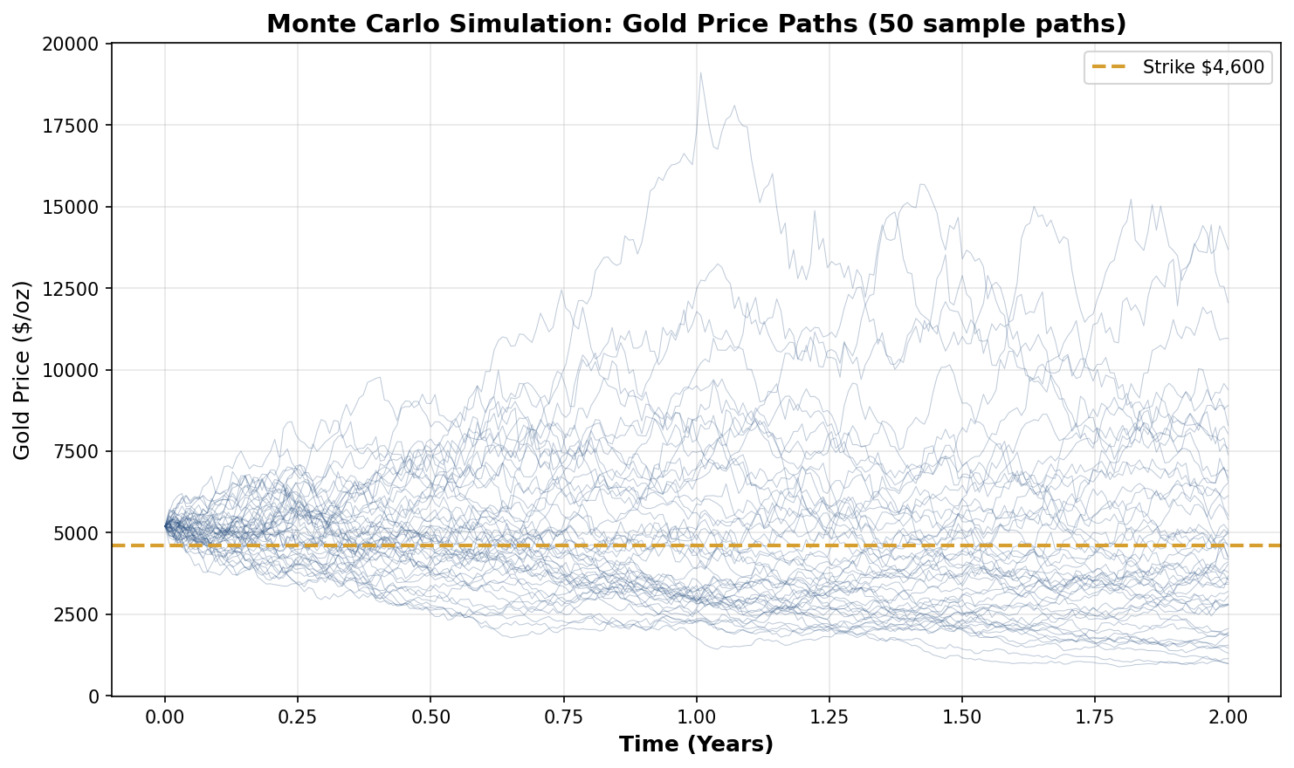
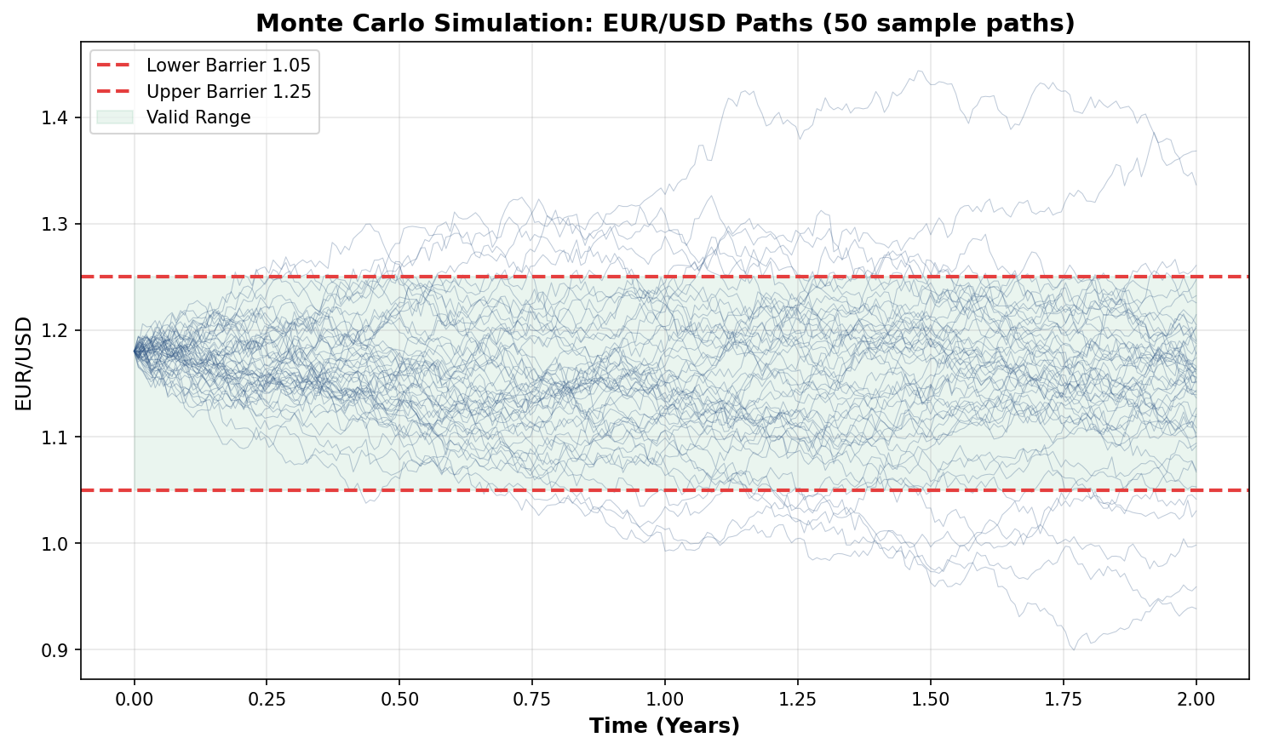

4.3 Convergence Verification
Monte Carlo estimates stabilize as path counts increase:
Paths | Price Estimate | Standard Error
5,000 | EUR +61.5M | EUR 3,844K
10,000 | EUR +61.6M | EUR 2,698K
25,000 | EUR +62.7M | EUR 1,768K
50,000 | EUR +63.1M | EUR 1,241K
100,000 | EUR +64.0M | EUR 896K

Standard errors decay proportionally to 1/√n, confirming proper convergence behavior.
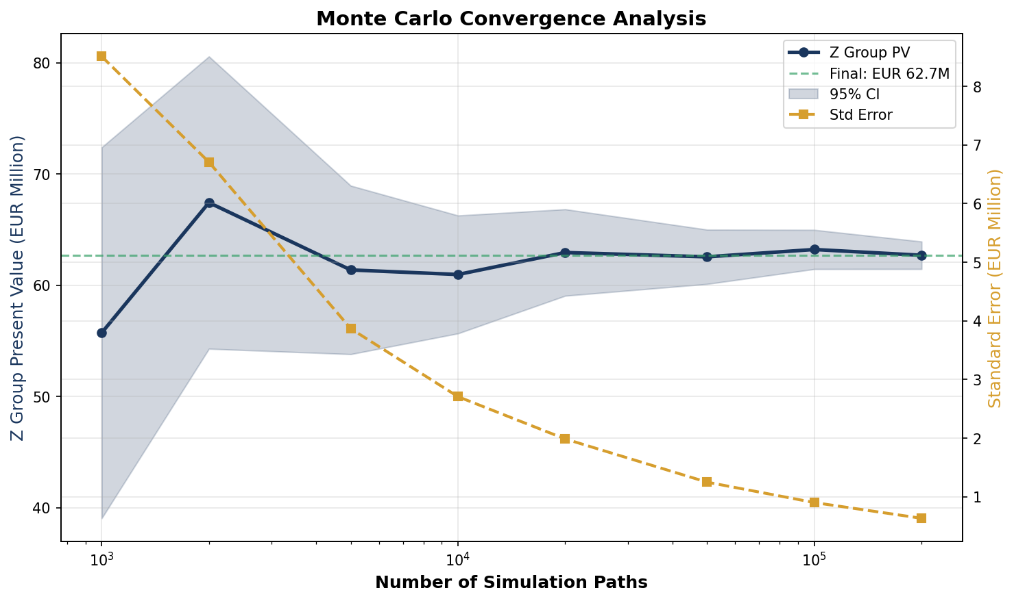

5 Critical Assessment

5.1 Strike Price Analysis
The specified strike of USD 4,600/oz warrants careful examination.
Forward Price Calculation:
F₀,T = S₀ · e^((r_USD − q) · T) = 5,203 · e^((0.036−0.036)·2) ≈ USD 5,203/oz
With convenience yield approximately equal to the USD risk-free rate, the forward is near spot. The strike sits 12% below the forward, placing Z Group in the money:
Moneyness = F₀,T / K = 5,203 / 4,600 = 113.1%
Alternative Strike Analysis:
Strike | Forward Relationship | Z Group PV
USD 4,000 | 23% below forward | EUR +146M
USD 4,300 | 17% below forward | EUR +101M
USD 4,600 | 12% below forward | EUR +63M
USD 4,900 | 6% below forward | EUR +29M
USD 5,200 | At-the-money | EUR ~0M
USD 5,500 | 6% above forward | EUR −27M
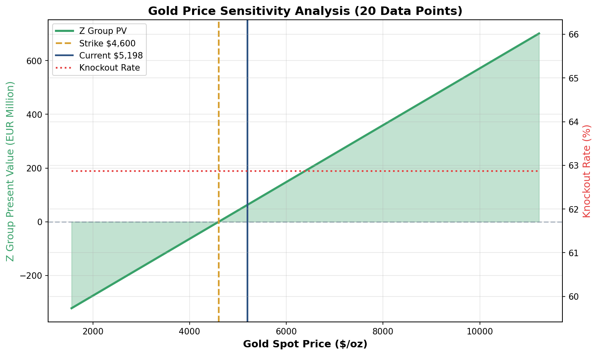

5.2 Barrier Configuration
With EUR/USD at 1.181, the upper barrier at 1.25 is now the proximate risk:
Distance to Upper Barrier = (U − X₀) / X₀ = (1.25 − 1.181) / 1.181 = 5.8%
Distance to Lower Barrier = (X₀ − L) / X₀ = (1.181 − 1.05) / 1.181 = 11.1%
With 6.2% annual EUR/USD volatility, the asymmetric positioning creates an upper-barrier-dominated knock-out profile.
Alternative Configurations:
Corridor | Knock-Out Rate | Expected Duration
[1.05, 1.25] | 64% | 12 months
[1.00, 1.30] | 27% | 15 months
[0.95, 1.35] | 10% | 17 months
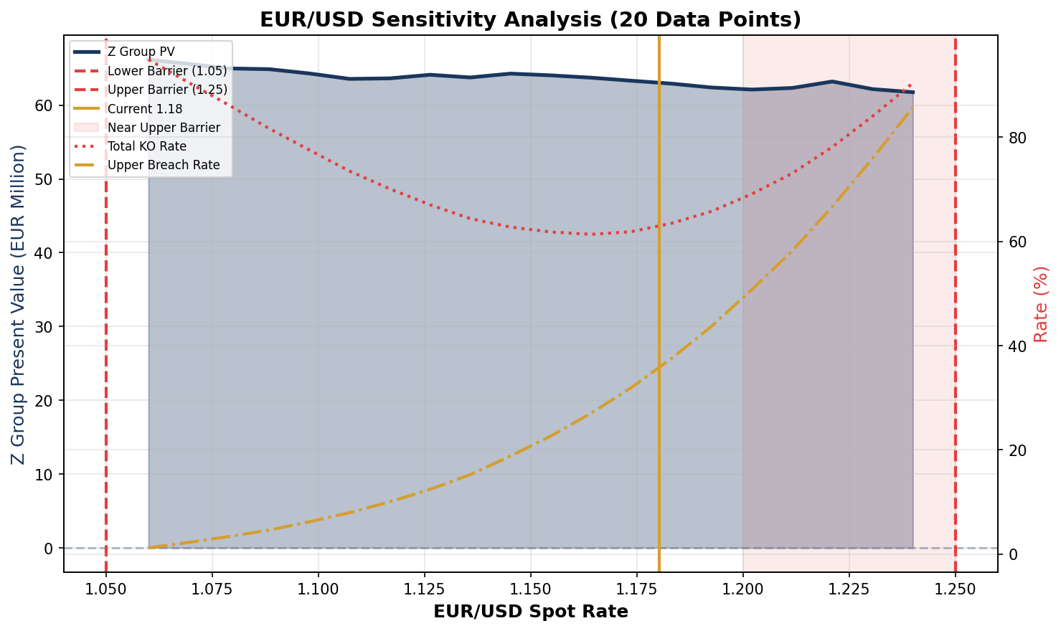
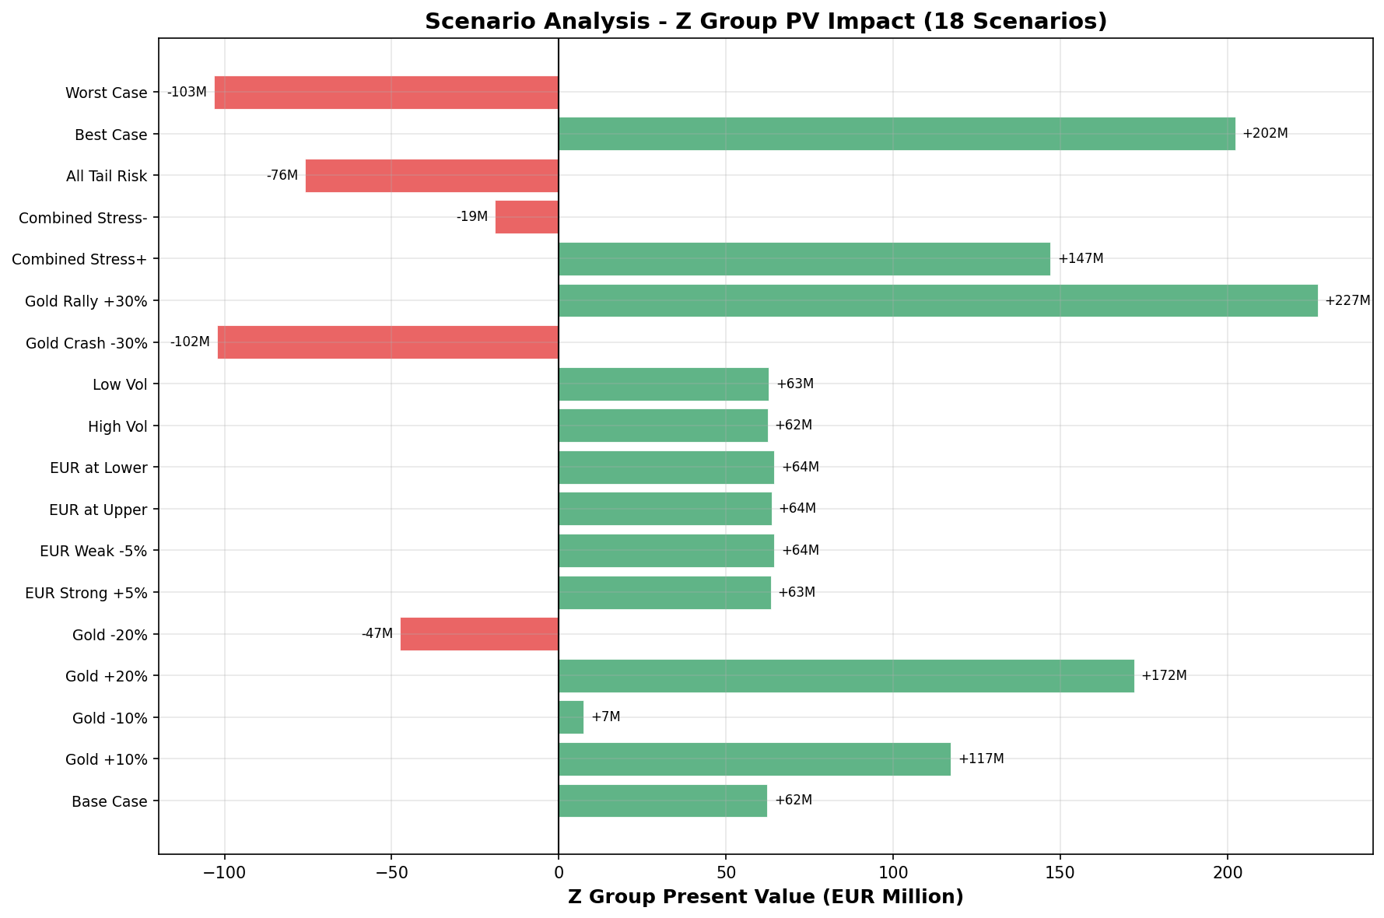

6 Risk Sensitivities

6.1 Greeks Summary
Greek | Value | Interpretation
Delta_gold | EUR 105,677 per USD 1 | First-order gold sensitivity
Gamma_gold | EUR −669 | Gold convexity
Delta_FX | EUR −8.18M per 0.01 FX | EUR/USD sensitivity (negative: upper barrier risk)
Vega_gold | EUR −2.88M per 1% vol | Gold vega (higher vol increases KO probability)
Rho_EUR | EUR −1,031M per 1bp | EUR rate sensitivity
Rho_corr | EUR −973K per 0.05 corr | Correlation sensitivity
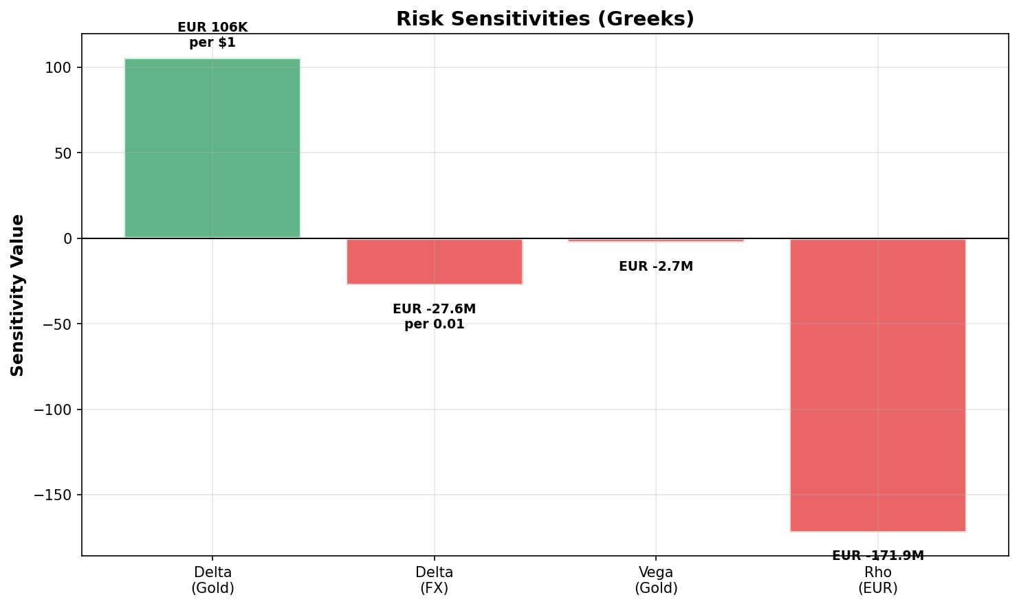

6.2 Hedging Implications
Delta Hedging: The gold delta of EUR 106K per dollar implies a hedge ratio of approximately:
Gold Hedge = (Δ_gold / S₀) × K = (105,677 / 5,203) × 4,600 ≈ 93,400 oz
Barrier Risk: With EUR/USD at 1.181, the upper barrier at 1.25 is only 5.8% away. As EUR/USD approaches either barrier, gamma and delta become increasingly unstable—the characteristic “pin risk” of barrier options. The negative FX delta (EUR −8.2M per 0.01) reflects that EUR appreciation toward 1.25 destroys contract value through knock-out.

7 Model Validation

7.1 Alternative Specifications
To ensure robustness, we compared valuations across three model specifications:
Model | Z Group PV | Knock-Out Rate
Base GBM | EUR +63.1M | 64.5%
Heston Stochastic Vol | EUR +64.1M | 64.1%
Merton Jump-Diffusion | EUR +65.7M | 64.1%

All models converge within 4%, with Heston and Merton producing slightly higher valuations due to stochastic volatility and jump dynamics amplifying the in-the-money payoff. Model specification risk remains secondary to market parameter uncertainty.

7.2 Analytical Benchmark
The vanilla gold forward (without barriers) provides a sanity check:
V_vanilla = e^(−r_EUR · T) · N · (F₀,T − K) / K = e^(−0.020 × 2) · 500M × (5,203 − 4,600) / 4,600
V_vanilla = EUR +63,004,791
The knock-out version (EUR +64.0M) is EUR 1.0M higher than the vanilla, reflecting that early termination locks in profits when gold is above strike—a reversal from the prior regime where knock-outs destroyed value.

8 Conclusions and Recommendations

8.1 Summary of Findings
The proposed structure is technically sound and priceable using standard Monte Carlo techniques. The February 2026 market environment has fundamentally altered the risk profile:
1. Position reversal: Gold’s surge to $5,203/oz places Z Group firmly in the money (113% moneyness), with a positive PV of EUR +64M. This contrasts sharply with earlier market conditions where the position was deeply out-of-the-money.
2. Barrier risk shift: The upper EUR/USD barrier at 1.25 is now only 5.8% from spot, making it the primary knock-out driver (37% of paths). The 64% total knock-out rate and 12-month expected duration represent a more balanced risk profile than the prior 93%/5-month scenario.
3. Elevated volatility: Gold volatility at 41% (EWMA) is more than double historical norms, increasing both the potential upside for Z Group and the mark-to-market volatility for Alphabank’s hedging book.

8.2 Recommendations
We recommend proceeding to term sheet stage with the following considerations:
1. Alphabank should carefully assess credit exposure given the positive Z Group PV, ensuring adequate collateral arrangements
2. The upper barrier proximity (5.8%) warrants active monitoring—EUR appreciation events could trigger knock-out and crystallize Z Group’s gain
3. Consider whether alternative barrier configurations (e.g., [1.00, 1.30] with 27% KO rate) would provide Z Group with more durable hedging protection

8.3 Next Steps
Upon Committee approval, we will:
• Finalize term sheet documentation
• Establish hedging framework with Trading Desk
• Coordinate credit approval with Risk Management
• Schedule client presentation

[END OF MEMORANDUM]

Appendix A: Nomenclature
Symbol | Description
Sₜ | Gold spot price (USD/oz) at time t
Xₜ | EUR/USD exchange rate at time t
K | Strike price (USD 4,600/oz)
N | Notional principal (EUR 500M)
T | Maturity (2 years)
L, U | Lower (1.05) and upper (1.25) barriers
r_EUR, r_USD | Risk-free rates
σ_S, σ_X | Volatilities
ρ | Correlation coefficient
q | Gold convenience yield
τ | Settlement time
τ_KO | Knock-out time

Appendix B: Figure Index
1. Monte Carlo Simulation: Gold Price Paths — gold_paths.png
2. Monte Carlo Simulation: EUR/USD Paths with Barriers — eurusd_paths.png
3. Monte Carlo Convergence Analysis — convergence.png
4. Gold Price Sensitivity Analysis — gold_sensitivity.png
5. EUR/USD Sensitivity Analysis — fx_sensitivity.png
6. Scenario Analysis — Z Group PV Impact — scenario_analysis.png
7. Risk Sensitivities (Greeks) — greeks_chart.png
8. Volatility Surface (2D Grid) — volatility_surface.png
9. Correlation Sensitivity Analysis — correlation_sensitivity.png
10. Payoff Distribution — payoff_distribution.png
11. Knockout Time Distribution and Barrier Breach Analysis — knockout_analysis.png
12. Market Conditions Change (Jan → Feb 2026) — valuation_comparison.png
13. Gold Price Evolution — gold_history.png

Appendix C: Additional Charts
The following charts provide supplementary analysis supporting the main body of this memorandum.
Volatility Surface
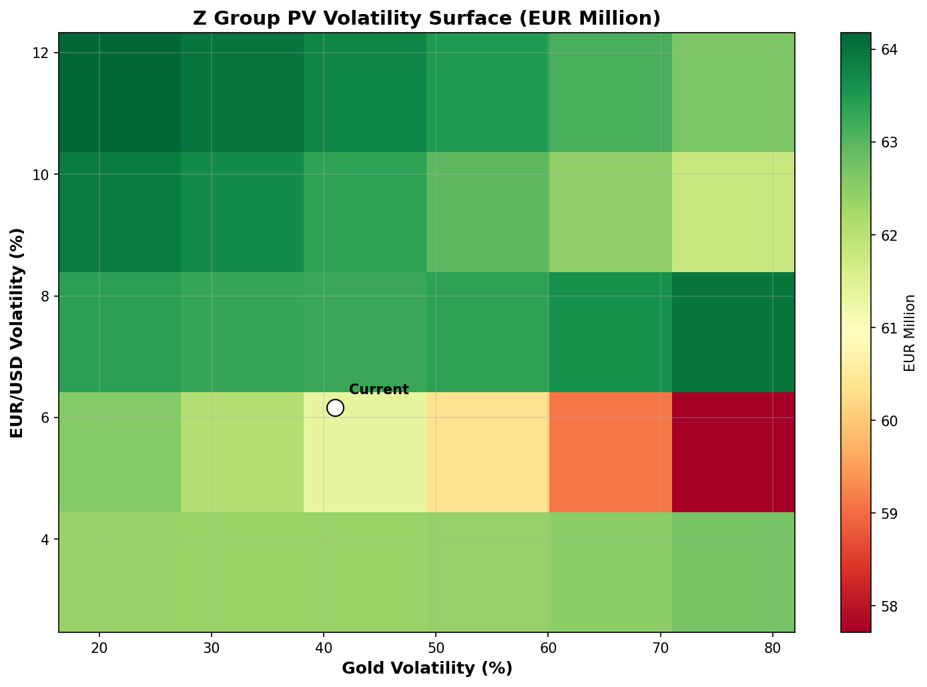

Correlation Sensitivity
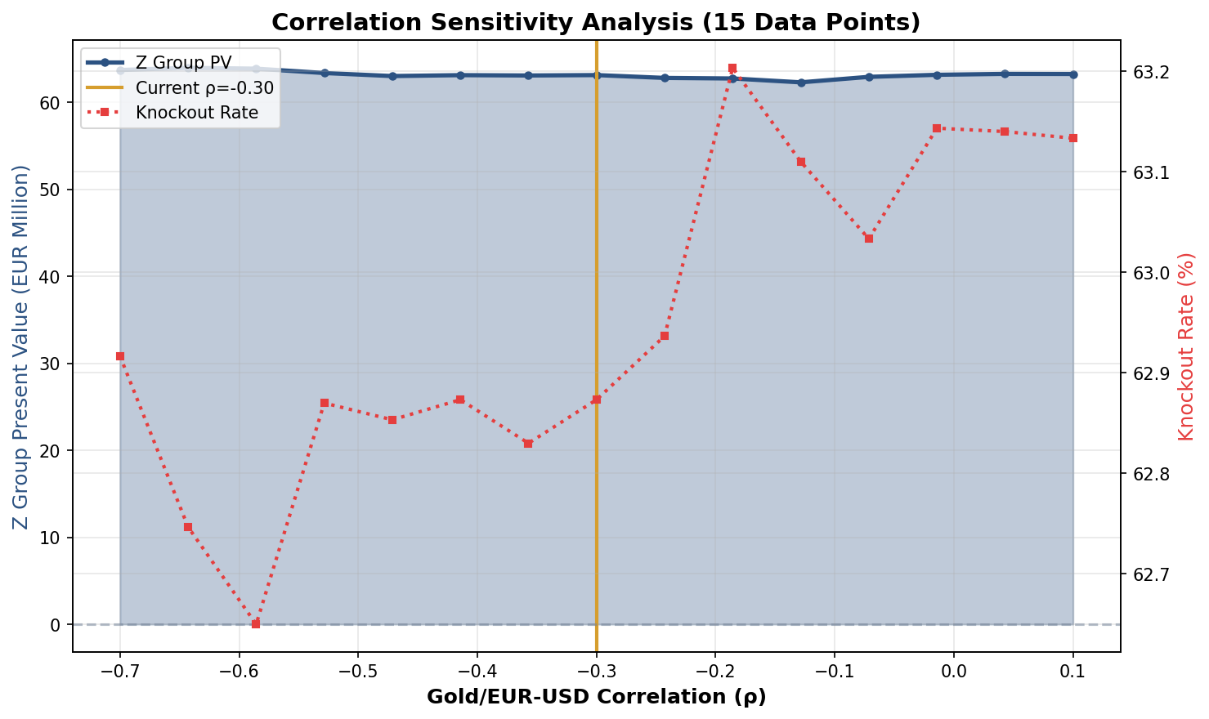

Payoff Distribution
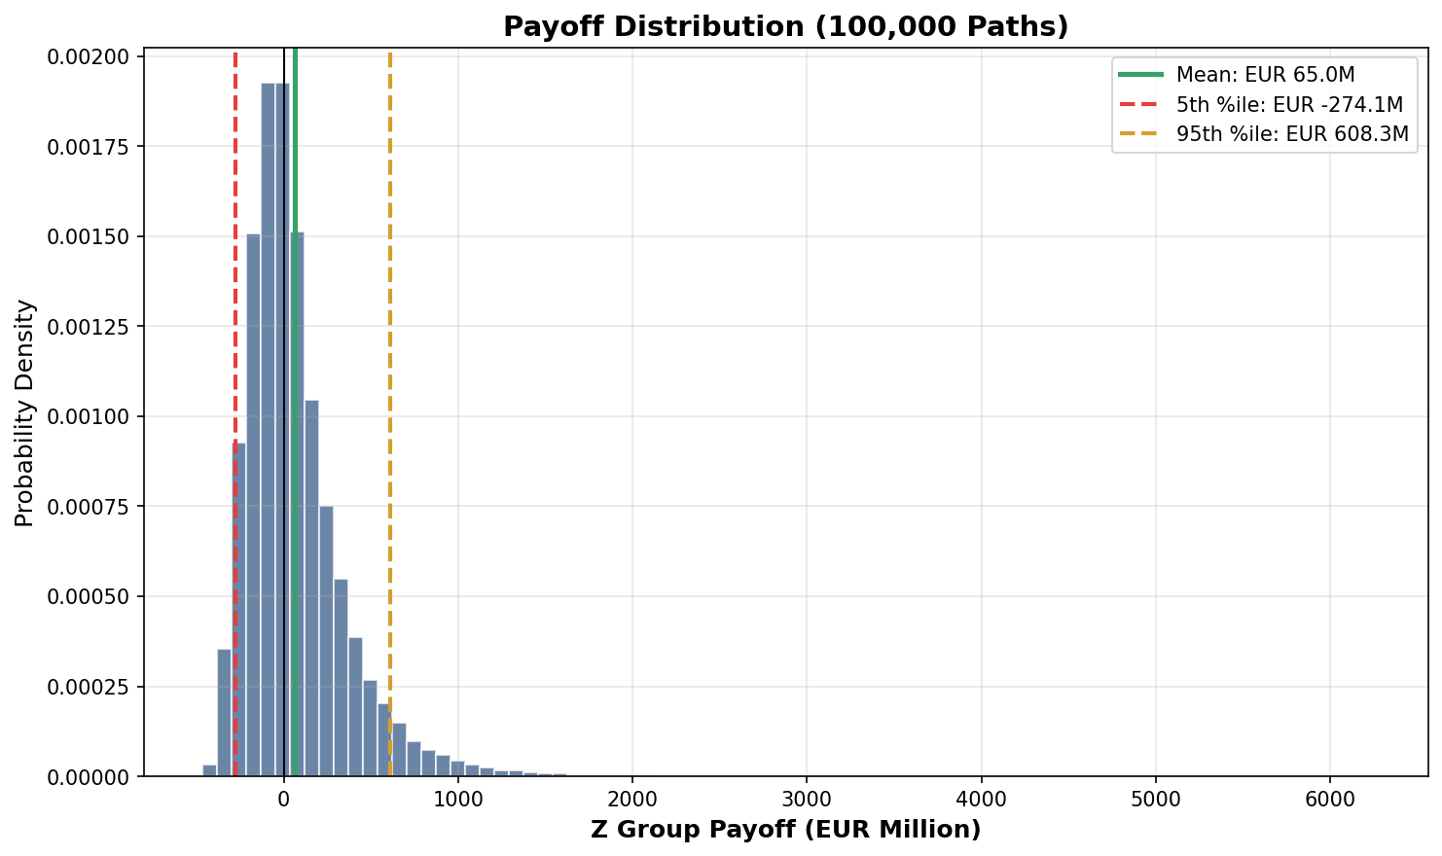

Knockout Analysis
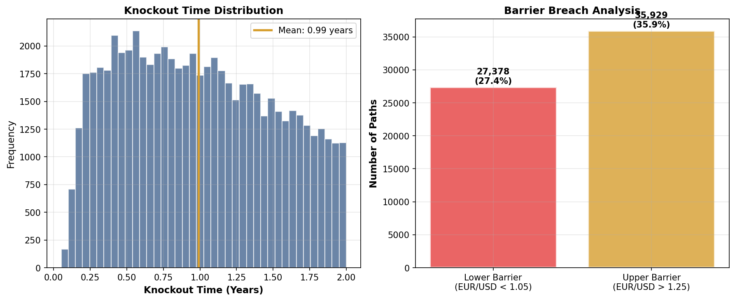

Valuation Comparison: Jan vs Feb 2026
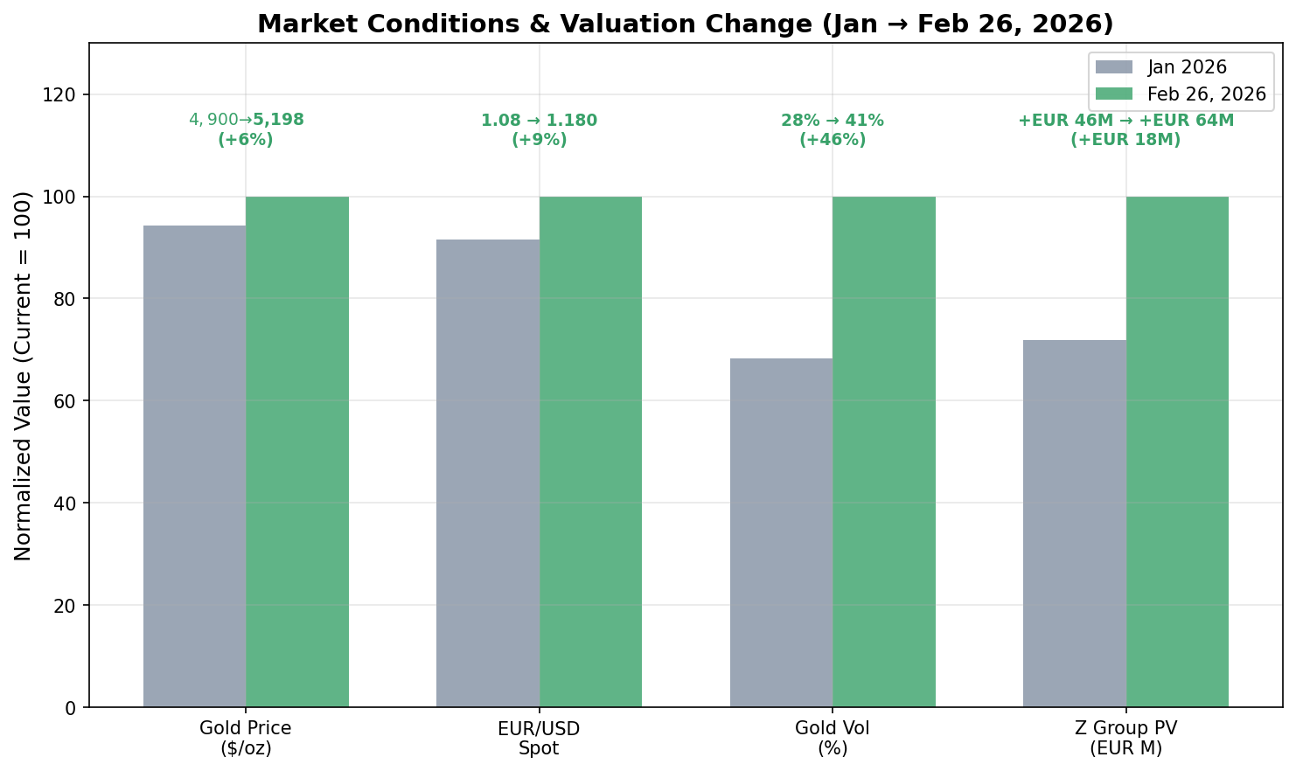

Gold Price History
