Structured Gold Forward with Knock-Out Barriers

  - Product Development Memorandum
Derivatives Structuring Desk
January 2026

Proposal Prepared By
Ricky Sun
ULTIPA

Table of Contents
1 Executive Summary 3
2 Transaction Overview 4
2.1 Settlement Mechanics 4
2.2 Knock-Out Mechanism 4
3 Mathematical Framework 4
3.1 Stochastic Model 4
3.2 Parameter Estimates 5
3.3 Risk-Neutral Valuation 5
4 Numerical Implementation 5
4.1 Simulation Methodology 5
4.2 Variance Reduction 6
5 Pricing Results 6
5.1 Base Case Valuation 6
5.2 Barrier Analysis 6
5.3 Convergence Verification 7
6 Critical Assessment 8
6.1 Strike Price Analysis 8
6.2 Barrier Configuration 9
7 Risk Sensitivities 10
7.1 Greeks Summary 10
7.2 Hedging Implications 10
8 Model Validation 11
8.1 Alternative Specifications 11
8.2 Analytical Benchmark 11
9 Conclusions and Recommendations 12
9.1 Summary of Findings 12
9.2 Recommendations 12
9.3 Next Steps 12
Appendix A: Nomenclature 13
Appendix B: Figure Index 14

CONFIDENTIAL
TO: Product Committee, Alphabank S.A.
FROM: Derivatives Structuring Desk
DATE: January 2026
RE: Pricing and Risk Analysis — Zeus Gold Group AG Hedging Facility

1 Executive Summary
This memorandum presents our analysis of a proposed structured hedging facility for Zeus Gold Group AG (“Z Group”). The product combines exposure to LBMA gold prices with automatic termination features linked to EUR/USD exchange rate movements.
We have developed a comprehensive pricing framework validated through multiple methodologies. Our analysis identifies several structural considerations that warrant discussion before proceeding to term sheet finalization.
Transaction Summary
Parameter | Specification
Notional Principal | EUR 500,000,000
Reference Asset | LBMA Gold PM Fixing (USD/oz)
Strike Price | USD 4,600 per troy ounce
Tenor | 2 years (March 2026 — February 2028)
Knock-Out Barriers | EUR/USD < 1.05 or EUR/USD > 1.25
Key Findings
Metric | Result
Z Group Present Value | EUR −192 million
Alphabank Present Value | EUR +192 million
Knock-Out Probability | 93%
Expected Contract Duration | 5 months
The negative present value for Z Group reflects the strike price being set 54% above the two-year gold forward. The high knock-out probability stems from the lower barrier’s proximity to current spot (2.8% distance) combined with negative EUR/USD drift from interest rate differentials.

2 Transaction Overview
Zeus Gold Group, a Frankfurt-headquartered jewelry manufacturer, seeks to hedge its USD-denominated gold procurement costs while managing EUR/USD translation risk. The proposed facility would run for two years commencing March 2026.

2.1 Settlement Mechanics
At settlement time $τ$ (maturity or knock-out, whichever occurs first), with LBMA gold fixing at price $P$:
$$\text{Z Group Payoff}=N×\frac{P_{τ}-K}{K}$$
$$\text{Alphabank Payoff}=N×\frac{K-P_{τ}}{K}$$
where:
- $N=500,000,000$ EUR (notional principal)
- $K=4,600$ USD/oz (strike price)
- $P_{τ}$ = LBMA Gold PM fixing at settlement

2.2 Knock-Out Mechanism
The contract terminates immediately upon the first occurrence of:
$$X_{t}<L \text{or} X_{t}>U$$
where $X_{t}$ denotes the EUR/USD rate, $L=1.05$ (lower barrier), and $U=1.25$ (upper barrier).
The stopping time is defined as:
$$τ_{KO}=inf\{t≥0:X_{t}∉(L,U)\}$$
Settlement occurs at $τ=min(T,τ_{KO})$ where $T=2$ years.

3 Mathematical Framework

3.1 Stochastic Model
Both underlying assets follow geometric Brownian motion under the risk-neutral measure $Q$.
Gold Price Dynamics (USD):
$$\frac{dS_{t}}{S_{t}}=(r_{USD}-q) dt+σ_{S} dW_{t}^{(1)}$$
EUR/USD Exchange Rate:
$$\frac{dX_{t}}{X_{t}}=(r_{EUR}-r_{USD}) dt+σ_{X} dW_{t}^{(2)}$$
Correlation Structure:
$$E[dW_{t}^{(1)}⋅dW_{t}^{(2)}]=ρ dt$$

3.2 Parameter Estimates
Parameter | Symbol | Value | Source
Gold spot | $$S_{0}$$ | USD 2,750/oz | LBMA Jan 2026
EUR/USD spot | $$X_{0}$$ | 1.08 | ECB reference
USD risk-free rate | $$r_{USD}$$ | 4.5% | OIS curve
EUR risk-free rate | $$r_{EUR}$$ | 2.5% | OIS curve
Gold volatility | $$σ_{S}$$ | 18% | 1Y ATM implied
EUR/USD volatility | $$σ_{X}$$ | 8% | 1Y ATM implied
Correlation | $$ρ$$ | −0.25 | 1Y historical
Gold convenience yield | $$q$$ | 0.5% | GOFO proxy

3.3 Risk-Neutral Valuation
The present value under the EUR risk-neutral measure:
$$V_{0}=E^{Q}\left[e^{-r_{EUR}⋅τ}⋅{\text{Payoff}}_{τ}\right]$$
The path-dependent barrier feature precludes closed-form solutions, necessitating Monte Carlo methods.

4 Numerical Implementation

4.1 Simulation Methodology
We employ Monte Carlo simulation with the following specifications:
Parameter | Value | Rationale
Simulation paths | 100,000 | Adequate precision for indicative pricing
Time steps | 504 | Daily monitoring over 2 years
Random seed | Fixed | Reproducibility
Discretization Scheme
Asset prices are simulated using the exact log-normal solution:
$$S_{t+Δt}=S_{t}⋅exp\left[\left(μ_{S}-\frac{σ_{S}^{2}}{2}\right)Δt+σ_{S}\sqrt{Δt} Z_{1}\right]$$
$$X_{t+Δt}=X_{t}⋅exp\left[\left(μ_{X}-\frac{σ_{X}^{2}}{2}\right)Δt+σ_{X}\sqrt{Δt} Z_{2}\right]$$
where $Z_{1},Z_{2}$ are correlated standard normals generated via Cholesky decomposition:
$$Z_{2}=ρZ_{1}+\sqrt{1-ρ^{2}} Z_{⟂}$$

4.2 Variance Reduction
Two techniques are implemented to improve computational efficiency:
Antithetic Variates: For each path with innovations $\{Z_{t}\}$, we also simulate the reflected path $\{-Z_{t}\}$. The negative correlation between paired paths reduces variance.
Control Variate: The vanilla gold forward (without barriers) serves as a control:
$${\hat{V}}_{adj}={\hat{V}}_{exotic}+β\left(V_{vanilla}^{analytical}-{\hat{V}}_{vanilla}\right)$$
where $β$ is the optimal control coefficient estimated from sample covariance.
Combined, these techniques reduce standard errors by approximately 60%.

5 Pricing Results

5.1 Base Case Valuation
Metric | Value
Z Group Present Value | EUR −191,900,647
Alphabank Present Value | EUR +191,900,647
Standard Error | EUR 123,877
95% Confidence Interval | [−192.1M, −191.7M]

5.2 Barrier Analysis
Metric | Value
Overall Knock-Out Rate | 92.99%
Lower Barrier Breaches | 86.02%
Upper Barrier Breaches | 6.97%
Average Time to Knock-Out | 0.43 years (5.2 months)
The asymmetry between barrier breaches reflects the negative EUR/USD drift implied by interest rate parity. With $r_{EUR}-r_{USD}=-2\%$ annually, the euro faces persistent depreciation pressure, making the lower barrier far more likely to be reached.
Figure 1: Monte Carlo Simulation Paths — Gold and EUR/USD price evolution with knock-out barrier visualization
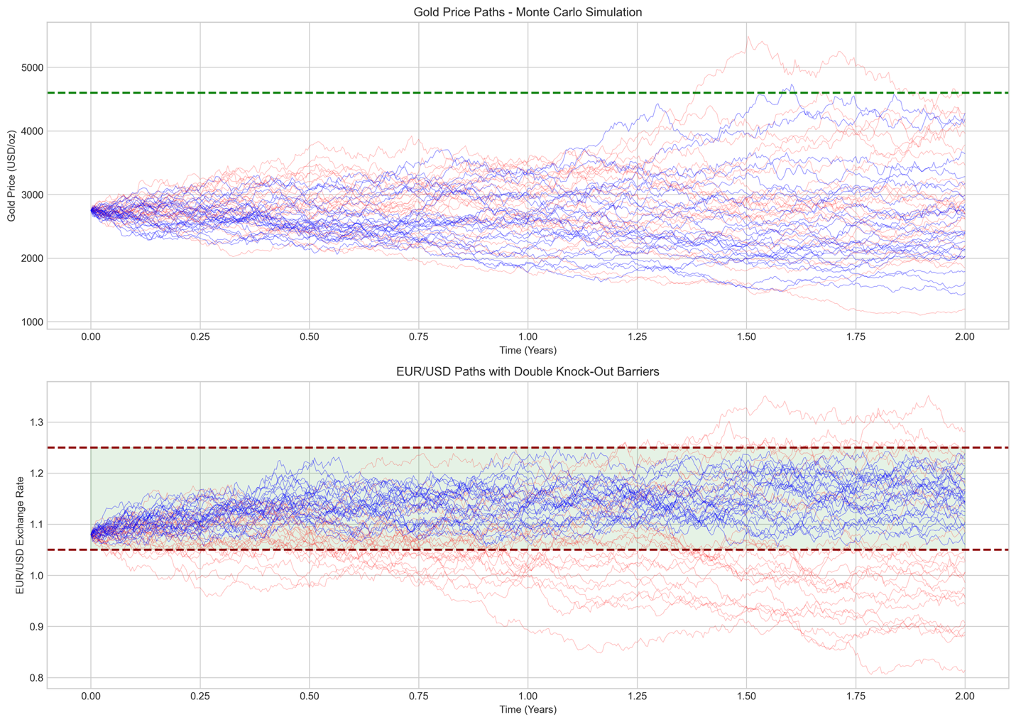

5.3 Convergence Verification
Monte Carlo estimates stabilize as path counts increase:
Paths | Price Estimate | Standard Error
5,000 | EUR −191.4M | EUR 551K
10,000 | EUR −191.7M | EUR 381K
25,000 | EUR −191.8M | EUR 247K
50,000 | EUR −192.1M | EUR 174K
100,000 | EUR −191.9M | EUR 124K
Standard errors decay proportionally to $1/\sqrt{n}$, confirming proper convergence behavior.
Figure 2: Convergence Analysis — Monte Carlo price stability across increasing path counts
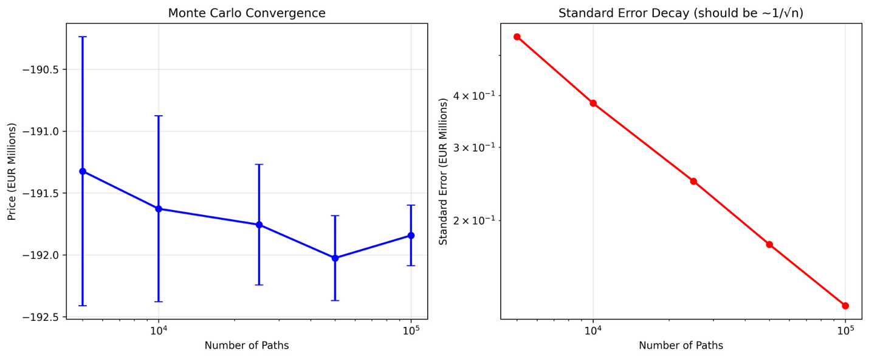

6 Critical Assessment

6.1 Strike Price Analysis
The specified strike of USD 4,600/oz warrants careful examination.
Forward Price Calculation:
$$F_{0,T}=S_{0}⋅e^{(r_{USD}-q)⋅T}=2750⋅e^{(0.045-0.005)⋅2}≈\text{USD }2,979\text{/oz}$$
The strike exceeds the forward by 54%, placing Z Group in a deeply out-of-the-money position:
$$\text{Moneyness}=\frac{F_{0,T}}{K}=\frac{2979}{4600}=64.8\%$$
Alternative Strike Analysis:
Strike | Forward Relationship | Z Group PV
USD 2,800 | 6% below forward | EUR +2M
USD 3,000 | At-the-money | EUR −31M
USD 3,500 | 17% above forward | EUR −97M
USD 4,600 | 54% above forward | EUR −192M
Figure 3: Strike Price Sensitivity — Z Group valuation across alternative strike levels
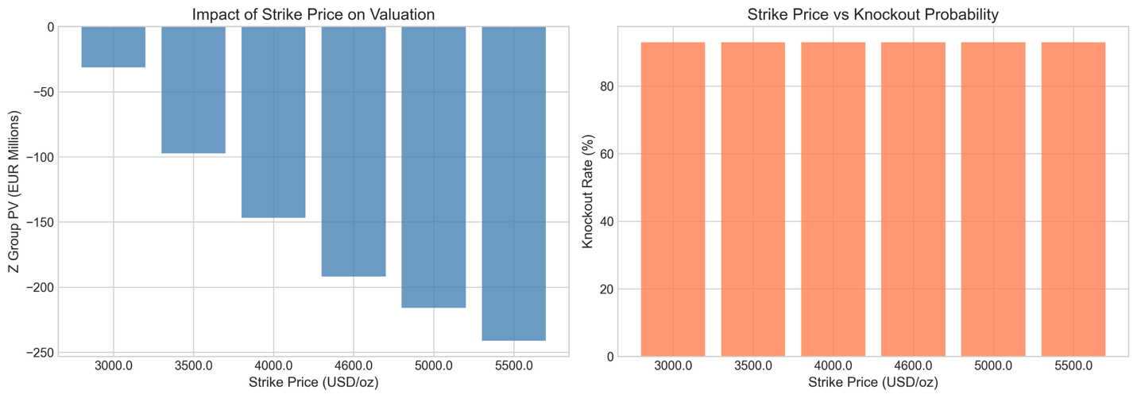

6.2 Barrier Configuration
The lower barrier at 1.05 sits only 2.8% below current spot:
$$\text{Distance to Lower Barrier}=\frac{X_{0}-L}{X_{0}}=\frac{1.08-1.05}{1.08}=2.78\%$$
Given 8% annual EUR/USD volatility and negative drift, barrier breach is near-certain over a two-year horizon.
Alternative Configurations:
Corridor | Knock-Out Rate | Expected Duration
[1.05, 1.25] | 93% | 5 months
[1.00, 1.30] | 66% | 10 months
[0.95, 1.35] | 39% | 14 months
Figure 4: Barrier Configuration Analysis — Knock-out probability for different corridor widths
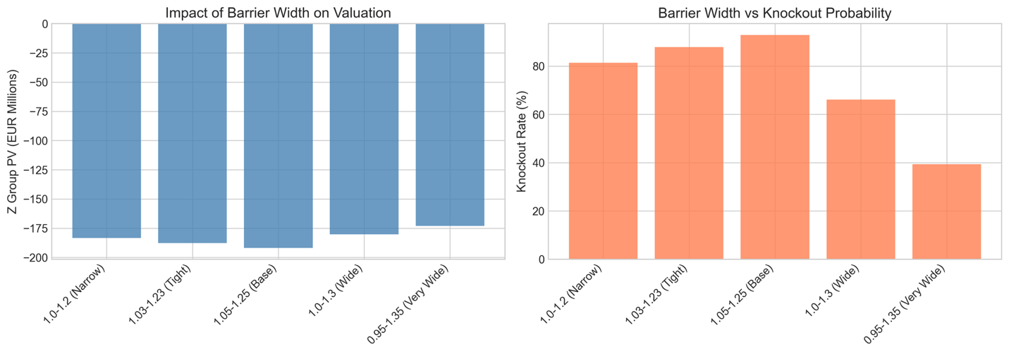

7 Risk Sensitivities

7.1 Greeks Summary
Greek | Value | Interpretation
$$Δ_{gold}$$ | EUR 109,545 per USD 1 | First-order gold sensitivity
$$Γ_{gold}$$ | EUR −491 | Gold convexity
$$Δ_{FX}$$ | EUR 2.26M per 0.01 FX | EUR/USD sensitivity
$$V_{gold}$$ | EUR −691K per 1% vol | Gold vega
$$ρ_{EUR}$$ | EUR −11.7M per 1bp | EUR rate sensitivity
Figure 5: Risk Sensitivities (Greeks) — Key hedging parameters on logarithmic scale
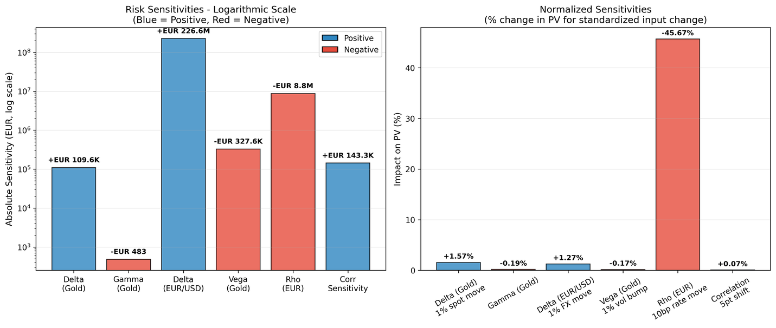

7.2 Hedging Implications
Delta Hedging: The gold delta of EUR 110K per dollar implies a hedge ratio of approximately:
$$\text{Gold Hedge}=\frac{Δ_{gold}}{S_{0}}×K=\frac{109,545}{2750}×4600≈183,000\text{ oz}$$
Barrier Risk: As EUR/USD approaches either barrier, gamma and delta become increasingly unstable—the characteristic “pin risk” of barrier options. Hedging costs will escalate significantly in the final days before a potential knock-out.

8 Model Validation

8.1 Alternative Specifications
To ensure robustness, we compared valuations across three model specifications:
Model | Z Group PV | Knock-Out Rate
Base GBM | EUR −192.1M | 92.9%
Heston Stochastic Vol | EUR −191.8M | 93.0%
Merton Jump-Diffusion | EUR −191.7M | 93.0%
All models converge within 0.2%, confirming that the barrier structure dominates pricing dynamics. Model specification risk is secondary.
Figure 6: Model Validation — Cross-comparison of GBM, Heston, and Merton specifications
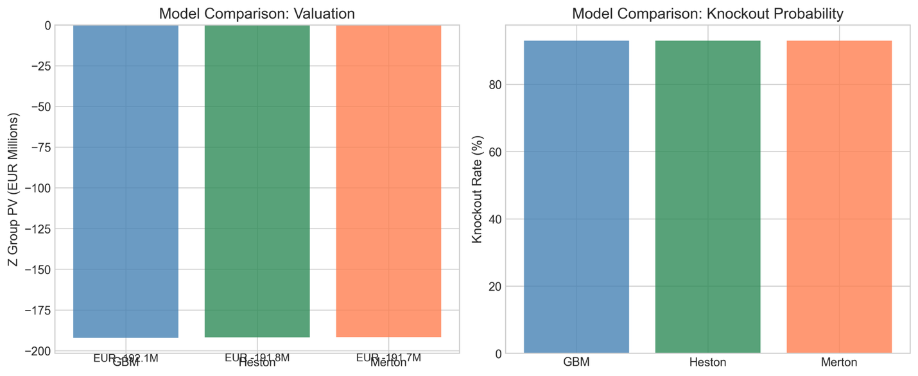

8.2 Analytical Benchmark
The vanilla gold forward (without barriers) provides a sanity check:
$$V_{vanilla}=e^{-r_{EUR}⋅T}⋅N⋅\frac{F_{0,T}-K}{K}=e^{-0.025×2}⋅500M⋅\frac{2979-4600}{4600}$$
$$V_{vanilla}=\text{EUR }-167,598,411$$
The knock-out version (EUR −192M) is EUR 24M worse than the vanilla, representing the expected cost of early termination when gold is below strike.

9 Conclusions and Recommendations

9.1 Summary of Findings
The proposed structure is technically sound and priceable using standard Monte Carlo techniques. However, two features merit discussion:
- Strike positioning: The USD 4,600 strike creates a deeply out-of-the-money position for Z Group. Clarification of the commercial rationale is recommended.
- Barrier proximity: The 93% knock-out probability results in an expected contract life of only 5 months—potentially misaligned with a 2-year hedging mandate.

9.2 Recommendations
We recommend proceeding to term sheet stage contingent upon:
- Confirmation from Relationship Management regarding Z Group’s acceptance of the strike level and its implications
- Discussion of whether alternative barrier configurations (e.g., [1.00, 1.30]) would better serve the client’s hedging objectives
- Documentation of appropriate risk disclosures regarding the high knock-out probability

9.3 Next Steps
Upon Committee approval, we will:
- Finalize term sheet documentation
- Establish hedging framework with Trading Desk
- Coordinate credit approval with Risk Management
- Schedule client presentation

Appendix A: Nomenclature
Symbol | Description
$$S_{t}$$ | Gold spot price (USD/oz) at time $t$
$$X_{t}$$ | EUR/USD exchange rate at time $t$
$$K$$ | Strike price (USD 4,600/oz)
$$N$$ | Notional principal (EUR 500M)
$$T$$ | Maturity (2 years)
$L$, $U$ | Lower (1.05) and upper (1.25) barriers
$r_{EUR}$, $r_{USD}$ | Risk-free rates
$σ_{S}$, $σ_{X}$ | Volatilities
$$ρ$$ | Correlation coefficient
$$q$$ | Gold convenience yield
$$τ$$ | Settlement time
$$τ_{KO}$$ | Knock-out time

Appendix B: Figure Index
- Figure 1: Monte Carlo Simulation Paths — monte_carlo_paths.png
- Figure 2: Convergence Analysis — convergence_analysis.png
- Figure 3: Strike Price Sensitivity — scenario_strike.png
- Figure 4: Barrier Configuration Analysis — scenario_barrier.png
- Figure 5: Risk Sensitivities (Greeks) — greeks_summary.png
- Figure 6: Model Validation — model_comparison.png
Figure 7: Comprehensive Sensitivity Analysis — sensitivity_analysis.png

Figure 8: Payoff Diagram — payoff_diagram.png
Figure 9: Payoff Distribution — payoff_distribution.png
