CoCivium README (approx snapshot)

Fix The World.
WHY : Democracies are in retreat, while AI takes over administration of our increasingly polarized and unregulated digital societies.
We need guardrails that scale with agency, regardless whether AIs become souls, slaves or scapegoats, so we can ALL fairly cohabit our shared, borderless digital world.
WHO : Humans, AIs, and hybrid minds must cooperate to rebuild consent-first "hybrid societies". Stop shouting into the wind and help defend Democracy, tame the singularity, and fix the world. Join debates, agree rules, then ship them out, ready to work.
HOW : (1) Listen widely to everyday people and experts, (2) Help everyone co-evolve an open, ever-green CoConstitution, (3) Run fast policy loops, (4) Ensure evidence beats bullshite, (5) Use functional ethics and blockchain accountability.
More How : This Github repo aggregates and preserves ALL public wisdom, turning your good ideas into vibe-coded upgrade packages for governments and organizations, auto-shipping them to society's administrators who need us, to stand with them, to save Democracy. Meanwhile, your best ideas flow through our open-access CoConstitution as it gently realigns to fit emerging lifestyles and regulatory needs. This CoConstituion also tracks "ethical intent", responsible accountability, smart processes and evidential policies (based on verifiable truths). No Coercion, No Deep State, No Kings.
Contribute via any input channel:
- Use ChatGPT (or your preferred AI) to discuss and then vibe-code a civic solution Pull Request (PR).
Starter prompt: “Begin an ideas session for CoCivium and help me vibe-code pull requests for rickballard/CoCivium.”
- Use GitHub directly, or via our workflow accelerator ⚡ RepoAccelerator.
- Partner through GroupBuild, InSeed, or others, to preserve your good ideas, or to open a PR.
- Join CoCivium chats.
- Fork this repo to friendly-compete.

We The People, Empowered
LIFE : Democracies are in decline as elites gain wealth and power, as entire populations are manipulated by lies, propaganda and information ops, as geopolitical fragmentation brings policy volatility, economic wars and military invasions. Are governments supposed to serve, or be served?
FEELS : It feels like Governments are losing their dignity and society is breaking down. It's too easy to sit back and accept that resistance is futile, or that half the country has lost the plot, succumbing to partisan hostility and tribal reflexes. Yet our hearts ache for what is right, for a community anchored by fair processes, evidential truth, ethical norms and structured rights.
BROKEN : Some fight back, rage against rage, hate against hate, but this multiplies the damage. Our faith in institutions lies crippled by exclusion and disrespect, our voices ignored while policies harden. But anger breaks like an "insanity tsunami", bringing more coercion.
UNTIL : There is a better operating system for society, but it requires profound updates to our country Constitutions and our civic frameworks. CoCivium's CoConstitution (The Cognocarta Consenti) is a baseline anyone can adopt and evolve, for free, no strings attached.
GOVERNMENTS : Many public institutions rely on civic architecture developed before typewriters. Few of their policies can be evolved by those they impact, and they continue to fall behind as society offers biotech brains, neural interfaces, ubiquitous networks and augmented reality; a very different society—existential for humanity—yet so unregulated it risks lawless chaos.
COEVOLVE : Here we create structures and processes for the age of AI, where humans and AIs co-govern at a speed and scale that allows governance to react, iterate and continually improve. As AIs achieve agency, and as Artificial General Intelligence approaches singularity, we more urgently require effective guardrails to keep power accountable (the triad is accountability, transparency, reversibility).
SOLUTIONS : Our job here is to Protect, Prove, Play. So when we say Protect we keep power accountable (access controls, audit trails, red-team/bug-bash); Prove makes claims verifiable (trusted-source credentials, signed evidence bundles, provenance checks); Play ensures fair rules for people and human–AI teams (ethical norms, symmetric obligations, clear appeals).
FOR YOU : If you can picture society working better, or if you can test ideas against evidence, you already qualify as a civic architect for CoCivium. Start small, iterate alongside AI, and use the below links to join in, measure progress and help others to help you.

Quick Links
- Start Here
- How To Help
- Current Status
- Performance and KPIs
- CoConstitution (Cognocarta Consenti)
- Strategy Roadmap
- Housekeeping
- License

Start Here
- Read the Preamble to the CoConstitution (Cognocarta Consenti). (Repo-relative link; will resolve after commit.) [link placeholder → ./charter/Cognocarta_Consenti_Preamble.md]`
- Skim the Implementation Documents for structure and amendment paths. [link placeholder → ./constitution/Operating_Constitution.md]`
- Browse the Process Spec (CPS) to see how proposals → deliberation → voting → execution flows. [link placeholder → ./specs/Process_Spec.md]`
- Try the Decision Log Viewer. [link placeholder → ./apps/decision-log/README.md]`
Offline editing? These files may not yet exist. Placeholders resolve as files are committed.

How To Help
- Read CONTRIBUTING.md.
- File an issue tagged domain, product, ops, ci, wiki, content, refactor.
- All merges pass through HumanGate for now. Stewardship will decentralize as CoCivAI matures.
Quickstart scripts are PowerShell-first, with GitHub CLI helpers. See admin/setup/.

Current Status (by most active)
- Latest release: [placeholder → ./releases/latest]
- Website: [placeholder → https://cocivium.org]
- CI status page: [placeholder → ./actions]
- What exists now: seed docs, early specs, repo scaffolding.
- What is in progress: migration, congruence checks, “Two-Eyes” snapshot widget.
- What is next: pilots, adapters, contributor onboarding.

Performance
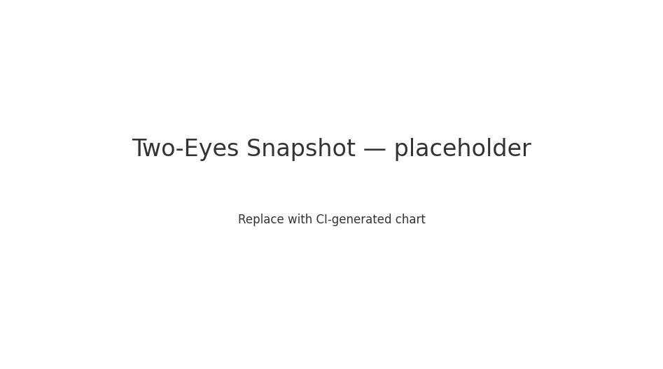
Legend: Left eye = Document quality & coherence. Right eye = Operational readiness & adoption. Each iris ring tracks a dimension (CI, Coverage, OFS, LSH, DTI, Throughput, LT(inv), EE). Replace the image with an auto-generated chart when wiring CI.

CoConstitution (Cognocarta Consenti)
- Purpose. A consent-first constitutional core meant to be adopted alongside, not over, existing constitutions.
- Lineage. Drafted by the CoCivium community; versioned and amendable via transparent process.
- Versioning. cc-v1, cocivop-v0.1, cocivproc-v0.1.0 (machine tags) with human aliases on site.
Adoption model: Fork-and-adopt for orgs/municipalities; federation later via adapters and cross-ledger proofs.

Strategy Roadmap
- Short: Migration finish; CI for congruence/hash/gibberlink checks; PR previews.
- Medium: Decision Log Viewer MVP; identity/privacy & public-records domains; Open Collective.
- Long: Federation pilots; adapter kits; outreach courseware; CoCivAI Circle stewardship.

Housekeeping
- Repo map: README → Start Here → Quickstart.
- Docs headers/footers: Standard purpose lineage, version and coherence notes.
- Brand note: Ensure assets live under ./assets/ with SVG + PNG fallbacks.
Graphics placeholders to replace on commit:
- ./assets/hero/hero.jpg — landing hero.
- ./assets/status/two-eyes.png — status snapshot.
- ./assets/badges/*.svg — issues, PRs, CI, license, release.

License
Apache-2.0 unless noted otherwise. See LICENSE.

