Bugs & Minor Fixer

Bug Report 01 — Ticket Download Page Not Working
Module: Ticket Download (Flask Route: /ticket)
Type: Functional / Runtime Error
Priority: 🔴 High
Status: Open
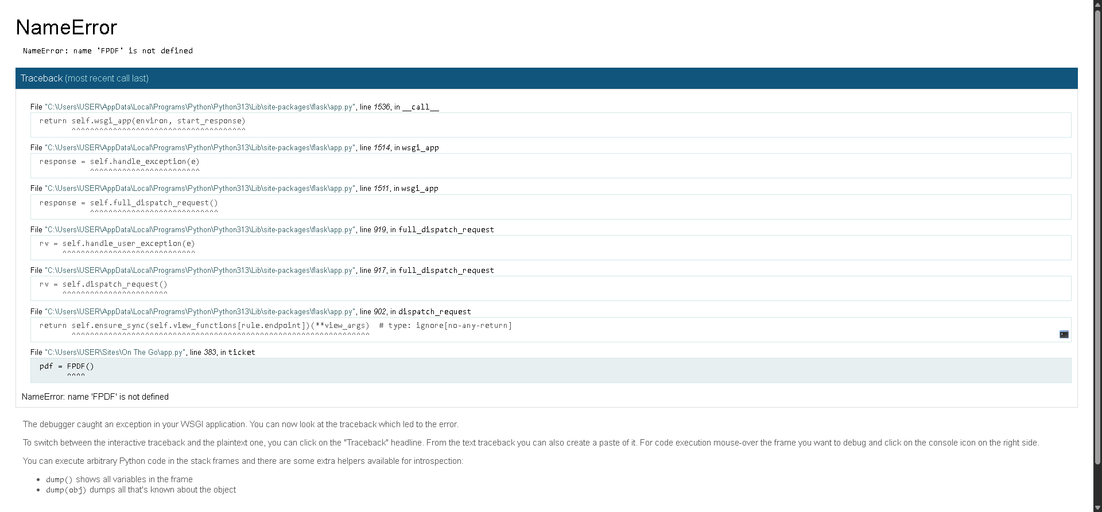
Description:
When attempting to generate and download the ticket (PDF file), the application throws a NameError and the download page does not appear.
Error Message:
NameError: name 'FPDF' is not defined

Steps to Reproduce:
- Log in to the site.
- Navigate to “My Bookings” or any section with a “Download Ticket” button.
- Click the “Download Ticket” link/button.
- Observe the Flask console and browser output.
- Expected Result:
- A PDF file (e.g., ticket.pdf) should be generated and downloaded automatically.
- Actual Result:
- The page fails to load and displays an internal server error (500). The console shows:
Root Cause Analysis:
- The FPDF class from the fpdf library was used in the route without importing it.
- Flask can’t find the FPDF symbol in the local scope.

Fix Recommendation:
- Add the import statement at the top of your Flask file (app.py):
- from fpdf import FPDF
- If not already installed, install it using:
- pip install fpdf

Bug Report 02 — Profile Picture Not Updating
Title: Profile picture upload fails to update the displayed image.
Severity: Medium
Priority: Medium

Before updating
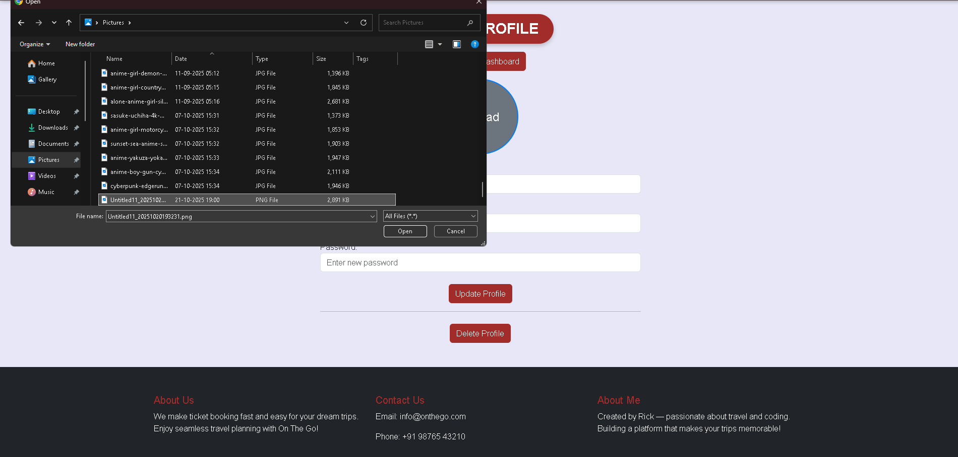

After updating
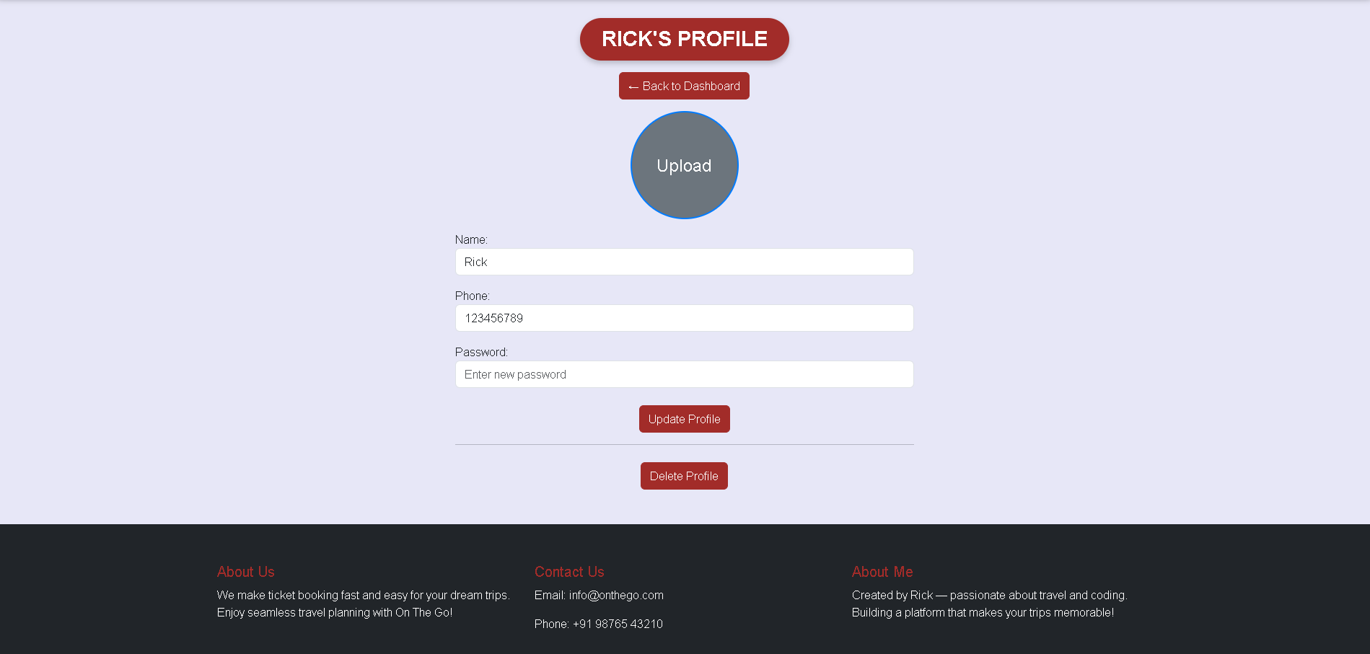

Module: User Profile / Account Settings
Environment:
- OS: Windows 10
- Browser: Chrome (latest)
- Server: Flask (local)
- URL: http://127.0.0.1:5000/profile
Steps to Reproduce:
- Log in to the application.
- Navigate to the Profile page.
- Click on the Upload Profile Picture option.
- Choose an image file and submit.
- Refresh or revisit the Profile page.
Expected Result:
The uploaded profile picture should appear and replace the previous image (or placeholder).
Actual Result:
Profile picture remains blank after uploading — no image is displayed or updated.
Error / Observation:
No visible error on UI, but the image file may not be properly saved or linked in the backend.
Possible Cause:
- The uploaded file isn’t being saved to the correct folder (static/uploads/) or the path isn’t being returned to the database.
- profile_image column might not be updated in the database.
- Flask’s static URL path might not be rendering the updated file after upload.

Bug Report 3 – Review Submission Issue
Title: Review form does not display submitted reviews correctly.
Severity: Low
Priority: Low
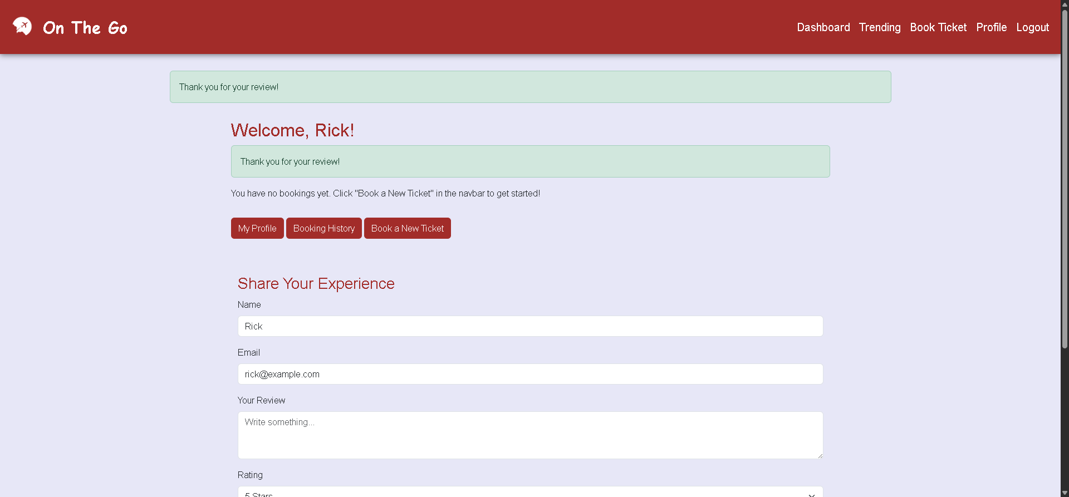
Module: Review / Feedback Section
Environment:
- OS: Windows 10
- Browser: Chrome (latest)
- Server: Flask (local)
- URL: http://127.0.0.1:5000/review
Steps to Reproduce:
- Log in to the application.
- Navigate to the Review or Feedback page.
- Enter a review message and rating (if applicable).
- Submit the form.
Expected Result:
The submitted review should appear on the page instantly or after refreshing, confirming it was successfully saved.
Actual Result:
The review either:
- Does not appear after submission, or
- Appears only after restarting the server, or
- Does not persist in the database.
Error / Observation:
No visible frontend errors, but database or render delay suspected.
Possible Cause:
- Flask route may not commit the review data properly to the database.
- The page might not be reloading or re-querying the updated reviews after submission.
- A missing redirect or db.session.commit() line in the route.

