**Bug 1 – Timer Resets After Page Refresh**

**before**

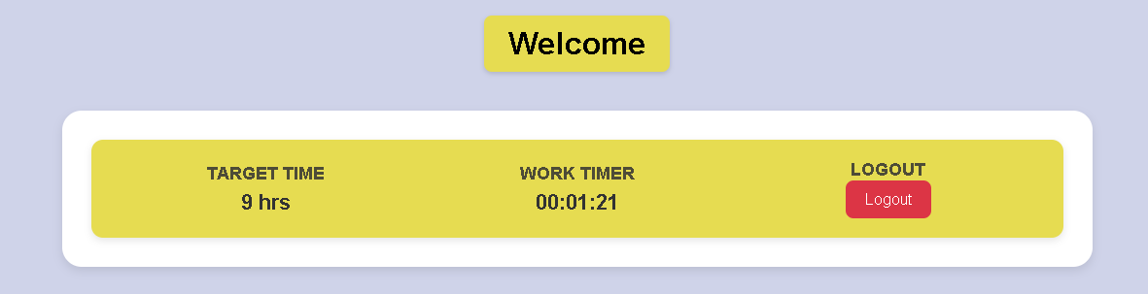

**After**

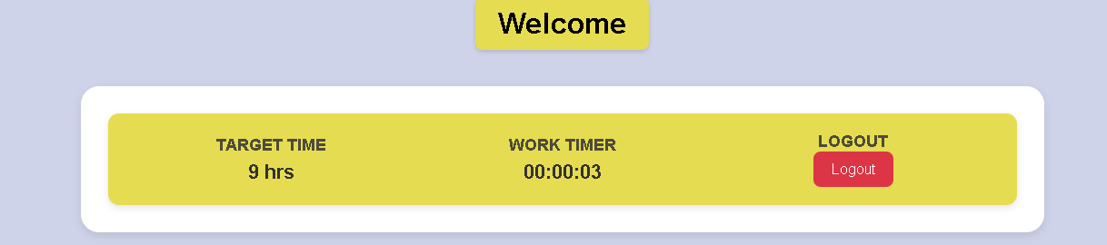

**Description:**  
In the Employee Dashboard, the active work session timer resets every time the page is refreshed or reloaded.

**Impact:**

* **Functional Issue:** The timer is meant to track active working time, but a refresh causes data loss.
* **User Impact:** If the user accidentally reloads or loses connection, the system misrepresents total active time.
* **Reliability Issue:** This reduces trust in time tracking accuracy.

**Possible Cause:**  
The timer runs only on the frontend (JavaScript) and does not store state in the backend or local storage.

**Probable Fix:**

* Implement **session persistence** by saving the timer’s state (start time, elapsed time) in the database or localStorage.
* On reload, fetch the stored time and continue counting from there.

**Notes:**  
Add an **auto-save** feature every few seconds, so data isn’t lost even if a refresh happens mid-session.

**Bug 2 – Typo in Flash Message After Leave Rejection**

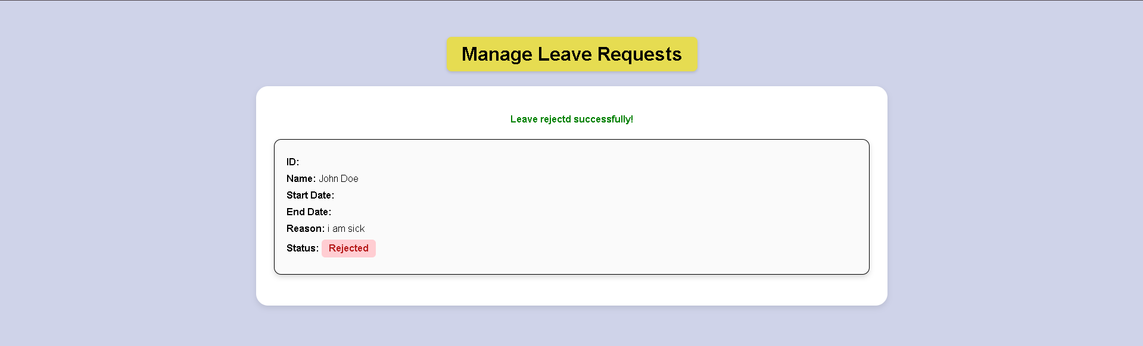

**Description:**  
After rejecting a leave request in the Admin Leave Management page, the flash message shows:

“Leave rejectd successfully!”

**Impact:**

* **UI Issue:** Minor text typo, but reduces professionalism and polish of the web app.
* **User Impact:** Can create confusion or appear careless in client-facing demos.

**Possible Cause:**  
Typographical error in the backend flash message string (Flask flash() function).

**Probable Fix:**  
Correct message text in the respective Flask route:

```bash

flash("Leave rejected successfully!", "success")

```

**Notes:**  
Review all flash messages for consistent tone and capitalization (e.g., “successfully” vs. “Successfully”).

**Bug 3 – Non-functional Subscribe Link**



**Description:**  
The “Subscribe” button on the landing page currently does not perform any action (no backend route or link attached).

**Impact:**

* **Functional Gap:** Breaks expected user behavior — clicking does nothing.
* **UX Issue:** Misleads users into thinking a feature exists.
* **Conversion Issue:** Potential lost opportunity for user engagement or newsletter collection.

**Possible Cause:**  
No backend route or form submission defined in Flask app for “/subscribe”.

**Probable Fix:**

* Add a /subscribe route in Flask to handle submissions.
* Or link the button to a newsletter signup endpoint or email list.

**Notes:**  
Include success/error flash messages for user feedback like *“Subscribed successfully!”* or *“Email already registered!”*.

**Bug 4 – Flash Message Appears in Wrong Section**

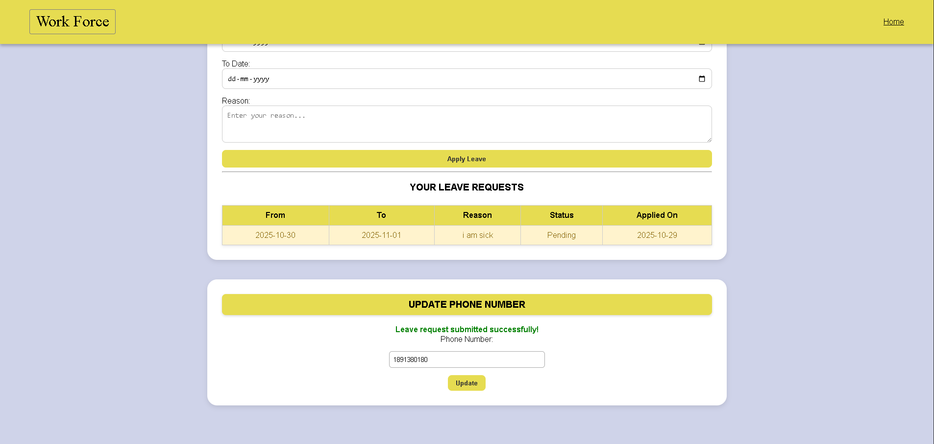

**Description:**  
After submitting a leave request, the success message appears in the “Update Phone Number” section (lower part of the dashboard) instead of at the top.

**Impact:**

* **UI/UX Issue:** Reduces visibility of success messages.
* **User Impact:** The user might think the request wasn’t submitted.
* **Design Issue:** Flash container likely positioned incorrectly in the HTML layout.

**Possible Cause:**  
Flash block ({% with messages = get_flashed_messages() %}) is defined below the main leave section in the HTML file.

**Probable Fix:**  
Move or duplicate the flash container to appear **above all forms** or within a global alert container in the dashboard layout.

**Notes:**  
Add consistent styling (colored alert boxes, fade-out animation) for all flash messages for better visibility.

**Optional Issues & Fixes**

| **Issue** | **Description** | **Suggested Fix** |
| --- | --- | --- |
| **No Footer in Dashboards** | Both Admin and Employee dashboards lack a footer section. | Add a simple footer with company name, contact info, or copyright. |
| **No Admin Registration Option** | Only employee registration exists; admins are manually added. | Add a restricted registration for admins or a setup script for initial admin creation. |