Software Engineering Documentation
StartupScan - complete and detailed version
Generated on: 03/09/2026 13:54

1. Summary and objectives
StartupScan is an AI-powered platform for evaluating startups, designed to reduce analysis time, increase feedback standardization, and produce executive artifacts for decision-making.
- Receive pitches in multimodal format.
- Generate an interpretable score and recommendations.
- Deliver a technical report, AI video, and visual pitch deck.
- Support continuous operation with job monitoring.

2. Implemented functional scope
- Multimodal submission (text, document, audio, video, and YouTube).
- Startup analysis with a 0-10 score and category-based recommendations.
- Local engine and GPT option with fallback.
- AI video in the result (D-ID/local/hybrid) with real-time progress.
- Slide-style pitch PDF with automatic context-based design.
- Pitch PDF with manual premium mode and user-selected template.
- Model management with training, retraining, activation, and real-time monitoring.
- Operational and investor dashboards.

3. Technical architecture
The solution uses a modular architecture with specialized services for analysis, video, and export.
Layer | Technology | Responsibility
Frontend | Django Templates + JS | Interface, forms, dashboards, and progress polling
Backend | Django + DRF | Orchestration, business rules, routes, and security
AI | scikit-learn + OpenAI | Scoring, interpretability, and narrative
Video | moviepy + D-ID | AI video generation and local rendering
Documentation | reportlab + python-docx | PDF and DOCX export
Persistence | SQLite/PostgreSQL | Analyses, submissions, and operational metadata
Architecture diagram:
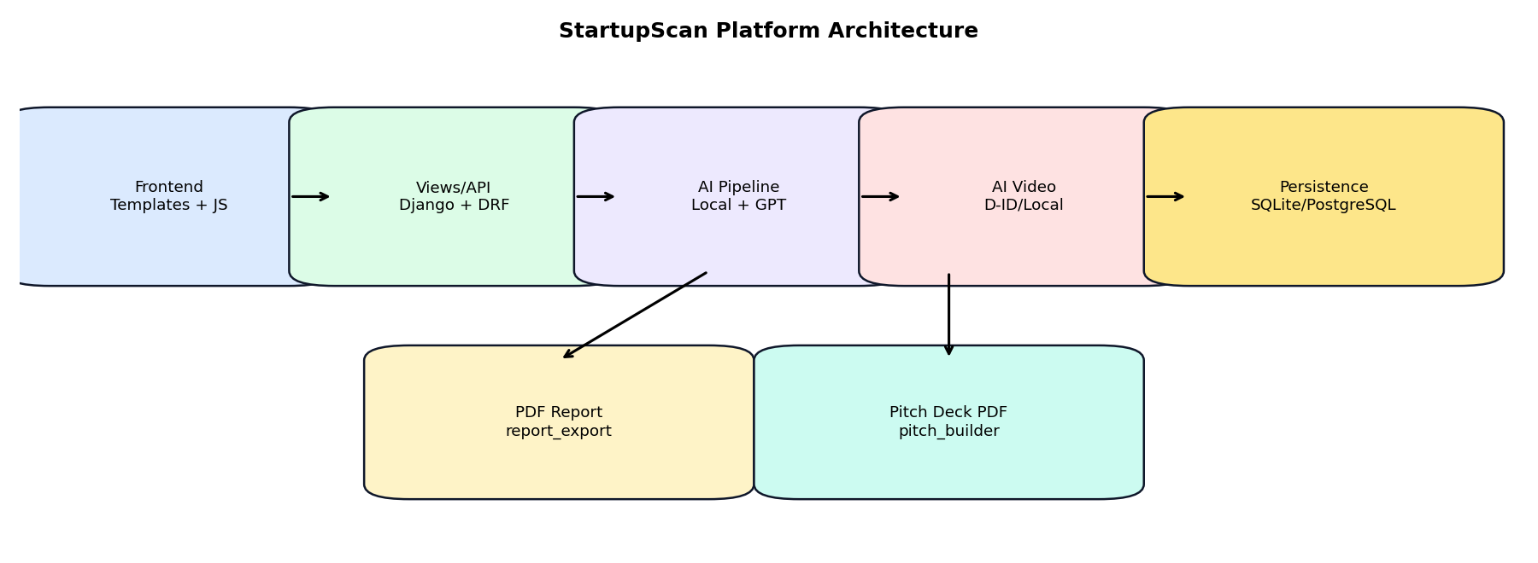
Functional flow:
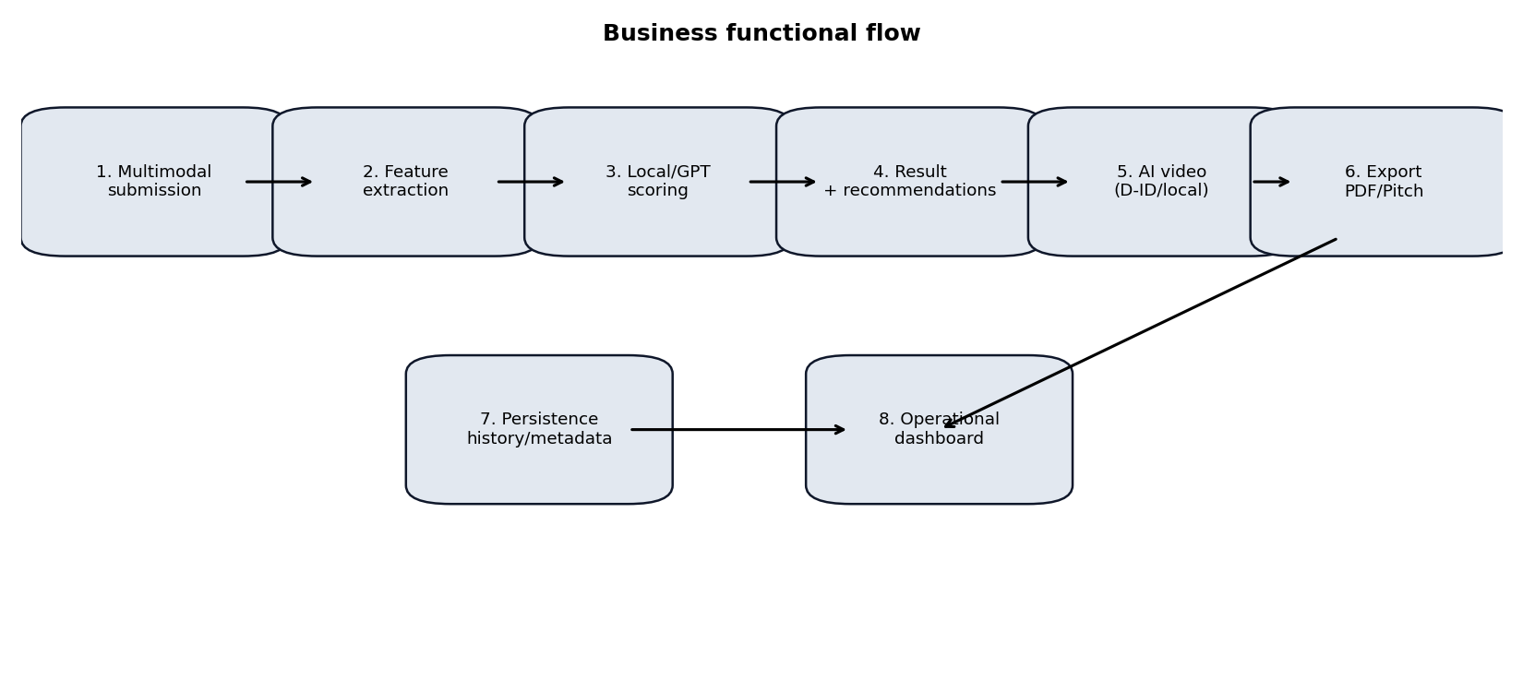
Example of evaluation categories:
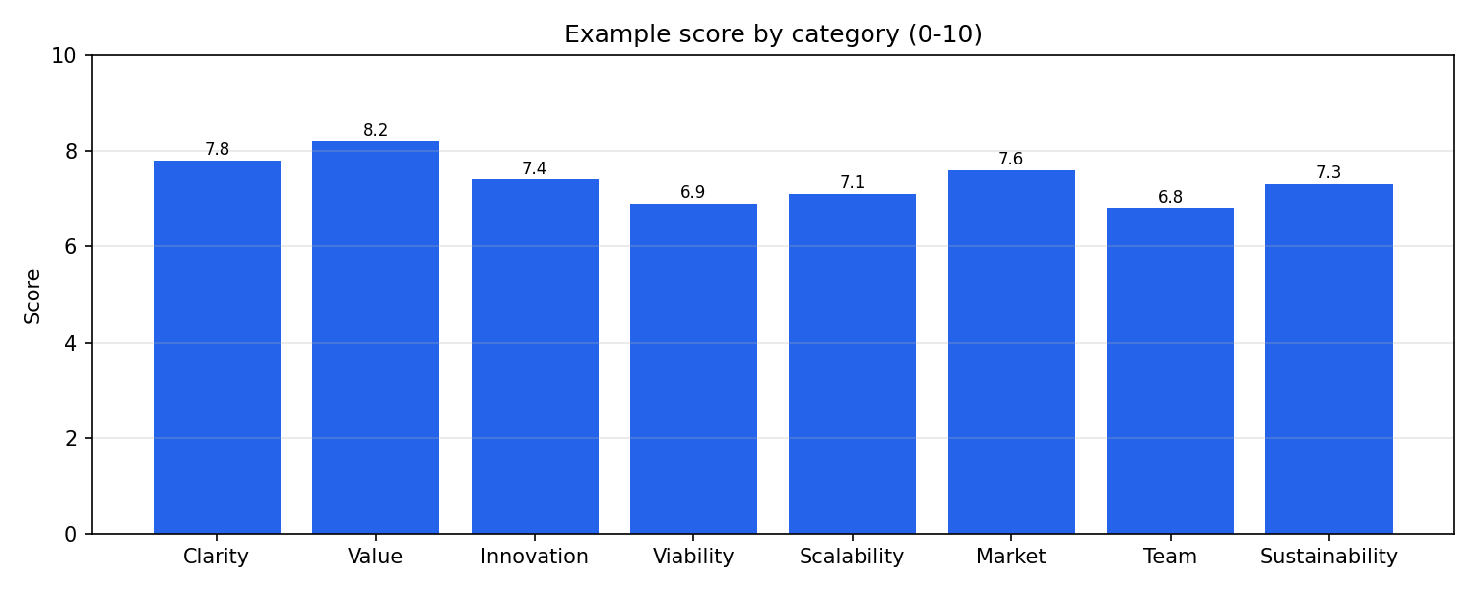
Asynchronous job phases:
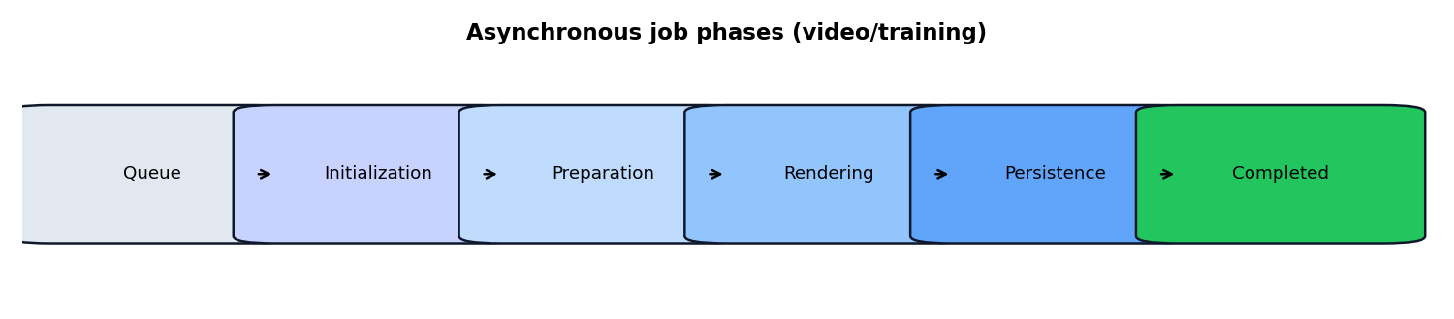

4. Business flows
Flow A - Multimodal evaluation:
- Receive multimodal input.
- Extract and consolidate context.
- Run local/GPT inference.
- Persist the structured result.
- Display score and recommendations.
Flow B - AI video:
- Select mode (auto/did_only/local_only).
- Create an asynchronous job.
- Track progress via endpoint.
- Persist artifact and metadata.
Flow C - Pitch deck PDF:
- Build the pitch narrative.
- Select the design mode (automatic/manual).
- Render visual slides.
- Deliver the PDF for download.

5. Main endpoints
Endpoint | Method | Description
/analyze/form/ | GET/POST | Multimodal evaluation form
/results/<id>/ | GET | Full analysis result
/results/<id>/pdf/ | GET | Technical analysis report
/results/<id>/pitch/pdf/ | GET | Visual pitch deck
/results/<id>/video/generate/ | POST | Starts video generation
/results/<id>/video/progress/<job_id>/ | GET | Video progress
/models/ | GET/POST | Model management and training
/investors/ | GET | Investor dashboard

6. Usage guide
- Access the New Pitch page.
- Fill in the startup and sector information.
- Submit multimodal data (text, document, audio, video, YouTube).
- Run the evaluation with the local engine or GPT.
- Review the result with score, categories, and recommendations.
- Optionally generate an AI video in the desired mode.
- Generate the technical PDF report.
- Generate a pitch PDF with automatic context-based design.
- Generate a pitch PDF with manual premium design (chosen template).

7. Operation, testing, and troubleshooting
- python3 manage.py check
- python3 manage.py test
- python3 docs/generate_engineering_pdf.py
- python3 docs/generate_engineering_docx.py
Minimum functional checklist:
- Valid multimodal submission.
- Score and categories present in the result.
- AI video with progress bar.
- Pitch PDF with both design modes.
- Technical report download.
Quick troubleshooting:
- D-ID failure: check key, credits, and the image HTTPS URL.
- GPT failure: check OPENAI_API_KEY and local fallback.
- PDF/DOCX failure: check dependencies and write permissions.

8. Documentation publishing
The project's operational delivery includes sending the updated documentation to the Discord webhook in PDF and DOCX formats.

