Homework 5: Texture Mapping

The assignment given was to map a given texture to a given model built of triangles. The model was provided as a text file along with each vertex’s proper texture coordinate. The model was to be built just as the previous homework, but instead of using lighting or given colors, the proper pixels of the image provided (the texture) was to be written to the framebuffer instead; which texture pixels, or texels, were to be used must be calculated based on the provided input as well as the set projection, orthogonal or perspective.

The texture was loaded to memory as a simple GzImage. Using this, the color value of each pixel could easily be read during processing. The coordinates for the texture were loaded at the same time the vertices were loaded; they were stored in a vector. From this point, the same interpolation method used for color calculation was used to interpolate the necessary texel to be applied to the model. During the standard bilinear image processing, the minimum and maximum coordinates for the texture were interpolated just as the vertices of the triangle were interpolated: first with the y axis, and then second with the x axis within the line rasterization function. During final setting of the pixel to the frame buffer, the texel was selected based on the interpolated U and V coordinates and this pixel was set as opposed to a set color or shader.

Implementation was simply a matter of developing an interpolation algorithm specific to texture coordinates, appropriately applying the interpolation function, and correctly applying the texels from the texture to the model in the framebuffer.

The perspective projection mode produces an artifact in which many attempts to correct were made but were unsuccessful. Various algorithms for perspective correctness were attempted such as scaling the texture by the vertices’ Z coordinates and by calculating the tangents and bitangents of the texture on each triangle to properly transform the texture to the appropriate scale. Attempts to correct this artifact can be seen below:

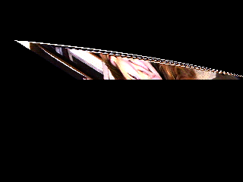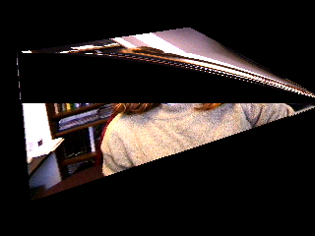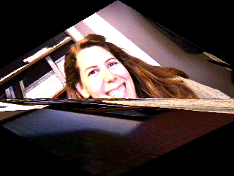

Despite this, the results of the chosen algorithm produced satisfactory results. The models were textured nearly perfectly. The artifact can be seen on the floor surface of the second image which is the perspective project. The first image, orthogonal projection, does not exhibit this artifact and shows perfect results of the texture mapping:

