Parameterized Report (demo)

Jane Smith (Jacobs)

2024-06-07

# Table of contents

## List of figures

## List of tables

# Section

This report received 3 plots and 2 tables from Shiny.

The names of the plots are: AllSites, Site.1, Site.2.

The tables are AllSites, Site.1, Site.2.

This was made in R (R Core Team 2016).

Plot 1:

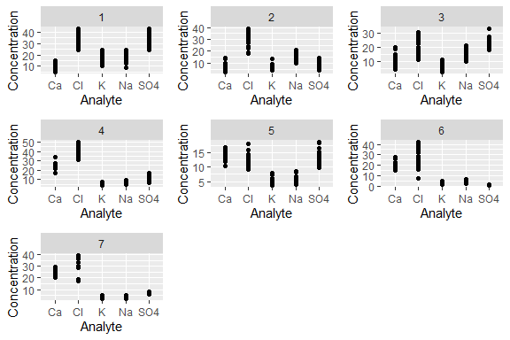

**Figure** **:** Figure with a caption

Table 1:

| Analyte | N | mean |
| --- | --- | --- |
| Ca | 51 | 10.01784 |
| Cl | 51 | 32.35353 |
| K | 51 | 17.22490 |
| Na | 51 | 16.81373 |
| SO4 | 51 | 34.86216 |

# References

R Core Team. 2016. *R: A Language and Environment for Statistical Computing*. Vienna, Austria: R Foundation for Statistical Computing. <https://www.R-project.org/>.

# Appendices

By default, un-rendered plots and tables go into the appendix.

## Plots



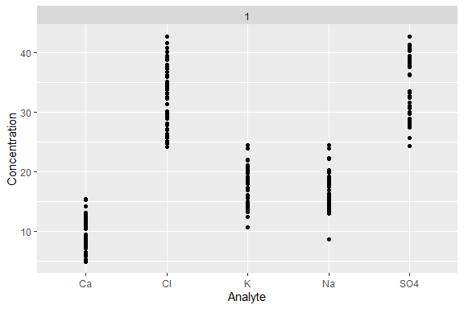

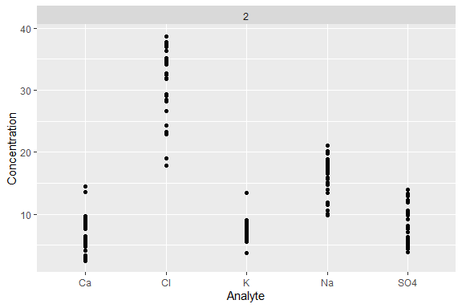

## Tables

**Table** **:** Site.1

| Analyte | N | mean |
| --- | --- | --- |
| Ca | 51 | 10.01784 |
| Cl | 51 | 32.35353 |
| K | 51 | 17.22490 |
| Na | 51 | 16.81373 |
| SO4 | 51 | 34.86216 |

**Table** **:** Site.4

| Analyte | N | mean |
| --- | --- | --- |
| Ca | 35 | 24.614571 |
| Cl | 35 | 40.143143 |
| K | 35 | 5.383429 |
| Na | 35 | 6.956571 |
| SO4 | 35 | 12.113143 |