Parameterized Report (demo)

Jane Smith (Jacobs)

2024-06-06

## Plot 1

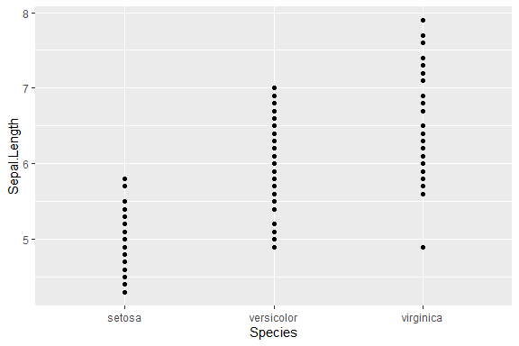

## Other plots

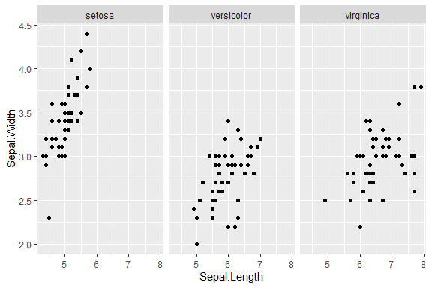

This was made in R (R Core Team 2016).

R Core Team. 2016. *R: A Language and Environment for Statistical Computing*. Vienna, Austria: R Foundation for Statistical Computing. <https://www.R-project.org/>.