**Group Members**

Rick Haffey (login: *rihaffey*)

**Compiling the program**

* Navigate to the directory containing the C++ code files
* Execute the following from the command line:
  + **g++ *.cpp –o ./output/program**

**Running the program**

* Copy the *program* executable file created above to */home/rihaffey*
* From the command line, excute the *myplayer.sh* script (located in the same directory)

**Static evaluation and heuristics**

* For each player, the code iterates through every cell of the game board, and for each cell
  + Examines every possible win it could be a part of:
    - Vertical
    - Horizontal
    - SE diagonal
    - SW diagonal
  + Heuristic: At each orientation, every cell could be involved in up to *n* (pieces-To-Win) possible wins (except where various positions are unusable due to cutoffs at or near board edges)
  + Heuristic: The value of every possible win = (2 ^ the number of owned pieces), so that the value increases exponentially as each possible win gets closer to an actual win
  + These values are summed to produce the cell's value
  + Static eval: If a state represents an *actual* win, the calculator returns a reference value (much higher than a normal calculated value) to represent this
  + Static eval: The process also takes into consideration blocks for a 'save', and returns a value that's less than a win, but much higher than most other calculated values (so as to *not* be chosen over a potential immediate win, but to be chosen in most other cases over just 'strategic' options.
  + Static eval: A draw evaluates to 0
* The cell values are summed to produce the overall game state value
* The minimax algorithm uses the *difference* between MAX and MIN’s state heuristic scores as the result of the UTILITY function.

**Minimax and Alpha-Beta pruning**

The logic used is based closely on the pseudocode for the algorithms described in AIMA. I’ve also included iterative deepening and timeout handling as follows:

The minimax algorithm is run so that the terminal test function exits if any of the following three criteria are met:

* The game is complete (WIN1, WIN2, or DRAW)
* The current search depth is greater than an iteratively increasing max_depth value
* The current run-time is within a configured threshold of the overall timeout period

The logic runs through the process, storing the results of the previous iteration, increasing the depth, and trying again. If the process nears the timeout during an iteration, processing exits and the result from the previous iteration is used to determine the next move.

I’ve also added a ‘first-chance’ move evaluator that checks for obvious moves (immediate win, immediate block, etc.), and if those conditions are present, returns the ‘obvious’ move. This cuts down on the minimax processing effort and time in those cases, and also provides a failsafe in the event something in the minimax algorithm isn’t calculating correctly.

**Results**

I used various methods for testing the program.

* During early development, most of the tests were manual, mimicking the behavior of the referee from the command line.
* As the player logic became more ‘stable’, I implemented a simple referee and random player, to mimic locally the behavior of the competition
* I also ran tests running two of my players against each other

Although I have seen big improvements in the performance (time and success) with most of my coding iterations, I’m still seeing situations where my heuristic is leading to counter-intuitive moves. As an example, there are cases where the heuristic doesn’t lead to selection of a block move in cases where the opponent will win without the block. In order to ‘mitigate’ this, I’ve included the first-chance move handler that takes a win or block as the move choice (prior to starting the minimax search), if one of those moves is available.

**Fitness of evaluation and heuristic functions**

The static evaluation function is an adequate approach, because it represents the relative values of a win, block, and draw in a way that mirrors their impact or value from the player’s perspective: a win is more valuable than any other move, a block is second most valuable (because it shouldn’t be chosen over a win, but *should* be chosen over any other strategic move), and a draw has no value. These representations also coincide well with how the values relate to the two different players.

From a heuristic standpoint, our estimation calculation will generate the same value in the above three cases as when the game is actual at a termination point for a win, block, or draw. In addition, the heuristic provides an optimistic means of calculating the value of a game state based on all the possible wins for that state.

**Additional AI Component: Machine Learning**

For the secondary AI technique, I chose to implement a machine learning component. To support this, I needed to make two primary adjustments to the player logic:

* Support for storing historical game results as training / knowledge base data
* Support for using this training data in making game-time move decisions

My approach was as follows:

* During every game, the player writes out a training data file that contains all the moves made during a game, as well as the final result of the game
* Below is an example training file:

1012005654430146515

-1

WIN1

* In the first row, each digit represents the moves during the course of the game. The next two rows indicate the outcome of the game (in this case, our player won the game.)
* At game-time, the player loads the data from all the training files, and sorts them based on move sequence (based on their ‘alphabetical’ order)
* The player then performs the following algorithm when determining the next move:
  + Find all the training results that have the same set of starting moves leading up to the current point of the game.
    - As an example, if the current game sequence was “1 0 1 2”, the previous training set would be included in the relevant historical entries.
  + For each ‘next’ column in the collection of relevant training sequences (the next character found in the play sequences in the training data -- e.g. column ‘0’ from the example data above), calculate the number of wins and losses associated with that sequence
  + If there is a ‘next’ column that has a clear advantage (more wins than losses), choose that column. If there is a tie, choose the column with the lower number of losses. (i.e. if column ‘3’ has 5 wins and 2 losses, and column ‘4’ has 3 wins and 0 losses, column ‘4’ would be chosen.
  + If there are only losing ‘next’ columns, but not all columns are represented in the historical data, randomly (or using a constrained minimax) choose a valid column from the non-losing remainder.
  + If either no data is present, or all the ‘next’ columns are losing columns, choose a random column (or perform the minimax algorithm to choose the next column.)

As of this point, I have implemented the above machine learning player, but with the following ‘qualifications’:

* The code is in C# rather than C++
* The code is separate from my player code that uses minimax. As a result, in all cases where the training data doesn’t provide a concrete next move, my player is just selecting a random (but valid) next move, and adding this to the training data for future runs.
* My next step would be to convert this to C++ and combine it with my existing minimax player. Due to time constraints I wasn’t able to complete this in time for the submission.
* The amount of training data required to make this useful is very large. Until now, most of my generation of the training data has been based on random play. I think a better approach would involve a more focused data generation approach, that follows *all* possible branches.

Below are some screens showing runs of the program involving the machine learning player:

*Before any training data is present:*

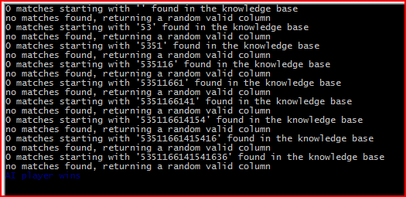

*After generating a (relatively small) set of training data:*

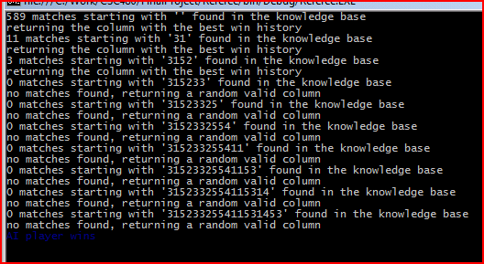

**SourceCode**

I’ve been storing all my code in Github during the development process. In addition to the code submitted on D2L, my entire source code repository is available [here](https://github.com/rickhaffey/CSC480/tree/master/FinalProject) for reference. You’ll see that I’ve had multiple versions of the project (C#, C, C++). In the early stages, I used C# (the language I’m most comfortable with) to solidify my ideas, build an initial, base implementation, etc. I then converted over to C++ (with an aborted C conversion in between), in order to support compiling and building in a Linux environment. [I was working on the assumption that the Mono .NET framework wouldn’t necessarily be present on the competition server.]