This document will demonstrate how to create a repository from the ardalis/CleanArchitecture github template repository, and adjust the folder names and code to line up with the repository’s name (CleanFun).

NOTE: this is a quick and dirty approach; a better way to achieve this is to create a dotnet template – I will be doing this in a future document.

We are going to create a repository named CleanFun.

Log in to github (<https://github.com>)

Now go the CleanArchitecture <https://github.com/ardalis/CleanArchitecture/>

Click the green button whose caption is “Use this template”

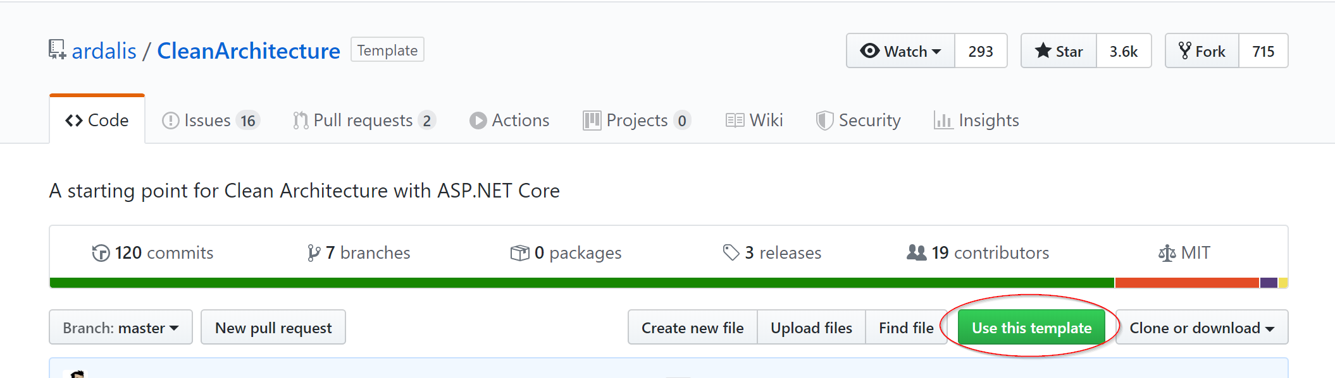

You will be asked for a name for your repository, put in the name CleanFun, click the green button titled “Create a repository from this template:”

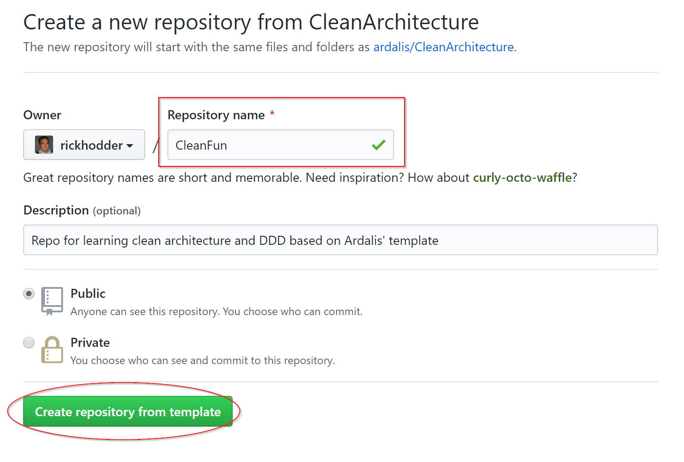

If all goes well you will have a repository named CleanFun, and it even tells you the repository that it was generated from:

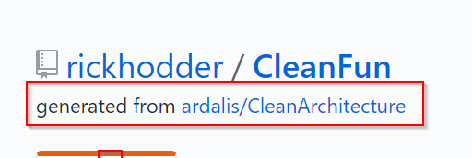

Next, we need to clone the repository to bring it to our PC. To do this, click on the green button titled “Clone or download”, and then click the clipboard icon to copy the address of the repository to the clipboard:

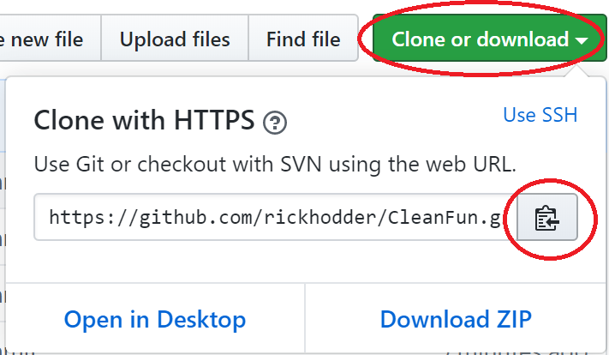

Open Visual Code, and press ctrl-shift-p, and at the prompt type “git clone” and press enter.

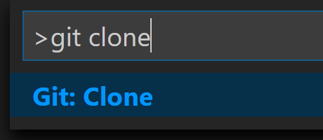

VSCode will ask for the Repository URL - paste from the clipboard and press Enter

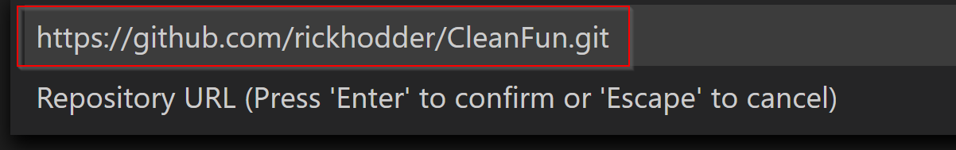

You will be asked to select your repository location. This is slightly confusing, particularly if you are new to using git.

The default location for github repositories in windows is c:\users\<yourlogin>\Source\Repos.

You might think that you should add “CleanFun” to the end of this location, but what really happens is that the name of the repository with .git removed (CleanFun~~.git~~) is the name of the folder created in the Repos folder.

So you choose the Repos folder and click on button titled “Select Repository Location”

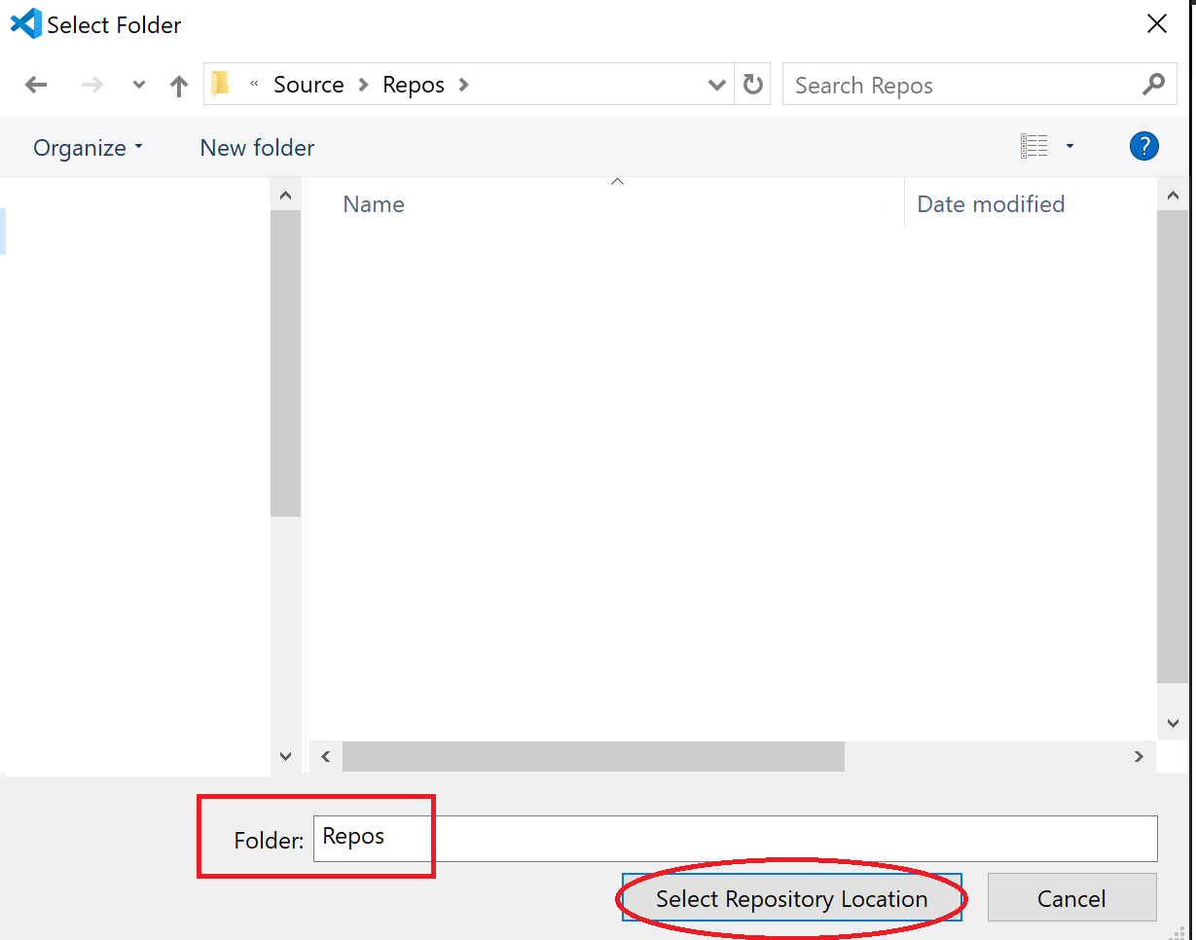

After the repository is cloned, VS Code will ask if you want to open the cloned repository, click the blue button titled “Open in New Window”

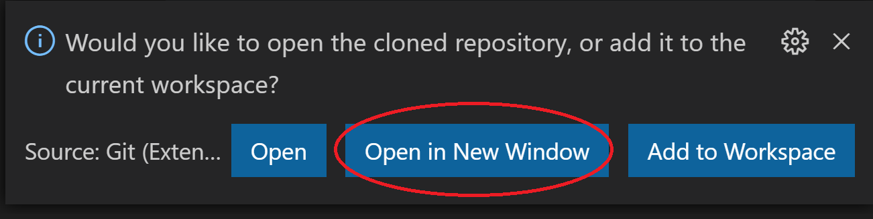

You may see other pop up windows but you can close and ignore those for now.

You should see the following in the Explorer pane:

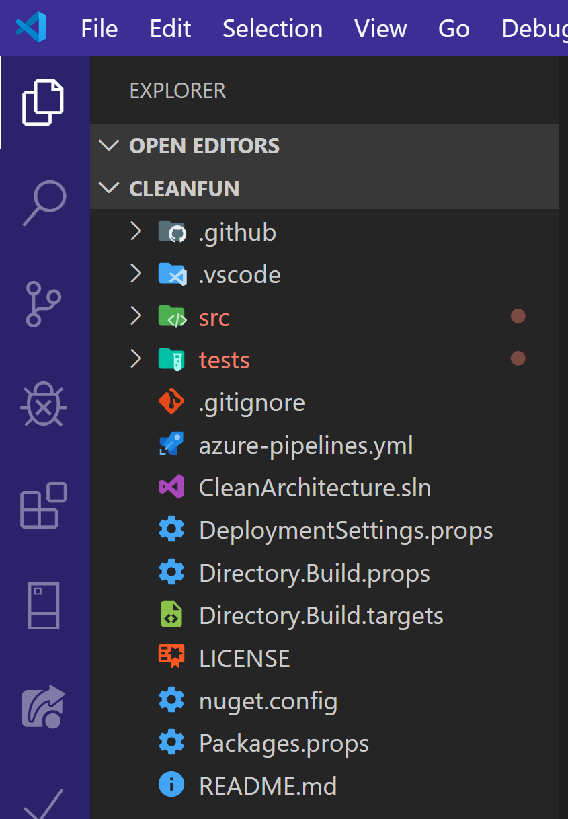

Before moving on, we should make sure that the web project builds and works.

Open the terminal window (ctrl-~)

Use the following command to build all of the code in the repository:

Dotnet build

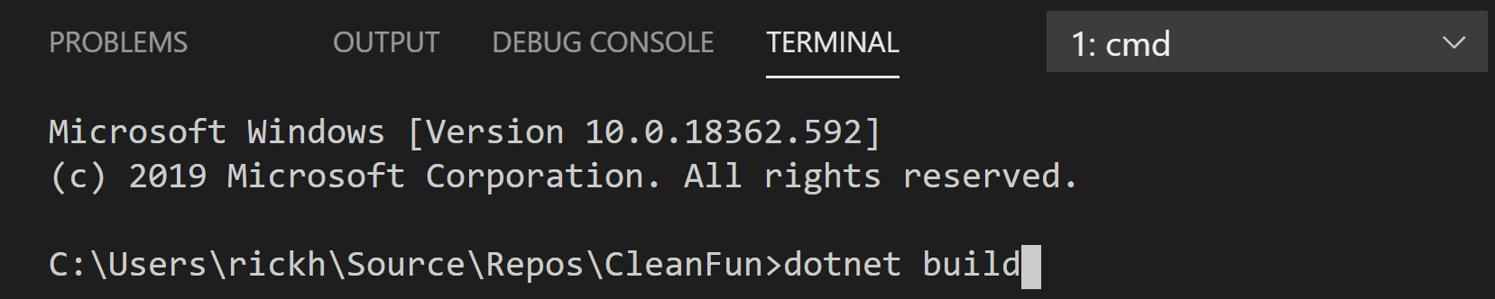

If all goes well, you should see the following in the Terminal window

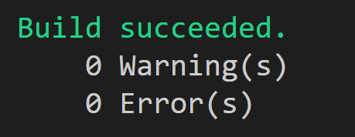

To be thorough, we should run the tests.

In the terminal window, run the following command, that will find and run all tests:

dotnet test

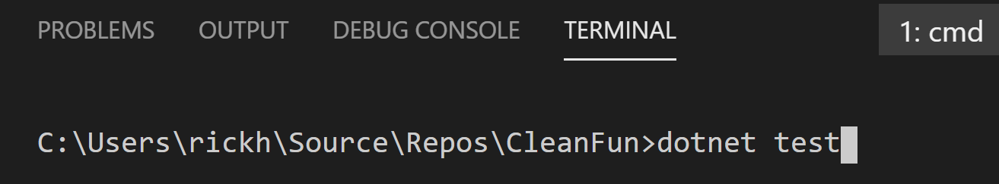

You should see the following:

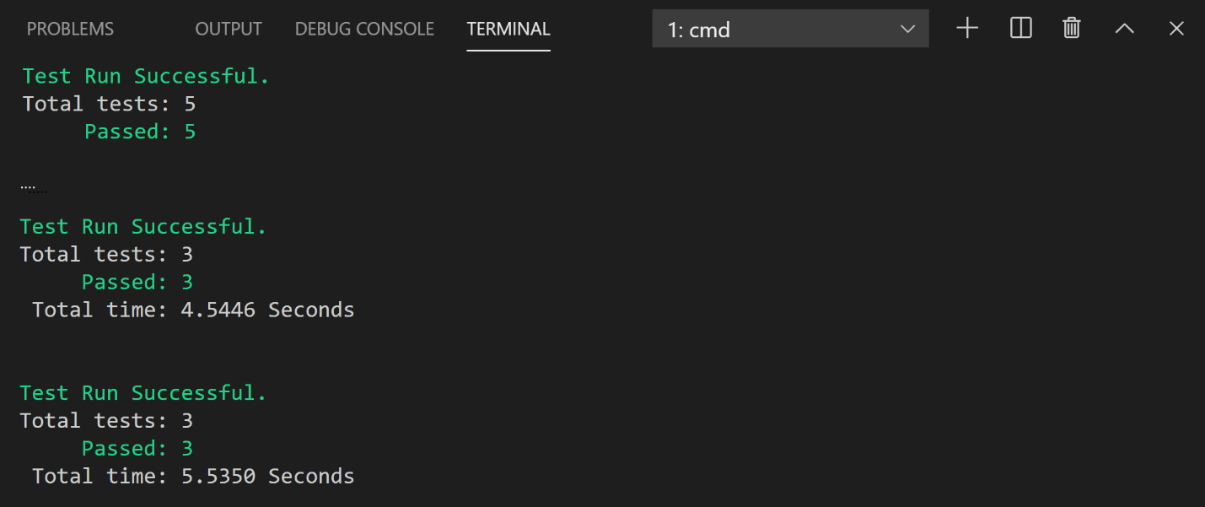

You will need scroll to make sure you can see it all.

So all of our tests passed.

Now run the web project, by typing the following into the terminal window

dotnet run --project src\CleanArchitecture.Web\CleanArchitecture.Web.csproj

And then press enter.

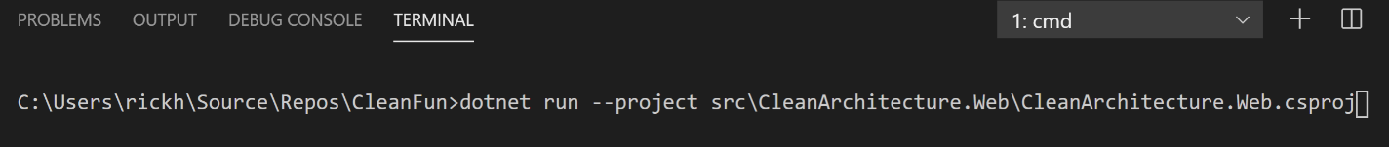

After a bunch of information scrolls by, you will see a message similar to the following:



Point a browser at the http address (it may have a different port number (57679) than in the image above).

You should see the following:

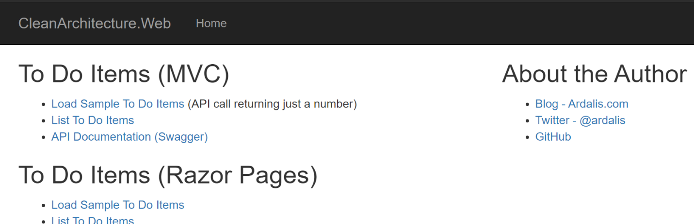

Now we know that it builds, runs and tests properly, we can make our adjustments.

Press ctrl-c to stop the application from running.

Now let’s do a little surgery to bring the names of the solution, folders, and project names (which all start with CleanArchitecture) to line up with the name of our repository (CleanFun) – first, we will rename the projects and solution. Run the following commands in the terminal window:

REM Renames project, test and solution files - replace "CleanFun" with the

REM new name for your projects and solution

REM then rebuilds and runs web app

REM NOTE: no spaces! Ex. CleanFun instead of Clean Fun

rename src\CleanArchitecture.Core\CleanArchitecture.Core.csproj CleanFun.Core.csproj

rename src\CleanArchitecture.Infrastructure\CleanArchitecture.Infrastructure.csproj CleanFun.Infrastructure.csproj

rename src\CleanArchitecture.SharedKernel\CleanArchitecture.SharedKernel.csproj CleanFun.SharedKernel.csproj

rename src\CleanArchitecture.Web\CleanArchitecture.Web.csproj CleanFun.Web.csproj

rename tests\CleanArchitecture.FunctionalTests\CleanArchitecture.FunctionalTests.csproj CleanFun.FunctionalTests.csproj

rename tests\CleanArchitecture.IntegrationTests\CleanArchitecture.IntegrationTests.csproj CleanFun.IntegrationTests.csproj

rename tests\CleanArchitecture.Tests\CleanArchitecture.UnitTests.csproj CleanFun.UnitTests.csproj

rename CleanArchitecture.sln CleanFun.sln

rename src\CleanArchitecture.Core CleanFun.Core

rename src\CleanArchitecture.Infrastructure CleanFun.Infrastructure

rename src\CleanArchitecture.SharedKernel CleanFun.SharedKernel

rename src\CleanArchitecture.Web CleanFun.Web

rename tests\CleanArchitecture.FunctionalTests CleanFun.FunctionalTests

rename tests\CleanArchitecture.IntegrationTests CleanFun.IntegrationTests

rename tests\CleanArchitecture.Tests CleanFun.Tests

Here’s what the explorer pane should look when you are done. Notice that the folders are now named CleanFun instead of CleanArchitecture:

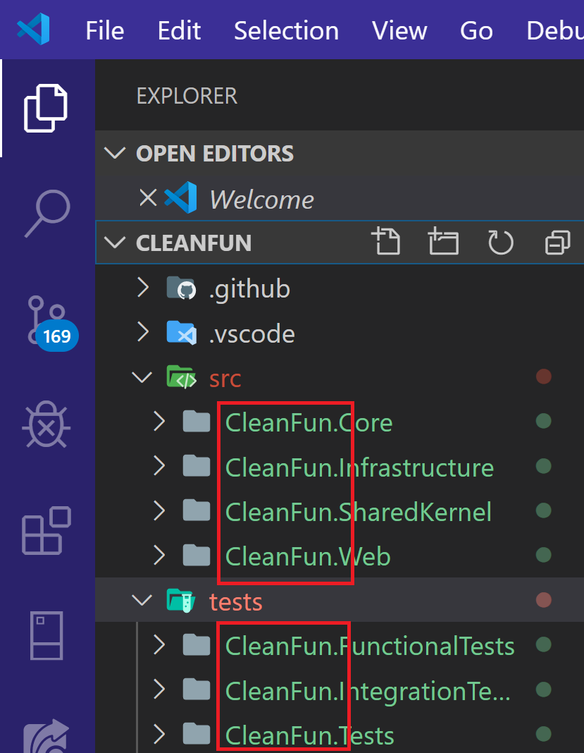

Next we want to change all the source code references from CleanArchitecture to CleanFun.

The simplest way to do this is click on the Search icon in VSCode (circled in red on the left, below), and replace CleanArchitecture with CleanFun, and press the “replace all” button (circled in red below).

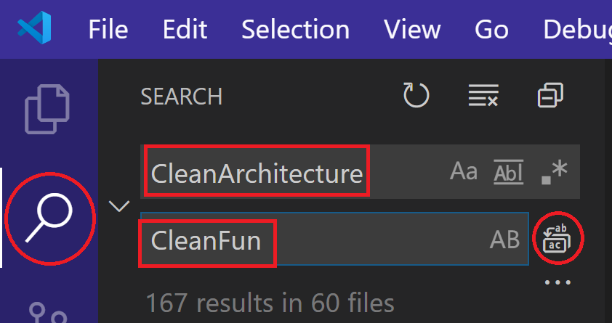

You will see a dialog that asks if you want to replace with CleanFun, choose the Replace button.

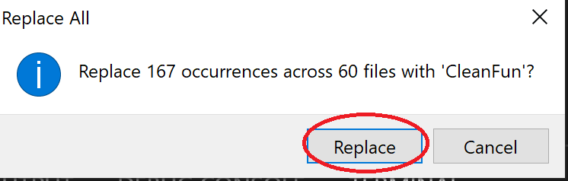

Now lets run the web application.

Go back to the terminal window, run the web application by executing the following command. Note that since we have changed the name of the web application folder and project from CleanArchitecture to CleanFun, we have to change the dotnet run command (changes highlighted in yellow)

dotnet run --project src\CleanFun.Web\CleanFun.Web.csproj

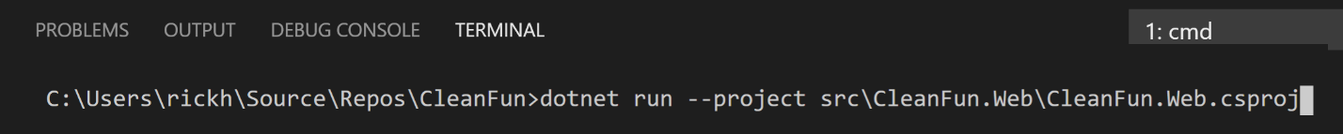

You will see a message similar to the following:



Point a browser at the http address (it may be a different port than in the image above).

You should see the following (notice that application now shows CleanFun.Web in the header instead of CleanArchitecture.Web:

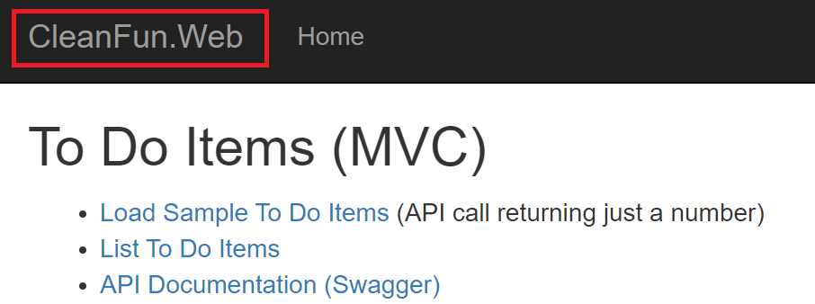

Go back to VSCode’s terminal window and press ctrl-c to stop the application.

To be thorough, we should run the tests again

In the terminal window, run the following command, that will find and run all tests:

dotnet test



You should see the following:



You will need scroll to make sure you can see it all.

So all of our tests passed.

Finally, we need to check in the changes to our repository.

To do this, click on the Source Control pane, enter a commit message of “Adjust items to CleanFun”, and press the commit button (the check mark circled in red, below):

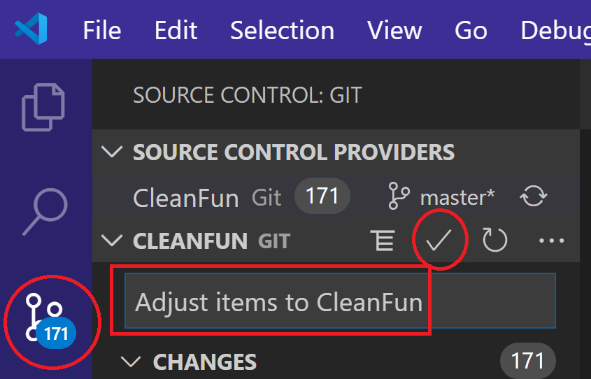

Because we changed the name of files and folders, you will see a dialog that asks if you want to automatically stage all your changes and commit them directly, click Yes:

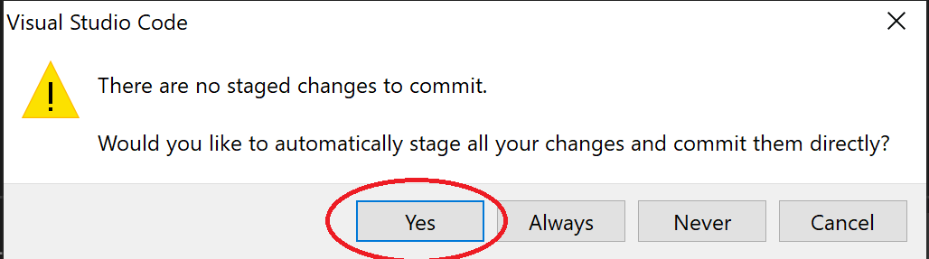

You have committed the changes to the local repository, so now you need to push the changes to github. To do this, you need to click the “synchronize changes” button, circled in red, below:

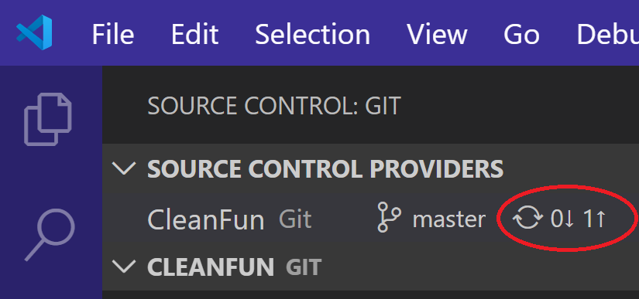

VS Code will ask if you want to synchronize changes, click Ok:

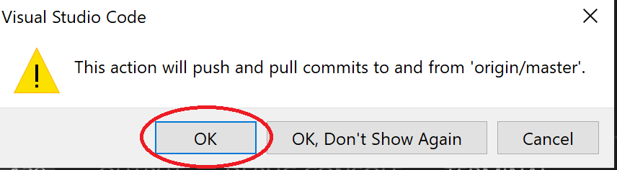

You are all set now – coding can commence!